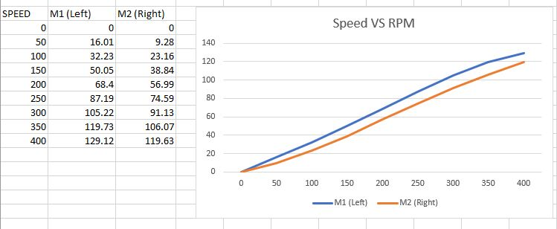

## **DC Motor**

The rotation of the shaft is achieved by applying a voltage of 6. To sense the rotation of a magnetic disk on the motor shaft’s rear protrusion, a 2-channel hall effect encoder is used. These encoders would provide feedback on rotation and the position of the motor shaft, allowing us to determine speed and distance.

Proportional-integral-derivatives (PID) and PWM must be implemented to obtain accurate movement of the robot, i.e. both motors should be producing the same revolutions per minute when the robot is going in a staight line.

### **PID Control**

The PID controller is a control loop feedback mechanism. It calculates the difference between a measured process variable and desired set point as the error value. The controller attempts to reduce error by tweaking the process through the manipulated variable.

PID control algorithm is given by the following formula:

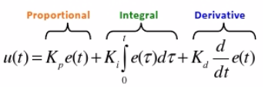

The 3 gains (P, I, D, which refers to Proportional, Integral, and Derivative respectively) will be added to output a signal that will make the output equal to the set point, eliminating the error signal.

### **PID Control Implementation**

The speed of each motor needs to be calculated. Speed is calculated by subtracting current ticks from previous ticks and dividing by the time elapsed. Error is then computed from this difference between the left and right motor.

The proportional term is obtained by multiplying this error with a gain.

The integral term is calculated by adding all the errors within a time frame and multiplying it by a gain.

The derivative term is computed by the differences between the left and right motor speed, then multiplied by a gain.

Summing these proportional, integral and derivatives terms, along with calibration, eliminates the values of the error to zero.

### **Pulse Width Modulation**

PWM is a technique used to encode messages into a pulse signal. It can encode information for transmission, and allows us to control the power supplied to the motor, and hence the speed which the motor rotates. The PWM duty cycle is varied to switch the motor on and off at a fast pace, maintaining full torque, instead of varying the voltage supply to control the speed of the motors.

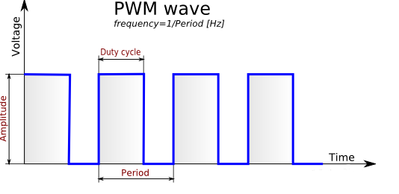

### **Problems Encountered**

PWM is strongly dependent on the voltage level. Should the voltage level drop, the movement of the robot and the sensor readings will be inaccurate, and recalibration needs to be done for the movements again. Thus, the battery should always be used at almost full voltage for testing and calibration purposes, and a range of voltage levels need to be determined to ensure that the motor functions as expected.

Different motors will have different properties, so the input of the same PWM with different motors would result in different rotation speeds and power. A master and slave motor power needs to be manipulated, with the slave motor matching the master’s motor power. This helps to achieve the same speed and number of rotations