Loyola, Alexander Philip M.

BSIT 2 – 1

Programming 2

Laboratory Activity 4

**PROGRAM CODE**:

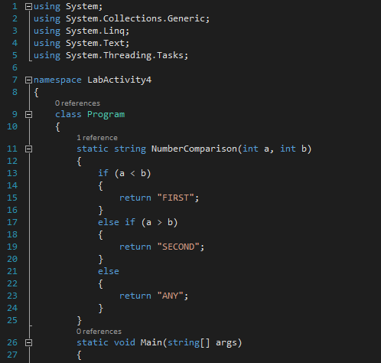

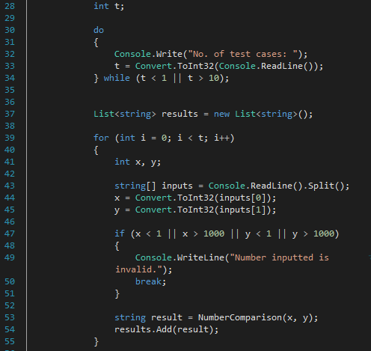

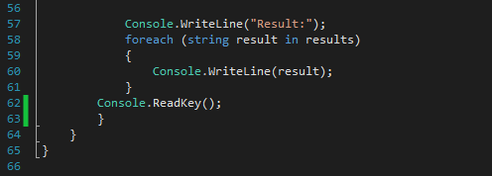

**PROGRAM OUTPUT**:

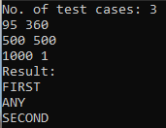

**EXPLANATION**:

First, I had to create a method that would compare the two numbers, and return what I need (the “FIRST”, “SECOND”, and “ANY”), since doing it manually would take a ton of work. Second, I had to put the “No. of test cases:” in a do-while loop, because I had to limit the number inputted (minimum of 1 and maximum of 10), where the loop will only stop when the condition in the while statement turns true. Third, I used for-loop in getting the user-inputted service cost since it is already dictated in the **t** variable on how many cases will be needed. Fourth, I used array in getting the actual user-input. I used the **Split()** method here to automatically separate the numbers in whitespaces (i.e. “95 360” when **Split()** is applied they become “95” and “360” respectively). Since I used array, they will be placed there in the order of the numbers (i.e. 95 is in the first index, 360 is in the second index). I used an if-statement here to verify if the number/s inputted is within the range (minimum is 1 and maximum is 1000), if it is not, it immediately ends the loop. After that, I created the **result** variable to save what the **NumberComparison()** method returned. I then created an array list named **results** and added the result variable there. Lastly, in order to display the results, I used a foreach-loop to display them.