# International Meme

# Chemistry Olympiad

# July 2021

# Official Amateur League Problems

# English version

# 

# 

# 

# 

# 

# 

# 

# 

Authors:

Vladislav Tishchenko, IChO 2021 participant

Daniil Kargin, IChO 2021 participant

Evan Griskjans, researcher at Daugavpils University

# Before You Start

Welcome to the International Meme Chemistry Olympiad!

We are very happy to see you (at least, digitally) participate in this competition.

This project could not be completed without the help of several people, and we’d like to thank them for their contribution.

First of all, a huge shoutout to our partners and sponsors **Young Folks LV** for providing the financial assistance needed to run the competition

Second, we incredibly appreciate the work made by our testers to improve the Olympiad.

Also, we appreciate the work done by our designer Julia.

We also appreciate the contribution to the development of several problems by Jonathan.

A few notes on the Olympiad paper, to prevent any further questions:

**Everything you will see below is a WORK OF FICTION developed by our brain-dead Problem Authors. All coincidences with real names are purely random, the Authors do not attempt to portray real people and/or real situations in the Problems.**

**We DO NOT condone any of the behaviour described in the Problems, the behaviour described in the Problems might be illegal in your country!**

**A few notes about the numerical answers:**

* Take the molar masses needed in the calculations rounded to the nearest integer except chlorine. (MCl=35.5 g/mol)
* Show your work in calculation answers, for just the correct answer you will receive no more than half of all possible points.
* Use as many significant digits as you wish in your answer.
* We consider an answer to be numerically correct if it falls within a 5% range of our calculated answer.
* Draw the structures for Organic Chemistry problems either by using the “Drawing” option in Google Docs or by drawing the structures on a piece of paper and then sending the structures to us after the Olympiad, indicating which Problems they belong to.
* All gases described in the Problems are assumed to be ideal gases **unless** not stated otherwise.
* All conditions described in the Problems are assumed to be standard conditions **unless** not stated otherwise.
* In all problems, assume enthalpy and entropy changes to be independent of temperature. Also assume that, when liquids are mixed, the new volume is the sum of their individual volumes.

# Analytical Chemistry

## Problem **A**.Little Ian, analysis! (13%)

Little Ian the Chemist was working part-time in an analytical chemistry lab. He was assigned to work at the Janitis Gas Analyzer machine. The Janitis Gas Analyzer machine works in the following manner:

First, the gases being analysed get pumped into a tube filled with anhydrous calcium chloride. The gases which pass through the calcium chloride get bubbled into three sequential Drechsel gas bottles filled with concentrated aqueous barium hydroxide. The remaining gas is ejected outside and the volume of the gas being ejected is measured as well as its density. Little Ian asked his girlfriend Johanna to inhale the gases ejected because their fume hood is malfunctioning.

Recently, a sample confiscated from an illegal laboratory was delivered to the lab for Ian to analyse. It contained a single compound consisting of carbon, hydrogen and oxygen. We’ll refer to this molecule as compound X. Little Ian conducted the following test to determine the molecular formula of compound X:

After orally ingesting a few grams of the substance, bewildered by his curiosity, he took 8.540g of compound X and burned it in a sealed flask. Then, the hot gases produced by the reaction were pumped into the Janitis Gas Analyzer machine.

Little Ian has noted down that the Janitis Gas Analyzer machine ejected no gas at all.

Then, Little Ian took apart the Janitis Gas Analyzer and weighed the calcium chloride inside. The weight of calcium chloride after passing the gases through it was 59.28g. Because he forgot to weigh the anhydrous calcium chloride before putting it inside the Janitis Gas Analyzer, Little Ian dissolved the calcium chloride in water and added sodium carbonate until a precipitate stopped forming. He filtered off and dried the precipitate, its mass being 50.00g.

Then, Little Ian took apart the Drechsel bottles with aqueous barium hydroxide while noting that the solution in the first and second jars was opaque. He filtered all the solutions from the Drechsel jars and heated the precipitate collected at 1800C during the night. Afterwards, the treated precipitate was dissolved in 2L of water, forming a solution with pH 13.69. Neglect the change of density of the solution as well as the mass of water spent in the reaction.

**A-1** Write down all the 6 balanced reaction equations that describe the chemical processes described in the text.

**A-2** Calculate the molar mass of compound X. It is less than 200 g/mol.

**A-3** Calculate the molecular formula of compound X.

Little Ian also dissolved some compound X in some water and produced an acidic solution. He also added some ferric chloride to the solution and witnessed formation of a light yellow precipitate.

Little Ian also mixed some X with a base and some ethyl chloride and produced a pleasantly-smelling compound.

**A-4** Determine the structural formula of compound X.

**A-5** Determine the functional groups present in compound X. Circle them on your drawing and write down their names next to the functional group circled.

Little Ian wanted to determine the pKa of compound X. To do that he decided to do the following experiment: he dissolved 0.244g of compound X in 100 mL of water, waited until compound X fully dissolved and measured the pH of the solution formed. The pH of the solution containing compound X was equal to 2.96. We can assume that water autoprotolysis can be negated in this experiment.

**A-6** Estimate the pKa of compound X. Hint: pKa is equal to the negative decimal logarithm of the acid dissociation constant of compound X. If you failed to calculate the molecular mass of compound X assume it is equal to 183 g/mol (It is not the true molecular mass of the compound)

Little Ian also wanted to analyse a compound containing an unknown element we’ll call element Z. Little Ian burned some binary compound (we’ll call it compound Y) containing 82.35% Z by mass and let the gases through the Janitis Gas Analyzer machine. He noted that the mass of the anhydrous calcium chloride inside the apparatus increased, as well as 3.59L of a gas with a density of 1.25kg*m-3 at a pressure of 755 Torr at a temperature of 17C was ejected from the machine. (Assume this gas is an ideal gas)

**A-7** Calculate the molar mass of the gas ejected from the Janitis Gas Analyzer.

**A-8** Determine the molecular formula of the gas mentioned above.

**A-9** Determine the formula of compound Y.

## Problem **B**. Compounds that break relationships (8%)

Chemist Peter wanted to get a Nobel prize. So, he spent lots of time in his lab and finally invented a chemical method that, in his opinion, would be worth a Nobel prize. The first person whom Peter showed his discovery was his incredibly beloved…. friend Anne. Basically, Peter claimed that he’d discovered that hydrochloric acid dissolved copper. Anne, who also was a chemist, highly doubted Peter’s claims. But, because she considered that Peter is a good friend of hers, she decided to have a look at his lab and witness how Peter dissolved some copper in hydrochloric acid. Peter and Anne ventured inside the chemistry lab where Peter conducted his experiments.

Peter took his hydrochloric acid and poured it into a beaker. He also added in a piece of copper and stepped away, showing the reaction to Anne, and hoping to impress her. Anne was quite shocked when the copper did indeed dissolve, forming a nice green solution. Anne asked Peter to carry out the same reaction again, but now in her lab and using her reagents. In Anne’s lab Peter repeated the same experiment successfully, but now using Anne’s reagents, and impressing Anne so much that she began considering him a potential relationship partner. When Anne recreated the experiment again after Peter left, nothing happened to copper. After that Anne started suspecting Peter in some hidden machinations with hydrochloric acid that he’d carried out.

She asked the security officer working in her lab to show her the security camera footage so that she could unveil the truth behind Peter’s magical hydrochloric acid. Anne was very disappointed with her discovery. It appeared that while Anne left the lab in order to visit the bathroom Peter had mixed the hydrochloric acid in the beaker with some liquid from a large plastic bottle he’d brought with him in his bag. Anne was furious and decided to debunk Peter’s hydrochloric acid mystery.

The next day she met Peter in the canteen and quietly stole the plastic bottle from his bag while Peter was aimlessly staring at her for the whole time they were sitting at the lunch table. Now, when she had the big plastic bottle with Peter’s “magic additive'' Anne could analyse it and determine the compounds Peter’d mixed in it.

**B-1** Explain why copper doesn’t dissolve in hydrochloric acid.

**B-2** Suggest how the compound in the plastic bottle might take part in the reaction of copper dissolution.

Anne decided to measure the pH of the mysterious reagent. She used some pH test strips and determined that the solution inside the white bottle was slightly acidic. During the experiment Anne behaved carelessly and didn’t wear lab gloves. Unfortunately she spilled some of Peter’s reagent on her hand, and after a few minutes she suddenly felt pain as a white chemical burn formed on her skin. Because she was a strong-hearted chemist, Anne endured the pain from the burns and continued her analysis.

Anne mixed some of Peter’s reagent with acidified potassium dichromate and observed formation of a strange dark-blue compound. She liked its colour, although it vanished after a few minutes.

Anne also mixed the reagent with acidified potassium iodide, forming a brown-coloured solution.

The same reagent also reacted weirdly with acidified potassium permanganate, producing a gas. Peter’s reagent also reacted incredibly violently with neutral potassium permanganate, producing a gas and a basic brown solution.

**B-3** Determine the molecular formula of Peter’s reagent. *Hint: it’s inorganic.*

**B-4** Write reaction equations describing the reactions of Peter’s reagent and potassium dichromate, potassium iodide **in excess** and potassium permanganate in acid.

**B-5** Write the reaction equation of copper dissolving in the mix of Peter’s reagent and hydrochloric acid as well as the redox half reactions of the aforementioned reaction.

Anne took 70 mL of the Peter’s reagent solution and weighed it. The weight of the solution was equal to 77.7 g.

**B-6** Determine the density of the Peter’s reagent Anne stole from Peter.

Anne mixed 10.00mL of Peter’s reagent with excessive potassium iodide in acidic medium. The mixture produced was transferred into a 1L volumetric flask and diluted up to the mark with deionised water. Anne measured a 40.00mL aliquot of that solution using a pipette (of course, following all safety precautions and pipetting that solution by mouth) and titrated it with 0.200M sodium thiosulfate. She required 20.00mL of titrant to reach the stoichiometric point.

**B-7** Anne is such a pro in Analytical Chemistry that she can run titrations without using an indicator. Still, which indicator should she have used in the procedure?

**B-8** How is this titration procedure called? (Not titration without an indicator, but the procedure described above…..)

**B-9** Determine the molarity of the solution of Peter’s reagent Anne had obtained earlier.

**B-10** Determine the molality of Peter’s reagent.

Anne wanted to prepare 100 mL of the copper-eating hydrochloric acid solution to show it to Peter. She had a 36% hydrochloric acid $(ρ=1.20 g/mL)$ solution by hand.

**B-11** Determine the molarity of the hydrochloric acid in Anne’s lab.

Anne wanted to make the solution as efficient as possible, so she decided to mix the reagents stoichiometrically. We can assume that the volume of the solution equals the volumes of components combined.

**B-12** Determine the volume of Peter’s reagent and hydrochloric acid needed to prepare the copper-eating solution.

**B-13** Calculate the density of the solution formed.

**B-14** Calculate how much copper can be dissolved in this solution. Take into account only the reaction between hydrochloric acid, Peter’s reagent and copper metal, although Anne is definitely skilled enough as an Analytical chemist to force any reaction, but this skill of Anne shall be ignored here.

# Inorganic Chemistry

## Problem **C**. Blood Magic and Jonathan (10%)

Jonathan decided to make some blood. He found out that he can make three compounds that kinda resemble blood. He called them compounds **A**, **B** and **C**. Jonathan didn’t spend a lot of time thinking and immediately began synthesising these compounds.

Compound **A** contains element **X**. To prepare **A** Jonathan needed to prepare an intermediate **D**. To prepare the intermediate **D** Jonathan reacted some gas **E** containing 82.36% by mass of element **X** with some compound **F** whose molecular structure is similar to that of silicon dioxide. Compound **F** doesn’t contain element **X**, its molar mass is 38 times more than the molar mass of hydrogen gas. The intermediate **D** is mixed with compound **G**, which is a transition metal chloride containing 65.54% chlorine by mass. The product of the reaction is compound **A** and compound **H**.

Another compound that looks like blood is compound **B**. It is prepared by reacting oxide **I** with gaseous hydrogen chloride at 0C with sulfuric acid present. Oxide **I** contains metal **Y**. Oxide **I** can be reduced to a green oxide **J**, which reacts both with alkali and acids. Oxide **I** reacts with water, forming an interesting acid **K**, which equilibrates with acid **L**. The equilibrium shifts towards formation of **L** on addition of acid. Acid **L** produces interesting salts, for example compound **M**, which is produced by mixing **L** with aqueous **E**. Compound **M** decomposes on heating, one of the decomposition products being **J**. 7.56g of **M** produces 4.56g of **J** on decomposition.

Compound **C** is the scariest compound of the trio. It also has the simplest molecular formula. It contains element **Z**. Compound **C** can be produced, for example, by mixing some compound **N**, containing 66.23% element **Z**, with some industrial bleach in an acidic medium. Element **Z** forms anions similar to those of bleach and potassium chlorate. One of those anions can be encountered in compound **O**. Compounds **O** and **N** react in acidic medium, also forming compound **C**. Compound **O** decomposes on heating, producing **N** and oxygen gas. Compound **O** contains 28.74% oxygen

**C-1** Determine the molecular formulas of compounds **A-O** and elements **X**, **Y** and **Z**.

**C-2** Write equations describing each reaction described in the text. *11 equations in total*

Jonathan decided to prepare some of compound **A** because it was the least toxic of them all.

He had prepared some of the reagents needed for the synthesis. Jonathan “borrowed” a cylinder containing **E** from a chemical reagents shop. The 2L cylinder filled with **E** was at a pressure of 8.05bar at room temperature. Assume **E** in the cylinder behaves as an ideal gas.

**C-3** Determine the mass of **E** in the cylinder. If you failed to determine the molecular formula of **E**, assume its molar mass is equal to 10 g/mol.

Jonathan also prepared some compound **F**. He managed to produce 2.85g of **F**.

**C-4** Write down a reaction equation that may be used to produce **F**.

Then, Jonathan carried out the reaction between **E** and **F**. The reaction Jonathan carried out has the yield of 73%. The product **D** reacts with **G** quantitatively, this means, the yield of the reaction is equal to 100%. But, Jonathan didn’t manage to source chemically pure **G**, he only managed to buy some technical-grade **G** in an electronics hardware store. He calculated that technical-grade **G** contained 87% by mass of compound **G.** Jonathan used almost all of **G** he had in an electronics project to etch a few PCBs, so he had only 11.21g of technical-grade **G** at his disposal.

**C-5** Calculate the total yield of **A** little Ian will produce.

**C-6** Explain why Jonathan uses **G** to etch PCBs. Write down the reaction equation. *Hint: Etching a PCB(printed circuit board) is a process of removing copper plated on a sheet of plastic. To avoid removing copper from traces and electrical connections, a protective film is applied on the copper where it should not dissolve.*

**C-7** How is the property of **J** of reacting with both acids and alkali called? Name at least three more such oxides.

Jonathan was inspired by crazy experiments of his mentor Little Ian the Chemist and decided to burn some sodium. Little Ian generously provided Jonathan a small amount of sodium for his experiments. So, Jonathan burnt a bit of sodium in the presence of air and weighed the reaction product. His reaction produced a miniscule clump of burning products of a mass 16030g. Jonathan was worried that sodium didn’t react completely, so he threw in the clump in a bathtub filled with ice-cold water. He noticed that 112L (at STP) of a gas were produced while the clump was dissolving. Afterwards he poured in hydrochloric acid inside the bathtub until the pH was neutral. He poured in about two jars of 36% HCl ($ρ=1.2g/mL$), which accounted for 35.8L of the acid.

**C-8** Which two products are formed when sodium is burned on air?

**C-9** Which pH level is considered neutral? Prove that in pure water the pH is equal to that level.

**C-10** Write down all reaction equations describing the chemical reactions Jonathan carried out. *total 6 equations*

**C-11** Calculate the mass of the sodium chunk Jonathan burned. Assume all reactions happened with 100% yield.

Little Ian, Jonathan’s mentor, was very keen on collecting spheres of elements. Being honest, the chunk of sodium Jonathan burned also was spherical.

**C-12** Calculate the radius of the sodium sphere Jonathan had burned. $ρ Na=0.97g/mL$. If you failed to calculate the mass of sodium Little Ian the Chemist gave to Jonathan assume it is 23000g (It is not the correct answer).

## Problem **D**. Amquid Limonia, Liquic Ionid and other MLG (12%)

Ross the Amateur Chemist decided to assert his dominance over Little OIavs. To do this, he decided to make Olavs do some experiments in a very strange solvent where chemistry seemed to work wrong….

Ross dissolved 2.08g of zinc metal in his “super solvent” as he now calls it. Zinc dissolved in it, producing a gas that occupied 0.79L at 298K and 1 bar (Assume it’s ideal). This gas also had a density of 1.21 g/L.

After Ross evaporated the “super solvent” from the flask, he weighed the solid product formed, its mass being 6.048g.

Ross hoped that Olavs would be too confused about the identity of the “super solvent”, but unfortunately Little Olavs was a very skilled Inorganic chemist and he almost immediately figured out the formula of the “super solvent”.

**D-1** Determine the chemical formula of the “super solvent”. It is a binary compound.

**D-2** Determine the chemical formula of the gas that was produced in the reaction between the “super solvent” and zinc metal. Write down the reaction equation describing that process.

Afterwards, it was Little Olavs’ turn to strike. Little Olavs developed a whole research paper on exotic MLG solvents, so he easily could destroy Ross the Amateur Chemist’s hopes to solve any problem in their chemical duel. As a warming exercise (which Ross already failed, disappointing Olavs by a lot) Little Olavs decided to show Ross some chemistry of quite a famous solvent. Olavs referred to it as Amquid Limonia. Because Amquid Limonia was not stable at room temperature, Little Olavs used dry ice to keep it chill which is of course not MLG. As the first experiment, Little Olavs carried out an amazing reaction: he dissolved barium nitrate and ammonium chloride in two separate test tubes containing Amquid Limonia and mixed them together. He observed a white precipitate - barium chloride! Also, Little Olavs had added a small portion of Amquid Limonia into water with phenolphthalein added into it, producing a pink solution. Ross the Amateur Chemist could not explain that chemistry that he’d observed….

It is known that Little Olavs prepared Amquid Limonia by condensing a gas with a molar mass 17 g/mol.

**D-3** What solvent bears the name of Amquid Limonia?

**D-4** Explain how the metathesis reaction Little Olavs carried out could happen in Amquid Limonia if it’s impossible in water.

Little Olavs also knew that Amquid Limonia is very similar to water in its chemical properties. For example, it also can undergo autoprotolysis (self-proton exchange) and produce something similar to hydronium and hydroxide ions in aqueous media.

**D-5** Write the reaction equation describing autoprotolysis of Amquid Limonia.

Now, Little Olavs decided to prank Ross even more by forcing him to calculate some acid-base equilibria in Amquid Limonia, threatening to otherwise send a video of Ross struggling to calculate the concentration of water in water to Ross’ friend Anastasia, who Ross was secretly admiring. In neutral Amquid Limonia Ross managed to measure that the concentration of the protonated species was equal to 10-15 M.

**D-6** Help Ross calculate the Kw analogue of Amquid Limonia in order to avoid being humiliated by Little Olavs. *Hint: Kw is equal to the product of the concentration of the protonated species and the deprotonated species in the solvent, for Amquid Limonia it is also true.*

Phew, Ross finally completed the first task designed by Olavs to destroy Ross in a chemical duel. The next task Olavs gave to Ross was to dissolve his favourite metal in Amquid Limonia, just for fun. Little Olavs gave Ross 1.3g of his favourite metal and forced him to throw it into Amquid Limonia. After some time, they collected a precipitate after evaporating Amquid Limonia directly into the air of the lab (as everybody knows, fume hoods are not MLG enough for Little Olavs), its mass being 1.83g.

**D-7** Determine the chemical formula of Olavs’ favorite metal. Do not forget that Olavs still threatens to send videos of Ross failing to solve these problems to Anastasia, the love of Ross’ life, and he needs help.

The next task Ross was given was comparably easy to accomplish. He just needed to prepare the strongest base that could exist in Amquid Limonia.

**D-8** What compound can be the strongest base in the medium of Amquid Limonia?

**D-9** Tick the boxes next to the name of the reagents Ross could use to prepare such a solution.

|  |  |  |  |
| --- | --- | --- | --- |
| ❒ NaOH | ❒ NEt3 | ❒ N(iPr)2Li | ❒ MeLi |
| ❒ BuLi | ❒ NaOEt | ❒ K2CO3 | ❒ H2SO4 |

Little Olavs got his hands on two solutions in Amquid Limonia: a solution of zinc nitrate and a basic solution Ross’d prepared earlier. Upon addition of the basic solution to a solution of zinc nitrate a precipitate occured, which then dissolved again when Olavs added even more base.

**D-10** Write the reaction equations describing this process as well as the equations describing a similar process, but in aqueous medium.

# Physical Chemistry

## Problem **E**. Expand, Evolve, Thermodynamics! (15%)

Vladislavs the Biochemist needed a freezer to store dead bodies. He could not manufacture one himself, so he decided to ask his friend Big Rolands to build one for him.

Big Rolands was a physicist himself, so he decided to make a somewhat efficient freezer not to disappoint Vladislavs, but not the most effective one-Vladislavs didn’t pay him for doing his job…

Big Rolands designed a completely gas-phase freezer because he thought it’d be easier to construct and to maintain. *In this problem you can assume that all gases described are ideal gases and that the ideal gas law applies to them in full extent.*

The freezer works using a closed thermodynamic cycle containing one adiabat, one isobar, one isotherm and one isochore. It uses some amount of an ideal monatomic gas circulating in it.

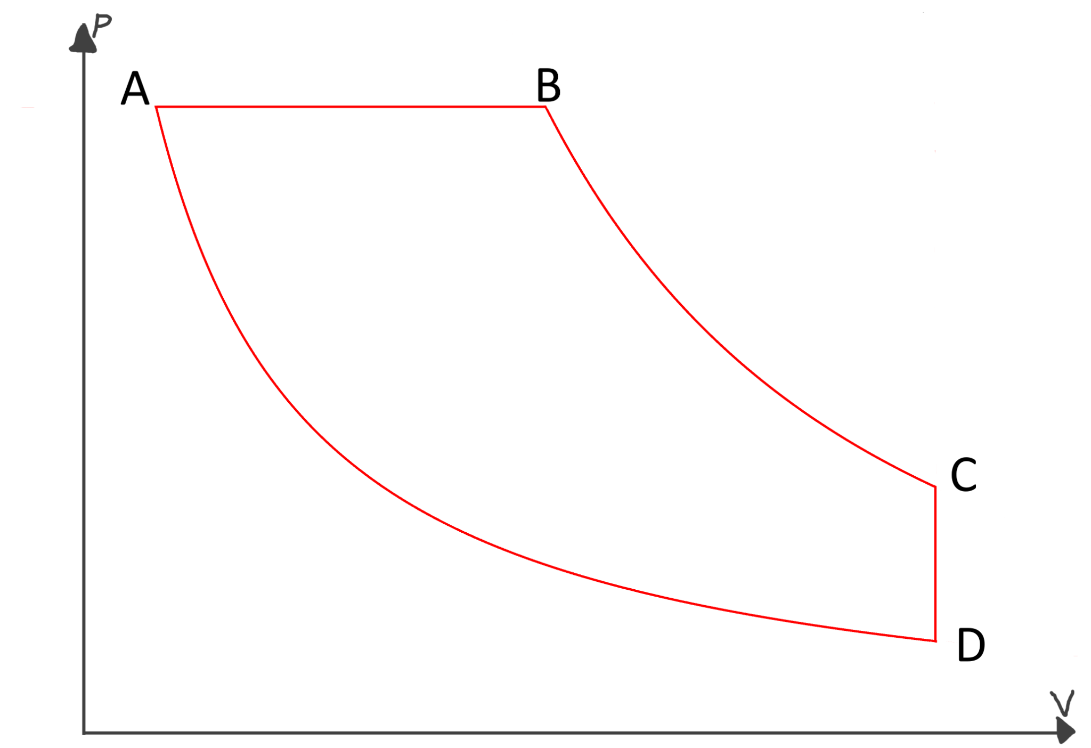

This thermodynamic cycle is plotted in the coordinates of p-V on the picture above.

At point A the temperature is equal to 258K, the volume of the gas in the machine is equal to 50L, the pressure is equal to 600 kPa.

In point B the volume occupied by the gas equals 175L, in point C-300L.

A-D is an isotherm, B-C is an adiabat.

**E-1** Determine the amount of the gas (in moles) in the freezer.

**E-2** Complete this table about the state functions of the gas in the freezer at points A,B,C and D.

|  |  |  |  |  |
| --- | --- | --- | --- | --- |
| Point | A | B | C | D |
| p, kPa | 600 |  |  |  |
| V, L | 50 | 175 | 300 |  |
| T, K | 258 |  |  |  |

**E-3** Which direction from point B must you go to make a freezer? What will happen if you go the other way around?

**E-4** Calculate the work done on the gas during one cycle.

**E-5** Calculate the heat removed from the colder side of the system by the gas during one cycle.

Vladislavs’ freezer for dead bodies is a small thermally insulated room with the following measures: height=2m, length=2m, width=4m. Vladislavs wanted to know how much energy will he need to completely cool down the air in his room and to sustain the temperature.

The density of air is $ρ=1.225 kg/m^{3}$ and the specific heat capacity of air is $c=0.718 kJ/(kg*K)$. Vladislavs still didn’t learn any thermodynamics, so let us help him in his calculations!

*If you failed to calculate the amount of heat removed by the machine during one cycle, assume it is equal to 170 kJ in the rest of the problem. Or, use the heat value you have calculated. If you failed to calculate the work required to do the cycle, assume it is equal to 50 kJ, which, of course, is not the right answer.*

**E-6** Calculate the amount of heat that needs to be removed from the air in Vladislavs’ freezer so that it cools down from 25C to -15C.

**E-7** How many cooling machine cycles must be carried out to remove this much heat? *Hint: the machine can not perform a non-integer amount of cycles.*

**E-8** How much work will be needed to do this cooling operation?

Vladislavs also noted that if the room is cooled down, the cooler is shut down and the room is left to itself it heats up back to the initial temperature in the course of two hours. He decided to periodically switch on the cooling machine to sustain the temperature in the freezer.

**E-9** How often will Vladislavs need to switch on the machine? Note that we can assume it does one cooling cycle immediately compared to the time the room requires to heat up.

Vladislavs finally prepared the whole machine, gave Big Rolands some of the money he promised and began experimenting with freezing dead bodies.

Vladislavs decided to visit the local farm and found a dead body of a mutant pickle. He gently placed it in a bag and carried it back to his lab. There, he weighed it and prepared it for freezing. The mass of the pickle in Vladislavs’ disposal was equal to 80 kg. As it is known, pickles consist mainly of water, so we can assume the mutant pickle also consisted mainly of water. Because of the huge heat capacity of water compared to other compounds found in pickles, we can assume that thermodynamically the pickle is equivalent to 72 kg worth of pure water in terms of heat capacity. You might need some heat capacity information in this task, everything you might need is located in this table:

|  |  |  |
| --- | --- | --- |
| $Cm (ice)$ | $Δ_{fusion}H, ice$ | $Cm (water)$ |
| $37.7 J/(mol*K)$ | $333.6 kJ/kg$ | $75.4 J/(mol*K)$ |

**E-10** Calculate the amount of work that Vladislavs needs to supply to the cooling machine in order to freeze the dead mutant pickle from T=25C to T=-15C. Show your calculations. *Do not forget that the cooling machine can not do non-integer amounts of work cycles!*

*If you failed to calculate the work in E-10, use the value of 29 MJ in the rest of the problem.*

Vladislavs realised that it’d be lots of energy needed to cool down the dead mutant pickle. So, he asked his friend Big Rolands to help him again. Big Rolands suggested Vladislavs use the power of electricity to power his machine. To complete this feat, Vladislavs extracted the electric motor from his washing machine and connected it to the cooling machine.

The electric motor has a power rating of 380W.

**E-11** Calculate how long must the motor power the cooler in order to freeze only the dead mutant pickle inside the freezer.

Still, Vladislavs’ freezer was leaking heat (see above), and he needed to consider this factor, too. Help him conduct his experiments!

**E-12** Determine the fraction of the motor power (in %) that will be spent to counter heat leaks in the freezer.

**E-13** Determine the time Vladislavs will actually need to freeze the dead mutant pickle, taking into account the heat losses in the freezer.

Vladislavs also wanted to increase the size of his freezer. But, for this machine there are limitations to the size of the room being cooled because of the heat losses.

We can assume that the time period in which a cycle must be run to sustain the room temperature is inversely proportional to the volume of the room. *For example, if a room of volume 4m3 needs to be cooled every 8 minutes to be sustained at -15C, a room of volume 2m3 needs to be cooled every 16 minutes to sustain its temperature.*

**E-14** Assuming that Vladislavs still uses his 380W motor to power the cooling machine, calculate the minimum time between two cycles of the machine so that the motor is able to sustain the temperature.

**E-15** Determine the maximum volume of the freezer Vladislavs can keep at -15C using his 380W motor and the same cooling machine.

## Problem **F**. Traces of DNA in pickle juice (15%)

Someone from a little known country drank a potion he synthesized at his chemistry lab and turned into a pickle near a domestic monument. The police didn’t like it (turning into a pickle is seen as disrespectful in his country), but weren’t surveilling the area, so they’re now suspecting three people - Big Nauris, Medium Ritums, and Little Olavs. Let’s help the police find the true culprit.

When a person turns into a pickle, lots of pickle juice is emitted and splattered all around. That pickle juice contains muriocytes *(Latin - muria, brine + Greek kytos, cell)* - the biological precursor cells which the human pickle body is made up of. The police found pickle juice splattered all over the monument, collected samples and took it to the lab of Vladislavs the Biochemist.

To determine the culprit, we will need to use gel electrophoresis to compare the DNA of muriocytes of the three suspects and that in the sample. Vladislavs promptly extracted the nucleus DNA from these cells, but, as expected, found it in low concentration. He now needs to conduct the polymerase chain reaction - an enzymatic reaction used to magnify the concentration of DNA. Help Vladislavs conduct this reaction.

First, the culprit’s DNA is extracted from the muriocytic nucleus. For that, the muriocytes have to be lysed - their lipid bilayer membranes disintegrated with a surfactant. The surfactant integrates into the cellular membrane and generates pores in it, as follows:

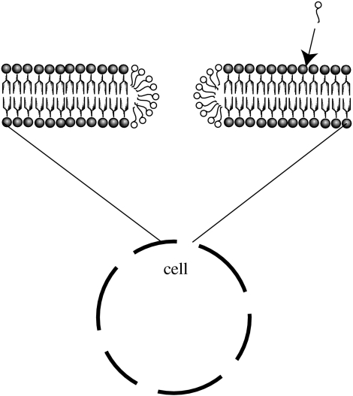

*Source:* [*https://www.ncbi.nlm.nih.gov/pmc/articles/PMC2504493/*](https://www.ncbi.nlm.nih.gov/pmc/articles/PMC2504493/)

The anion in sodium dodecyl sulfate (SDS), a surfactant often used for cellular lysis, is shown below:

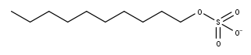

**E-1** Indicate which part of the anion is the tail and which is the head, if the porated cell in the figure is placed in water.

The critical micelle concentration (CMC) is the concentration of surfactant at which all further added surfactant forms micelles. Up until CMC, the surface tension of the surfactant solution keeps changing, but after - stays constant.

**E-2** Determine the CMC of SDS from the following graph:

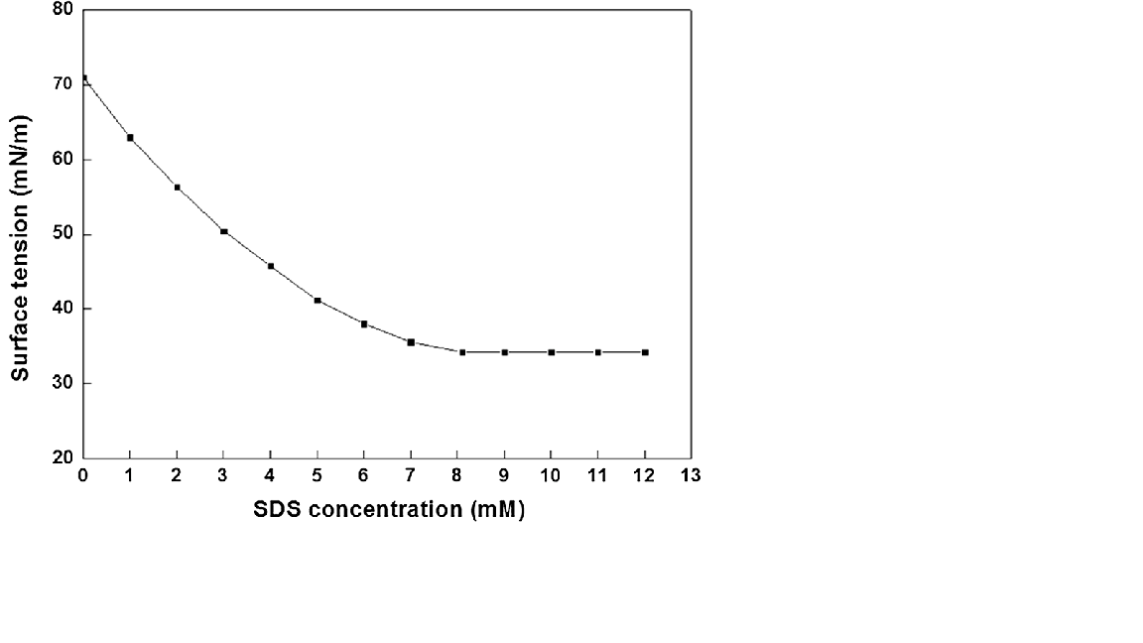

Phew, that lysis procedure sure was quite a bit of work. Now, the extracted DNA has to be amplified using the polymerase chain reaction. The polymerase chain reaction is an in vitro procedure where the DNA is duplicated once per cycle. The cycles are repeated many times to ensure an appropriate final concentration of DNA. We will consider only one part of the PCR - melting.

Melting is the stage where the DNA has to be dissociated. The chemical equation for dissociation of DNA is as follows:

$AA' -> 2A$

**E-3** Assuming no dissociated DNA was present at the start of the reaction, express the reaction equilibrium constant K from the initial concentration of the DNA dimer and final concentration of DNA monomers.

Vladislavs determined that at 298K the equilibrium constant K for the melting stage of PCR is equal to 4.20*10-6. He also measured that after reaching equilibrium the concentration of monomer DNA was equal to 16 uM.

**E-4** Determine the initial concentration of dimer DNA that Vladislavs had in the muriocyte cell.

Vladislavs decided to increase the concentration of DNA to carry out his tests using PCR.

**E-5** If the desired concentration of DNA is 0.035M and the amount of DNA doubles every PCR cycle, calculate the necessary amount of cycles Vladislavs need to carry out on the muriocyte DNA.

OK… Now, thanks to your help, the muriocytic DNA was amplified. For forensic analysis, it now must be cleaved by a restriction endonuclease. The DNA is cleaved at particular spots which match the enzymes. This will yield a certain amount of DNA fragments which is unique to a particular person. The number of these fragments can then be determined by gel electrophoresis. By comparing the number of such fragments amongst suspects and with the muriocytic fragments, we can determine the true culprit.

After cleaving the DNA, Vladislavs then decided to try to conduct a gel electrophoresis on the DNA fragments he’d produced earlier. Unfortunately, the gel electrophoresis did not separate the fragments well and he couldn’t count the amount of the fragments in the muriocytes.

So, Vladislavs decided to carry out another test. He used some enzyme that could bind to the DNA fragment in an irreversible reaction. The interesting thing about this reaction is that in every person it occurs as a different-order reaction kinetically. So, Vladislavs decided to measure out the rate of the reaction at different enzyme and fragment concentrations for each test subject’s muriocytes and the muriocytes found on the monument.

He plotted his data in four tables:

|  |  |  |  |
| --- | --- | --- | --- |
| Name of Subject | Big Nauris | | |
| Trial No. | [Fragment],M | [Enzyme],M | rate, 10-3 M/s |
| 1 | 0.01 | 0.05 | 0.851 |
| 2 | 0.02 | 0.05 | 1.825 |
| 3 | 0.05 | 0.10 | 9.330 |

|  |  |  |  |
| --- | --- | --- | --- |
| Name of Subject | Medium Ritums | | |
| Trial No. | [Fragment],M | [Enzyme],M | rate, 10-3 M/s |
| 1 | 0.01 | 0.05 | 0.725 |
| 2 | 0.02 | 0.05 | 1.665 |
| 3 | 0.05 | 0.10 | 8.706 |

|  |  |  |  |
| --- | --- | --- | --- |
| Name of Subject | Little Olavs | | |
| Trial No. | [Fragment],M | [Enzyme],M | rate, 10-3 M/s |
| 1 | 0.01 | 0.05 | 1.621 |
| 2 | 0.02 | 0.05 | 2.623 |
| 3 | 0.05 | 0.10 | 12.311 |

|  |  |  |  |
| --- | --- | --- | --- |
| Name of Subject | Monument Sample | | |
| Trial No. | [Fragment],M | [Enzyme],M | rate, 10-3 M/s |
| 1 | 0.06 | 0.05 | 5.681 |
| 2 | 0.12 | 0.05 | 9.228 |
| 3 | 0.04 | 0.08 | 7.879 |

The reaction rate can be expressed using this equation:

$r=k*[Frag]^{a}*{[Enz]}^{b}$

where *[Frag]* and *[Enz]* are molar concentrations of the DNA fragment and the enzyme respectively; *a* and *b* are reaction orders in respect to fragment and enzyme of the reactions, *k* is a constant, it is unchanged for every person.

The reaction orders with respect to both reagents of the culprit and the monument muriocyte should be almost the same.

**E-6** Determine the reaction orders with respect to both enzyme and DNA fragment of every sample. Do not forget to show your calculations, too! Fill this table:

|  |  |  |
| --- | --- | --- |
| Name | Order with respect to [Frag] | Order with respect to [Enz] |
| Big Nauris |  |  |
| Medium Ritums |  |  |
| Little Olavs |  |  |
| Monument sample |  |  |

**E-7** Calculate the rate constant k of this reaction.

With this data, Vladislavs the Biochemist managed to determine the identity of the culprit. And his name was…. [CLASSIFIED]

**E-8** Who was the culprit?

# Organic Chemistry

## Problem **G**. How to understand Julia (11%)

High school student Julia decided to study Organic Chemistry. She has already learnt all Organic Chemistry in her high school textbook, and she decided to have a look at such a thing as named reactions. Some chemist friend told Julia about one very interesting reaction called Julia Olefination. She thought that it’d be great to recreate the reaction bearing the same name as her but she didn’t really know how the reaction worked. Let’s explore Julia olefination together with Julia!

The Julia olefination reaction happens in two main stages: substitution and reduction.

The Julia olefination reaction proceeds according to this scheme: 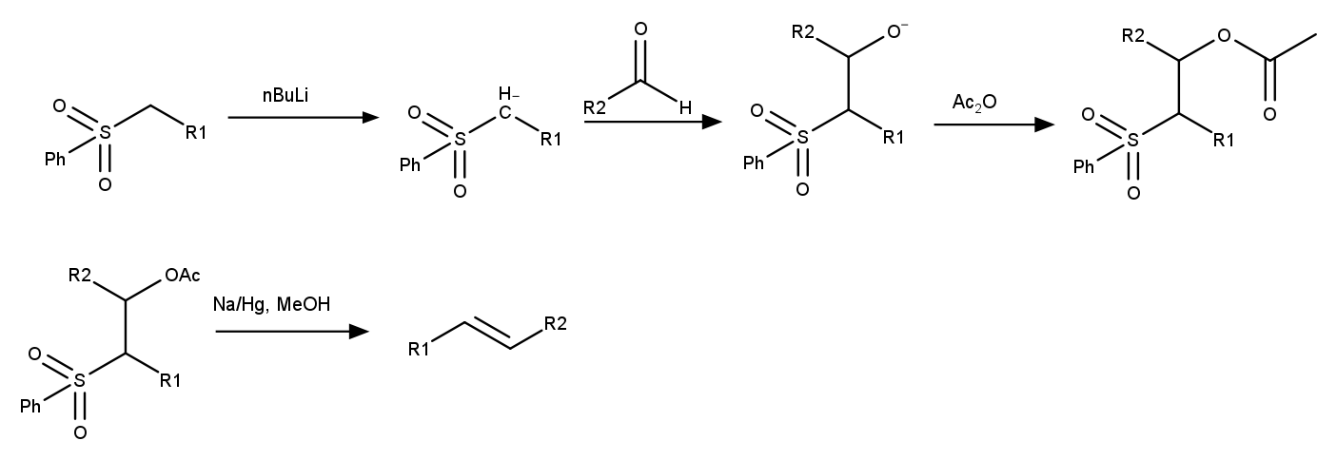

First of all, the initial phenyl sulfone is mixed with n-butyllithium and then an aldehyde. The product is then mixed with acetic anhydride to form an ester. The sulfone ester is reduced by sodium amalgam in methanol, forming the *trans*-double bond.

**G-1** What is sodium amalgam and how is it made?

**G-2** Which role does butyllithium have in the substitution phase? *Hint: have a closer look at the changes in the structure of the molecule that occur after adding BuLi.*

Julia discovered that during the reduction stage of Julia olefination the first reaction that happens is an E1cb elimination of acetic acid, forming the unsaturated sulfone which is then reduced by sodium amalgam. E1cb elimination needs quite a strong base present to kickstart the process.

**G-3** What base is formed in the reductive mixture of Na/Hg and methanol? Write the name of the base as well as the reaction equation describing its formation.

**G-4** Why is sodium amalgam rather than metallic sodium being used in the Julia olefination?

Julia first needed to make a sulfone to do the Julia olefination. Thus, Julia made the following synthesis scheme for the sulfone (*see abbreviation deciphering in Organic Chemistry Info Sheet*):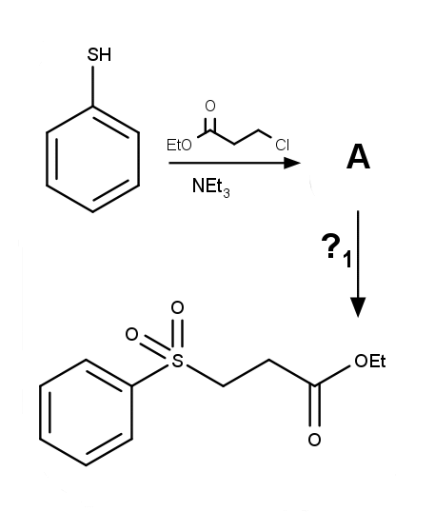

**G-5** Determine the intermediate **A** and the reagent **?1** in Julia’s synthesis.

Julia got her hands on some sodium amalgam generously provided by Little Ian aka Mr. White Powder A and began planning the Julia olefination she’d planned to complete. She also wanted to test out her knowledge of the Claisen ester condensation reaction, which is used to fuse a carbonyl compound with an ester. The scheme of the Claisen ester condensation is as follows:

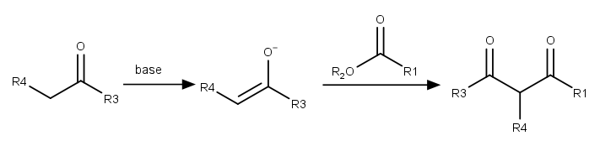

The Claisen condensation is a special type of the Aldol reaction. This reaction involves an enolizable carbonyl compound which is converted into an enolate using a strong base such as LDA. The enolate then substitutes the ester and forms a 1,3-dicarbonyl compound.

Julia decided to make an interesting Julia olefination. Julia made the synthesis following the scheme below. This Julia olefination reaction is very interesting because it doesn’t produce a *trans*-double bond as it is supposed to, but rather a *cis*-one.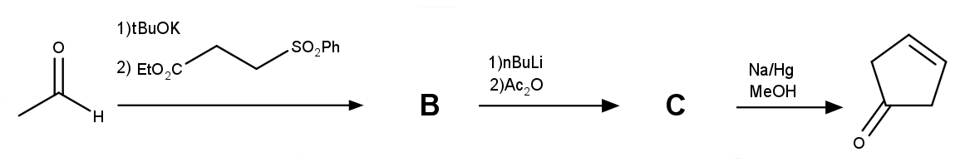

**G-6** Determine the intermediates **B** and **C** in Julia’s synthesis.

**G-7** Why wasn’t the double bond formed *trans*-oriented?

## Problem **H**. LIL BO’ CHEM (16%)

Gustav the High school student decided to become a Pharma Boss. He discovered that pharmacists need to sell any sort of drugs, so Nick decided to make some at home to sell. He made a few synthesis schemes, but unfortunately Gustav’s father came into Gustavs’s room and seized part of his synthesis schemes, saying that drawing is a waste of time and that Gustav should become a lawyer.

Although, it didn’t stop Gustav from completing his plans, and he still had enough of the schemes intact to restore the syntheses.

Gustav decided that his potential buyers will need to calm their anxiety down after seeing the mess in his room/lab/shop, and thought that adding a sedative such as alprazolam to his stock will be useful. He made an easy to follow synthesis scheme, but unfortunately it didn’t quite survive the attack of Gustav’s dad.

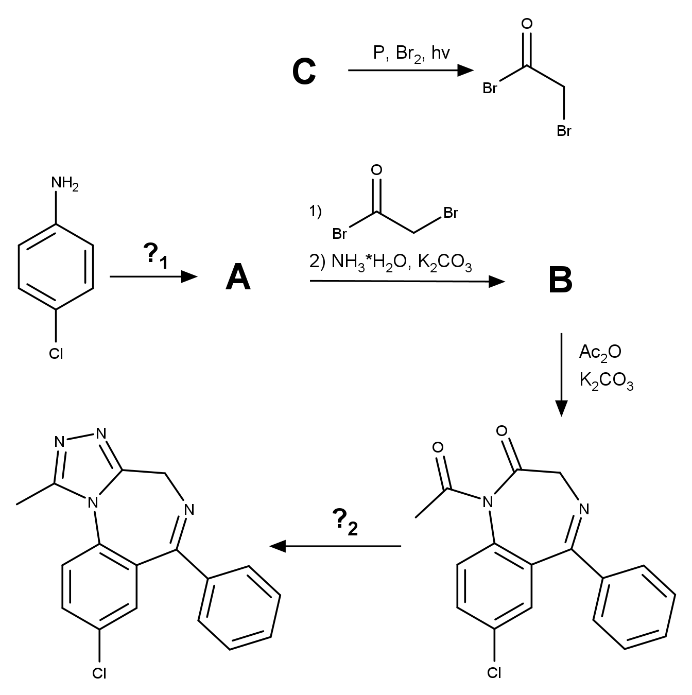

**H-1** Determine the intermediates **A-C** and the reagents **?1 and ?2** in the synthesis scheme.

**H-2** Why is NBS (N-bromosuccinimide) not a good reagent for producing the $α$-bromoacetylbromide?

Gustav also thought that it’d be a great idea to add some medication to numb the pain of buyers who injure their legs when they maneuver themselves between the heaps of junk in his room, so he decided to sell benzocaine. 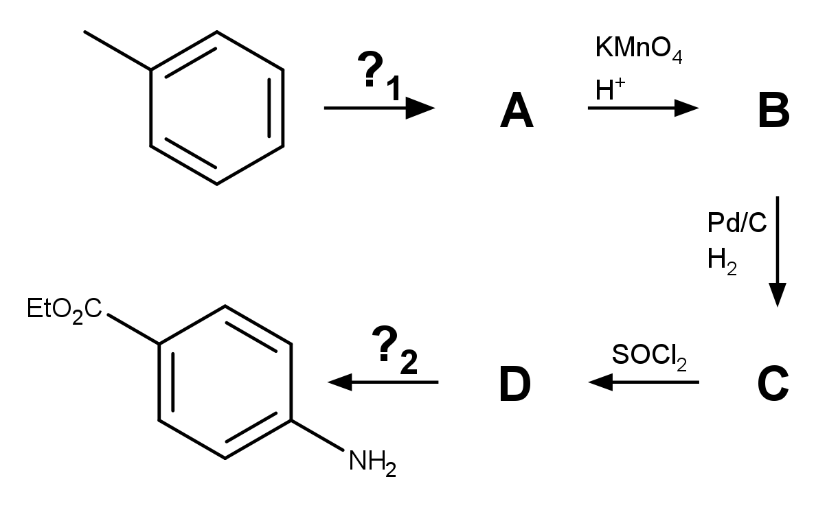

**H-3** Determine the intermediates **A-D** and reagents **?1** and **?2** in this synthesis scheme

**H-4** Explain which process the reaction of **C** and SOCl2 is pushed forward by.

**H-5** Which side products form during the toluene=>**A** conversion?

Gustav wanted to prepare a drug so common as aspirin. Though, he wanted to prepare something similar to aspirin, but not an exact replica. He found a name of a compound with similar properties to aspirin - N-(4-hydroxyphenyl)acetamide.

**H-6** Draw the molecular formula of that compound.

**H-7** What is a more common name for this compound?

A very common substitute for a carboxylic acid functional group in drug chemistry is a tetrazole group. It has almost the same pKa and is mostly deprotonated inside the human organism. Gustav decided that his analog of aspirin will have the carboxylic acid group replaced by a tetrazole group. He decided to name the compound Gustavopirin. Gustav drew the molecular formula of Gustavopirin on a sheet of paper so that it'd be easier for him to make the compound synthesis scheme.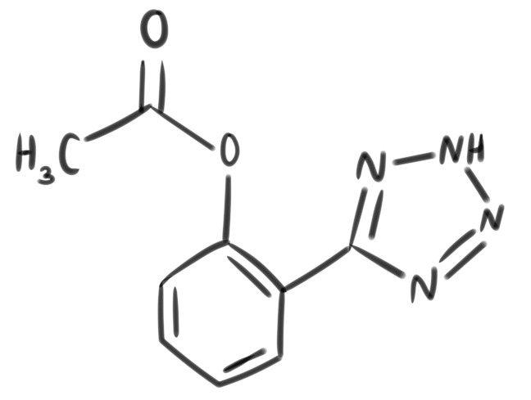

**H-8** Determine all the functional groups in Gustavopirin and circle the tetrazole group on the drawing. Write names of each functional group on the drawing.

**H-9** Draw the molecular formula of aspirin. *Hint: in nickpirin the carboxylic acid group of aspirin is replaced by a tetrazole group.*

Gustav also devised a synthesis scheme for Gustavopirin. It is not very complicated but still is an interesting one to have a look at. Unfortunately, this synthesis scheme also did not survive the attack of Gustav’s mother, so a decent part of it is missing.

Intermediate **C** is an unstable particle that Gustav immediately reacted with copper (I) cyanide to avoid any product losses.

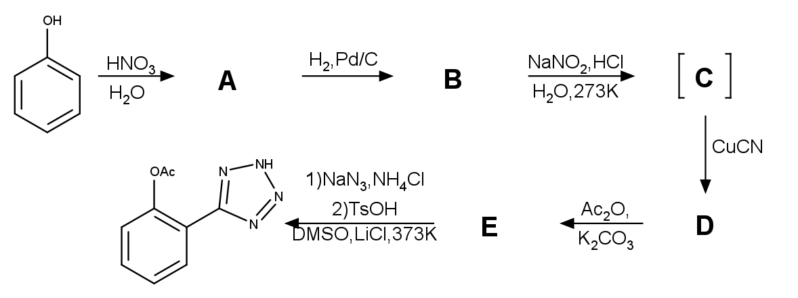**H-10** Determine the structural formulas of intermediates **A-E**.

**H-11** What makes **C** so unstable in aqueous medium? Explain it.

**H-12** How is the reaction between **C** and copper (i) cyanide called?

**H-13** Why is dilute nitric acid used as a reagent for phenol nitration? Why concentrated nitric acid in a mixture with concentrated sulfuric acid must be used to nitrate benzaldehyde?

**H-14** Is **A** the only product of the reaction between phenol and dilute nitric acid? Draw the structural formula of the other reaction product or write “no by-product” as an answer.