# International Meme

# Chemistry Olympiad

# July 2021

# Official Pro League Problems

# English version

# Before You Start

Welcome to the International Meme Chemistry Olympiad!

We are very happy to see you (at least, digitally) participate in this competition.

This project could not be completed without the help of several people, and we’d like to thank them for their contribution.

First of all, a huge shoutout to our partners and sponsors **Young Folks LV** for providing the financial assistance needed to run the competition

Second, we incredibly appreciate the work made by our testers to improve the Olympiad.

Also, we appreciate the work done by our designer Julia.

We also appreciate the contribution to the development of several problems by Jonathan.

A few notes on the Olympiad paper, to prevent any further questions:

**Everything you will see below is a WORK OF FICTION developed by our brain-dead Problem Authors. All coincidences with real names are purely random, the Authors do not attempt to portray real people and/or real situations in the Problems.**

**We DO NOT condone any of the behaviour described in the Problems, the behaviour described in the Problems might be illegal in your country!**

**A few notes about the numerical answers:**

* Take the molar masses needed in the calculations rounded to the nearest integer except chlorine. (MCl=35.5 g/mol)
* Show your work in calculation answers, for just the correct answer you will receive no more than half of all possible points.
* Use as many significant digits as you wish in your answer.
* We consider an answer to be numerically correct if it falls within a 5% range of our calculated answer.
* Draw the structures for Organic Chemistry problems either by using the “Drawing” option in Google Docs or by drawing the structures on a piece of paper and then sending the structures to us after the Olympiad, indicating which Problems they belong to.
* All gases described in the Problems are assumed to be ideal gases **unless** not stated otherwise.
* All conditions described in the Problems are assumed to be standard conditions **unless** not stated otherwise.
* In all physical chemistry problems, assume enthalpy and entropy changes to be independent of temperature. Also assume that, when liquids are mixed, the new volume is the sum of their individual volumes.

# Analytical Chemistry

## Problem **A**.Little Ian’s trips (16%)

Little Ian the Chemist was working part-time in an analytical chemistry lab. He was assigned to work at the Janitis Gas Analyzer machine. The Janitis Gas Analyzer machine works in the following manner:

First, the gases being analysed get pumped into a tube filled with anhydrous calcium chloride. The gases which pass through the calcium chloride get bubbled into three sequential Drechsel gas bottles filled with concentrated aqueous barium hydroxide. The remaining gas is ejected outside and the volume of the gas being ejected is measured as well as its density. Little Ian asked his girlfriend Johanna to inhale the gases ejected because their fume hood is malfunctioning.

Recently, a sample confiscated from an illegal laboratory was delivered to the lab for Ian to analyse. It contained a single compound consisting of carbon, hydrogen, oxygen and one more element we’ll call element Z. We’ll refer to this molecule as compound X. Little Ian conducted the following test to determine the molecular formula of compound X:

After orally ingesting a few grams of the substance, bewildered by his curiosity, he took 6.825g of compound X and burned it in a sealed flask. Then, the hot gases produced by the reaction were pumped into the Janitis Gas Analyzer machine.

Little Ian has noted down that the Janitis Gas Analyzer machine ejected 3.59L of a gas with a density of 1.2525kg*m-3 at a pressure of 755 Torr at a temperature of 17C directly into Johanna’s lungs. (Assume this gas is an ideal gas)

Then, Little Ian took apart the Janitis Gas Analyzer and weighed the calcium chloride inside. The weight of calcium chloride after passing the gases through it was 60.225g. Because he forgot to weigh the anhydrous calcium chloride before putting it inside the Janitis Gas Analyzer, Little Ian dissolved the calcium chloride in water and added sodium carbonate until a precipitate stopped forming. He filtered off and dried the precipitate, its mass being 50.000g.

Then, Little Ian took apart the Drechsel bottles with aqueous barium hydroxide while noting that the solution in the first and second jars was opaque. He filtered all the solutions from the Drechsel jars and heated the precipitate collected at 1800C during the night. Afterwards, the treated precipitate was dissolved in 2L of water, forming a solution with pH 13.48. Neglect the change of density of the solution as well as the mass of water spent in the reaction.

The IR spectrum of compound X: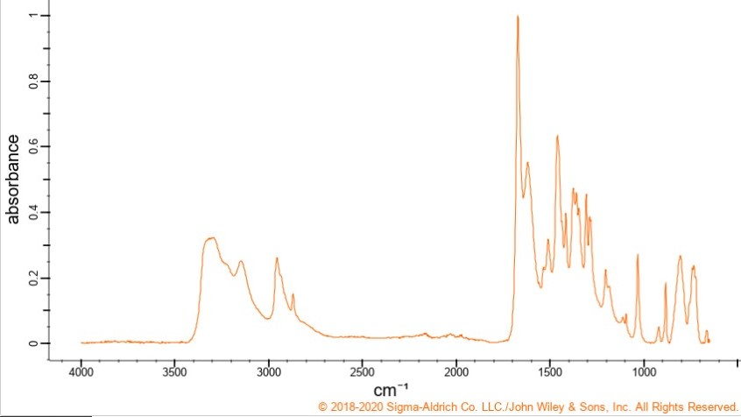

**Assume that all reactions have 100% yield and every gas that can be absorbed by a compound inside the Janitis Gas Analyzer is fully absorbed.**

**A-1** Determine the element called element Z.

**A-2** Write down all the 6 balanced reaction equations that describe the chemical processes described in the text.

**A-3** Calculate the molecular formula of compound X.

**A-4** Calculate the degree of unsaturation of compound X.

**A-5** Determine the functional groups present in compound X.

Little Ian also was given a sample with the molecular formula C6H8N2O2S. The compound will be referred to as compound Y. Little Ian carried out another Janitis Gas Analyzer test but he was very hungry and ate the piece of paper where all the experimental data collected was recorded. The only information Little Ian could recall was the mass of compound Y being combusted: 5.160g. But, he still somehow needs to file the lab report, so he decided to estimate the data he should have collected using calculations.

**A-6** Calculate the volume and density of the gas that will be ejected from the Janitis Gas Analyzer after the experiment at the same temperature and pressure as in the first experiment.

**A-7** Calculate the pH of the solution that will be formed from the precipitate in the Drechsel bottles after Little Ian conducted the Janitis Gas Analyser experiment.

The 13C NMR spectrum of compound Y is below: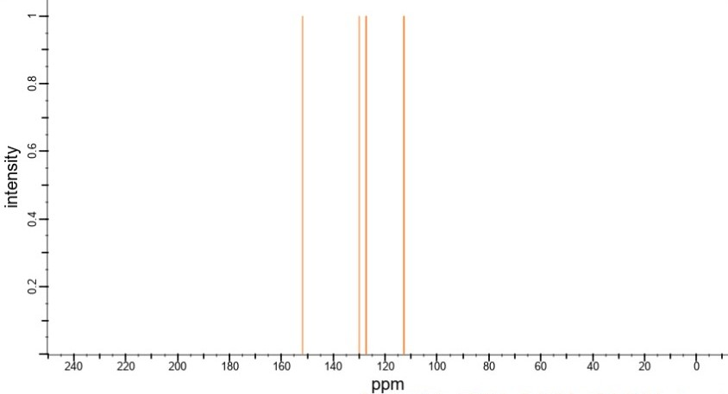

**A-8** Determine the structural formula of compound Y.

**A-9** Write a balanced reaction equation describing combustion of compound Y.

**A-10** How is compound Y being used nowadays?

On the next day in the lab, a coworker came to Little Ian and asked him to store some of his acid for a period of time. Little Ian agreed, so the coworker gave Little Ian about a kilogram of a compound Little Ian’s coworker referred to as “acid”. Little Ian wanted to know whether this acid had any interesting properties, so he decided to borrow some of the acid from the jar and to run some experiments. He took 1.42g of the “acid” and dissolved it in 80.00 mL of deionized water. Then he inserted a pH meter in the solution and started titrating it with 0.500 M aqueous sodium hydroxide. He plotted the pH of the solution against the volume of added base and got the following graph: 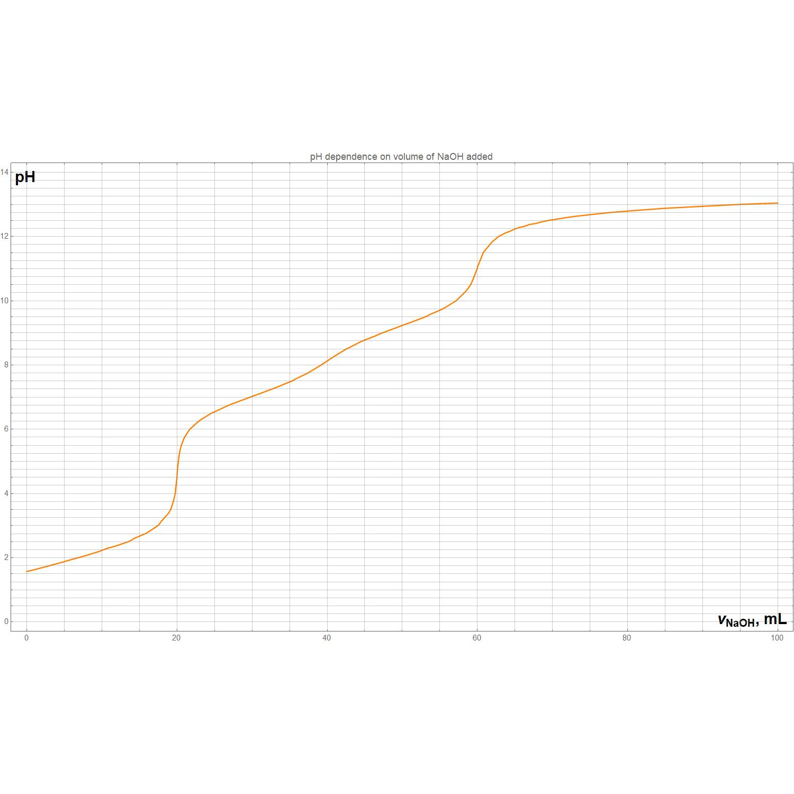

He also made a mass spectral analysis of the compound, its mass being 142 g/mol and elemental analysis being O 45.07% H 2.11%.

**A-11** Determine the molecular formula of the “acid”

**A-12** Indicate all the stoichiometric points on the titration curve.

**A-13** Derive the expression for the titration curve in terms of the added titrant volume (in mL),pH and other constant values. Kw=10-14

**A-14** Indicate the region of the curve where Little Ian’s acid is predominantly in its free form (fully protonated).

**A-15** Determine the pKa(-s) and the acid constant(-s) for the “acid” using the graph. Indicate the points on the graph you used to determine the pKa(-s) and explain why you chose them.

**A-16** Which changes could be observed in the titration curve if Little Ian used ammonium hydroxide of the same concentration rather than sodium hydroxide?

**A-17** Derive the formula for the titration curve of the same sample of Little Ian’s acid with 0.500M aqueous ammonium hydroxide in terms of VNH3*H2O,V0,Kan,Kb,pH. Do **not** ignore the change of the volume of the solution. Kw=10-14

Little Ian and another coworker Robert were incredibly bored during the working day in the lab. So they decided to play a chemistry guessing game while waiting for a synthesis to finish. The game has the following rules:

Little Ian took some of the “acid” he obtained earlier and dissolved it in water. Afterwards he poured in a random amount of base and measured the pH of the formed solution. Then Little Ian and Robert took guesses to determine which species of the acid is dominant at these conditions. The loser paid the canteen bill for the both, so the stakes were high. Little Ian wanted to prepare himself so he calculated a formula that’d allow him to win.

**A-18** Derive the formulas that express molar fractions of each component in the mixture in terms of pH and acid constant(-s) for the “acid”. **Ignore** water autoprotolysis in this question.

**A-19** Determine which species will be predominant in Little Ian’s solution at:

a)pH 4.75

b)pH 7.5

c)pH 9.8

d)pH 1

## Problem **B**. Colour becomes Power (8%)

Nauris the Chemist was very busy with grading National Olympiad papers for the whole night. Exhausted, in the morning he decided that he was fed up with working for the Government and began scheming a coup. To overthrow the Government, he needed to gain political power, but with great power comes great responsibility, so he first wanted to try his hands on the power in a galvanic cell. Help him prepare for surveilling the Government’s inner affairs as an outsider by analyzing a device he stole from his student Anastasia the Pickle.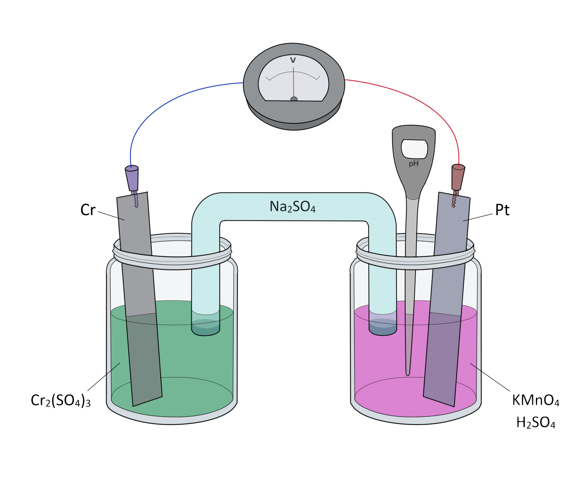

The device consists of two previously emptied pickle jars with solutions of potassium permanganate in sulfuric acid and chromium (iii) sulfate. In the respective pickle jars, a platinum electrode and a chromium electrode are inserted. The jars are connected by a sodium sulfate salt bridge. A voltmeter is connected with its “-” pin to the chromium electrode and to the platinum electrode with its “+” pin. Also, a pH meter is submerged into the pickle jar containing acidified potassium permanganate. Nauris was so angry at the Government that his hands were shaking and he managed to spill some manganese (ii) sulfate solution into the permanganate pickle jar so that the concentration of Mn2+ in the pickle jar became 0.05M.

*Some of the standard redox potentials you may need to complete the task are listed in the table below:*

|  |  |
| --- | --- |
| *Redox pair* | *E0red, V* |
| Cr3+/Cr | -0.74 |
| H+/H2 | 0.00 |
| MnO4-/Mn2+ | +1.51 |
| H2O/H2,OH- | -0.83 |
| O2,H+/H2O | +1.23 |

**B-1** Determine the direction the voltmeter arrow will turn when the voltmeter is connected to the pickle jars. Assume that it’d turn opposite to the direction of the electron flow in the circuit.

**B-2** Determine the cathode and the anode of the galvanic cell. Indicate the galvanic cell’s polarity by drawing a “+” and a “-” sign at the corresponding electrodes.

**B-3** Write the anode and the cathode half-reactions occuring in the galvanic cell and calculate its standard potential.

**B-4** Write the cell’s total net reaction equation.

**B-5** Write Nauris’s cell’s structural formula using common cell notation (*e.g.* *Ag(s)|AgNO3(aq)||CuSO4(aq)|Cu(s)* )

Nauris wanted to determine the concentration of chromium in the jar filled with the green solution. He took a 10mL sample of the green solution in one of the pickle jars, diluted it to 100mL and decided to carry out a photometric titration using EDTA. First, in a 2cm cuvette a sample containing 0.055M Cr3+ an excessive amount of EDTA and acid to pH 4.0 was added by Nauris, the absorption at 18350 cm-1 was equal to 22. Assume that the samples follow the Lambert-Beer absorption law. Then Nauris added an excess of EDTA to his sample, waited until the colour completely changed and also measured the absorbance. The absorbance reading of the sample Nauris collected from the green solution in the galvanic cell and diluted was equal to 8.

**B-6** Calculate the molar absorption coefficient of the Cr3+-EDTA complex.

**B-7** Calculate the concentration of Cr3+ in the green solution.

The Cr3+-EDTA complex absorbs at two wavelengths: it has a very strong and broad absorption band at 18350 cm-1 and slight absorption at 25000 cm-1.

**B-8** Estimate the color of the Cr3+-EDTA complex.

Then, Nauris recorded the readings of the pH meter. The pH in the permanganate solution was reported to be 2.00. After that he connected the electrodes with a nichrome wire, thus closing the electrical circuit and resonating with the anticipation of his political power. The galvanic cell produced an electromotive force of 2.085 V.

**B-9** Calculate the concentration of permanganate ions in the galvanic cell. Assume that the reaction happens at T=298K.

Nauris left the circuit working until the reaction fully stopped. The reaction stopped after 2h 24min because the chromium electrode fully dissolved, its mass being 1.56g. We can assume that the whole reaction occurred with a constant voltage . Now Nauris wants to determine the amount of power in his hands.

**B-10** Calculate the current in the galvanic cell electrical circuit during the process.

**B-11** Calculate the power of the galvanic cell (in W) and the total work made by the galvanic cell (in J).

The remaining permanganate solution Nauris transferred into an Erlenmeyer flask and started titrating it with an acidified 1M H2O2 solution. He required 31.00 mL of the titrant until he reached the end point of titration.

**B-12** Why didn’t Nauris add an indicator while titrating? How did he determine the titration

endpoint?

**B-13** Write the reaction equation for the titration process.

**B-14** Calculate the initial volume of the permanganate solution in the galvanic cell.

Nauris also wanted to try and recharge his galvanic cell by connecting it to a DC power supply in reverse polarity. This would allow him to control even more electric (and hopefully, political) power.

**B-15** Will Nauris be able to recharge his galvanic cell? Prove it by writing the cathode and anode half-reaction equations as well as the total reaction equation.

**B-16** How is the electrochemical process that Nauris decided to carry out called?

# Inorganic Chemistry

## Problem **C**. Elements go bang (9%)

Little Ian recently was occupied in an Inorganic Chemistry lab. There, his girlfriend Johanna the Inorganic Chemist told him about some very cool element we’ll refer to as element **X.**

Little Ian became very interested in element **X** because of its high psychedelic and destructive abilities.

Little Ian took 0.92g of a blue solid **H** and began heating it in a sealed 1L flask filled with argon at 298K. Among the products, Ian collected 0.25g of a black solid. After cooling to 390K, the pressure in the flask went up from 1 bar at the beginning of the experiment to 2.16 bar. **A** was produced during this reaction. **B** is obtained when oxidising compound **E**, which in turn contains 82,35% element **X**. **B** is notable for being a stable free radical.

**A** can also be produced on decomposition of oxide **F** which contains 74.07% oxygen.

Little Ian let **A** and **B** into a tube filled with dry ice and collected **C**, a bluish liquid. **C** was mixed with sodium hydroxide, producing **D**. Little Ian also prepared another blue compound by dissolving his favourite metal **Y** in **E** in a dry ice bath. Unfortunately, the nice colour disappeared by heating back to room temperature, but at least Little Ian now had compound **G** which contained 58,97% **Y**. Little Ian mixed aqueous **H** with some sodium hydroxide and produced a blue precipitate and a solution of compound **I**. Then Little Ian mixed compounds **I** and **G** and produced the most important intermediate- **J**. **J** was then mixed with aqueous lead(ii) nitrate and produced Little Ian’s most favourite compound- **K**. Compounds **J** and **K** are incredibly dangerous because of their toxicity and thermal instability.

All of the compounds **A-K** contain element **X**.

**C-1** Determine the molecular formulas of compounds **A-K**, and elements **X** and **Y.**

**C-2** Draw Lewis dot structures of compound **B** and the anions of **J** and **H**.

**C-3** Write reaction equations describing all the chemical processes in the text. *total 9 equations*

**C-4** Explain why did the blue colour disappear after heating the mixture of **E** and **Y**.

Little Ian also loved element **Z**. It is quite similar in its properties to element **X**, but they still do differ.

Element **Z** exists in different allotropes. Little Ian got some unstable and reactive **Z1** which on heating produced **Z2**.

Little Ian mixed a bit of **Z** with **Y** and heated them together. The compound **L** produced in the reaction reacts vigorously with some water, producing a gas **M**. **M** burns very well on air, forming **O**. **O** is also formed when **Z1 or Z2** is burned on air. **O** reacts with water and forms a compound **S** with 3,06% hydrogen. Little Ian mixed some **Z** with chlorine and received two different products **P** and **R**, with 22,55% **Z** and 14,87% **Z** respectively. **P** is not really stable on air, it produces **Q**. **Q** and **R** react with water and form the same product **S**. **M** can react with hydrogen iodide to form **T**, which is a very unstable compound. **T** can react with iodine and form **N** which contains 10,88% **Z**. **N** can be mixed with **Z1** and be partially hydrolysed, forming **T** and **S**.

**C-5** Determine the molecular formulas of compounds **L-T** and element **Z** as well as the allotropes **Z1** and **Z2**.

**C-6** Write all the reaction equations described in the text. *total 15 equations*

A multitude of compounds containing **Z** are used very widely in organic synthesis. One of them, the compound with the formula **Z**Ph3 is used in a multitude of reactions because of **Z**’s very interesting chemical properties. **Z**Ph3 is used as one of the reagents in the following named reactions:

1. A highly stereoselective reaction used to couple acids and alcohols
2. A coupling reaction to form olefins
3. A substitution reaction to selectively replace hydroxyl groups with halogens

**C-7** Name the reactions mentioned above and briefly describe the reaction conditions, products formed and the reagents needed. (no need for mechanisms)

**C-8** Explain which property of **Z** is the reason for usage of **Z** in such reactions.

**C-9** Determine the molecular geometry of compounds **E**, **P** and **R**.

## Problem **D**. Liquic Ionid, Amquid Limonia and other MLG (12%)

## Ross the Amateur Chemist decided to assert his dominance over Little OIavs. To do this, he decided to make Olavs do some experiments in a very strange solvent where chemistry seemed to work wrong….

Ross dissolved 2.08g of zinc metal in his “super solvent” as he now calls it. Zinc dissolved in it, producing a gas that occupied 0.79L at 298K and 1 bar (Assume it’s ideal). This gas also had a density of 1.21 g/L.

After Ross evaporated the “super solvent” from the flask, he weighed the solid product formed, its mass being 6.048g.

Ross hoped that Olavs would be too confused about the identity of the “super solvent”, but unfortunately Little Olavs was a very skilled Inorganic chemist and he almost immediately figured out the formula of the “super solvent”.

**D-1** Determine the chemical formula of the “super solvent”. It is a binary compound.

**D-2** Determine the chemical formula of the gas that was produced in the reaction between the “super solvent” and zinc metal. Write down the reaction equation describing that process.

Afterwards, it was Little Olavs’ turn to strike. Little Olavs developed a whole research paper on exotic MLG solvents, so he easily could destroy Ross the Amateur Chemist’s hopes to solve any problem in their chemical duel. As a warming exercise (which Ross already failed, disappointing Olavs by a lot) Little Olavs decided to show Ross some chemistry of quite a famous solvent. Olavs referred to it as Amquid Limonia. Because Amquid Limonia was not stable at room temperature, Little Olavs used dry ice to keep it chill which is of course not MLG. As the first experiment, Little Olavs carried out an amazing reaction: he dissolved barium nitrate and ammonium chloride in two separate test tubes containing Amquid Limonia and mixed them together. He observed a white precipitate - barium chloride! Also, Little Olavs had added a small portion of Amquid Limonia into water with phenolphthalein added into it, producing a pink solution. Ross the Amateur Chemist could not explain that chemistry that he’d observed….

It is known that Little Olavs prepared Amquid Limonia by condensing a gas with a molar mass M-17 g/mol.

**D-3** What solvent bears the name of Amquid Limonia?

**D-4** Explain how the metathesis reaction Little Olavs carried out could happen in Amquid Limonia if it’s impossible in water.

Little Olavs also knew that Amquid Limonia is very similar to water in its chemical properties. For example, it also can undergo autoprotolysis (self-proton exchange) and produce something similar to hydronium and hydroxide ions in aqueous media.

**D-5** Write the reaction equation describing autoprotolysis of Amquid Limonia.

Now, Little Olavs decided to prank Ross even more by forcing him to calculate some acid-base equilibria in Amquid Limonia, threatening to otherwise send a video of Ross struggling to solve the question of the identity of Amquid Limonia to Ross’ friend Anastasia, who Ross was secretly admiring. In neutral Amquid Limonia Ross managed to measure that the concentration of the protonated species was equal to 10-15 M.

**D-6** Help Ross calculate the Kw analogue of Amquid Limonia in order to avoid being humiliated by Little Olavs. *Hint: Kw is equal to the product of the concentration of the protonated species and the deprotonated species in the solvent, for Amquid Limonia it is also true.*

Phew, Ross finally completed the first task designed by Olavs to destroy Ross in a chemical duel. The next task Olavs gave to Ross was to dissolve his favourite metal in Amquid Limonia, just for fun. Little Olavs gave Ross 1.08g of his favourite metal and forced him to throw it into Amquid Limonia. After some time, they collected a precipitate after evaporating Amquid Limonia directly into the air of the lab (as everybody knows, fume hoods are not MLG enough for Little Olavs), its mass being 5.67g.

**D-7** Determine the chemical formula of Olavs’ favorite metal. Do not forget that Olavs still threatens to send videos of Ross failing to solve these problems to Anastasia, the love of Ross’ life, and he needs help.

The next task Ross was given was comparably easy to accomplish. He just needed to prepare the strongest base that could exist in Amquid Limonia..

**D-8** What compound can be the strongest base in the medium of Amquid Limonia?

**D-9** Tick the boxes next to the name of the reagents Ross could use to prepare such a solution.

|  |  |  |  |
| --- | --- | --- | --- |
| ❒ NaOH | ❒ NEt3 | ❒ N(iPr)2Li | ❒ MeLi |
| ❒ BuLi | ❒ NaOEt | ❒ K2CO3 | ❒ H2SO4 |

Little Olavs prepared two solutions in Amquid Limonia: a solution of zinc nitrate and a basic solution Ross’d prepared earlier. Upon addition of the basic solution to a solution of zinc nitrate a precipitate occured, which then dissolved again when Olavs added even more base.

**D-10** Write the reaction equations describing this process as well as the equations describing a similar process, but in aqueous medium.

Sadly, Ross still managed to solve these problems, so Little Olavs decided to present to him a challenge Ross never would be able to solve…

So, Olavs gave Ross a jug of a superacid. This superacid is prepared via the reaction between concentrated hydrogen fluoride and antimony pentafluoride. Olavs considered fluoroantimonic acid to be very MLG because it could dissolve almost anything.

**D-11** Explain why fluoroantimonic acid is so strong.

Olavs then dissolved some 4-methylnonane in the superacid.

**D-12** Write the reaction equation describing the reaction between 4-methylnonane and fluoroantimonic acid.

The next compound Ross was forced to work with by Little Olavs was 1,3-dipropylimidazolium dicyanamide. This compound is liquid at room temperature, which makes it very MLG, so it’s the reason Olavs liked it so much.

**D-13** Which type of lattice does 1,3-dipropylimidazolium dicyanamide have? Draw the molecular formula of this compound.

|  |  |  |  |
| --- | --- | --- | --- |
| ❒ molecular | ❒ ionic | ❒ atomic | ❒ metallic |

Little Olavs decided to increase the MLG level in his mixture even more. First, he tried crystallising the compound. He determined that the density of the compound was equal to 1.2 g/mL. The compound formed a cesium chloride-type lattice. We can use the close-packed spheres assumption on this compound.

**D-14** Calculate the parameter of the lattice cell of 1,3-dipropylimidazolium dicyanamide. If you failed to determine its molar mass, assume it is 260 g/mol.

Afterwards Olavs decided that the achieved degree of MLG was not sufficient, and he decided to mix his compound with water. In water, a following series of reactions occurs, describing water autoprotolysis:

(1)

(2)

The reaction (1) is reversible, its equilibrium constant at 298K being 1.8*10-16 and its expression:

**D-15** Prove that in pure water the ion product Kw is equal to 10-14.

**D-16** Explain, using the nucleophile-electrophile theory, why the reaction between H+ and water proceeds fully.

In Olavs’ MLG solution, this was not quite true… Nevertheless, knowing that he is a very cool Inorganic Chemist who knows what he does, Olavs dissolved some water in his solution he’d patented as Liquic Ionid. Afterwards he measured the standard potential of the reaction against the SHE, receiving the value of -0.504V. Olavs neither added any acid to the mixture, nor chose such a solvent that could interact with water autoprotolysis. The only thing he also knew was the density of the solution - it was equal to 1.10g/mL.

**D-17** Calculate the concentration and the molar fraction of water in Olavs’ Liquic Ionid. Use only equation (1) and its equilibrium constant expression to describe the protolytic processes in the Liquic Ionid.

At this moment, Little Olavs was happy enough about the MLG level of the Liquic Ionid to stop his experiments and to leave his lab and Ross behind. Ross, unfortunately, failed Little Olavs’ challenge and as a punishment Olavs sent the video of him struggling to determine the water concentration in water to his love Anastasia, breaking Ross’ heart….

# Physical Chemistrн

## Problem **E**. Traces of DNA in pickle juice (14%)

Someone from a little known country drank a potion he synthesized at his chemistry lab and turned into a pickle near a domestic monument. The police didn’t like it (turning into a pickle is seen as disrespectful in his country), but weren’t surveilling the area, so they’re now suspecting three people - Big Nauris, Medium Ritums, and Little Olavs. Let’s help the police find the true culprit.

When a person turns into a pickle, lots of pickle juice is emitted and splattered all around. That pickle juice contains muriocytes *(Latin - muria, brine + Greek kytos, cell)* - the biological precursor cells which the human pickle body is made up of. The police found pickle juice splattered all over the monument, collected samples and took it to the lab of Vladislavs the Biochemist.

To determine the culprit, we will need to use gel electrophoresis to compare the DNA of muriocytes of the three suspects and that in the sample. Vladislavs promptly extracted the nucleus DNA from these cells, but, as expected, found it in low concentration. He now needs to conduct the polymerase chain reaction - an enzymatic reaction used to magnify the concentration of DNA. Help Vladislavs conduct this reaction.

First, the culprit’s DNA is extracted from the muriocytic nucleus. For that, the muriocytes have to be lysed - their lipid bilayer membranes disintegrated with a surfactant. The surfactant integrates into the cellular membrane and generates pores in it, as follows:

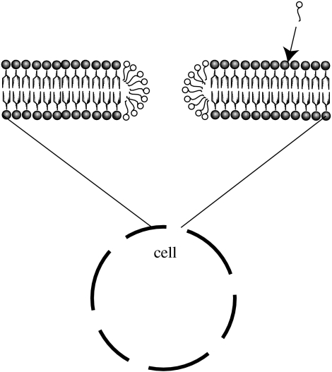

*Source:* [*https://www.ncbi.nlm.nih.gov/pmc/articles/PMC2504493/*](https://www.ncbi.nlm.nih.gov/pmc/articles/PMC2504493/)

The anion in sodium dodecyl sulfate (SDS), a surfactant often used for cellular lysis, is shown below:

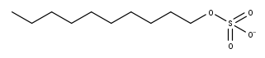

**E-1** Indicate which part of the anion is the tail and which is the head, if the porated cell in the figure is placed in water.

**E-2** Such strongly ionic surfactants are not always used since they tend to denature (change the structure of) proteins. Is this a problem for Vladislavs the Biochemist in this experiment? Why?

The critical micelle concentration (CMC) is the concentration of surfactant at which all further added surfactant forms micelles. Up until CMC, the surface tension of the surfactant solution keeps changing, but after - stays constant.

**E-3** Determine the CMC of SDS from the following graph:

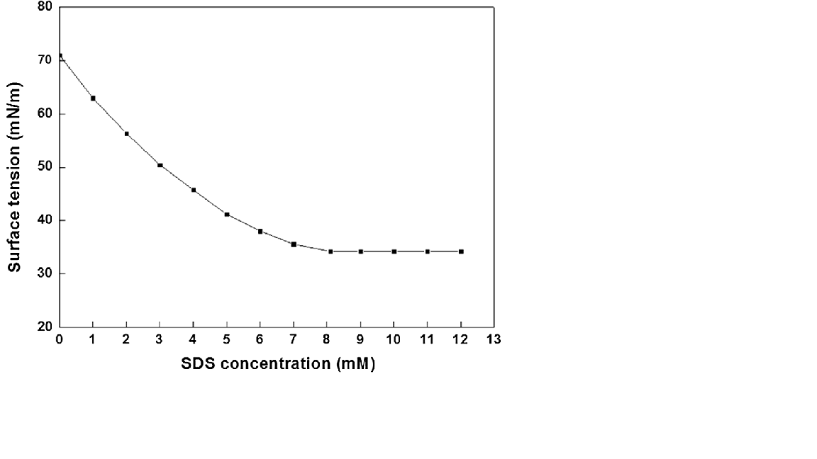

Vladislavs the Biochemist is kind of surprised by the strength of the interaction of the dodecyl sulfate’s anionic moiety with water. The potential of the ion-dipole interaction is as follows:

The separation distance r can be estimated as half of the oxygen atom van der Waals radius (r = 152 pm), and half of the water molecule’s length along its principal axis (l = 28.7 pm) k=9.0*109 N*m2*C-2, μ=6.17×10−30 C⋅m.

**E-4** Determine the charge on each oxygen atom (remember that sulfate anion exhibits resonance) and the interaction potential of the dodecyl sulfate with water’s dipole. Will it interact with the hydrogenic or oxygenic face of water?

**E-5** Assume that every sulfate anionic oxygen interacts with two water molecules. Per pore made in the muriocytic membrane, 69 dodecyl sulfate anions integrate into the membrane. Assuming negligible hydrophobic interactions, calculate the enthalpy change from the formation of one pore in the membrane if water’s dipole is 6.17×10−30 C⋅m.

Vladislavs conducted a cell counting experiment and determined that the absorption of the 10 mL sample of the mixture he took, diluted to 100 mL, is 1.80. The molar absorption of the dye that Vladislavs used (one dye molecule binds to one cell) is 3330 M-1 cm-1. Vladislavs intends to add 0.5 M SDS to 100 mL of collected muriocytes to lyse them.

**E-6** Determine the total number of cells in the 100 mL cell suspension.

Help Vladislavs determine the amount of SDS that he should add. Assume that a negligible amount of micelles are formed before CMC, that SDS forms micelles only when integrated into the membrane. On average, 420 pores are formed in a cell.

**E-7** Determine the volume of SDS that should be added and the heat thus evolved.

Phew, that lysis procedure sure was quite a bit of work. Now, the extracted DNA has to be amplified using the polymerase chain reaction. A 10 mL sample is taken for the reaction. The polymerase chain reaction is an in vitro procedure where the DNA is duplicated once per cycle. The cycles are repeated many times to ensure an appropriate final concentration of DNA. We will consider only one part of the PCR - melting.

Melting is the stage where the DNA has to be dissociated. The dimerization of DNA is mediated by hydrogen bonds, as demonstrated below:

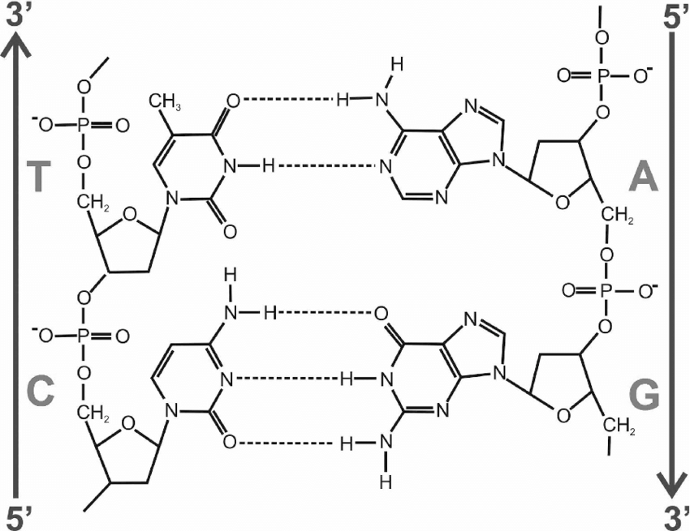

Source:[*https://www.researchgate.net/publication/327500345/figure/fig6/AS:668188459139077@1536319951907/Section-of-the-Watson-Crick-DNA-structure-showing-hydrogen-bonds-connecting-the.png*](https://www.researchgate.net/publication/327500345/figure/fig6/AS:668188459139077@1536319951907/Section-of-the-Watson-Crick-DNA-structure-showing-hydrogen-bonds-connecting-the.png)

The chemical equation for dissociation of DNA is as follows:

**E-8** Assuming no initially present dissociated DNA, express the equilibrium constant K from the initial concentration of DNA dimers and final concentration of each DNA monomer.

**E-9** Determine K if the concentration of each monomer of DNA is 99% of that of initial dimerized DNA, assuming there are 46 DNA molecules per cell.

**E-10** The strength of the average hydrogen bond in DNA is found to be approximately 4 J/mol. If the enthalpy of dissociation is 204 kJ/mol, and the total number of base pairs is 20069, determine the number of A-T and G-C pairs, respectively, in each DNA molecule.

**E-11** If K of dissociation at 298 K is 0.01, determine the temperature at which it will reach the K you calculated in **E-9.**

**E-12** If the desired concentration of DNA is 1 M and the amount of DNA doubles every cycle, calculate the minimum number of cycles.

OK… Now, thanks to your help, the muriocytic DNA has been amplified. For forensic analysis, it now must be cleaved by a restriction endonuclease. The DNA is cleaved at particular spots which match the enzymes. This will yield a certain amount of DNA fragments which is unique to a particular person. The number of these fragments can then be determined by gel electrophoresis. By comparing the number of such fragments amongst suspects and with the muriocytic fragments, we can determine the true culprit.

Restriction endonucleases follow Michaelis-Menten kinetics. A represents the concentration of cleavage sites:

Let us take a particular fragment C. The fragment needs to be cleaved by two different endonucleases in order to be yielded. There are then two paths to such a fragment:

All elementary reactions proceed through Michaelis-Menten kinetics. The rate of such reactions is expressed as follows:

**E-13** Write the total rate for disappearance of the initial DNA, [I].

Vladislavs wants to play engineer and approximate the Michaelis-Menten rate expression. However, can he really do that?

**E-14** Write out the rate of reaction of an endonuclease with DNA as an infinite series using the formula for the Taylor series of

**E-15** Can you approximate the rate law using the above series in the form if the reaction rate is 50% of the maximum rate? Also determine the maximum ratio of when the ratio of the precise value and approximation is up to 103% or over 97%, whichever requirement is stricter. Will Vladislavs using the approximation lead to overestimation or underestimation of the rate?

**E-16** The association of the enzymes with DNA is slow. Can you, in this case, use the steady state approximation on the rate of generation of A and B? Write the expression of a steady state approximation applied to A and B. What kind of information about A and B is deduced from this expression?

Finally, Vladislavs wants to use gel electrophoresis to find the true culprit. For that, he needs to use a dye. The dye will associate with the DNA molecules, and thus the DNA molecules, moved according to their weight in the electrophoresis procedure, will be visible under UV light. If the pattern of a particular suspect’s set of DNA matches that of the muriocytic DNA, the true culprit is found.

The equilibrium constant for association of the dye to a DNA fragment is 16 at 293K. The equation is as follows:

DNA + B ⇔ B-DNA

The air conditioning machine in the lab broke, so Vladislavs wants to find the maximum temperature at which the dyed DNA molecules will be visible.

**E-17** If the dye’s association enthalpy is -31.7 kJ/mol, the concentration of dye is 0.5 M, and the concentration of DNA is 1 M, express the concentrations B-DNA and B as a function of temperature.

A 1 mL sample of this mixture is now placed in the gel for electrophoresis.

The mixture is now irradiated by UV light. Assume that the remaining B is dispersed throughout the gel (bad assumption, I know), and the electrophoresis pattern (with only the solvent and B-DNA) takes up ⅕ of the gel’s volume. The quantum yield for fluorescence of the dye molecule is 0.7. The minimum light intensity for detection against the background light intensity is A. Assume that the background light is coming only from the remaining B (the room is dark). The molar absorption for all B-containing species is 5000 M-1 cm-1.

**E-18** Express the temperature at which B-DNA is no longer detectable as a function of A.

And so, through all this effort, Vladislavs determined the culprit to be [CLASSIFIED].

## 

## Problem **F**. Vapour of muriomorphosis (16%)

Little John lives in a time when people have been genetically engineered to gain the ability to transform into pickles. This transformation - scientifically termed muriomorphosis - is initiated by interaction of one of many types of ligands with a muriomorphotic receptor on the surface of the oral and nasal cavities. The interaction sets off a cascade of biochemical reactions. Little John has been assigned to work with molecule **X** - one out of many ligands that can interact with the muriomorphotic receptor that Little John (and everyone) has.

However, Little John is afraid to get anywhere near the substance. Since the molecule interacts with receptors inside the nose, breathing it in might be able to cause the transformation, which Little John is extremely cautious of (he’s never done it before). Therefore, Little John wants to make sure that the vapour pressures of the substance at room temperature are not excessive and will not turn him into a pickle.

First, let us estimate the strength of the intermolecular interaction that holds the substance together. The electric dipole of molecule **X** is low, so we can assume that the interactions are dispersion-like. Dispersion interaction strength can be approximated as follows, by the London formula:

where is the polarizability volume, is the ionization energy, and is the radius of the molecule.

**F-1** The molecule has a globular shape. What assumptions should be made in this calculation? Mark **Yes** or **No** for each assumption.

|  |  |
| --- | --- |
|  | The ionization energy should be approximately uniform across the surface of the molecule. |
|  | The molecule is small. |
|  | The molecule is inorganic. |
|  | The molecule is organic. |

To estimate the polarizability volume, we can use the Clausius-Mossotti equation:

where is the electric relative permittivity of the substance, and is the permanent dipole. Some clever scientists (who are NOT afraid of turning into pickles) collected data on the dependence of density and relative permittivity of molecule **X** on temperature:

|  |  |  |
| --- | --- | --- |
|  |  |  |
| 0 | 0.99 | 12.5 |
| 20 | 0.99 | 11.4 |
| 40 | 0.99 | 10.8 |

Also given is the molar mass of molecule **X** = 4206.9 g/mol, as determined using a mass spectrometer. *ε*0 = 8.8*10-12 F*m

**F-2** To use linear regression to determine the polarizability volume, the equation has to be linearized. As in **y = ax + b**, write out the y, a, and b terms that describe the Clausius-Mossotti equation.

|  |  |
| --- | --- |
| y |  |
| a |  |
| b |  |

**F-3** Using linear regression, determine the polarizability volume of molecule **X**.

**F-4** The spherical molecule **X** has 37 surface atoms, with 4.00 angstrom^2 molecular surface area per each atom. Determine the surface area of the molecule, and thus its radius.

**F-5** Using the ionization energy 2001 kJ mol-1, determine the dispersion interaction energy and (assume to be equal in magnitude) vaporization enthalpy.

**F-6** Some more clever scientists who are not afraid of becoming pickles found the vapour pressure of molecule **X** at 200 K to be 2 Pa. Estimate the vapour pressure at 298 K.

**F-7** Thus, assuming the enthalpies and entropies of vapourization to be independent of temperature, determine the entropy of vapourization.

OK, so we’ve calculated a bunch of nonsensical data. But Little John wants real answers, now. Will it (how quickly will it) turn him into a pickle?

Assume the vapour of molecule **X** behaves like an ideal gas. It interacts with the receptor according to the following elementary reaction:

**F-8** Deduce the [concentration-based] rate law for the reaction, assuming and are known.

Receptors can be imagined as little protrusions from the walls of the oral and nasal cavities. The collision flux (number of collisions of molecule **X** with the wall per unit area per time interval) can be calculated as follows:

**F-9** Calculate the collision flux of molecule **X** at 298 K.

The probability of a molecule **X** that is heading for the wall of hitting a muriomorphotic receptor is 0.0021. The projection of the receptoral molecular surface onto the cavity’s “wall” (assuming it is flat) has an area of 400 angstrom^2.

**F-10** Estimate the number of receptors in the cavity per unit area.

**F-11** The activation energy of the ligand-receptor interaction is 74 kJ/mol. Calculate the probability that the ligand will have enough energy to associate with the receptor.

The Arrhenius factor can be approximated using the following formula:

where S is the surface area of the molecule, and is the reduced mass of the two molecules.

**F-12** Finally, assuming that only a third of the orientations of molecule **X** hitting the receptor are appropriate for the reaction, and assuming that a collision with appropriate orientation and energy will lead to a reaction, calculate the rate constant of the reaction at 298 K.

**F-13** Calculate the initial reaction rate using the collision flux. To calculate it, think about the probability of each collision leading to the association reaction.

**F-13** Thus calculate the concentration of muriomorphotic receptors. Using this information (hint: you must equate the two rate expressions), and assuming that the concatenation of the two cavities is spherical, estimate the total number of muriomorphotic receptors in the cavity. Another hint: you have receptors per area unit and receptors per volume unit. Think about how spherical surface area can be converted to spherical volume.

**F-14** The equilibrium constant of ligand association to the muriomorphotic receptor is 11. Estimate the dissociation reaction rate constant.

Little John only needs a total of **10^3** receptor associations to transform into a pickle. The total volume of the oral and nasal cavities is **5 dm^2**.

**F-15** Using the following formula:



and ignoring the dissociation, calculate the time within which that number will be reached (time that Little John has to run out of the room out of fear).

**F-16** Clever Chemist Zane is studying molecule **Y**, which has a transition state during association with the receptors that has more in-phase pi interactions. The activation energy has been shifted by 10 kJ/mol. Has the activation energy increased or decreased? Calculate the new activation energy.

**F-17** Calculate the new rate constant and the time within which Little Zane will transform into a pickle.

Why does Little John even have to study this molecule **X**? Something far worse than a complete transformation is a partial transformation into a pickle. It can happen if receptor association is thermodynamically too weak, and not all the cells coordinate well enough during the transformation. Consequences are usually permanent and may include brain damage, green and juicy skin, internal aches, and degradation of muscular tissue. Little John, as the voluntary protector of mankind, has been tasked with determining if molecule **X** can cause this occurrence.

The partial transformation occurs if less than 25% of receptors are activated at equilibrium.

**F-18** Calculate the equilibrium number of ligand-receptor complexes, assuming none are initially present. Will molecule **X** cause a partial transformation?

**F-19** Assuming the dissociation constant and initial vapour pressure remain the same, what is the equilibrium number of ligand-receptor complexes of molecule **Y**? Is molecule **Y** safer to use?

Thank you for helping Little John make the right choice for his phobias.

# Organic Chemistry

## Problem **G**. RD Corp. and Mechanisms (14%)

Daniel decided to apply for an Organic Chemist job in RD Corp. Because of the enormous number of applicants to the position, Ross the Chemist, the lead chemist in the company, decided to carry out an Organic Chemistry exam for all applicants. Daniel studied hard before applying (he even got an IChO gold medal before university), but still he was very worried that he might fail the test.

The day of the exam finally came, and Daniel nervously went into the examination lab accompanied by Ross the Chemist and a stack of papers.

The first task Daniel had to complete was very simple: he had to mix reagent **L** and some compound **O**.

Reagent **L** has such a structural formula: 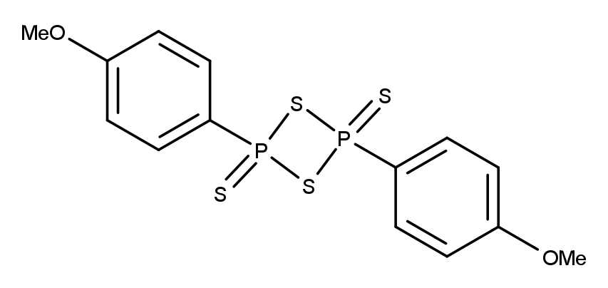

Compound **O**, on the other hand, has two peaks in its 13C NMR spectrum, and such a mass spectrum:

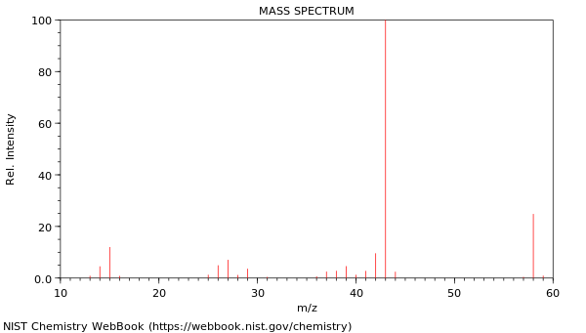

**G-1** What is the true name for reagent **L**?

**G-2** Deduce the name and structural formula of compound **O.**

**G-3** Draw the structural formula of the reaction product between **O** and reagent **L.**

**G-4** Draw a curly-arrow mechanism for the reaction in **G-3**.

**G-5** Which named reaction is very similar to this reaction?

The next task Ross the Chemist gave to Daniel is to prepare compound **Rossiol**. Of course, the synthesis is not complete (it is a very tough exam), so Daniel needed to first deduce the intermediates in the synthesis. 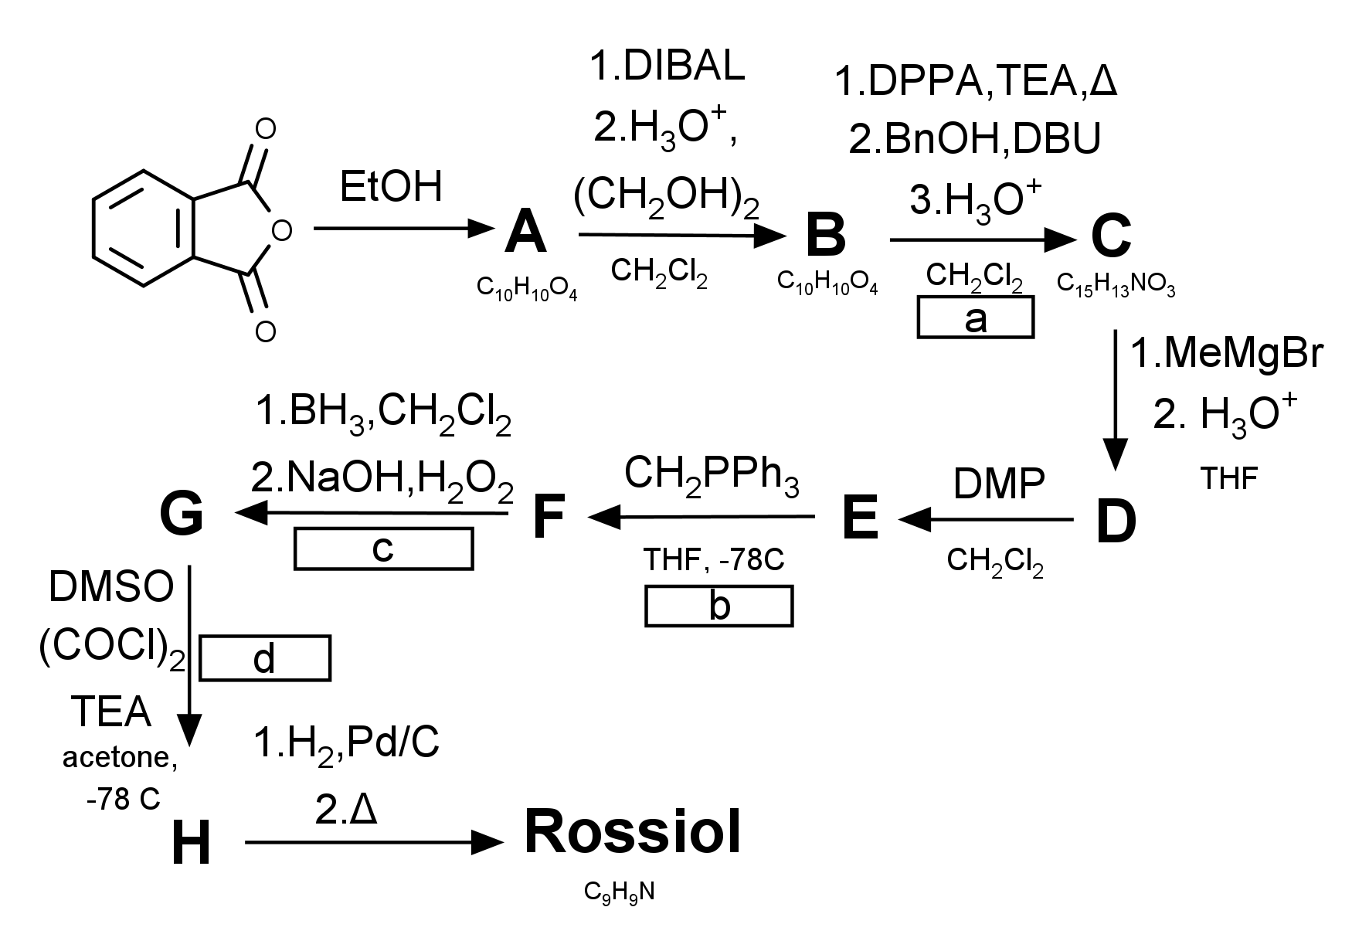

The empirical formulas for some intermediates are known: **A:**C10H10O4; **B:**C10H10O4; **C:**C15H13NO3; **Rossiol:**C9H9N

There is also an 1H NMR spectrum (150 MHz, simulated) of compound **E** available for Daniel’s usage (on next page).

It is also known that a compound containing monovalent uncharged nitrogen is formed as one of the intermediates in the step **a**.

**G-6** Determine the structural formulas of compounds **A-H** and **Rossiol**. Draw them without indicating stereochemistry.

**G-7** What are the names of the reactions **a-d**?

**G-8** Draw a curly-arrow mechanism for reaction **a**.

**G-9** Suggest a way to prepare the reagent CH2PPh3 for the reaction **b**.

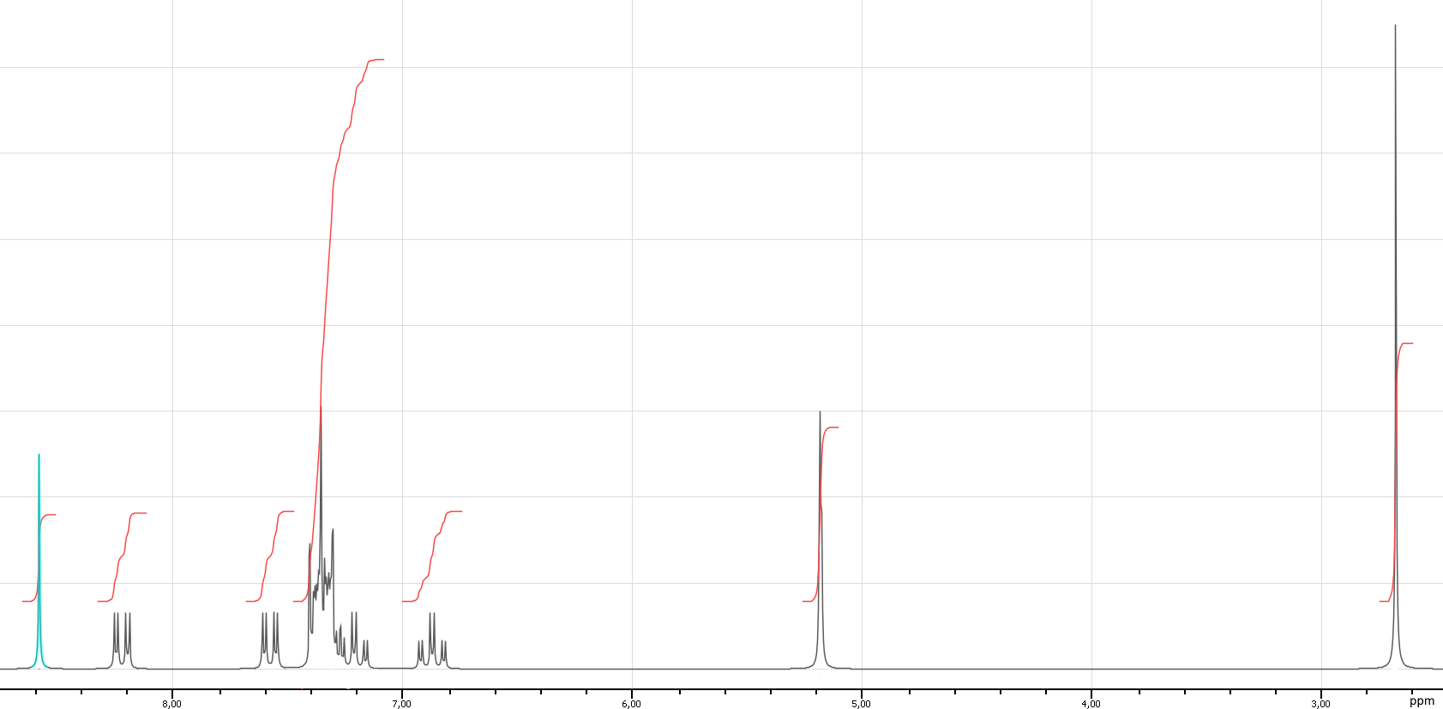

A simulated 1H NMR spectrum of compound **E.** The ratio of integrals is as follows (from left to right): 1:1:1:6:1:2:3

The last challenge Ross the Chemist presented to Daniel was to complete this reaction successfully:

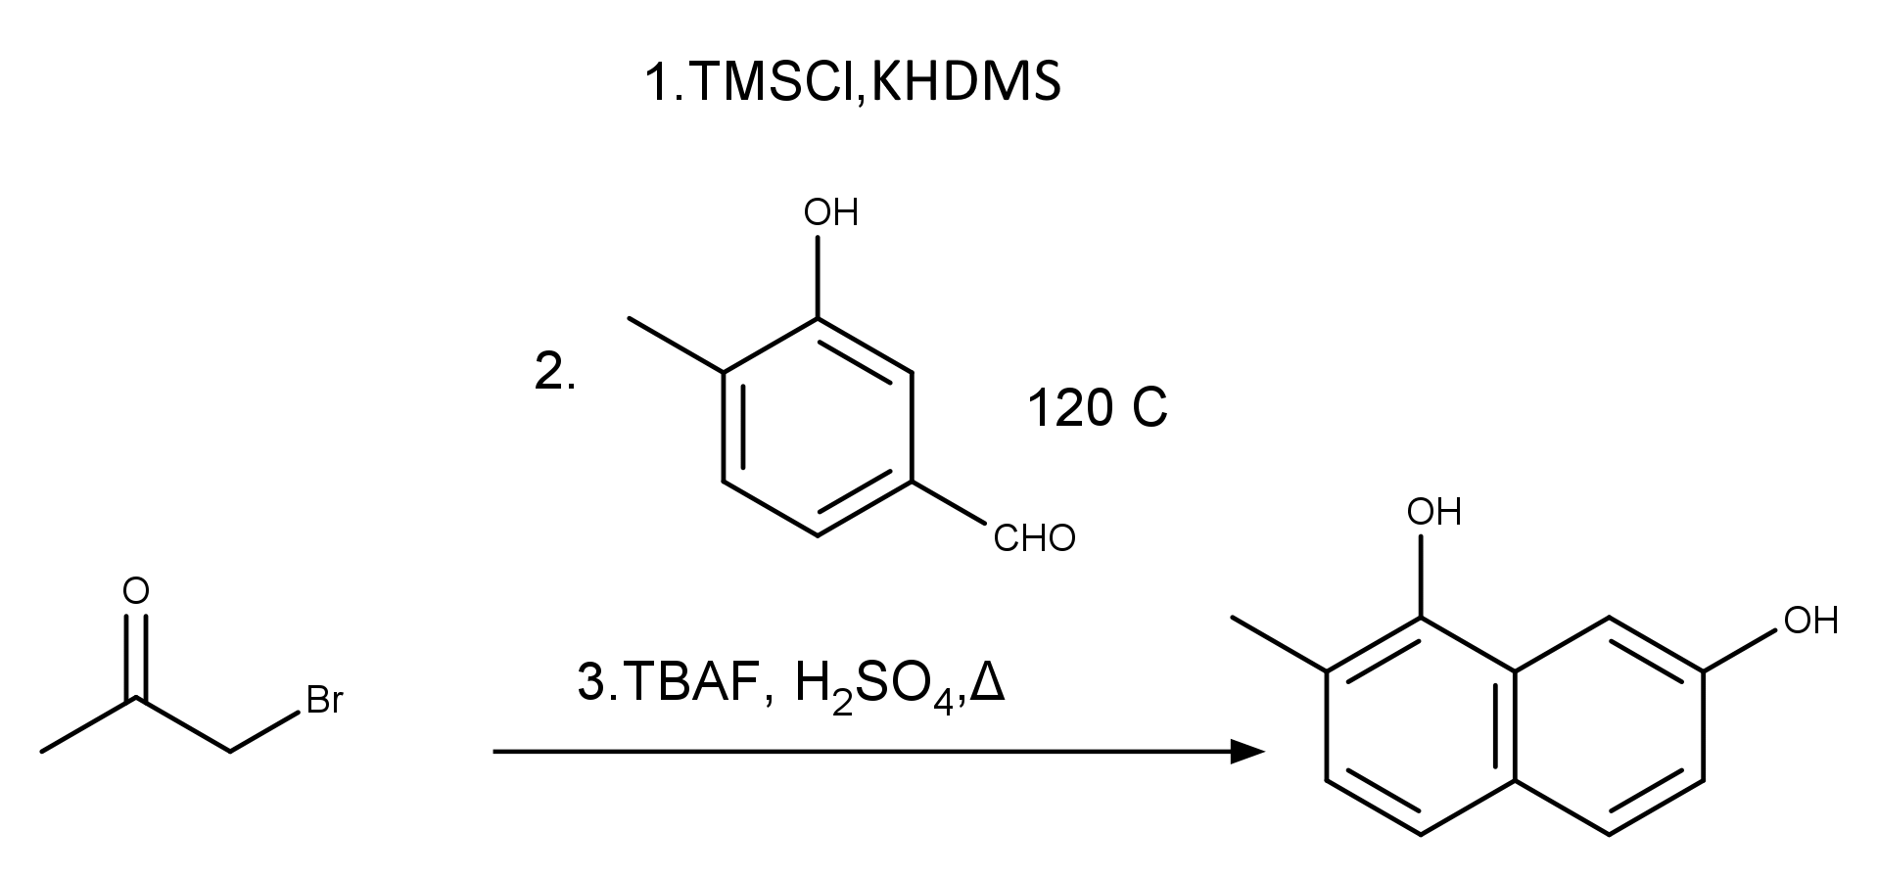

**G-10** Draw a curly-arrow mechanism for this reaction.

**G-11** If there are any name reactions as steps in the mechanisms, write down their names in your mechanism.

## Problem **H**. LIL BO’ CHEM (11%)

Gustav the High school student decided to synthesise some medicines at home to sell. He made a few synthesis schemes, but unfortunately Gustav’s father came into Gustav’s room and seized part of his synthesis schemes, saying that drawing is a waste of time and that Gustav should become a lawyer.

Although, it didn’t stop Gustav from completing his plans, and he still had enough of the schemes intact to restore the syntheses.

Gustav decided that his potential buyers will need to calm their anxiety down after seeing the mess in his room/lab/shop, and thought that adding a sedative such as alprazolam to his stock will be useful. He made an easy to follow synthesis scheme, but unfortunately it didn’t quite survive the attack of Gustav’s dad. 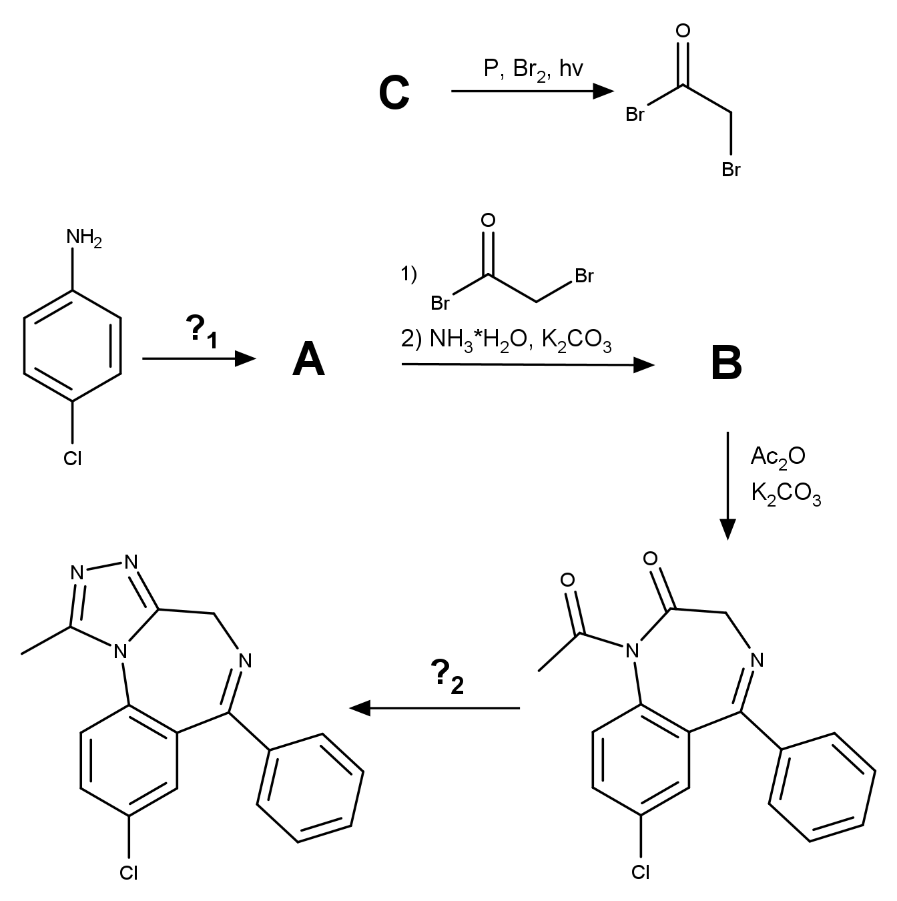

**H-1** Determine the intermediates **A-C** and the reagents **?1 and ?2** in the synthesis scheme.

**H-2** Why is NBS (N-bromosuccinimide) not a good reagent for producing the -bromoacetylbromide?

**H-3** What is the name of the reaction 4-chloroaniline=>**A?**

Then, Gustav planned to prepare some pharmacological compounds that’d help him sleep better. He found a molecular formula of a drug that counters insomnia online and designed a synthesis. Sadly, this molecule also didn’t survive Gustav’s dad and his raid. 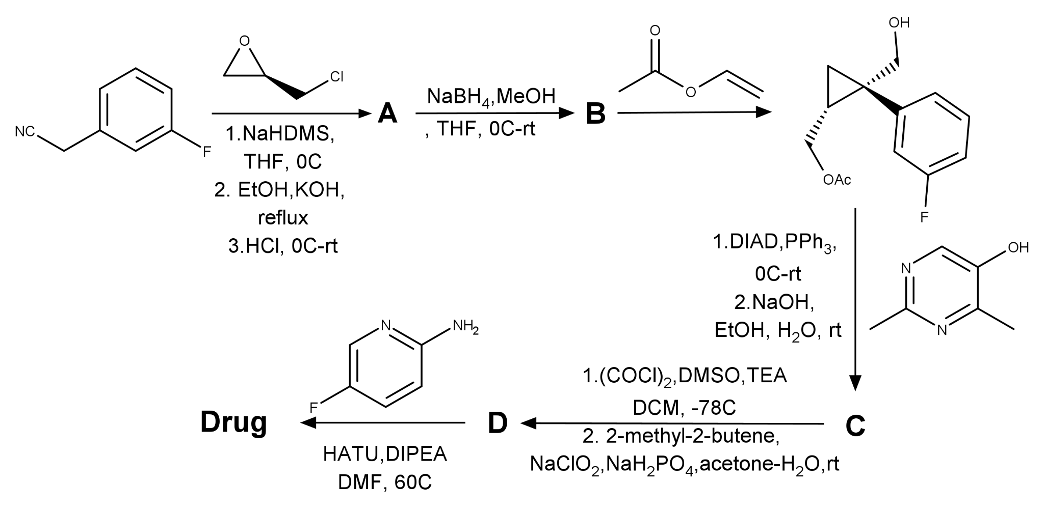Gustav recalled the following information:

**A** contains two oxygen atoms and no nitrogen atoms

The molar mass of **Drug** is 410.4 g/mol

**H-4** Determine the structural formulas of compounds **A-D** and **Drug** in the synthesis.

**H-5** What are the names of two reactions used in step **C->D**? Why is 2-methyl-2-butene used in the second reaction of the step?

**H-6** Draw the mechanism of the reaction step resulting in **C** (PPh3, DIAD,.....). What is the name of this reaction?