MMT Ichi TradingView Beginner Guide

What This Guide Is For
This guide explains how to use the three public MMT Ichi Workflow scripts:
- MMT Ichi Workflow Overlay
- MMT Ichi Workflow Overlay Profiles
- MMT Ichi Workflow Strategy
It is written for someone who is new to both trading and TradingView.
The big idea is simple:
- Strategy tells you whether a ticker and timeframe are worth trusting.
- Overlay tells you what the chart is doing right now.
- Overlay Profiles does the same execution job as the normal overlay, but automatically loads ticker-specific defaults when a supported symbol is detected.

One Important Idea First
These three scripts do not all have the same role.
Script | Main Job
MMT Ichi Workflow Strategy | Validate the chart with backtest-style metrics.
MMT Ichi Workflow Overlay | Read the live chart and show execution guidance.
MMT Ichi Workflow Overlay Profiles | Read the live chart like the normal overlay, but with symbol-specific defaults when a profile exists.
That means the normal order is:
- Strategy first
- Overlay or Overlay Profiles second
Most beginners should use:
- Strategy
- plus one overlay variant, not both
You can put both overlays on a chart for comparison, but that is not the cleanest way to learn.

Basic Trading Words
Term | Simple Meaning
Long | A trade idea that wants price to rise.
Short | A trade idea that wants price to fall.
Entry | The price area where the trade idea begins.
Target | The area where the trade hopes to travel.
Invalidation | The level that tells you the setup is no longer valid.
Timeframe | How much time each bar represents, such as 1D or 1W.
Backtest | A test of the strategy rules on past data.
Ichimoku | A charting framework that uses a cloud, conversion line, base line, and lagging confirmation.

How The MMT Ichi Logic Works
The public MMT scripts are built around the same Ichimoku score model.
They score both the current timeframe and the higher timeframe from -4 to +4.
The four score parts are:
Score Part | Bullish Reading | Bearish Reading
Price vs Cloud | Price is above the cloud | Price is below the cloud
Future Cloud | Future cloud is bullish | Future cloud is bearish
TK Alignment | Tenkan is above Kijun | Tenkan is below Kijun
Chikou Confirmation | The lagging confirmation is bullish | The lagging confirmation is bearish
That means:
- +4 = strongest bullish alignment
- 0 = mixed or neutral structure
- -4 = strongest bearish alignment
The higher timeframe is used as a filter.
- Long setups want a bullish higher timeframe.
- Short setups want a bearish higher timeframe.

Script 1: MMT Ichi Workflow Strategy

Purpose
This is the validation layer.
Use it first to decide whether the current ticker and timeframe behave well with the MMT Ichi model. It does not exist to tell you that a trade must be taken right now. It exists to tell you whether the chart has earned your attention.

Simple Construction
The strategy:
- uses the same Ichimoku scoring model as the overlays
- tests three trade families on the current chart:
  - Breakout
  - Checklist
  - Kijun Bounce
- measures the results using strategy metrics
- gives the chart a simple verdict

Main Dashboard Fields
Field | What It Means
Chart | The current symbol and timeframe.
Model | The active preset, direction filter, and higher timeframe.
Modules | Which setup families are enabled.
Net P/L | Net profit or loss over the tested period.
Profit Factor | Gross profit divided by gross loss. Higher is better.
Max DD | Maximum drawdown. Lower is safer.
Trades / Win | Number of closed trades and win rate.
Verdict | Quick summary: Valid, Caution, Thin Data, or Avoid.

How To Use The Strategy
Read the strategy card first.
Verdict | Plain-English Meaning
Valid | This chart behaves well enough to consider trading with the overlay.
Caution | The chart can work, but the evidence is weaker than you want.
Thin Data | There are too few trades to trust the result yet.
Avoid | The chart does not validate well for this model.
Simple beginner rule:
- if the strategy says Avoid, do not trust the overlays aggressively

Script 2: MMT Ichi Workflow Overlay

Purpose
This is the standard execution overlay.
Use it after the strategy has told you the chart is worth watching. Its job is to show whether the chart is bullish, bearish, or neutral and whether a live Ichimoku setup is active.

Simple Construction
The overlay:
- scores the chart on the current timeframe
- scores a higher timeframe for confirmation
- classifies the regime as Bull, Bear, or Neutral
- looks for specific setup families
- draws guidance, targets, and invalidation directly on the chart

Main Dashboard Fields
Field | What It Means
Chart | The active symbol and timeframe.
Preset | The current Ichimoku preset and lengths.
CTF Score | Current timeframe Ichimoku score from -4 to +4.
HTF Score | Higher timeframe score from -4 to +4.
Regime | Bull, Bear, or Neutral.
Trade Call or Active Setup | The current trade state.
Wait For or Execution | Either the next thing the script wants to see, or the active E / T / X row.

Overlay Setup Families
Setup | Simple Meaning
Checklist | Full Ichimoku alignment. This is the strictest setup.
Kijun Bounce | Trend continuation after price retests the Kijun line and holds.
Breakout | Price exits the cloud with enough alignment to continue.
Edge-to-Edge | Price enters the cloud and may travel to the opposite side.

What The Overlay Messages Mean
Message | Plain-English Meaning
NO TRADE RIGHT NOW | No active setup is being tracked.
Wait for bullish cloud alignment | The chart is not bullish enough yet for a long-biased workflow.
Wait for bearish cloud alignment | The chart is not bearish enough yet for a short-biased workflow.
Watch for breakout, checklist, or kijun bounce | Structure is aligned, but the trigger bar has not appeared yet.
Execution: E / T / X | A setup is active, and the overlay is showing entry, target, and invalidation.

What The Overlay Draws On The Chart
Chart Item | What It Means
cloud shading | The current Ichimoku cloud area
regime shading | Bullish, bearish, or neutral background bias
marker labels | Setup labels such as breakout or checklist
guidance box | The large on-chart trade guidance message
ENTRY tag | The reference entry area
TARGET tag | The current target
EXIT / INVALIDATION tag | The level that would break the setup
dotted flat target lines | Nearby flat-Kumo target levels

Script 3: MMT Ichi Workflow Overlay Profiles

Purpose
This is the profile-aware version of the overlay.
Use it when you want the script to load vetted ticker-specific defaults automatically on supported symbols instead of using one generic Ichimoku preset for every chart.

Simple Construction
The profile overlay does everything the normal overlay does, plus one extra step:
- it checks whether the current ticker has a saved symbol profile
- if yes, it loads the profile label, Ichimoku lengths, and direction default
- if no, it falls back to the manual settings

Supported Profile Behavior
When a profile is active, the dashboard changes slightly:
- the normal Preset row becomes Profile
- the value will show the active profile name and cloud lengths
Example supported profile labels in the current script include:
- BTC Long
- ETH Long
- SOL Long
- GLD Long
- SPY Long
- DBC Long
- LQD Short
- KRE Long
If no profile exists for the ticker, the script falls back to Manual.

When To Use Overlay Profiles Instead Of The Normal Overlay
Use Overlay Profiles when:
- the ticker is one of the covered symbols
- you want the script to choose the tuned defaults for you
Use the normal Overlay when:
- you want full manual control
- you are comparing presets yourself
- the ticker is not one of the profiled symbols

How To Use The Three Scripts Together
The intended workflow is:
- Choose a ticker and timeframe.
- Read the Strategy card first.
- If the verdict is acceptable, move to an overlay.
- Use:
  - Overlay for the standard model
  - or Overlay Profiles for the auto-profile model
- Wait for the overlay to move from no trade to an active setup.

Beginner Workflow
Step | What To Do | What You Are Looking For
1 | Open a chart | Start on 1D for simplicity.
2 | Add MMT Ichi Workflow Strategy | Read the validation card first.
3 | Check Verdict | Prefer Valid. Be careful with Caution or Thin Data. Avoid Avoid.
4 | Add one overlay | Use standard Overlay or Overlay Profiles.
5 | Read CTF Score, HTF Score, and Regime | This tells you if the chart is aligned.
6 | Read Trade Call / Active Setup and Wait For / Execution | This tells you whether the chart is ready now or still waiting.
7 | If active, read E, T, and X | These are the live trade guidance levels.

What The Chart Syntax Means

In The Strategy Card
- Valid
  - best case: the chart has acceptable historical behavior with the model
- Caution
  - the chart can work, but quality is weaker
- Thin Data
  - the sample is too small to trust
- Avoid
  - the chart is not validating well

In The Overlay Dashboard
- CTF Score
  - current timeframe score
- HTF Score
  - higher timeframe score
- Regime
  - Bull, Bear, or Neutral
- Trade Call
  - what the script thinks you should do now
- Wait For
  - the next condition the script is waiting for
- Execution
  - a compact row showing:
    - E = entry
    - T = target
    - X = invalidation

In The Profile Overlay Dashboard
- Profile
  - the active symbol profile, if one exists
- Manual
  - no profile is active, so the script is using manual settings

Recommended Defaults For Beginners

Strategy
- keep the default preset first
- keep the default higher timeframe first
- leave all three modules enabled

Overlay
- use one overlay at a time
- keep the default preset first
- keep Long Only if you are new and reviewing bullish markets

Overlay Profiles
- turn Use Symbol Profiles on
- verify that the Profile row matches the ticker you expected

Common Beginner Mistakes
Mistake | Better Approach
Using the overlay before checking the strategy | Read the strategy card first.
Treating Thin Data as a strong green light | Thin data means the sample is too small.
Using both overlays at once on day one | Start with one overlay so the chart stays readable.
Ignoring the higher timeframe | The workflow depends on higher-timeframe confirmation.
Confusing Breakout with Checklist | Checklist is stricter and stronger than a breakout.
Assuming Edge-to-Edge is the same as a normal breakout | It is a cloud-travel state, not the same setup family.

Two Simple Flowcharts

Flowchart 1: Strategy First, Overlay Second
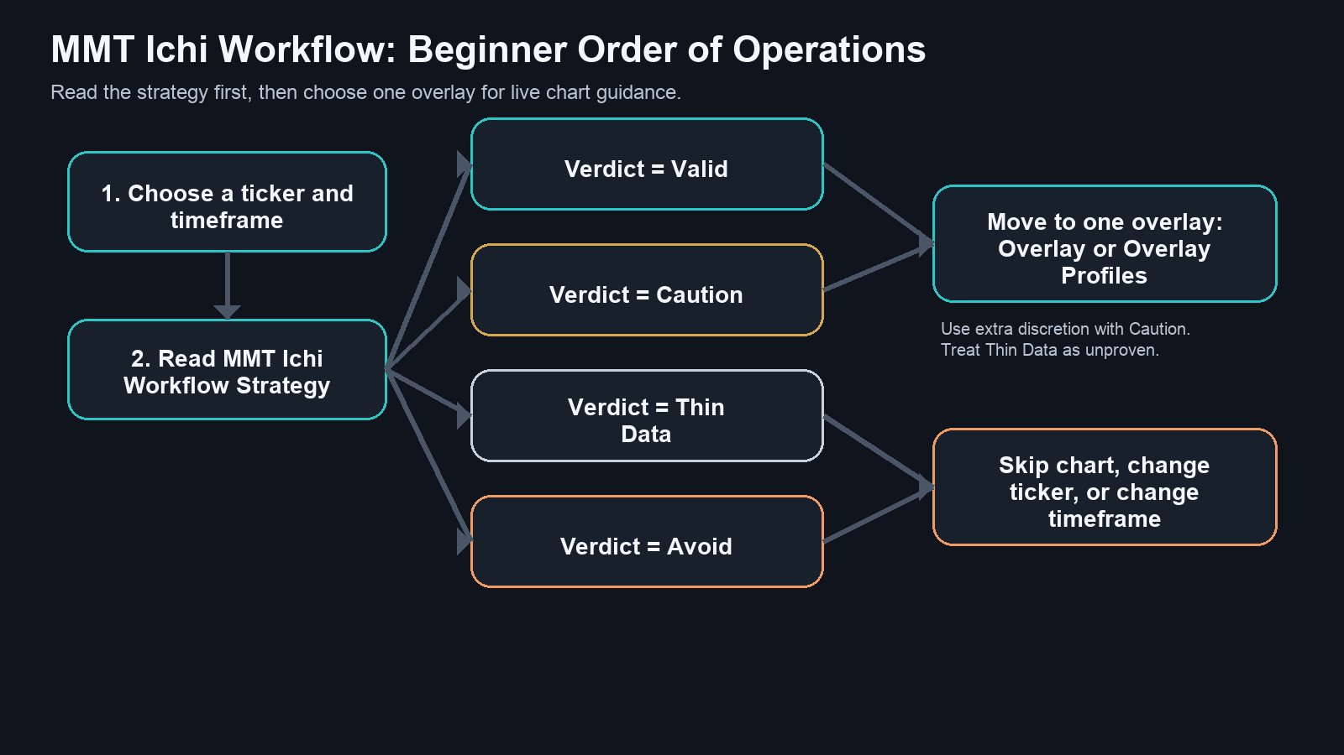
MMT Ichi Workflow Overview

Flowchart 2: Overlay Decision Logic
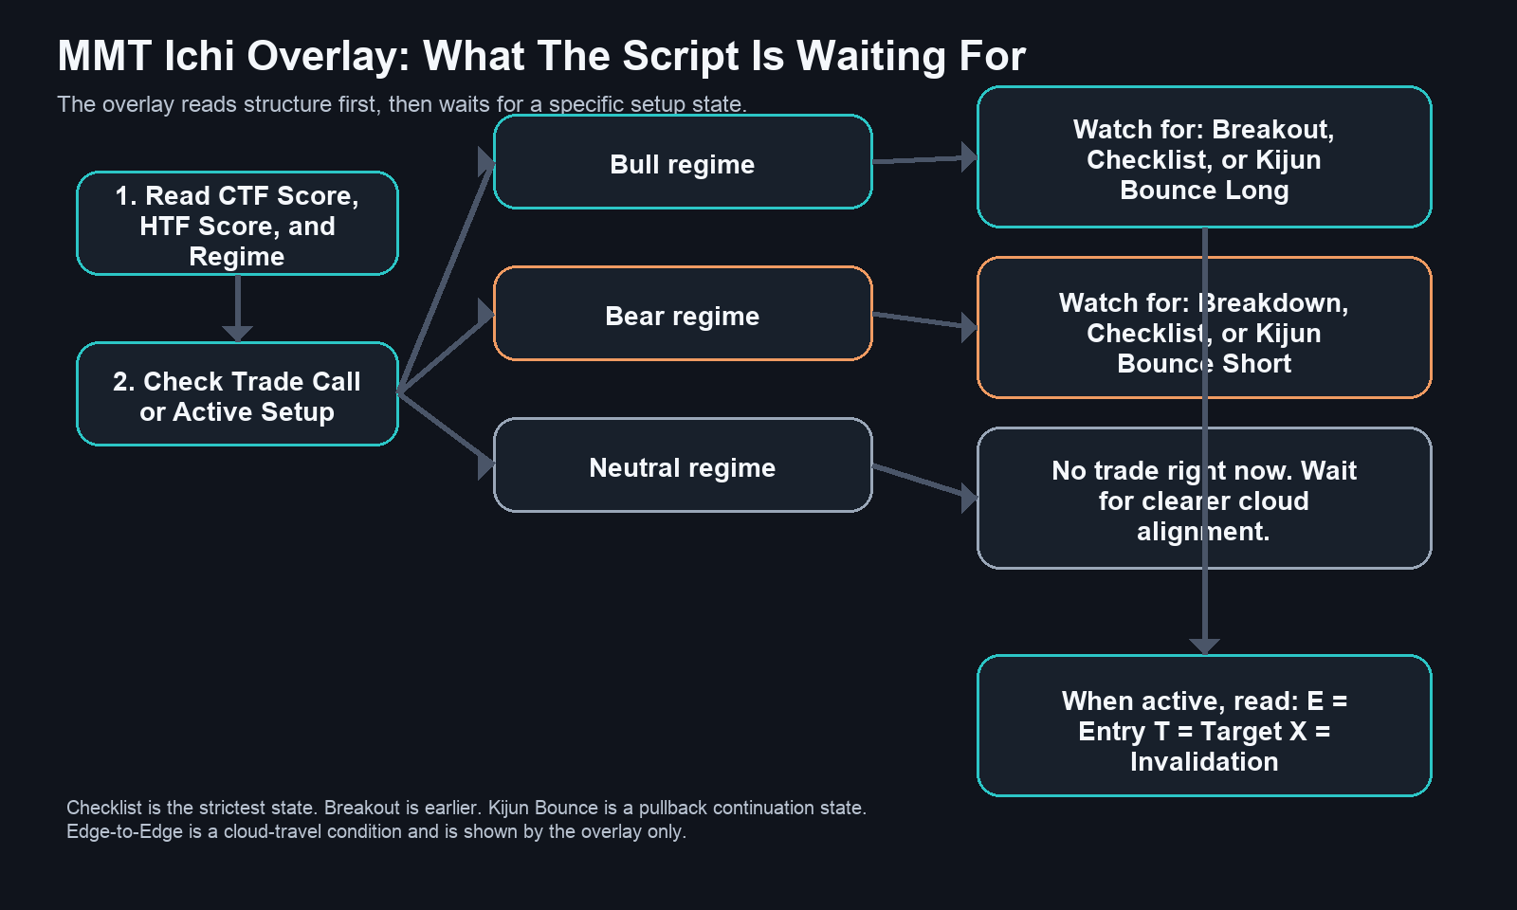
MMT Ichi Overlay Decision Map

Short Version To Remember
- Strategy answers: Is this chart worth trading?
- Overlay answers: What is the chart doing right now?
- Overlay Profiles answers the same question, but with ticker-specific defaults when available

Final Reminder
The clean beginner workflow is:
- Strategy first
- then Overlay or Overlay Profiles
- trust the overlay more when the strategy already likes the chart

