YOUR NAME: Guillermo Moronta Fernandez

**Golden Links Membership System**

At the end of every April, the Golden Links Golf club finishes their annual recruitment drive for new members. The Recruitment Officer reviews the membership applications received and checks the member file to make sure they are not an existing but inactive member. If this is the case, the old member’s record is simply updated. If they were previously a member who let their membership lapse, the Recruitment Officer will archive the old membership member number and create a new one, indicating that this is a returning member. For new applications who have been vetted, a new membership number will be issued. Once the members have been entered into the membership file by the Recruitment Officer, the system will send new members an email with their membership number and password. The original membership cards will be filed for one year, then archived.

Once the members have their passwords, they are eligible to participate in the many facilities that Golden Links has to offer. For example, one of the services available to members is the ability to book golf lessons with the golf pro.

All lessons are given in half hour blocks. The member asks the Shop clerk to book a lesson with the Golf Pro for a particular day and start time. The Shop clerk accesses the member file to verify that they are a member in good standing; enters into the Schedule file a brief description of what the member wishes to learn or improve and checks if the requested day and time are available. If the requested day and/or time is booked, the Shop clerk discusses a suitable alternate day and/or time. The member can accept this date and time or request a new preferred date and time. When everything is agreed upon, the Shop clerk sets the appointment status to ‘active’, sends a confirmation email to the member’s email address and files the lesson request in the lesson request folder.

Each morning the Shop Clerk prints out the appointment schedule for the day. For each appointment time slot booked, the name of the member, skill level of the member, reason for the appointment, and location of the lesson are visible to the golf pro. Once completed the golf pro enters a complete status for the lesson and any comments that may be needed for future lessons.

**Required:**

**UML**

1. Create the Use Case Diagram [10] (List all Use Cases found)
2. Create the related Use Case Narratives [30] (Select 5 Use Cases from the narrative).
3. Draw the Sequence Diagram for each Use Case Narrative [30]

**Please return your midterm as a single Word or PDF document.**

**DO NOT SUBMIT EACH PAGE AS INDIVIDUAL DOCUMENTS.**

Use Case Diagram

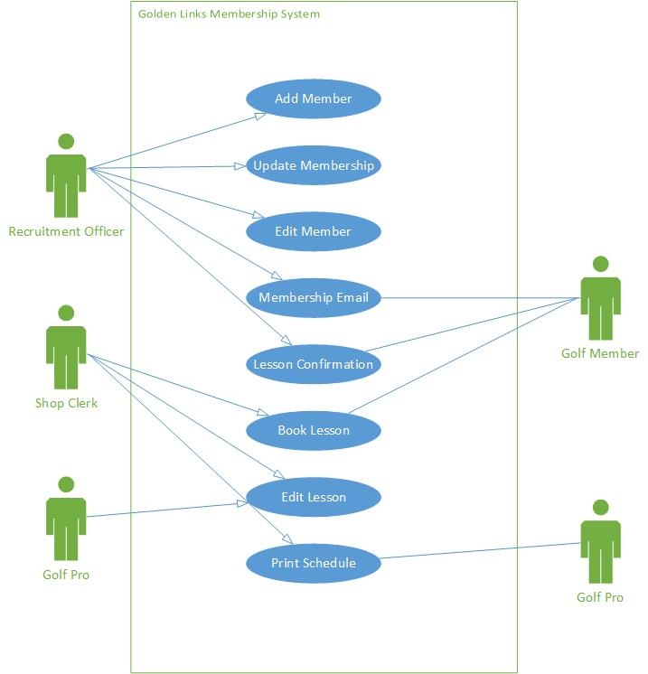

|  |  |  |
| --- | --- | --- |
| **Use Case Name:** | *Add Member* | |
| **Description:** | *Create new membership* | |
| **Actor(s):** | *Recruitment Officer* | |
| **Preconditions:** | *Membership renewal from the requested member has lapsed or the membership request is a new and unique entry.* | |
| **Trigger:** | *Membership Applications are submitted and reviewed at the end of April.* | |
| **Normal flow of events:** | **Actor action** | **System Response** |
| 1. *Recruitment Officer creates a new member, indicating whether it is for an old member or not.* | 1. *System confirms successful addition of a new member.* |
| **Alternate flow of events:** | *n/a* |  |
| **Post-conditions:** | *New Membership is created, issuing a new membership number* | |
| **Outstanding Issues:** | *n/a* | |

|  |  |  |
| --- | --- | --- |
| **Use Case Name:** | *Update Membership* | |
| **Description:** | *Updates an existing membership* | |
| **Actor(s):** | *Recruitment Officer* | |
| **Preconditions:** | *Membership must already exist and have not had their membership lapse.* | |
| **Trigger:** | *Membership Applications are submitted and reviewed at the end of April, Recruitment officer verifies that is an existing, but inactive, member.* | |
| **Normal flow of events:** | **Actor action** | **System Response** |
| 1. *Recruitment officer verifies that the membership application is for an existing, but inactive, member and updates their files* | 1. *System returns confirmation of successful update of the member* |
| **Alternate flow of events:** | *n/a* |  |
| **Post-conditions:** | *Membership file is updated* | |
| **Outstanding Issues:** | *n/a* | |

|  |  |  |
| --- | --- | --- |
| **Use Case Name:** | *Membership email* | |
| **Description:** | *The system sends out a confirmation to new members once they have successfully been added to the Golf Links system.* | |
| **Actor(s):** | *Recruitment Officer* | |
| **Preconditions:** | *Member must be a new and unique member* | |
| **Trigger:** | *A new membership has been created within the system by the Recruitment Officer* | |
| **Normal flow of events:** | **Actor action** | **System Response** |
| 1. *Recruitment Officer enters new members into the system* | 1. *System confirms new memberships and sends out emails containing membership numbers and passwords to the relevant members* |
| **Alternate flow of events:** | *n/a* |  |
| **Post-conditions:** | *New members are sent a membership number and password via email* | |
| **Outstanding Issues:** | *n/a* | |

|  |  |  |
| --- | --- | --- |
| **Use Case Name:** | *Edit Member* | |
| **Description:** | *Membership information is edited* | |
| **Actor(s):** | *Recruitment Officer* | |
| **Preconditions:** | *Must be an existing member within the system* | |
| **Trigger:** | *A membership file must be edited* | |
| **Normal flow of events:** | **Actor action** | **System Response** |
| 1. *Recruitment Officer edits an existing member’s information* | 1. *System confirms successful edit of member information* |
| **Alternate flow of events:** | *n/a* |  |
| **Post-conditions:** | *Member information is edited.* | |
| **Outstanding Issues:** | *n/a* | |

|  |  |  |
| --- | --- | --- |
| **Use Case Name:** | *Lesson Confirmation* | |
| **Description:** | *Once a lesson has been booked, the shop clerk sends confirmation to the member and files the lesson* | |
| **Actor(s):** | *Shop Clerk* | |
| **Preconditions:** | *Must be an existing and active member*  *Member requests a lesson and has agreed to a schedule* | |
| **Trigger:** | *Member has accepted a date for the requested lesson* | |
| **Normal flow of events:** | **Actor action** | **System Response** |
| 1. *Shop Clerk set the appointment status of the lesson to ‘active’* 2. *Shop Clerk sends a confirmation email to the member* 3. *Shop Clerk files the lesson* | 1. *System confirmation of the lesson being filed* |
| **Alternate flow of events:** | *n/a* |  |
| **Post-conditions:** | *Appointment status is set to active and a member receives confirmation of the lesson* | |
| **Outstanding Issues:** | *n/a* | |

Sequence Diagram

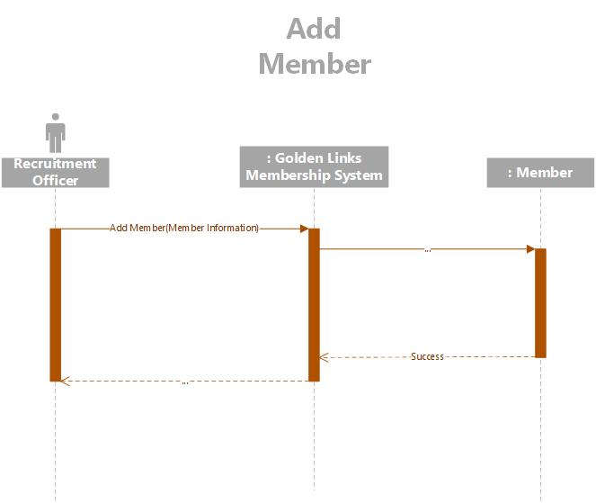

Sequence Diagram

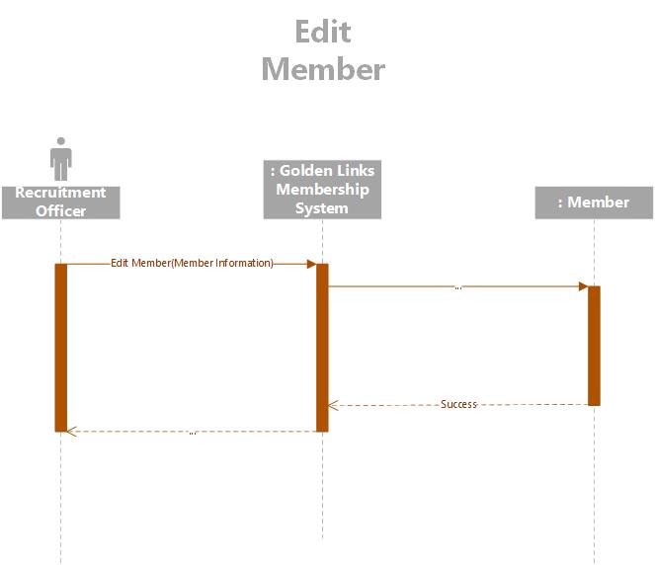

Sequence Diagram

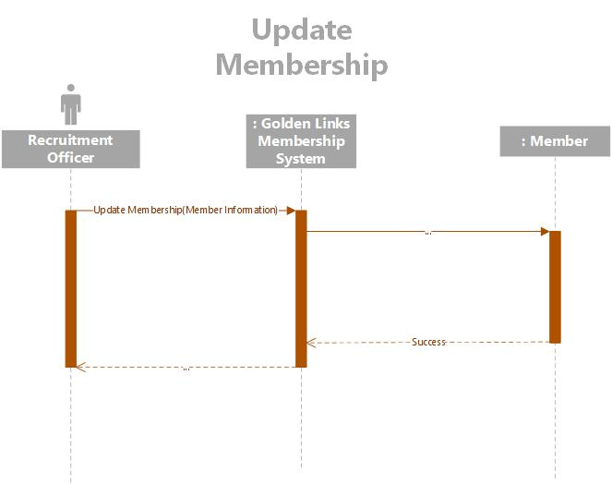

Sequence Diagram

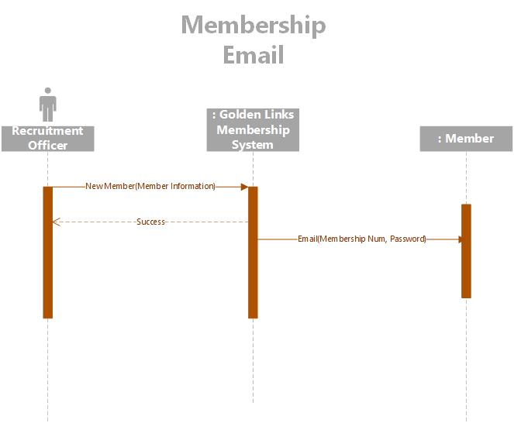

Sequence Diagram

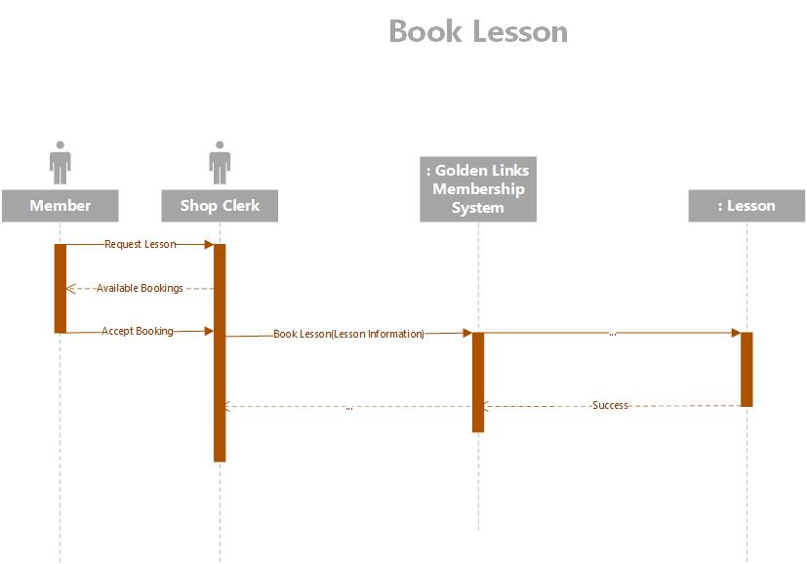

Sequence Diagram

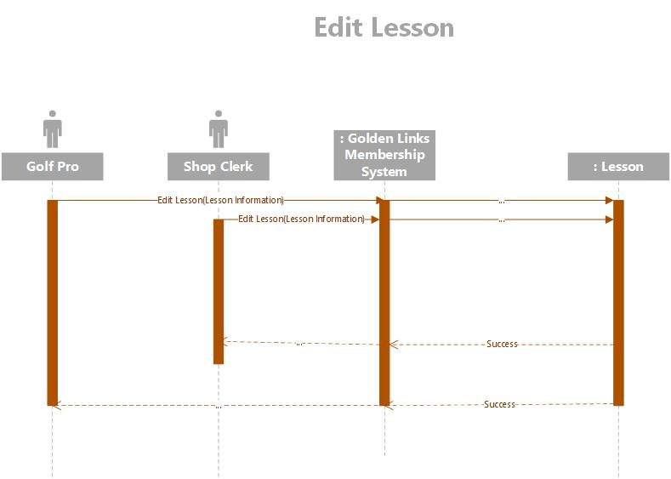

Sequence Diagram

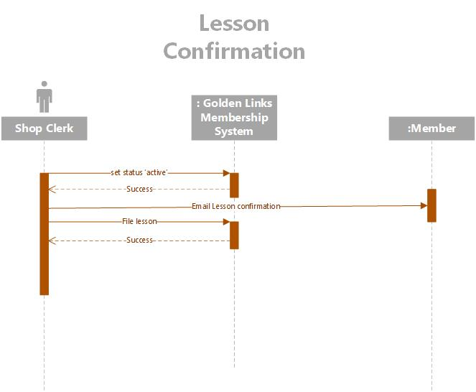

Sequence Diagram

