**An Article on Microservices**



The microservices architectural pattern is a trendy topic and getting high attentions nowadays.

Microservices is a technique through which whole software system is decomposed or make into the small units that can easily be deployed, scaled and tested independently.

Microservices architecture will be more understandable when we compare it with monolithic architecture.

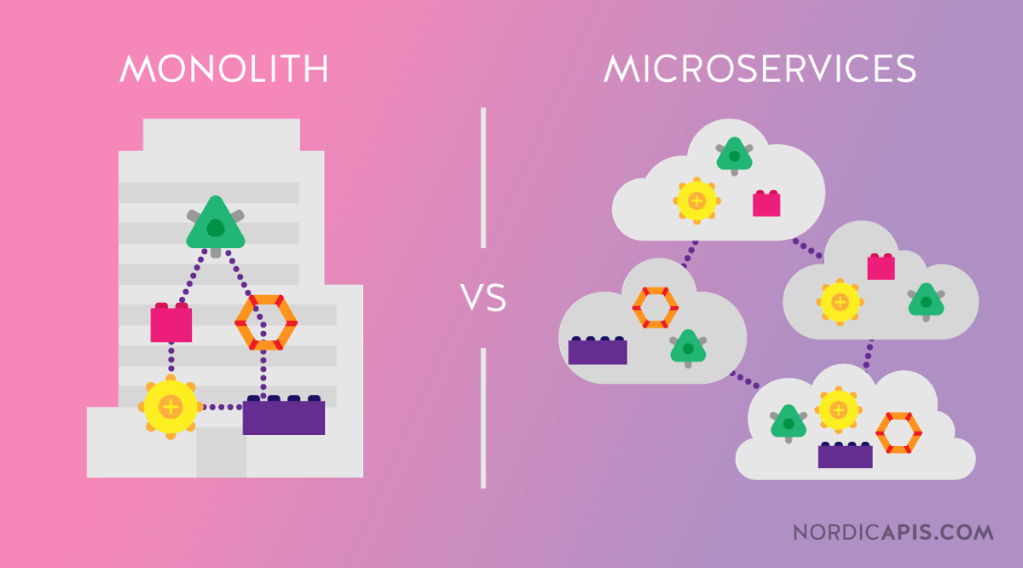

**Monolithic Architecture**

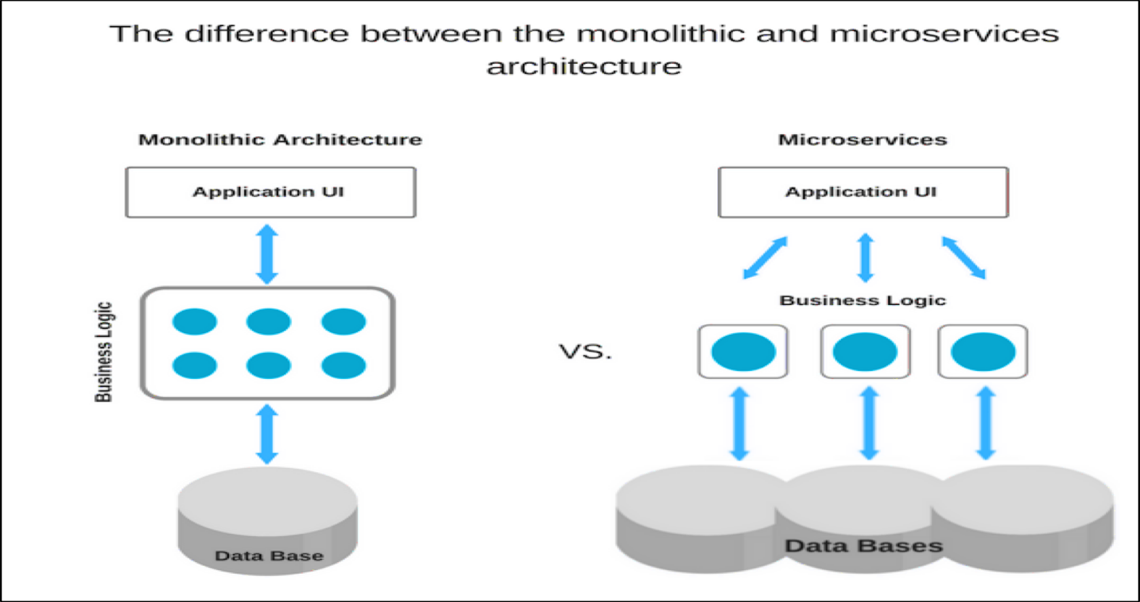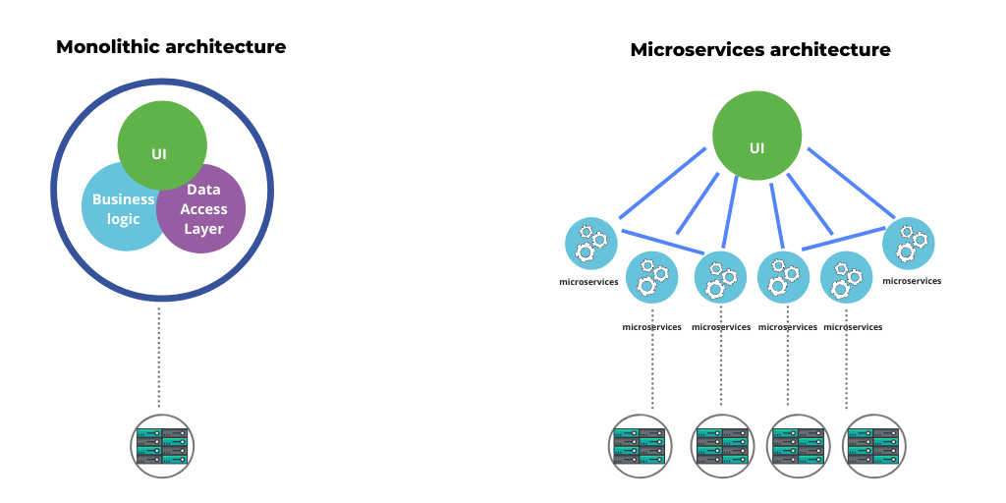

In Monolithic Architecture the entire software is composed of single piece that is designed to be self-contained. It means that all components of monolithic program are interconnected and interdependent where each component along with associated components must be present to execute the process of compilation of code.

There are some disadvantages of monolithic architecture that are defined below:

* As monolithic application grows in size, it become more difficult to do easy and frequent releases due to highly coupled components. Releases takes more time and people to plane. Also, frequent release is risked of breaking the application due to newly release feature.
* In case of larger monolithic application, the deployment time becomes slow and long. For a single change, the entire application needs to be redeployed and this become difficult to frequent deployment and thus obstacle for continuous delivery. So, in order to add new features every time in an application, this is a serious issue.
* It is difficult to manage project and team because It takes a huge time and effort to plan the release and manage tightly coupled interdependent modular development.
* It becomes very expensive to scale a monolithic application.
* It is very difficult to replace a component with another better designed component without effecting the whole application architecture.

**Microservices Architecture**

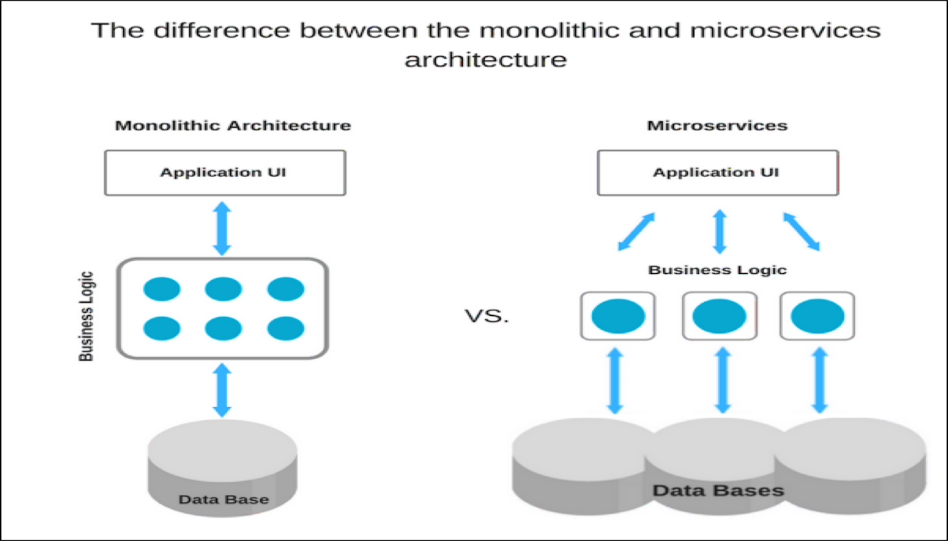

Microservices architecture expresses the setup where application components are standalone application of their own.

The following are characteristics of Microservices architecture:

* Microservices can offer scaling within seconds and can also integrate with third-party services.
* In Microservices architecture different components can be implemented and programmed in different programming language.
* Application can be developed and deploy independently. So, project management become easier.
* A microservice can be deployed by a small team easily.
* In Microservices architecture, required changes made into the particular component, so the entire application does not affect and need to be redeploy.

Along with the advantages, there are some disadvantages of microservices architecture. These are as under:

* In microservices architecture testing and debugging can become complicated because of distributed deployment.
* As the whole application is decomposed into several microservices, it becomes more complicated to handle operation of many components rather than a single component.
* Because of several microservices, it is quite challenging to secure application.

**Conclusion**

Designing and implementing microservices architecture is challenging as compared to monolithic architecture but microservices is better choice for a complex and evolving application. Microservices are useful when the application is very huge and need to be independent for each service. Also, any change can not affect the whole application. It is very useful and handy tool for modern software development. Microservices architecture is very efficient for team to move with new features without disrupting the whole software activities.

Thanks for reading..