FIFO

#include<stdio.h>
int i, j, no_frames, no_ref, flag=0, ref[50], frame[50], pg_fault=0, victim=-1;
void main()
{
printf("\nFirst In First Out Page Replacement Algorithm\n");
printf("\nEnter number of Frames: ");
scanf("%d", &no_frames);
printf("Enter number of Reference String: ");
scanf("%d", &no_ref);
printf("\nEnter the Reference String: ");
for(i=0; i<no_ref; i++)
scanf("%d", &ref[i]);
printf("\nThe given Reference String:");
for(i=0; i<no_ref; i++)
printf("%5d", ref[i]);
for(i=1; i<=no_frames; i++)
frame[i]=-1;
printf("\n");
for(i=0; i<no_ref; i++)
{
flag=0;
printf("\nReference No %d: \t", ref[i]);
for(j=0; j<no_frames; j++)
{
if(frame[j]==ref[i])
{
flag=1;
break;
}
}
if(flag==0)
{
pg_fault++;
victim++;
victim = victim % no_frames;
frame[victim] = ref[i];
for(j=0; j<no_frames; j++)
printf("%5d", frame[j]);
}
}
printf("\n\nNumbers of Page Faults are %d\n\n", pg_fault);
}

OUTPUT

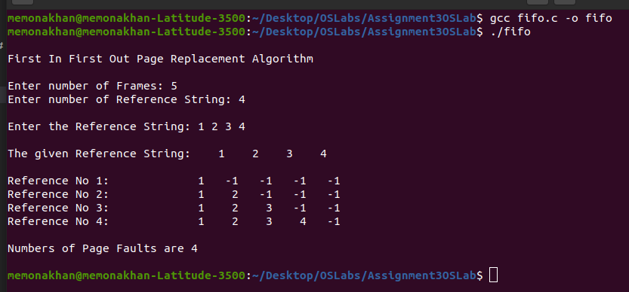

LRU

#include<stdio.h>
int i, j, no_frame, no_ref, flag=0, ref[50], frame[50], pg_fault=0, victim=-1;
int recent[10], lru_cal[50], count=0;

int lru_victim()
{
int i, j, temp1, temp2;
for(i=0;i<no_frame;i++)
{
temp1=frame[i];
lru_cal[i]=recent[temp1];
}
temp2=lru_cal[0];
for(j=1;j<no_frame;j++)
{
if(temp2>lru_cal[j])
temp2=lru_cal[j];
}
for(i=0;i<no_frame;i++)
if(ref[temp2]==frame[i])
return i;
return 0;
}
void main()
{
printf("\nLeast Recently Used Page Replacement Algorithm\n");
printf("\nEnter number of Frames: ");
scanf("%d", &no_frame);
printf("\nEnter number of Reference String: ");
scanf("%d", &no_ref);
printf("\nEnter Reference String: ");
for(i=0;i<no_ref;i++)
scanf("%d", &ref[i]);
printf("\nThe given Reference String:");
for(i=0;i<no_ref;i++)
printf("%5d", ref[i]);
for(i=1;i<=no_frame;i++)
{
frame[i]=-1;
lru_cal[i]=0;
}
for(i=0;i<10;i++)
recent[i]=0;
printf("\n");
for(i=0;i<no_ref;i++)
{
flag=0;
printf("\nReference NO %d \t", ref[i]);
for(j=0;j<no_frame;j++)
{
if(frame[j]==ref[i])
{
flag=1;
break;
}
}
if(flag==0)
{
count++;
if(count<=no_frame)
victim++;
else
victim=lru_victim();
pg_fault++;
frame[victim]=ref[i];
for(j=0;j<no_frame;j++)
printf("%5d", frame[j]);
}
recent[ref[i]]=i;
}
printf("\n\nNumber of Page Faults are %d\n\n", pg_fault);
}

OUTPUT

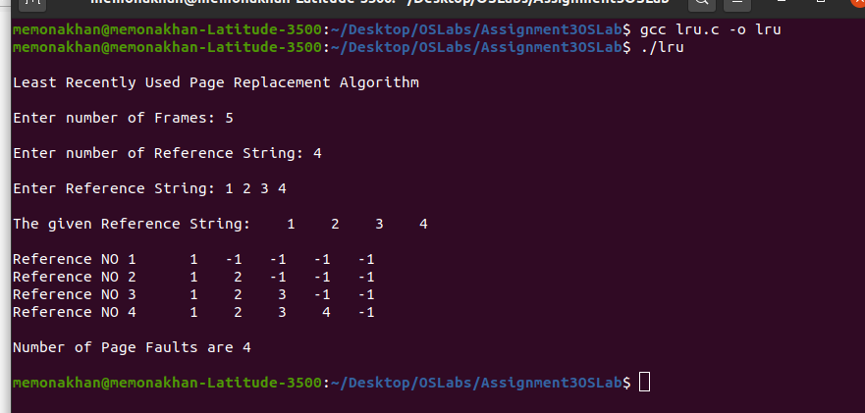

LFU

#include<stdio.h>
int i, j, no_frame, no_ref, flag=0, ref[50], frame[50], pg_frame=0, victim=-1;
int recent[10], optcal[50], count=0;
int optvictim(int index)
{
int i, j, temp, notfound;
for(i=0;i<no_frame;i++)
{
notfound=1;
for(j=index;j<no_ref;j++)
if(frame[i]==ref[j])
{
notfound=0;
optcal[i]=j;
break;
}
if(notfound==1)
return i;
}
temp=optcal[0];
for(i=1;i<no_frame;i++)
if(temp<optcal[i])
temp=optcal[i];
for(i=0;i<no_frame;i++)
if(frame[temp]==frame[i])
return i;
return 0;
}

void main()
{
printf("\nLeast Frequently Used Page Replacement Algorithm\n");
printf("\nEnter the number of Frames: ");
scanf("%d", &no_frame);
printf("Enter the number of Reference String: ");
scanf("%d", &no_ref);
printf("Enter the Reference String: ");
for(i=0;i<no_ref;i++)
scanf("%d", &ref[i]);
printf("\nThe given String: \t");
for(i=0;i<no_ref;i++)
printf("%4d", ref[i]);
for(i=0;i<no_frame;i++)
{
frame[i]=-1;
optcal[i]=0;
}
for(i=0;i<10;i++)
recent[i]=0;
printf("\n");
for(i=0;i<no_ref;i++)
{
flag=0;
printf("\nReference NO %d \t", ref[i]);
for(j=0;j<no_frame;j++)
{
if(frame[j]==ref[i])
{
flag=1;
break;
}
}
if(flag==0)
{
count++;
if(count<=no_frame)
victim++;
else
victim=optvictim(i);
pg_frame++;
frame[victim]=ref[i];
for(j=0;j<no_frame;j++)
printf("%4d", frame[j]);
}
}
printf("\n\nNumber of Page Faults are %d\n\n", pg_frame);
}

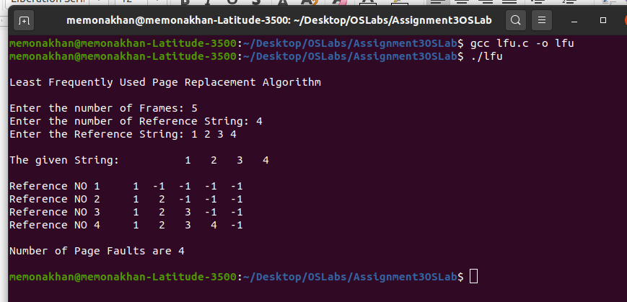
OUTPUT

