Sequential File Allocation Algorithm

#include<stdio.h>
void main()
{
int n,i,j,b[20],sb[20],t[20],x,c[20][20];
printf("Enter number of Files: ");
scanf("%d",&n);
for(i=0;i<n;i++)
{
printf("Enter number of Blocks occupied by File %d: ",i+1);
scanf("%d",&b[i]);
printf("Enter the starting block of file %d: ",i+1);
scanf("%d",&sb[i]);
t[i]=sb[i];
for(j=0;j<b[i];j++)
c[i][j]=sb[i]++;
}
printf("File No\tStart block\tLength\n");
for(i=0;i<n;i++)
printf("%d\t %d \t\t%d\n",i+1,t[i],b[i]);
printf("Enter File No: ");
scanf("%d",&x);
printf("File No is: %d\n",x);
printf("Length is:%d\n",b[x-1]);
printf("Blocks occupied:");
for(i=0;i<b[x-1];i++)
printf("%4d",c[x-1][i]);
printf("\n");
}

OUTPUT

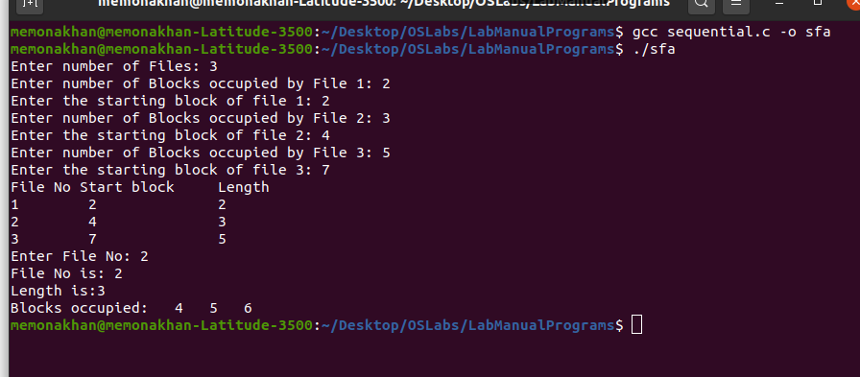

Indexed File Allocation Algorithm

#include<stdio.h>
void main()
{
int n,m[20],i,j,sb[20],s[20],b[20][20],x;
printf("Enter number of Files: ");
scanf("%d",&n);
for(i=0;i<n;i++)
{
printf("Enter starting block of file %d: ",i+1);
scanf("%d",&sb[i]);
printf("Enter blocks occupied by file %d: ",i+1);
scanf("%d",&m[i]);
printf("Enter blocks of file %d: ",i+1);
for(j=0;j<m[i];j++)
scanf("%d",&b[i][j]);
}
printf("\nFile\tIndex\tLength\n");
for(i=0;i<n;i++)
{
printf("%d\t%d\t%d\n",i+1,sb[i],m[i]);
}
printf("\nEnter File No: ");
scanf("%d",&x);
printf("\nFile No is: %d\n",x);
i=x-1;
printf("Index is: %d\n",sb[i]);
printf("Blocks occupied are: ");
for(j=0;j<m[i];j++)
printf("%3d",b[i][j]);
printf("\n");
}
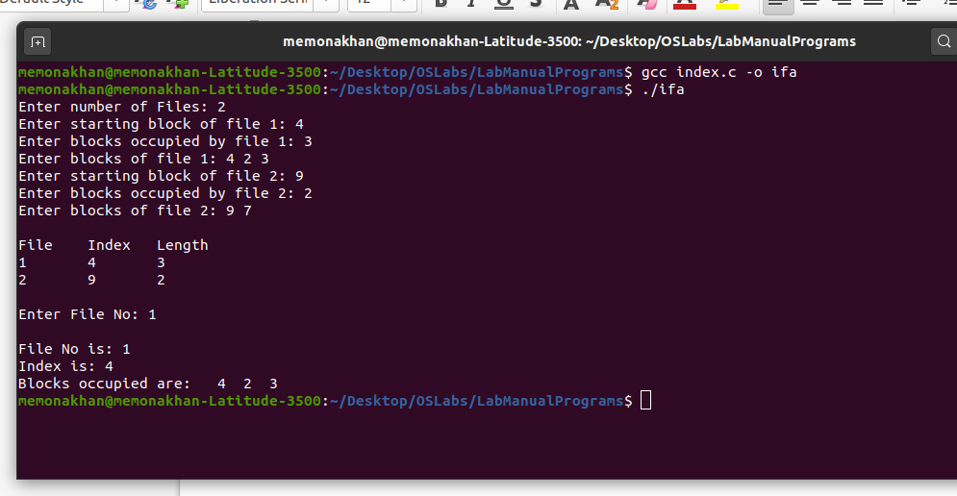
OUTPUT

Linked File Allocation Algorithm

#include<stdio.h>
struct file
{
// char fname[10];
int fno,start,size,block[10];
}f[10];

void main()
{
int i,j,n;
printf("Enter number of Files: ");
scanf("%d",&n);
for(i=0;i<n;i++)
{
printf("Enter File No:");
scanf("%d",&f[i].fno);
printf("Enter Starting block:");
scanf("%d",&f[i].start);
f[i].block[0]=f[i].start;
printf("Enter number of Blocks:");
scanf("%d",&f[i].size);
printf("Enter Block numbers:");
for(j=1;j<=f[i].size;j++)
{
scanf("%d",&f[i].block[j]);
}
}
printf("File\tStart\tSize\tBlock\n");
for(i=0;i<n;i++)
{
printf("%d\t%d\t%d\t",f[i].fno,f[i].start,f[i].size);
for(j=1;j<=f[i].size-1;j++)
printf("%d--->",f[i].block[j]);
printf("%d",f[i].block[j]);
printf("\n");
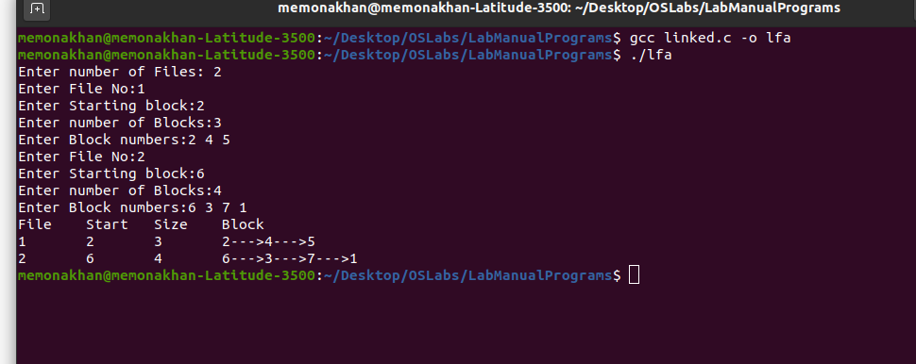
}
}

OUTPUT

MVT (Multiprogramming Variable Task)

#include<stdio.h>
void main()
{
int i,m,n,tot,s[20];
printf("Enter Total Memory Size: ");
scanf("%d",&tot);
printf("Enter number of Pages: ");
scanf("%d",&n);
printf("Enter Memory for OS: ");
scanf("%d",&m);
for(i=0;i<n;i++)
{
printf("Enter size of page %d: ",i+1);
scanf("%d",&s[i]);
}
tot=tot-m;
for(i=0;i<n;i++)
{
if(tot>=s[i])
{
printf("Allocate page %d\n",i+1);
tot=tot-s[i];
}
else
printf("Process p%d is blocked\n",i+1);
}
printf("External Fragmentation is = %d\n",tot);
}

OUTPUT

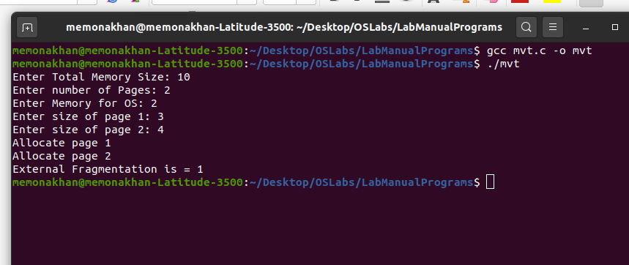

MFT (Multiprogramming Fixed Task)

#include<stdio.h>
void main()
{
int ms,i,ps[20],n,size,p[20],s,intr=0;
printf("Enter size of Memory: ");
scanf("%d",&ms);
printf("Enter Memory for OS: ");
scanf("%d",&s);
ms-=s;
printf("Enter no. of partitions to be divided: ");
scanf("%d",&n);
size=ms/n;
for(i=0;i<n;i++)
{
printf("Enter Process and Process size: ");
scanf("%d%d",&p[i],&ps[i]);
if(ps[i]<=size)
{
intr=intr+size-ps[i];
printf("Process %d is Allocated\n",p[i]);
}
else
printf("Process %d is Blocked",p[i]);
}
printf("total fragmentation is %d\n",intr);
}

OUTPUT

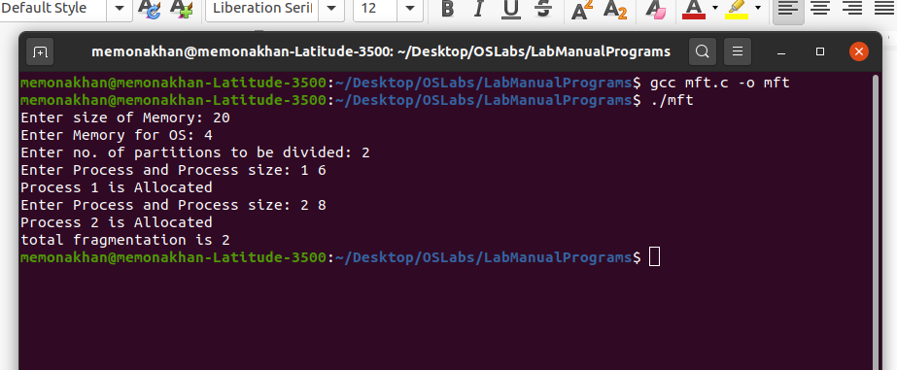

Banker’s Algorithm for Dead Lock Avoidance and Dead Lock Prevention

#include<stdio.h>
struct da
{
int max[10],a1[10],need[10],before[10],after[10];
}p[10];
void main()
{
int i,j,k,l,r,n,tot[10],av[10],cn=0,cz=0,temp=0,c=0;
printf("\nENTER THE NO. OF PROCESSES: ");
scanf("%d",&n);
printf("ENTER THE NO. OF RESOURCES: ");
scanf("%d",&r);
for(i=0;i<n;i++)
{
printf("PROCESS %d \n",i+1);
for(j=0;j<r;j++)
{
printf("MAXIMUM VALUE FOR RESOURCE %d: ",j+1);
scanf("%d",&p[i].max[j]);
}
for(j=0;j<r;j++)
{
printf("ALLOCATED FROM RESOURCE %d: ",j+1);
scanf("%d",&p[i].a1[j]);
p[i].need[j]=p[i].max[j]-p[i].a1[j];
}
}
for(i=0;i<r;i++)
{
printf("ENTER TOTAL VALUE OF RESOURCE %d: ",i+1);
scanf("%d",&tot[i]);
}
for(i=0;i<r;i++)
{
for(j=0;j<n;j++)
temp=temp+p[j].a1[i];
av[i]=tot[i]-temp;
temp=0;
}
printf("\nRESOURCES ALLOCATED NEEDED TOTAL AVAIL ");
for(i=0;i<n;i++)
{
printf("\n P%d \t",i+1);
for(j=0;j<r;j++)
printf("%d",p[i].max[j]);
printf("\t");
for(j=0;j<r;j++)
printf("%d",p[i].a1[j]);
printf("\t");
for(j=0;j<r;j++)
printf("%d",p[i].need[j]);
printf("\t");
for(j=0;j<r;j++)
{
if(i==0)
printf("%d",tot[j]);
}
printf(" ");
for(j=0;j<r;j++)
{
if(i==0)
printf("%d",av[j]);
}
}
printf("\n\nAVAIL BEFORE\t AVAIL AFTER ");
for(l=0;l<n;l++)
{
for(i=0;i<n;i++)
{
for(j=0;j<r;j++)
{
if(p[i].need[j] >av[j])
cn++;
if(p[i].max[j]==0)
cz++;
}
if(cn==0 && cz!=r)
{
for(j=0;j<r;j++)
{
p[i].before[j]=av[j]-p[i].need[j];
p[i].after[j]=p[i].before[j]+p[i].max[j];
av[j]=p[i].after[j];
p[i].max[j]=0;
}
printf("\n P %d \t",i+1);
for(j=0;j<r;j++)
printf("%d",p[i].before[j]);
printf("\t");
for(j=0;j<r;j++)
printf("%d",p[i].after[j]);
cn=0;
cz=0;
c++;
break;
}
else
{
cn=0;cz=0;
}}}
if(c==n)
printf("\nTHE ABOVE SEQUENCE IS A SAFE SEQUENCE\n");
else
printf("\nDEADLOCK OCCURED\n");
}

OUTPUT
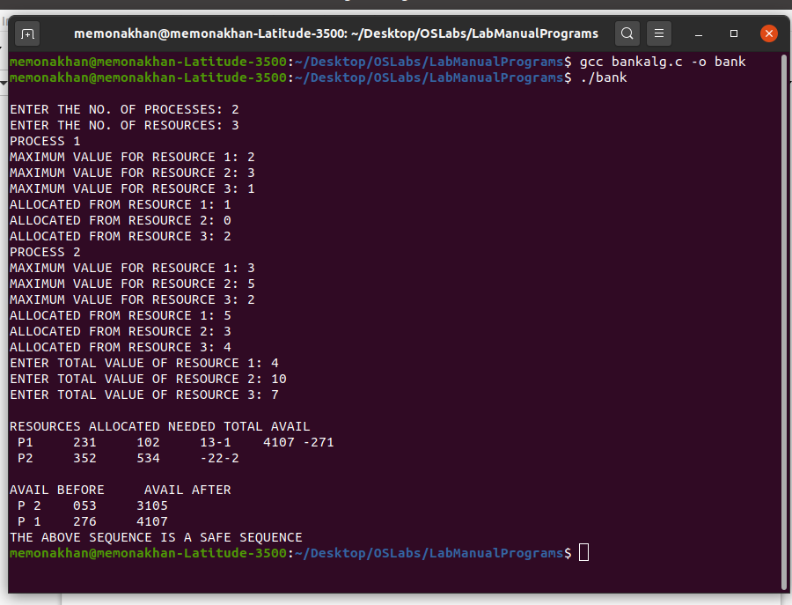

Paging Memory Allocation Technique

#include <stdio.h>
struct pstruct
{
int fno;
int pbit;
}ptable[10];
int pmsize,lmsize,psize,frame,page,ftable[20],frameno;
void info()
{
printf("MEMORY MANAGEMENT USING PAGING\n");
printf("Enter the Size of Physical memory: ");
scanf("%d",&pmsize);
printf("Enter the size of Logical memory: ");
scanf("%d",&lmsize);
printf("Enter the partition size: ");
scanf("%d",&psize);
frame = (int) pmsize/psize;
page = (int) lmsize/psize;
printf("\nThe physical memory is divided into %d no.of frames",frame);
printf("\nThe Logical memory is divided into %d no.of pages\n",page);
}
void assign()
{
int i;
for (i=0;i<page;i++)
{
ptable[i].fno = -1;
ptable[i].pbit= -1;
}
for(i=0; i<frame;i++)
ftable[i] = 32555;
for (i=0;i<page;i++)
{
printf("Enter the Frame number where page %d must be placed: ",i);
scanf("%d",&frameno);
ftable[frameno] = i;
if(ptable[i].pbit == -1)
{
ptable[i].fno = frameno;
ptable[i].pbit = 1;
}
}
printf("\nPAGE TABLE\n");
printf("PageAddress FrameNo. PresenceBit\n\n");
for (i=0;i<page;i++)
printf("%d\t\t%d\t\t%d\n",i,ptable[i].fno,ptable[i].pbit);
printf("\nFRAME TABLE\n");
printf("FrameAddress PageNo\n");
for(i=0;i<frame;i++)
printf("%d\t\t%d\n",i,ftable[i]);
}
void cphyaddr()
{
int laddr,paddr,disp,phyaddr,baddr;
printf("\nProcess to create the Physical Address\n");
printf("Enter the Base Address: ");
scanf("%d",&baddr);
printf("Enter the Logical Address: ");
scanf("%d",&laddr);
paddr = laddr / psize;
disp = laddr % psize;
if(ptable[paddr].pbit == 1 )
phyaddr = baddr + (ptable[paddr].fno*psize) + disp;
printf("The Physical Address where the instruction present: %d\n",phyaddr);
}
void main()
{
info();
assign();
cphyaddr();
}

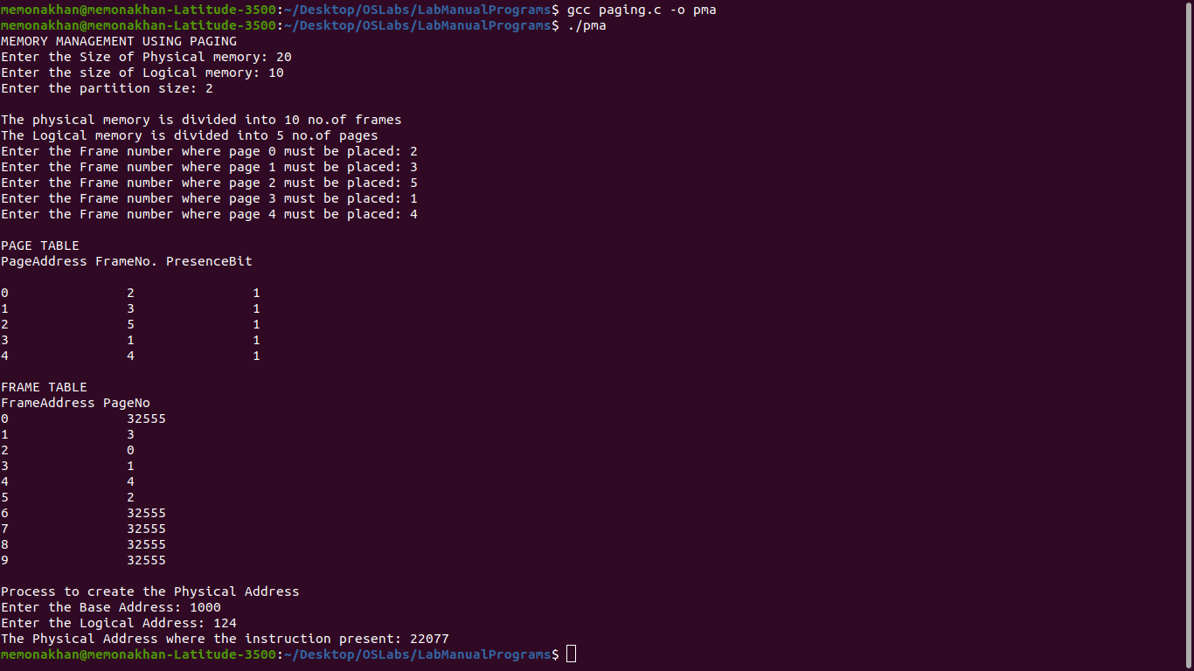
OUTPUT

Segmentation Memory Allocation Technique

#include <stdio.h>
#include <math.h>
int sost;
void gstinfo();
void ptladdr();
struct segtab
{
int sno;
int baddr;
int limit;
int val[10];
}st[10];
void gstinfo()
{
int i,j;
printf("Enter the size of the segment table: ");
scanf("%d",&sost);
for(i=1;i<=sost;i++)
{
printf("Enter the information about segment %d : ",i);
st[i].sno = i;
printf("Enter the base Address: ");
scanf("%d",&st[i].baddr);
printf("Enter the Limit: ");
scanf("%d",&st[i].limit);
for(j=0;j<st[i].limit;j++)
{
printf("Enter the %d address Value: ",(st[i].baddr + j));
scanf("%d",&st[i].val[j]);
}
}
}
void ptladdr()
{
int i,swd,d=0,n,s,disp,paddr;
printf("\n\t\t\t SEGMENT TABLE \n");
printf("\n\tSEG.NO\tBASE ADDRESS\tLIMIT \n\n");
for(i=1;i<=sost;i++)
printf("\t\t%d \t\t%d\t\t%d\n\n",st[i].sno,st[i].baddr,st[i].limit);
printf("\nEnter the logical Address: ");
scanf("%d",&swd);
n=swd;
while (n != 0)
{
n=n/10;
d++;
}
s = swd/pow(10,d-1);
disp = swd%(int)pow(10,d-1);
if(s<=sost)
{
if(disp < st[s].limit)
{
paddr = st[s].baddr + disp;
printf("\nLogical Address is: %d",swd);
printf("\nMapped Physical address is: %d",paddr);
printf("\nThe value is: %d",( st[s].val[disp] ) );
}
else
printf("\nLimit of segment %d is high\n\n",s);
}
else
printf("\nInvalid Segment Address \n");
}
void main()
{
char ch;
gstinfo();
do
{
ptladdr();
printf("\nDo U want to Continue(Y/N)");
flushall();
scanf("%c",&ch);
}while (ch == 'Y' || ch == 'y' );
}

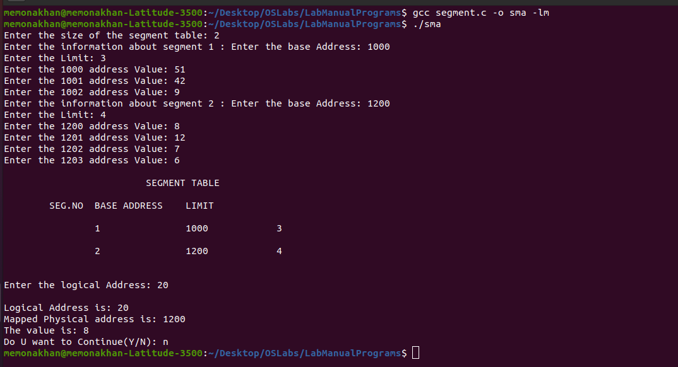
OUTPUT

