FCFS

#include<stdio.h>
void main(){
int i, no_of_process, sum, waiting_time, turn_around_time, total_waiting_time, total_turn_around_time;
int burst_time[10];
float avg_waiting_time, avg_turn_around_time;
printf("Enter number of processes :\n");
scanf("%d", &no_of_process);
for(i=0; i<no_of_process; i++) {
printf("\n Enter the Burst Time of the process %d : ", i+1);
scanf("\n %d", &burst_time[i]);
}
printf("\n\n FIRST COME FIRST SERVE SCHEDULING ALGORITHM \n");
printf("\n Process ID \t Burst Time \t Waiting Time \t Turn Around Time \n");
printf("1 \t\t %d \t\t 0 \t\t %d \n", burst_time[0], burst_time[0]);
sum=0;
total_waiting_time = 0;
total_turn_around_time = burst_time[0];
for(i=1; i<no_of_process; i++) {
sum += burst_time[i-1];
waiting_time = sum;
turn_around_time = sum + burst_time[i];
total_waiting_time = total_waiting_time + waiting_time;
total_turn_around_time = total_turn_around_time + turn_around_time;
printf("\n %d \t\t %d \t\t %d \t\t %d", i+1, burst_time[i], waiting_time, turn_around_time);
printf("\n\n");
}
avg_waiting_time = (float)total_waiting_time / no_of_process;
avg_turn_around_time = (float)total_turn_around_time / no_of_process;
printf("\n Average Waiting Time %4.2f", avg_waiting_time);
printf("\n Average Turnaround Time %4.2f\n", avg_turn_around_time);
}

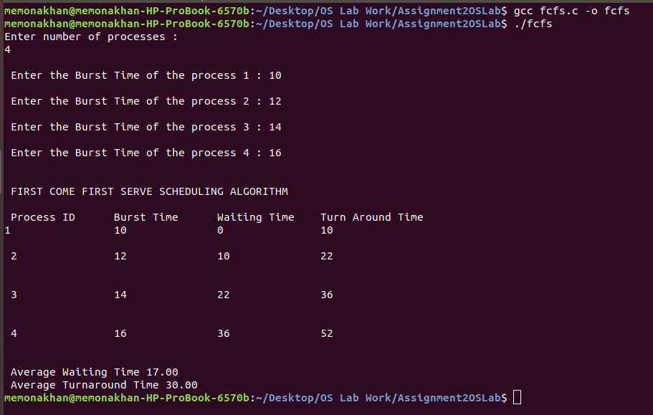

SJF

#include<stdio.h>
void main()
{
int i, j, k, no_of_process, sum, waiting_time[10], turn_around_time[10], total_waiting_time, total_turn_around_time;
int temp, pos;
int burst_time[10], process[10];
float avg_waiting_time, avg_turn_around_time;
printf("Enter number of processes : \n");
scanf("%d", &no_of_process);
for(i=0; i<no_of_process; i++) {
printf("\n Enter the Burst Time of Process %d : ", i);
scanf("\n %d", &burst_time[i]);
}
for(i=0; i<no_of_process; i++)
process[i] = i;
for(i=0; i<no_of_process; i++)
{
pos = i;
for(j=i+1; j<no_of_process; j++)
{
if(burst_time[j] < burst_time[pos])
pos = j;
}
temp = burst_time[i];
burst_time[i] = burst_time[pos];
burst_time[pos] = temp;
temp = process[i];
process[i] = process[pos];
process[pos] = temp;
}
printf("\n PROCESS ID \t BURST TIME \t WAITING TIME \t TURNAROUND TIME \n\n");
waiting_time[0] = 0;
for(i=0; i<no_of_process; i++) {
sum = 0;
for(k=0; k<i; k++) {
waiting_time[i] = sum+burst_time[k];
sum = waiting_time[i];
}
}
for(i=0; i<no_of_process; i++) {
turn_around_time[i] = burst_time[i] + waiting_time[i];
}
for(i=0; i<no_of_process; i++) {
printf("%5d \t\t%5d \t\t %5d \t\t %5d \n\n", process[i], burst_time[i], waiting_time[i], turn_around_time[i]);
}
total_waiting_time = 0;
total_turn_around_time = burst_time[0];
for(i=1; i<no_of_process; i++) {
total_waiting_time = total_waiting_time + waiting_time[i];
total_turn_around_time = total_turn_around_time + turn_around_time[i];
}
avg_waiting_time = (float)total_waiting_time / no_of_process;
avg_turn_around_time = (float)total_turn_around_time / no_of_process;
printf("\n AVERAGE WAITING TIME %4.2f", avg_waiting_time);
printf("\n AVERAGE TURN AROUND TIME %4.2f\n", avg_turn_around_time);

}

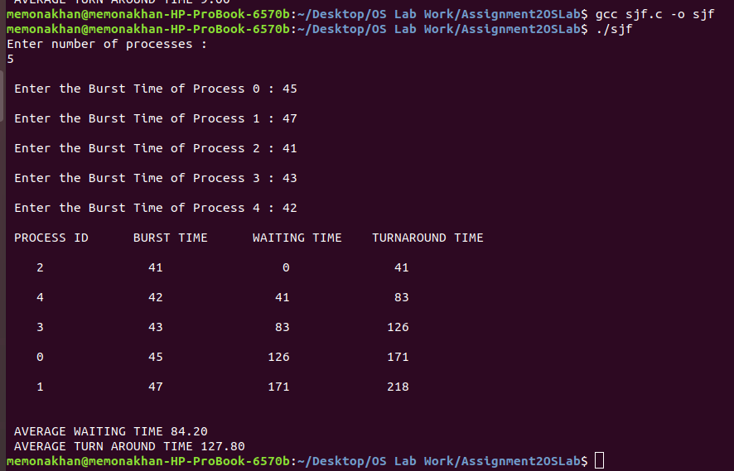

Priority

#include <stdio.h>
void main()
{
int i, j, no_of_process, turn_around_time[10], waiting_time[10], burst_time[10], pid[10], pr[10], temp;
int total_waiting_time = 0, total_turn_around_time = 0;
float avg_waiting_time, avg_turn_around_time;
printf("Enter the Number of Processes: ");
scanf("%d", &no_of_process);
for (i=0; i<no_of_process; i++){
pid[i] = i;
printf("Enter the Burst time of Process %d : ", i+1);
scanf("%d", &burst_time[i]);
printf("Enter the Priority of Process %d : ", i+1);
scanf ("%d", &pr[i]);
}
for (i=0; i<no_of_process; i++)
for(j=i+1; j<no_of_process; j++)
{
if (pr[i] > pr[j] ){
temp = pr[i];
pr[i] = pr[j];
pr[j] = temp;
temp = burst_time[i];
burst_time[i] = burst_time[j];
burst_time[j] = temp;
temp = pid[i];
pid[i] = pid[j];
pid[j] = temp;
}}
turn_around_time[0] = burst_time[0];
waiting_time[0] = 0;
for (i=1; i<no_of_process; i++){
waiting_time[i] = waiting_time[i-1] + burst_time[i-1];
turn_around_time[i] = waiting_time[i] + burst_time[i];
}
printf("\n---------------------------------------------------------------\n");
printf("Pid\t Priority\tBurst time\t Waiting Time\tTurn Arround Time\n");
printf("\n--------------------------------------------------------------\n");
for(i=0; i<no_of_process; i++){
printf("\n%d\t\t%d\t%d\t\t%d\t\t%d", pid[i], pr[i], burst_time[i], waiting_time[i], turn_around_time[i]);
}
for(i=0; i<no_of_process; i++)
{
total_turn_around_time = total_turn_around_time + turn_around_time[i];
total_waiting_time = total_waiting_time + waiting_time[i];
}
avg_waiting_time = (float)total_waiting_time / no_of_process;
avg_turn_around_time = (float)total_turn_around_time / no_of_process;
printf("\n\nAverage Waiting Time: %f\nAverage Turn Around Time: %f\n", avg_waiting_time, avg_turn_around_time);
}

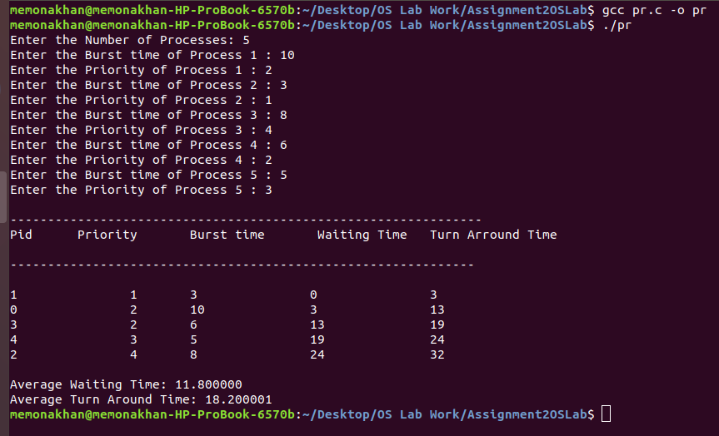

RR

#include<stdio.h>
void main()
{
int quantum, need[10], waiting_time[10], turn_around_time[10], i, j, no_of_process, n1;
int burst_time[10], flag[10], total_turn_around_time = 0, total_waiting_time = 0;
float avg_waiting_time, avg_turn_around_time;
// printf("\t\t ROUND ROBIN SCHEDULING \n");
printf("Enter the number of Processes : ");
scanf("%d", &no_of_process);
n1 = no_of_process;
printf("Enter the Quantum : ");
scanf("%d", &quantum);
for(i=1; i<=no_of_process; i++) {
// printf("\n Enter the process ID %d",i);
// scanf("%d",&pid[i]);
printf("Enter the Burst Time for the process %d : ",i);
scanf("%d", &burst_time[i]);
need[i] = burst_time[i];
}
for(i=1; i<=no_of_process; i++) {
flag[i] = 1;
waiting_time[i] = 0;
}
while(no_of_process != 0) {
for(i=1; i<=no_of_process; i++) {
if(need[i] >= quantum) {
for(j=1; j<=no_of_process; j++){
if((i != j) && (flag[i] == 1) && (need[j] != 0))
waiting_time[j] += quantum;
}
need[i] -= quantum;
if(need[i] == 0) {
flag[i] = 0;
no_of_process--;
} }
else{
for(j=1; j<=no_of_process; j++){
if((i != j) && (flag[i] == 1) && (need[j] != 0))
waiting_time[j] += need[i];
}
need[i] = 0;
no_of_process--;
flag[i] = 0;
}}}
for(i=1; i<=n1; i++){
turn_around_time[i] = waiting_time[i] + burst_time[i];
total_waiting_time = total_waiting_time + waiting_time[i];
total_turn_around_time = total_turn_around_time + turn_around_time[i];
}
avg_waiting_time = (float)total_waiting_time / n1;
avg_turn_around_time = (float)total_turn_around_time / n1;
// printf("\n\n ROUND ROBIN SCHEDULING ALGORITHM \n\n");
printf("\n\n Process \t BurstTime \t Waiting Time \t TurnaroundTime\n ");
for(i=1; i<=n1; i++){
printf("\n %5d \t\t %5d \t\t %5d \t\t %5d \n", i, burst_time[i], waiting_time[i], turn_around_time[i]);
}
printf("\n The average Waiting Time=%4.2f", avg_waiting_time);
printf("\n The average Turn around Time=%4.2f\n", avg_turn_around_time);
}

