FORK EXEC

#include<stdio.h>
#include<unistd.h>
#include<sys/wait.h>

void main()
{
int ret;
printf("Demonstration of Fork/Exec\n\n");
ret = fork();
if(ret>0){
printf("This is Parent process it will Wait \n");
wait(NULL);
}
else if (ret == 0){
printf("Child Process ID: %d \nFork Returned: %d \n", getpid(),ret);
execl("/bin/date","date",(char*)0);
}
}

OUTPUT

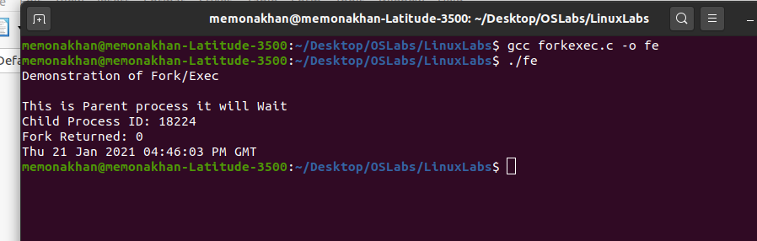

Threads

#include<stdio.h>
#include<pthread.h>
#include<stdlib.h>

int sum;

void *runner(void *param)
{
int upper=atoi(param);
int i;
sum = 0;
if(upper>0)
{
for(i=1;i<upper;i++)
{
sum+=i;
}
pthread_exit(0);
}
}

void main(int argc , char *argv[])
{
pthread_t tid;
pthread_attr_t attr;
if(argc !=2)
{
printf("usage :a.out <integer value> \n");
exit(0);
}
if(atoi (argv[1])<0)
{
printf("%d must be >=0\n" , atoi(argv[1]));
exit(0);
}
pthread_attr_init(&attr);
pthread_create(&tid, &attr, runner, argv[1]);
pthread_join(tid, NULL);
printf("Sum of Numbers (1 to %d) = %d\n", atoi(argv[1])-1, sum);
}

OUTPUT

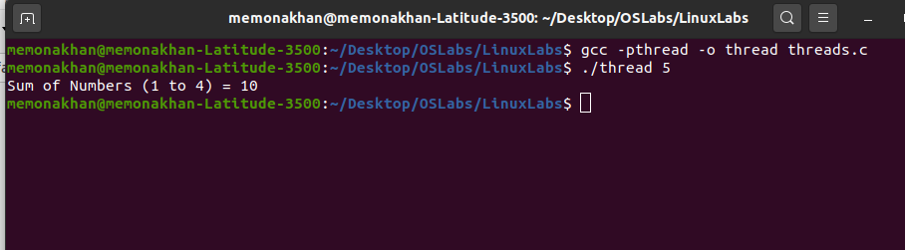

Signals

#include<signal.h>
#include<stdio.h>
#include<sys/types.h>
#include<unistd.h>

void my_function()
{
printf("ALRM Signal Recieved! \n");
printf("Output from My Function \n");
}
void main()
{
signal(SIGALRM,my_function);
alarm(2);
pause();
printf("Signal Recieved\n");
printf("Output from Main Function\n");
}

OUTPUT
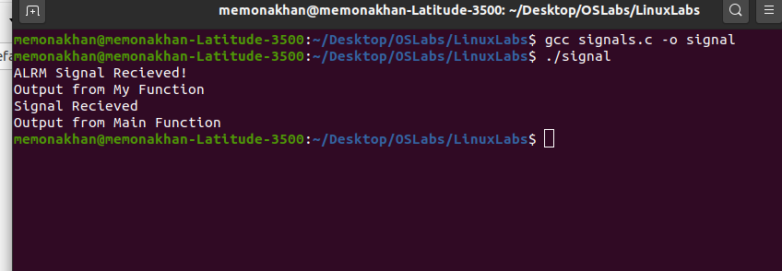

PIPE

#include<stdio.h>
#include<stdlib.h>
#include<unistd.h>
#include<sys/uio.h>
#include<sys/types.h>
#include<sys/ipc.h>
#include<fcntl.h>

void main()
{
int pid,pfd[2],n,a,b,c;
if(pipe(pfd)==-1)
{
printf("\nError in Pipe Connection\n");
exit(1);
}
pid=fork();
if(pid>0)
{
printf("\nParent Process");
printf("\nFibonacci Series");
printf("\nEnter the Limit for the Series: ");
scanf("%d",&n);
close(pfd[0]);
write(pfd[1],&n,sizeof(n));
close(pfd[1]);
exit(0);
}
else
{
close(pfd[1]);
read(pfd[0],&n,sizeof(n));
printf("\nChild Process");
a=0;
b=1;
close(pfd[0]);
printf("\nFibonacci Series is:");
printf("\n%d\n%d\n",a,b);
while(n>2)
{
c=a+b;
printf("%d\n",c);
a=b;
b=c;
n--;
}
}
}

OUTPUT

