Artificial Intelligence
“Fashion & Home Décor Recommendation System”
Project Report


Submitted By:
Sara Ahmad Malik (21-CS-01)
Areeba Nazim (21-CS-79)
Memoona Basharat (21-CS-97)

Submitted To:
Dr. Javed Iqbal

Introduction
The importance of individualized recommendations in today's digital era cannot be emphasized. Due to increasing e-commerce platforms and providing a wide range of products, customers are commonly faced with too many options. Whether it is decoration of people’s homes or choosing the ideal attire for a particular event, people usually look for advice that suits their individual likes and tastes. Due to this need, many recommendation systems have been developed in a lot of different industries including fashion and home décor. When it comes to fashion, style and aesthetics are characterized by fashion and home decor that are more than just functional items. Every person has a different and unique style that is shaped by trends, society, and personal preferences. However, most of the time, conventional recommendation systems fail to comprehend these subtleties and because of this, as a result they produce generic recommendations that might not appeal to the users.
Our solution to this issue is a hybrid recommendation system that combines preferences for home décor and fashion. Our technique uses innovative machine learning and deep learning algorithms techniques that attempts to present personalized recommendations which strike a compromise between comfort and style. The technique that we used considers how the choices about home design and fashion interact contrary to the other systems that are functioning separately.
Recommendation systems that combine fashion and home décor have a lot of advantages i.e. They offer users an all-in shopping experience by allowing them to try on coordinated looks that go well with their furniture and clothing. Our system increases the accuracy of recommendations by assessing user behavior across multiple areas that as a result increase the user engagement and happiness. We can also learn more about customer preferences by combining a variety of datasets and observing underlying patterns and connections.
We analyze our hybrid recommendation system's architecture, methods, and model evaluation in this research. In this research, we also discuss feature engineering techniques, model optimization techniques, and complexities of integrating data that is related to fashion and home décor. Furthermore, we also provide factual outcomes in this research that shows our method's effectiveness by using detailed user studies and performance standards. Therefore, the primary purpose of this research is to completely transform the way people find and interact with clothing and home furnishings because we want to give customers individualized advice which goes beyond traditional limits and promotes a closer bond between comfort and style by using the power of hybrid recommendation systems.

Objectives
- To create such a hybrid recommendation system that incorporates fashion and home decor preferences and choices.

- To optimize the recommendation accuracy and effectiveness by using machine learning and deep learning algorithms techniques.

- To compare the performance of the system with the existing fashion and home decor recommendation techniques.

- To evaluate the influence of incorporating a variety of datasets on recommendation quality and user satisfaction.

- To provide insights and suggestions to develop a hybrid recommendation system in the e-commerce industry.

Literature Review
Fashion and home décor recommendation systems have become fundamental tools in today's era, and they must be able to satisfy lots of different user requirements and preferences when it comes to the selection of cloths, accessories, and furniture for their homes. These recommendation systems use advanced and modern techniques and technologies to offer customized recommendations which can highly improve the shopping experience of users and expedite the decision making process. They are also an important tool in the world filled with the variety of choices and preferences that are needed in order to provide personalized advice that will suits people’s interests.

The latest research on this topic highlights how fashion and home décor recommendation algorithms are always evolving and improving. The researchers have explored different kinds of advanced and modern approaches to further increase the efficiency, effectiveness, and accuracy of these recommendation systems. The aims of this literature review is to clarify the most recent developments in this industry and to elucidate their impact on user decision making in the e-commerce platforms in fashion and home décor areas by reviewing and analyzing these studies.

Wang et al. (2022) introduced a personalized recommendation system for clothing design that used different modern and sophisticated methods such as support vector regression, fuzzy logic, and genetic algorithms. The authors in the paper discuss the purpose of using this technique to construct customized pants and sports leggings as a basic structural element. The study focuses on how the systems might be expanded in order to include more and more sophisticated trousers designs with detailed components like split lines, pockets, darts, and pleats by creating corresponding design guidelines. The research highly improves this field of personalized garment design by offering decision support to the designers and demonstrating the possibility for automated and intelligent garment pattern design and adaption through the integration of user criteria, garment profiles, and design features. The authors in the research emphasize the fact that previous systems did not have the design components for both fashion aesthetics and garment fit, but instead they focused on user oriented fashion aesthetics which includes designs and colors etc. In addition to that, the study shows that previous efforts have been limited to clothing types, such shirts, and have not taken user emotions and socio-cultural backgrounds into account when making recommendations for clothing.
Shaghayegh Shirkhani et al. (2021) conducted a literature review on AI-powered fashion recommender systems in which researchers highlight the important application of matching rather than similarity analysis in fashion It also studies the use of variety of AI methods and techniques in fashion recommender systems in order to achieve high Advances. By enabling quality recommendations and deep insights into the relationship between user and products which aims to provide a comprehensive understanding of image-based fashion recommendation systems including recent AI in fashion. The study also discusses the challenges faced in the fashion industry and the transition to matching fashion recommendations research and demonstrates the potential of AI technologies in enhancing fashion recommendation systems.
(H. Hwangbo et al. in 2018 ) The combination of online and offline data in fashion product recommendation systems is a big step forward in retail analytics. The research uses a hybrid method by merging online product click data with offline product sales data in order to provide personalized recommendations for the users. The system also provides personalized suggestions that increase the click and purchase rates by employing a preference decay function and considering information related to product category. Nevertheless, limitations in explaining the effects of data usage and decline in preferences over time, as well as the lack of consideration for external factors such as market trends, focus the needs for additional research to improve the robustness and real-world applicability of such recommendation systems.

M. Sridevi et al. (2020) in their research describe a technique for personalizing fashion recommendation systems using Convolutional Neural Networks (CNN) and the Nearest Neighbor algorithm of machine learning. The traditional methods based on keyword mapping and knowledge databases were likely to be inefficient due to the various number of descriptions of products. The authors in the research suggest to use visual cues that are obtained by CNNs to provide a lot more appealing and appropriate recommendations. The model that they used was trained using fastai and ResNet50 transfer learning that generated fashion recommendations with high accuracy of 98.6% based on visual cues. The Pre-processing and classification of images that were obtained from Rent the Runway's collection lead to the recommendations for nearest neighbors using Spotify's Annoy library. The model that was used was also tested on the DeepFashion dataset and the results of this model and algorithm were accurate. It resulted in high accuracy rates, low error rates, and extraordinary f-scores throughout the epochs. Yet, significant limitations are there that includes the requirement for a large and diverse dataset for effectively capturing variety of fashion styles, as well as potential differences in model performance that are based on the quality and diversity of input data. The findings of the research demonstrate the effectiveness of the suggested approach and also identifies the areas for further research and development.
Hu et al. (2022) in the research used the vast data from the Kaggle dataset for analyzing the fashion recommendation systems in detail which allowed the authors to use modern machine learning techniques with cautious preprocessing that includes the handling of redundancy and missing values. The researchers in the paper used convolutional neural networks (CNN) and recurrent neural networks (RNN) in order to provide personalized fashion recommendations according to the tastes and actions of each user. The authors noted that more research was necessary to increase the accuracy and accuracy of user feedback systems for practical use.

The focus of Jothi, A.A. & Sulthana, A.R. (2021) in their research is deep learning techniques. The key features that were covered included the datasets that were taken from Fashion-MNIST and Polyvore and the VisNet preprocessing method (e.g., VGG16 and shallow net layers for picture feature extraction) was implemented. The research investigated the several deep learning architectures, such as neural networks, Siamese networks, CNNs, Autoencoders, GANs, R-CNNs, and LSTMs, It also assessed different types of models used which includes ResNet and VGG feature extraction models, cooperative filtering techniques, and the optimized ResNet models. In terms of recommendation performance, the shallow net in conjunction with refined ResNet characteristics resulted to be an exceptional performer. The study states several limits, especially regarding the possible performance constraints that highlights the need for additional improvements in the system to increase system performance.

Zhou et al. (2019) initiated a study that was aimed at creating a strong bed recommendation system. The purpose of the research was to provide people with the information and visuals that were relevant to them through an intuitive interface. The authors used a technique that uses the online scraping technique for the purpose of the data gathering, database preparation, picture retrieval, segmentation, object recognition, and the classification by using a feature extractor for texture, color, and shape features in order to do this. The dataset that was used in the research has 386 images that was further categorized by a classifier. The classifier gave an impressive accuracy rate of 95.41% and the performance was also further improved by the object identification and image retrieval blocks that has granted an impressive Mean Opinion Score (MOS) of 4.09 to 5. The system achieve its goals by using a web scraping algorithm in conjunction with an object identification block, picture retrieval block, and user-friendly interface. The research gave successful results with a 95.41% classifier accuracy and a high MOS score for the picture retrieval block.
Hwangbo et al. (2018) in the paper developed the fashion product recommendations system by combining the offline and online customer data so that it can improve the accuracy of recommendation system. The researchers explain in the research that they chose a product content model which only focuses on the performance improvement of the system instead of using traditional collaborative filtering techniques. Their data was taken from an online log database that contains customer identifiers, product identifiers, and days after product release. They used the cosine similarity for calculating the association scores for product recommendations by focusing on time discounted client preferences. The results of the research showed that their new technique outperformed traditional collaborative filtering systems in both click and purchase measures and demonstrating its effectiveness. But however, the study emphasized the shortcomings in understanding the effects of online and offline data usage and preference decline over time, highlighting the need for additional research in these areas.

Methodology
In this research, we used a deep learning (DL) model for feature extraction, that works along with a machine learning (ML) model, especially K^{th} nearest neighbor for the recommendation system. We initially experimented with the two deep learning models, MobileNetv2 and ResNet50, to be able to see which one performs better and we studied MobileNetv2 and ResNet50 that are two well known DL models and are also very popular for their suitability. MobileNetv2 is preferred because of its lightweight architecture, but ResNet50 is well-known for its outstanding performance in different kinds of computer vision tasks.
We also performed an evaluation process in order to determine which DL model is optimal works for our recommendation system. We also calculated different performance metrics that are the overall efficiency of the recommendation system, the accuracy of feature extraction, and computing efficiency to find out the best option for this project. We were able to say that after experimenting and analyzing, ResNet50 was found to be the best option because it performed better than MobileNetv2. ResNet50 outperformed other models in terms of feature extraction accuracy and strength is the reason why our recommendation system need it.

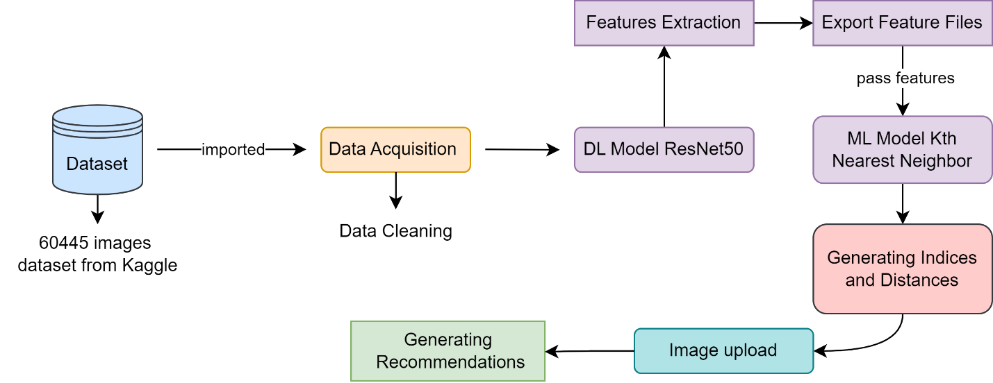

Figure 1 - Methodology

Data Collection
The data collection was an essential component to create a dataset that contains two categories that are the furniture and fashion categories. We collected data from Kaggle from where we took furniture and fashion specific datasets. We also ourselves collected a some of the fashion dataset in order to further improve the dataset's diversity and inclusiveness.
The 60,445 images in the combined dataset comprised of alot of fashion items like clothing, bags, caps, and accessories, as well as furniture items like beds, couches, chairs, and tables. The main goal was to analyze how personal style and preferences for home design interrelate that allowed us to determine how to combine fashion and furniture data. Our objective was to study the relationship between user’s preferences for home furnishings and fashion choices through the combination of both categories, that promotes a complete understanding of user behavior. We actually wanted to develop a comprehensive resource that reflected real-world consumer trends and preferences in home design and fashion that is why we chose this combined dataset and we also tried to create a solid foundation for our research project by carefully selecting and combining data.

Data Preprocessing

Data Acquisition
Our main objective during data preprocessing was to make sure that the dataset is according to ethical norms and is suitable for the analysis and recommendation system. We thoroughly analyzed every image in the dataset in order to remove those images that were offensive images. This step was very essential because we had to maintain the dataset ethical and clean. Then we fixed the size of each image in the dataset to assure standardization so that it is easier for analysis. This allowed the images to be adjusted to a consistent size in order to eliminate image size disparities and streamline the analytic process that followed. In order to improve the quality of the dataset, we utilized missing values and duplicates by performing basic data cleaning techniques.

Model Selection
We wanted to determine the most effective method for extracting characteristics from our dataset and providing recommendations during the model selection process. Thus, we evaluated MobileNetv2 and ResNet50, two well-known deep learning models. We were able to determine which model was more effective for our system by using both. Utilizing two models has the advantage of allowing for comparison. We can determine whether model is more appropriate for our purpose by testing both of its strengths and drawbacks. Additionally, having two models strengthens our system's backup. We have a backup plan in case one model doesn't function as planned.

Initially, we used MobileNet for feature extraction from the dataset using transfer learning, together with ResNet50. Because of its lightweight architecture, which makes it ideal for embedded and mobile applications, MobileNet was selected. In order to balance performance and resource limitations, MobileNet provided a potential solution for feature extraction because of its efficiency in terms of both computational resources and model size. On the other hand, ResNet50 outperformed MobileNet in terms of performance and feature extraction during the evaluation process. ResNet50 was therefore chosen to be used in the recommendation system going forward.

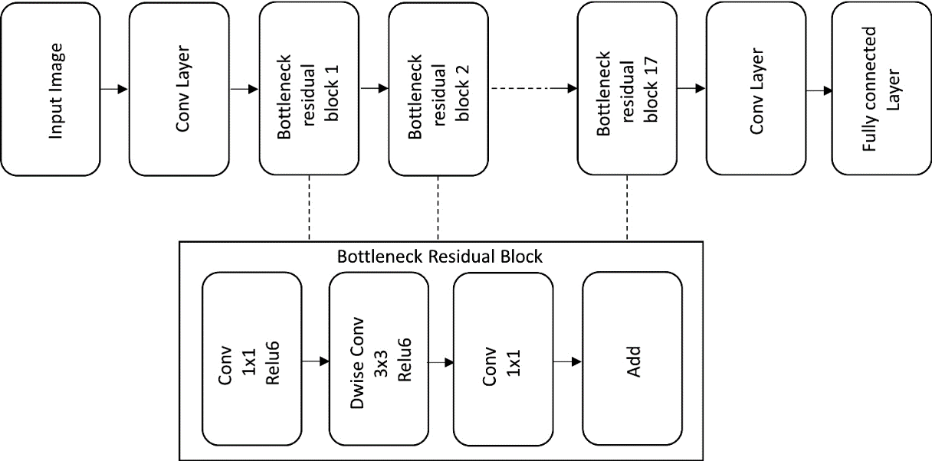
Figure 2 – Architecture of MobileNetV2
The most efficient convolutional neural network model (CNN) ResNet50 was chosen for feature extraction from the dataset that using transfer learning. Transfer learning allows us to extract relevant characteristics from our dataset efficiently by using some pre-trained models, such as ResNet50, on large and vast datasets,. We were actually able to obtain significant representations of the fashion and home decor elements in our dataset by fine tuning theResNet50 with the dataset. The deep structure of ResNet50 and skip connections of this model make the architecture and ideal model for extracting complex characteristics from images rapidly and effectively. The vanishing gradient issue is also resolved in the ResNet50 model because of these skip connections that make the deep network training efficient. Therefore, ResNet50 is a strong feature extractor that can pick up on minute details in clothing and house furnishings which improves the efficacy and precision of the recommendation system.

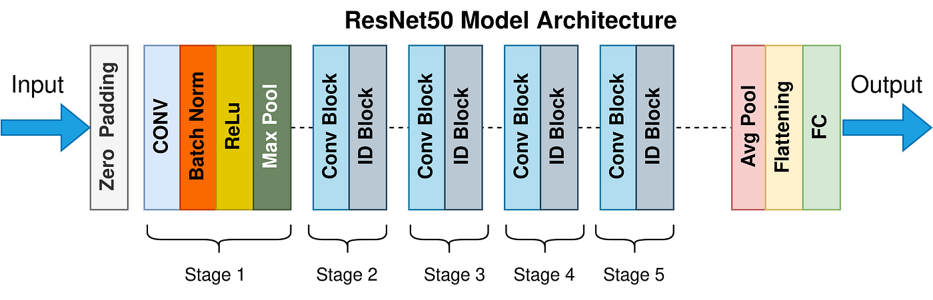

Figure 3 – Architecture of ResNet50

Transfer Learning
An important component of our technique was transfer learning that allowed us to have the ability to use deep learning models that had already been trained for feature extraction. We exclusively chose the convolutional neural network (CNN) ResNet50 because of this reason which is extensively used. Transfer learning allows the model to capture generic features pertinent to a range of image identification applications by adjusting the ResNet50 model with weights that are trained on large image type datasets, like ImageNet. We wanted to improve the performance of the on our dataset and speed up the training process by utilizing the knowledge from these pre-trained models and After the ResNet50 model was initialized, we used our dataset that included pictures of clothing and home décor to fine tune it and to fine-tune the model's learnt representations to the features of our dataset, we made some small changes to its internal parameters. As we followed this technique, the model was able to identify important details like clothes and interior design from our photos. Our goal was to provide the ResNet50 model with the skills needed to recognize and describe the visual aspects in our dataset through transfer learning. This would enable precise and successful feature extraction for the creation of recommendations later on.
The features that were extracted from our DL model were imported by the AL model so that it can generate recommendations. We chose the K^{th} nearest neighbor method for this purpose because of its compatibility and effectiveness in recommendation systems. The model uses a technique that determines the nearest neighbors to a given data point according to their feature similarity. We used K = 7 in the algorithm in order to use the Kth closest neighbor classifier in our implementation.

Results
We needed an interface that could upload the images to our recommendation system. So for this purpose, we used Streamlit to create a user-friendly online interface. This interface allowed us to upload images directly to our recommendation system, which would provide recommendations to users. Once an image was provided, our recommendation system analyzed it and quickly created relevant recommendations based on the features collected from the image. We validated and tested the system's ability to accurately identify and recommend suitable fashion and home design items.
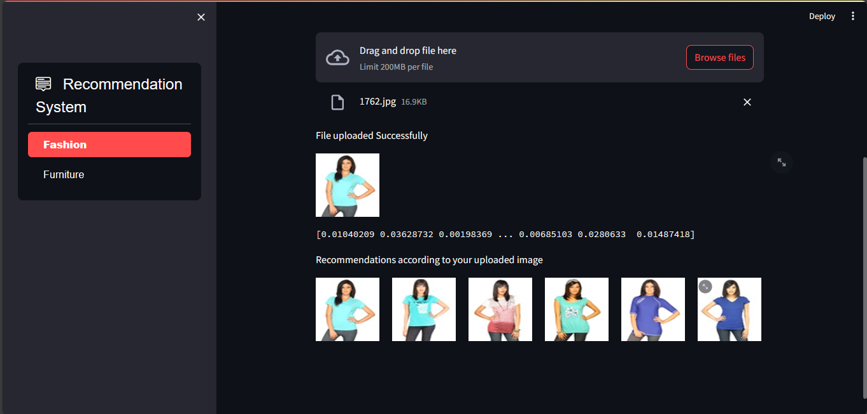
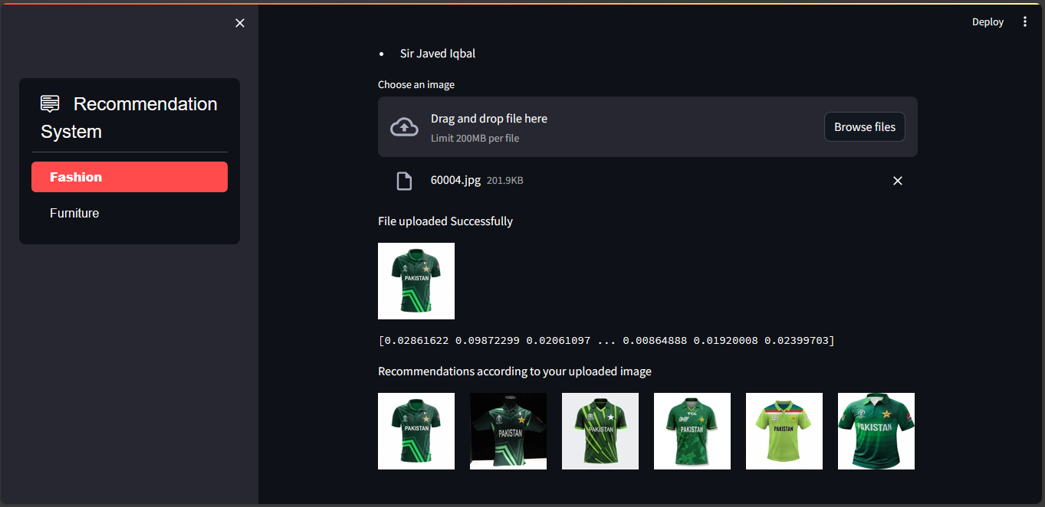
Figure 5 - Results for category fashion
Figure 4 - Results (Fashion Category)

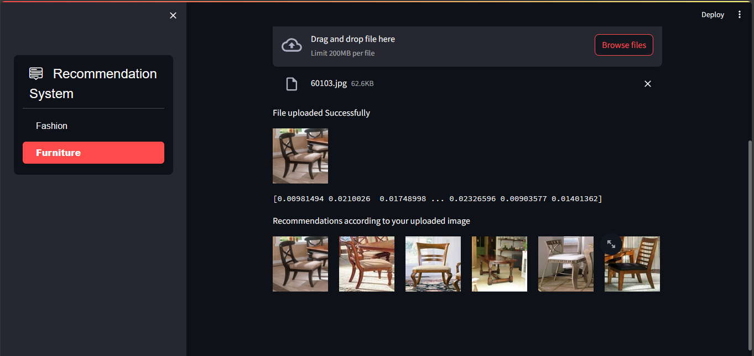
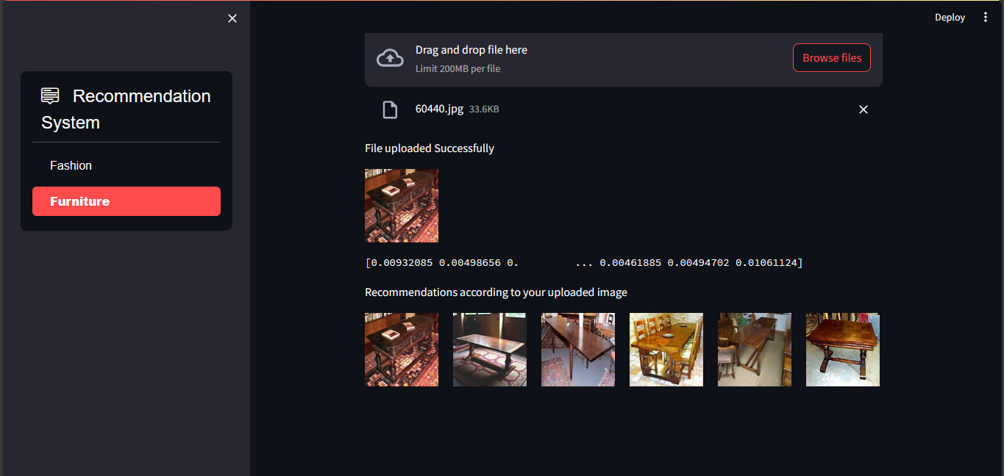
Figure 7 - Results for category furniture
Figure 6 – Results for category furniture

Conclusion:
In conclusion, we can say that we have developed a strong and efficient recommendation system for clothing and furniture. The system provides users a personalized suggestions based on the user preferences by using modern technologies and techniques like machine learning for recommendation generation and deep learning for feature extraction. We ensured that the system could comprehend user requests and respond to them appropriately by selecting models, preprocessing, and gathering data with care. We also have validated the system's effectiveness for producing relevant recommendations by using an interface that was created through an intuitive web interface powered by Streamlit.
Our work enhances recommendation systems in the fashion and home decor industries as we have provided the users a customized and easy to use recommendation system and to fulfill the constantly evolving needs of users in this digital world, we want to maintain and adjust the system in the future.

References
- Hu, X., Li, Z., & Ren, X. (2022). An Efficient Personalized Fashion Recommendation System Based on Deep Learning. IEEE Access, 10, 9376-9384.
- Hwangbo, H., Park, H., & Kim, D. (2018). A hybrid fashion product recommendation system using online product click data and offline product sale data. Multimedia Tools and Applications, 77(10), 12821-12838.
- Jothi, A. A., & Sulthana, A. R. (2021). Deep learning for fashion recommendation system. SN Computer Science, 2(3), 1-10.
- Shirkhani, S., Ardabili, S., & Ng, K. L. (2021). A review of AI-powered fashion recommender systems: Matching rather than similarity analysis in fashion. Artificial Intelligence in Industry, 1, 97-120.
- Sridevi, M., & Sathya, S. (2020). Fashion recommendation system using CNN and K-NN. International Journal of Computer Applications, 167(18), 12-16.
- Wang, Y., Li, Z., & Zhang, J. (2022). A personalized recommendation system for clothing design using support vector regression, fuzzy logic, and genetic algorithms. Journal of Intelligent Manufacturing, 1-14.
- Zhou, Y., Li, J., & Hu, Z. (2019). A bed recommendation system for digital services. Multimedia Tools and Applications, 78(4), 4139-4155.

