JobiVerse: Creating a Smart and Digital Recruitment Ecosystem for Job Seekers and Employers



Authors: -
Sara Ahmad Malik (21-CS-01)
Areeba Nazim (21-CS-79)
Memoona Basharat (21-CS-97)
Supervised By:-
Dr. Farrukh Zeeshan Khan

Department of Computer Science,
University of Engineering & Technology Taxila.
2025

JobiVerse: Creating a Smart and Digital Recruitment Ecosystem for Job Seekers and Employers

Sara Ahmad Malik (21-CS-01)
Areeba Nazim (21-CS-79)
Memoona Basaharat (21-CS-97)



A dissertation submitted in partial fulfilment of the requirements for the Degree of Bachelor’s in Computer Science

Supervisor
Dr. Farrukh Zeeshan Khan

Department of Computer Science
University of Engineering and Technology, Taxila
June 2025

To our Parents
&
The Respected Teachers

Acknowledgement
Praise Allah Almighty, Lord of the worlds, the Merciful and the Beneficent, who gave us strength, thoughts, and cooperative people to enable us to accomplish this goal and fulfil the required functionalities.
This was all not possible without the guidance, continuous appreciation, and moral support of our honourable supervisor, Dr. Farrukh Zeeshan Khan. He was always there whenever we needed his help and advice. We are thankful to him, who made our concepts clearer and helped us a great deal at each step during the implementation of this project.
At last, we would like to acknowledge all the assistance and contributions of the UNIVERSITY OF ENGINEERING AND TECHNOLOGY, TAXILA, for supporting us with all that is needed, starting from the books and ending with the complete care that it is providing us with, to help us to be professionals in the field of Computer Science.

Declaration
We, Sara Ahmad Malik (21-CS-01), Areeba Nazim (21-CS-79) and Memoona Basharat (21-CS-97), at this moment, declare that we have developed the project titled “JobiVerse: Creating a Smart and Digital Recruitment Ecosystem for Job Seekers and Employers” and written our thesis through our efforts.
No portion of this project, report, or work that we present is copied from any other application or thesis of this university or any other university.

Sara Ahmad Malik (21-CS-01)

Areeba Nazim (21-CS-79)

Memoona Basharat (21-CS-97)
Certificate Of Approval
This is to certify that the final year project of BS (CS) 2k21 was developed by Sara Ahmad Malik (21-CS-01), Areeba Nazim (21-CS-79) and Memoona Basharat (21-CS-97) under the supervision of “Dr. Farrukh Zeeshan Khan” and that, in his opinion, it is in scope and is in fully adequacy and quality of the degree of Bachelor of Science in Computer Sciences.
External Examiner

Supervisor
Dr. Farrukh Zeeshan Khan
Computer Science Department
UET, Taxila

Head of Department
Department of Computer Science
UET, Taxila
Abstract
In recent years, the job market has become very competitive, requiring both job seekers and recruiters to go through additional complex steps to find the right match. Job seekers face difficulty while curating ATS optimized resumes, finding jobs according to their expertise and experience and applying at multiple positions effectively. Another issue faced by applicants is not knowing whether their application is being opened or not or what part of the resume’s recruiters interact more. On the other hand, recruiters must sift to thousands of applications to find the right candidate. Existing platforms like LinkedIn, indeed and Glassdoor tried to bridge this gap in the job market but lack the AI-powered tools for efficient job recommendations, automated resume generation and AI-optimized tool for filtering of candidates.
To address these issues, this paper presents JobiVerse, a Software-as-a-Service (SaaS) Web Application designed to reform the recruitment ecosystem by utilizing modern Artificial Intelligence (AI) tools and Machine Learning (ML) technologies. JobiVerse serves as an all-in-one platform that modifies both job seeking and recruitment process by providing AI-powered tools. For job seekers tools like Applicant Tracking System (ATS) friendly resume generation, personalized job recommendation system and real time application tracking are available to make applying for jobs fast and efficient. For recruiters tools like AI-powered candidate filtering to automate candidate screening is available. Moreover, an integrated interviewing system is present to reduce time spent juggling between different platforms.
JobiVerse follows Agile Framework as Development Methodology, ensuring repetitive development with continuous feedback. The platform’s architecture consists of Next.js and Tailwind CSS-based frontend to create modern and responsive interface. While the backend is developed using Express.js and Python to handle the AI-driven tools. My SQL database is utilized to ensure structured data management. The testing phase includes extensive unit, integration and performance testing to guarantee seamless user experience.
The research highlights the usefulness of AI-powered recruitment solutions and their effect on the job market. Future enhancements may include integrating modified AI technology to incorporate sentiment analysis for interview assessments and integrating blockchain-based verification system to enhance authentication process.
Table of Contents
Chapter 1: Introduction 1
1.1. Introduction 2
1.1. Objectives 3
1.2. Problem Statement 3
1.3. Project Scope 4
1.3.1. Candidate Portal Features 4
1.3.2. Recruiter Portal Features 4
1.3.3. Admin Portal Features: 5
1.4. Assumptions and Constraints 5
1.4.1. Assumptions 5
1.4.2. Constraints 6
Chapter 2: Literature Review 7
2.1. Introduction 8
2.2. Literature Review 8
Development Methodology 17
Chapter 3: Requirement Analysis 18
3.1. List of Stakeholders 19
3.2. Requirement Elicitation 20
3.3. Functional Requirements 23
3.4. Non-Functional Requirements 24
3.5. User Case Design and Description 26
3.5.2. Profile Creation 28
3.5.3. Build Resume using AI tool 29
3.5.4. Resume Analysis and Feedback 29
3.5.5. Job Recommendations 29
3.5.6. Post a Job 29
3.5.7. Manage Job Applications 30
3.5.8. Schedule Interviews 30
3.5.9. Conduct Interviews 30
Software Development Lifecycle Model 30
3.6.2. Justification for Selection 31
3.6.3. Phases of the Development Lifecycle Model 31
Chapter 4: System Design 33
4.1. High Level System Architecture 34
4.2. Key Modules of the System 34
4.3. Work Breakdown Structure(WBS) 35
4.4. Activity Diagram 37
4.5. Architecture Diagram 41
4.6. Database Design 44
Chapter 5: System Implementation 46
5.1. Front End Development 47
5.1.1. Core Design Principles 47
5.2. Backend Implementation 59
5.3. AI Module Implementation 63
5.3.1. Job Recommendation System 64
5.3.2. Resume Generator 66
Chapter 6: Testing 69
Unit Testing 70
System Testing 70
User Acceptance Testing (UAT) 71
Test Cases 71
Chapter 7: Conclusion 72
7.1. Challenges Faced and Lessons Learned 73
7.2. Project Summary 74
7.3. Future Work 75
References 77

Table of Figures
Figure 1: Methodology Diagram 17
Figure 2: User Case Diagram 26
Figure 3: Agile Development Model 29
Figure 4: Work Breakdown Structure (WBS) Diagram 33
Figure 5: Activity Diagram of JobiVerse 36
Figure 6: Activity Diagram of User Authentication 37
Figure 7: Activity Diagram for User Onboarding 37
Figure 8: Activity Diagram for Resume Generation 38
Figure 9: Activity Diagram for Video Conferencing 38
Figure 10: Activity Diagram for Job Application 39
Figure 11: JobiVerse Architecture 41
Figure 12: JobiVerse Database Diagram 42

Chapter 1: Introduction

Introduction
The job market has changed significantly in the past few years, with advancements in technology that reshape the recruitment environment. Despite all these advancements and platforms like LinkedIn, indeed and Glassdoor, job seekers and recruiters face numerous challenges throughout the recruitment process. Job seekers often struggle to tailor optimized resumes, get personalized recommendations that align with their skills and expertise and track their applications. Similarly, the recruiters have to sift through thousands of applicants to find the right candidate, making the whole process time and resource consuming and tiring.
Already available job-related platforms’ primary functionality is job listings without providing AI-powered tools that can improve and provide efficiency. Additionally, most of the candidates do not even make it to the interview because their resumes get rejected by Applicant Tracking System (ATS) used by recruiters due to improper formatting or keyword mismatches, causing qualified candidates to miss out on opportunities. The lack of personalized job recommendations aligning with their skills, expertise and career aspirations also add to the frustrations of the job seekers. Lack of AI technology, the recruiters also face number of challenges. Recruiters must go through thousands of applications to get the pool of most qualified candidates.
To address these challenges, this research introduces JobiVerse, a Software-as-a Service (SaaS) web application that utilizes modern AI technology to provide tools to job seekers and recruiters to automate recruitment process. By integrating AI-powered tools like resume builder, personalized job recommendations, automated candidate filtering, interview scheduling systems, JobiVerse focuses on streamlining both job seeking and recruitment process.
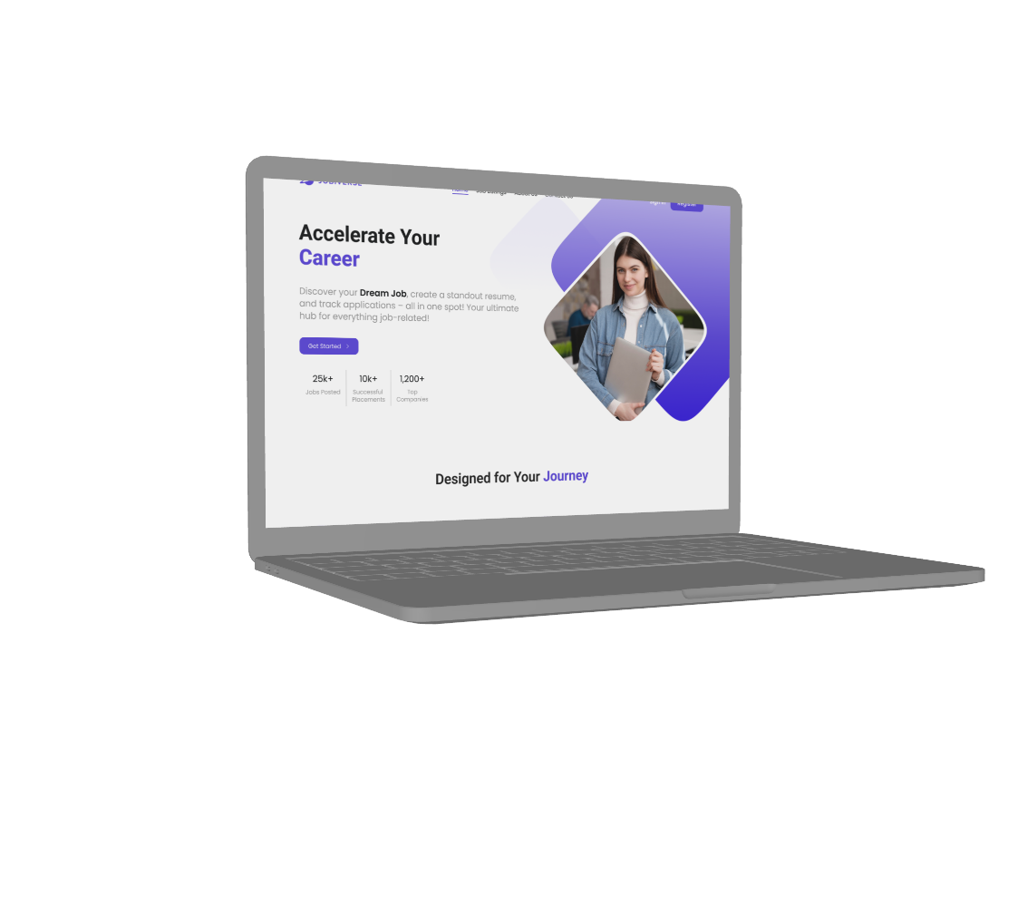
Each figure must have a caption.
Each figure must be discussed and referred to in the text.

Objectives
The main objective of JobiVerse is to develop an efficient and smart digital recruitment platform that utilizes AI and ML technologies to facilitate job seekers and recruiters. The following are some of the specific objectives:
- To develop a centralized hiring platform that integrates AI-powered tools for job seekers and recruiters to facilitate them.
- To automate resume building that generates ATS-friendly and optimized resumes for job seekers.
- To tailor a personalized job recommendation system that uses AI to recommend jobs that align with candidate’s skills, expertise and career goals.
- To improve and streamline candidate screening process by providing AI filtering system for the recruiters.
- To enable real time application tracking system to provide applicants get analysis of their resumes.
- To integrate an interviewing system to schedule and conduct interviews within the platform.
- To enhance the hiring process by speeding up the recruitment process, providing efficient job matching, candidate screening and candidate filtering.
By achieving these objectives, JobiVerse aims to modernize and revolutionize the existing recruitment ecosystem into smart, efficient, fast, streamlined and user-friendly system.

Problem Statement
The present job seeking and recruitment process is time and resource consuming and inefficient, with a lot of challenges faced by both job seekers and recruiters. There are a number of problems faced by the candidates during the whole recruitment process including creating ATS friendly resumes, being unable to find a perfect job match due to lack of personalized job recommendations. Also lack of proper application tracking system for candidates to view the resume analysis. On the other hand, recruiters also face a lot of difficulties like sifting through numerous applications to find the perfect candidates for the job. Also, the traditional screening method that includes human involvement might end up producing results including biases in selection. Lack of all-in-one system for screening candidates, scheduling and conducting interviews makes hiring a tiring process as recruiters have to juggle between different applications. All these challenges point out the need for an AI-powered platform to streamline and simplify each process included in the recruitment process for both job seekers and recruiters.

Project Scope
The scope of the project is to provide an efficient, intelligent and AI-driven recruitment platform that enhances both job seeking and recruitment process.

Candidate Portal Features
JobiVerse have the following features:
- Profile Creation: Users can create detailed professional profiles including skills, education and relevant experience.
- AI-powered Resume Generator: Users can generate ATS optimized resumes within the platform.
- Resume Analysis: Candidates can get their resumes analyzed by AI and get insights on the resume content.
- Personalized Job Recommendations: Candidates will be able to get personalized job recommendations aligning with their skills, experience and career aspirations.
- Application Tracking: Users can track their application and get the application analysis report.

Recruiter Portal Features
JobiVerse provide the following tools for the recruiters and hiring managers:
- Company Profile and Job Posting: Recruiters can create their verified company profiles to post job openings.
- AI-Powered Candidate Filtering: Recruiters have a tool to filter all the applications and create a pool of the most suitable and qualified candidates.
- Integrated Interviewing System: Users can conduct interviews within the platform.

Admin Portal Features:
Admin portals have the following functionality to maintain system integrity:
- User Management System: Ensures that user profile and job postings and verified and accurate.
- Content Moderation: Can remove span and inappropriate job postings made by unverified profiles.
- Account Management: Allows the control over candidate and recruiters account to maintain system integrity.
Technology Stacks
- Frontend: Next.js, Tailwind CSS
- Backend: Next.js, Python
- Database: MongoDB
- Hosting and Deployment: Vercel
Future Scope
- Implement Blockchain for more secure verification of accounts.
- Enhance AI models for sentiment analysis during applicants screening during interviews.
- Develop mobile application version for more accessibility.

Assumptions and Constraints

Assumptions
- The successful implementation of JobiVerse deeply relies on several assumptions:
- Job Seekers and recruiters are willing to adopt AI tools for job seeking and recruitment.
- Organizations will be open to use AI candidate filtering as an alternative of traditional candidate filtering.
- Users will provide accurate, correct and up to date information for efficient job matching.
- All users will have access to a good internet connection for seamless platform operation.

Constraints
Despite JobiVerse’s potential, it faces several constraints
- Technical Limitations: AI models need continuous and regular training and improvement to enhance functionality and accurate results.
- Data Privacy and Security: Handling sensitive user data e.g. resumes, personal details, job applications require proper and robust data protection steps like secure encryption and using strong security protocols.
- ATS Compatibility: The resumes generated within platform must be ATS friendly and fully optimized.
- Scalability: The platform should be able to handle large numbers of users without degradation in the operation.
- Legal and Compliance Issues: Must comply with data protection regulations to ensure ethical usage of platform.

Chapter 2: Literature Review

2.1. Introduction
With changing times, the recruitment and job seeking process is becoming more and more complicated, which has led to significant research into digital platforms that focuses on solving the challenges faced by recruiters and job seekers. Developers as well as scholars have invested their time and resources to explore a broad range of AI-driven tools including automated recruitment platforms, recommendation engines, resume generators, resume optimizers and virtual interviewing systems. All these studies have one goal, that is to make the recruitment process efficient, speedy and accurate to the details. The following review highlights the key contributions of existing literature in the domain of AI powered recruitment systems.

2.2. Literature Review
Automated Hiring Platforms and Recruitment Frameworks
Ajunwa and Greene [1] presented fundamental and important findings in the field of Automated Hiring Platforms (AHPs), highlighting their transformation potential in modern recruitment processes. These platforms focus on enhancing efficiency by automating the intake and evaluation of large number of job applications through standardized procedures. AHPs work by centralizing candidate’s data and applying filtering algorithms for screening to filter the most qualified candidates’ pool immediately, which can significantly reduce the time taken by recruiters to manually filter out applications.
References are usually placed at the end of the sentence.
The authors record that this centralized not only streamline processing speed but also enhances the consistency of hiring process, it also reduces human errors and biases by limiting human involvement. However, such automation must be approached with added caution and care, as algorithms are trained on historical data that can have biased observations made by humans which can reinforce existing inequalities and biases in making decisions. AHPs, according to Ajunwa and Greene[], are not merely neutral tools, they are socio-technical systems whose outputs are shaped by both technological design as well as social context. Hence, these systems require continuous regulatory oversights, transparency and ethical reviews during implementation to ensure equitable and unbiased hiring decisions.
Following on the topics of specialized recruitment systems, [2]Martins et al. (2022) presents a captivating case study within the tourism sector, where hiring process undergoes changes seasonally and require speedy, flexible responses. Their research focuses on the iterative development of a digital hiring platform, designed with the help of industry stakeholders to address domain-specific hiring issues. By adopting a two-stage methodology combining stakeholder interviews along with usability testing, the researchers ensured that the platform was developed in a way that is in accordance with the unique needs of tourism job seekers and employers. Important features of the platform include user-friendly interfaces, integrated profile-job alignment algorithms and streamline workflows for accurate job matching. Most importantly, Martins et al. proposes expanding evaluation criteria for candidate screening by introducing soft skills, such as emotional intelligence, which is an important factor for customer-engaging roles but is often overlooked in automated systems. This advances towards the approach proposed by Ajunwa and Greene that is ethically aware design, highlighting how domain-specific knowledge and user-involvement can facilitate the development of more responsible and inclusive Automated Hiring Platforms.
Expanding the research done in this field, [3]Vijayanand (2024) introduces a Deep Belief Learning (DBL) framework focused on two important HR challenges, first being talent acquisition and second is employee retention, Existing recruitment platforms including the automated platforms lack the functionality of predicting and employee’s long-term success and identifying candidates who are culturally aligned with the organizational values. Vijayanand’s DNL model utilizes Deep Learning technology to analyze both structured data, such as resumes, expertise, experience and performance, metrices, and unstructured data, such as employee surveys and open-ended feedback. This dual analysis approach allows for a more nuanced understanding of employee work patterns, performance and turnover risks. The research highlights that the organizations utilizing DBL saw improvement in hiring accuracy and employee satisfaction. The unique factor of this work is its comprehensive perspective, instead of focusing only on the initial recruitment, the model is designed to support ongoing talent development and talent retention steps. Doing so, it complements the functioning efficiency emphasized by [1]Ajunwa and Greene (2019) and the domain specific functionality explained by [2]Martins et al. (2022), providing a complete and efficient blueprint for intelligent HR ecosystems. Together, these three works shed light on the multi-dimensional nature of AI in recruitment ecosystem, where practical ethical and predictive factors must combine for the development of an innovative digital hiring system like JobiVerse.

AI-Powered Job Recommendation Systems
A continuously changing and evolving domain of AI-powered recruitment is the integration of smart recommendation systems, which focuses on providing personalized job recommendations based on the user’s skills, experience, expertise, preferences, background and historical behavior of user. [4]Upreti et al. (2022) introduces a Machine Learning foundation to modify the traditional job searching portals by looking at more than the generic job listings and providing users with personalized recommendations. This work analyzes the limitations of traditional job listing platforms, which often show users irrelevant or unmatched opportunities not aligning with user’s preferences. By including both collaborative filtering and content-based recommendation models, their work develops job suggestions alignment with user’s education, experience, skills and preferences. The writers also provide a detailed review of the existing Employment Recommendation Systems (ERSs) ecosystem, proposing a need for algorithms capable of adapting to diverse and unique user profiles. Their proposed system of hybrid model combines user preferences combined with role specific content analysis, shows reduction in application time and improvement in candidate-job fit.
Working on the concept of personalized recommendations, [5]Zhao et al. (2023) delve into the transformative role of Large Language Models (LLMs) in recommendation systems. Diverting from the traditional neural networks, which often struggle with elaborateness of human language, LLMs such as GPT provide a refined understanding of user inputs using advanced foundational learning and fine tuning. Their work focuses on the integration of Chain-Of-Thought Prompting and contextual-aware embedding techniques, enabling more flexible and logical recommendations. While their primary focus is more than just recruitment, the techniques highlighted in the study, specially the ability of the LLMs to engage multi step logical reasoning, can remarkably improve the quality of job recommendation systems. For platforms similar to JobiVerse, utilizing the ability of LLMs can help not only with better job matches but also with smarter systems to facilitate users in refining their real time search criteria.
Accompanying the works of [4]Upreti et el. And [5]Zhao et el. about the exploration of LLMs, [6]Hasan and Ferdous (2024) designed a hybrid recommendation system developed for movie recommendations, but it is equally beneficial for the recruitment domain. Their framework employs a combination of cosine similarity for semantic matching and text-to-number conversion to structured and unstructured data item and users. Using the Alternating Least Squares (ALS) algorithm, they recorded high accuracy with a Root Mean Square Error (RMSE) of 0.8951. The authors present the importance of repetitive parameter optimization and suggest incorporation of sentiment analysis as a next step to improve model dependability. While their findings are related to entertainment, the methodologies of hybrid strategy have understandable alignment with the recruitment domain that must consider user intent, role fit and emotional alignment with the recommended job.
Combined these three works emphasize evolving refinement of AI-powered recommendation systems. These researchers present a clear diversion from traditional filtering systems towards the models enhanced by deep contextual understanding and semantic processing, ultimately laying the foundation for intelligent platforms similar to JobiVerse to transform the overall job-seeking experience.
Resume Building, Optimization and Screening
The transformation of the hiring process into digital hiring system has powered advancements in resume generation tools, specifically the AI-powered and Natural Language Processing (NLP) tools. [7]Kale and Andreopoulos (2023) propose a generative resume optimization system that utilizes GPT-2 for tailoring optimized resume content. The framework gets contextually relevant information from the job description, employment history and candidate’s skillset and uses this collected data to generate resumes that are optimized for Applicant Tracking Systems (ATS) and ready for the application. This framework differs from other systems because of its capacity to dynamically customize resumes at scale, improving recruiter engagement and increasing the number of interview calls. By combining language generation with a user-friendly interface, the platform allows users with little to no expertise to tailor optimized resumes. The utilization of NLP in resume generation process ensures resumes are not only well written but also has job specific keywords and structures added, enhancing visibility in automated screening systems. [7]Kale and Andreopoulos’ approach are significantly important for platforms like JobiVerse that integrates intelligent content generation to optimize recruitment process.
Continuing, [8]Mulla et al. (2023) introduce a resume generator that combines document generation with job prediction capabilities. Their system allows users to input their personal information, education information and professional details, which are then given to a multi-step recommendation engine. The engine then preprocesses the data, then it does similarity-based matching, rescoring and sorting data according to user preferences. Even though the tool lacks extensive customization options and availability of multiple resume templates, the system’s practical utility lies in its dual functionality, it not only generates resumes but also suggests relevant available jobs based on user’s profile. This functionality bridges the gap between document generation and job search, modifying the resume from static element to a dynamic job-search facilitator. [8]Mulla et al. ’s tool is free and easy to use, making is helpful for people starting their journey as job seekers or for the institution supporting workforce development. The vision they present aligns with the bigger goal of JobiVerse, which plans to build a platform that interconnects resume building, job recommendation and candidate screening.
Adding an additional layer of innovation to resume processing, [9]Tijare et al. (2023) presents a system for smart resume screening that automates the extraction of resume components and then their classification using advanced AI techniques. Their system employs BERT for name recognition and customized entity tagging, allowing the system to achieve over 90% accuracy in browsing through contact details, education, experience and skillset. This highly précised parsing is very important for large enterprises or recruitment agencies that have to handle thousands of applications. Additionally, the ability of the tool to support multiple file formats and reduce human involvement makes it an ideal system to be integrated with larger AI recruitment ecosystems. With the current system focusing on English language resumes, the authors propose future work on the integration of multilingual support and further refinements in classification. This work emphasizes the importance of AI-powered parsing as a foundational capability for larger platforms like JobiVerse, which have to efficiently process resumes before applying deeper analytics.
[10]Mishra, Singh and Jisha (2024) take a more comprehensive step towards resume analysis by mixing BERT based understanding with job recommendation and feedback system. Their model expands beyond just keyword matching by interpreting the general semantics and contextual relevance between resume content and job descriptions. One of the unique features of their work was its ability to give personalized feedback to users, highlighting mismatches and gaps in resume relative to specific job postings. This feedback provided can help users in refining their documents and upskilling as needed. Moreover, their system includes predictive analytics tools that identifies upcoming job opportunities aligning with the user’s skills and employment history. This not only helps users find immediate opening but also gives them motivation to strategically shape their long-term career paths. Mishra et al. ’s work highlights how AI can enhance the quality of resumes but can also enhance the adaptability of their resume. Their work simplifies the vision of platforms like JobiVerse that seek to unify resume optimization and career growth.
Together the above four research works reflect the modification of resume related tools for static generators to AI-powered and interactive models. They represent a spectrum of capabilities, from GPT-based content generation to BERT-powered parsing and recommendation systems. When integrated, these systems can serve as the technological core of AI-based platforms similar to JobiVerse. These systems not only function as an independent system, but they can work when combined together to offer personalized, real-time guidance and support throughout a user’s job seeking journey.
Fairness, Bias and Ethical Consideration in AI-Based Systems
[11]Chen et al. (2023) presents an important analysis of bias in recommendation systems, highlighting seven primary types and offering and organized taxonomy of debiasing techniques. The work proclaims that as recommendation systems become more integrated into crucial areas like recruitment, the risks associated with biased decision-making become extremely prominent. These issues call for more transparent models and rigorous real-world testing to bridge the gap between conceptual fairness and practical outcomes. Their findings underscore the need for bias-intelligent algorithm design and development, which is important for platforms like JobiVerse that aim to build trust with user base.
[1]Ajunwa and Greene (2019) also addressed these concerns in their work by examining how AHPs can reduce or elevate the workplace inequalities because these models depend on the historical data that can have outcomes of biases. Their work asks for a more regulatory approach toward automation of hiring, ensuring that efficiency does not come at the expense of fairness and equality. Together, these works form a strong basis for ethical considerations in the deployment of AI in recruitment.
AI-Powered Interview Platforms and Candidate Assessments
[12]Sanghavi et al. (2024) presents the SAMRT Interview System, an AI-based recruitment robot with integrated speech recognition technology, NLP and social collaboration tools. The model serves multiple functions:
- It acts as concierge.
- It conducts interviews.
- It also tutors candidates.
Using simulated interviews, it evaluates the candidate’s performance based on user’s performance and also provides real time feedback to the candidate. This multi-functional design shows the potential for AI that can enhance the experience for both recruiters and job seekers enhancing recruiters’ productivity and candidate’s preparation, aligning well with the features for future enhancements of JobiVerse.
Generative AI in Resume Processing and HR Workflow
[13]Tran et al. (2023) focuses on the growing administrative load faced by HR departments by presenting a generative AI-based system for resume analysis. The model automates the process of application screening and job-resume alignment, reducing the time and resources taken by the HRs to sift through thousands of applications. By utilizing natural language generation, the model is capable of providing feedback and highlighting strengths and weaknesses in resumes. This automation frees the HR team to use their time and resources focusing on more strategic functions like candidate engagement and culture fit assessment. The authors focus on the system’s scalability and suggest integration with larger HR systems at enterprise level. Their work focuses on how generative AI can revolutionize backend HR workflows, which is important for long tern scalability of platforms similar to JobiVerse.
Machine Learning Based Job Matching and Resume Analysis
[14]Caro Cortés and Ospina López (2024) propose a machine learning based to solve employment problems in Colombia. Their system hopes to close the gap between job seekers and the relevant job opportunities by integrating the CUOC framework. In order to recommend jobs for the job seekers, the platform uses a mixture of machine learning algorithms like K means clustering to segment the job seekers on the basis of their profile similarities and the K nearest neighbours classifier, deep neural networks, and AdaBoost for accurate matching. These models run alongside natural language processing (NLP) and compliance to the data structure to ensure the same resume content is consistently interpreted and job requirements are met. This approach bears strengths in its wide utilization of both unsupervised and supervised learning models for improving the precision of recommending jobs. Django backed web based system with modular and scalable architecture lends itself to a wide variety of recruitment environment. More importantly, the system aims to make the user experience more personal by grouping similar candidates and using classification algorithms to determine whether the candidates would be appropriate for the role. To further improve match quality, NLP techniques are included to semantic align job postings and resume content. This paper is valuable as it focuses on implementation in a very localized labor market context where tailored AI solution can be used to support employment ecosystems in developing countries. These architecture and methodology are especially suitable for researchers and developers of region-specific intelligent recruitment platforms.
In the paper titled 'AI Resume Analyzer: Towards a scalable, big data powered system for resume optimization', [15]Bhatt et al (2024) put forward the idea of large data powered system built by AI pipeline, which will assist job seekers in optimizing their resumes. Preprocessing and feature extraction on the large volume unstructured resume data is done taking advantage of the MapReduce paradigm as used by the system to handle it efficiently. After preprocessing, KNN classifier is used to determine resume quality and predict suitability for the job. By executing this dual layered approach, we are able to simultaneously achieve structural refinement and smart matching to promote scalability with personalized insights. What is of particular interest about the AI Resume Analyzer is its use of big data techniques with machine learning in an attempt to provide efficient systems that can operate at scale and provide feedback tailored to the user. Besides predicting on how well a resume matches a set of job descriptions given, the system provides practical advice for improvement in resume quality. Some of these include improvements to the formatting as well suggestions from optimizing the keywords to better match industry expectations. Both the authors also underline the flexibility of their model to suggest different job markets and integrate with current recruitment infrastructures. Results from this work highlight the growing value and value of scalable AI systems in the current hiring milieu, especially in venues where diverse organizations must quickly handle thousands of resumes to screen candidates. The goal of focusing on the efficiency and the persona, the AI Resume Analyzer is aligned with objectives of platforms such as JobiVerse, a platform to optimize the hiring pipeline from resume submission to job placement.

The last paragraph or last heading of your literature review must have following things:
- Drawbacks of existing systems
- Identification of Gaps
- How your proposed work is fulfilling the above stated gaps?

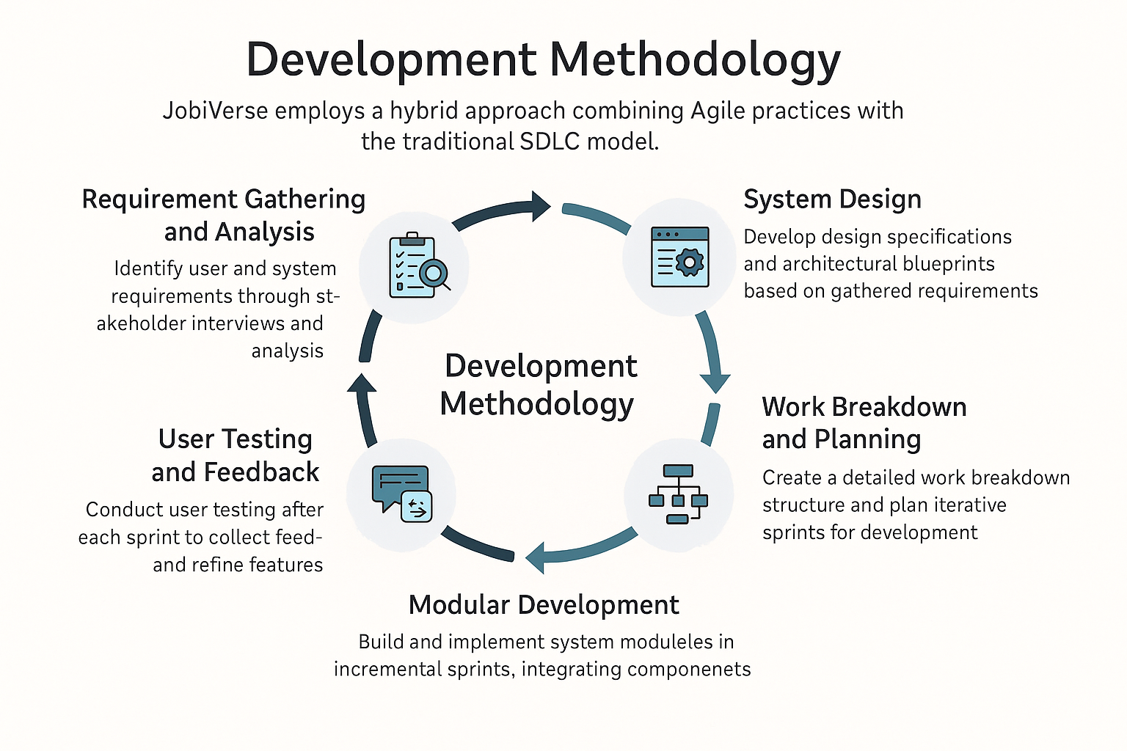
Figure 1: Methodology Diagram

Chapter 3: Requirement Analysis

Requirement analysis phase is of key importance for the definition of what should be achieved (features and scope) and in what context JobiVerse platform will operate. In this phase, the system aligns with the expectations and the needs of all the stakeholders and the system works perfectly in the real world. This phase breaks down user needs in a structured manner that reduces ambiguity and defines the whole picture of design and development in terms of requirements. In requirement analysis, we go through a step of a detailed stakeholder expectations, system functionalities that the system should be able to provide, the constraints but mainly the quality attributes that governs the behavior of the system and the use cases which illustrate how the end users shall come in contact with the system. Each of these elements are outlined in this chapter and bring some clarity to how the work can be done.

3.1. List of Stakeholders
Therefore, the finding of stakeholders is important so that all the user needs and expectations are accounted in the system design. Working in a system, each stakeholder group brings in different perspectives to the system’s objective by which it creates the right feature to deliver effective value. The following are the Clients of JobiVerse:
- Job Seekers:
Primary end users of the JobiVerse platform are Job Seekers. The goal of theirs is to generate a good resume and to get custom job recommendations and track their application progress. To build resumes, receive resume analysis along with AI, use job recommendation systems and feedback tools, they rely heavily on these features. For this group, the system must offer ease of use, accuracy of the recommendations, transparency in application status.
- Employers/Companies:
Employers and companies that Place jobs with JobiVerse to post job vacancies, View profiles of candidates, And Manage the entire process of a recruitment workflow. Their expectations for the platform are that it would provide efficient resume screening tools; intelligent filtering of the candidate for skills match and experience; and efficient communication with applicants. This group needs tools such as job posting modules, recruiter dashboards, as well as automated shortlisting systems.
- JobiVerse System Administrators: Manage JobiVerse platform’s overall backend infrastructure. Their job is to make sure that the platform is available at all times, manage users access and permissions, monitor server’s performance, and finish updating the system. Overall, their requirements are related to maintainability of system, control over user's access to resources, data integrity, and the scalability of the platform.
- AI/ML Engineers: These stakeholders are the AI/ML Engineers that design and optimize machine learning algorithms that power, for example, resume parsing, job recommendations, feedback mechanisms and more. To be able to use it, a Data Scientist needs to have access to a structured and anonymized datasets, ability to be able to run and train AI models and finally Map it to their environment according to the frameworks.
- UI/UX Designers: This group makes sure that the way the JobiVerse platform functions smoothly and engaging for the user. They are responsible for the making wireframes, usability testing and iterating on design based on results. These are all things interfaces should be able to be flexible and consistent, be able to have the same user flow, and be accessible too.
- External Stakeholders: Regulatory Bodies: These external stakeholders make sure that the platform complies with local and international laws relating to data protection and the employment. Concerned mainly about user consent, ethical usage of AI, encrypting the data and ensuring the data is stored properly. The platform’s privacy policies, data processing logic, as well as audit features are driven by regulatory expectations.
Taken together, these stakeholders all make up a cohesive system around the JobiVerse platform. A balance between needs and constraints of each group is achieved through addressing the needs and constraints of each group to make a system that is balanced, functional and compliant thus making the system deliver on its promise of an intelligent and efficient recruitment.

3.2. Requirement Elicitation
One of the most important stages in software development lifecycle is requirement elicitation, which establishes the platform on which system design, functionality, and user experience are based. In the case of JobiVerse, a smart recruitment and job application platform the research stage consisted of a thoughtful combination of qualitative studies, interviews with the key stakeholders, a competitive landscape analysis and persona-based explorations that allowed to draw substance about what is actually important to users.

The main objective of this stage was to find out the pain points, motivations, and expectations of two main user groups that include candidates (job seekers) and recruiters (employers or HR personnel). The requirement elicitation process was based on empathetic and user-centered approach in order to guarantee the final design would suit to reality of job-hunting and hiring processes.
3.2.1. Methods for Elicitation
To obtain the exhaustive requirements of JobiVerse, there was a combination of the following methods:
- User Interviews
Interviews were done on a structured basis on the following:
- There were 10 applicants (working professionals and fresh graduate applicants)
- 5 startup and mid-size company recruiters
- This enabled in-depth interpretations of issues, aspirations and behavioral patterns.

- Questionnaire and surveys
A quantitative survey involving 50+ participants was conducted, which asked questions about areas of pain (resume tailoring, job relevancy, and other application tracking) on a digital platform.
- Competitive Analysis
Well-known networking sites, such as LinkedIn, Rozee.pk, Indeed, and Glassdoor, were also examined to visualize the gaps in features and usability site opportunities, which can be rescued by JobiVerse.
- Personas Empathy Mapping
Personas were elaborated into empathy maps to identify what real users are thinking, feeling, getting frustrated with and achieving. This made this part more humanized.
- Use Case Scenarios
There were some scenarios written to know how the users would use JobiVerse in various modules including resume creation, job searching and to schedule interviews.

3.2.2. Key Insights
The requirement elicitation step has allowed the discovery of the following user driven needs:
For Candidates:
- Candidates can also be found in the job market in terms of their qualifications.
- One of the ideas to create AI-generated personalized job-specific resumes.
- Relevant and valid job suggestions.
- Feedback or status application tracking.
- Centralised resume control.
- Scheduling interview notification and application information updates.
For Recruiters:
- An informative guided portal to post job adverts.
- Intelligent screening of candidates.
- Capability to directly access resumes and short list/reject in an efficient manner.
- Scheduling interviewing tools Integrated.
- This is a systematic overview of prospective interviews and applicant development.
3.2.3. Outcomes
The products of this stage were details of a wide range of:
- Functional requirements (job posting, creation of resumes, track applications and so on)
- Performance, usability, security are the non-functional requirements.
- User flow and stories user
- The basis of system architecture and wireframes as well as UI design choices
These needs informed the development of the whole JobiVerse, hence every module which includes resume writing with the assistance of AI to the recruiter dashboards were all based on the real needs of users.

3.3. Functional Requirements
Therefore, the finding of stakeholders is important so that all the user needs and expectations are accounted in the system design. Working in a system, each stakeholder group brings in different perspectives to the system’s objective by which it creates the right feature to deliver effective value. The following are the Clients of JobiVerse:

- User Registration and Authentication
- The system shall also permit job seekers and recruiters to create individual accounts.
- It shall provide secure login with username/password and will provide optional multiple level of authentication.
- Upon registration, it should assign roles to users (job seekers or recruiters).
- Resume Upload and Resume Builder
- Users shall be able to upload their resumes in the conventional formats such as PDF and DOCX.
- It shall have an AI powered resume builder with input fields whereby all the personal, educational and professional information can be filled step by step.
- It means the builder will permit real time preview, and resume generation.
- Resume Parsing and Analysis
- The key sections of metadata in the resume like contact information, education, work history, skills will be extracted by the system from uploaded resumes.
- It will analyze resumes with NLP to generate the relevance score, the keyword density insight and the optimization suggesting.
- Job Recommendation Engine
- Jobs to users are to be recommended based on skill, experience and user profile preferences.
- AI algorithms shall be used to match personalized and predictive job.
- A dynamical updating of job recommendations to the recommendations based upon user activity and system feedback.
- Job Application Tracking and History
- Users shall be able to apply to jobs directly from the platform.
- Each application status should be tracked by the users (submitted, under review, shortlisted).
- Candidate applications will be viewable by the recruiter and the status of those applications will be updated by the recruiter.

- Recruiter Dashboard and Job Management
- With detailed description and requirements of new job vacancies, recruiters will be able to post new job vacancies.
- Custom criteria will empower them to filter and search through resumes of candidate resumes.
- They need to have access to some analytics around application trends, response rates and hiring results.

3.4. Non-Functional Requirements
These are non functional requirements (NFR) of JobiVerse system. Instead, they concentrate on performance instead of what the system does. These additional characteristics ensure that in case of the software’s reliability, efficiency and functionality change, there won’t be any damages due to the software.
- Performance
- Under normal load, the user actions should cause the system to respond within 2 seconds.
- It has to resume parsing and job recommendation processing in 5 seconds or less.
- Scalability
- It has to be able to scale horizontally as the user base becomes larger, especially during the peak recruitment months.
- This should support cloud based infrastructure under this occasion of spike in the activity.
- Usability
- It should have a consistent user interface across all the devices and screen sizes.
- We are supporting the users with disabilities by following the standard accessibility guidelines WCAG 2.1.
- Security
- When it come to data encryption, all user data should be encrypted in rest and in transit, using industry standard protocols.
- Access should be prevented based on role to the extent possible.
- GDPR and local data protection regulation must be followed by the system.

- Maintainability
- Modular design principles should be followed by this codebase so the updates can be less of a hassle.
- The logs, from System and from Monitoring tools, must be integrated to facilitate troubleshooting and the maintenance.
- Reliability and Availability
- Backup and failover systems should be present on the platform to achieve 99.9% uptime.
- When it happens, scheduled maintenance should be minimal and communicated in advance to users.
These are the functional and non-functional requirements which collectively make sure that JobiVerse is not only feature rich but also highly stable, secure, and should be ready for scaling to a very large level.

3.5. User Case Design and Description
The use case design phase gives the means with a structured and visual way to describe what the user wants from a function point of view. This helps in profiling out how the users would be interacting with different components of the system with a goal. This section contains a summary of tabular form, summarizing all use cases, and then it has detailed descriptions of each use case.
Table 2: Use Case Table
Use Case ID | Use Case Title | Primary Actor | Description
UC1 | User Registration and Login | Job Seeker and Recruiter | Allow users to securely create accounts and access their dashboards.
UC2 | Profile Creation | Job Seeker and Recruiters | Allow users to input their data like Education, Experience, Skills and preferences.
UC3 | Build Resume using AI Tool | Job Seeker | Allows users to build resumes using step by step AI powered template
UC4 | Resume Analysis and Feedback | Job Seeker | Provides relevance scores and improvement recommendations for uploaded resumes.
UC5 | Job Recommendation | Job Seeker | Suggest jobs to users based on their profile.
UC6 | Post a Job | Recruiter | Allow recruiters to post job listings for job seekers to view and apply.
UC7 | Manage Applications | Recruiter | Allow recruiters to view and filter the received job applications.
UC8 | Schedule Interview | Recruiter | Allow recruiters to schedule interviews with short-listed candidates.
UC9 | Conduct Interview | Recruiter | Allow recruiters to conduct online virtual interviews.

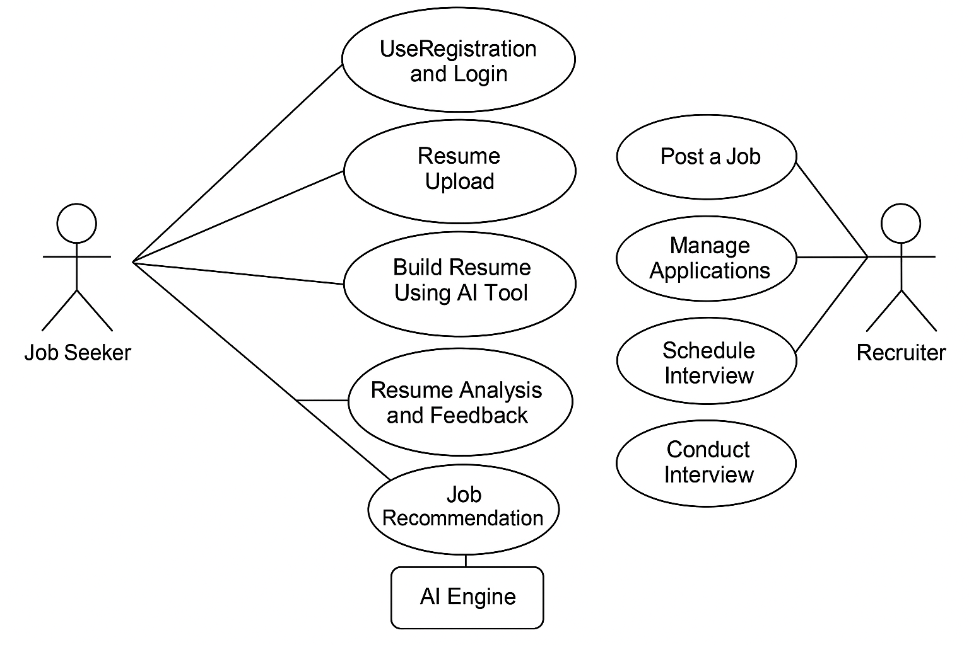
Figure 2: User Case Diagram

    - User Registration and Signup
- Actors: Job Seekers and Recruiters
- Preconditions: User has access to valid email address and internet Connection.
- Descriptions: Allow users to securely create accounts and access their dashboards.
- Postconditions: The user is registered or authenticated and has been given access to their dashboards.

Profile Creation
- Actors: Job Seekers and Recruiters
- Preconditions: User has verified account.
- Descriptions: Allow users to input their data like Education, Experience, Skills and preferences.
- Postconditions: The profile is successfully created.

Build Resume using AI tool
- Actors: Job Seekers
- Preconditions: Allows users to build resumes using step by step AI powered template
- Descriptions: Allow users to input their data like Education, Experience, Skills and preferences.
- Postconditions: An optimized downloadable resume is generated.

Resume Analysis and Feedback
- Actors: Job Seekers
- Preconditions: Resume has either been uploaded or created/
- Descriptions: Provides relevance scores and improvement recommendations for uploaded resumes.
- Postconditions: User receive valuable insights for the resume.

Job Recommendations
- Actors: Job Seekers
- Preconditions: User has completed profile setup.
- Description: Suggest jobs to users based on their profile.’
- Postconditions: Recommended list of jobs.

Post a Job
- Actors: Recruiter
- Preconditions: Resume has either been uploaded or created.
- Descriptions: Provides relevance scores and improvement recommendations for uploaded resumes.
- Postconditions: User receive valuable insights for the resume.

Manage Job Applications
- Actors: Recruiter
- Preconditions: Multiple candidates have applied for the job.
- Descriptions: Allow recruiters to view and filter the job applications received.
- Postconditions: User’s application status has been updated and the recruiter can move forward.

Schedule Interviews
- Actors: Recruiter
- Preconditions: Candidates have been shortlisted.
- Descriptions: Allow recruiters to schedule interviews with short-listed candidates.
- Postconditions: Interview is scheduled and the applicant gets a notification of being short-listed for the interview.

Conduct Interviews
- Actors: Recruiter
- Preconditions: Interview has been scheduled
- Descriptions: Allow recruiters to conduct online virtual interviews.
- Postconditions: Interview has been conducted and the recuiter has gathered the feedback of the candidate.

Software Development Lifecycle Model
The Software development cycle lifecycle or more commonly called as SDLC model, is a set of systematic process that begins with planning, follows by creating, followed by testing, and later by product delivery. The project success depends on how LDLC activities are structured and executed, that is, what of the choice of SDLC model. For this system, resume building, AI analysis, job recommendations and recruiter functionalities, a Hybrid Agile-Waterfall model is chosen.

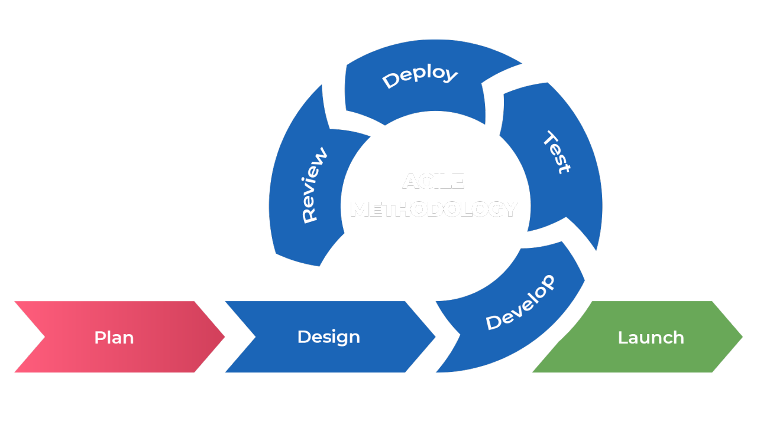
Figure 3: Agile Development Model
Adjust all the captions of the figures like this.

3.6.2. Justification for Selection
- Defined from Beginning: Some of the functional and non functional requirements are clearly defined from the beginning (e.g. registration, job posting).
- Iterative UI Development: As many product features like the resume builder and the feedback system are user-centered, they need iteration improvement based on user feedback.
- Parallel Development: Backend logic (e.g., resume parsing, AI analysis) is parallel to backend with resumed features developed in sprints.
- Agile iterations: agile iterations allow job seekers and recruiters to give feedback quickly.

3.6.3. Phases of the Development Lifecycle Model
- Requirement Gathering and Analysis
- It was conducted by using competitive analysis, system analysis, and stakeholder interviews.
- Through use cases, functional specifications as well as non functional requirements.
- System Design
- Architectural diagrams, design documents and data flow diagrams are created.
- Wireframing and prototyping tools are used to prepare UI/UX mockups of both a job seeker’s and a recruiter’s experience.
- Implementation (Agile Sprints)
- Each module is listed as such as Authentication, Resume Builder, Job Posting, etc.
- Each sprint works on a set of features by unit test and sprint review.
- Testing
- Unit Testinng: Individual modules are tested in isolation, which is Unit Testing.
- Module Interaction: Tests to check that modules function together.
- System Testing: Complete end-to-end testing.
- Feedback given out to a set of users chosen for review.
- Deployment
- The system is tested successfully, and deployed on a staging server for final validating using the same failure symptoms.
- It is once approved, released with continuous integration pipelines to the production.
- Maintenance and Updates
- Regular maintenance cycles are planned.
- Continuous updating of the system based on the user feedback and changing technologies is made sure using agile iterations.

Chapter 4: System Design

In software development, system design is a very important phase of designing how the system will be made, structured and implemented. It turns specified functional and non functional requirements obtained in the requirement analysis phase into a detailed technical plan. This chapter presents the system architecture, the key modules; component interaction; and how the different constituents of the JobiVerse platform come together.

4.1. High Level System Architecture
The JobiVerse platform is based on the three-tier system architecture:
- Presentation Layer: The front end development using up to date frameworks like Next.js to create user friendly interface.
- Application Layer: The backend services including user authentication, resume parsing, recommendation system and user management is implemented using Express.js and Python.
- Data Layer: a relational database My SQL is used for structured and unstructured data.

4.2. Key Modules of the System
- User Management Module: Manages user registration, login and authentication.
- Resume Management Module: Handles resume parsing, resume creation and resume analysis.
- Recommendation Module: Utilizes AI/ML models to recommend users with relevant job opening.
- Job Management Module: Enables the recruiters to post a job, receive and manage application.
- Interview Scheduler Module: Allows recruiters to schedule and conduct interviews of the shortlisted candidates.
- Admin Dashboard: Allows administrators to oversee the function of the platform.

4.3. Work Breakdown Structure(WBS)
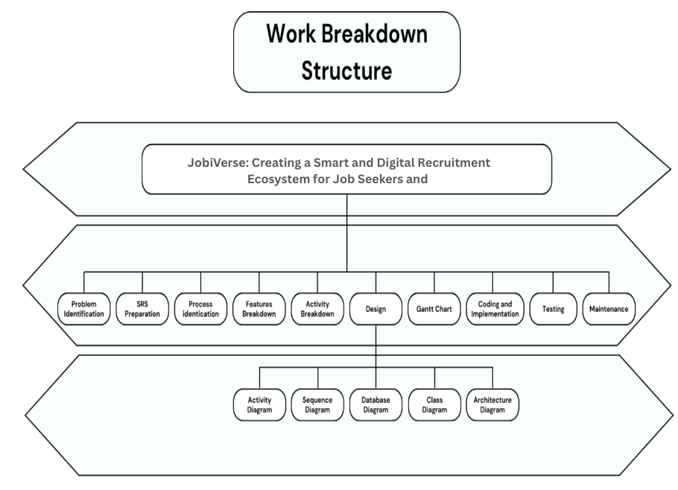
Figure 4: Work Breakdown Structure (WBS) Diagram
- Problem Specification
The JobiVerse is founded by such gap in job hunting and hiring ecosystem. Currently there were no AI powered, simple and user friendly interface for both job seekers and employers in existing platforms. In this phase, we did thorough analysis of the pain points of the user, which included finding irrelevant job matches, browsing outdated resumes and communication between the recruiter and candidates is not happening in real time.
- SRS Preparation (Software Requirement Specification)
The document for the SRS for JobiVerse was made meticulously in order to capture all the functional and non functional requirements of the system. They include (user roles, job seekers, recruiters, admins), (features: resume builder, job postings, analytics) and system constraints. It was a contractual base between stakeholders and developers that everyone is on the project scope and expectation.
- Process Identification
This helped us in process identification and defining core workflows of the application, namely account creation, job recommendation algorithms, resume analysis, job application tracking and interactions between the employer and the candidate. They mapped out these processes in a logical sequence and did the groundwork for a robust system which guarantees user satisfaction and the platform efficiency.
- Feature Breakdown
Each major feature of JobiVerse was further divided into sub features. In doing so, the ‘Resume Builder’ was subdivided into template selection, AI analysis, editing tools, and export options. “Skill based recommendations,” “location filters” and “role specific alerts” made up of “Job Matching”. It was useful for better planning, resource allocation and development in a modular fashion.
- Activity Breakdown
In this phase, tasks involved in developing each of the modules were broken down. For instance, on the ‘Resume Builder’ module, we did UI design, had to integrate AI, backend storage, and tests with it. The team could estimate time and effort required for each segment by listing down the activities involved and streamline development as well as manage dependencies better.
- Design
In this phase, each task associated with the development of the modules was broken down. On the ‘Resume Builder’ module, we did the UI design, integrated AI, backend storage, and tests along with it. This helped the team to list down the activities involved for each segment and determine that only how much time and effort will be required for developing each segment, as well as improving development cycle as well as managing dependency better.
- Coding and Implementation
The development phase involved writers who implemented code following the accepted design models and project demands. The teams operated simultaneously using Git for version tracking while deploying Agile for sprint management purposes. API development helped different system modules connect efficiently while security standards were implemented during initial development activities.
- Testing
After implementing core functionalities the team performed full-scale testing protocols. A thorough testing process was conducted that included unit testing together with integration testing and finally user acceptance testing (UAT). The testing team used automated and manual testing tools for to detect any possible glitches while confirming system performance consistency on different devices under various user circumstances.
- Maintenance
System reliability became the focus during maintenance after deployment occurred. The maintenance activities included periodic updates of the system alongside performance improvements along with bug repairs and support assistance for users.

4.4. Activity Diagram
System modeling benefits greatly from the activity diagram because this graphic technique displays the path which control and activities move through a system. Within JobiVerse, the activity diagram illustrates the system interactions between users who include job seekers and recruiters during their system use from login to key functions like posting vacancies and job application.
The activity diagram helps users understand system behavior while identifying all user interaction paths with decision points and parallel activities and process synchronization requirements. The diagrams establish a crucial link between user needs depicted in use cases and the resulting technical structure.
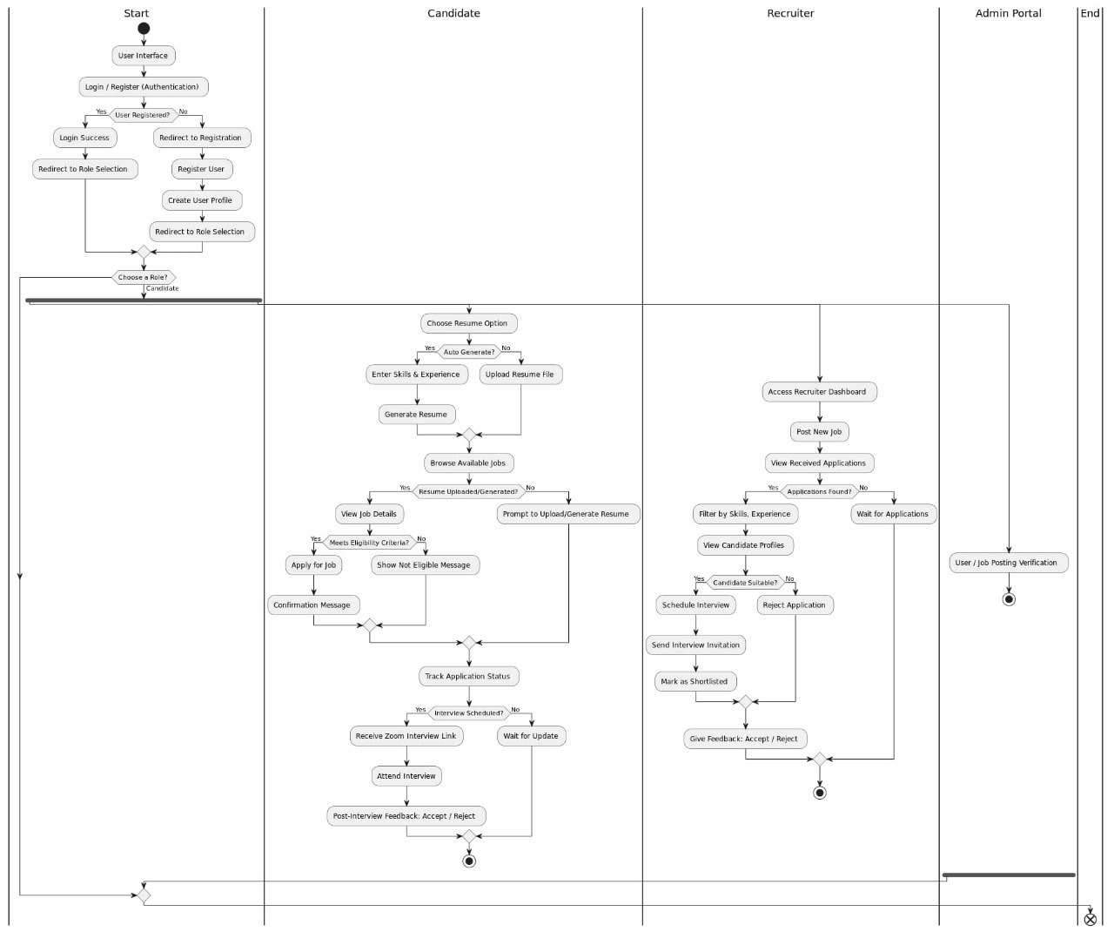
Figure 5: Activity Diagram of JobiVerse

All figures must have text descriptions. And must be referred to in the text.
Usually, the text of the figure is close to the your actual text, so that figures are viewable/readable. Make changes in all figures which aren’t readable.

- User Authentication
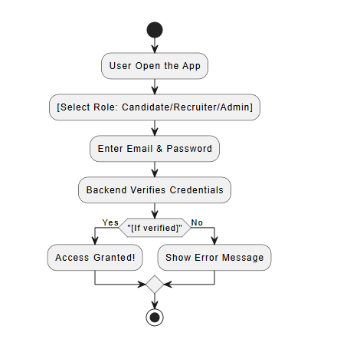
Figure 6: Activity Diagram of User Authentication
- Onboarding
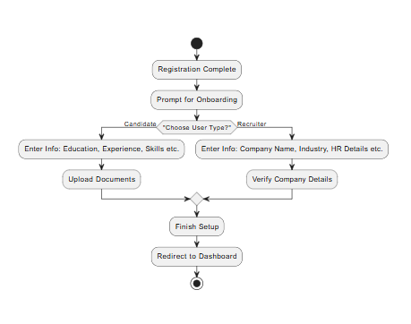
Figure 7: Activity Diagram for User Onboarding
- Resume Generation
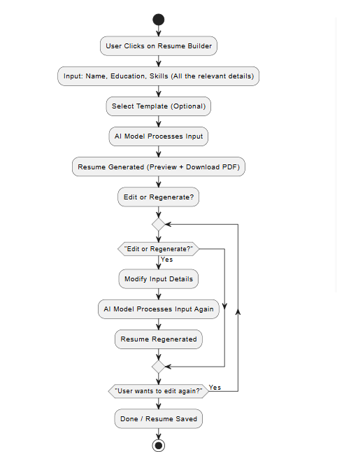
Figure 8: Activity Diagram for Resume Generation
- Video Conferencing
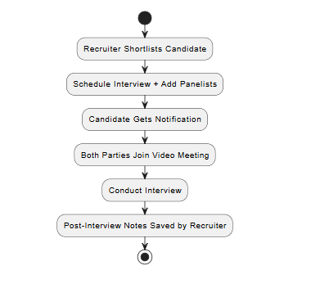
Figure 9: Activity Diagram for Video Conferencing
- Job Application
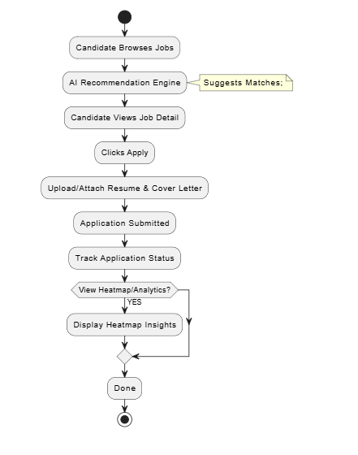
Figure 10: Activity Diagram for Job Application

4.5. Architecture Diagram
JobiVerse is created to provide a simple and smart job-matching experience by means of clearly outlined layers:
- There are Job Seekers, Recruiters and Admins who perform actions in the system.
- Next.js was selected allowing a modern and responsive Frontend interface to exist, built around Tailwind CSS, delivering an improved job search, resume creation, and recruiter dashboard interfacing.
- The Backend, which relies on Next.js, Python, and uses the Gemini API, is in charge of business logic and facilitating the communication between the frontend component and the AI component.
- AI Modules There are:
- Gemini LLM to create a resume
- TF-IDF and cosine similarity based job Recommendation
- Feedback and advice through resume Analysis
All the information is safe on a centralized Data Storage level, which is optimized on the resume data, job listings, and user profiles.
Data Sources Data Sources provide the system with real-time and unchanging data sources like job listings, user input and company data, which lead to smart recommendations and creating personalized resumes.
This microservice architecture is set to make JobiVerse scalable, maintainable, and that will be able to provide a personalized experience in terms of the AI-based recruitment process.
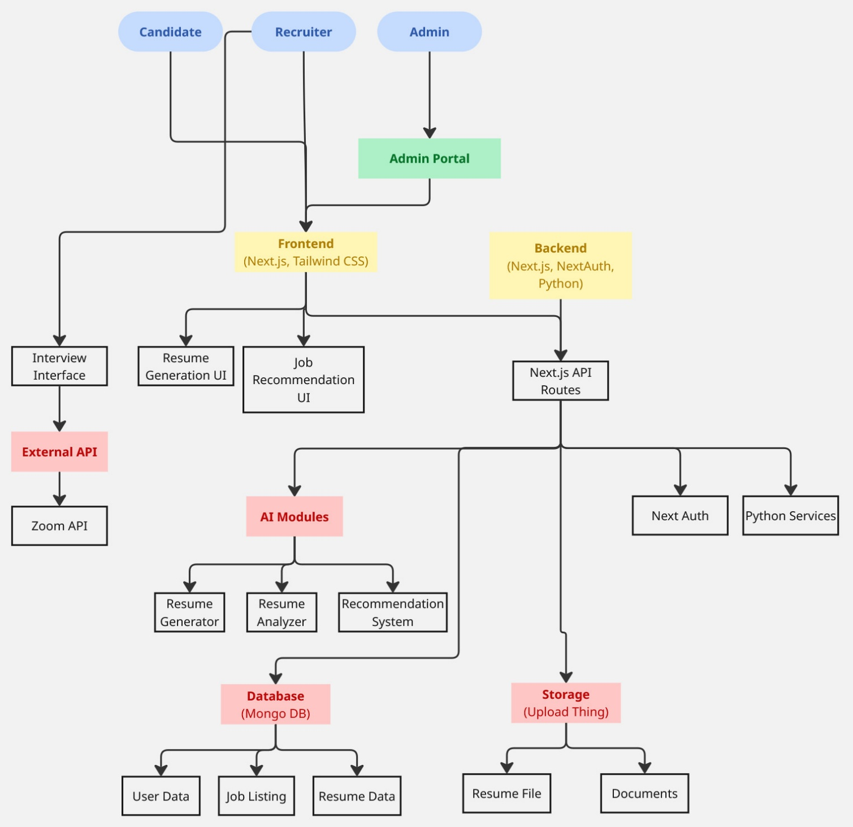
Figure 11: JobiVerse Architecture

4.6. Database Design
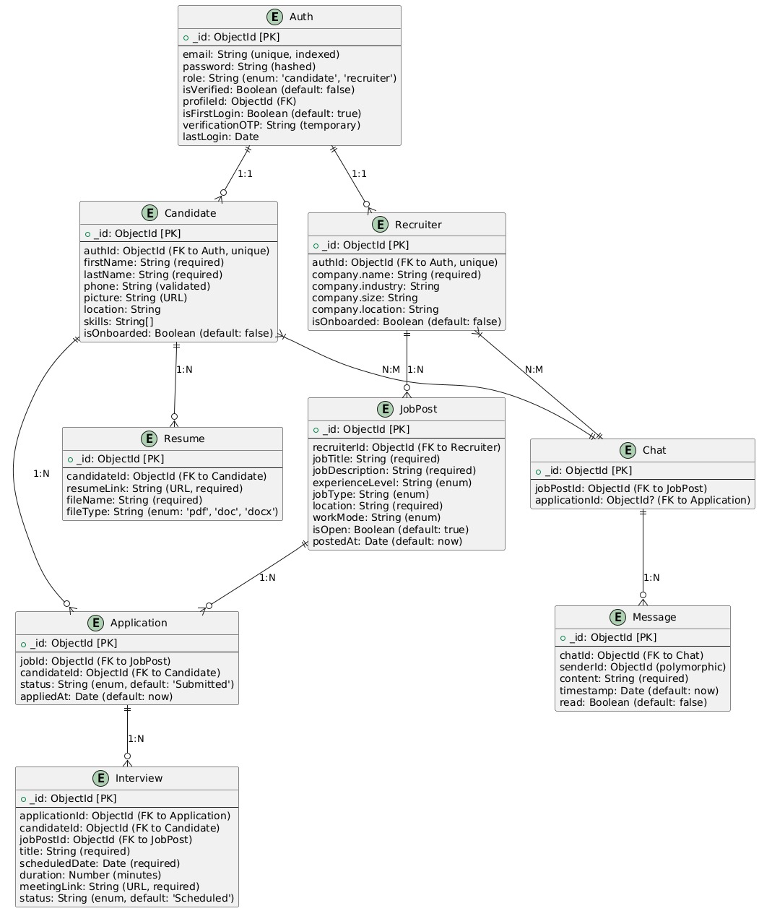
Figure 12: JobiVerse Database Diagram

JobiVerse database is aimed to enable a multi-role job platform by means of AI-assisted opportunities. It is relationally structured with MongoDB-style references and deals with how candidates and recruiters interact, how job posts receive applications and how interviews are conducted.
Table 3: Entity Details
Entities | Detail
Auth | This is a central authentication table. Each user is first registered herewith secure credentials and designated role.
Candidate & Recruiter | These two entities extend from Auth table via one-on-one relation. This stores information related to candidates and recruiters.
Resume | Candidates can upload multiple resumes. Each record stores the file link, format, and is tied to the candidate’s profile.
JobPost | Recruiters can create multiple job postings. Details of each jon posting is stored here.
Application | This entity tracks the candidate’s application.
Interview | Once shortlisted, the recruiter schedules an interview. Interview data is stored here.
Chat & Message | This entity stores all the chat data between recruiter and candidate.

Chapter 5: System Implementation

Front End Development
The JobiVerse frontend was designed with a user-first philosophy, prioritizing clarity, accessibility, and responsiveness. Developed using Next.js for server-side rendering and routing, and Tailwind CSS for utility-first styling, the frontend ensures fast performance, intuitive user flows, and seamless integration with backend APIs. A consistent design system and modular component architecture enhance maintainability and scalability.

Core Design Principles
The foundation of JobiVerse's interface rests on three fundamental design principles that collectively ensure an optimal user experience. These principles guide every aspect of the platform's development, from initial wireframing to final implementation, creating a cohesive ecosystem that serves all user types effectively.
- User-Centric Workflows
JobiVerse implements distinct workflow optimizations for each primary user group to maximize efficiency and satisfaction. For job seekers, the platform offers guided resume creation tools that simplify document preparation, coupled with AI-powered job recommendations that surface the most relevant opportunities. Recruiters benefit from specialized interfaces including streamlined job posting forms and intelligent candidate matching systems that reduce hiring time. Administrative users access comprehensive monitoring and moderation tools that maintain platform integrity while requiring minimal technical expertise. Each interface element undergoes rigorous testing to ensure it aligns perfectly with the target user's needs and expectations.
- Responsive Design
The platform's responsive architecture guarantees consistent functionality across all devices and screen sizes. Built on a mobile-first framework using Tailwind CSS, the interface automatically adapts its layout and content presentation based on the viewing environment. This adaptive system prioritizes essential functions on smaller screens while progressively enhancing the experience on larger displays. Touch targets expand for mobile users, typography scales appropriately, and complex data visualizations transform into simplified formats when viewed on constrained displays. These responsive behaviors combine to deliver a seamless experience whether users access JobiVerse from smartphones, tablets, or desktop workstations.
- Performance Optimization
JobiVerse incorporates multiple performance-enhancing techniques to ensure rapid loading and smooth interaction. The development team implemented strategic code splitting through Next.js dynamic imports, loading only essential components during initial page visits. Non-critical elements like secondary navigation menus and help sections load asynchronously to prioritize core functionality. Static site generation techniques pre-render frequently accessed pages, while incremental static regeneration keeps content fresh without compromising speed. Media assets undergo compression and format optimization, with WepP replacing traditional JPEGs for images and SVG preferred for icons and illustrations. These optimizations collectively achieve sub-two-second page loads all across all connection speeds, meeting modern user expectations for web application performance.

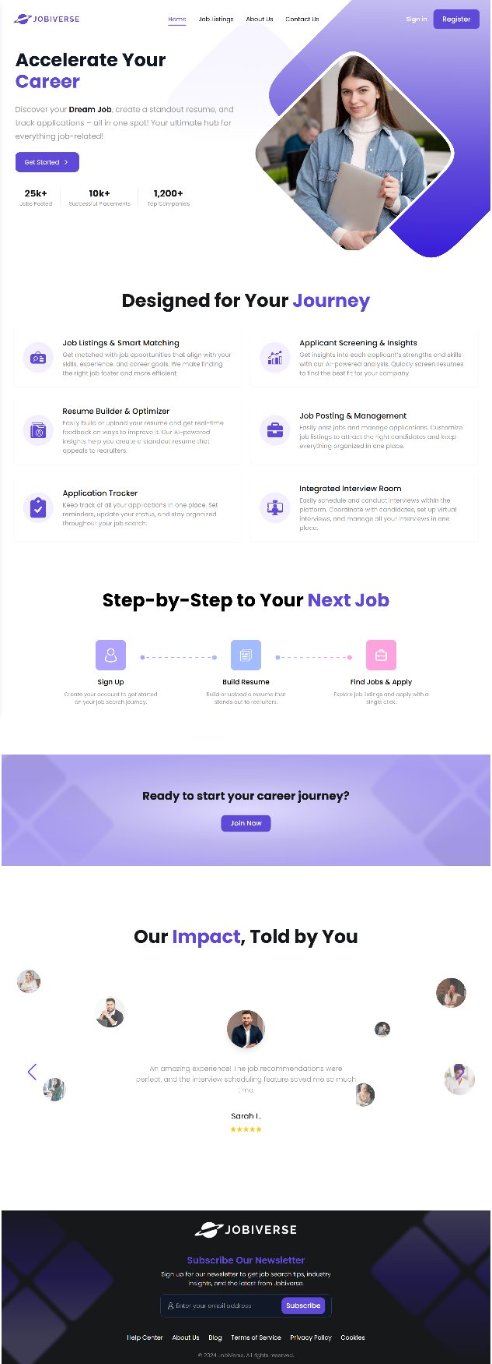
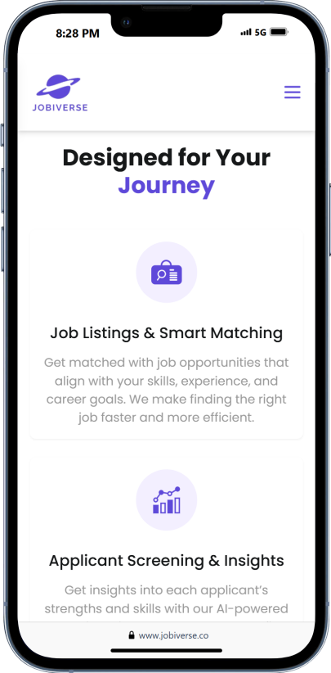
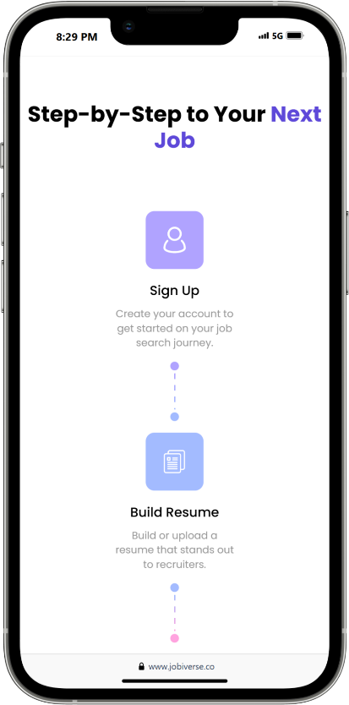
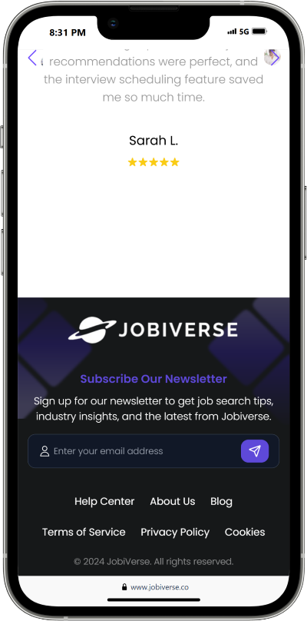
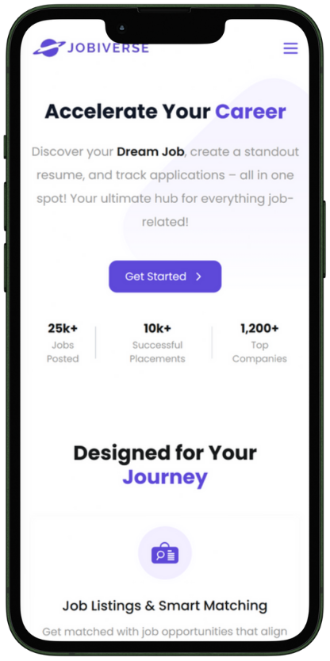

Login
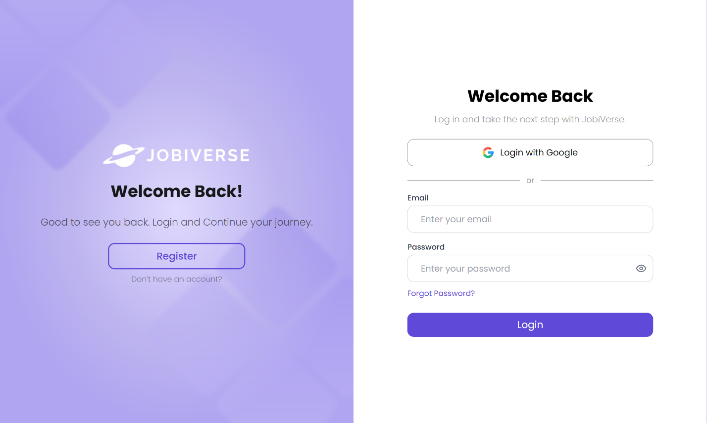
Signup
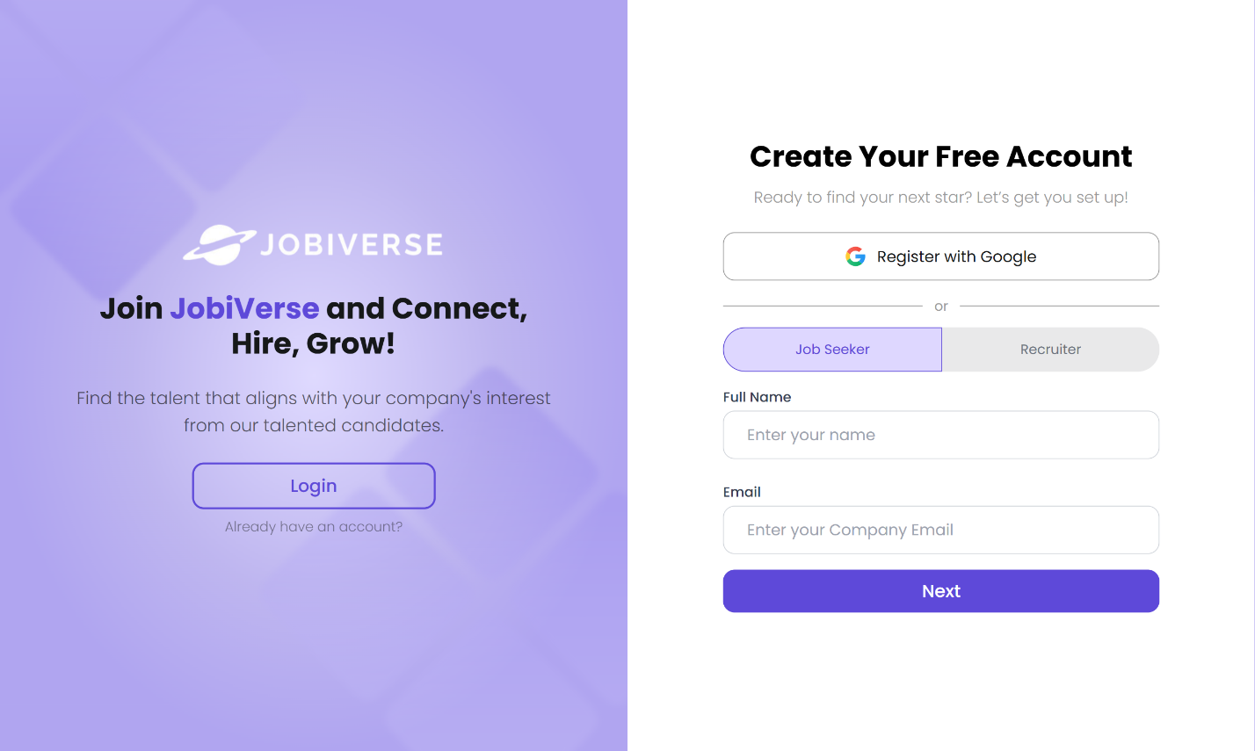

Email Verification
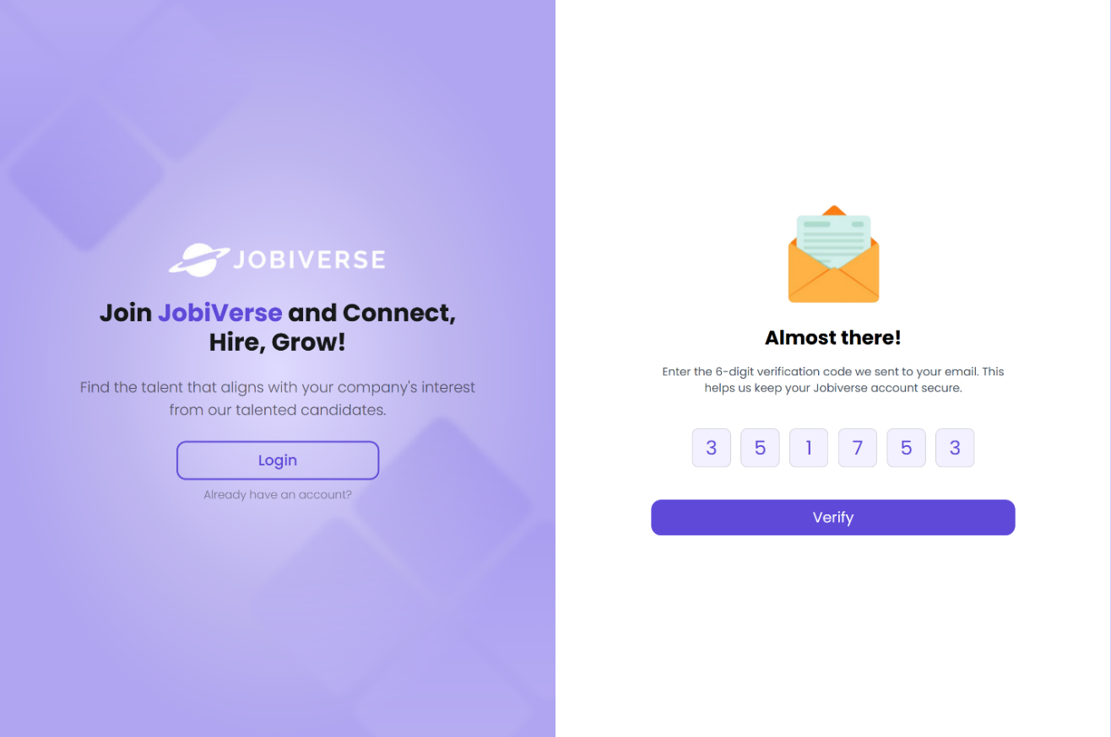
Password Creation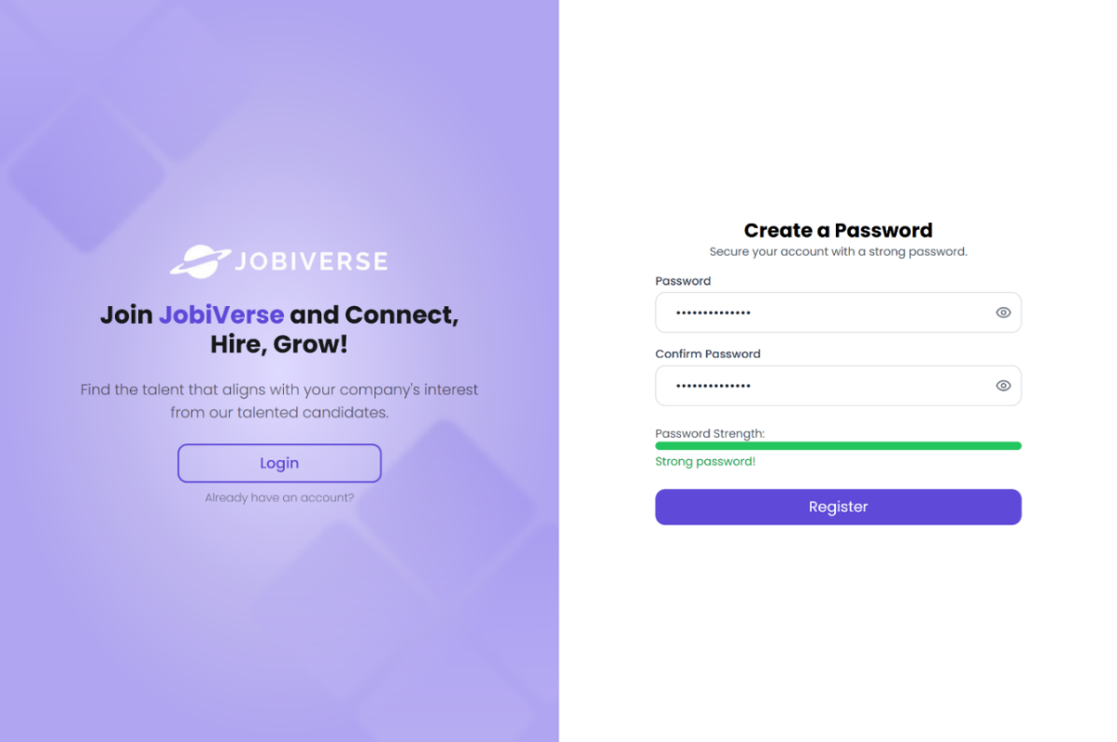
Candidate Onboarding
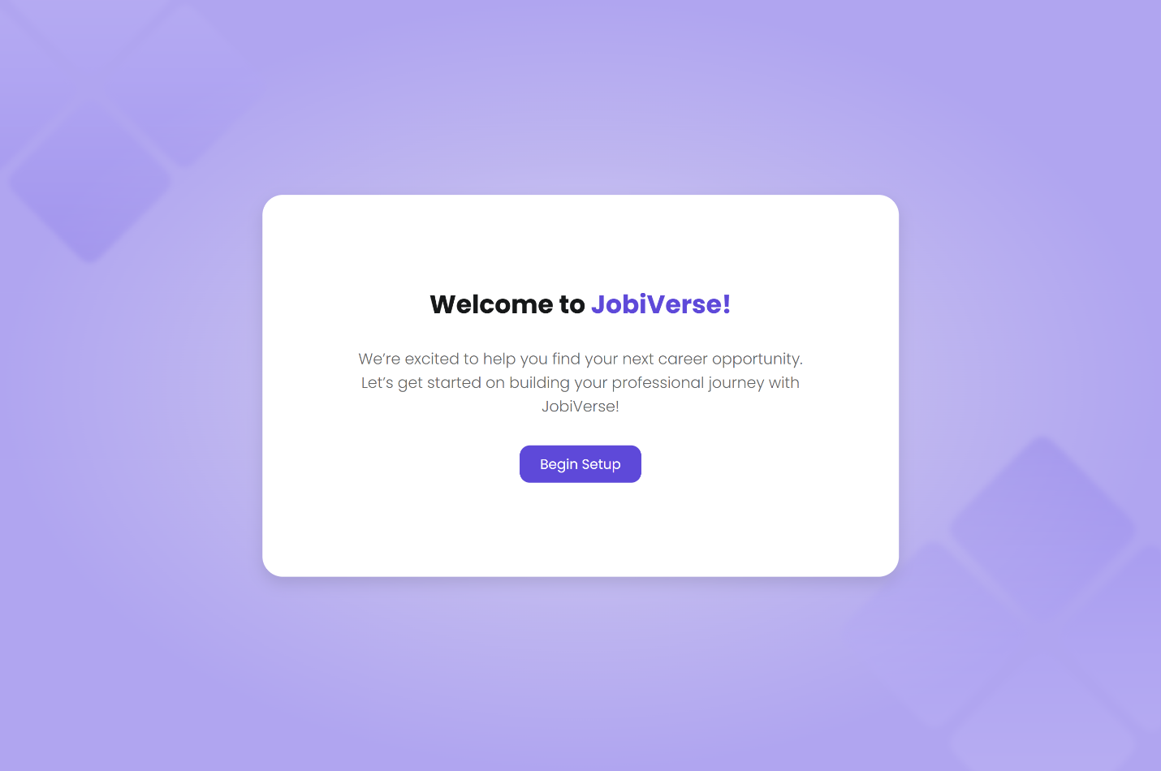
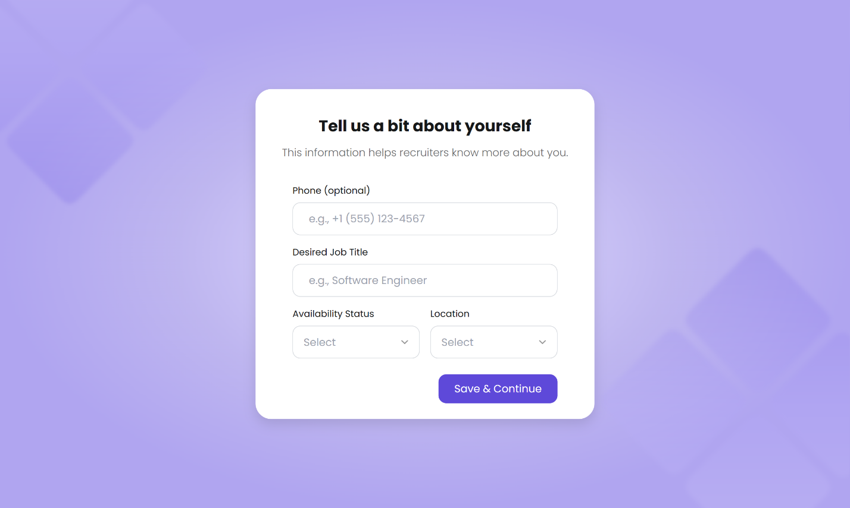
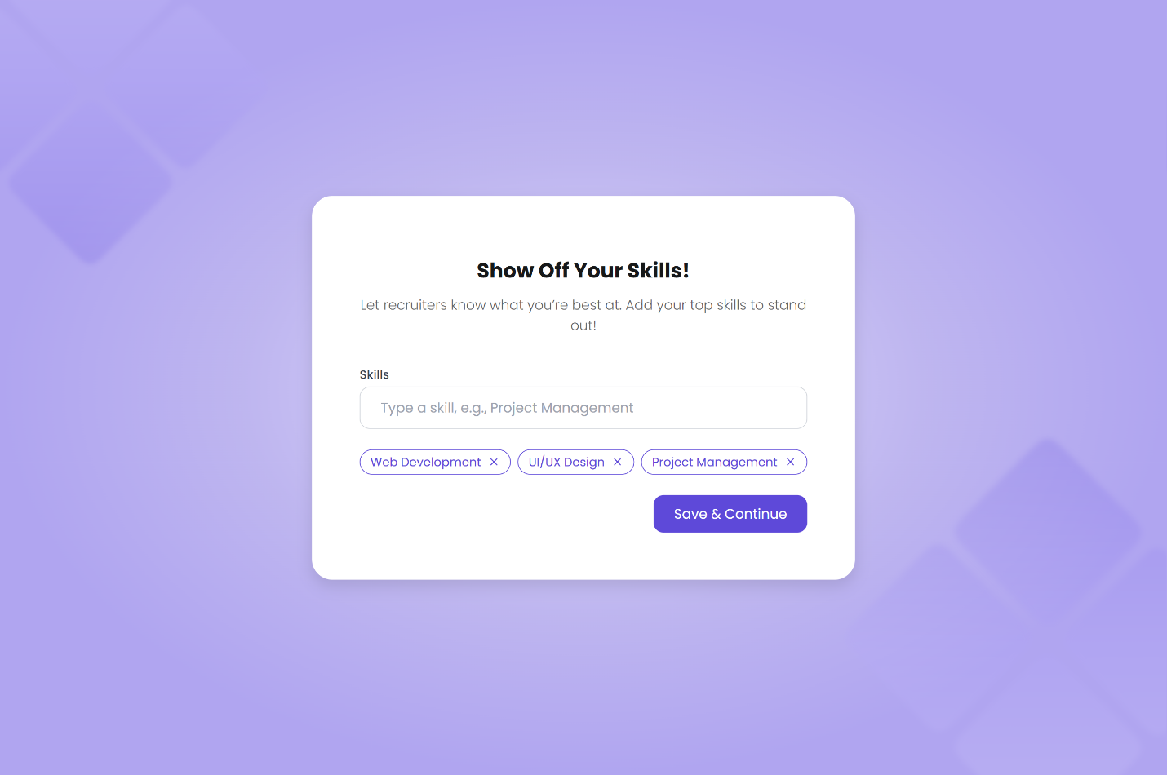
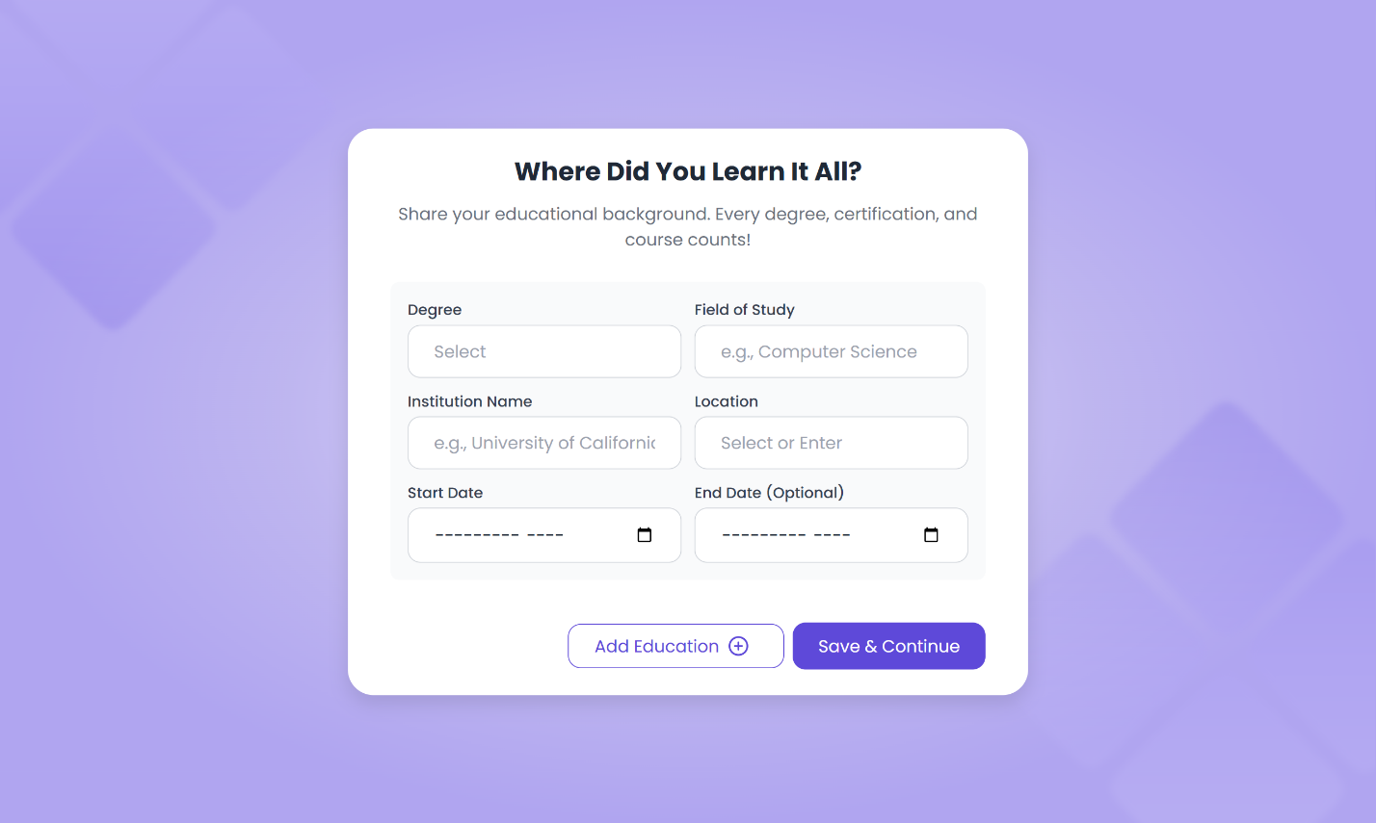
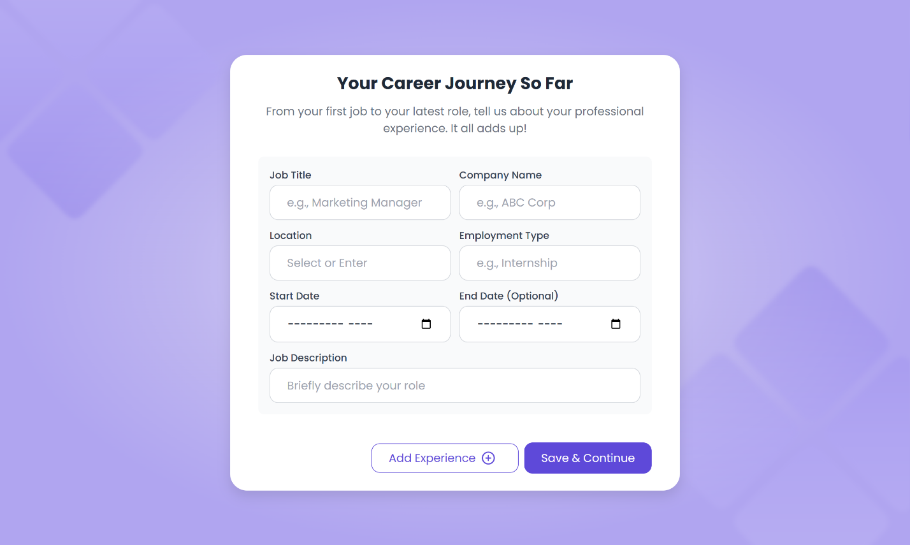
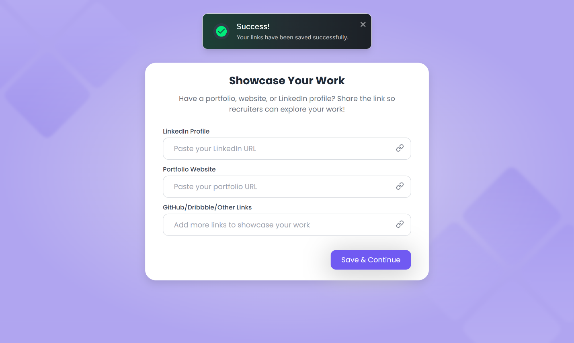
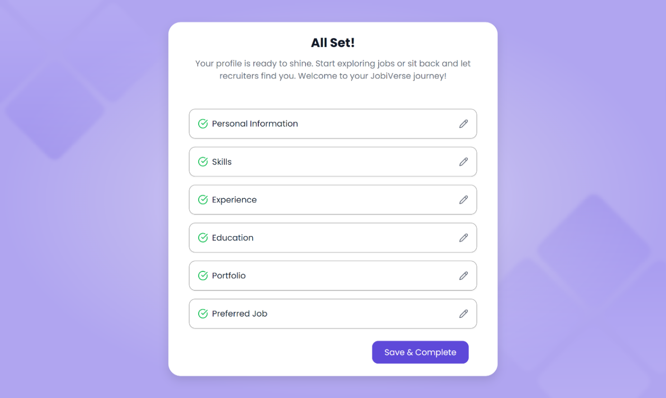
Dashboard
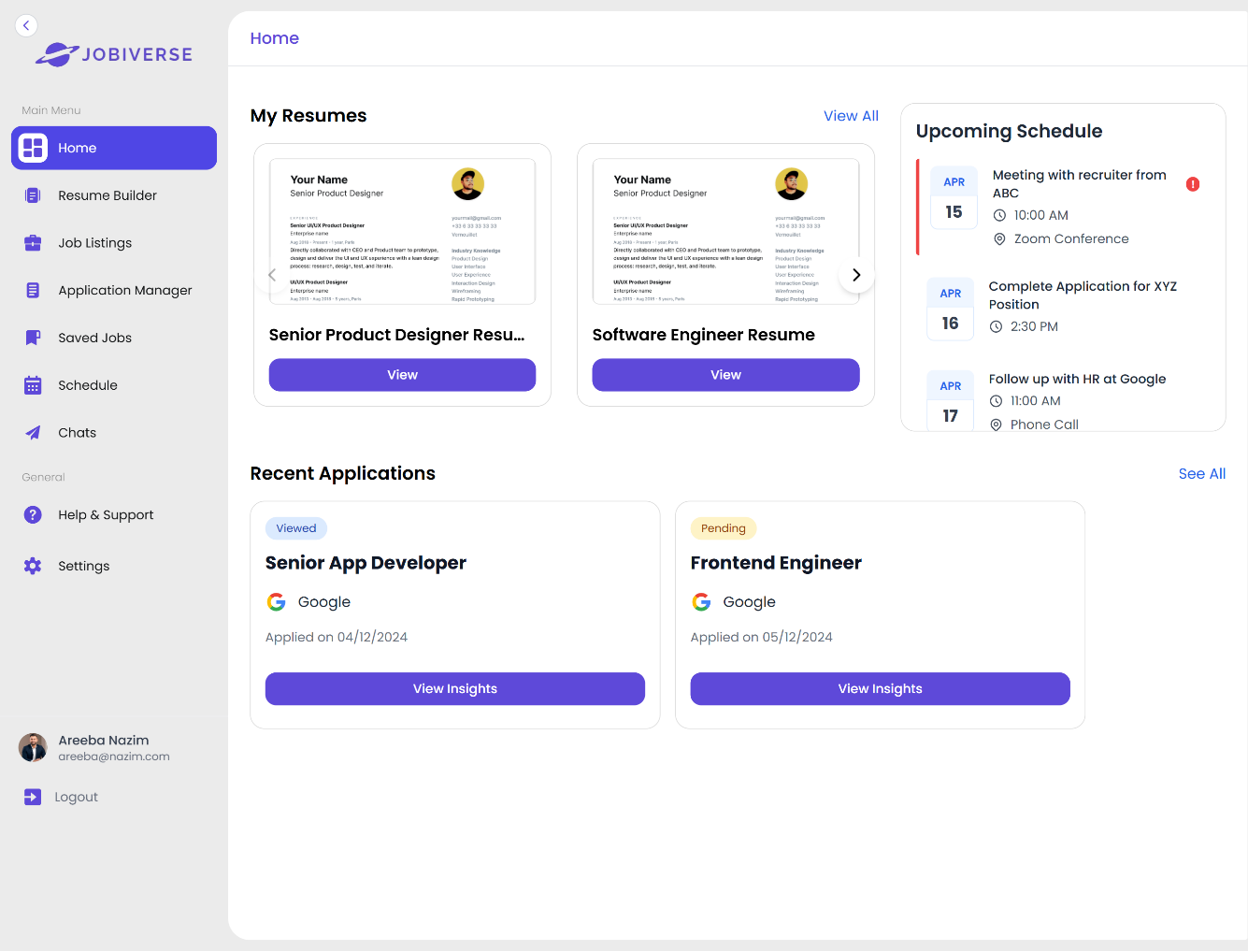
Job Listings
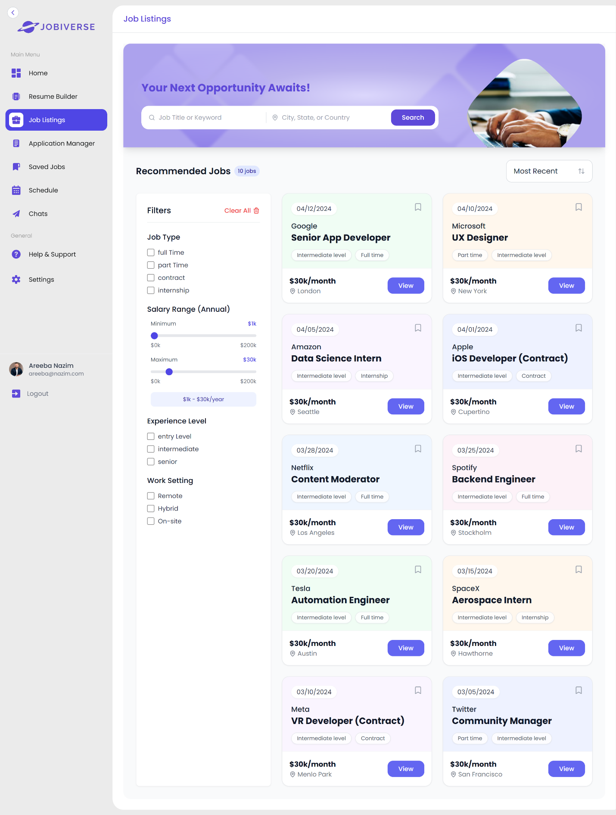

Job Details
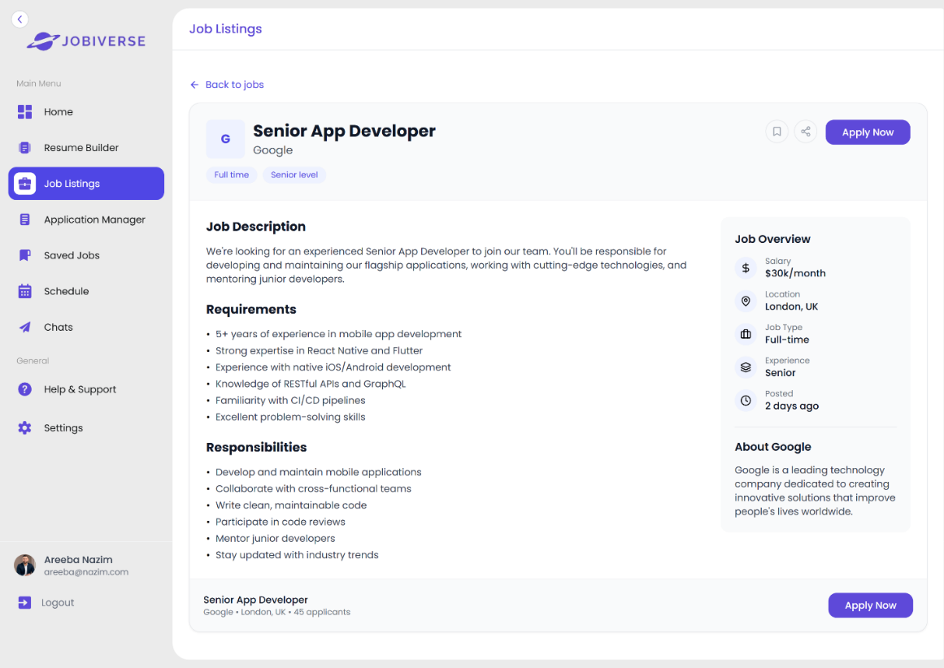
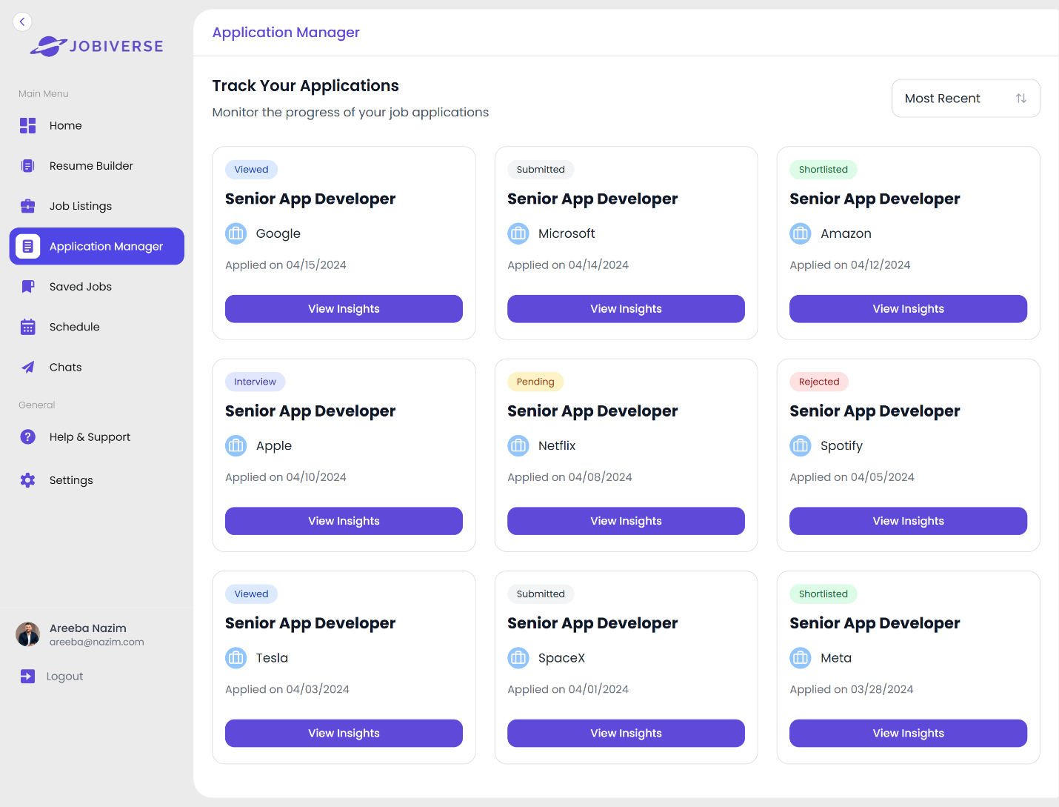
Application Manager
Saved Jobs
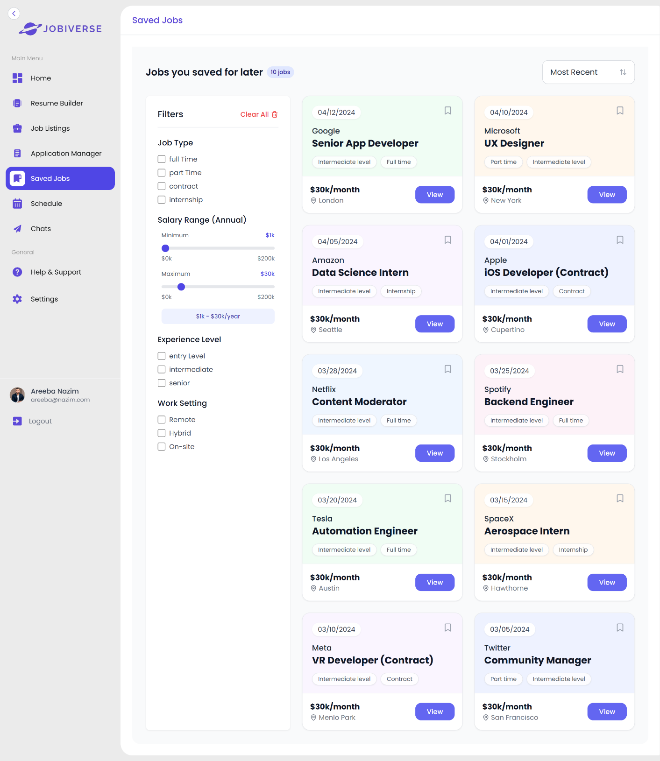

Resume Upload
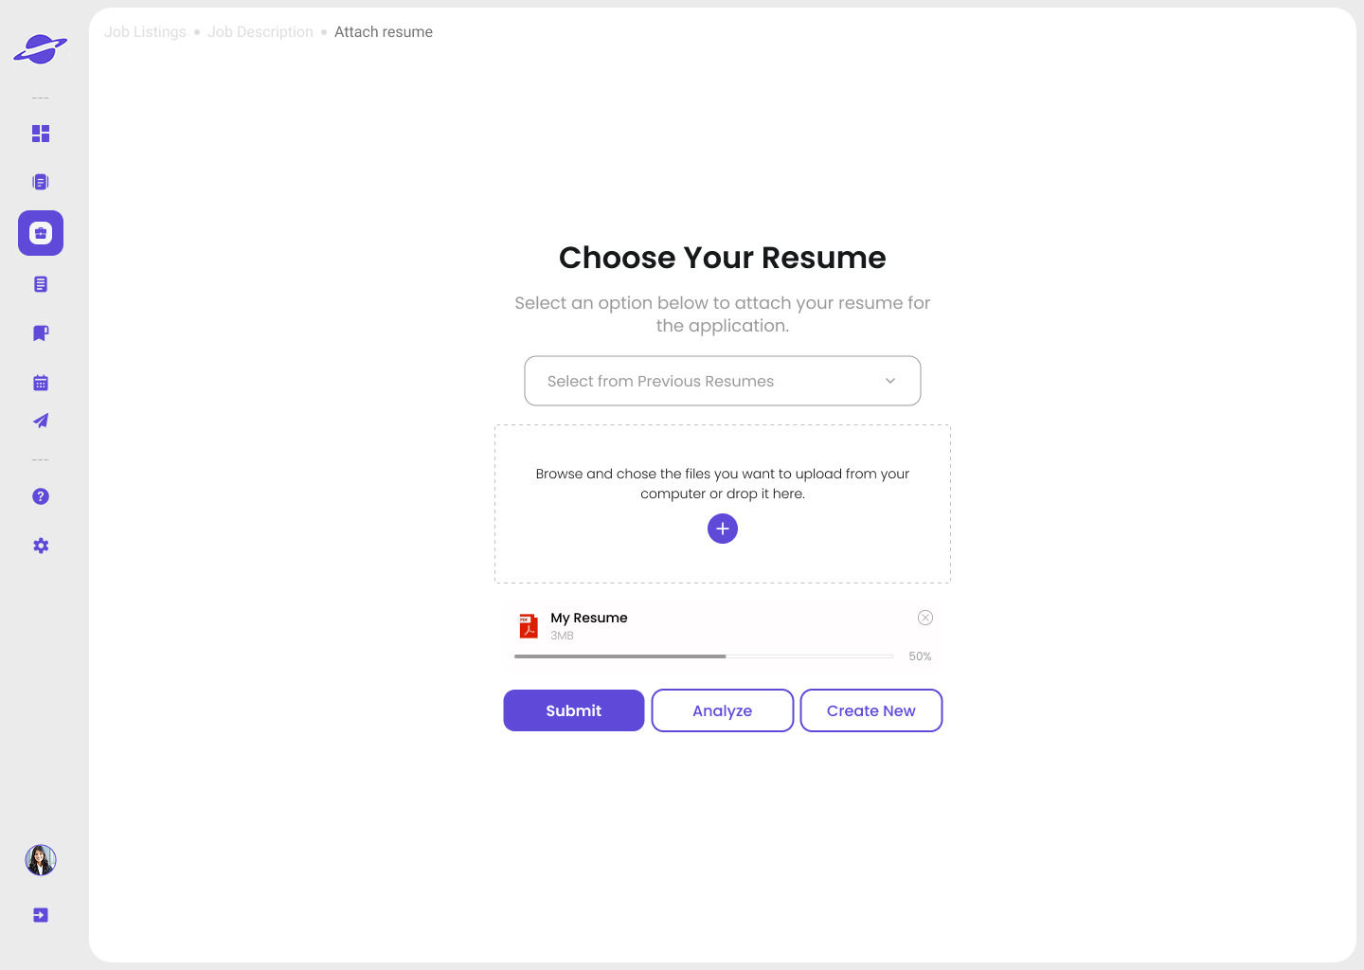

Backend Implementation
JobiVerse backend consists of a scalable, secure and efficient solution that will carry out the main logic and the APIs to all the features that will run the platform. It has been built fully on Next.js (App Router with Server Components and API routes) and utilizes both server-side rendering and APIs to implement such functionalities as authentication, profile management, resume actions, and job management as well as communication between recruiters and candidates. The backend is closely connected with the MongoDB, an effective NoSQL database, which stores the data as a collection and document, allowing the flexibility in different user roles, multidimensional data structures.

Database Architecture
MongoDB is used as the primary database system. Unlike traditional relational databases, MongoDB uses collections (similar to tables) to store groups of documents (equivalent to rows). Each document is a JSON-like object that allows for nested, flexible data structures.
The following are the core collections in the JobiVerse system:
Collection | Detail
Auth | This is a central authentication table. Each user is first registered herewith secure credentials and designated role.
Candidate & Recruiter | These two entities extend from Auth table via one-on-one relation. This stores information related to candidates and recruiters.
Resume | Candidates can upload multiple resumes. Each record stores the file link, format, and is tied to the candidate’s profile.
JobPost | Recruiters can create multiple job postings. Details of each jon posting is stored here.
Application | This entity tracks the candidate’s application.
Interview | Once shortlisted, the recruiter schedules an interview. Interview data is stored here.
Chat & Message | This entity stores all the chat data between recruiter and candidate.

Authentication and Authorization
Authentication flow is done through NextAuth.js. It handles:
- Session generation and checkout
- Protected cookie administration
- JWT as access control tokens
On sign up, users receive an email that requires them to use One-Time Password (OTP):
- Nodemailer will be utilized in sending the OTPs to the email provided by the user.
- OTP values are generated secured and randomly using crypto.
- OTPs have a time limit and are hashed and then stored to ensure extra security.

The hashing of a password is done through the bcrypt library that:
- Produces a special salt
- Password is securely hashed
- Encrypts the last salt with the hash
Onboarding and Profile Management
Once authenticated, the users are directed indicatively through an onboarding procedure, during which the user is presented with features that are specific to his or her position. Onboarding is useful in assisting both candidates and the recruiters:
- Photo uploads
- Resume/document uploads
- Firm info configuration (recruiters)
To manage and store UploadThing (built on AWS S3) is used to handle the following:
- Resume files
- Profile pictures
- Auto-generated resumes
The data of any user and recruiter keeps inside their profile and is under the control of Next.js server functions and MongoDB storage.
Job Posting and Application Management
The posters of new jobs can complete a structured form, covering such fields as:
- Job Title
- Job Description
- Required Skills
- Job Type (e.g. remote, on-site)
- The type of environment (e.g. startup, enterprise)
- Salary range, Location, etc.
Every job may be updated, close up or opened, and tracked as to the application activity.
New candidates receive job recommendations in the form of an AI-based Recommendation System (coded in Python) according to their stored preferences, work history, and resume text. Applicants may do it in the following ways:
- Uploading personal resume
- Creating a resume that shows the work position with the help of Gemini 1.5 Pro through FastAPI integration

The resumes which are automatically generated are uploaded via UploadThing and listed in the Resumes collection.
Resume Analysis and Tracking
When one presents a resume or post a resume:
- In artificial intelligence, modules are used in analysis and scoring
- Areas of weakness are brought out
- It provides recommendations on how to improve
It is possible also to see progress of every job application:
- No matter how one saw it
- The duration that the recruiters take on a page of resume
- Heatmaps of what parts were read most
This functionality is hosted by Heatmap.js in terms of visual analytics.
Recruiters Features and Interview Scheduling
Recruiters will be able to see the Applicants dashboard and herein can:
- See the details of candidate
- Weed through the job candidates in skills, experience, etc.
- Reject or shortlist candidates
- Book interviews on the dashboard directly
Interviews have been incorporated with Zoom API that would enable the recruiters to:
- Schedule time of the day as well as duration
- Include interviewers and candidates
- Automatic meeting invites send
Regular interviews are registered in the Schedule list and appear in the dashboard of both candidates and the recruiters.
Additional Website Features
- Password Management: Users are able to change their passwords and hashing will be done through bcrypt.
- Email Alerts: All the notifications and messages will be via Nodemailer.
- Event Management: JavaScript based scheduling logic is used to track upcoming interviews and meetings.

Security and Roles: Role-based access will be imposed on all the API routes via the session tokens of NextAuth.

AI Module Implementation
JobiVerse is powered by Artificial Intelligence and builds upon the basic job portal without turning it to a less intelligent platform, instead making it an intelligent, responsive solution for career building. To tackle the challenge facing users of three critical problems they created the AI integration modules over which the user is able to create an optimized resume while finding semantically matched job opportunity that the user is interested in and passively discover job opportunities based on their preferences. These modules were developed with the help of Large Language Models (LLMs), Natural Language Processing (NLP), and classical machine learning techniques. Next, each of the major AI features is described in the following sections: their design, objectives, and implementation.

Job Recommendation System
It is very difficult and tiresome for job seekers to find the right job from thousands of listings. Now, traditional job portals are based on keyword matching but yield irrelevant or redundant results. To address this, JobiVerse has an AI powered Job Recommendation System powered by Natural Language Processing (NLP) and semantic similarity algorithms to give super precise, customized job suggestions to users. This system allows that the system adapt dynamically on what the user is currently doing and what they like, so from a real time point of view, the system responds giving an intelligent experience that is tailored exactly to their user profile and to their ideas appearing what they are expecting as a user. This module is a fully interactive, instead of static, recommendation system that provides users an ability to browse jobs with personalized filters and context meanings rather than keyword based.
- Objective
This module’s objective is to provide a personalized active job search experience created for those seeking career change. The job title, work type and candidate preference are taken from the users profile and their values are combined with a semantically rich recommendation engine to provide relevant job opportunities beyond simple text matching. But it is aimed to fill in the gap between user intent and job supply through smarter filtering and ranking algorithms.
- Inputs Collected
The following real time inputs are accepted by this system from the user.
- Job Preference: What kind of job the user is searching for now, is called Job Title.
- Work Type: Full_Time, Part_Time, Remote, Internship etc.
- Gender Preference: In cases other than if the job posting has a preference field such as ‘Male,” ‘Female’ or ‘Both.
This is because the final output would need to have both a semantic match as well as be user specific and so these preferences need to be applied to the job listings to filter before the semantic matching is applied.
- Processing and Implementation
To begin, a dataset of 10,000 job listings is preprocessed using standard NLP techniques:
- Conversion to lowercase
- Removal of stopwords and special characters
- Tokenization and stemming (e.g., using PorterStemmer)
Key textual fields—such as job titles, skills, qualifications, and descriptions—are merged into a single clean_text field for each listing. Then, the TF-IDF (Term Frequency–Inverse Document Frequency) method is applied to convert these text strings into numerical vectors that emphasize contextually significant terms.
Next, cosine similarity is calculated between each vector and the user’s job title input, enabling the system to rank job listings based on semantic closeness. The similarity matrix is computed once and cached in memory to ensure faster performance during active searches.
When the user initiates a query, the system:
- Filters the dataset by Work Type and Gender Preference.
- Identifies the closest-matching job entry.
- Finds top-N similar jobs using the precomputed similarity scores.
- Displays job recommendations sorted by most recent posting date.

d. Output
Each recommendation includes detailed attributes such as:
- Job Title
- Company Name
- Work Type
- Required Skills and Qualifications
- Experience Level
- Salary Range
- Job Description
- Responsibilities and Benefits
- Posting Date
This comprehensive output ensures users get a 360° view of every job, empowering them to make informed decisions without needing to scroll through irrelevant listings.
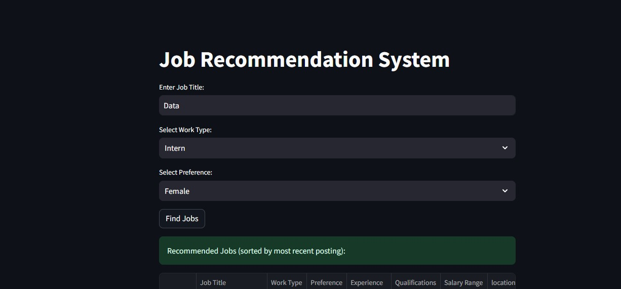
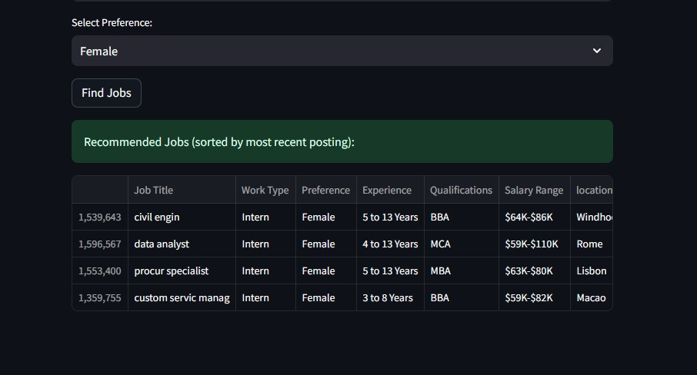

Resume Generator
It’s not difficult to find yourself in today’s competition for jobs without a differently and professionally written resumé. Yet not everyone on the job search has the time, writing ability, or familiarity with applicant tracking systems (ATS) to write such documents. To fill this gap, JobiVerse leverages an intelligent resume generation module aided by Google’s Gemini 1.5 Pro API, a top of the line Large Language Model (LLM). This module is an implementation of an automated process of building resumes that comply with ATS guidelines using provided user information and the target job description. With generative AI furthering saving resumes creation time and improving CV relevance and quality by crafting structured, polished and job-specific CVs, it’s not only time-saving but also easy to do. A user friendly experience with a streamlined version of the otherwise manual, time intensive task of resume creation for a user.
- Objective
A second objective of this module is to create a well formatted, content rich and personalised resume from user input combined with the Gemini LLM. The system takes a provided information by the user and builds resume based on what they have given and what requirements do of their work.

- Input Collected
The structured interface is used to collect the following inputs from the user so as to ensure accuracy and relevance:
- Target Role: User job which it is applying for.
- Job Personnel: Those already employed in your company doing the job description.
- Work Experience: Positions held, responsibilities and achievements for Work Experience.
- Technical Skills: Languages, tools, frameworks or platforms that the user is skilled in.
- Education Details: Degrees, institutions, and years of graduation.
- Previous Projects: Any significant academic, freelance, or professional projects relevant to the job.

The details it has given the model to draw upon can be used to create a highly detailed resume designed for the specific job role and standards within the industry.

- Processing and Implementation
The collected inputs are formatted into a carefully designed prompt based off of which google.generativeai Python library you’ll be using. The data provided with this prompt is to be ordered into a professional resume format by the Gemini 1.5 Pro model. The content of the model is generated in discrete sections, including:
- Profile Summary
- Education
- Work Experience
- Skills
- Projects
The system is robust by having retry mechanism in case of any failures in API request due to the time out or the rate limit. The output is parsed from the AI generated resume and stored in a structured JSON file (Generated_CV.json) that can be edited, downloaded and reused in future session.

- Output
This means the total resume is highly structured, ATS friendly resume with personalized content in each of the standard resume sections. It is formatted to be read friendly and which is compatible with the current recruitment software. Structured JSON output format allows the content to be rendered in different formats (e.g., PDF, Word) or be reused in other JobiVerse tools (e.g., resume feedback, job matching) very easily.
The entire process of managing a resume with this AI resume generator that is powered by this AI is fast and easy. Job targeted resumes can now be generated by users who might otherwise have a problem with language, formatting, or self presentation, and get created in seconds. Also since it pertains to what the user has described about the job, it is more likely to pass ATS filters and receive recruiter attention. Talking about this module, this is a major value addition for JobiVerse, which brings about more user engagement and better chances in job placement.

Chapter 6: Testing

Unit Testing
Unit testing involved checking the working of the separate components at the coding level. All the functions and modules, including generating logic of the resume, API endpoints, and database queries were tested separately, using framework such as Jest (JavaScript/TypeScript) or PyTest (Python based AI modules).
Examples of Components to Be Unit Tested:
- JSON resume formatter
- Job recommendation filter in put validation
- Parsing logic of an AI output
- Functions of database query
Each development sprint included running unit tests and the core idea was that any new functionality should not disrupt the existing one. Real life inputs were simulated using mock data and the results were compared to the expected outcome.

System Testing
The platform was tested in systems, and all modules were expected to perform according to expectations. This entailed trial combinations of:
- Front ends and back ends Forms and APIs
- User input and AI modules streams
- Database storage and resume downloads
- Semantic filtering engine: job recommendation interface
They tried both positive and negative scenarios. Example, an invalid input in the context of job search should give error messages or fallbacks, whereas the valid filters would respond within relevant results. The edge cases, including empty job set or large file upload were also validated during this phase.

User Acceptance Testing (UAT)
A sample of users was used in conducting UAT; they were:
- People who search for a job and check out resume building and seeking employment
- The posters of jobs by recruiters or the job-screening by recruiters
The Google Forms and in-app surveys were used to obtain feedback to assess the usability, performance, and accuracy. According to the answers:
- Formatting and tone of resumes was enhanced
- The experience was put more emphasis in job recommendations
- The interface of the recruiter was streamlined to post job faster
The feedback loop made the platform match user expectations in the real-world setting and led to final adjustments before being put in place.

Test Cases
Defined test cases covered a wide range of functionalities. Below are sample test cases:
Test Case ID | Description | Input | Expected Output | Status
TC-001 | Resume generated with complete input | Valid Job Title, skills, etc. | Structured resume in JSON format | Passed
TC-002 | Invalid job title in job search | Random string input | “No Result Found” message. | Passed
TC-003 | Resume feedback on weak resumes | Minimal work history | Ai suggestions with score | Passed
TC-004 | Job post creation by recruiter | All required fields completed | Job listed on recruiter dashboard | Passed
TC-005 | Recommendation filtering (remote jobs only) | Filter: Remote | List of remote job listings | Passed

Chapter 7: Conclusion

Challenges Faced and Lessons Learned
Building the JobiVerse was an eye-opening experience that helped us to overcome all the obstacles of the real world and learn the priceless novelties of software development, design, and user-centric thinking. In the process of this project, I came across technical, organizational, and design related challenges that in the end led to an enhancement of not only the final product but also my problems solving skills.
The scope of the project was one of the issues that were first addressed. Having a lot of innovative features, including AI chat assistants, advanced analytics, and tools that engage recruiters, it was necessary to prioritize key functionality to achieve the most significant changes. It was a valuable lesson to me when it comes to scope control and iterations not to build a platform larger than it needed before the most basic components began to prove themselves to be sound.
There were several challenges that were involved in working with third party APIs as well. Such complex integrations as scheduling interviews using the services of Zoom and generating resumes using the Gemini API provided by Google are associated with extensive focus on authentication, error processing, and data formatting. These challenges enabled me to formulate more solid retry mechanisms, improved asynchronous channels, and enhanced cognition of APIs-based systems design.
The technical infrastructure as such was also complex, especially when supporting two user personas (candidates and recruiters) in a full-stack application (Next.js, Python, MongoDB). Enhancing safe role-based access, streamlined onboarding journey, and proper session management required special backend approach and thorough testing. I was taught how to keep the user flows distinct yet allow the user to have access to common features such as messaging, resumes viewing and scheduling interviews.
Regarding the design, the creation of an interface, which was both effective and intuitive, needed lots of iterations. An example of this was recruiter dashboard, which was required to display these various forms of information, applications, resumes and links to the interviews, without feeling overwhelming to the user. This difficulty made it clear that usability testing and gradual disclosure in UX are important, and the information should be displayed only when required.
Pressure moments happened in time, specifically integration and testing times, and in-depth testing of APIs or solving any discrepancies between resume data and job descriptions. Such moments emphasised the necessity towards early validation, automated testing, and evenly module architecture in ensuring systems are maintainable.
Nonetheless, despite the above mentioned challenges, the project represented rich learning experience. I got actual experience with learning AI-driven modules such as resume development and job matching systems, enhanced my programming knowledge in a full-stack body build, and witnessed the strength of user-focused design. I also got to know how to deal with strange cases, how to be prepared in case of failure, how to design something with real users in mind-not to get features.
To sum it up, the issues encountered during the development process of the project JobiVerse were not obstacles on the way, but stepping stones. All these obstacles taught me to be a more accurate designer and developer and all my lessons have now become the elements of new issues solved with clarity in mind, empathy and strength.

Project Summary
JobiVerse breaking through the history of job-seeking and hiring as we know it and introducing energetic and smart AI-based technologies is an essential step of modernization of the system. This platform has been able to connect the job seeker with the potential recruiters and this is through providing and ecosystem that automates several critical processes along the hiring process such as resume creation, job matching, application tracking and schedule of interviews.
A mixture of Generative AI and Natural Language Processing (NLP) underlies the core of JobiVerse and ensures that the user experience is personalized and promotes improved accuracy of recommendations. In order to create custom, ATS friendly resumes when given input and when presented with a certain job description, the Resume Generator component of the system utilizes the Gemini 1.5 Pro API of Google. This lessens the human load on the user and also positively enhances the possibility of passing the automated screening systems that is employed by contemporary employers.
Semantic similarity of TF-IDF and cosine similarity is implemented in job recommendation engine, which gives very relevant suggestions through both the user preferences and context information presented in the job listing. The platform also has a passive recommendation system which enables the platform to suggest jobs that one can look into based on the information found on his/her profile without having to enter the job manually, thus more convenient and attractive.
Technically, the architecture was built on full-stack environment based on Next.js, Tailwind CSS, Node.js, Python, and MongoDB, so the architecture will be responsive, modular, and scalable. One used agile and SDLC to handle development lifecycles, and AI modules were developed and trained with chosen realistic datasets.
The database was also developed with the angle that there will be role-based interactions (candidates, recruiters, admins), resume uploads tracking and job posting management, as well as chat and interview booking. With the functionality of the recruiter dashboards, candidate profiles, and intelligent interview invitations, the JobiVerse will present a formal and streamlining system that will suit both ends, the side of employment.
Not only has this project attained its set objectives but it also established a firm ground towards future improvements. It demonstrates how it is possible to harness smart algorithms, user-centered design, and modern web technologies in order to create an all-encompassing, expansionary, and effective service that would facilitate work in the digital era.

Future Work
Although JobiVerse currently offers a robust and intelligent platform for job seekers and recruiters, several avenues for future development have been identified to expand its capabilities and reach:
- Multilingual Resume Generation:
At the moment, resume generation is only in English. The areas that can be enhanced in future versions would be the inclusion of multilingual support based on translation APIs and multilingual LLMs so that the platform can dominate a larger client base all around the world.
- LLM-Powered Career Assistant
AI chatbot assistant can also be implemented to the platform to help users in real-time with career advice, resume writing assistance, interview preparation and application hints, which will enhance the confidence of the user and decrease the need to resort to outside assistance.
- Advanced Resume Feedback with sentiment and skill gap Analysis
Adding sentiment detection and industry-specific competency analysis to the understanding of the current skills gap will facilitate the better optimization of the resume to better fit the demands of employers.
- Voice and Video Interview Analytics
Adding sentiment analysis and face tracking in interviews with virtual participants may aid in the recruitment of soft skills, confidence, and communications that have been analyzed more objectively.
- Portfolio and Cover Letter Builder
The users can make use of a built-in feature of creating professional portfolios and cover letters that can improve the rest of the application set.
- Recruiter Analytics Dashboard
Providing the recruiters real-time metrics in a dashboard including the application funnel rate, time-to-hire, engagement score, and source tracking will improve decision-making and outcomes of hiring.
- Mobile Application
A cross-platform mobile application designed to run on both Android and iOS would enhance coverage, particularly of remote or mobile first users. Overall, some notifications, job alerts, as well as voice-based interactions may be introduced to increase engagement.
Following through on such future directions, JobiVerse could become a holistic ecosystem of career development, and not only at the moment of application, but indeed within the whole employment experience.

References
1. Ajunwa, I. and D. Greene. (2019) "Platforms at work: Automated hiring platforms and other new intermediaries in the organization of work," in Work and labor in the digital age. Emerald Publishing Limited. p. 61-91.
2. Martins, N., S. Dominique-Ferreira, and C. Lopes. (2022). Design and development of a digital platform for seasonal jobs: Improving the hiring process. Journal of Global Scholars of Marketing Science. 32(3): p. 452-469.
3. Vijayanand, N. (2024) Revolutionizing Human Resources Management Using Deep Belief Learning Approach For Talent Acquisition And Retention In The Digital Era. in 2024 International Conference on Integration of Emerging Technologies for the Digital World (ICIETDW). 2024. IEEE.
4. Upreti, K., et al. (2022) "A comprehensive framework for online job portals for job recommendation strategies using machine learning techniques," in ICT Infrastructure and Computing: Proceedings of ICT4SD 2022. 2022, Springer. p. 729-738.
5. Zhao, Z., et al. (2023) Recommender systems in the era of large language models (llms). arXiv preprint arXiv:2307.02046.
6. Hasan, M.R. and J. Ferdous. (2024). Dominance of AI and Machine Learning Techniques in Hybrid Movie Recommendation System Applying Text-to-number Conversion and Cosine Similarity Approaches. Journal of Computer Science and Technology Studies. 6(1): p. 94-102.
7. Kale, S.S. and W.B. Andreopoulos. (2023) Job tailored resume content generation. in 2023 IEEE Ninth International Conference on Big Data Computing Service and Applications (BigDataService). IEEE.
8. Mulla, A., et al.. (2023) Resume Builder Application with Automated Job Prediction. NeuroQuantology. 21(1): p. 128.
9. Tijare, P., et al. (2023) A smart resume screening tool for customized shortlisting. in ITM Web of Conferences. EDP Sciences.
10. Mishra, A., S. Singh, and R. Jisha. (2024) AI-Powered Model for Intelligent Resume Recommendation and Feedback. in 2024 15th International Conference on Computing Communication and Networking Technologies (ICCCNT). IEEE.
11. Chen, J., et al. (2023) Bias and debias in recommender system: A survey and future directions. ACM Transactions on Information Systems. 41(3): p. 1-39.
12. Sanghavi, K., P. Borse, and S. Gandhakse, SMART Interview System. JOURNAL OF TECHNICAL EDUCATION: p. 180.
13. Tran, T.T., et al. (2023). Improving human resources’ efficiency with a generative AI-based resume analysis solution. in International Conference on Future Data and Security Engineering. Springer.
14. Cortés, C.M.C. and J.P.O. López. (2024) Job Recommender System for the Unique Framework of Classification of Occupations in Colombia (CUOC) using collaborative filtering. Ingeniería y Universidad. 28.
15. Bhatt, A., et al. (2024). Resume Analyzer based on MapReduce and Machine Learning. in 2024 IEEE International Conference on Interdisciplinary Approaches in Technology and Management for Social Innovation (IATMSI). IEEE.

