恢复出厂设置后，在保存dhcp分配net模式的IP的前提下，给每一个虚拟机加一个静态的地址。在保证了上网的前提下，组建成局域网。

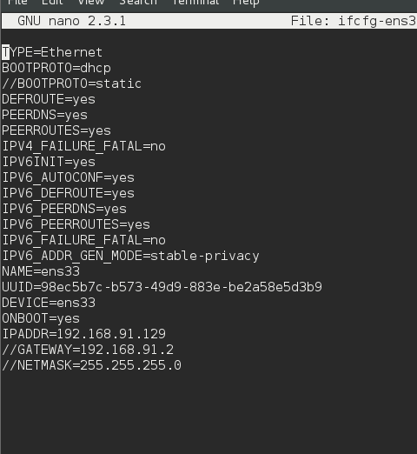

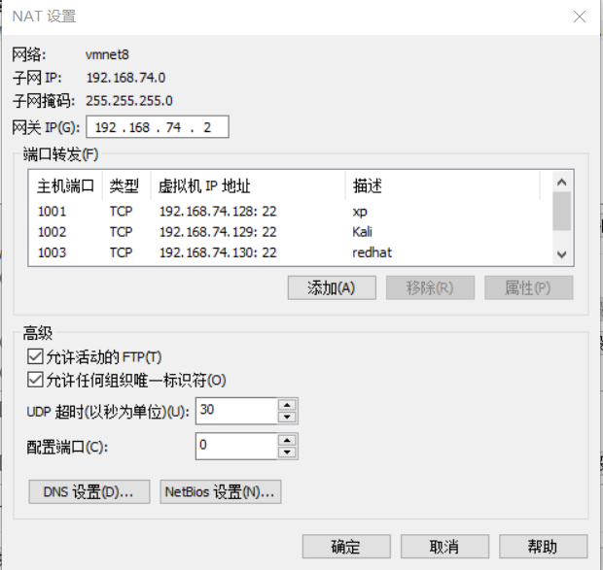

><https://blog.csdn.net/linuxnews/article/details/51249381>

1.[paulc@localhost ~]$ cd /etc/sysconfig/network-scripts/

2.[root@localhost network-scripts]# nano ifcfg-ens33

------------------------------------------------------

TYPE=Ethernet

BOOTPROTO=static

DEFROUTE=yes

PEERDNS=yes

PEERROUTES=yes

IPV4_FAILURE_FATAL=no

IPV6INIT=yes

IPV6_AUTOCONF=yes

IPV6_DEFROUTE=yes

IPV6_PEERDNS=yes

IPV6_PEERROUTES=yes

IPV6_FAILURE_FATAL=no

IPV6_ADDR_GEN_MODE=stable-privacy

NAME=ens33

UUID=98ec5b7c-b573-49d9-883e-be2a58e5d3b9

DEVICE=ens33

ONBOOT=yes

IPADDRO=192.168.74.130

GATEWAY0=192.168.74.0

PREFIX0=24

------------------------------

3.重启网卡并测试网络：

[root@localhost network-scripts]# [systemctl](http://www.linuxprobe.com/chapter-08/) restart network

关闭NetworkManager：  
系统：RedHat 7.2  
方式：  
systemctl status NetworkManager  
systemctl start NetworkManager 等等  
系统：RedHat 6.2  
service NetworkManager status | start | stop