X.X Measure Intracellular NAD⁺ and NADH (Colorimetric)

SOP NO.: X.X  Version: 1 | TITLE  Measuring intracellular NAD⁺ and NADH amount using colorimetric assay | Page 1 of 5
Last Reviewed Date:  Mar.04.2026 | SOP Author(s):  Xingjian Yang, Jeehwan Oh, JP van Pijkeren | Status:

Protocol adapted from the manufacturer https://www.abcam.com/en-us/products/assay-kits/nad-nadh-assay-kit-colorimetric-ab65348 and https://bio-protocol.org/en/bpdetail?id=1902&type=0. Other methods just for reference: https://www.frontiersin.org/journals/cellular-and-infection-microbiology/articles/10.3389/fcimb.2016.00145/full; https://www.sciencedirect.com/science/article/pii/S0043135406001916.

Background

NAD/NADH Assay Kit (Colorimetric) ab65348 provides a convenient and sensitive tool to quantify NAD⁺, NADH, and measure their ratio.
The NAD cycling enzyme mix in the kit specifically acts on NADH/NAD, but not NADP nor NADPH, in a cycling reaction which significantly increases sensitivity and specificity. There is no requirement to purify NADH/NAD from samples. The levels of both NADt (total NAD⁺ and NADH) and NADH can be easily measured; the level of NAD⁺ can be calculated by subtracting NADH from NADt. The assay is read by absorbance at 450 nm.

1. Required Equipment, Materials and Reagents:
Equipment: Microplate reader capable of measuring absorbance (OD) at 450 nm (colorimetric), bead beater, table top centrifuge (4℃), block heater (60℃)
Materials: 1.5 mL microcentrifuge tubes, tips, 96 well clear plate with clear flat bottom (colorimetric assay), 10 kDa Spin Column (Abcam, Catlog #: ab93349),
Reagents:
- NAD/NADH Assay Kit (Colorimetric) (Abcam, Catlog #: ab65348)
- DNase/RNase Free Distilled Water (Ultrapure, Catlog #: 10977023)
- DMSO (VWR, Catlog #: 97063-136)

Preparation

Reagent Preparation (only need to perform once for each kit): Day 0

Thaw Extraction Buffer II and Cycling Buffer I at room temp.

Thaw NADH Standard, NAD Cycling Enzyme Mix, Developer Solution, and Stop Solution (all vials) on ice. Keep the NAD Cycling enzyme Mix AWAY FROM LIGHT.

Briefly centrifuge vials at low speed prior to opening.

Reconstitute the reagents by:

NADH Standard II: Reconstitute NADH Standard II with 200 µL of pure DMSO to generate a 1nmol/µL (1 mM) NADH Standard II solution. Store at -20°C.

NAD Cycling Enzyme Mix: Reconstitute NAD Cycling Enzyme Mix in 220 µL Cycling Buffer I. Keep on ice protected from light during the assay. Store at -80°C.

Developer Solution II: Reconstitute Developer Solution II in 1.2 mL of ddH2O. Pipette up and down several times to ensure the pellet is completely dissolved. Do not vortex. Store at - 20°C.

Extraction Buffer II and Cycling Buffer I: Ready to use as supplied. Equilibrate to room temperature before use. Store at 4°C or at -20°C.

Stop Solution II: Ready to use as supplied. Equilibrate to room temperature before use. Store at - 20°C

Reconstituted reagents are stable for 2 months.

Culture Preparation: Day 1-3

Streak L. reuteri strain(s) of interest on MRS agar plate(s) with corresponding conditions from cryo stock and incubate at 37°C in the hypoxic chamber until clear and separated colonies appear on the plate(s).

Innoculate an isolated colony into 10 mL MRS media with corresponding conditions in a 15mL centrifuge tube and incubate in a 37°C incubator overnight (~18 hrs). Prewarm 10 mL MRS media with corresponding conditions (different sugars, antibiotics, etc.) in a 15mL centrifuge tube at 37°C for the next day.

Wash and subculture the overnight culture(s) into prewarmed MRS media with corresponding conditons to reach a final concentration of OD₆₀₀=0.1/mL by:

Measure OD₆₀₀ of overnight culture(s)

Calculate the amount of overnight culture(s) you need to subculture 10 mL media to reach a final OD₆₀₀ = 0.1/mL.

Transfer the required amount of overnight culture(s) to 1.5 mL centrifuge tube(s), centrifuge at 13000 rpm for 30 secs, remove the supernatent.

Wash the cells with 1mL dH₂O, resuspend by pipetting, centrifuge at 13000 rpm for 30 secs, remove the supernatent

Resuspend the cells in 100 µL dH₂O

Transfer the resuspended culture(s) into the prewarmed MRS media with corresponding conditions and incubate the culture at 37°C incubator until cell harvest.

NOTE: NAD⁺/NADH ratio changes at different growth phases. It is recommended to run growth curves for each of your conditions and determine the normalized cell harvesting time before you run this assay.

After incubation is done, harvest the cells at OD₆₀₀ = 2/mL for 1mL by:

Measure OD₆₀₀ of the culture(s)

Calculate the amount of culture(s) you need for harvesting 1mL cells of OD600 = 2/mL

Centrifuge at 13000rpm for 1 min at 4°C, remove the supernatent(s), repeat this step if your OD is too low and samples need to be concentrated.

Wash the cells with 1mL dH2O, resuspend by pipetting, centrifuge at 13000 rpm for 1 min at 4°C, remove the supernatent as much as possible without touching the pellet.

Store the cell pellet(s) at -80°C until next step.

NOTE: You have the option to adjsut the OD₆₀₀ for harvesting cells depending on the sensitivity of the assay. OD₆₀₀ = 2/mL worked for me.

Sample Preparation (NAD⁺/NADH extraction): Day 4

NOTE: NADH is fluorecent and sensitive to light. Try your best to keep your extractions away from light. It is recommended to perfrom the assay in a dark room with only an indirect light source to prevent oxidation of NADH.

Thaw freezed pellet(s) on ice and resuspend with 1 mL Extraction Buffer II.

Transfer the resupended cells into the centrifuge cap micro tube containing 0.6 g Zirconia glass beads.

Disrupt bacterial cells by two cycles of bead-beating for 90 secs with a 30 secs interval on ice.

Vortex the extraction(s) for 10 seconds.

Prepare cell-free extract by centrifuging the sample at 15000 rpm for 3 mins at 4°C

Collect supernatant (containing extracted NAD/NADH, about 600uL ) and transfer into a 10 kDa Spin Column (ab93349)

Add sample(s) to the spin column, centrifuge at 10,000 x g for 15 minutes at 4°C. If there are leftovers in the spin column(s), spin for a longer time.

Transfer 450 uL filtrate into a new 1.5 mL centrifuge tube.

You have the option to store the filtrate(s) at -20°C until next step. Remember to keep away from light.

Operation: Day 4

Standard Preparation

NOTE: Always prepare fresh standard samples for every use.

NOTE: Diluted standard samples must be used within 4 hours.

Add 5 µL NADH Standard II to 495 µL Extraction Buffer II to reach a final concentration of 10 µM (10 pmoles/µL).

Gently pipette up and down a few times to ensure all standard is removed from tip.

Mix by inversion.

Using the diluted 10 pmoles/µL NADH standard, add 0, 2, 4, 6, 8, 10 µl NADH Standard into a series of wells, generating 0, 20, 40, 60, 80, 100 pmoles/well of NADH Standard. A template layout for 96-well plate is provided below.

Adjust the volume to 50 µl/well with Extraction Buffer II. It is recommended to plate in duplicates. 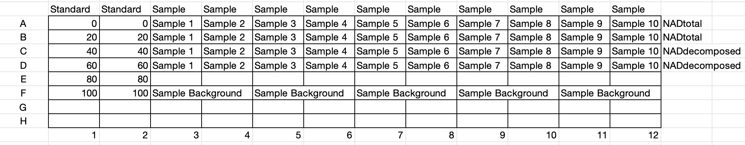

NAD+ Decomposition (if NADH detection is needed)

Aliquot 200 µL of extracted samples into 1.5 mL microcentrifuge tubes.

Heat samples to 60°C for 30 minutes in a heating block. Under these conditions, all NAD+ will be decomposed while the NADH will still be intact.

Cool samples on ice for 5 minutes.

If precipitation occurs, centrifuge for 5 minutes at 4°C at top speed in a microcentrifuge to remove any insoluble material.

Label samples as NAD decomposed samples.

Reaction Well Set Up

Standard wells = 50 µL standard dilutions.

Sample Background wells = 1 – 50 µL samples (adjust volume to 50 µL/well with Extraction Buffer II). I use 50 uL samples directly.

NADtotal Sample wells = 1 – 50 µL samples (adjust volume to 50 µL/well with Extraction Buffer II). I use 50 uL samples directly.

NADH Sample wells = 1 – 50 µL NAD decomposed samples (adjust volume to 50 µL/well with Extraction Buffer II). I use 50 uL samples directly.

Prepare required amount of Reaction Mix and Background Reaction Mix as stated in the calculation and box below:

X µL component x (Number reactions +1)
Component | Reaction Mix (µL) | Background reaction Mix(µL)
Cycling Buffer I | 98 | 100
NAD Cycling Enzyme Mix | 2 | 0

Mix Master Reaction Mix by inversion

Add 100 µL of the Reaction Mix to each standard and sample well. Use a clean tip for each well.

Add 100 µL of Background Reaction Mix to sample background control sample wells.

Incubate plate at room temperature for 5 minutes to convert NAD to NADH.

Add 10 µL of Developer Solution II into each well and mix. NOTE: The color develops very fast, you need to be quick or use a multichannel pipette if you have a large amount of sample to test at the same time

Let the reaction cycle at room temperature for 1-4 hours or longer depending on the reading.

Measure plate at OD 450 nm multiple times or in kinetics mode during the 1 – 4 hours. There is a protocol named Abcam NAD/NADH 1-4 hours saved in the Glomax Plate Reader for direct use.

The plate can be read multiple times while the color is still developing. Longer incubation times maybe needed depending on the OD reading.

OPTIONAL: The reaction can be stopped by adding 10 µL of Stop Solution II into each well and mixing thoroughly. The color should be stable for 48 hours in a sealed plate after addition of the Stop Solution II.

Calculation

An organized excel spreadsheet for calculations is here: https://github.com/Memoryjianjian/VPL_NAD-H-_Calculations_Template.git

For your reference:

Concentration of NADt or NADH in the test samples is calculated as:

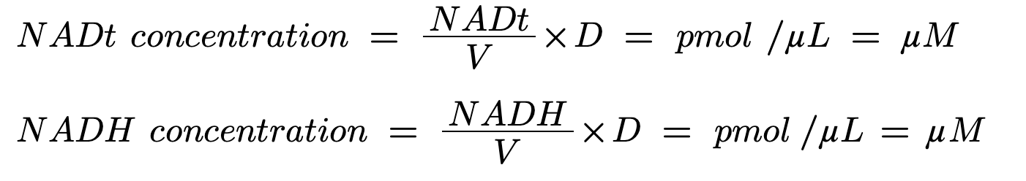

Where:

NADt = amount of NADt in the sample well calculated from standard curve (in pmoles).

NADH = amount of NADH in the sample well calculated from standard curve (in pmoles).

V = sample volume added to the reaction well (in µL).

D = sample dilution factor (before addition to the well).

NAD/NADH Ratio is calculated as:

