**Inspection by Innova Code to The Programmers**

**Members:**

Cristian Felix

Ariel González

Isaac Escobar

Richard Gualotuña

**Rubric:**

Requirements 9.5/10

Use Case D 9.5/10

Class D 9/10

Code 3/10

Executable 8.5/10 .

**Final Grade Total: 39.5**

**Description**

1. **Github**
2. **Requirements:**  -1 Contradictions in document when says it must be simple but implementing html

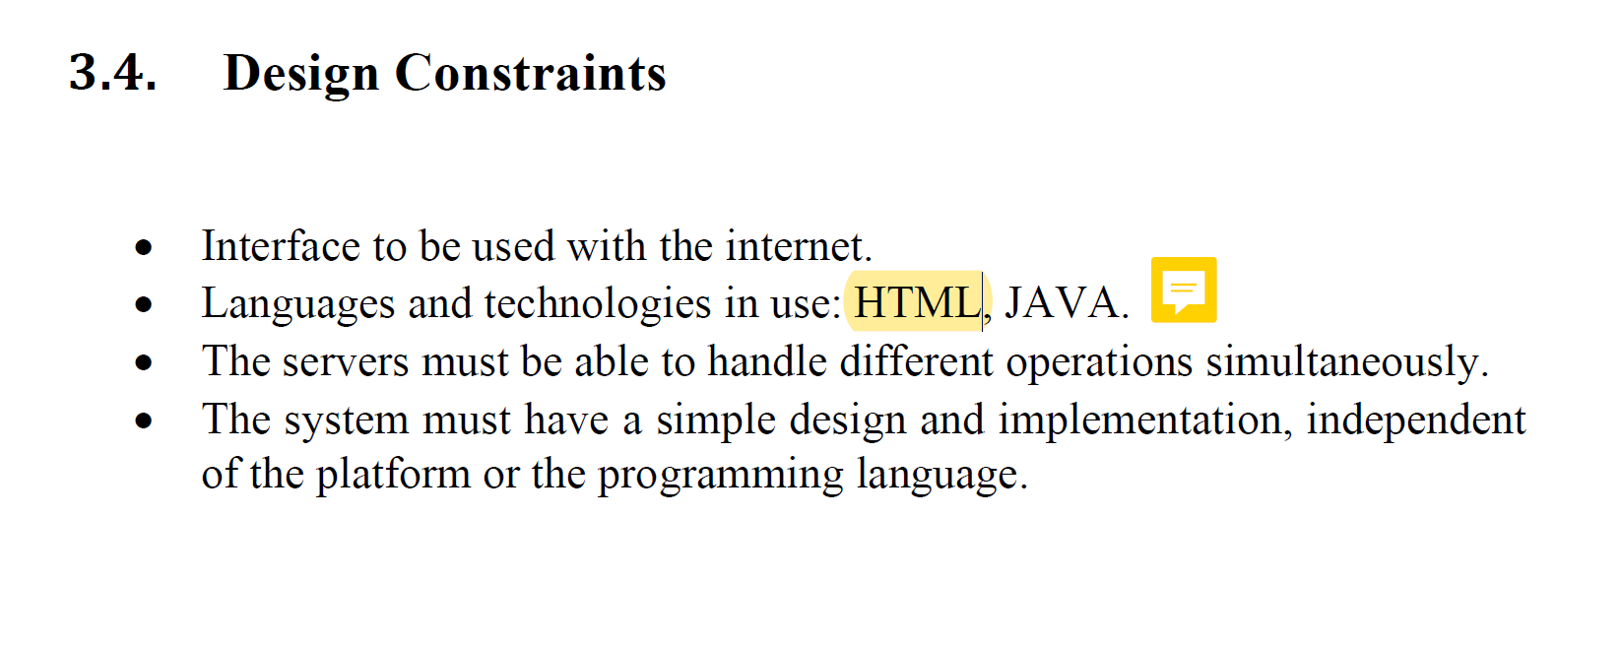

1. **Use Case D:** -0.5;the relationship are badly use
2. **Class D** -1;the relationship are inverse, and use diferent verbs in the same situation
3. **Code:** -7;unused import libraries, redundant type arguments, Indentation, declaring variables after methods, creating files in main method.

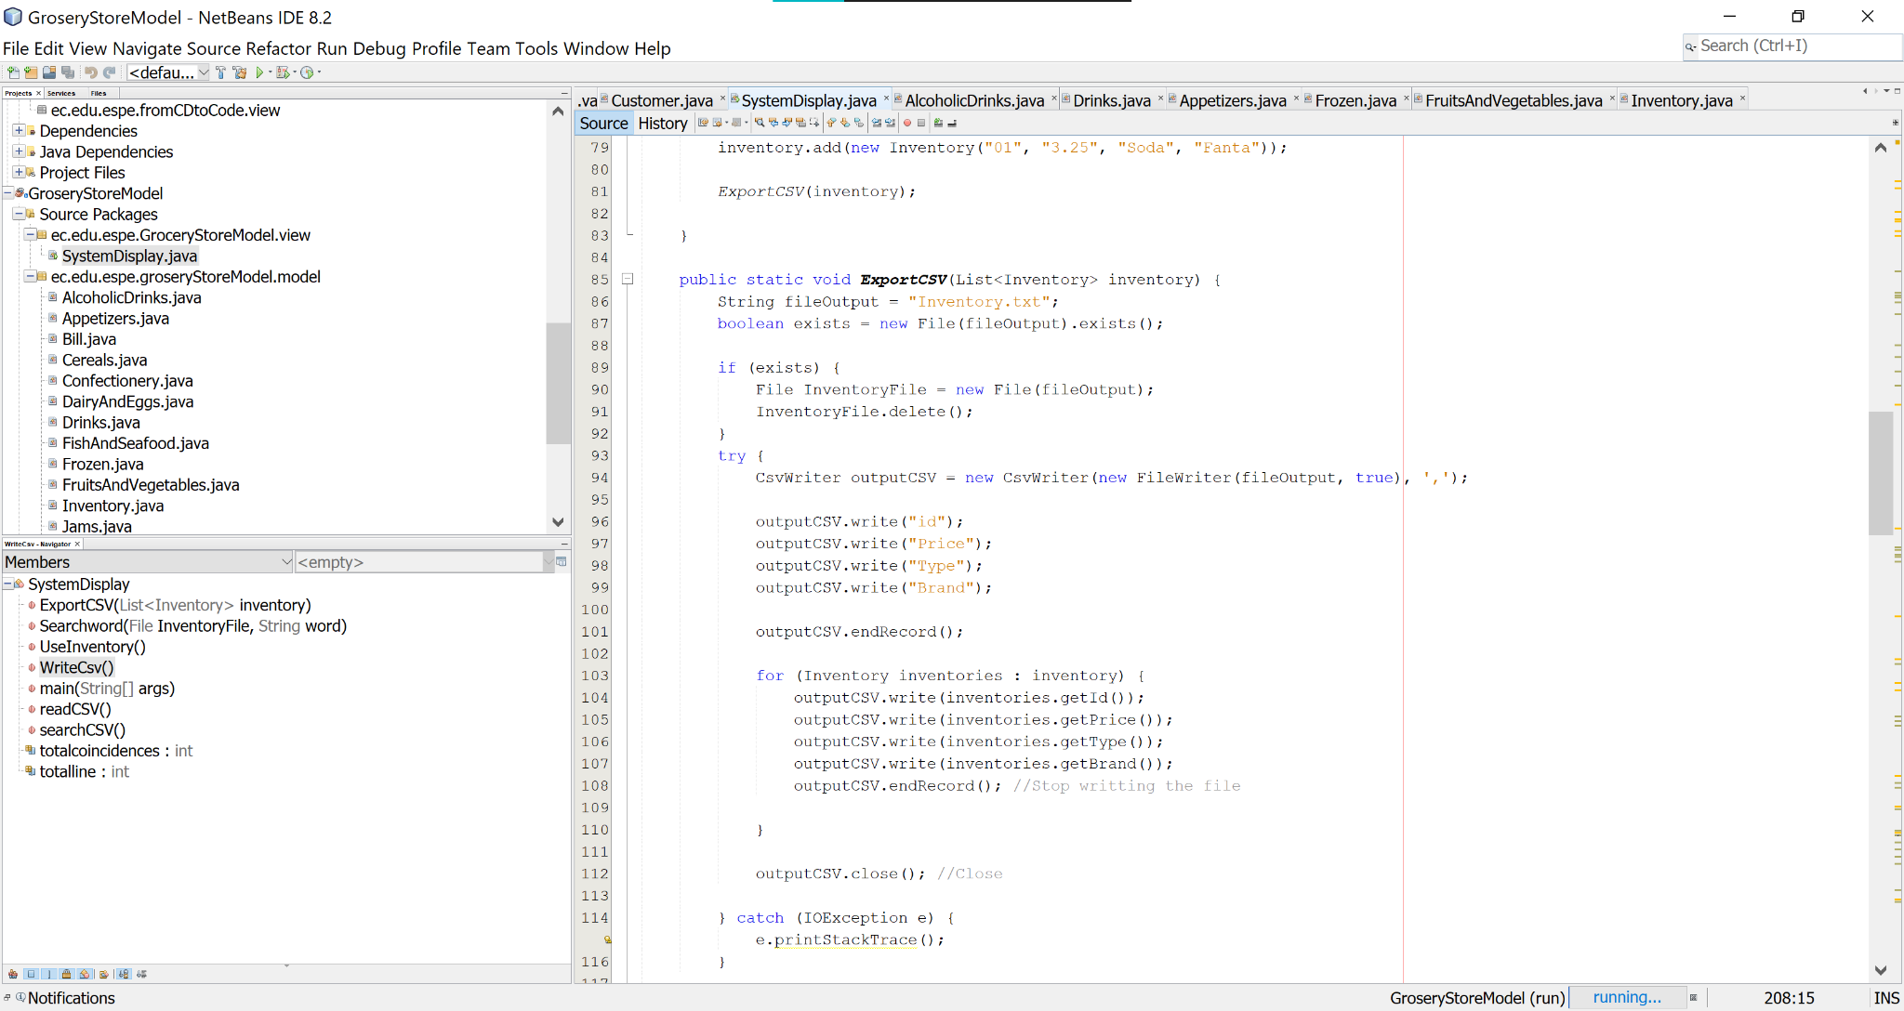

1. **Executable**: -1.5; option 2 shoppingcart doesn’t work, option 3 Bylling system doesn’t work, invalid products in csv file.

