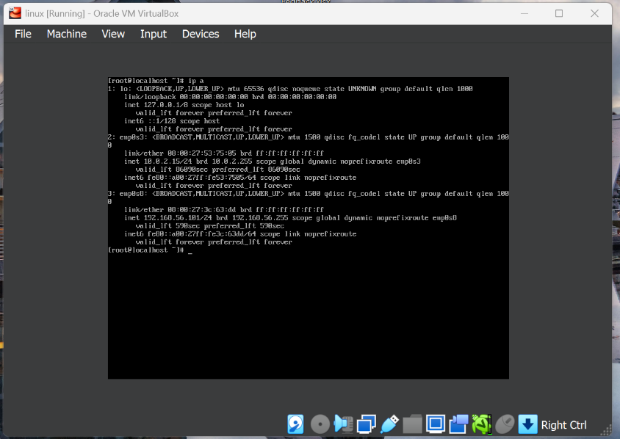
1. Install CentOS /RHEL

2. What is the difference between cat, more and command?
Cat shows all the file content in screen
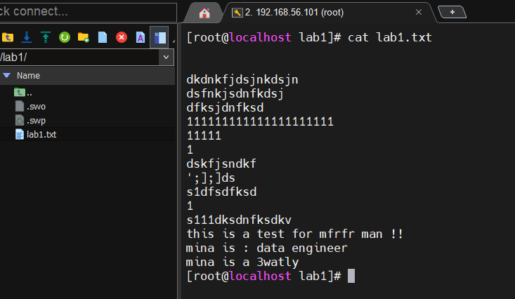

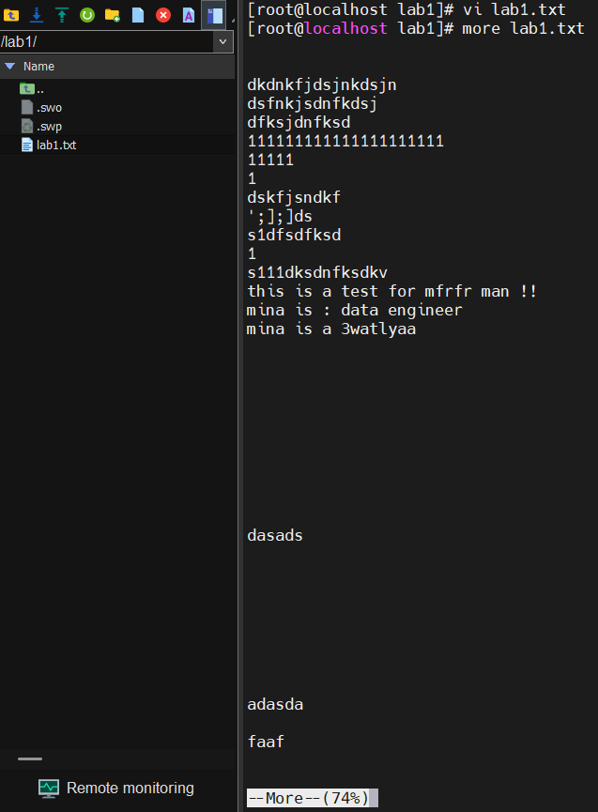
More is used to make the file as slides and divide it to more slides like this:
3. What is the difference between rm and rmdir using man?
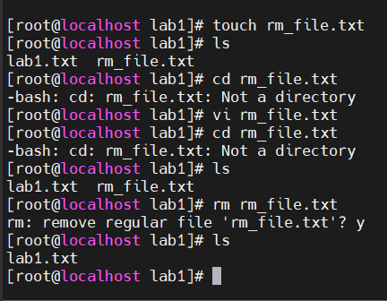
Rm is responsible for remove files like .txt in my example here

Rmdir is used to remove the directory based on the path is right not inside it like that.
Rmdir is responsible for deleting the dirs but when it is empty
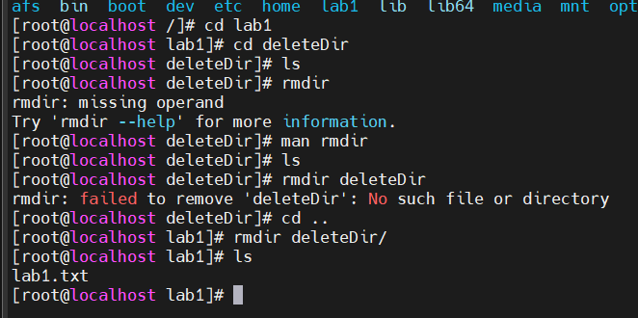

4. Create the following hierarchy under your home directory:
a) Remove dir11 in one-step. What did you notice? And how
did you overcome that?
I notice that the dir should removed with rm -r to delete the related files and dir
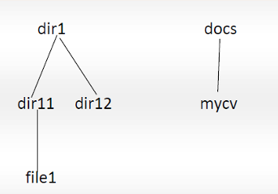
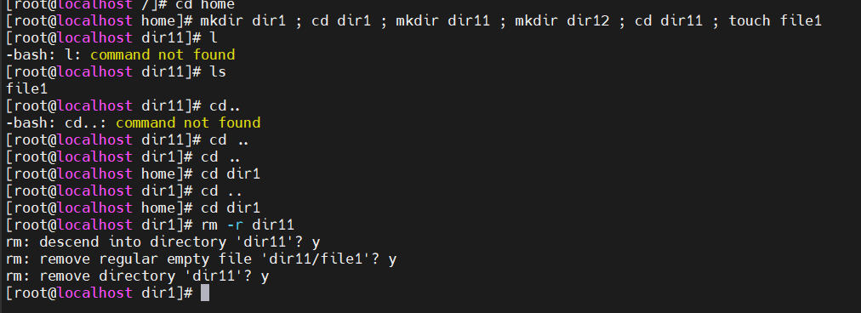

b) Then remove dir12 using rmdir–p command. State what happened to the hierarchy (Note: you are in your home directory).
It will delete the dir from the main dir that's because it hasn't no files
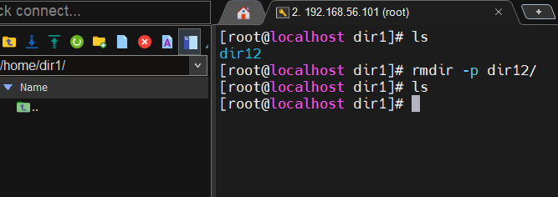

c) The output of the command pwd was /home/user. Write the absolute and relative path for the file mycv
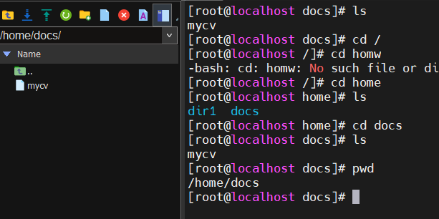

7. You are in /usr/bin, list four ways to go to your home directory

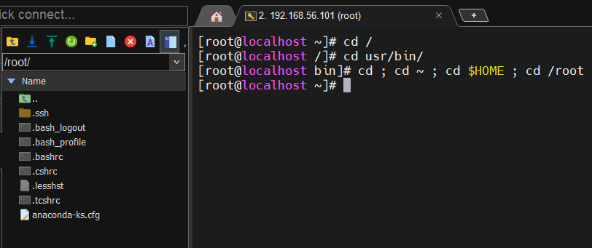

8. List Linux commands in /usr/bin that start with letter w
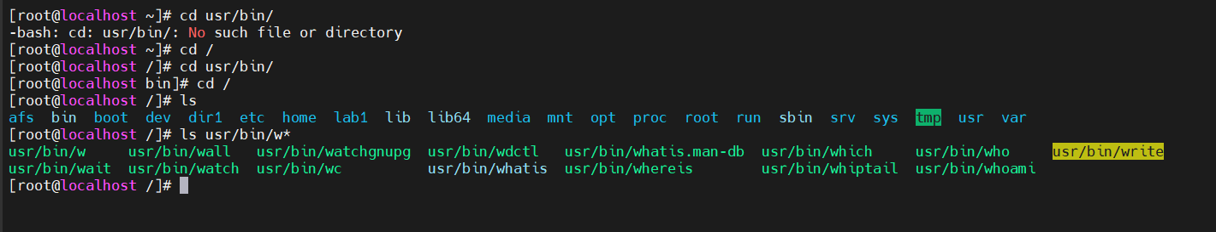

9. Display the first 4 lines of /etc/passwd
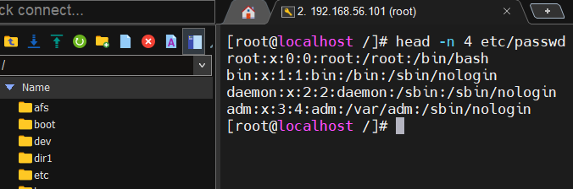

10. Display the last 7 lines of /etc/passwd
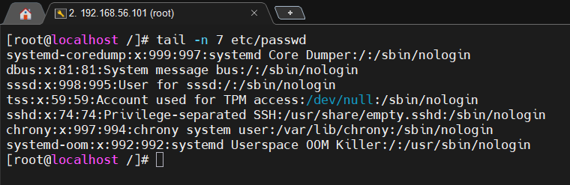

11 . Display the man page of the passwd file.
