- Create the following directories: dir1, dir2, dir3, and copy them and their contents to /tmp. Ans:
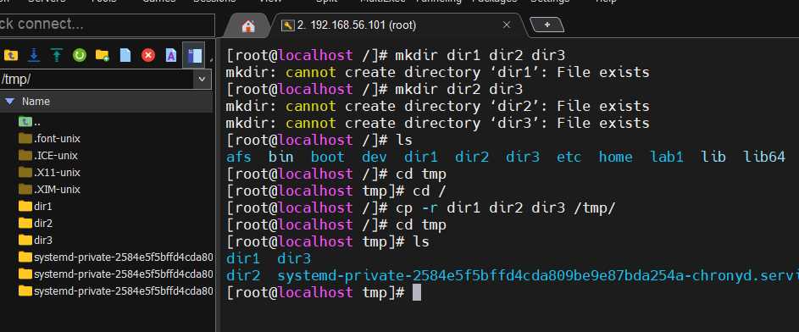

- Move back the three directories with their contents from the last step to /opt. Ans:
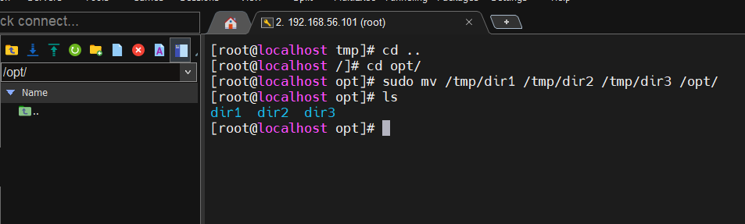

- Create nested directories in one command. Example: mkdir Egypt/Alex/mycompany Ans:
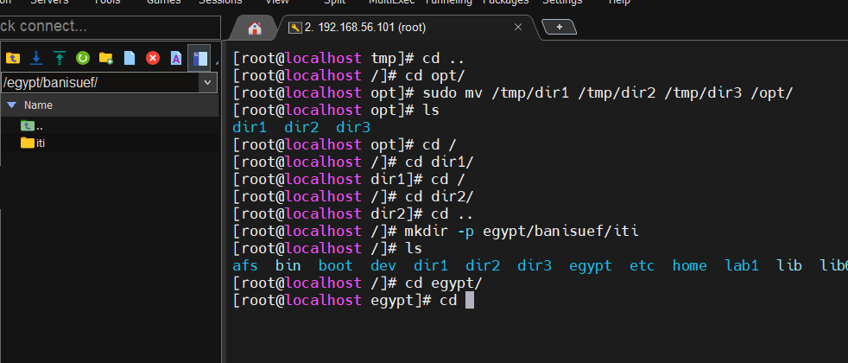

- Create a directory named lab_dir in your home directory, and inside it, create three empty files named file1.txt, file2.txt, and file3.txt. Ans:
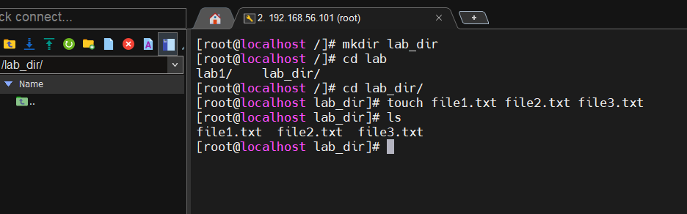

- Go to the newly created lab_dir directory, then go back to your home directory using a relative path. Ans:

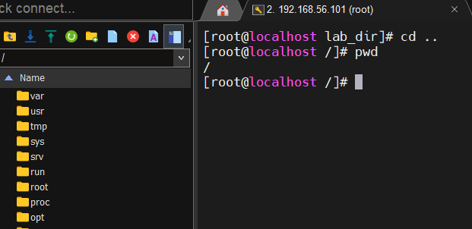
- Copy file1.txt to your home directory and rename it to file1_backup.txt. Ans:
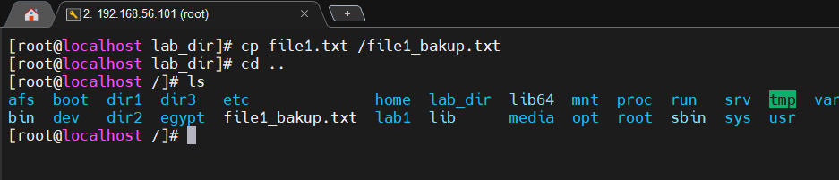

- Move file2.txt into a new folder called moved_files/ and rename it to file2_renamed.txt. Ans:
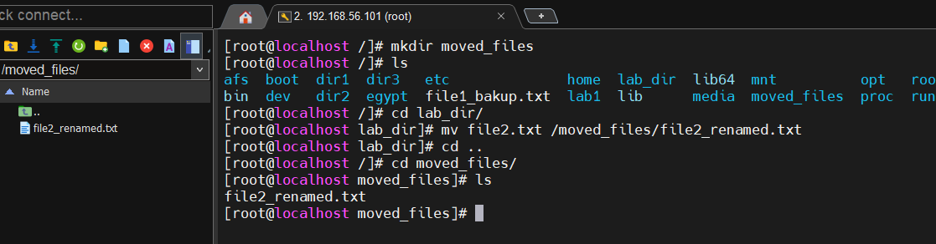

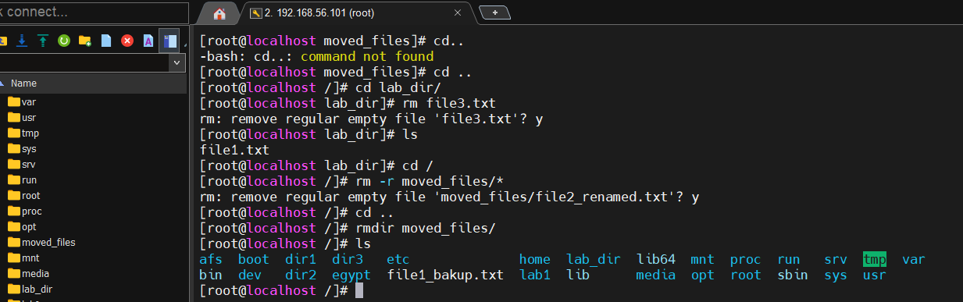
- Delete file3.txt and then delete the moved_files directory (after deleting its contents). Ans:

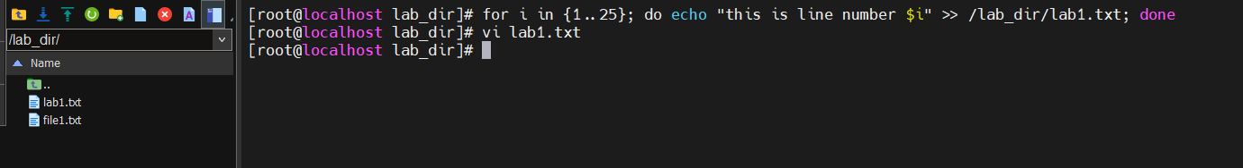
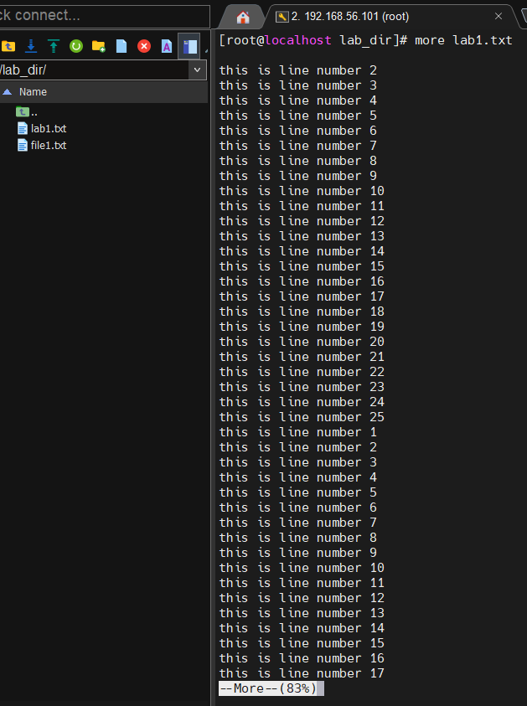
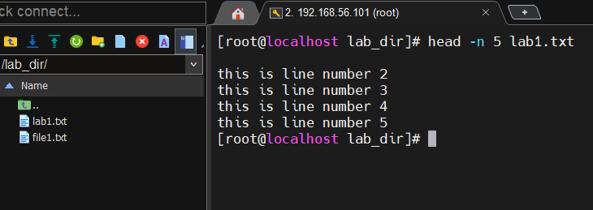
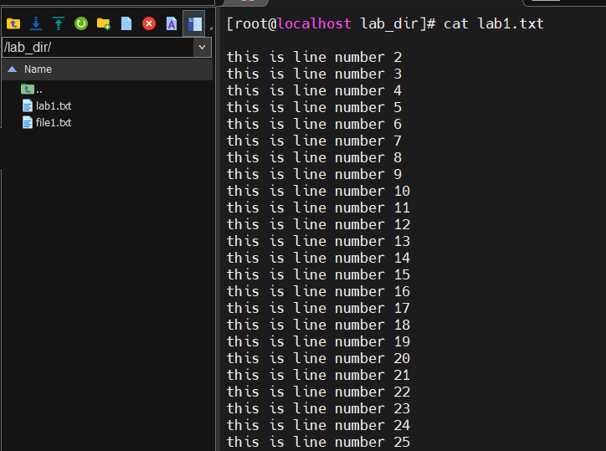
- Create a text file with more than 20 lines using a loop, then use: • cat to view all contents • more and less to scroll • head to show top 5 lines • tail to show last 5 lines Ans:
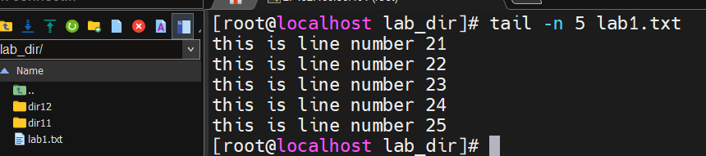
- List files in long format with hidden files. Then list them sorted by modification time. Ans:
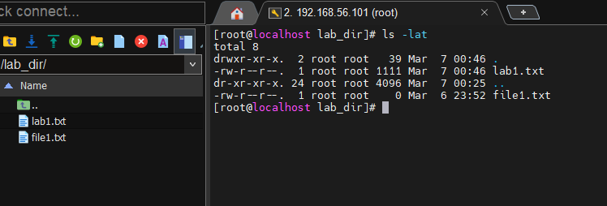

- List all the files/directories that are starting with "b", followed by any two characters, and ending with "k". Ans:
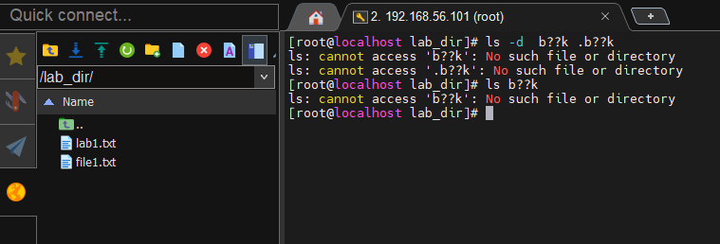

- Create a directory called archive, then move all .txt files into it, list the contents, and show the first 3 lines of each file. Ans:
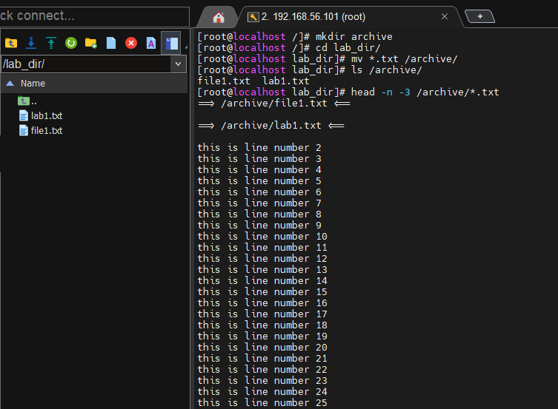

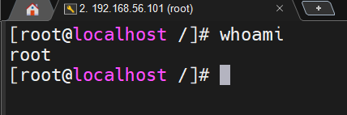
- Know what user you are logged in with. Ans:

- Change the password of a user and root. Ans:
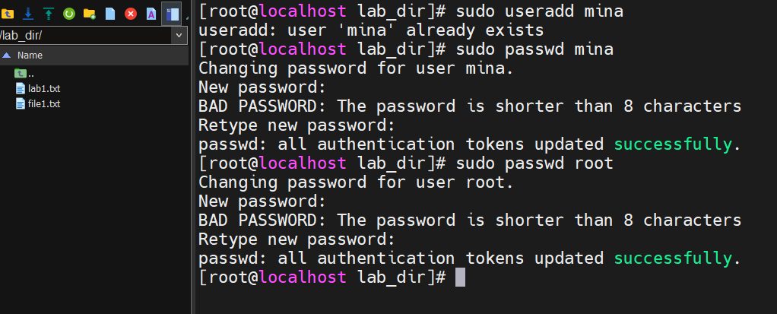
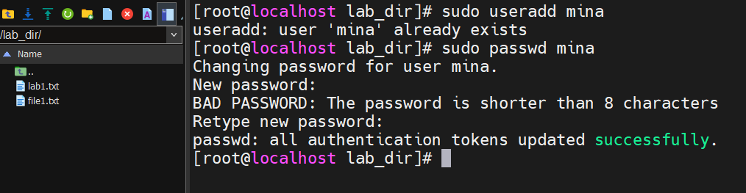

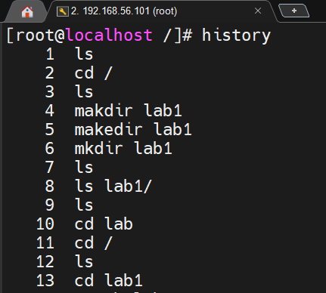
- Display all the previous commands that you have used. Ans:

- last users logged in Ans:

