1. Create a user account with the following attribute
Username: yourname
Fullname/comment: yourname iti
Password: yourname
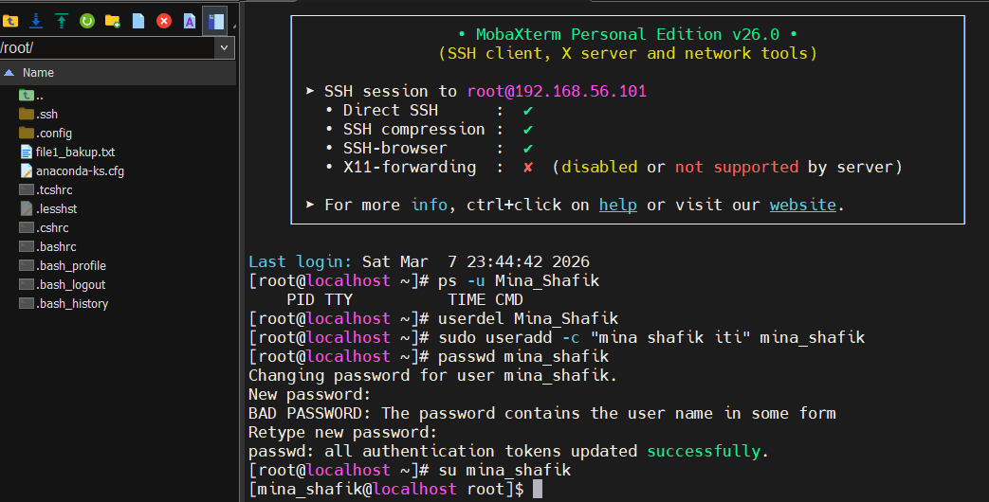
2. Create a user account with the following attribute
Username: baduser
Full name/comment: Bad User
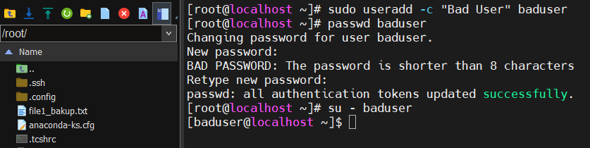
Password: baduser

3. Create a supplementary (Secondary) group called pgroup with group ID of 30000
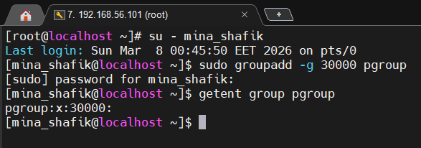

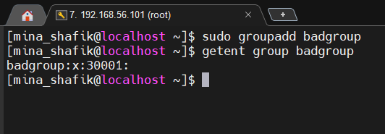
4. Create a supplementary group called badgroup

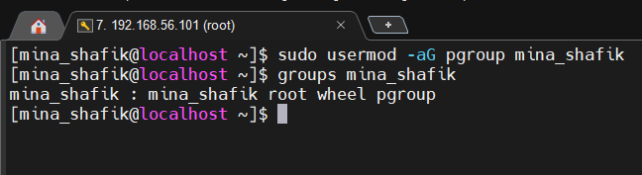
5. Add yourname user to the pgroup group as a supplementary group

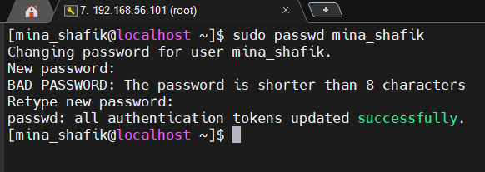
6. Modify the password of yourname’s account to password

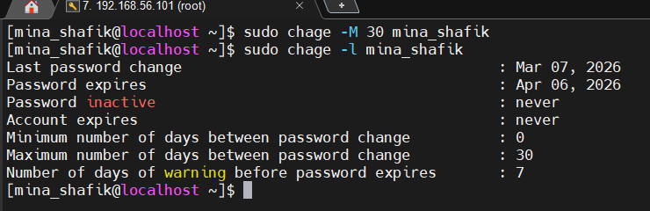
7. Modify yourname’s account so the password expires after 30 days

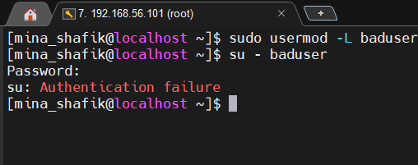
8. Lock bad user account so he can't log in

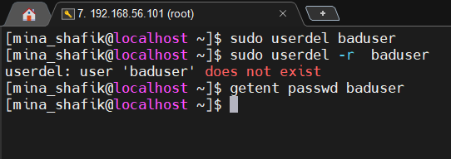
9. Delete bad user account

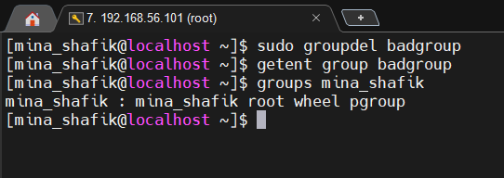
10. Delete the supplementary group called badgroup.

11. Create a folder called myteam in your home directory and change its permissions to
read only for the owner.
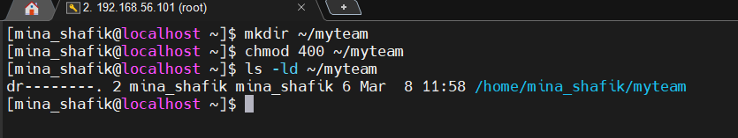

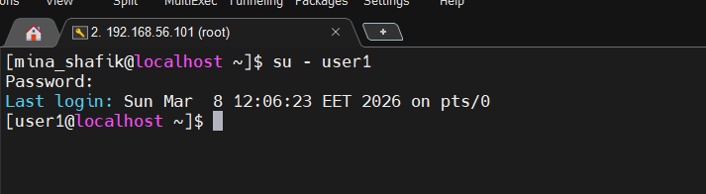
12. Log out and log in by another user

13. Try to access (by cd command) the folder (myteam)
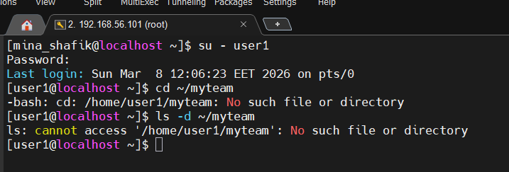
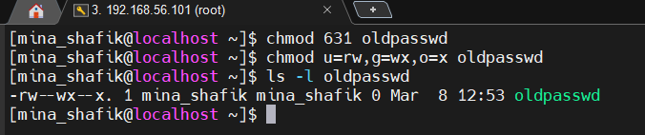
14. Using the command Line: Change the permissions of oldpasswd file to give owner read and write permissions and for group write and execute and execute only for the others (using chmod in 2 different ways)

15. Change your default permissions to be no permission to everyone then create a
directory and a file to verify.
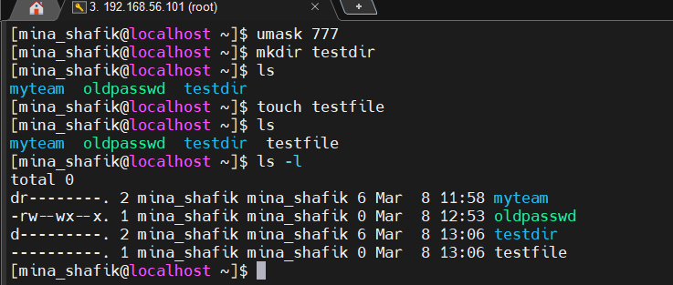

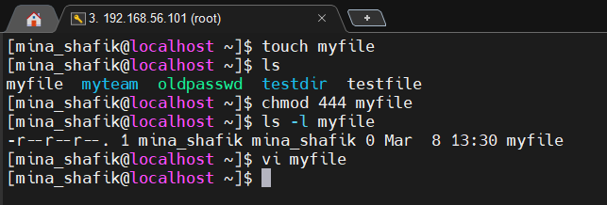
16. Create a file with permission 444. Try to edit in it and to remove it? Note what happened

17. What is the difference between the “x” permission for a file and for a directory?
For a file, x means the file can be executed as a program or script.
For a directory, x means you can enter/traverse the directory.
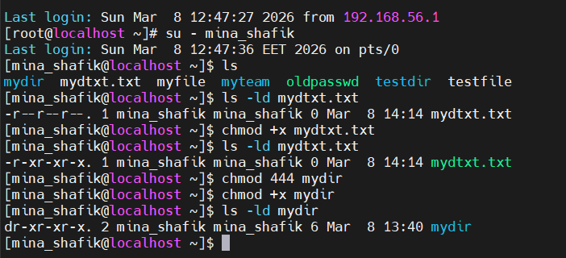
18. What are the minimum permission needed for:
Copy a directory (permission for source directory and permissions for target parent directory)
Source directory:
Need read (r) to list files
Need execute (x) to access/traverse the directory and its contents
Target parent directory:
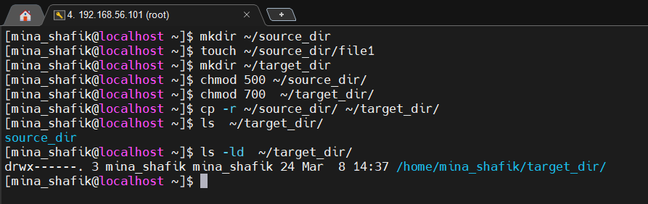
Need write (w) to create new directory in it, Need execute (x) to access the directory

Copy a file (permission for source file and and permission for target parent directory)
Source file:
Need read (r)to read the content
Target parent directory:
Need write (w) to create the new file
Need execute (x) to access the directory
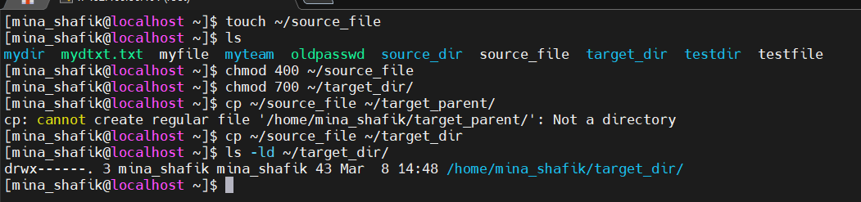
Delete a file
File itself:
No specific permission required on the file
Parent directory:
Need write (w) to remove an entry
Need execute (x) to access the directory
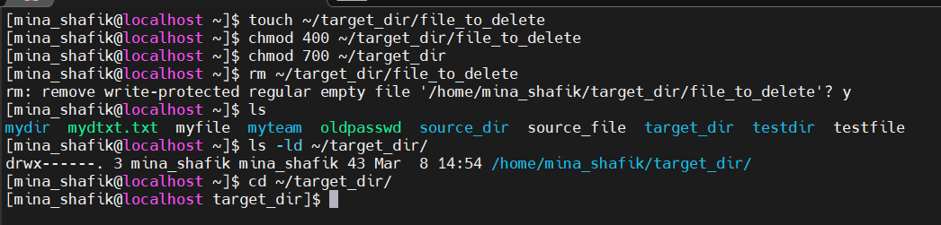
Change to a directory
Directory:
Need execute (x) only allows you to enter/traverse
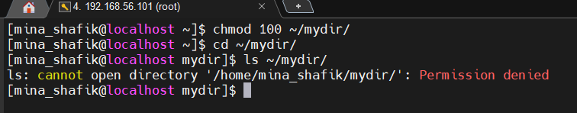

List a directory content (ls command)
Directory:
r to list file names
x to access/traverse the directory
ls -l also requires x to see file details.
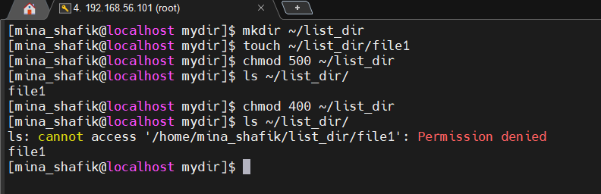
View a file content (more/cat command), Modify a file content
File:
r → to read the content
Parent directory:
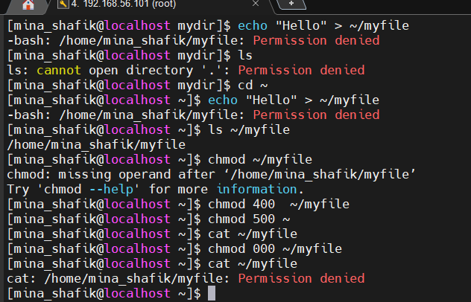
x → to access the directory to reach the file

Modify a file content
File:
w → write to the file
Parent directory:
x → to access the file
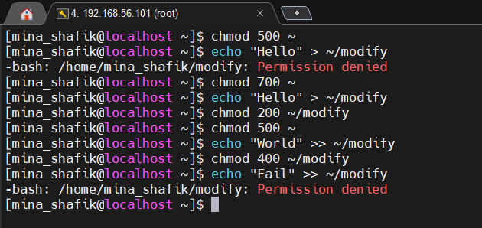

VIM Editor:
Command to install vim → dnf install vim -y
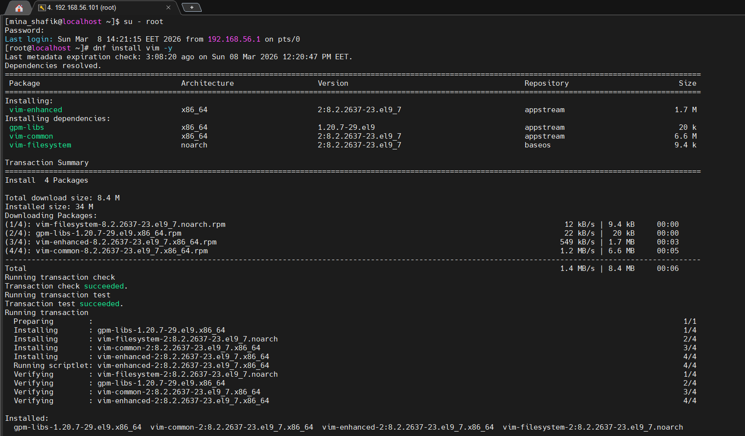
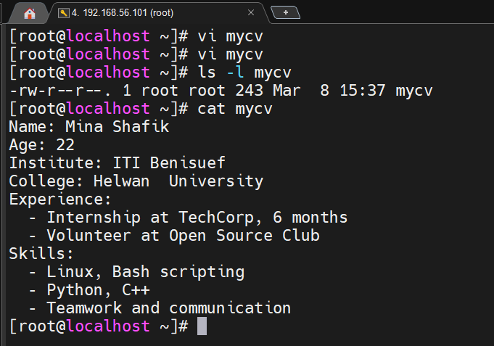
1. Using vi write your CV in the file mycv. Your CV should include your name, age, school, college, experience,...

2. Open mycv file using vi command then: Without using arrows state how to:
a. Move the cursor down one line at time.
j → moves the cursor down one line
b. Move the cursor up one line at time.
k → moves the cursor up one line
c. Search for word age
The cursor will jump to the first occurrence of “age”.
Press n jump to next occurrence.
Press N jump to previous occurrence.
d. Step to line 5 (assuming that you are in line 1 and file is more than 5 lines).
Moves the cursor directly to line 5.
(Example: 1G → first line and so on, G alone → last line)
e. Delete the line you are on and line 5.
Delete the line you are currently on: dd
Delete line 5 specifically: Go to line 5: 5G
Delete that line: dd
f. How to step to the end of line and change to writing mode in one-step
Press A
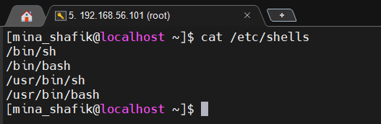
3. List the available shells in your system.

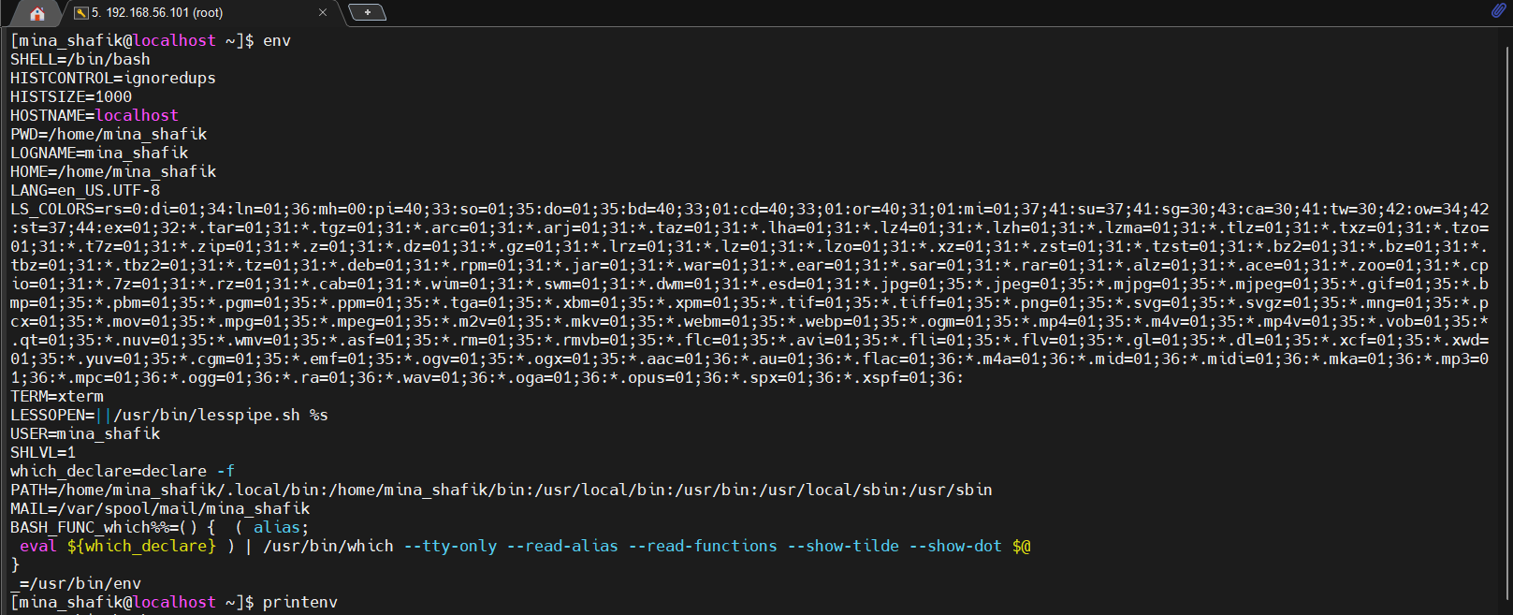
4. List the environment variables in your current shell.

5. What are the commands that list the value of a specific variable?
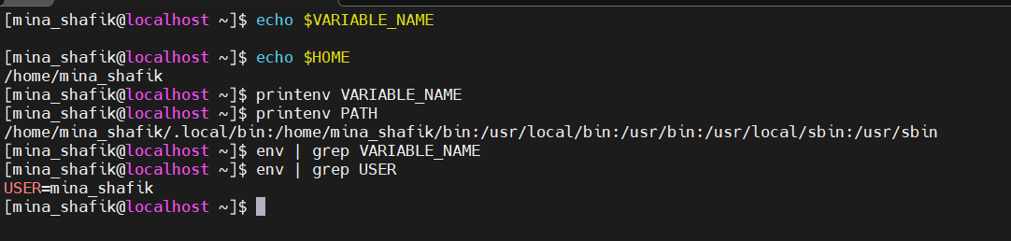
6. Execute the following command :
echo \ then press enter
What is the purpose of \ ?
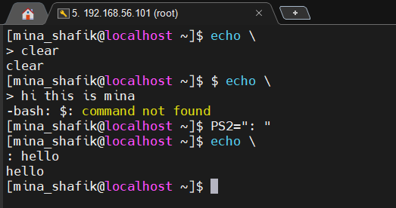
Notice the prompt ”>” what is that? and how can you change it from “>” to “:”.

7. Create a Bash shell alias named ls for the “ls –lta” command
