LAB 04

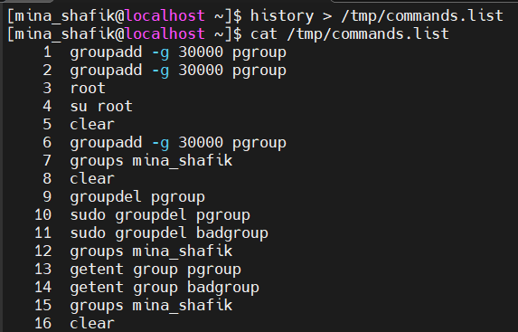
1. List the user commands and redirect the output to /tmp/commands.list
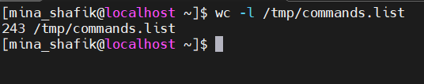
2. Count the number of user commands
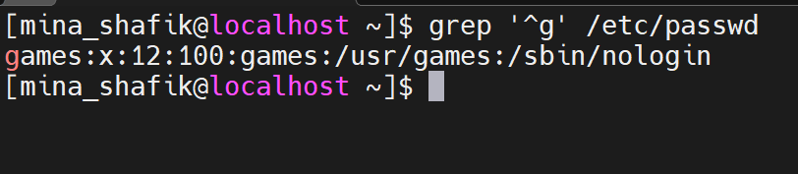
3. Get all the users names whose first character in their login is 'g'.
4. Get the logins name and full names (comment) of logins starts with "g".
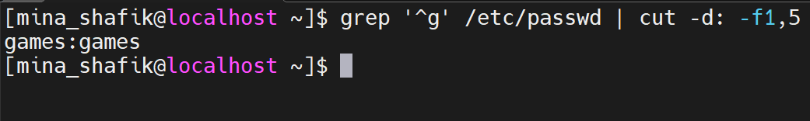
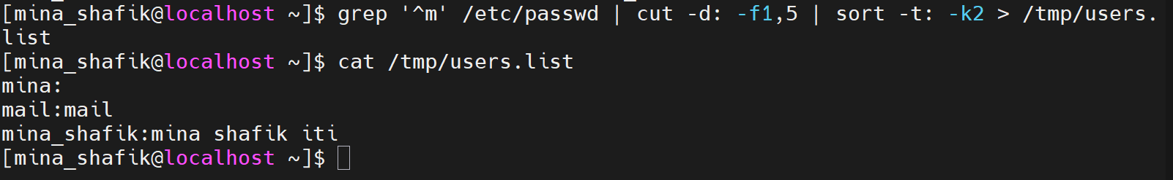
5. Save the output of the last command sorted by their full names in a file.
6. Display the number of users who is logged now to the system.
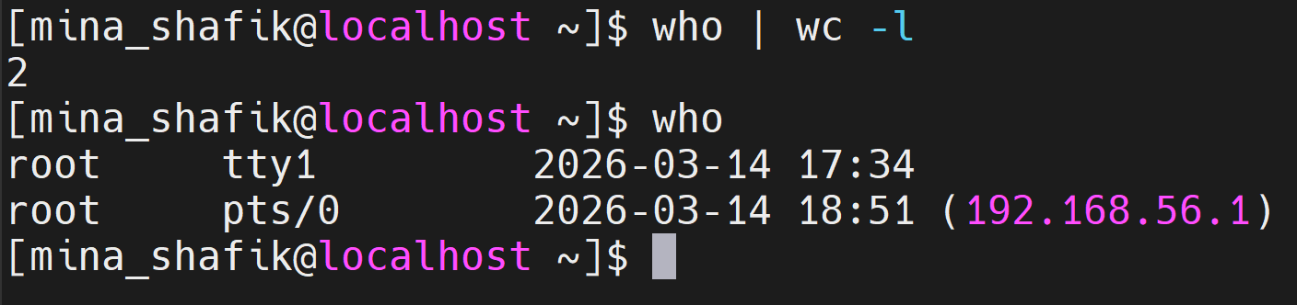
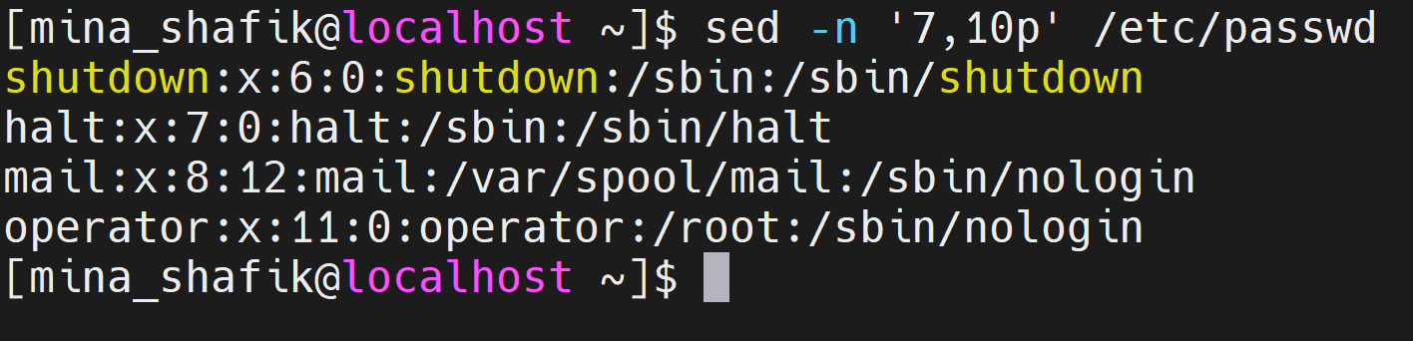
7. Display lines 7 to line 10 of /etc/passwd file
8. What happens if you execute:

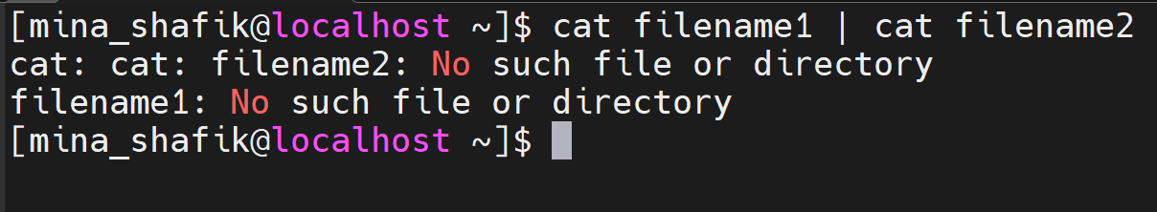
a. cat filename1 | cat filename2

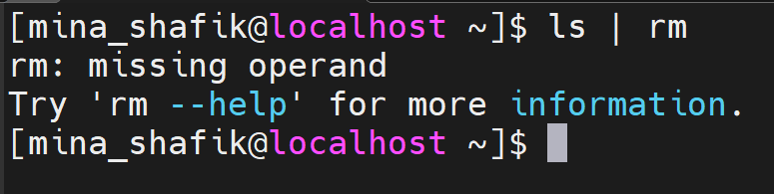
b. ls | rm

c. ls /etc/passwd | wc –l
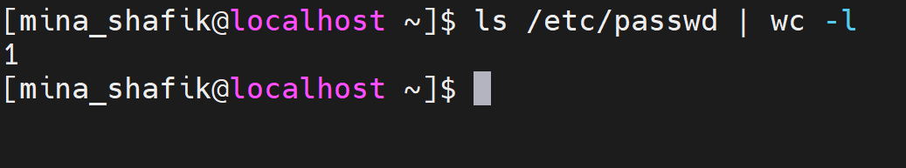
LAB 04 – Processes

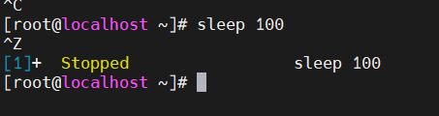
1. Issue the command sleep 100.


2. Stop the last command.

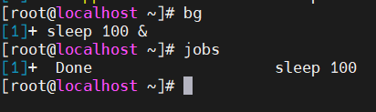
3. Resume the last command in the background.

4. Issue the jobs command and see its output.

5. Send sleep command to foreground and send it again to the background.
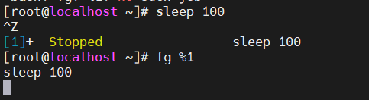
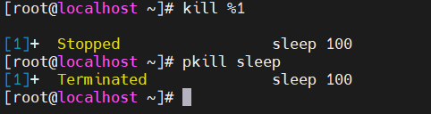
6. Kill the sleep command.

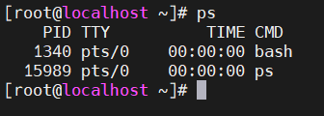
7. Display your processes only.
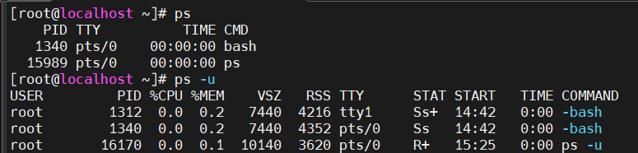
8. Display all processes except yours.
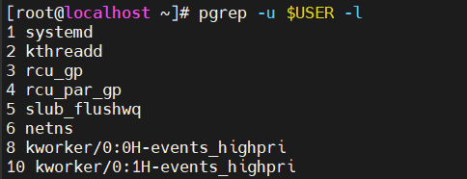
9. Use the pgrep command to list your processes only.
10.Kill your processes only.
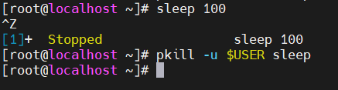

LAB 04: Exploring the Logging System
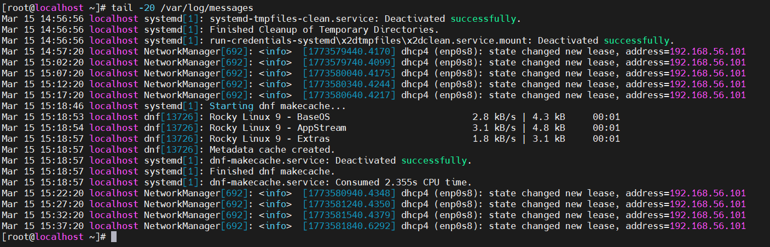
1. Display the last 20 lines of the system log file /var/log/messages.
It contains all details about the log and who logged what, when and how

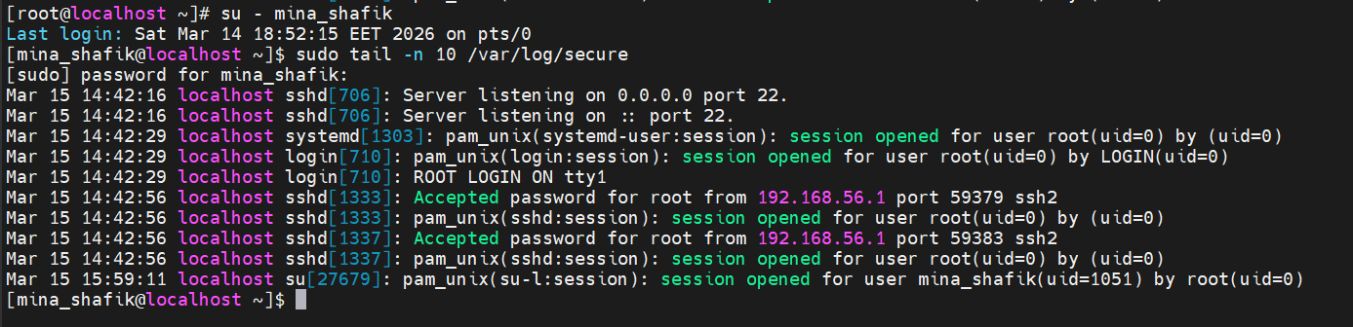
2. Display last 10 lines of /var/log/secure , explain what this file contains.
SSH login attempts (successful and failed)
User authentication events
sudo command usage
su (switch user) attempts
PAM authentication messages
Security warnings

3. Use the tail -f command to monitor /var/log/messages in real time.
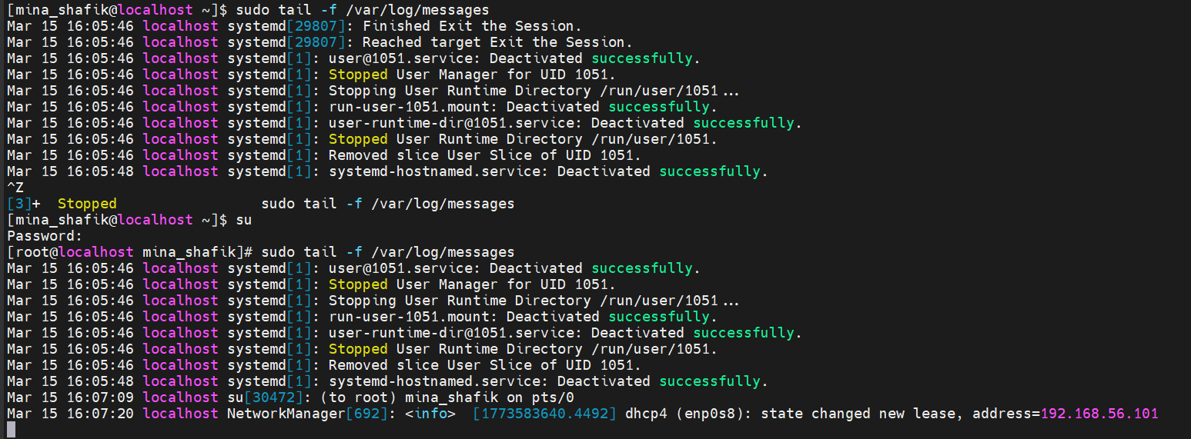
Open another terminal and log in/out, then observe the output.

It’s about the system messages that if there are any changes like switching the user in out case

4. What is the difference between /var/log/messages and /var/log/dmesg?
/var/log/messages: General system log, System events, service messages, warnings, errors, network activity, and daemon logs

/var/log/dmesg: Kernel boot log,Messages generated by the Linux kernel, mainly during system startup and hardware detection

Using journalctl
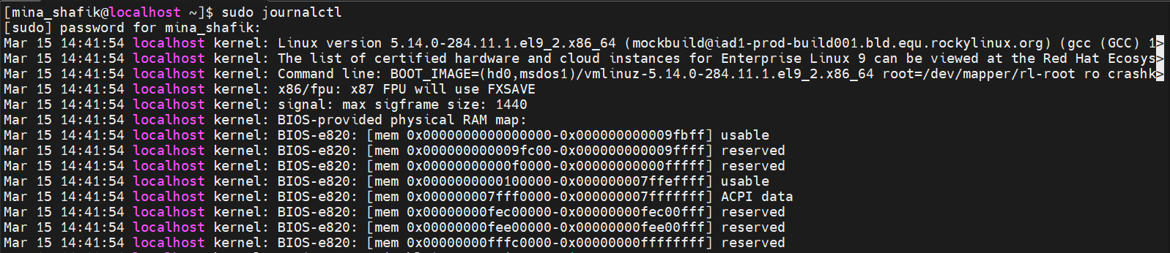
5. Display all journal log entries using journalctl.

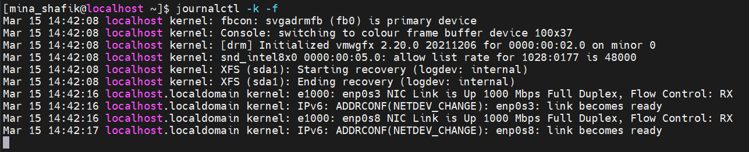
6. Display only kernel messages using journalctl.
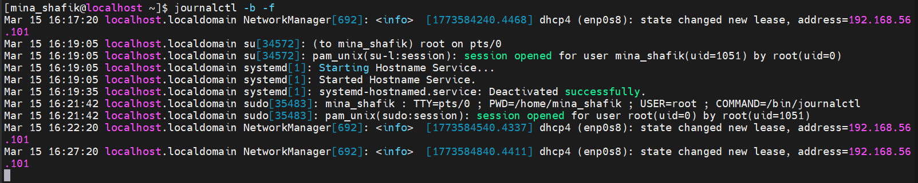
7. Display logs from the current boot only.
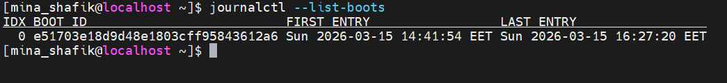
8. Display logs from the previous boot.
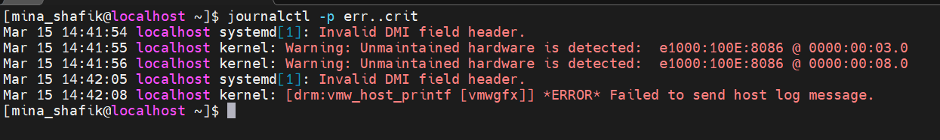
9. Filter journal logs to show only error and critical priority messages.

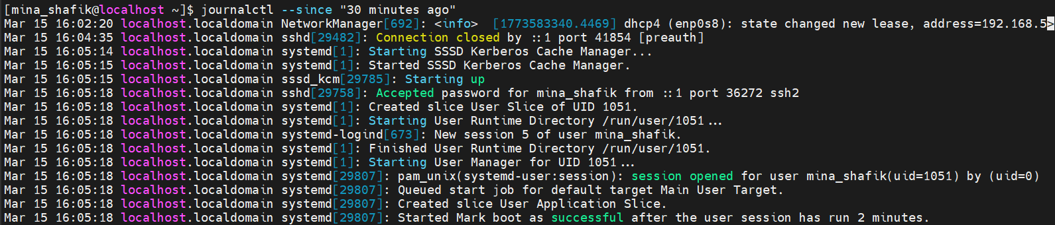
10.Display logs generated in the last 30 minutes.

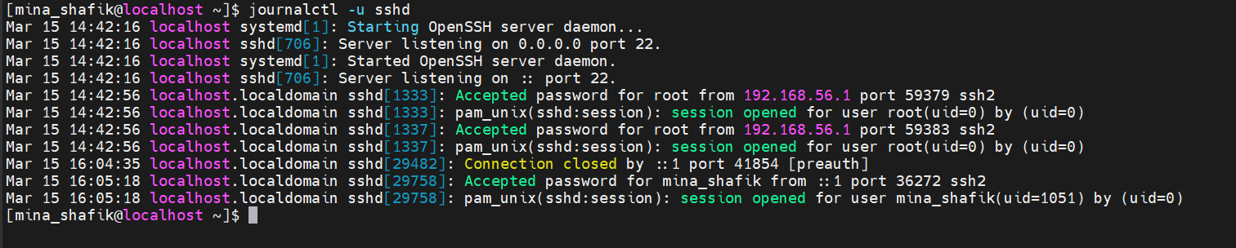
11.Display logs for a specific service (e.g., sshd):

