LAB 05
1. Compress a file by gzip and bzip2 commands and decompress it again.
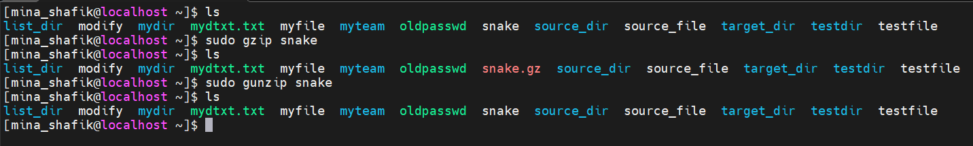
State the differences between two commands.

2. What is the command used to view the content of a compressed file.

sudo zcat filename.gz

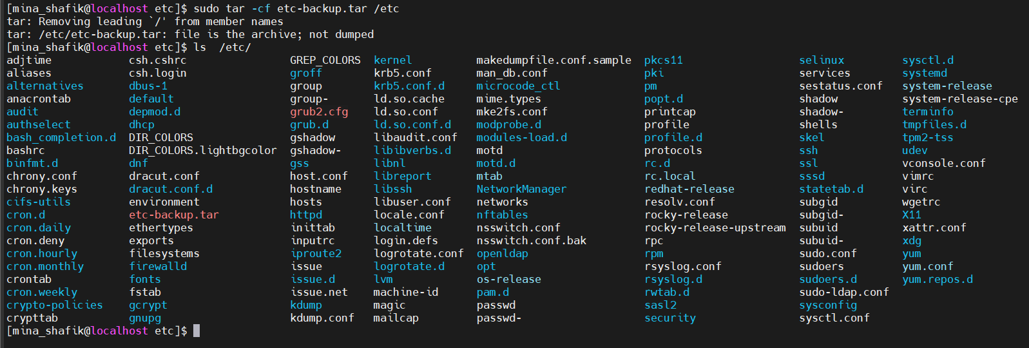
3. Backup /etc directory using tar utility.

4. Starting from your home directory,
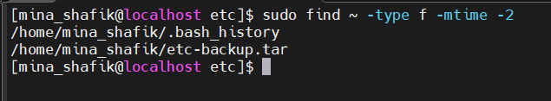
find all files that were modified in the last two day.

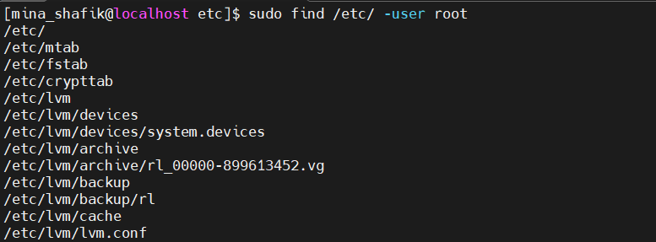
5. Starting from /etc, find files owned by root user.

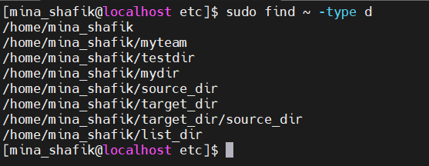
6. Find all directories in your home directory.
7. Write a command to search for all files on the system that,
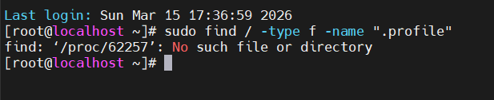
its name is ".profile".

8. Identify the file types of the following:
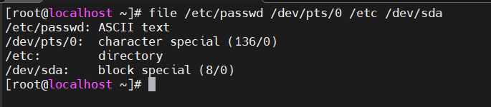
/etc/passwd, /dev/pts/0, /etc, /dev/sda

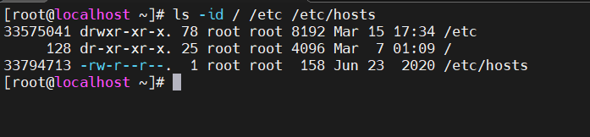
9. List the inode numbers of /, /etc, /etc/hosts

