Linux Shell Scripting Lab
Instructions
• All scripts must start with #!/bin/bash
• Use comments (#) to explain your logic.
• Test your scripts on a Linux terminal before submitting.
Q1 Variables & User Input
Scenario: A new engineer joins your team. Write a script that asks for their name, department, and years of experience, then prints a formatted welcome message.
Your Tasks:
1. Prompt the user to enter: name, department, and years of experience
2. Store each value in a properly named variable
3. Print: 'Welcome [name]! You joined the [dept] team with [X] years of experience.'
4. If years of experience equals 0, print: 'Welcome aboard as a fresher!' instead
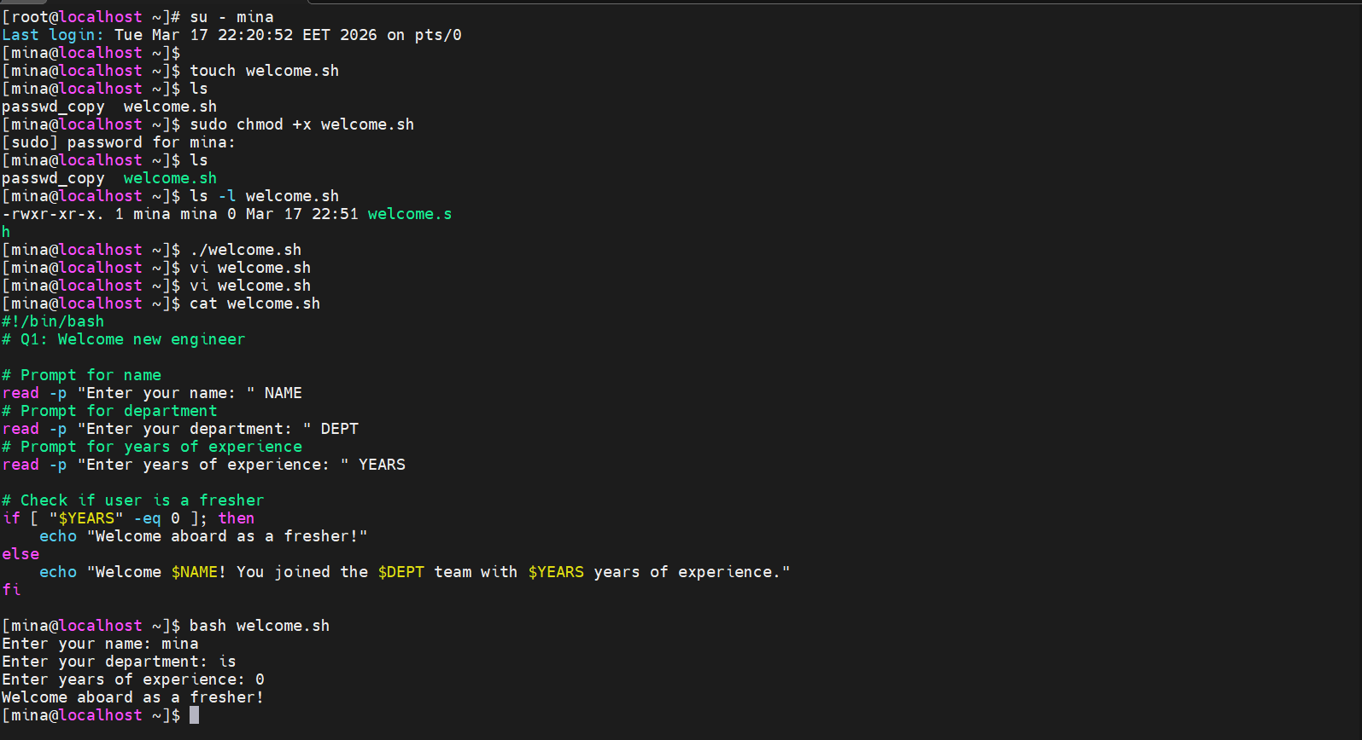

Q2 File & Directory Check
Scenario: Before running a backup job, the script must verify that the source folder and a config file both exist on the system.
Your Tasks:
5. Accept two arguments: $1 = folder path, $2 = config file path
6. Check if the folder exists (-d); print 'OK: folder found' or 'ERROR: folder missing'
7. Check if the config file exists (-f); print OK or ERROR accordingly
8. If either is missing, exit the script with exit 1
9. If both exist, print: 'All checks passed. Ready to run.'
Starter Code:

#!/bin/bash# Usage: ./q2.sh /path/to/folder /path/to/config.cfg

FOLDER=$1CONFIG=$2

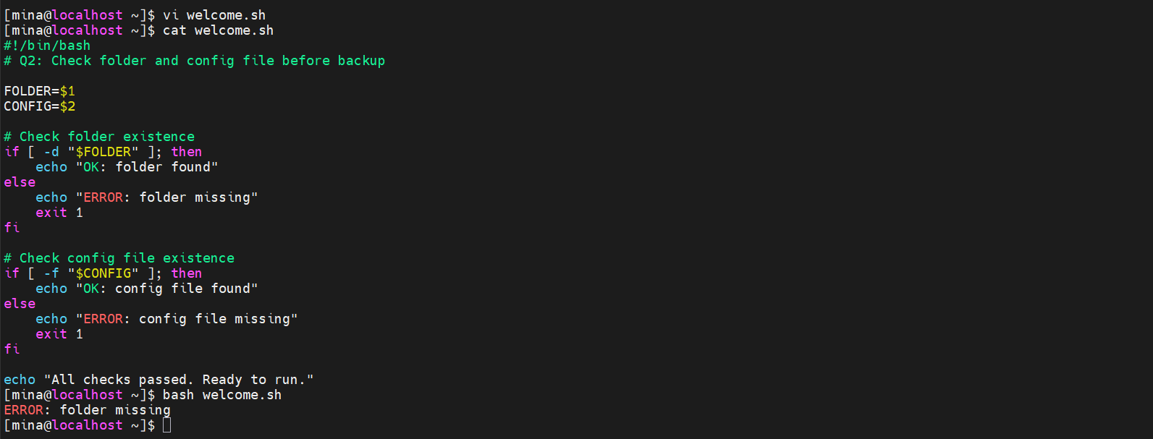
Q3 Log File Analysis
Scenario: Your server produces a log file called server.log. Write a script to extract useful information from it quickly.
Your Tasks:
10. Count how many lines contain the word ERROR (use grep -c)
11. Save all ERROR lines to a file called errors_today.txt
12. Count unique IP addresses — assume each line starts with an IP address (hint: awk '{print
$1}')
13. Print a summary: 'Total errors: X | Unique IPs: Y'
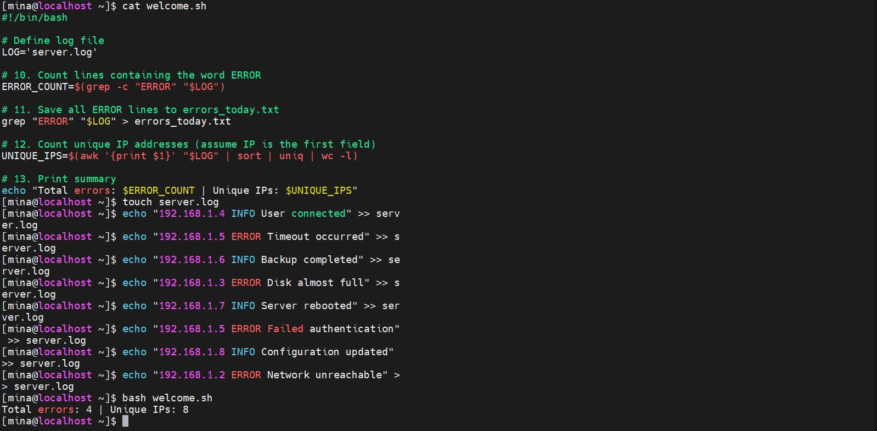
Starter Code:
#!/bin/bashLOG='server.log'# Hint: sort | uniq | wc -l counts unique values

Q4 Loops — Bulk File Creator
Scenario: A data pipeline needs 7 daily report folders (day1 through day7), each containing an empty report file.
Your Tasks:
14. Use a for loop from 1 to 7
15. Inside each iteration: create a folder called dayN/ and an empty file report_dayN.txt
inside it
16. Print: 'Created: day1/report_day1.txt' for each iteration
17. After the loop, use find to count and print the total number of files created

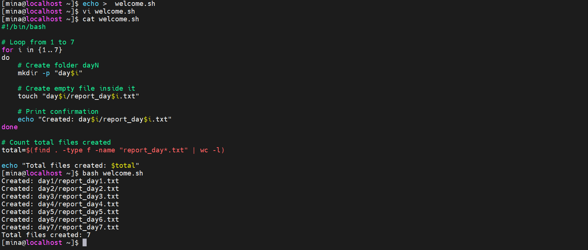
Q5 Loops — Disk Space Monitor
Scenario: Write a monitoring script that checks disk usage every 5 seconds and stops when usage is below a safe threshold.
Your Tasks:
18. Use a while loop that runs as long as disk usage of / is above 20%
19. Inside the loop: print current usage % and the timestamp using date
20. Use sleep 5 between checks
21. When usage drops below 20%, print: 'Disk usage is normal. Exiting.'
22. Add a safety counter — if the loop runs more than 10 times, break and print a warning
Starter Code:
#!/bin/bashCOUNT=0# Hint: df -h / | awk 'NR==2 {print $5}' | tr -d '%'
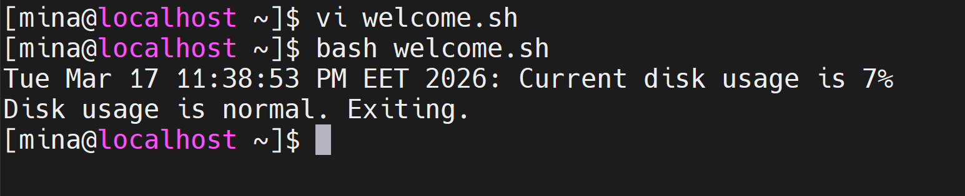

Q6 Functions with Local Variables
Scenario: Write a script with two functions that process employee data. Functions must use local variables so they do not overwrite each other.
Your Tasks:
23. Function get_grade(salary): returns 'Senior' if salary >= 90000, 'Mid' if >= 70000, else
'Junior'
24. Function format_employee(name, dept, salary): prints a formatted line and calls
get_grade()
25. Call format_employee for at least 3 employees with different salaries
26. Demonstrate that local variables work: define RESULT inside each function with local
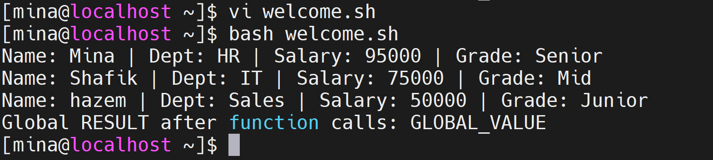
and prove the global RESULT is unchanged after both calls

Q7 awk — CSV Data Processing
Scenario: You have a file sales.csv with columns: region,product,quantity,price. Write a script using awk to analyze it.
Your Tasks:
27. Print all rows where quantity > 100
28. Calculate total revenue per region (revenue = quantity * price) and print a summary
29. Find the product with the highest price
30. Use BEGIN to print a report header and END to print total revenue across all rows
Starter Code:
#!/bin/bashFILE='sales.csv'# Create sample data first:# printf 'region,product,quantity,price\nNorth,Laptop,50,1200\nSouth,Phone,200,800
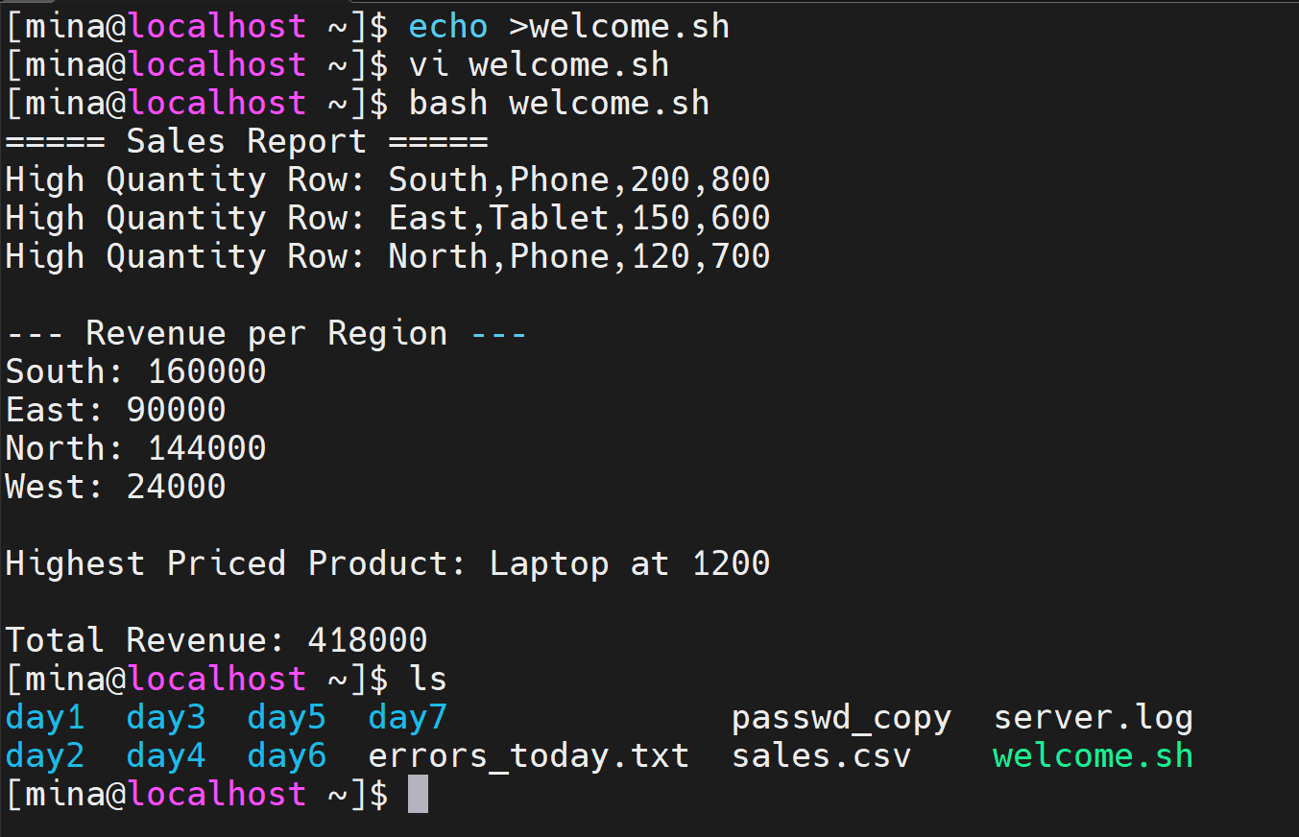

Q8 sed — Config File Cleanup
Scenario: You received a messy config file from a client. It has wrong values, comment lines, and blank lines. Clean it with sed.
Your Tasks:
31. Remove all lines starting with # (comment lines)
32. Remove all blank/empty lines
33. Replace all occurrences of 'localhost' with '192.168.1.10'
34. Replace 'port=8080' with 'port=443'
35. Save the cleaned output to config_clean.conf
36. Print: 'Done. Lines before: X Lines after: Y' (use wc -l)
Starter Code:
#!/bin/bashINPUT='config.conf'OUTPUT='config_clean.conf'# Hint: chain multiple sed commands using -e# Hint: wc -l < filename counts lines in a file

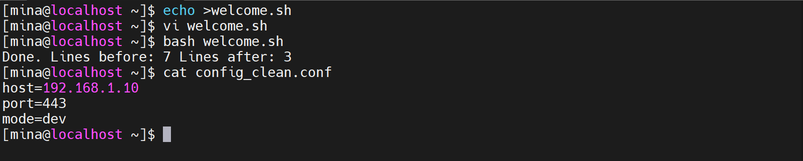

Q9 cut & Pipelines
Scenario: You have employees.csv with columns: id,name,department,salary,status. Use cut and pipes to extract data.
Your Tasks:
37. Print only the name and department columns (skip the header with tail -n +2)
38. List only active employees (status = active) — combine grep and cut
39. Find the highest salary using cut and sort -n
40. Count employees per department using cut, sort, and uniq -c
41. Save a report of name + salary sorted by salary descending to report.txt
Starter Code:
#!/bin/bashFILE='employees.csv'# Hint: tail -n +2 skips the header line
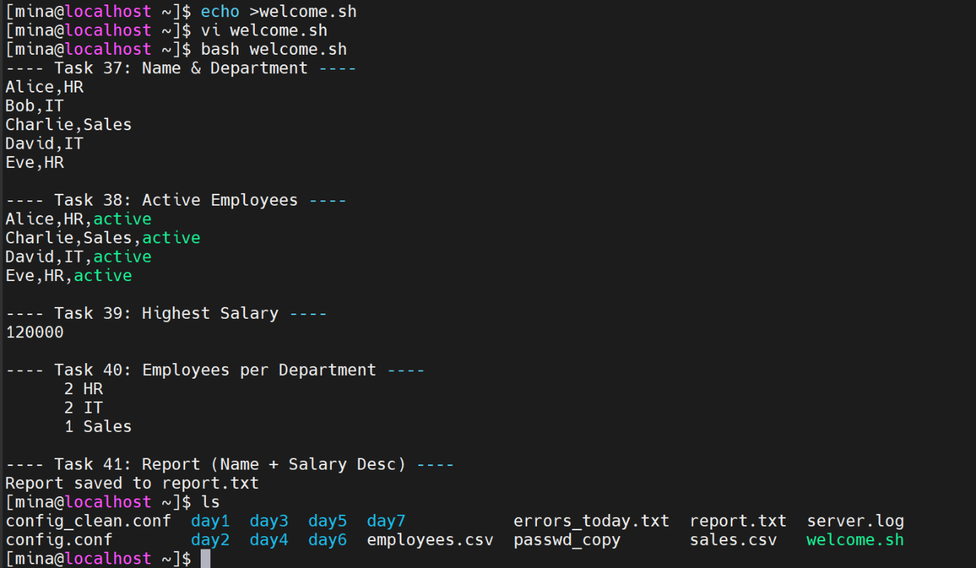

Q10 Full Script — System Health Check
Scenario: Write a complete system health check script combining everything learned. The ops team will run this every morning.
Your Tasks:
42. Function check_disk(): alert if / usage > 80% (use df -h)
43. Function check_memory(): alert if free RAM < 500mb (use free -m)
44. Function check_process(name): check if a process is running using pgrep — print
RUNNING or STOPPED
45. Call all functions from main; pass 'sshd' and 'cron' to check_process
46. Append all ALERT messages to health.log with a timestamp
47. Print a final summary line: 'X checks passed Y alerts raised'

