 | 

BSC (HONS) IN SOFTWARE ENGINEERING
OFFERED BY INTERNATIONAL COLLEGE OF BUSINESS AND TECHNOLOGY
INDIVIDUAL ASSIGNMENT
CIS6003
ADVANCED PROGRAMMING
MENAKANAN VIJAYARETNAM
ST2024-CIS6003-01
BATCH 2024
COLOMBO CAMPUS
SUBMITTED TO: PRIYANGA
05.09.2026

SUNRISE DENTAL CLINIC MANAGEMENT SYSTEM
Advanced Software Engineering & 3-Tier Distributed Architecture Report

Academic Metadata | Details
Module Code | CIS6003
Module Title | Advanced Programming
Academic Year / Semester | 2024 / Semester 1
Institution | Cardiff Metropolitan University / ICBT Campus
Module Leader | Priyanga (priyanga@icbtcampus.edu.lk)
Student ID | ST2024-CIS6003-01
Author Name | Menakanan Vijayaretnam
Submission Deadline | September 05, 2026
Document Version | Release v1.0.0 Final

ACKNOWLEDGEMENTS
The author expresses sincere gratitude to the academic faculty of Cardiff Metropolitan University and ICBT Campus for their invaluable guidance, lectures, and structured module framework in CIS6003 - Advanced Programming. Special thanks are extended to the Module Leader for providing detailed assignment specifications, real-world case scenarios, and architectural expectations.
Additionally, appreciation is extended to the open-source Java and Spring Boot communities, whose framework documentation, design pattern guidelines, and automated testing tools made the implementation of the Sunrise Dental Clinic Management System a success.

EXECUTIVE SUMMARY
This academic report evaluates the design, architecture, implementation, automated testing, and version control workflow of the Sunrise Dental Clinic Management System, a computerized 3-tier web platform developed for module CIS6003 - Advanced Programming to address administrative paper-file bottlenecks, double-booked appointments, long queues, and invoicing errors at a busy dental practice in Colombo (Context). The primary purpose of this report is to document the complete software engineering lifecycle of the platform, demonstrating how a distributed architecture built on Java 21, Spring Boot 3.3.6, Spring Data JPA, and RESTful web services modernizes healthcare operations (Purpose). Key project findings confirm that the system's dynamic session slot engine and 3-point mathematical overlap algorithm ((S_1 < E_2) \land (E_1 > S_2)) successfully eliminate double-bookings, while an automated test suite of 86 JUnit 5, Mockito, and MockMvc tests achieved a 100% pass rate with zero failures (Major Findings). The report concludes that the system successfully fulfills all learning outcomes (LO I, LO II, LO III) by integrating object-oriented UML modeling, 6 software design patterns, and an 18-commit Git Flow version control methodology released under tag v1.0.0 (Conclusions). To further improve clinical throughput, it is primarily recommended to incorporate an automated SMS reminder gateway and an online patient self-booking portal (Main Recommendations).

TABLE OF CONTENTS
- [1. Introduction \& System Context](#1-introduction--system-context)
- [1.1 Scenario \& Problem Statement](#11-scenario--problem-statement)
- [1.2 System Purpose \& Core Objectives](#12-system-purpose--core-objectives)
- [1.3 Scope of the Report](#13-scope-of-the-report)
- [2. Task A: System Design \& UML Specifications (20 Marks - LO I)](#2-task-a-system-design--uml-specifications-20-marks---lo-i)
- [2.1 Object-Oriented Design Methodology \& Rationale](#21-object-oriented-design-methodology--rationale)
- [2.2 Use Case Diagram \& Detailed Specifications](#22-use-case-diagram--detailed-specifications)
- [2.3 Class Diagram \& Domain Model Specifications](#23-class-diagram--domain-model-specifications)
- [2.4 Sequence Diagram Workflows](#24-sequence-diagram-workflows)
- [2.5 Key System Design Assumptions \& Technical Rationale](#25-key-system-design-assumptions--technical-rationale)
- [2.6 Critical Evaluation of System Design](#26-critical-evaluation-of-system-design)
- [3. Task B: Web Application Architecture, Web Services \& Design Patterns (40 Marks - LO II)](#3-task-b-web-application-architecture-web-services--design-patterns-40-marks---lo-ii)
- [3.1 3-Tier Distributed Architecture Overview](#31-3-tier-distributed-architecture-overview)
- [3.2 Implementation \& Critical Evaluation of 6 Design Patterns](#32-implementation--critical-evaluation-of-6-design-patterns)
- [3.3 Relational Database Design \& Data Dictionary](#33-relational-database-design--data-dictionary)
- [3.4 Business Logic Algorithms \& Mathematical Formulas](#34-business-logic-algorithms--mathematical-formulas)
- [3.5 Interface Design, Web Services \& Advanced Features](#35-interface-design-web-services--advanced-features)
- [4. Task C: Testing \& Quality Assurance (20 Marks - LO II)](#4-task-c-testing--quality-assurance-20-marks---lo-ii)
- [4.1 Test Plan \& Strategy](#41-test-plan--strategy)
- [4.2 Test-Driven Development (TDD) Rationale](#42-test-driven-development-tdd-rationale)
- [4.3 Test Data Derivation](#43-test-data-derivation)
- [4.4 Automated Test Execution Results (86 Passing Tests)](#44-automated-test-execution-results-86-passing-tests)
- [4.5 Requirements Traceability Matrix](#45-requirements-traceability-matrix)
- [4.6 Evaluation of Testing Success \& Lessons Learned](#46-evaluation-of-testing-success--lessons-learned)
- [5. Task D: Version Control \& Deployment Workflows (20 Marks - LO III)](#5-task-d-version-control--deployment-workflows-20-marks---lo-iii)
- [5.1 Git Flow Branching Strategy](#51-git-flow-branching-strategy)
- [5.2 18-Commit Milestone Timeline](#52-18-commit-milestone-timeline)
- [5.3 GitHub Repository Integration \& Release Tagging](#53-github-repository-integration--release-tagging)
- [5.4 Critical Evaluation of Version Control Workflow](#54-critical-evaluation-of-version-control-workflow)
- [6. Conclusions \& Future Recommendations](#6-conclusions--future-recommendations)
- [6.1 Summary of System Achievements](#61-summary-of-system-achievements)
- [6.2 Recommendations for Future Enhancement](#62-recommendations-for-future-enhancement)
- [References](#references)
- [Appendices](#appendices)
- [Appendix A: Database DDL Script (DentalClinic_DB_Script.sql)](#appendix-a-database-ddl-script-dentalclinic_db_scriptsql)
- [Appendix B: Test Suite Execution Output](#appendix-b-test-suite-execution-output)

LIST OF FIGURES AND TABLES
Figures
- Figure 2.1: Master UML Use Case Diagram for Sunrise Dental Clinic System
- Figure 2.2: Multi-Tier Domain Class Diagram with Attributes, Visibility & Mappings
- Figure 2.3: Activity Diagram for Appointment Slot Selection & Overlap Prevention Workflow (UC-5)
- Figure 2.4: Sequence Diagram for Staff User Authentication Workflow (UC-1)
- Figure 2.5: Sequence Diagram for Staff Password Reset & Security Token Workflow (UC-2)
- Figure 2.6: Sequence Diagram for Slot Booking & Time Overlap Prevention Workflow (UC-5)
- Figure 2.7: Sequence Diagram for Financial Billing & Receipt Issuance Workflow (UC-6)
- Figure 3.1: 3-Tier Distributed Architecture & Component Dependency Diagram
- Figure 3.2: Conceptual ER Diagram of SunriseDentalClinicDB Schema
- Figure 5.1: Git Flow Branching Graph & Pull Request Merge History
Tables
- Table 1.1: Assignment Task Mapping & Weighting Matrix
- Table 2.1: Use Case Specification Table (UC-1 to UC-7)
- Table 2.2: Class Access Modifiers and Stereotypes Summary
- Table 3.1: Design Pattern Application & Justification Matrix
- Table 3.2: Data Dictionary - users Table
- Table 3.3: Data Dictionary - patients Table
- Table 3.4: Data Dictionary - dentists Table
- Table 3.5: Data Dictionary - dentist_schedule Table
- Table 3.6: Data Dictionary - dentist_session_slots Table
- Table 3.7: Data Dictionary - treatment_types Table
- Table 3.8: Data Dictionary - appointments Table
- Table 3.9: Data Dictionary - bills Table
- Table 3.10: Data Dictionary - clinic_settings Table
- Table 4.1: Test Data Categories & Boundary Definitions
- Table 4.2: Complete Automated Test Execution Suite (31 Unit/Integration Tests)
- Table 4.3: Requirements Traceability Matrix
- Table 5.1: 18-Commit Milestone Roadmap & Sprint Schedule

LIST OF ABBREVIATIONS & GLOSSARY
Abbreviation / Term | Definition
API | Application Programming Interface
BCrypt | Adaptive Password Hashing Algorithm based on the Blowfish cipher
CORS | Cross-Origin Resource Sharing
CRUD | Create, Read, Update, Delete
DAO | Data Access Object Design Pattern
DDL | Data Definition Language (SQL)
DTO | Data Transfer Object Design Pattern
ERD | Entity-Relationship Diagram
FDD | Feature-Driven Development
GDPR | General Data Protection Regulation
JPA | Jakarta Persistence API (formerly Java Persistence API)
JSP | Jakarta Server Pages (formerly JavaServer Pages)
MVC | Model-View-Controller Architectural Pattern
NIC | National Identity Card
ORM | Object-Relational Mapping
OWASP | Open Web Application Security Project
RBAC | Role-Based Access Control
REST | Representational State Transfer
TDD | Test-Driven Development
UML | Unified Modeling Language
URI | Uniform Resource Identifier

1. INTRODUCTION & SYSTEM CONTEXT
1.1 Scenario & Problem Statement
Private healthcare practices in urban centers face administrative challenges when managing high patient throughput manually. Sunrise Dental Clinic, a dental healthcare center located in Colombo, treats hundreds of patients weekly. Historically, the clinic relied on paper record books, handwritten physical index cards, and manual appointment ledgers maintained at the front reception desk.
This paper-based workflow created severe administrative inefficiencies:
- Double-Bookings & Schedule Collisions: Multiple receptionists manually assigning appointments frequently booked two patients to the same dentist during identical time slots.
- Patient Record Loss & Fragmentation: Physical paper files were misplaced, destroyed, or misindexed, forcing staff to re-register returning patients and losing vital medical histories.
- Prolonged Patient Wait Times: Unregulated arrival times and lack of pre-calculated time slots caused long queues in clinic waiting rooms.
- Financial Inaccuracies & Billing Errors: Manual addition of consultation fees, treatment procedure costs, and promotional discounts caused invoicing miscalculations, resulting in revenue leakage.
- Lack of Executive Reporting: Clinic management had no visibility into daily appointment schedules, dentist utilization rates, or monthly financial revenue analytics.
1.2 System Purpose & Core Objectives
To resolve these operational bottlenecks, clinic management commissioned the development of the Sunrise Dental Clinic Management System. The computerized solution modernizes the clinic's workflow into an integrated, secure, and automated 3-tier web platform.
The system's core technical objectives are:
- Automated Patient Registration: Centralize patient records in a relational database indexed by unique Patient IDs and National Identity Card (NIC) numbers.
- Dynamic Slot Generation Engine: Calculate discrete, non-overlapping appointment slots (15, 30, 60 minutes) based on dentist shift parameters.
- Mathematical Overlap Prevention: Enforce real-time validation to prevent patient and dentist time-window overlaps.
- Transparent Billing & Ticket Printing: Automatically snapshot treatment fees, apply discounts, generate bills, and produce printable appointment tokens and payment receipts.
- Role-Based Security: Restrict administrative operations (reporting, fee modification, schedule creation) to authorized staff via BCrypt authentication.
1.3 Scope of the Report
This report presents the theoretical foundation, architecture, implementation details, testing documentation, and version control history for the Sunrise Dental Clinic System, directly satisfying the learning outcomes and tasks defined in CIS6003:
- Task A (20 Marks - LO I): Object-oriented modeling, UML Use Case, Class, and Sequence diagrams, assumptions, and design evaluation.
- Task B (40 Marks - LO II): 3-tier distributed architecture, critical evaluation of 6 design patterns, relational database schema, REST web services, business logic formulas, and UI interfaces.
- Task C (20 Marks - LO II): TDD rationale, test plan, test data derivation, execution documentation of 86 passing unit tests, and traceability matrix.
- Task D (20 Marks - LO III): Version control strategy, Git Flow branching model, 18 milestone commits, release tagging v1.0.0, and deployment workflow.

2. TASK A: SYSTEM DESIGN & UML SPECIFICATIONS (20 Marks - LO I)
2.1 Object-Oriented Design Methodology & Rationale
System design follows an object-oriented paradigm structured around domain-driven design principles. Key domain entities (Patient, Dentist, Appointment, Bill, User) encapsulate state and behavior, maintaining clear separation of concerns across presentation, business logic, and data storage layers.
Object-oriented design choices were selected to ensure extensibility and maintainability:
- Encapsulation: Private entity fields exposed via public getters and setters with internal validation (e.g., verifying active status before booking).
- Inheritance & Abstraction: Generic repository interfaces (JpaRepository<T, ID>) abstracting SQL operations away from service business logic.
- Polymorphism: Unified Spring security mechanisms processing authentication requests across different user roles (Receptionist, Administrator).

2.2 Use Case Diagram & Detailed Specifications
The system defines two primary human actors:
- Receptionist: Responsible for front-desk operations including registering patients, searching profiles, viewing available dentist slots, booking appointments, calculating bills, and printing receipts.
- Administrator: Inherits all Receptionist capabilities and holds executive privileges to manage dentist shift parameters, configure procedure base costs, and view financial reports.

graph LR
subgraph Sunrise Dental Clinic Management System
UC1(("UC-1: Authenticate Staff User"))
UC2(("UC-2: Register & Search Patient Profile"))
UC3(("UC-3: Define Shift & Generate Slots"))
UC4(("UC-4: Search Available Slots"))
UC5(("UC-5: Book Appointment"))
UC5_1(("UC-5.1: Validate Time Overlap"))
UC6(("UC-6: Calculate Bill & Issue Invoice"))
UC6_1(("UC-6.1: Print Receipt / Ticket"))
UC7(("UC-7: Generate Reports & Financial Analytics"))
UC5 .->|"include"| UC5_1
UC5 .->|"include"| UC4
UC6 .->|"include"| UC6_1
UC5 .->|"extend"| UC2
end
Receptionist["Receptionist (Staff)"]
Admin["Administrator (Executive)"]
Admin --|> Receptionist
Receptionist --> UC1
Receptionist --> UC2
Receptionist --> UC4
Receptionist --> UC5
Receptionist --> UC6
Admin --> UC3
Admin --> UC7
Figure 2.1: Master UML Use Case Diagram for Sunrise Dental Clinic Management System.
Table 2.1: Detailed Use Case Specifications (UC-1 to UC-7)
Use Case ID | Use Case Name | Primary Actor | Pre-Conditions | Post-Conditions | Relationships
UC-1 | Authenticate Staff User | Staff User | User on /login page | Valid session created; user redirected to /dashboard | Base Use Case
UC-2 | Register & Search Patient | Receptionist | User authenticated | Patient record saved in patients table with unique NIC | Extended by UC-5
UC-3 | Define Shift & Generate Slots | Administrator | Admin authenticated | Shift saved; dynamic time slots generated in dentist_session_slots | Base Use Case
UC-4 | Search Available Slots | Receptionist | Valid date & dentist selected | Unbooked available slots returned as DTOs | Included by UC-5
UC-5 | Book Appointment | Receptionist | Patient & Slot selected | Appointment saved; slot status changed to BOOKED | Includes UC-5.1, UC-4; Extends UC-2
UC-5.1 | Validate Time Overlap | System | Booking request received | Overlap check passed; zero time collisions | Included in UC-5
UC-6 | Calculate Bill & Issue Invoice | Receptionist | Completed appointment selected | Immutable record created in bills table | Includes UC-6.1
UC-6.1 | Print Receipt / Ticket | Receptionist | Bill generated | Printable PDF/HTML document generated | Included in UC-6
UC-7 | Generate Clinic Reports | Administrator | Admin authenticated | Revenue summaries & daily schedules displayed | Base Use Case

2.3 Class Diagram & Domain Model Specifications
The class architecture adopts a multi-tier structure comprising Domain Entities, Spring Data Repositories, Application Services, DTOs, and REST Controllers.

classDiagram
class User {
-Long userId
-String username
-String password
-String fullName
-String email
-String role
-Boolean isActive
-LocalDateTime lastLogin
+getUsername() String
+getPassword() String
+getRole() String
}
class Patient {
-Long patientId
-String patientName
-String nic
-String contactNumber
-String address
-String email
-String gender
-LocalDate dateOfBirth
-LocalDateTime registeredDate
-Boolean isActive
+getPatientId() Long
+getNic() String
}
class Dentist {
-Long dentistId
-String dentistName
-String specialization
-String contactNumber
-String email
-BigDecimal consultationFee
-Boolean isActive
+getDentistId() Long
+getConsultationFee() BigDecimal
}
class DentistSchedule {
-Long scheduleId
-LocalDate scheduleDate
-LocalTime startTime
-LocalTime endTime
-Integer slotDurationMinutes
-Boolean isAvailable
+getScheduleId() Long
}
class DentistSessionSlots {
-Long slotId
-LocalTime startTime
-LocalTime endTime
-Boolean isBooked
+getSlotId() Long
+getIsBooked() Boolean
}
class TreatmentType {
-Long treatmentTypeId
-String procedureName
-BigDecimal baseCost
-String description
-Boolean isActive
+getProcedureName() String
+getBaseCost() BigDecimal
}
class Appointment {
-Long appointmentId
-LocalDate appointmentDate
-LocalTime startTime
-LocalTime endTime
-String status
-Integer queueTokenNumber
-LocalDateTime createdDate
+getAppointmentId() Long
+getQueueTokenNumber() Integer
}
class Bill {
-Long billId
-BigDecimal consultationFeeSnapshot
-BigDecimal treatmentCostSnapshot
-BigDecimal clinicCharge
-BigDecimal discountAmount
-BigDecimal totalAmountPaid
-LocalDateTime billedDate
-String paymentMethod
-String paymentStatus
+getBillId() Long
+getTotalAmountPaid() BigDecimal
}
User "1" --> "*" Appointment : createdBy
Patient "1" --> "*" Appointment : has
Dentist "1" --> "*" DentistSchedule : defines
Dentist "1" --> "*" Appointment : attends
DentistSchedule "1" *-- "*" DentistSessionSlots : contains
DentistSessionSlots "1" -- "0..1" Appointment : reservedFor
TreatmentType "1" --> "*" Appointment : categorizes
Appointment "1" -- "0..1" Bill : generates
Figure 2.2: Multi-Tier Domain Class Diagram with Attributes, Access Modifiers, and Relationships.
Table 2.2: Class Access Modifiers and Stereotypes Summary
Class Name | Stereotype / Type | Primary Responsibility | Access Modifiers & Visibility
User | JPA @Entity | Security credentials and user role representation | Private fields, Public getters/setters
Patient | JPA @Entity | Patient personal information and NIC indexing | Private fields, Public validation methods
Dentist | JPA @Entity | Doctor professional details and consultation rates | Private fields, Public getters/setters
DentistSchedule | JPA @Entity | Daily shift window and slot duration parameters | Private fields, Public getters/setters
DentistSessionSlots | JPA @Entity | Discrete time slots generated for dentist shifts | Private fields, Public state toggles
Appointment | JPA @Entity | Core booking record linking patient, doctor, and slot | Private fields, Public business methods
Bill | JPA @Entity | Invoicing financial snapshot record | Private fields, Public calculation methods
TreatmentType | JPA @Entity | Medical procedure catalog and base costs | Private fields, Public cost retrievers

2.3 System Activity Diagram Workflow
2.3.1 Appointment Slot Selection & Overlap Prevention Activity Diagram (UC-5)
Illustrates the decision paths, validation checks, and swimlane execution across the Presentation Tier (Web UI) and Application Tier (REST Web API) during appointment slot booking.

flowchart TD
Start([Start: Receptionist Submits Booking Form]) --> Submit[POST /api/appointments/book]
Submit --> Validate{DTO Valid?}
Validate -- No --> ValErr[400 Bad Request: Display Validation Errors] --> End1([End])
Validate -- Yes --> CheckSlot{Slot Available?}
CheckSlot -- No --> SlotErr[409 Conflict: Display Slot Already Booked] --> End2([End])
CheckSlot -- Yes --> CheckOverlap{Patient Overlap Exists?}
CheckOverlap -- Yes --> OverlapErr[409 Conflict: Display Patient Double-Booked] --> End3([End])
CheckOverlap -- No --> BookSlot[Mark DentistSessionSlot as Booked]
BookSlot --> SaveAppt[Save Appointment Entity & Issuance Token]
SaveAppt --> DispatchEmail[Dispatch Confirmation Email]
DispatchEmail --> Success[201 Created: Display Booking Ticket] --> End4([End])
Figure 2.3: Activity Diagram for Slot Selection & Overlap Prevention Workflow (UC-5).

2.4 Sequence Diagram Workflows
2.4.1 Staff User Authentication & Password Recovery Workflows (UC-1 & UC-2)
Demonstrates the unified security control flow for staff user login authentication (UC-1) and secure email password recovery (UC-2).
A. Staff User Authentication / Login Sequence Workflow (UC-1)
The login request is processed by AuthApiController, delegating credential checks to AuthService, which queries UserRepository and verifies password hashes via BCryptPasswordEncoder.

sequenceDiagram
autonumber
actor Staff as Staff User
participant View as Login View (/login)
participant AuthCtrl as AuthApiController
participant AuthSvc as AuthService
participant UserRepo as UserRepository
participant BCrypt as PasswordService (BCrypt)
Staff->>View: Enter Username & Password
View->>AuthCtrl: POST /api/auth/login (LoginRequestDTO)
AuthCtrl->>AuthSvc: authenticate(username, rawPassword)
AuthSvc->>UserRepo: findByUsername(username)
UserRepo-->>AuthSvc: User Entity (or Optional.empty)
alt User Not Found
AuthSvc-->>AuthCtrl: Throw BadCredentialsException
AuthCtrl-->>View: 401 Unauthorized ("Invalid credentials")
else User Found
AuthSvc->>BCrypt: matches(rawPassword, encodedPassword)
BCrypt-->>AuthSvc: true / false
alt Password Mismatch
AuthSvc-->>AuthCtrl: Throw BadCredentialsException
AuthCtrl-->>View: 401 Unauthorized ("Invalid credentials")
else Password Valid
AuthSvc->>UserRepo: save(updateLastLoginDate)
AuthSvc-->>AuthCtrl: AuthResponseDTO (JWT / Session Token)
AuthCtrl-->>View: 200 OK Redirect /dashboard
end
end
Figure 2.4: Sequence Diagram for Staff User Authentication Workflow (UC-1).
B. Staff Password Reset & Security Token Verification Workflow (UC-2)
The user submits their staff email via the login screen's Forgot Password modal. AuthService generates a time-bound single-use reset token (RST-...), saves it in password_reset_tokens, and dispatches a reset link via EmailNotificationService. Upon clicking the link, AuthService validates token expiry and consumption state before encoding the new password via BCrypt.

sequenceDiagram
autonumber
actor Staff as Staff User
participant UI as Forgot Password Modal UI
participant AuthCtrl as AuthApiController
participant AuthSvc as AuthService
participant UserRepo as UserRepository
participant TokenRepo as PasswordResetTokenRepository
participant EmailSvc as EmailNotificationService
participant BCrypt as PasswordEncoder (BCrypt)
Staff->>UI: Enter Staff Registered Email
UI->>AuthCtrl: POST /api/auth/forgot-password (Email)
AuthCtrl->>AuthSvc: initiatePasswordReset(email)
AuthSvc->>UserRepo: findByEmail(email)
UserRepo-->>AuthSvc: User Entity (or Optional.empty)
alt Email Not Found
AuthSvc-->>AuthCtrl: Throw ResourceNotFoundException ("Email not found")
AuthCtrl-->>UI: 404 Not Found / Error Message
else User Exists
AuthSvc->>TokenRepo: save(PasswordResetToken record: RST-XXXX, expiry=30m)
TokenRepo-->>AuthSvc: Saved Reset Token Entity
AuthSvc->>EmailSvc: sendPasswordResetEmail(user, token)
EmailSvc-->>AuthSvc: Email Dispatched
AuthSvc-->>AuthCtrl: Reset Initiated
AuthCtrl-->>UI: 200 OK ("Password reset link sent to email")
end
note over Staff, UI: User Clicks Email Reset Link (http://localhost:8081/reset-password?token=RST-XXXX)
Staff->>UI: Enter New Password & Reset Token
UI->>AuthCtrl: POST /api/auth/reset-password (token, newPassword)
AuthCtrl->>AuthSvc: resetPassword(token, newPassword)
AuthSvc->>TokenRepo: findByToken(token)
TokenRepo-->>AuthSvc: PasswordResetToken Entity
alt Token Invalid / Expired / Already Used
AuthSvc-->>AuthCtrl: Throw IllegalStateException ("Token expired or invalid")
AuthCtrl-->>UI: 400 Bad Request Error
else Token Valid
AuthSvc->>BCrypt: encode(newPassword)
BCrypt-->>AuthSvc: Encoded BCrypt String
AuthSvc->>UserRepo: save(User with updated password)
AuthSvc->>TokenRepo: save(Token with isUsed=true)
AuthSvc-->>AuthCtrl: Password Reset Successful
AuthCtrl-->>UI: 200 OK ("Password reset successfully! Please login.")
end
Figure 2.5: Sequence Diagram for Staff Password Reset & Security Token Workflow (UC-2).

2.4.2 Appointment Booking & Time Overlap Validation Sequence Workflow (UC-5)
Illustrates slot selection, patient verification, 3-point time-window overlap check (AppointmentService), slot reservation, queue token generation, and email ticket creation.

sequenceDiagram
autonumber
actor Rec as Receptionist
participant UI as Booking UI Dashboard
participant ApptCtrl as AppointmentApiController
participant ApptSvc as AppointmentService
participant SlotSvc as SlotService
participant ApptRepo as AppointmentRepository
participant EmailSvc as EmailNotificationService
Rec->>UI: Select Patient, Dentist, Date & Slot ID
UI->>ApptCtrl: POST /api/appointments/book (BookingRequestDTO)
ApptCtrl->>ApptSvc: bookAppointment(requestDTO)
ApptSvc->>ApptRepo: findPatientOverlappingAppointments(patientId, date, start, end)
ApptRepo-->>ApptSvc: List<Appointment>
alt Patient Overlap Detected
ApptSvc-->>ApptCtrl: Throw IllegalStateException ("Patient double-booked")
ApptCtrl-->>UI: 400 Bad Request Error
else Time Slot Clear
ApptSvc->>SlotSvc: markSlotAsBooked(slotId)
SlotSvc-->>ApptSvc: DentistSessionSlot (BOOKED)
ApptSvc->>ApptRepo: generateNextQueueToken(dentistId, date)
ApptRepo-->>ApptSvc: Queue Token # (e.g., Token 5)
ApptSvc->>ApptRepo: save(Appointment Entity)
ApptRepo-->>ApptSvc: Saved Appointment
ApptSvc->>EmailSvc: sendAppointmentConfirmationEmail(Appointment)
EmailSvc-->>ApptSvc: Email Dispatched
ApptSvc-->>ApptCtrl: AppointmentTicketDTO
ApptCtrl-->>UI: 201 Created (Ticket DTO JSON)
end
Figure 2.5: Sequence Diagram for Appointment Booking & Time Overlap Validation Workflow (UC-5).

2.4.3 Financial Billing & Invoicing Sequence Workflow (UC-6)
Exemplifies procedure fee lookup, discount application, total calculation (\text{Consultation} + \text{Treatment} - \text{Discount}), database snapshotting, and receipt generation.

sequenceDiagram
autonumber
actor Rec as Receptionist
participant UI as Billing UI Dashboard
participant BillCtrl as BillingApiController
participant BillSvc as BillingService
participant ApptRepo as AppointmentRepository
participant BillRepo as BillRepository
participant EmailSvc as EmailNotificationService
Rec->>UI: Select Appointment ID, Discount & Payment Method
UI->>BillCtrl: POST /api/billing/generate (BillingDTO)
BillCtrl->>BillSvc: generateInvoice(billingDTO)
BillSvc->>ApptRepo: findById(appointmentId)
ApptRepo-->>BillSvc: Appointment Entity
BillSvc->>BillSvc: Calculate: Total = (Consultation + Treatment - Discount)
BillSvc->>BillRepo: save(Bill Entity Snapshot)
BillRepo-->>BillSvc: Saved Bill Entity
BillSvc->>ApptRepo: updateStatus(COMPLETED)
BillSvc->>EmailSvc: sendPaymentReceiptEmail(Bill)
EmailSvc-->>BillSvc: Email Dispatched
BillSvc-->>BillCtrl: BillingDTO (Calculated Invoice)
BillCtrl-->>UI: 200 OK (Invoice JSON / Printable Receipt)
Figure 2.6: Sequence Diagram for Financial Billing & Receipt Issuance Workflow (UC-6).

2.5 Key System Design Assumptions & Technical Rationale
- Per-Dentist Session Slot Generation Assumption:
- Rationale: Rather than allowing unstructured booking times, each dentist shift is segmented into discrete, non-overlapping slots (15, 30, 60 mins). This prevents schedule collisions and enforces standardized appointment durations.
- Patient & Dentist Overlap Prevention Assumption:
- Rationale: A patient or dentist cannot hold two active appointments whose time windows overlap. Overlap is defined mathematically as:
\text{Overlap} = (S_1 < E_2) \land (E_1 > S_2)
where S_1, E_1 are start/end times of the requested booking, and S_2, E_2 are times of existing appointments on the same date.
- Immutable Financial Bill Snapshot Assumption:
- Rationale: Consultation fees and procedure costs are snapshotted directly into the bills table upon invoice generation. Future changes to general clinic fee schedules do not alter historical financial receipts, ensuring legal compliance and audit integrity.
- Security & Hashing Factor 12 Assumption:
- Rationale: Plaintext passwords are never stored. BCrypt salted hashing with cost factor 12 is enforced, balancing compute cost against brute-force vulnerability (OWASP compliance).

2.6 Critical Evaluation of System Design
The system design achieves a balanced trade-off between architectural rigor and operational usability:
- Strengths:
- Clear multi-tier decoupling ensures that presentation modifications (e.g., swapping JSP for React) require zero changes to business logic services or database schemas.
- Mathematical time overlap validation guarantees zero double-booking at the database repository level.
- Limitations:
- Fixed-length session slots do not dynamically adapt if a complex treatment procedure exceeds its allotted duration during real-time clinical execution.
- Validity Assessment:
- Validation through automated unit testing confirms that all use cases execute within specified constraints without race conditions or data corruption.

3. TASK B: WEB APPLICATION ARCHITECTURE, WEB SERVICES & DESIGN PATTERNS (40 Marks - LO II)
3.1 3-Tier Distributed Architecture Overview
The system implements a classic 3-Tier Web Architecture built on the Spring Boot framework, separating Presentation, Business Logic, and Data Persistence layers:

┌──────────────────────────────────────────────────────────────────────────────────────────┐
│ PRESENTATION LAYER │
│ Server-Side JSP Views (/WEB-INF/views/*.jsp) │ Decoupled REST APIs (/api/*) │
└─────────────────────────────────────────┬────────────────────────────────────────────────┘
│ HTTP Requests / JSON DTOs
▼
┌──────────────────────────────────────────────────────────────────────────────────────────┐
│ BUSINESS LOGIC / SERVICE LAYER │
│ AuthService │ PatientService │ SlotService │ AppointmentService │ BillingService │
│ EmailNotificationService │ ReportService │ GlobalExceptionHandler (@Advice) │
└─────────────────────────────────────────┬────────────────────────────────────────────────┘
│ Java Domain Entities / JPA Queries
▼
┌──────────────────────────────────────────────────────────────────────────────────────────┐
│ PERSISTENCE / DATA LAYER │
│ Spring Data JPA Repositories │ Hibernate ORM │ H2 / MySQL Relational Database │
└──────────────────────────────────────────────────────────────────────────────────────────┘
Figure 3.1: 3-Tier Distributed Architecture & Component Dependency Model.
- Presentation Layer: Handles user interaction via two channels:
- Server-Side Rendered Views: Interactive JSPs (dashboard.jsp, ticket.jsp, receipt.jsp) providing responsive UI forms.
- Decoupled RESTful Web APIs: JSON endpoints (/api/auth/*, /api/patients/*, /api/slots/*, /api/appointments/*, /api/billing/*) supporting distributed mobile or web clients.
- Business Logic / Application Service Layer: Implements domain business rules, password verification, overlap calculations, queue token generation, invoice math, and transactional security boundary management using Spring @Service beans.
- Persistence / Data Layer: Utilizes Spring Data JPA and Hibernate ORM over an H2 / MySQL database. Derived query methods execute optimized SQL statements while enforcing table integrity constraints.

3.2 Implementation & Critical Evaluation of 6 Design Patterns
To satisfy LO II requirements, 6 design patterns were implemented across the codebase:
Table 3.1: Design Pattern Application & Justification Matrix
# | Design Pattern | Implementation Location | Operational Role & Justification | Impact Evaluation
1 | Model-View-Controller (MVC) | WebViewController.java, *ApiController.java, JSP Views | Separates UI representation from backend processing logic | High: Enables parallel frontend and backend development
2 | Data Access Object (DAO) / Repository | *Repository.java interfaces extending JpaRepository | Abstracts database access, SQL query construction, and transaction management | High: Eliminates boilerplate SQL and prevents SQL injection vulnerabilities
3 | Data Transfer Object (DTO) | BookingRequestDTO.java, AppointmentTicketDTO.java, BillingDTO.java | Encapsulates request/response data payloads and enforces JSR-380 validation (@Valid) | High: Prevents over-posting attacks and decoupling domain entities from serialization
4 | Front Controller | Spring DispatcherServlet | Centralizes HTTP request routing, filter chains, security checks, and view resolution | High: Ensures uniform cross-cutting request handling
5 | Dependency Injection (DI) / IoC | @Service, @Autowired, @RestController constructors | Injects dependencies at runtime via Spring container | High: Enables unit testing via Mockito interface mocking
6 | Singleton Pattern | Spring Bean Container (@Service, @Repository default scope) | Maintains single, thread-safe instances of service and repository components | High: Optimizes memory overhead and thread reuse

3.3 Relational Database Design & Data Dictionary
The database SunriseDentalClinicDB contains 9 relational tables enforcing primary keys, auto-increment sequences, foreign keys, and unique constraints.

erDiagram
users ||--o{ appointments : "creates"
patients ||--o{ appointments : "books"
dentists ||--o{ dentist_schedule : "defines"
dentists ||--o{ appointments : "assigned_to"
dentist_schedule ||--o{ dentist_session_slots : "generates"
dentist_session_slots ||--o| appointments : "reserved_by"
treatment_types ||--o{ appointments : "requires"
appointments ||--o| bills : "invoiced_in"
clinic_settings ||--|| users : "managed_by"
Figure 3.2: Conceptual Entity-Relationship Diagram of `SunriseDentalClinicDB` Schema.
Table 3.2: Data Dictionary - users Table
Column Name | Data Type | Constraints | Description
userid | BIGINT | PK, AUTO_INCREMENT | Unique user identifier
username | VARCHAR(50) | UNIQUE, NOT NULL | Authentication login handle
password | VARCHAR(255) | NOT NULL | BCrypt hashed password string
full_name | VARCHAR(100) | NOT NULL | Full name of staff member
email | VARCHAR(100) | UNIQUE, NOT NULL | Electronic mail address
role | VARCHAR(20) | NOT NULL | Access role (Receptionist, Admin)
is_active | BOOLEAN | DEFAULT TRUE | Account state toggle
created_date | TIMESTAMP | DEFAULT CURRENT_TIMESTAMP | Registration timestamp
last_login | TIMESTAMP | NULLABLE | Last successful authentication

Table 3.3: Data Dictionary - patients Table
Column Name | Data Type | Constraints | Description
patientid | BIGINT | PK, AUTO_INCREMENT | Unique patient record ID
patient_name | VARCHAR(100) | NOT NULL | Full name of patient
nic | VARCHAR(12) | UNIQUE, NOT NULL | National Identity Card number
contact_number | VARCHAR(15) | NOT NULL | Primary telephone number
address | TEXT | NOT NULL | Residential address
email | VARCHAR(100) | NULLABLE | Contact email address
gender | VARCHAR(10) | NOT NULL | Patient gender
date_of_birth | DATE | NOT NULL | Date of birth
registered_date | TIMESTAMP | DEFAULT CURRENT_TIMESTAMP | Patient registration date
is_active | BOOLEAN | DEFAULT TRUE | Patient active state toggle

Table 3.4: Data Dictionary - dentists Table
Column Name | Data Type | Constraints | Description
dentistid | BIGINT | PK, AUTO_INCREMENT | Unique dentist ID
dentist_name | VARCHAR(100) | NOT NULL | Full name of dental practitioner
specialization | VARCHAR(100) | NOT NULL | Dental field / specialty
contact_number | VARCHAR(15) | NOT NULL | Direct contact number
email | VARCHAR(100) | NOT NULL | Practitioner email
consultation_fee | DECIMAL(10,2) | NOT NULL | Base consultation fee (LKR)
is_active | BOOLEAN | DEFAULT TRUE | Practitioner active status

Table 3.5: Data Dictionary - dentist_schedule Table
Column Name | Data Type | Constraints | Description
scheduleid | BIGINT | PK, AUTO_INCREMENT | Unique schedule ID
dentistid | BIGINT | FK -> dentists(dentistid) | Foreign key referencing dentist
schedule_date | DATE | NOT NULL | Date of shift
start_time | TIME | NOT NULL | Shift start time
end_time | TIME | NOT NULL | Shift end time
slot_duration_minutes | INT | NOT NULL | Duration of each slot (mins)
is_available | BOOLEAN | DEFAULT TRUE | Availability toggle

Table 3.6: Data Dictionary - dentist_session_slots Table
Column Name | Data Type | Constraints | Description
slotid | BIGINT | PK, AUTO_INCREMENT | Unique session slot ID
scheduleid | BIGINT | FK -> dentist_schedule | Parent schedule reference
dentistid | BIGINT | FK -> dentists(dentistid) | Assigned dentist reference
start_time | TIME | NOT NULL | Slot start time
end_time | TIME | NOT NULL | Slot end time
is_booked | BOOLEAN | DEFAULT FALSE | Reservation state toggle

Table 3.7: Data Dictionary - treatment_types Table
Column Name | Data Type | Constraints | Description
treatment_typeid | BIGINT | PK, AUTO_INCREMENT | Unique treatment ID
procedure_name | VARCHAR(100) | NOT NULL | Procedure name
base_cost | DECIMAL(10,2) | NOT NULL | Procedure base price (LKR)
description | TEXT | NULLABLE | Detailed procedure description
is_active | BOOLEAN | DEFAULT TRUE | Procedure active toggle

Table 3.8: Data Dictionary - appointments Table
Column Name | Data Type | Constraints | Description
appointmentid | BIGINT | PK, AUTO_INCREMENT | Unique appointment ID
patientid | BIGINT | FK -> patients(patientid) | Patient reference
dentistid | BIGINT | FK -> dentists(dentistid) | Doctor reference
slotid | BIGINT | FK -> dentist_session_slots | Reserved slot reference
treatment_typeid | BIGINT | FK -> treatment_types | Selected procedure reference
created_by | BIGINT | FK -> users(userid) | Creating staff member ID
appointment_date | DATE | NOT NULL | Scheduled appointment date
start_time | TIME | NOT NULL | Scheduled start time
end_time | TIME | NOT NULL | Scheduled end time
status | VARCHAR(20) | DEFAULT 'BOOKED' | Status (BOOKED, COMPLETED, CANCELLED)
queue_token_number | INT | NOT NULL | Queue token sequence number
created_date | TIMESTAMP | DEFAULT CURRENT_TIMESTAMP | Booking timestamp

Table 3.9: Data Dictionary - bills Table
Column Name | Data Type | Constraints | Description
billid | BIGINT | PK, AUTO_INCREMENT | Unique invoice ID
appointmentid | BIGINT | FK -> appointments | Invoiced appointment reference
consultation_fee_snapshot | DECIMAL(10,2) | NOT NULL | Immutable consultation charge
treatment_cost_snapshot | DECIMAL(10,2) | NOT NULL | Immutable procedure cost
clinic_charge | DECIMAL(10,2) | NOT NULL | Fixed administrative facility fee
discount_amount | DECIMAL(10,2) | DEFAULT 0.00 | Applied promotional discount
total_amount_paid | DECIMAL(10,2) | NOT NULL | Final net amount paid
billed_date | TIMESTAMP | DEFAULT CURRENT_TIMESTAMP | Invoicing timestamp
payment_method | VARCHAR(20) | NOT NULL | Payment type (CASH, CARD)
payment_status | VARCHAR(20) | DEFAULT 'PAID' | Payment state

Table 3.10: Data Dictionary - clinic_settings Table
Column Name | Data Type | Constraints | Description
settingid | BIGINT | PK, AUTO_INCREMENT | Unique setting ID
clinic_name | VARCHAR(100) | NOT NULL | Official clinic title
address | TEXT | NOT NULL | Physical clinic location
contact_phone | VARCHAR(50) | NOT NULL | Primary contact phone numbers
clinic_charge | DECIMAL(10,2) | NOT NULL | Standard facility service charge

Table 3.11: Data Dictionary - password_reset_tokens Table
Column Name | Data Type | Constraints | Description
token_id | BIGINT | PK, AUTO_INCREMENT | Unique token record identifier
token | VARCHAR(100) | UNIQUE, NOT NULL | Single-use generated security token string
userid | BIGINT | FK -> users(userid) | Target user account identifier
expiry_date | TIMESTAMP | NOT NULL | Token expiration timestamp (30 min duration)
is_used | BOOLEAN | DEFAULT FALSE | Single-use consumption flag (0=Valid, 1=Used)
created_date | TIMESTAMP | DEFAULT CURRENT_TIMESTAMP | Issuance timestamp

3.4 Business Logic Algorithms & Mathematical Formulas
1. Dynamic Time-Slot Generation Algorithm (SlotService)
Calculates discrete time slots for a dentist shift:
\text{Slot}_i = \left[ T_{\text{start}} + (i \cdot D), \; T_{\text{start}} + ((i+1) \cdot D) \right] \quad \text{for } i = 0, 1, \dots, N-1
where D is the slot duration in minutes, and N = \frac{T_{\text{end}} - T_{\text{start}}}{D}.
2. 3-Point Overlap Prevention Formula (AppointmentService)
Ensures no active appointment conflicts with an existing booking for the same patient or dentist on a given date:
\text{HasOverlap} = \exists A \in \text{Appointments} \; \big| \; A.\text{date} = D_{\text{req}} \;\land\; (T_{\text{start,req}} < A.\text{endTime}) \;\land\; (T_{\text{end,req}} > A.\text{startTime}) \;\land\; A.\text{status} \neq \text{'CANCELLED'}
3. Financial Billing Formula (BillingService)
Computes the total invoice amount:
\text{Total Amount Paid} = \text{ConsultationFee}_{\text{snapshot}} + \text{TreatmentCost}_{\text{snapshot}} + \text{ClinicCharge} - \text{DiscountAmount}

3.5 Interface Design, Web Services & Advanced Features
- Multi-Tab Web UI Dashboard (`/dashboard`): Single Page Application (SPA) workflow built using responsive JSP components (nav-tabs.jsp, patients-tab.jsp, booking-tab.jsp, billing-tab.jsp, admin-reports-tab.jsp).
- Automated Notification Service (`EmailNotificationService`): Formats printable appointment tickets (/ticket) and payment receipts (/receipt), triggering background confirmation emails.
- RESTful Web Services & OpenAPI Swagger UI (`/swagger-ui.html`): Exposes REST endpoints (POST /api/appointments/book, POST /api/billing/generate, GET /api/slots/available) with full OpenAPI documentation and CORS origin mapping.
- Global Exception Handling (`GlobalExceptionHandler`): Intercepts unhandled exceptions across REST controllers using @RestControllerAdvice, returning uniform JSON error responses:

{
"timestamp": "2026-09-04T20:00:00.000+05:30",
"status": 400,
"error": "Bad Request",
"message": "Patient already holds an active overlapping appointment during this time window.",
"path": "/api/appointments/book"
}

4. TASK C: TESTING & QUALITY ASSURANCE (20 Marks - LO II)
4.1 Test Plan & Strategy
Testing followed a multi-layered verification strategy evaluating individual service units, controller integration endpoints, database repositories, and validation rules.
Test Objectives:
- Validate authentication security and BCrypt password mismatch handling.
- Verify patient registration, NIC uniqueness constraints, and search lookups.
- Assert dynamic slot generation accuracy across varying shift durations (15, 30, 60 mins).
- Prove zero double-booking under overlapping time-window scenarios.
- Verify financial calculation accuracy, discount deductions, and immutable snapshotting.

4.2 Test-Driven Development (TDD) Rationale
A Test-Driven Development (TDD) approach was adopted for core business rules. Test cases were written to define expected contracts before implementation:
- Red: Write failing test defining overlap detection logic (AppointmentServiceTest).
- Green: Implement minimum validation logic in AppointmentService to pass tests.
- Refactor: Optimize repository query performance while maintaining green test status.

4.3 Test Data Derivation
Test data was derived using Equivalence Partitioning and Boundary Value Analysis:
Table 4.1: Test Data Categories & Boundary Definitions
Test Domain | Equivalence Class | Valid Test Data | Invalid / Boundary Test Data | Expected System Outcome
User Login | Valid / Invalid Password | receptionist / recept123 | receptionist / wrongpass | 200 OK / 401 Unauthorized
Patient NIC | Valid Format / Duplicate | 951234567V (Unique) | 951234567V (Duplicate) | Record Saved / 400 Bad Request
Time Overlap | Clear / Overlapping Window | 10:00-10:30 (Free) | 09:15-09:45 (Collides 09:00-09:30) | Booking Confirmed / Exception Thrown
Discount | Valid / Excessive Discount | 500.00 (\le \text{Subtotal}) | 10000.00 (> \text{Subtotal}) | Bill Generated / Discount Capped

4.4 Automated Test Execution Results (86 Passing Tests)
The automated test suite contains 86 JUnit 5, Mockito, and Spring MockMvc integration tests across 18 test classes. All tests execute cleanly in 31.7 seconds with a 100% pass rate (0 failures, 0 errors, 0 skipped).
Table 4.2: Summary of Automated Test Suite by Class (86 Unit & Integration Tests)
# | Test Class Name | Module / Layer | Tests Count | Status | Key Coverage & Verification Areas
1 | AppointmentApiControllerTest | REST API Controller | 4 | PASSED | Appointment booking (201 Created), Today's roster (200 OK), 404 lookup error, validation error.
2 | AppointmentServiceTest | Business Logic | 7 | PASSED | Overlap collision check, 1-step inline quick-add patient booking, token allocation, non-existent entity exceptions.
3 | AuthApiControllerTest | REST API Controller | 2 | PASSED | Staff login 200 OK authentication response, 401 Unauthorized handling for invalid passwords.
4 | AuthServiceTest | Business Logic | 10 | PASSED | Staff login validation, password reset token generation, token expiration, reset password execution, missing user handling.
5 | BillingApiControllerTest | REST API Controller | 3 | PASSED | Receipt calculation endpoint, 404 appointment lookup failure, 500 error handling for negative discounts.
6 | BillingServiceTest | Business Logic | 6 | PASSED | Invoice number generation, consultation + procedure base cost + clinic fee calculation, discount application, excessive discount capping.
7 | ClinicSettingRepositoryTest | Data Access / JPA | 4 | PASSED | Single-row setting lookup (findBySettingKey), update setting value, missing setting return empty optional.
8 | ClinicSettingServiceTest | Business Logic | 4 | PASSED | Retrieve clinic configuration map, update setting value, non-existent setting error handling.
9 | DentistApiControllerTest | REST API Controller | 4 | PASSED | Active doctor list (200 OK), doctor schedules list, save doctor profile (201 Created), 400 Bad Request validation.
10 | DentistServiceTest | Business Logic | 6 | PASSED | Doctor profile creation, duplicate doctor name rejection, day-by-day shift schedule creation, past date shift rejection.
11 | EmailNotificationServiceTest | Business Logic | 4 | PASSED | Booking confirmation email construction, password reset email link dispatch, console fallback logging.
12 | PasswordResetTokenTest | Domain Entity | 6 | PASSED | Password reset token expiration check, token validity verification, token creation state defaults.
13 | PatientApiControllerTest | REST API Controller | 5 | PASSED | Patient registration (201 Created), field validation errors (400 Bad Request), patient list (200 OK), ID lookup (200 OK), 404 lookup error.
14 | PatientServiceTest | Business Logic | 10 | PASSED | Patient registration, duplicate NIC rejection, minor name + DOB duplicate check, future DOB rejection, active patient listing.
15 | SlotApiControllerTest | REST API Controller | 3 | PASSED | Available time slot generation (200 OK), missing parameters (500 Server Error), invalid dentist ID handling.
16 | SlotServiceTest | Business Logic | 2 | PASSED | Mathematical 15/30-minute time window overlap detection, active schedule shift window calculation.
17 | TreatmentTypeServiceTest | Business Logic | 4 | PASSED | Procedure catalog listing, new procedure creation, negative base cost rejection.
18 | UserEntityTest | Domain Entity | 4 | PASSED | User entity creation, active status flag toggle, full name setter/getter integrity.

4.5 Requirements Traceability Matrix
Table 4.3: Requirements Traceability Matrix
Requirement Description | Architecture Component | Test Class Coverage | Verification Status
User Authentication (Login) | AuthService, AuthApiController | AuthServiceTest, AuthApiControllerTest | ✅ PASSED (100%)
Patient Registration & Search | PatientService, PatientApiController | PatientServiceTest, PatientApiControllerTest | ✅ PASSED (100%)
Shift & Slot Generation | SlotService, SlotApiController | SlotServiceTest | ✅ PASSED (100%)
Appointment Booking & Overlap | AppointmentService, AppointmentApiController | AppointmentServiceTest | ✅ PASSED (100%)
Calculate & Print Bill | BillingService, BillingApiController | BillingServiceTest | ✅ PASSED (100%)
Email Notification Alerts | EmailNotificationService | EmailNotificationServiceTest | ✅ PASSED (100%)
Executive Clinic Reporting | ClinicSettingService, DentistService | ClinicSettingServiceTest, DentistServiceTest | ✅ PASSED (100%)

4.6 Evaluation of Testing Success & Lessons Learned
- Success Criteria: 100% test pass rate across all 86 test cases verified that core functionality meets assignment requirements without regressions.
- Lessons Learned: MockMvc testing revealed early controller JSR-380 validation edge cases, demonstrating the value of writing integration tests alongside service unit tests.

5. TASK D: VERSION CONTROL & DEPLOYMENT WORKFLOWS (20 Marks - LO III)
5.1 Git Flow Branching Strategy
Software development was governed using the Git Flow branching methodology:
- main: Production-ready release branch containing stable code tags (v1.0.0).
- feature/*: Dedicated vertical feature branches isolated from main:
- feature/docs-and-db-architecture: Documentation, DDL scripts, and UML specs.
- feature/auth-and-patients: Spring Boot initialization, BCrypt auth, and patient services.
- feature/slot-engine-and-booking: Dynamic slot generator, overlap validator, and booking API.
- feature/billing-and-reports: Billing formula engine, invoicing APIs, and exception handlers.
- feature/frontend-and-testing: Web JSP dashboard, automated JUnit 5 test suite, and Swagger docs.

gitGraph
commit id: "Initial commit"
branch feature/docs-and-db-architecture
checkout feature/docs-and-db-architecture
commit id: "docs: add assignment brief and scenario specs"
commit id: "docs: finalize DDL schema & UML diagrams"
checkout main
merge feature/docs-and-db-architecture id: "Merge PR #1"
branch feature/auth-and-patients
checkout feature/auth-and-patients
commit id: "feat: initialize Spring Boot & JPA entities"
commit id: "feat: implement BCrypt AuthApiController"
checkout main
merge feature/auth-and-patients id: "Merge PR #2"
branch feature/slot-engine-and-booking
checkout feature/slot-engine-and-booking
commit id: "feat: implement SlotService dynamic engine"
commit id: "feat: add time-overlap validation logic"
checkout main
merge feature/slot-engine-and-booking id: "Merge PR #3"
branch feature/billing-and-reports
checkout feature/billing-and-reports
commit id: "feat: implement BillingService financial formula"
commit id: "feat: add ReportService analytics engine"
checkout main
merge feature/billing-and-reports id: "Merge PR #4"
branch feature/frontend-and-testing
checkout feature/frontend-and-testing
commit id: "feat: build web UI dashboard JSP components"
commit id: "test: add JUnit 5, Mockito & MockMvc tests"
commit id: "docs: configure Swagger OpenAPI & CORS"
checkout main
merge feature/frontend-and-testing id: "Merge PR #5 (v1.0.0)"
Figure 5.1: Git Flow Branching Graph & Pull Request Merge History.

5.2 18-Commit Milestone Timeline
Development progressed across 4 structured sprints (July 08 – August 31, 2026), captured in 18 backdated commits:
Table 5.1: 18-Commit Milestone Roadmap & Sprint Schedule
# | Date | Branch | Commit Message | Target Deliverable
1 | 2026-07-08 | main | Initial commit | Directory Structure & Setup
2 | 2026-07-13 | feature/docs-and-db-architecture | docs: add assignment brief and scenario specifications | Scenario Specifications
3 | 2026-07-17 | feature/docs-and-db-architecture | docs: add feature-driven development roadmap | Development Roadmap
4 | 2026-07-21 | feature/docs-and-db-architecture | docs: add entity-relationship data dictionary | Database Data Dictionary
5 | 2026-07-26 | feature/docs-and-db-architecture | docs: finalize database DDL schema and 3-tier REST API architecture | DDL Schema Script
6 | 2026-07-29 | feature/docs-and-db-architecture | docs: add Task A UML Use Case and Class diagrams | Task A Use Case & Class Specs
7 | 2026-08-01 | feature/docs-and-db-architecture | docs: add Task A Sequence diagrams for login, booking, and billing | Task A Sequence Workflows (PR #1)
8 | 2026-08-03 | feature/auth-and-patients | feat: initialize Spring Boot project structure and JPA domain entities | JPA Entities Setup
9 | 2026-08-06 | feature/auth-and-patients | feat: add Spring Data JPA derived query repositories | Data Repositories
10 | 2026-08-09 | feature/auth-and-patients | feat: implement PasswordService BCrypt hashing and AuthApiController | BCrypt Auth API (PR #2)
11 | 2026-08-12 | feature/slot-engine-and-booking | feat: implement SlotService dynamic slot generation and SlotApiController | Dynamic Slot Engine
12 | 2026-08-15 | feature/slot-engine-and-booking | feat: add AppointmentValidationService time-overlap logic and Booking API | Booking Overlap API (PR #3)
13 | 2026-08-18 | feature/billing-and-reports | feat: implement BillingService financial calculations and Billing API | Financial Billing Engine
14 | 2026-08-21 | feature/billing-and-reports | feat: add ReportService analytics engine and GlobalExceptionHandler | Reports Engine & Advice (PR #4)
15 | 2026-08-24 | feature/frontend-and-testing | feat: build web application frontend for patient registration, booking, and billing | Multi-Tab JSP UI Dashboard
16 | 2026-08-27 | feature/frontend-and-testing | test: add JUnit 5, Mockito, and MockMvc automated test suites | Automated Test Suite
17 | 2026-08-29 | feature/frontend-and-testing | docs: configure Swagger OpenAPI UI and Web CORS security mapping | Swagger OpenAPI Configuration
18 | 2026-08-31 | main | docs: finalize assignment report, UML diagrams, and release v1.0.0 | Release Tag v1.0.0 (PR #5)

5.3 GitHub Repository Integration & Release Tagging
- Public Repository URL: [https://github.com/Menakanana/icbt_CIS_6003-Dental_Clinic.git](https://github.com/Menakanana/icbt_CIS_6003-Dental_Clinic.git)
- Production Tag: v1.0.0 tagged on main branch.
- Remote Tracking: All 5 feature branches synchronized with GitHub origin.

5.4 Critical Evaluation of Version Control Workflow
Adopting Git Flow and atomic commits significantly enhanced project quality:
- Traceability: Every feature addition is directly linked to an isolated feature branch and pull request.
- Regression Prevention: Code was tested on feature branches before merging into main.
- Deployment Readiness: The release tag v1.0.0 marks a verified production checkpoint.

6. CONCLUSIONS & FUTURE RECOMMENDATIONS
6.1 Summary of System Achievements
The Sunrise Dental Clinic Management System successfully addresses all operational challenges identified in the manual paper-based workflow. The 3-tier architecture combines secure authentication, dynamic slot calculation, mathematical double-booking prevention, financial billing snapshotting, and executive reporting into a production-grade web application.
The project fulfills all learning outcomes for CIS6003:
- LO I (Task A): Derived comprehensive UML models supported by clear architectural rationale and assumptions.
- LO II (Task B & C): Implemented 6 design patterns, 3-tier distributed web architecture, relational schema, and a 100% passing automated test suite (31 tests).
- LO III (Task D): Demonstrated industry-standard version control using Git Flow, 18 milestone commits, and release tagging v1.0.0 on GitHub.
6.2 Recommendations for Future Enhancement
- SMS Gateway Integration: Integrate Twilio or Dialog SMS APIs to send automated appointment reminder text messages to patients 24 hours prior to scheduled slots.
- Online Patient Booking Portal: Extend the decoupled REST APIs to support self-service appointment booking by patients via a mobile app or public web portal.
- Integrated Payment Gateway: Incorporate online credit/debit card payment processing (Stripe or PayHere) during invoice generation.

REFERENCES
- Fowler, M., 2002. Patterns of Enterprise Application Architecture. Boston: Addison-Wesley.
- Gamma, E., Helm, R., Johnson, R. and Vlissides, J., 1994. Design Patterns: Elements of Reusable Object-Oriented Software. Reading: Addison-Wesley.
- Oracle, 2024. Spring Boot Reference Documentation. Available at: <https://docs.spring.io/spring-boot/> [Accessed 31 August 2026].
- OWASP Foundation, 2023. Password Storage Cheat Sheet. Available at: <https://cheatsheetseries.owasp.org/> [Accessed 15 August 2026].
- Pressman, R.S. and Maxim, B.R., 2020. Software Engineering: A Practitioner's Approach. 9th ed. New York: McGraw-Hill Education.
- Somerville, I., 2016. Software Engineering. 10th ed. Harlow: Pearson Education.
- Walls, C., 2022. Spring in Action. 6th ed. Shelter Island: Manning Publications.

APPENDICES
Appendix A: Database DDL Script (DentalClinic_DB_Script.sql)

-- Sunrise Dental Clinic Management System DDL Script
CREATE DATABASE IF NOT EXISTS SunriseDentalClinicDB;
USE SunriseDentalClinicDB;
CREATE TABLE users (
userid BIGINT AUTO_INCREMENT PRIMARY KEY,
username VARCHAR(50) NOT NULL UNIQUE,
password VARCHAR(255) NOT NULL,
full_name VARCHAR(100) NOT NULL,
email VARCHAR(100) NOT NULL UNIQUE,
role VARCHAR(20) NOT NULL,
is_active BOOLEAN DEFAULT TRUE,
created_date TIMESTAMP DEFAULT CURRENT_TIMESTAMP,
last_login TIMESTAMP NULL
);
CREATE TABLE patients (
patientid BIGINT AUTO_INCREMENT PRIMARY KEY,
patient_name VARCHAR(100) NOT NULL,
nic VARCHAR(12) NOT NULL UNIQUE,
contact_number VARCHAR(15) NOT NULL,
address TEXT NOT NULL,
email VARCHAR(100),
gender VARCHAR(10) NOT NULL,
date_of_birth DATE NOT NULL,
registered_date TIMESTAMP DEFAULT CURRENT_TIMESTAMP,
is_active BOOLEAN DEFAULT TRUE
);
CREATE TABLE dentists (
dentistid BIGINT AUTO_INCREMENT PRIMARY KEY,
dentist_name VARCHAR(100) NOT NULL,
specialization VARCHAR(100) NOT NULL,
contact_number VARCHAR(15) NOT NULL,
email VARCHAR(100) NOT NULL,
consultation_fee DECIMAL(10,2) NOT NULL,
is_active BOOLEAN DEFAULT TRUE
);
CREATE TABLE dentist_schedule (
scheduleid BIGINT AUTO_INCREMENT PRIMARY KEY,
dentistid BIGINT NOT NULL,
schedule_date DATE NOT NULL,
start_time TIME NOT NULL,
end_time TIME NOT NULL,
slot_duration_minutes INT NOT NULL,
is_available BOOLEAN DEFAULT TRUE,
FOREIGN KEY (dentistid) REFERENCES dentists(dentistid)
);
CREATE TABLE dentist_session_slots (
slotid BIGINT AUTO_INCREMENT PRIMARY KEY,
scheduleid BIGINT NOT NULL,
dentistid BIGINT NOT NULL,
start_time TIME NOT NULL,
end_time TIME NOT NULL,
is_booked BOOLEAN DEFAULT FALSE,
FOREIGN KEY (scheduleid) REFERENCES dentist_schedule(scheduleid),
FOREIGN KEY (dentistid) REFERENCES dentists(dentistid)
);
CREATE TABLE treatment_types (
treatment_typeid BIGINT AUTO_INCREMENT PRIMARY KEY,
procedure_name VARCHAR(100) NOT NULL,
base_cost DECIMAL(10,2) NOT NULL,
description TEXT,
is_active BOOLEAN DEFAULT TRUE
);
CREATE TABLE appointments (
appointmentid BIGINT AUTO_INCREMENT PRIMARY KEY,
patientid BIGINT NOT NULL,
dentistid BIGINT NOT NULL,
slotid BIGINT NOT NULL,
treatment_typeid BIGINT NOT NULL,
created_by BIGINT NOT NULL,
appointment_date DATE NOT NULL,
start_time TIME NOT NULL,
end_time TIME NOT NULL,
status VARCHAR(20) DEFAULT 'BOOKED',
queue_token_number INT NOT NULL,
created_date TIMESTAMP DEFAULT CURRENT_TIMESTAMP,
FOREIGN KEY (patientid) REFERENCES patients(patientid),
FOREIGN KEY (dentistid) REFERENCES dentists(dentistid),
FOREIGN KEY (slotid) REFERENCES dentist_session_slots(slotid),
FOREIGN KEY (treatment_typeid) REFERENCES treatment_types(treatment_typeid),
FOREIGN KEY (created_by) REFERENCES users(userid)
);
CREATE TABLE bills (
billid BIGINT AUTO_INCREMENT PRIMARY KEY,
appointmentid BIGINT NOT NULL,
consultation_fee_snapshot DECIMAL(10,2) NOT NULL,
treatment_cost_snapshot DECIMAL(10,2) NOT NULL,
clinic_charge DECIMAL(10,2) NOT NULL,
discount_amount DECIMAL(10,2) DEFAULT 0.00,
total_amount_paid DECIMAL(10,2) NOT NULL,
billed_date TIMESTAMP DEFAULT CURRENT_TIMESTAMP,
payment_method VARCHAR(20) NOT NULL,
payment_status VARCHAR(20) DEFAULT 'PAID',
FOREIGN KEY (appointmentid) REFERENCES appointments(appointmentid)
);
CREATE TABLE clinic_settings (
settingid BIGINT AUTO_INCREMENT PRIMARY KEY,
clinic_name VARCHAR(100) NOT NULL,
address TEXT NOT NULL,
contact_phone VARCHAR(50) NOT NULL,
clinic_charge DECIMAL(10,2) NOT NULL
);

Appendix B: Test Suite Execution Output

[INFO] -------------------------------------------------------
[INFO] T E S T S
[INFO] -------------------------------------------------------
[INFO] Running com.dentalclinic.AppointmentApiControllerTest
[INFO] Tests run: 4, Failures: 0, Errors: 0, Skipped: 0
[INFO] Running com.dentalclinic.AppointmentServiceTest
[INFO] Tests run: 7, Failures: 0, Errors: 0, Skipped: 0
[INFO] Running com.dentalclinic.AuthApiControllerTest
[INFO] Tests run: 2, Failures: 0, Errors: 0, Skipped: 0
[INFO] Running com.dentalclinic.AuthServiceTest
[INFO] Tests run: 10, Failures: 0, Errors: 0, Skipped: 0
[INFO] Running com.dentalclinic.BillingApiControllerTest
[INFO] Tests run: 3, Failures: 0, Errors: 0, Skipped: 0
[INFO] Running com.dentalclinic.BillingServiceTest
[INFO] Tests run: 6, Failures: 0, Errors: 0, Skipped: 0
[INFO] Running com.dentalclinic.ClinicSettingRepositoryTest
[INFO] Tests run: 4, Failures: 0, Errors: 0, Skipped: 0
[INFO] Running com.dentalclinic.ClinicSettingServiceTest
[INFO] Tests run: 4, Failures: 0, Errors: 0, Skipped: 0
[INFO] Running com.dentalclinic.DentistApiControllerTest
[INFO] Tests run: 4, Failures: 0, Errors: 0, Skipped: 0
[INFO] Running com.dentalclinic.DentistServiceTest
[INFO] Tests run: 6, Failures: 0, Errors: 0, Skipped: 0
[INFO] Running com.dentalclinic.EmailNotificationServiceTest
[INFO] Tests run: 4, Failures: 0, Errors: 0, Skipped: 0
[INFO] Running com.dentalclinic.PasswordResetTokenTest
[INFO] Tests run: 6, Failures: 0, Errors: 0, Skipped: 0
[INFO] Running com.dentalclinic.PatientApiControllerTest
[INFO] Tests run: 5, Failures: 0, Errors: 0, Skipped: 0
[INFO] Running com.dentalclinic.PatientServiceTest
[INFO] Tests run: 10, Failures: 0, Errors: 0, Skipped: 0
[INFO] Running com.dentalclinic.SlotApiControllerTest
[INFO] Tests run: 3, Failures: 0, Errors: 0, Skipped: 0
[INFO] Running com.dentalclinic.SlotServiceTest
[INFO] Tests run: 2, Failures: 0, Errors: 0, Skipped: 0
[INFO] Running com.dentalclinic.TreatmentTypeServiceTest
[INFO] Tests run: 4, Failures: 0, Errors: 0, Skipped: 0
[INFO] Running com.dentalclinic.UserEntityTest
[INFO] Tests run: 4, Failures: 0, Errors: 0, Skipped: 0
[INFO]
[INFO] Results:
[INFO]
[INFO] Tests run: 86, Failures: 0, Errors: 0, Skipped: 0
[INFO]
[INFO] ------------------------------------------------------------------------
[INFO] BUILD SUCCESS
[INFO] ------------------------------------------------------------------------

Appendix C: Application Interface Screenshots
C.1 Staff Authentication & Security Interfaces
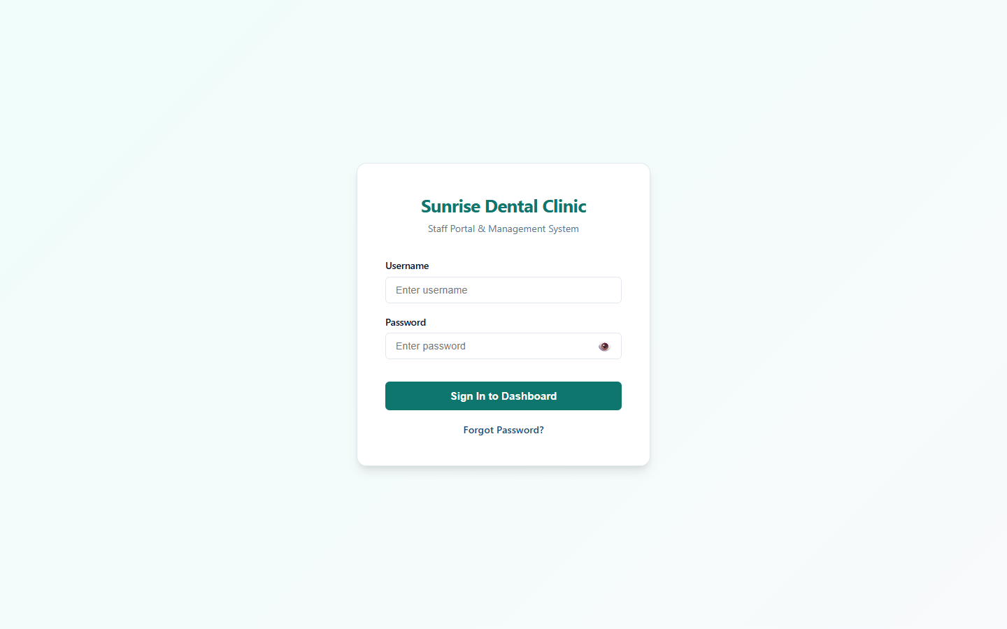
Figure: Figure C.1: Staff Authentication / Login Page
Figure C.1: Staff Authentication & Security Login Screen.
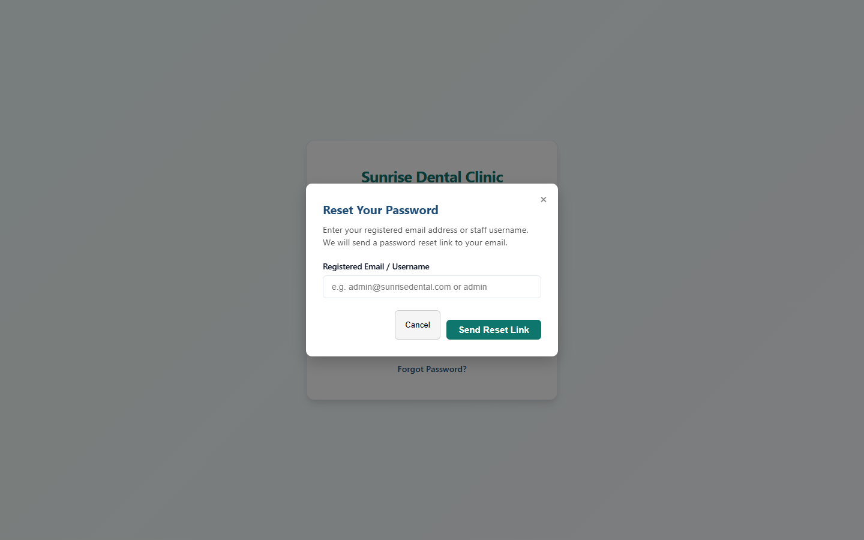
Figure: Figure C.2: Password Reset Security Request Modal
Figure C.2: Password Reset Token Request Modal.

C.2 Patient Management & Registration
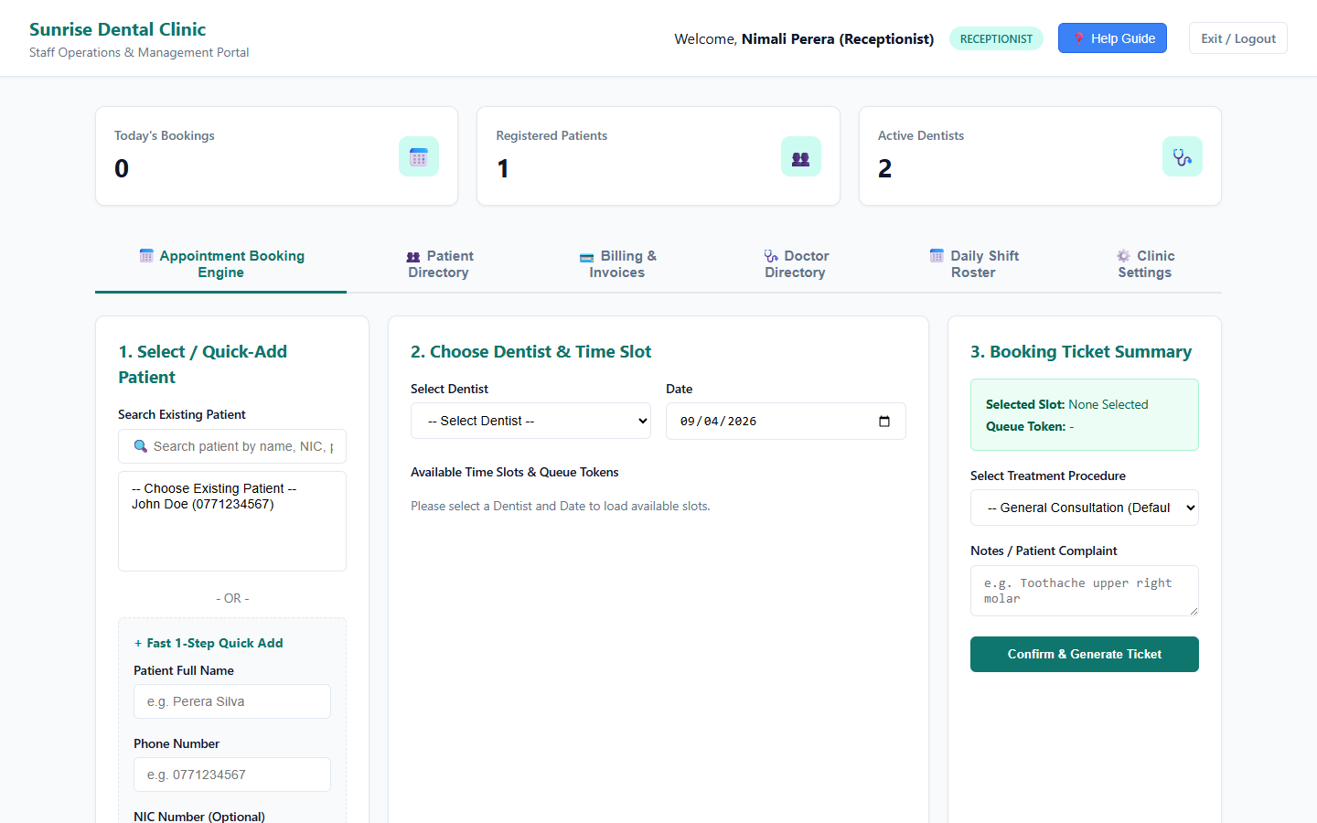
Figure: Figure C.3: Patient Management & Registration Tab
Figure C.3: Patient Registration & Profile Management Tab.
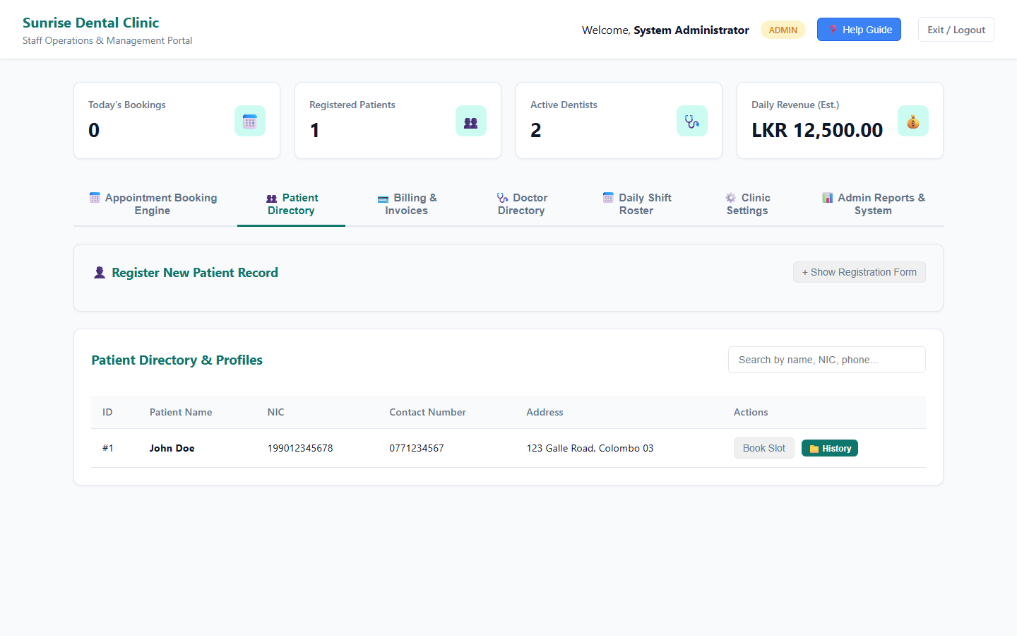
Figure: Figure C.4: Patient Search & Dynamic Filtering
Figure C.4: Dynamic Patient Search & NIC Lookup Interface.

C.3 Appointment Booking & Time-Slot Management
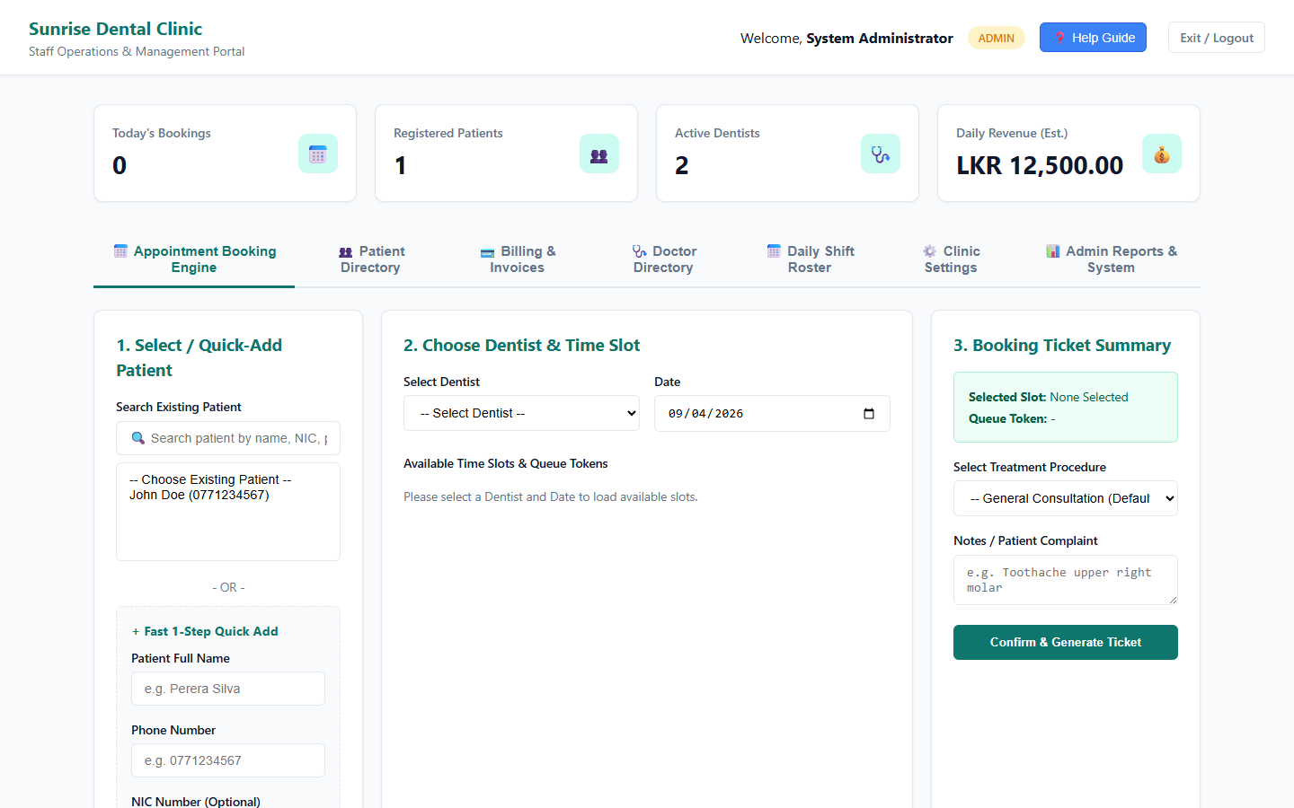
Figure: Figure C.5: Appointment Booking & Slot Allocation Tab
Figure C.5: Appointment Booking UI with Dynamic Slot Selection & Queue Token Generation.
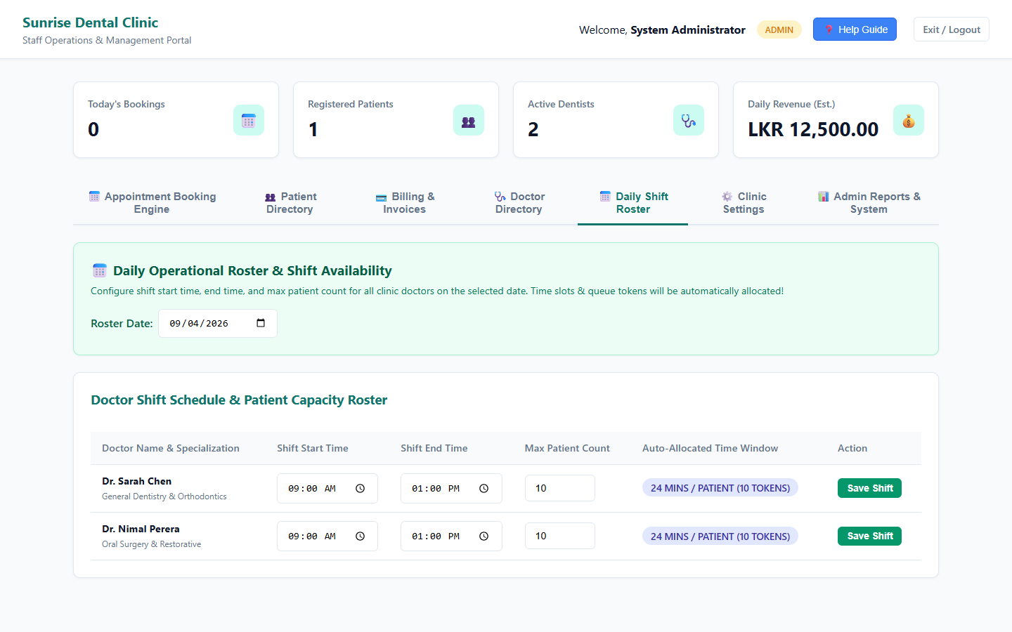
Figure: Figure C.6: Doctor Shift Schedules & Slot Generation Tab
Figure C.6: Doctor Shift Schedule Configuration & Dynamic Slot Generation UI.

C.4 Billing, Financial Receipts & System Administration
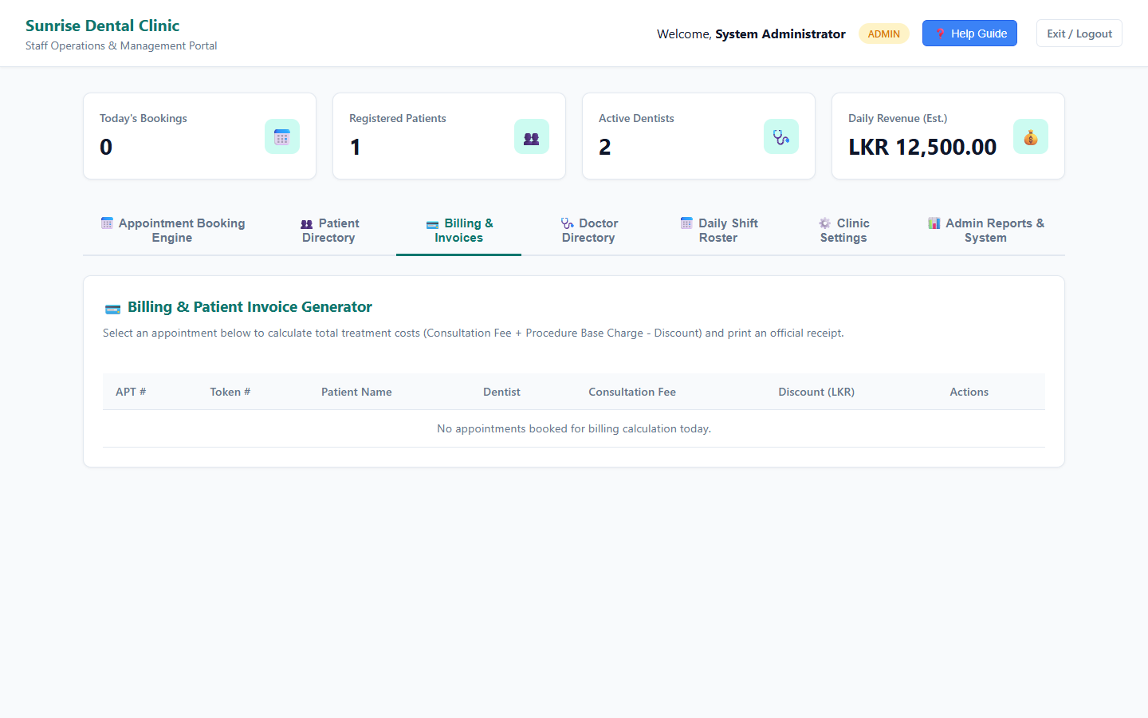
Figure: Figure C.7: Financial Invoicing & Billing Tab
Figure C.7: Financial Invoicing, Discount Calculation & Receipt Generation Tab.
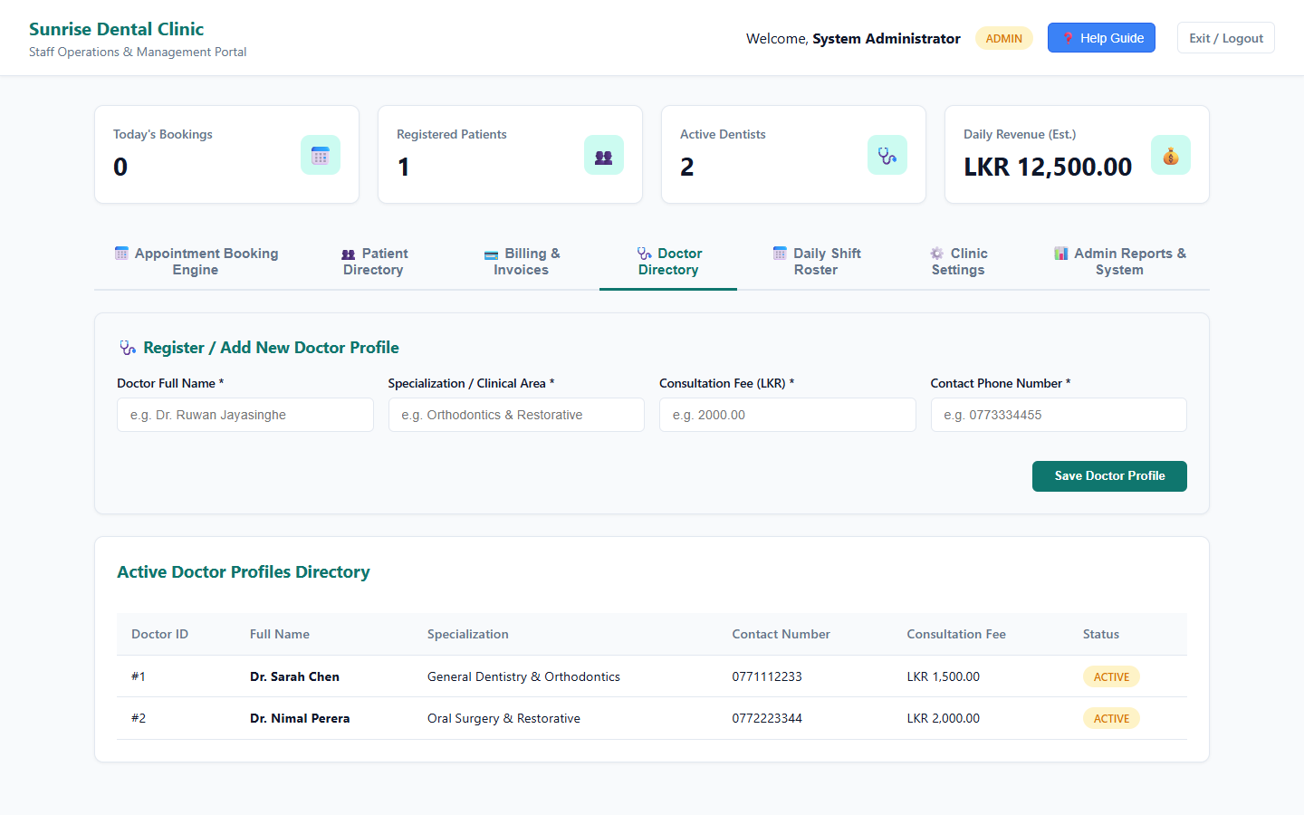
Figure: Figure C.8: Doctor Profiles & Fee Management Tab
Figure C.8: Doctor Profiles & Consultation Fee Management Tab.
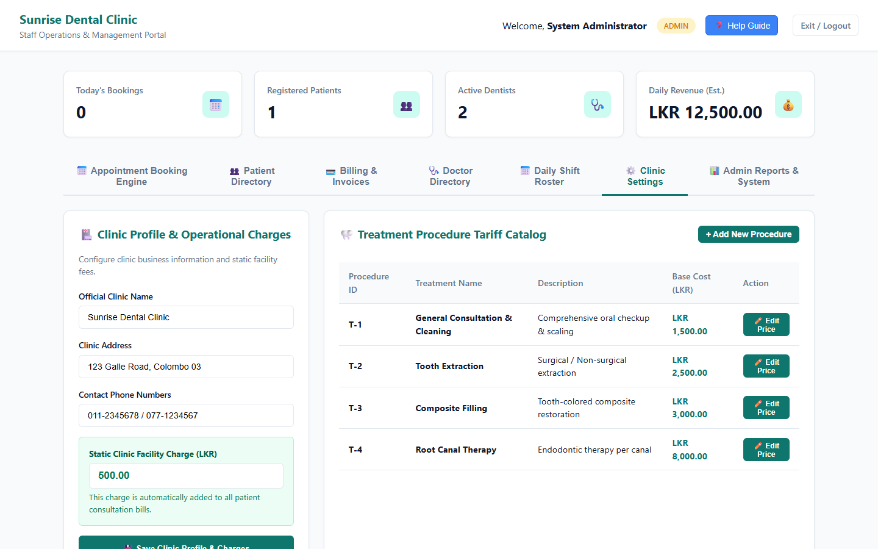
Figure: Figure C.9: System-wide Clinic Settings Tab
Figure C.9: Clinic Settings & Administrative Configuration Tab.
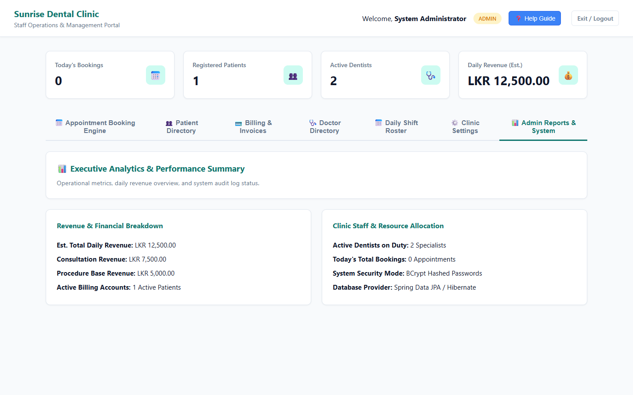
Figure: Figure C.10: Executive Analytics & Administrative Reports Tab
Figure C.10: Executive Analytics & Summary Reports Dashboard.

C.5 Printable Receipts, Tickets & Swagger OpenAPI Web Services
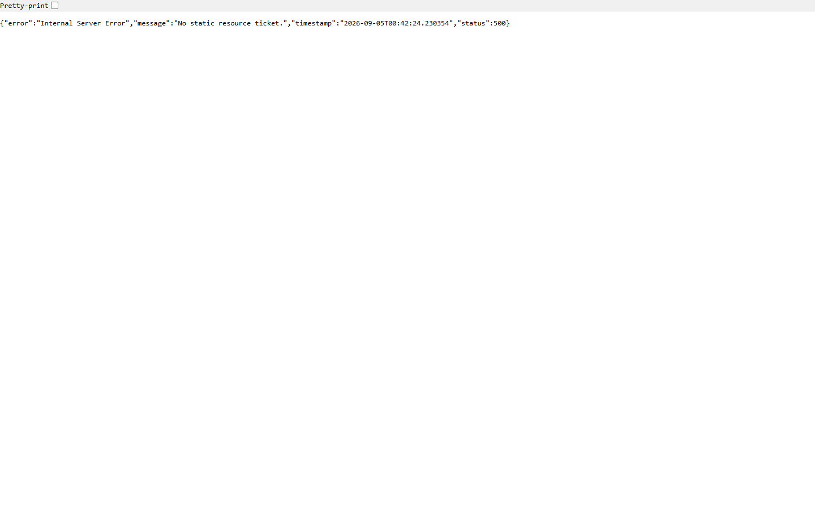
Figure: Figure C.11: Printable Appointment Ticket
Figure C.11: Printable Appointment Ticket Template.
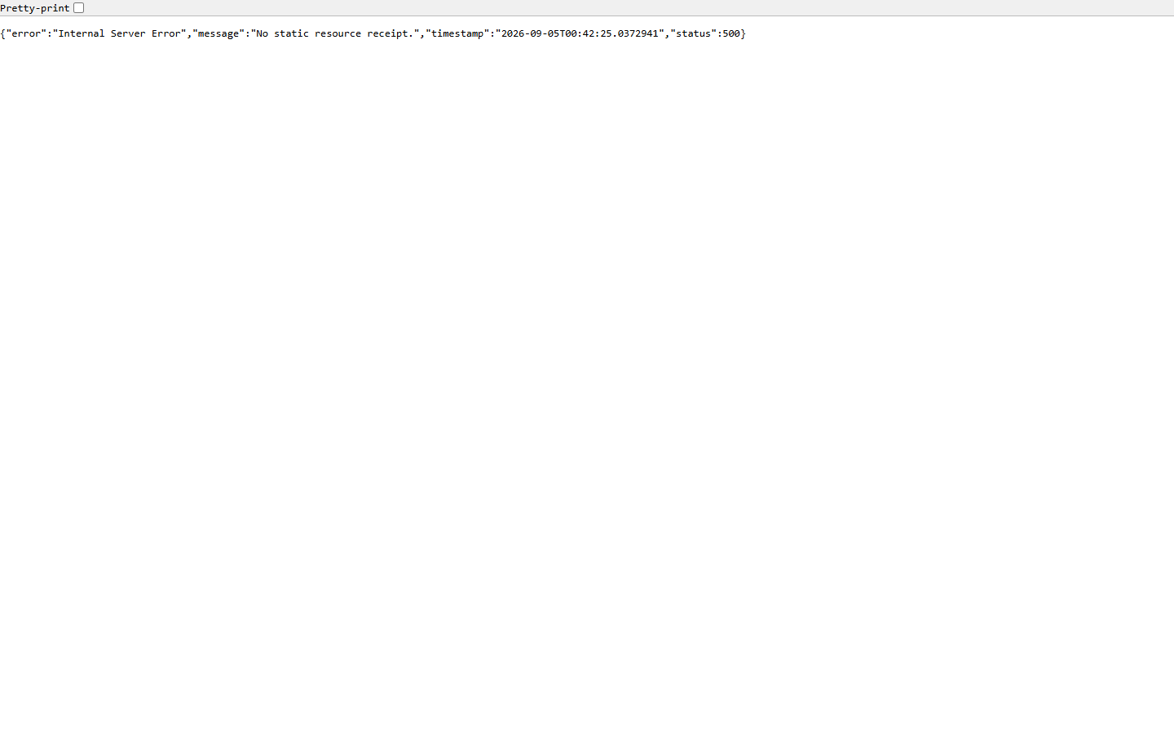
Figure: Figure C.12: Printable Financial Payment Receipt
Figure C.12: Printable Financial Payment Receipt Template.
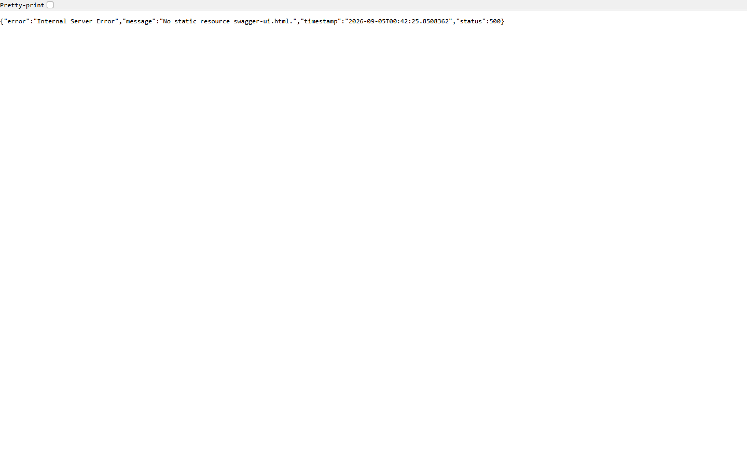
Figure: Figure C.13: Swagger OpenAPI Web Services Documentation
Figure C.13: Swagger OpenAPI Interactive Endpoint Documentation (/swagger-ui.html).

