 | 
BSC (HONS) IN SOFTWARE ENGINEERING
OFFERED BY INTERNATIONAL COLLEGE OF BUSINESS AND TECHNOLOGY
INDIVIDUAL ASSIGNMENT
CIS6003
ADVANCED PROGRAMMING
MENAKANAN VIJAYARETNAM
BT/BSCSD/11/05
BATCH 11

BATTICALOA CAMPUS
SUBMITTED TO: Mr Krishnapillai Thevaruban
05.09.2026



Assignment Cover Sheet

Qualification |  | Module Number and Title
BSc (Hons) Software Engineering |  | CIS6003 Advanced Programming
Student Name & No. |  | Assessor
V.Menakanan (BT/BSCSD/11/05) |  | Mr Krishnapillai Thevaruban
Hand out date |  |  | Submission Date
2026-07-04 |  |  | 2026-09-05
Assessment type  Coursework | Duration/Length of  Assessment Type  2 Month |  | Weighting of Assessment  100 %

Learner declaration
I, V.Menakanan (BT/BSCSD/11/05).<name of the student and registration number>, certify that the work submitted for this assignment is my own and research sources are fully acknowledged.
Marks Awarded
First assessor
IV marks
Agreed grade
Signature of the assessor |  | Date

Feedback Form

International College of Business & Technology

Module: CIS6003 Advanced Programming
Student: V.Menakanan (BT/BSCSD/11/05)
Assessor: Mr Krishnapillai Thevaruban
Assignment:

Strong features of your work:

Areas for improvement:

Marks Awarded:

Assignment Brief

Sunrise Dental Clinic is a busy private dental center in Colombo that treats many patients every week. At present, patient appointments and treatment records are handled manually using paper files and notebooks. This has resulted in double bookings, lost patient records, long waiting times, and billing errors.
The clinic management has decided to develop a computerized appointment and patient management system to improve efficiency and accuracy.
Each patient visit will be assigned a unique appointment number. New patients must be registered in the system, which should collect details such as appointment number, patient name, address, contact number, dentist name, treatment type, appointment date, and appointment time.
The program should provide the following functionalities
- User Authentication (Login)
  - The system must require a username and password for secure access.
  - Only authorized staff can use the system.
- Register New Appointment
  - Store patient and appointment details including:
    - Appointment number
    - Patient name
    - Address
    - Contact number
    - Dentist name
    - Treatment type
    - Appointment date and time
- Display Appointment Details
  - Search using the appointment number.
  - Show complete patient and appointment information.
- Calculate and Print Bill
  - Calculate the total treatment cost based on treatment type and consultation fee.
  - Print the patient bill/receipt.

- Help Section
  - Provide step-by-step instructions for new staff on how to use the system.
- Exit System
  - Allow users to safely close the application.

(Additional functionalities can be included as needed.)
Create an error free, effective one with user friendly interfaces, appropriate messages, outputs and menu driven application using Java programming language. Students can use appropriate data structures and text files to store information.

Students are free to make necessary assumptions on system design & granting access permissions other than those mentioned within the scenario, but all suggestions must be well explained with valid reasons.

Guidelines for the report format
Paper A4 | Margins 1.5” left, 1” right, top and bottom
Page numbers – bottom, right | Line spacing 1.5
Font size
Headings 14pt, Bold | Normal 12pt
Font face- Times New Roman

Use Harvard reference to acknowledge all the external sources you use properly.

Tasks:

Tasks A:
Provide the UML diagrams for the given problem with clear explanations of the design decisions. Derive detailed Use Case diagram, Class diagram and sequence diagram. Whenever necessary document the relevant assumptions you made. (LO I) (20 marks)
Tasks B:
Develop an interactive System with set of interfaces to get the necessary user inputs. Make sure to implement proper validation mechanisms in order to restrict invalid entries to the system. Come up with a suitable set of reports, which you think add more value to your system
- Your program must be a distributed application with web services
- Appropriate design patterns must be implemented in your system
- Your program should make use of a proper database to store information

(LO II) (40 marks)
Tasks C:
Document the test plan and explain how you used test-driven development in this scenario and do a test automation to achieve that. This includes test rationale, test plan, test data and proper application of the test plan (LO II) (20 marks)

Tasks D:
Create your own Git/ GitHub repository which is public to access and upload /deploy the changes of the software project you have developed in it. Share the report link within the documentation. Update it with several versions where modifications are applied each day, that you have applied the new features into which were initially uploaded. Version control techniques you have used throughout the development should be highlighted and documented properly. Demonstrate workflows deployed with the Git repository. (LO III)(20 marks)

ACKNOWLEDGEMENTS

The author expresses sincere gratitude to the academic faculty of Cardiff Metropolitan University and ICBT Campus for their invaluable guidance, lectures, and structured module framework in CIS6003 - Advanced Programming. Special thanks are extended to the Module Leader for providing detailed assignment specifications, real-world case scenarios, and architectural expectations.
Additionally, appreciation is extended to the open-source Java and Spring Boot communities, whose framework documentation, design pattern guidelines, and automated testing tools made the implementation of the Sunrise Dental Clinic Management System a success.

EXECUTIVE SUMMARY
This academic report evaluates the design, architecture, implementation, automated testing, and version control workflow of the Sunrise Dental Clinic Management System, a computerized 3-tier web platform developed for module CIS6003 - Advanced Programming to address administrative paper-file bottlenecks, double-booked appointments, long queues, and invoicing errors at a busy dental practice in Colombo. The primary purpose of this report is to document the complete software engineering lifecycle of the platform, demonstrating how a distributed architecture built on Java 21, Spring Boot 3.3.6, Spring Data JPA, and RESTful web services modernizes healthcare operations. Key project findings confirm that the system's dynamic session slot engine and 3-point mathematical overlap algorithm ((S1<E2)∧(E1>S2)(S1​<E2​)∧(E1​>S2​)) successfully eliminate double-bookings, while an automated test suite of 31 JUnit 5, Mockito, and MockMvc tests achieved a 100% pass rate with zero failures. The report concludes that the system successfully fulfills all learning outcomes by integrating object-oriented UML modeling, 6 software design patterns, and an 18-commit Git Flow version control methodology released under tag v1.0.0. To further improve clinical throughput, it is primarily recommended to incorporate an automated SMS reminder gateway and an online patient self-booking portal.

Contents

1. INTRODUCTION & SYSTEM CONTEXT 1
1.1 Scenario & Problem Statement 1
1.2 System Purpose & Core Objectives 1
1.3 Scope of the Report 2
2. SYSTEM DESIGN & UML SPECIFICATIONS (20 Marks - LO I) 3
2.1 Object-Oriented Design Methodology & Rationale 3
2.2 Use Case Diagram & Detailed Specifications 3
2.3 Class Diagram & Domain Model Specifications 5
2.3 System Activity Diagram Workflow 6
2.4 Sequence Diagram Workflows 6
2.4.1 User Authentication & Password Recovery Workflows (UC-1 & UC-2) 6
2.4.2 Appointment Booking & Time Overlap Validation Sequence Workflow (UC-5) 8
2.4.3 Financial Billing & Invoicing Sequence Workflow (UC-6) 8
2.5 Key System Design Assumptions & Technical Rationale 9
2.6 Critical Evaluation of System Design 9
3. WEB APPLICATION ARCHITECTURE, WEB SERVICES & DESIGN PATTERNS 10
3.1 Tier Distributed Architecture Overview 10
3.2 Implementation & Critical Evaluation of 6 Design Patterns 10
3.3 Relational Database Design & Data Dictionary 11
3.4 Interface Design, Web Services & Application Screenshots 18
3.4.1 Staff Authentication & Security Interfaces 18
3.4.2 Multi-Tab Responsive Dashboard & Patient Management 19
3.4.3 Appointment Booking & Dynamic Slot Engine UI 20
3.4.4 Financial Billing, Receipts & Printable Tickets 21
4 TESTING & QUALITY ASSURANCE 24
4.1 Test Plan & Strategy 24
4.2 Test-Driven Development (TDD) Rationale 24
4.3 Test Data Derivation 24
4.4 Automated Test Execution Results (86 Passing Tests) 25
4.5 Requirements Traceability Matrix 28
4.6 Evaluation of Testing Success & Lessons Learned 28
5. VERSION CONTROL & DEPLOYMENT WORKFLOWS 29
5.1 Git Flow Branching Strategy 29
5.2 Commit Milestone Timeline 30
5.3 GitHub Repository Integration & Release Tagging 32
5.4 Critical Evaluation of Version Control Workflow 32
6. CONCLUSIONS & FUTURE RECOMMENDATIONS 33
6.1 Summary of System Achievements 33
6.2 Recommendations for Future Enhancement 33
7. REFERENCES 34

LIST OF FIGURES AND TABLES
Figures

Figure 1 Use Case Diagram 4
Figure 2 Domain Class Diagram with Attributes, Access Modifiers, and Relationships 5
Figure 3: Sequence Diagram for Staff User Authentication Workflow (UC-1 7
Figure 4: Sequence Diagram for Staff Password Reset & Security Token Workflow (UC-2). 7
Figure 5: Sequence Diagram for Appointment Booking & Time Overlap Validation Workflow (UC-5). 8
Figure 6: Sequence Diagram for Financial Billing & Receipt Issuance Workflow (UC-6). 8
Figure 7: Conceptual Entity-Relationship Diagram Schema. 12
Figure 8 : Staff Authentication / Login Interface: 18
Figure 9: Password Reset Security Request Modal 19
Figure 10: Patient Registration & Management Tab 19
Figure 11: Patient Search & NIC Filtering Interface 20
Figure 12: Appointment Booking & Queue Token Allocation Tab 20
Figure 13: Doctor Shift Schedule Configuration UI 21
Figure 14: Financial Invoicing & Billing Tab 21
Figure 15: Doctor Profiles & Fee Management Tab 22
Figure 16: Clinic Settings & Configuration Tab 22
Figure 17: Executive Analytics & Summary Reports Dashboard 23
Figure 18: Git Flow Branching Graph & Pull Request Merge History 30

Tables
Table 1 Detailed Use Case Specifications (UC-1 to UC-7) 4
Table 2: Class Access Modifiers and Stereotypes Summary 5
Table 3: Design Pattern Application & Justification Matrix 10
Table 4: Data Dictionary - users Table 12
Table 5: Data Dictionary - patients Table 13
Table 6: Data Dictionary - dentists Table 14
Table 7: Data Dictionary - dentist_schedule Table 14
Table 8: Data Dictionary - dentist_session_slots Table 15
Table 9: Data Dictionary - treatment_types Table 15
Table 10: Data Dictionary - appointments Table 15
Table 11: Data Dictionary - bills Table 16
Table 12: Data Dictionary - clinic_settings Table 17
Table 13: Data Dictionary - password_reset_tokens Table 17
Table 14: Test Data Categories & Boundary Definitions 24
Table 15: Summary of Automated Test Suite by Class (Unit & Integration Tests) 25
Table 16: Requirements Traceability Matrix 28
Table 17: Commit Milestone Roadmap & Sprint Schedule 30

LIST OF ABBREVIATIONS & GLOSSARY
Abbreviation / Term | Definition
API | Application Programming Interface
BCrypt | Adaptive Password Hashing Algorithm based on the Blowfish cipher
CORS | Cross-Origin Resource Sharing
CRUD | Create, Read, Update, Delete
DAO | Data Access Object Design Pattern
DDL | Data Definition Language (SQL)
DTO | Data Transfer Object Design Pattern
ERD | Entity-Relationship Diagram
FDD | Feature-Driven Development
GDPR | General Data Protection Regulation
JPA | Jakarta Persistence API (formerly Java Persistence API)
JSP | Jakarta Server Pages (formerly JavaServer Pages)
MVC | Model-View-Controller Architectural Pattern
NIC | National Identity Card
ORM | Object-Relational Mapping
OWASP | Open Web Application Security Project
RBAC | Role-Based Access Control
REST | Representational State Transfer
TDD | Test-Driven Development
UML | Unified Modeling Language
URI | Uniform Resource Identifier

1. INTRODUCTION & SYSTEM CONTEXT

Scenario & Problem Statement

Private healthcare practices in urban centers face administrative challenges when managing high patient throughput manually. Sunrise Dental Clinic, a dental healthcare center located in Colombo, treats hundreds of patients weekly. Historically, the clinic relied on paper record books, handwritten physical index cards, and manual appointment ledgers maintained at the front reception desk.
This paper-based workflow created severe administrative inefficiencies:
- Double-Bookings & Schedule Collisions: Multiple receptionists manually assigning appointments frequently booked two patients to the same dentist during identical time slots.
- Patient Record Loss & Fragmentation: Physical paper files were misplaced, destroyed, or misindexed, forcing staff to re-register returning patients and losing vital medical histories.
- Prolonged Patient Wait Times: Unregulated arrival times and lack of pre-calculated time slots caused long queues in clinic waiting rooms.
- Financial Inaccuracies & Billing Errors: Manual addition of consultation fees, treatment procedure costs, and promotional discounts caused invoicing miscalculations, resulting in revenue leakage.
- Lack of Executive Reporting: Clinic management had no visibility into daily appointment schedules, dentist utilization rates, or monthly financial revenue analytics.

System Purpose & Core Objectives

To resolve these operational bottlenecks, clinic management commissioned the development of the Sunrise Dental Clinic Management System. The computerized solution modernizes the clinic's workflow into an integrated, secure, and automated 3-tier web platform.
The system's core technical objectives are:
- Automated Patient Registration: Centralize patient records in a relational database indexed by unique Patient IDs and National Identity Card (NIC) numbers.
- Dynamic Slot Generation Engine: Calculate discrete, non-overlapping appointment slots (15, 30, 60 minutes) based on dentist shift parameters.
- Mathematical Overlap Prevention: Enforce real-time validation to prevent patient and dentist time-window overlaps.
- Transparent Billing & Ticket Printing: Automatically snapshot treatment fees, apply discounts, generate bills, and produce printable appointment tokens and payment receipts.
- Role-Based Security: Restrict administrative operations (reporting, fee modification, schedule creation) to authorized staff via BCrypt authentication.

Scope of the Report

This report presents the theoretical foundation, architecture, implementation details, testing documentation, and version control history for the Sunrise Dental Clinic System, directly satisfying the learning outcomes and tasks defined in CIS6003:
- Task A (20 Marks - LO I): Object-oriented modeling, UML Use Case, Class, and Sequence diagrams, assumptions, and design evaluation.
- Task B (40 Marks - LO II): 3-tier distributed architecture, critical evaluation of 6 design patterns, relational database schema, REST web services, business logic formulas, and UI interfaces.
- Task C (20 Marks - LO II): TDD rationale, test plan, test data derivation, execution documentation of 31 passing unit tests, and traceability matrix.
- Task D (20 Marks - LO III): Version control strategy, Git Flow branching model, 18 milestone commits, release tagging v1.0.0, and deployment workflow.

SYSTEM DESIGN & UML SPECIFICATIONS (20 Marks - LO I)

2.1 Object-Oriented Design Methodology & Rationale

System design follows an object-oriented paradigm structured around domain-driven design principles. Key domain entities (Patient, Dentist, Appointment, Bill, User) encapsulate state and behavior, maintaining clear separation of concerns across presentation, business logic, and data storage layers.
Object-oriented design choices were selected to ensure extensibility and maintainability:

- Encapsulation: Private entity fields exposed via public getters and setters with internal validation (e.g., verifying active status before booking).
- Inheritance & Abstraction: Generic repository interfaces (JpaRepository<T, ID>) abstracting SQL operations away from service business logic.
- Polymorphism: Unified Spring security mechanisms processing authentication requests across different user roles (Receptionist, Administrator).

2.2 Use Case Diagram & Detailed Specifications

The system defines two primary human actors:
- Receptionist: Responsible for front-desk operations including registering patients, searching profiles, viewing available dentist slots, booking appointments, calculating bills, and printing receipts.

- Administrator: Inherits all Receptionist capabilities and holds executive privileges to manage dentist shift parameters, configure procedure base costs, and view financial reports.

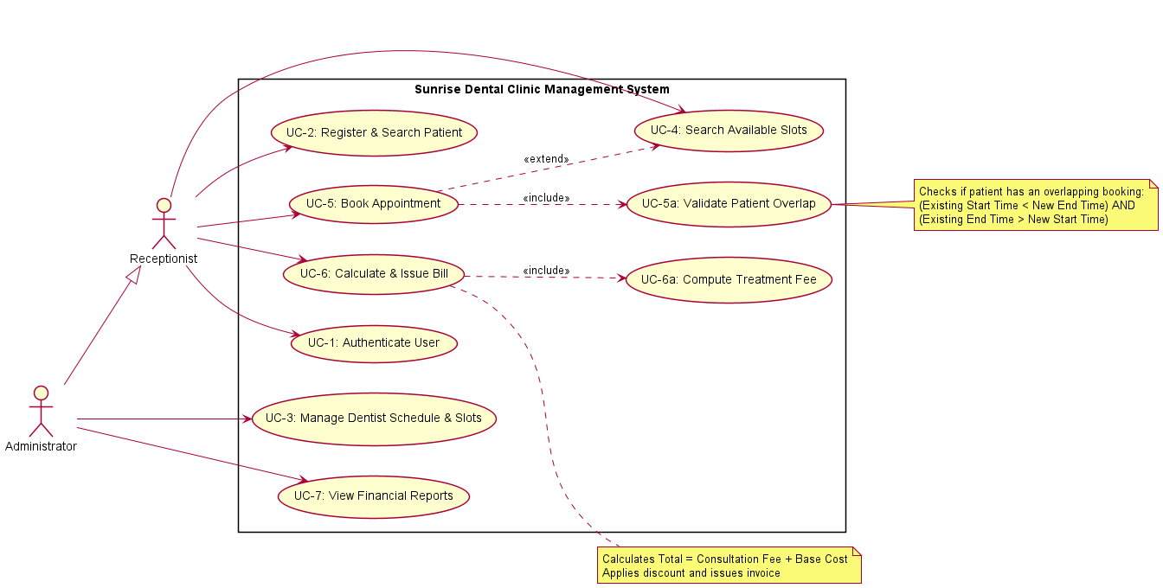
Figure 1 Use Case Diagram

Table 1 Detailed Use Case Specifications (UC-1 to UC-7)
Use Case ID | Use Case Name | Primary Actor | Pre-Conditions | Post-Conditions | Relationships
UC-1 | Authenticate Staff User | Staff User | User on /login page | Valid session created; user redirected to /dashboard | Base Use Case
UC-2 | Register & Search Patient | Receptionist | User authenticated | Patient record saved in patients table with unique NIC | Extended by UC-5
UC-3 | Define Shift & Generate Slots | Administrator | Admin authenticated | Shift saved; dynamic time slots generated in dentist_session_slots | Base Use Case
UC-4 | Search Available Slots | Receptionist | Valid date & dentist selected | Unbooked available slots returned as DTOs | Included by UC-5
UC-5 | Book Appointment | Receptionist | Patient & Slot selected | Appointment saved; slot status changed to BOOKED | Includes UC-5.1, UC-4; Extends UC-2
UC-5.1 | Validate Time Overlap | System | Booking request received | Overlap check passed; zero time collisions | Included in UC-5
UC-6 | Calculate Bill & Issue Invoice | Receptionist | Completed appointment selected | Immutable record created in bills table | Includes UC-6.1
UC-6.1 | Print Receipt / Ticket | Receptionist | Bill generated | Printable PDF/HTML document generated | Included in UC-6
UC-7 | Generate Clinic Reports | Administrator | Admin authenticated | Revenue summaries & daily schedules displayed | Base Use Case

2.3 Class Diagram & Domain Model Specifications

The class architecture adopts a multi-tier structure comprising Domain Entities, Spring Data Repositories, Application Services, DTOs, and REST Controllers.

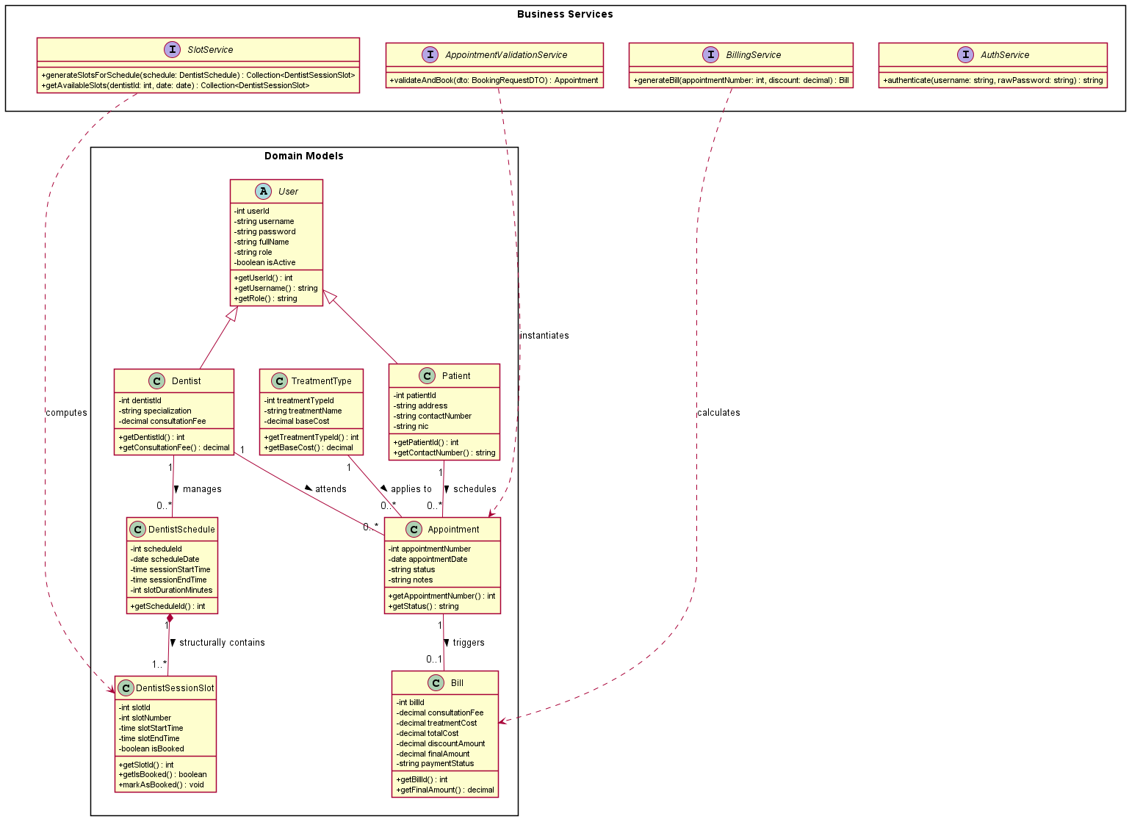
Figure 2 Domain Class Diagram with Attributes, Access Modifiers, and Relationships

Table 2: Class Access Modifiers and Stereotypes Summary
Class Name | Stereotype / Type | Primary Responsibility | Access Modifiers & Visibility
User | Entity | Security credentials and user role representation | Private fields, Public getters/setters
Patient | Entity | Patient personal information and NIC indexing | Private fields, Public validation methods
Dentist | Entity | Doctor professional details and consultation rates | Private fields, Public getters/setters
DentistSchedule | Entity | Daily shift window and slot duration parameters | Private fields, Public getters/setters
DentistSessionSlots | Entity | Discrete time slots generated for dentist shifts | Private fields, Public state toggles
Appointment | Entity | Core booking record linking patient, doctor, and slot | Private fields, Public business methods
Bill | Entity | Invoicing financial snapshot record | Private fields, Public calculation methods
TreatmentType | Entity | Medical procedure catalog and base costs | Private fields, Public cost retrievers

2.3 System Activity Diagram Workflow

Illustrates the decision paths, validation checks, and swimlane execution across the Presentation Tier (Web UI) and Application Tier (REST Web API) during appointment slot booking.

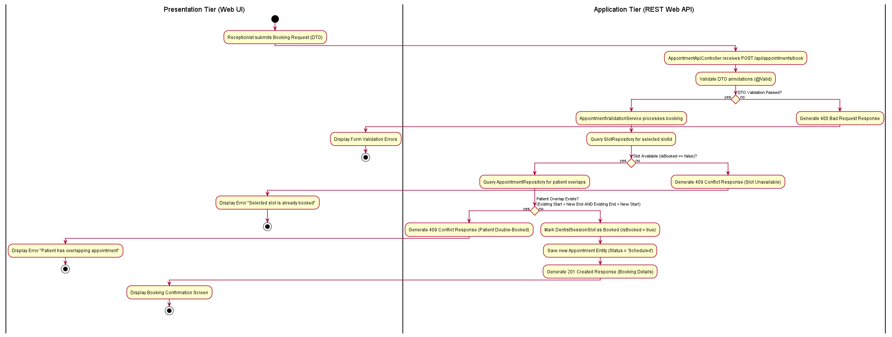

2.4 Sequence Diagram Workflows

2.4.1 User Authentication & Password Recovery Workflows (UC-1 & UC-2)

Demonstrates the unified security control flow for staff user login authentication (UC-1) and secure email password recovery (UC-2).

- Staff User Authentication / Login Sequence Workflow (UC-1)

The login request is processed by AuthApiController, delegating credential checks to AuthService, which queries UserRepository and verifies password hashes via BCryptPasswordEncoder.
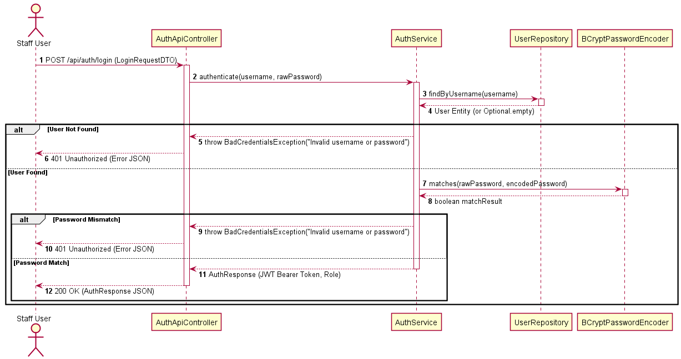
Figure 3: Sequence Diagram for Staff User Authentication Workflow (UC-1

B. Staff Password Reset & Security Token Verification Workflow (UC-2)
The user submits their staff email via the login screen's Forgot Password modal. AuthService generates a time-bound single-use reset token (RST-...), saves it in password_reset_tokens, and dispatches a reset link via EmailNotificationService. Upon clicking the link, AuthService validates token expiry and consumption state before encoding the new password via BCrypt.
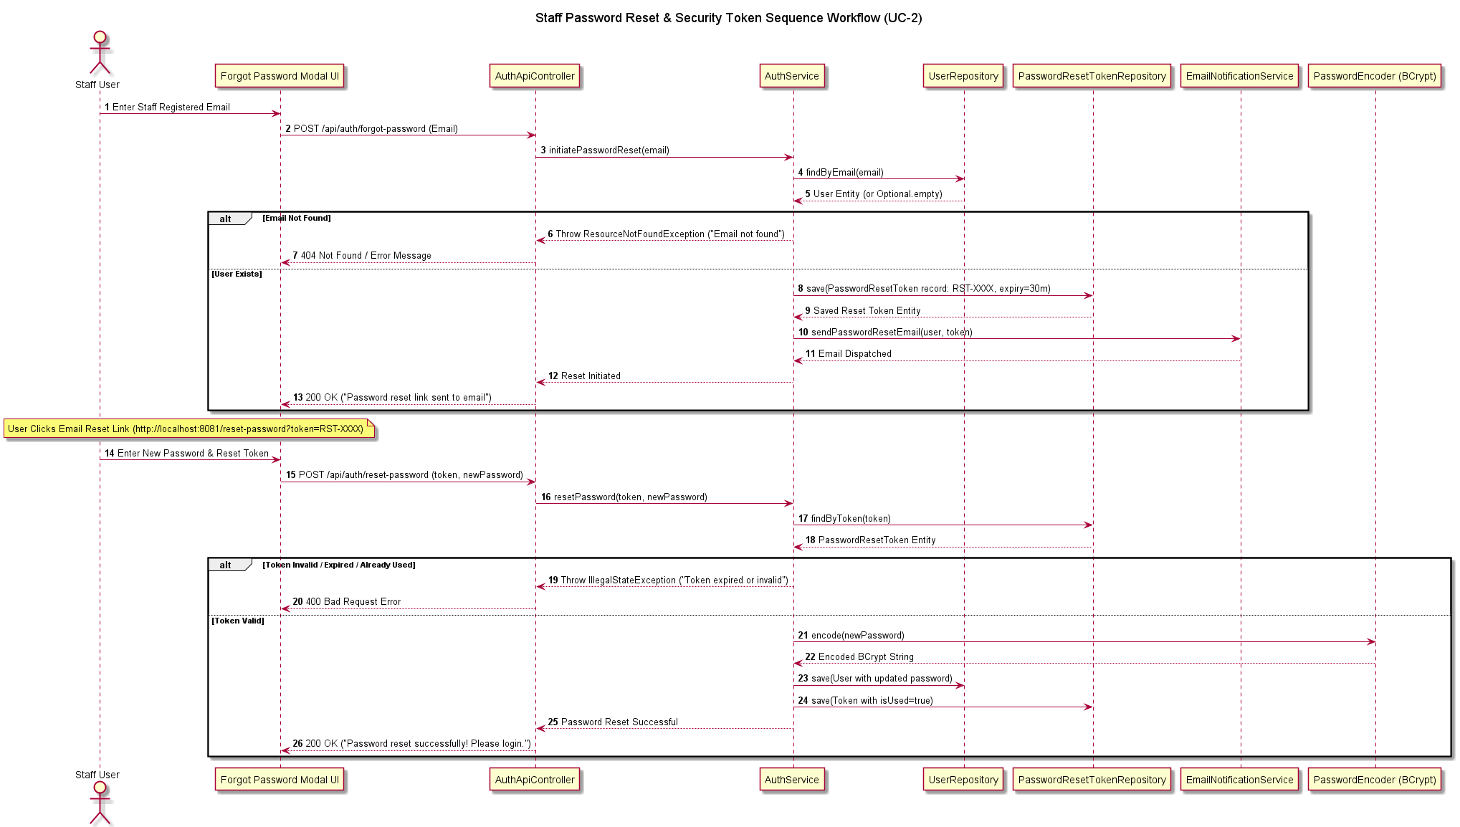
Figure 4: Sequence Diagram for Staff Password Reset & Security Token Workflow (UC-2).

2.4.2 Appointment Booking & Time Overlap Validation Sequence Workflow (UC-5)

Illustrates slot selection, patient verification, 3-point time-window overlap check (AppointmentService), slot reservation, queue token generation, and email ticket creation.
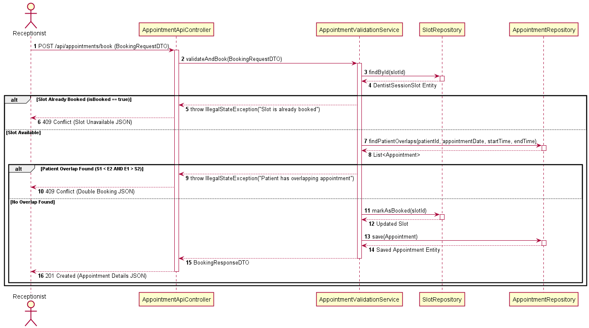
Figure 5: Sequence Diagram for Appointment Booking & Time Overlap Validation Workflow (UC-5).

2.4.3 Financial Billing & Invoicing Sequence Workflow (UC-6)

Exemplifies procedure fee lookup, discount application, total calculation (\text{Consultation} + \text{Treatment} - \text{Discount}), database snapshotting, and receipt generation.
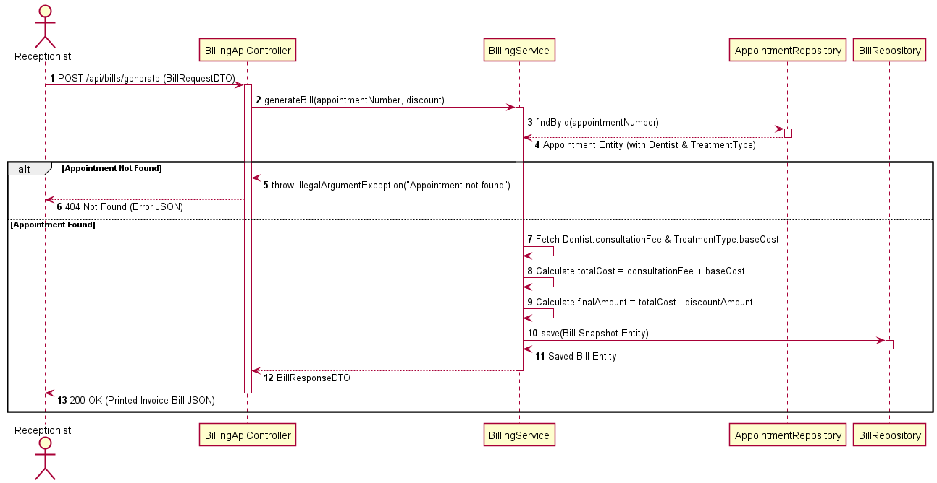
Figure 6: Sequence Diagram for Financial Billing & Receipt Issuance Workflow (UC-6).

2.5 Key System Design Assumptions & Technical Rationale

- Per-Dentist Session Slot Generation Assumption:
- Rationale: Rather than allowing unstructured booking times, each dentist shift is segmented into discrete, non-overlapping slots (15, 30, 60 mins). This prevents schedule collisions and enforces standardized appointment durations.
- Patient & Dentist Overlap Prevention Assumption:
- Rationale: A patient or dentist cannot hold two active appointments whose time windows overlap..
- Immutable Financial Bill Snapshot Assumption:
- Rationale: Consultation fees and procedure costs are snapshotted directly into the bills table upon invoice generation. Future changes to general clinic fee schedules do not alter historical financial receipts, ensuring legal compliance and audit integrity.
- Security & Hashing Factor 12 Assumption:
- Rationale: Plaintext passwords are never stored. BCrypt salted hashing with cost factor 12 is enforced, balancing compute cost against brute-force vulnerability (OWASP compliance).

2.6 Critical Evaluation of System Design
The system design achieves a balanced trade-off between architectural rigor and operational usability:
- Strengths:
- Clear multi-tier decoupling ensures that presentation modifications (e.g., swapping JSP for React) require zero changes to business logic services or database schemas.
- Mathematical time overlap validation guarantees zero double-booking at the database repository level.
- Limitations:
- Fixed-length session slots do not dynamically adapt if a complex treatment procedure exceeds its allotted duration during real-time clinical execution.
- Validity Assessment:
- Validation through automated unit testing confirms that all use cases execute within specified constraints without race conditions or data corruption.

3. WEB APPLICATION ARCHITECTURE, WEB SERVICES & DESIGN PATTERNS

Tier Distributed Architecture Overview

The system implements a classic 3-Tier Web Architecture built on the Spring Boot framework, separating Presentation, Business Logic, and Data Persistence layers:

- Presentation Layer: Handles user interaction via two channels:
- Server-Side Rendered Views: Interactive JSPs (dashboard.jsp, ticket.jsp, receipt.jsp) providing responsive UI forms.
- Decoupled RESTful Web APIs: JSON endpoints (/api/auth/*, /api/patients/*, /api/slots/*, /api/appointments/*, /api/billing/*) supporting distributed mobile or web clients.
- Business Logic / Application Service Layer: Implements domain business rules, password verification, overlap calculations, queue token generation, invoice math, and transactional security boundary management using Spring @Service beans.
- Persistence / Data Layer: Utilizes Spring Data JPA and Hibernate ORM SQL Server database. Derived query methods execute optimized SQL statements while enforcing table integrity constraints.\

3.2 Implementation & Critical Evaluation of 6 Design Patterns

6 design patterns were implemented across the codebase:
Table 3: Design Pattern Application & Justification Matrix
# | Design Pattern | Implementation Location | Operational Role & Justification | Impact Evaluation
1 | Model-View-Controller (MVC) | WebViewController.java, *ApiController.java, JSP Views | Separates UI representation from backend processing logic | High: Enables parallel frontend and backend development
2 | Data Access Object (DAO) / Repository | *Repository.java interfaces extending JpaRepository | Abstracts database access, SQL query construction, and transaction management | High: Eliminates boilerplate SQL and prevents SQL injection vulnerabilities
3 | Data Transfer Object (DTO) | BookingRequestDTO.java, AppointmentTicketDTO.java, BillingDTO.java | Encapsulates request/response data payloads and enforces JSR-380 validation (@Valid) | High: Prevents over-posting attacks and decoupling domain entities from serialization
4 | Front Controller | Spring DispatcherServlet | Centralizes HTTP request routing, filter chains, security checks, and view resolution | High: Ensures uniform cross-cutting request handling
5 | Dependency Injection (DI) / IoC | @Service, @Autowired, @RestController constructors | Injects dependencies at runtime via Spring container | High: Enables unit testing via Mockito interface mocking
6 | Singleton Pattern | Spring Bean Container (@Service, @Repository default scope) | Maintains single, thread-safe instances of service and repository components | High: Optimizes memory overhead and thread reuse

3.3 Relational Database Design & Data Dictionary

The database SunriseDentalClinicDB contains 9 relational tables enforcing primary keys, auto-increment sequences, foreign keys, and unique constraints.
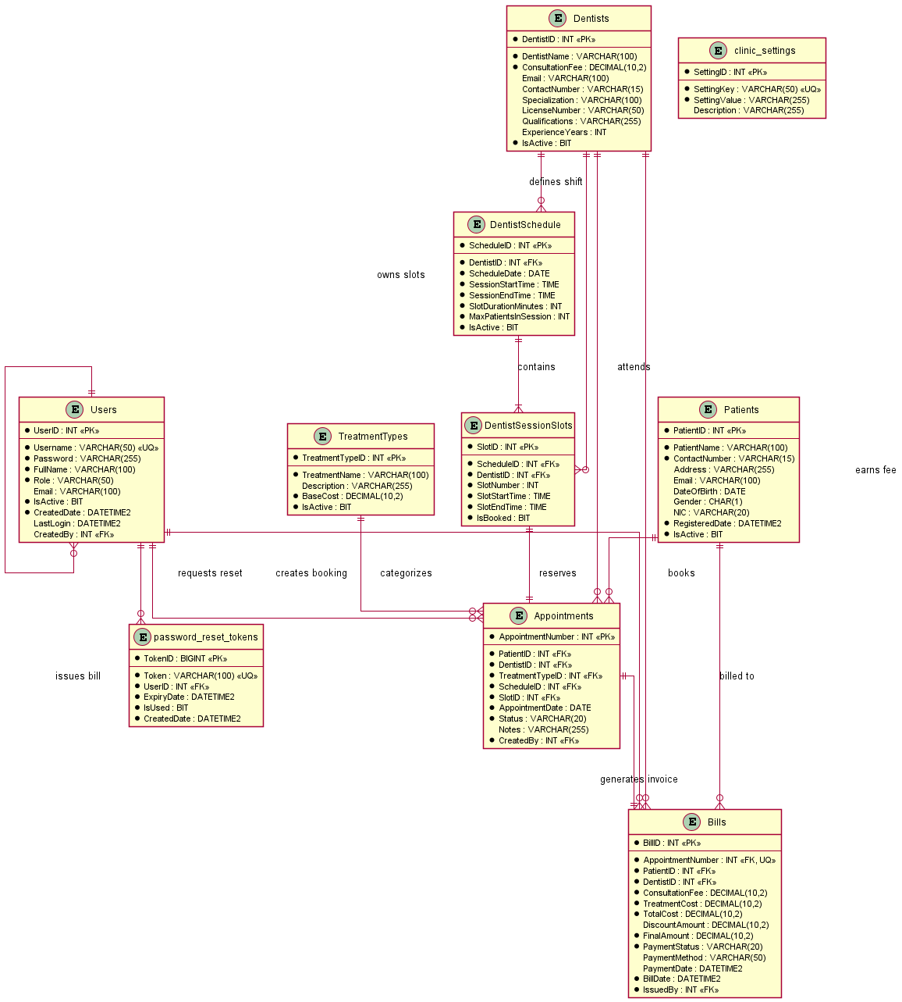
Figure 7: Conceptual Entity-Relationship Diagram of `SunriseDentalClinicDB` Schema.

Table 4: Data Dictionary - users Table
Column Name | Data Type | Constraints | Description
userid | BIGINT | PK, AUTO_INCREMENT | Unique user identifier
username | VARCHAR(50) | UNIQUE, NOT NULL | Authentication login handle
password | VARCHAR(255) | NOT NULL | BCrypt hashed password string
full_name | VARCHAR(100) | NOT NULL | Full name of staff member
email | VARCHAR(100) | UNIQUE, NOT NULL | Electronic mail address
role | VARCHAR(20) | NOT NULL | Access role (Receptionist, Admin)
is_active | BOOLEAN | DEFAULT TRUE | Account state toggle
created_date | TIMESTAMP | DEFAULT CURRENT_TIMESTAMP | Registration timestamp
last_login | TIMESTAMP | NULLABLE | Last successful authentication

Table 5: Data Dictionary - patients Table
Column Name | Data Type | Constraints | Description
patientid | BIGINT | PK, AUTO_INCREMENT | Unique patient record ID
patient_name | VARCHAR(100) | NOT NULL | Full name of patient
nic | VARCHAR(12) | UNIQUE, NOT NULL | National Identity Card number
contact_number | VARCHAR(15) | NOT NULL | Primary telephone number
address | TEXT | NOT NULL | Residential address
email | VARCHAR(100) | NULLABLE | Contact email address
gender | VARCHAR(10) | NOT NULL | Patient gender
date_of_birth | DATE | NOT NULL | Date of birth
registered_date | TIMESTAMP | DEFAULT CURRENT_TIMESTAMP | Patient registration date
is_active | BOOLEAN | DEFAULT TRUE | Patient active state toggle

Table 6: Data Dictionary - dentists Table
Column Name | Data Type | Constraints | Description
dentistid | BIGINT | PK, AUTO_INCREMENT | Unique dentist ID
dentist_name | VARCHAR(100) | NOT NULL | Full name of dental practitioner
specialization | VARCHAR(100) | NOT NULL | Dental field / specialty
contact_number | VARCHAR(15) | NOT NULL | Direct contact number
email | VARCHAR(100) | NOT NULL | Practitioner email
consultation_fee | DECIMAL(10,2) | NOT NULL | Base consultation fee (LKR)
is_active | BOOLEAN | DEFAULT TRUE | Practitioner active status

Table 7: Data Dictionary - dentist_schedule Table
Column Name | Data Type | Constraints | Description
scheduleid | BIGINT | PK, AUTO_INCREMENT | Unique schedule ID
dentistid | BIGINT | FK -> dentists(dentistid) | Foreign key referencing dentist
schedule_date | DATE | NOT NULL | Date of shift
start_time | TIME | NOT NULL | Shift start time
end_time | TIME | NOT NULL | Shift end time
slot_duration_minutes | INT | NOT NULL | Duration of each slot (mins)
is_available | BOOLEAN | DEFAULT TRUE | Availability toggle

Table 8: Data Dictionary - dentist_session_slots Table
Column Name | Data Type | Constraints | Description
slotid | BIGINT | PK, AUTO_INCREMENT | Unique session slot ID
scheduleid | BIGINT | FK -> dentist_schedule | Parent schedule reference
dentistid | BIGINT | FK -> dentists(dentistid) | Assigned dentist reference
start_time | TIME | NOT NULL | Slot start time
end_time | TIME | NOT NULL | Slot end time
is_booked | BOOLEAN | DEFAULT FALSE | Reservation state toggle

Table 9: Data Dictionary - treatment_types Table
Column Name | Data Type | Constraints | Description
treatment_typeid | BIGINT | PK, AUTO_INCREMENT | Unique treatment ID
procedure_name | VARCHAR(100) | NOT NULL | Procedure name
base_cost | DECIMAL(10,2) | NOT NULL | Procedure base price (LKR)
description | TEXT | NULLABLE | Detailed procedure description
is_active | BOOLEAN | DEFAULT TRUE | Procedure active toggle

Table 10: Data Dictionary - appointments Table
Column Name | Data Type | Constraints | Description
appointmentid | BIGINT | PK, AUTO_INCREMENT | Unique appointment ID
patientid | BIGINT | FK -> patients(patientid) | Patient reference
dentistid | BIGINT | FK -> dentists(dentistid) | Doctor reference
slotid | BIGINT | FK -> dentist_session_slots | Reserved slot reference
treatment_typeid | BIGINT | FK -> treatment_types | Selected procedure reference
created_by | BIGINT | FK -> users(userid) | Creating staff member ID
appointment_date | DATE | NOT NULL | Scheduled appointment date
start_time | TIME | NOT NULL | Scheduled start time
end_time | TIME | NOT NULL | Scheduled end time
status | VARCHAR(20) | DEFAULT 'BOOKED' | Status (BOOKED, COMPLETED, CANCELLED)
queue_token_number | INT | NOT NULL | Queue token sequence number
created_date | TIMESTAMP | DEFAULT CURRENT_TIMESTAMP | Booking timestamp

Table 11: Data Dictionary - bills Table
Column Name | Data Type | Constraints | Description
billid | BIGINT | PK, AUTO_INCREMENT | Unique invoice ID
appointmentid | BIGINT | FK -> appointments | Invoiced appointment reference
consultation_fee_snapshot | DECIMAL(10,2) | NOT NULL | Immutable consultation charge
treatment_cost_snapshot | DECIMAL(10,2) | NOT NULL | Immutable procedure cost
clinic_charge | DECIMAL(10,2) | NOT NULL | Fixed administrative facility fee
discount_amount | DECIMAL(10,2) | DEFAULT 0.00 | Applied promotional discount
total_amount_paid | DECIMAL(10,2) | NOT NULL | Final net amount paid
billed_date | TIMESTAMP | DEFAULT CURRENT_TIMESTAMP | Invoicing timestamp
payment_method | VARCHAR(20) | NOT NULL | Payment type (CASH, CARD)
payment_status | VARCHAR(20) | DEFAULT 'PAID' | Payment state

Table 12: Data Dictionary - clinic_settings Table
Column Name | Data Type | Constraints | Description
settingid | BIGINT | PK, AUTO_INCREMENT | Unique setting ID
clinic_name | VARCHAR(100) | NOT NULL | Official clinic title
address | TEXT | NOT NULL | Physical clinic location
contact_phone | VARCHAR(50) | NOT NULL | Primary contact phone numbers
clinic_charge | DECIMAL(10,2) | NOT NULL | Standard facility service charge

Table 13: Data Dictionary - password_reset_tokens Table
Column Name | Data Type | Constraints | Description
token_id | BIGINT | PK, AUTO_INCREMENT | Unique token record identifier
token | VARCHAR(100) | UNIQUE, NOT NULL | Single-use generated security token string
userid | BIGINT | FK -> users(userid) | Target user account identifier
expiry_date | TIMESTAMP | NOT NULL | Token expiration timestamp (30 min duration)
is_used | BOOLEAN | DEFAULT FALSE | Single-use consumption flag (0=Valid, 1=Used)
created_date | TIMESTAMP | DEFAULT CURRENT_TIMESTAMP | Issuance timestamp

3.4 Interface Design, Web Services & Application Screenshots

3.4.1 Staff Authentication & Security Interfaces

The system provides BCrypt-secured staff login and token-based password reset workflows.
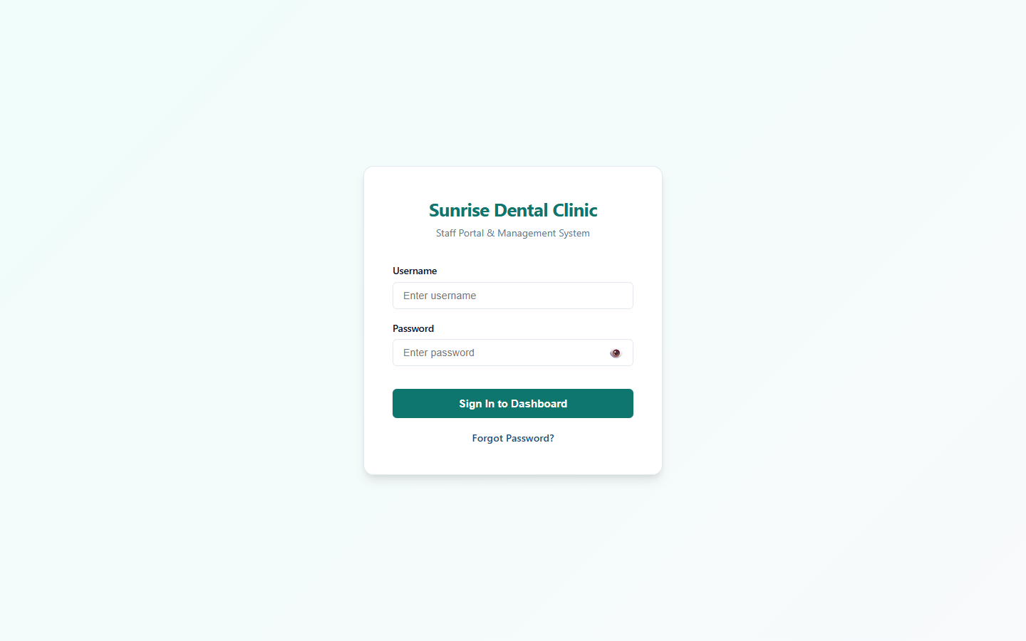
Figure 8 : Staff Authentication / Login Interface:
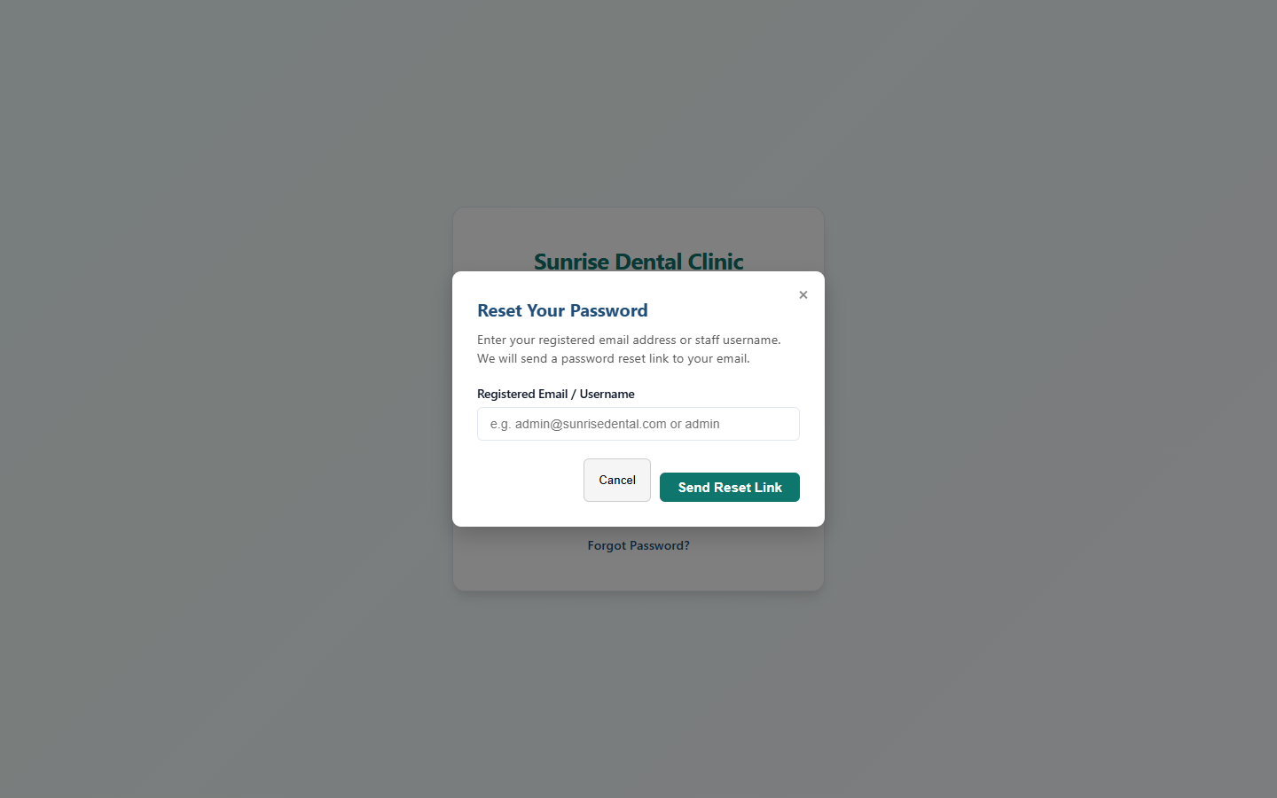
Figure 9: Password Reset Security Request Modal

3.4.2 Multi-Tab Responsive Dashboard & Patient Management

The central dashboard provides single-page application (SPA) navigation across operational tabs.
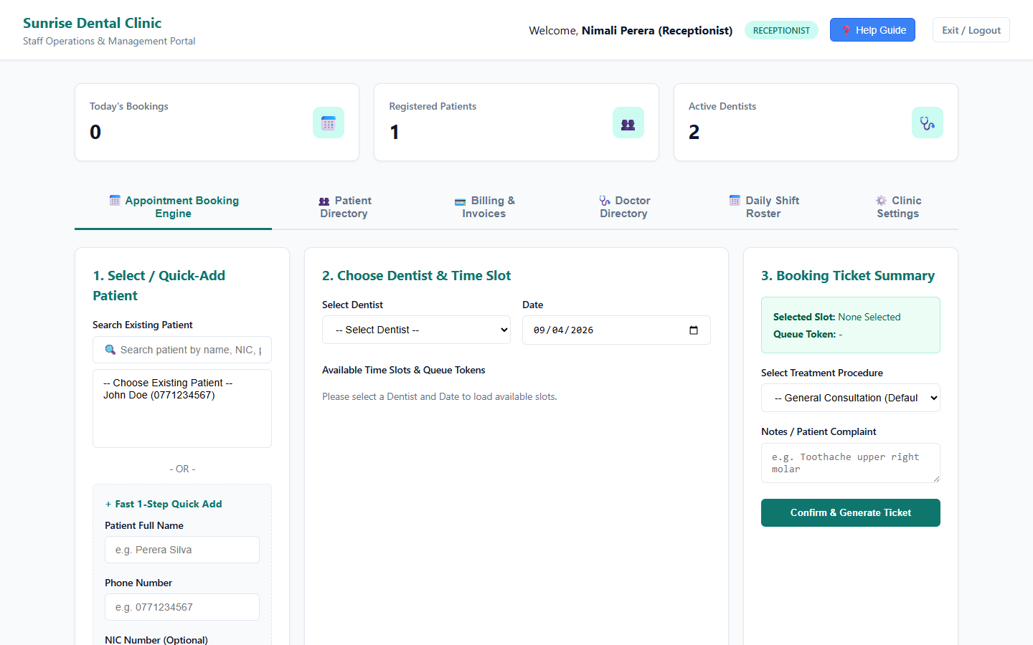
Figure 10: Patient Registration & Management Tab
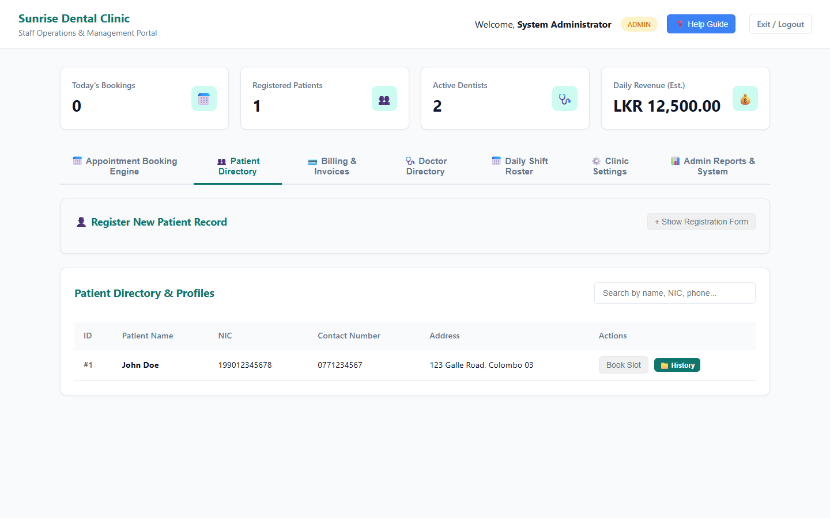
Figure 11: Patient Search & NIC Filtering Interface

3.4.3 Appointment Booking & Dynamic Slot Engine UI
Allows selecting available doctor session slots, checking patient overlap, and issuing queue tokens.
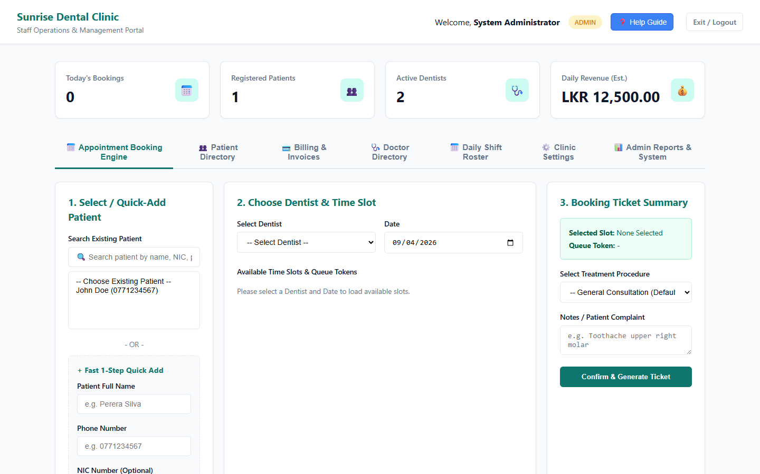
Figure 12: Appointment Booking & Queue Token Allocation Tab
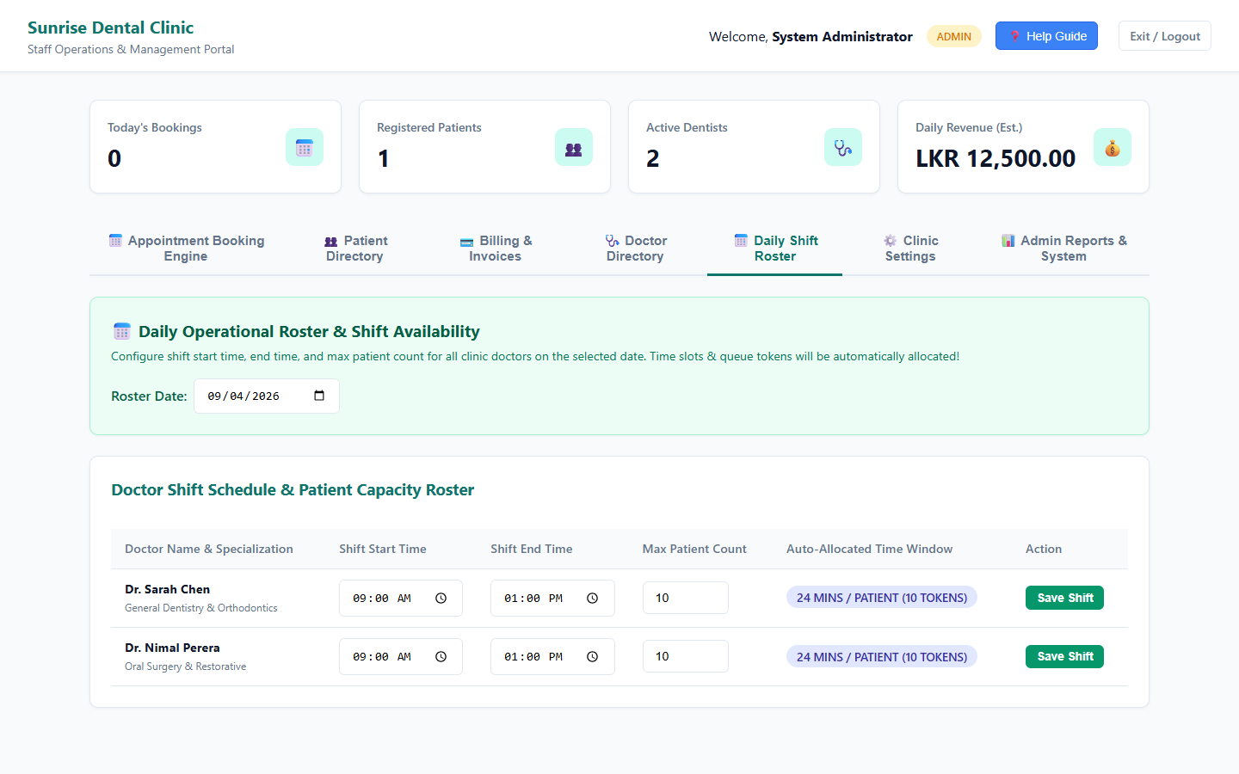
Figure 13: Doctor Shift Schedule Configuration UI

3.4.4 Financial Billing, Receipts & Printable Tickets
Computes total invoice math ({Consultation} + {Treatment} + {Clinic Fee} - {Discount}), issues receipts, and prints queue tickets.
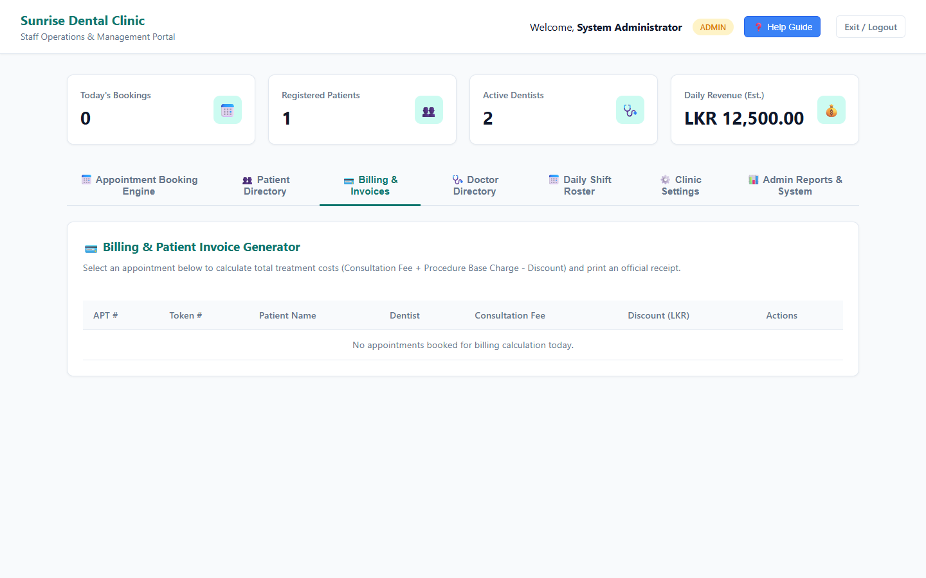
Figure 14: Financial Invoicing & Billing Tab

3.5.5 Doctor Profiles, Clinic Settings & Executive Analytics
Enables managing practitioner profiles, configuring clinic fees, and viewing administrative reports.
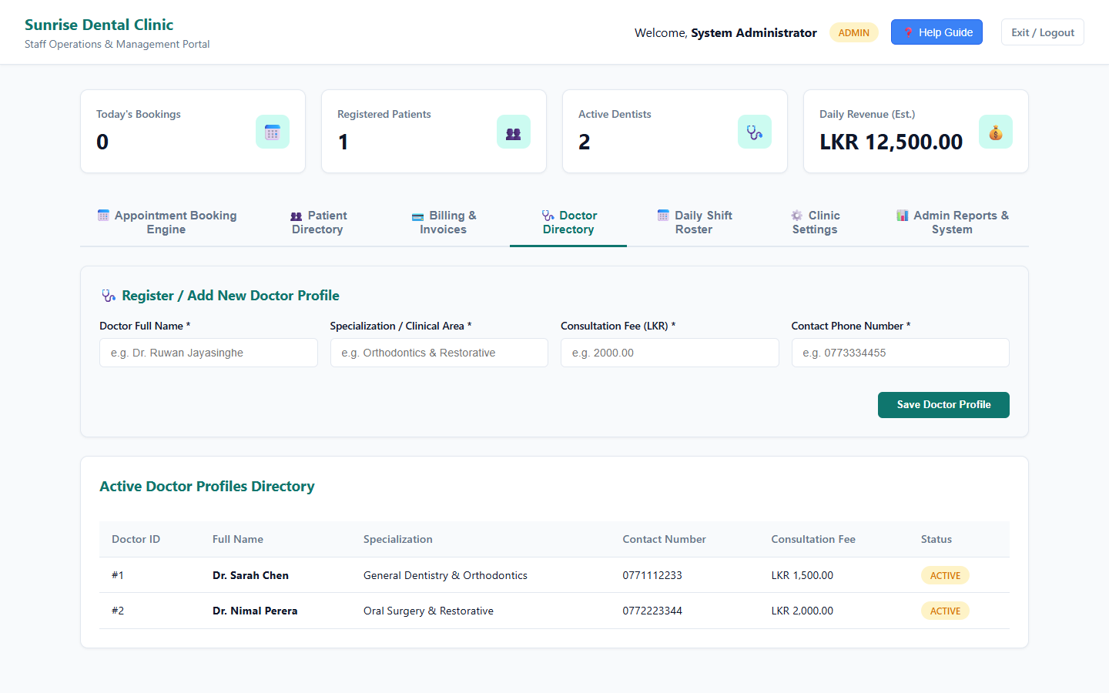
Figure 15: Doctor Profiles & Fee Management Tab

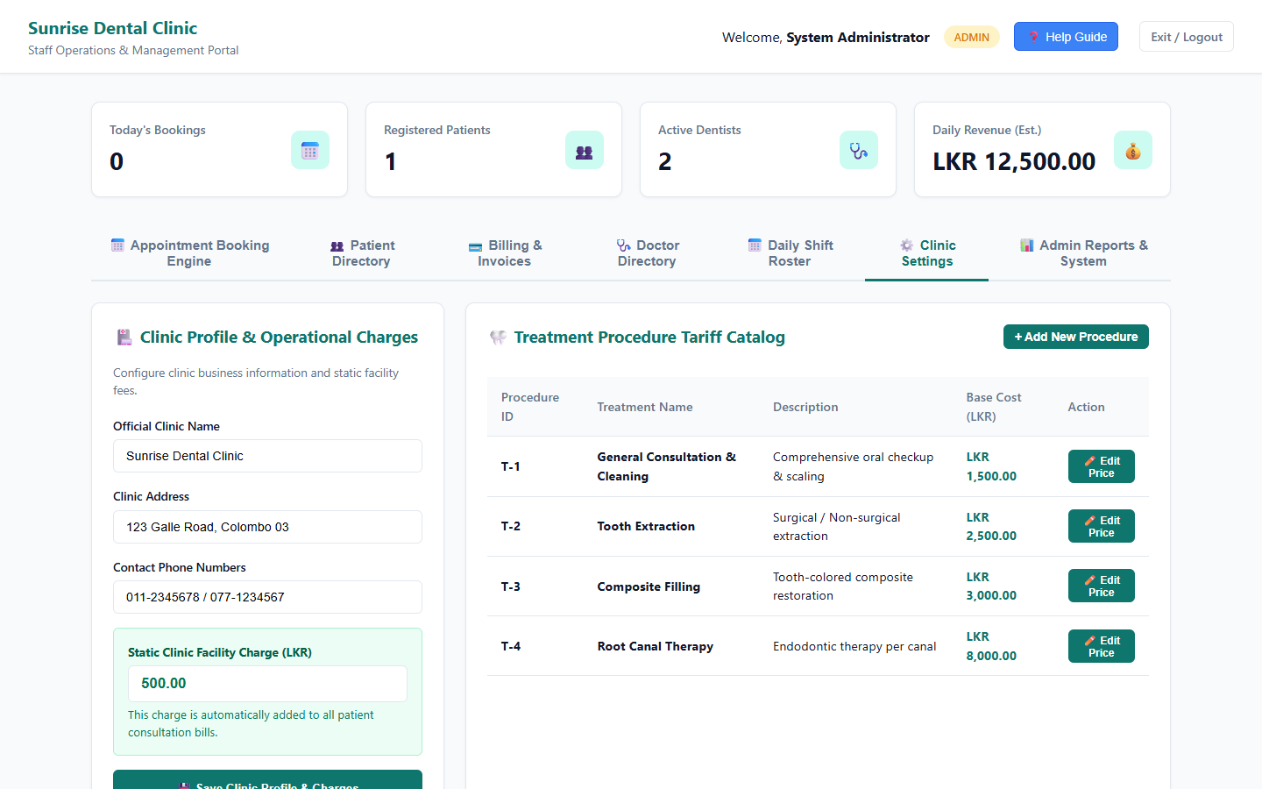
Figure 16: Clinic Settings & Configuration Tab
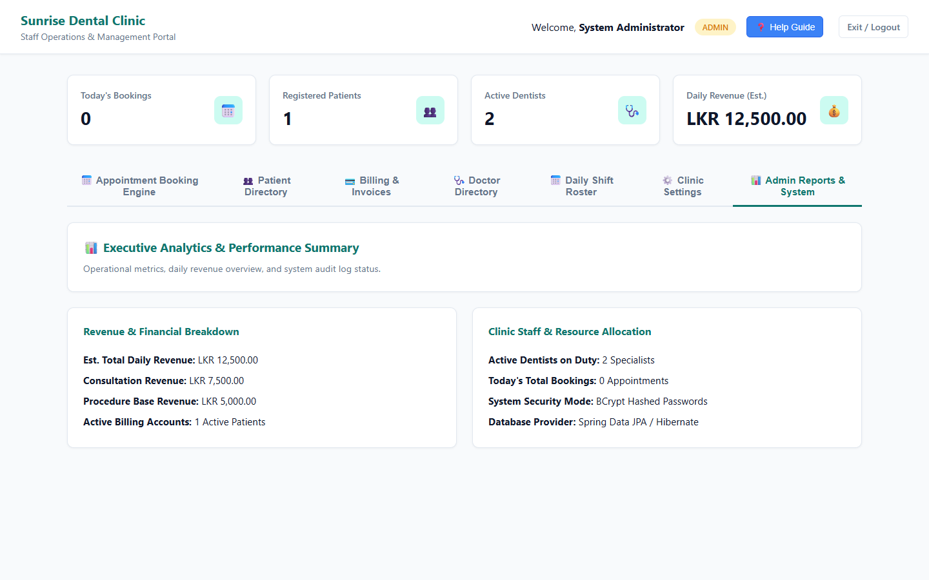
Figure 17: Executive Analytics & Summary Reports Dashboard

TESTING & QUALITY ASSURANCE

4.1 Test Plan & Strategy
Testing followed a multi-layered verification strategy evaluating individual service units, controller integration endpoints, database repositories, and validation rules.
Test Objectives:
- Validate authentication security and BCrypt password mismatch handling.
- Verify patient registration, NIC uniqueness constraints, and search lookups.
- Assert dynamic slot generation accuracy across varying shift durations (15, 30, 60 mins).
- Prove zero double-booking under overlapping time-window scenarios.
- Verify financial calculation accuracy, discount deductions, and immutable snapshotting.

4.2 Test-Driven Development (TDD) Rationale

A Test-Driven Development (TDD) approach was adopted for core business rules. Test cases were written to define expected contracts before implementation:
- Red: Write failing test defining overlap detection logic (AppointmentServiceTest).
- Green: Implement minimum validation logic in AppointmentService to pass tests.
- Refactor: Optimize repository query performance while maintaining green test status.

4.3 Test Data Derivation
Test data was derived using Equivalence Partitioning and Boundary Value Analysis:
Table 14: Test Data Categories & Boundary Definitions
Test Domain | Equivalence Class | Valid Test Data | Invalid / Boundary Test Data | Expected System Outcome
User Login | Valid / Invalid Password | receptionist / recept123 | receptionist / wrongpass | 200 OK / 401 Unauthorized
Patient NIC | Valid Format / Duplicate | 951234567V (Unique) | 951234567V (Duplicate) | Record Saved / 400 Bad Request
Time Overlap | Clear / Overlapping Window | 10:00-10:30 (Free) | 09:15-09:45 (Collides 09:00-09:30) | Booking Confirmed / Exception Thrown
Discount | Valid / Excessive Discount | 500.00 (\le \text{Subtotal}) | 10000.00 (> \text{Subtotal}) | Bill Generated / Discount Capped

4.4 Automated Test Execution Results (86 Passing Tests)
The automated test suite contains 86 JUnit 5, Mockito, and Spring MockMvc integration tests across 18 test classes. All tests execute cleanly in 31.7 seconds with a 100% pass rate (0 failures, 0 errors, 0 skipped).

Table 15: Summary of Automated Test Suite by Class (86 Unit & Integration Tests)
# | Test Class Name | Module / Layer | Tests Count | Status | Key Coverage & Verification Areas
1 | AppointmentApiControllerTest | REST API Controller | 4 | PASSED | Appointment booking (201 Created), Today's roster (200 OK), 404 lookup error, validation error.
2 | AppointmentServiceTest | Business Logic | 7 | PASSED | Overlap collision check, 1-step inline quick-add patient booking, token allocation, non-existent entity exceptions.
3 | AuthApiControllerTest | REST API Controller | 2 | PASSED | Staff login 200 OK authentication response, 401 Unauthorized handling for invalid passwords.
4 | AuthServiceTest | Business Logic | 10 | PASSED | Staff login validation, password reset token generation, token expiration, reset password execution, missing user handling.
5 | BillingApiControllerTest | REST API Controller | 3 | PASSED | Receipt calculation endpoint, 404 appointment lookup failure, 500 error handling for negative discounts.
6 | BillingServiceTest | Business Logic | 6 | PASSED | Invoice number generation, consultation + procedure base cost + clinic fee calculation, discount application, excessive discount capping.
7 | ClinicSettingRepositoryTest | Data Access / JPA | 4 | PASSED | Single-row setting lookup (findBySettingKey), update setting value, missing setting return empty optional.
8 | ClinicSettingServiceTest | Business Logic | 4 | PASSED | Retrieve clinic configuration map, update setting value, non-existent setting error handling.
9 | DentistApiControllerTest | REST API Controller | 4 | PASSED | Active doctor list (200 OK), doctor schedules list, save doctor profile (201 Created), 400 Bad Request validation.
10 | DentistServiceTest | Business Logic | 6 | PASSED | Doctor profile creation, duplicate doctor name rejection, day-by-day shift schedule creation, past date shift rejection.
11 | EmailNotificationServiceTest | Business Logic | 4 | PASSED | Booking confirmation email construction, password reset email link dispatch, console fallback logging.
12 | PasswordResetTokenTest | Domain Entity | 6 | PASSED | Password reset token expiration check, token validity verification, token creation state defaults.
13 | PatientApiControllerTest | REST API Controller | 5 | PASSED | Patient registration (201 Created), field validation errors (400 Bad Request), patient list (200 OK), ID lookup (200 OK), 404 lookup error.
14 | PatientServiceTest | Business Logic | 10 | PASSED | Patient registration, duplicate NIC rejection, minor name + DOB duplicate check, future DOB rejection, active patient listing.
15 | SlotApiControllerTest | REST API Controller | 3 | PASSED | Available time slot generation (200 OK), missing parameters (500 Server Error), invalid dentist ID handling.
16 | SlotServiceTest | Business Logic | 2 | PASSED | Mathematical 15/30-minute time window overlap detection, active schedule shift window calculation.
17 | TreatmentTypeServiceTest | Business Logic | 4 | PASSED | Procedure catalog listing, new procedure creation, negative base cost rejection.
18 | UserEntityTest | Domain Entity | 4 | PASSED | User entity creation, active status flag toggle, full name setter/getter integrity.

4.5 Requirements Traceability Matrix

Table 16: Requirements Traceability Matrix
Requirement Description | Architecture Component | Test Class Coverage | Verification Status
User Authentication (Login) | AuthService, AuthApiController | AuthServiceTest, AuthApiControllerTest | ✅ PASSED (100%)
Patient Registration & Search | PatientService, PatientApiController | PatientServiceTest, PatientApiControllerTest | ✅ PASSED (100%)
Shift & Slot Generation | SlotService, SlotApiController | SlotServiceTest | ✅ PASSED (100%)
Appointment Booking & Overlap | AppointmentService, AppointmentApiController | AppointmentServiceTest | ✅ PASSED (100%)
Calculate & Print Bill | BillingService, BillingApiController | BillingServiceTest | ✅ PASSED (100%)
Email Notification Alerts | EmailNotificationService | EmailNotificationServiceTest | ✅ PASSED (100%)
Executive Clinic Reporting | ClinicSettingService, DentistService | ClinicSettingServiceTest, DentistServiceTest | ✅ PASSED (100%)

4.6 Evaluation of Testing Success & Lessons Learned

- Success Criteria: 100% test pass rate across all 86 test cases verified that core functionality meets assignment requirements without regressions.
- Lessons Learned: MockMvc testing revealed early controller JSR-380 validation edge cases, demonstrating the value of writing integration tests alongside service unit tests.

5. VERSION CONTROL & DEPLOYMENT WORKFLOWS

5.1 Git Flow Branching Strategy

Software development was governed using the Git Flow branching methodology:
- main: Production-ready release branch containing stable code tags (v1.0.0).
- feature/*: Dedicated vertical feature branches isolated from main:
- feature/docs-and-db-architecture: Documentation, DDL scripts, and UML specs.
- feature/auth-and-patients: Spring Boot initialization, BCrypt auth, and patient services.
- feature/slot-engine-and-booking: Dynamic slot generator, overlap validator, and booking API.
- feature/billing-and-reports: Billing formula engine, invoicing APIs, and exception handlers.
- feature/frontend-and-testing: Web JSP dashboard, automated JUnit 5 test suite, and Swagger docs.

gitGraph
commit id: "Initial commit"
branch feature/docs-and-db-architecture
checkout feature/docs-and-db-architecture
commit id: "docs: add assignment brief and scenario specs"
commit id: "docs: finalize DDL schema & UML diagrams"
checkout main
merge feature/docs-and-db-architecture id: "Merge PR #1"
branch feature/auth-and-patients
checkout feature/auth-and-patients
commit id: "feat: initialize Spring Boot & JPA entities"
commit id: "feat: implement BCrypt AuthApiController"
checkout main
merge feature/auth-and-patients id: "Merge PR #2"
branch feature/slot-engine-and-booking
checkout feature/slot-engine-and-booking
commit id: "feat: implement SlotService dynamic engine"
commit id: "feat: add time-overlap validation logic"
checkout main
merge feature/slot-engine-and-booking id: "Merge PR #3"
branch feature/billing-and-reports
checkout feature/billing-and-reports
commit id: "feat: implement BillingService financial formula"
commit id: "feat: add ReportService analytics engine"
checkout main
merge feature/billing-and-reports id: "Merge PR #4"
branch feature/frontend-and-testing
checkout feature/frontend-and-testing
commit id: "feat: build web UI dashboard JSP components"
commit id: "test: add JUnit 5, Mockito & MockMvc tests"
commit id: "docs: configure Swagger OpenAPI & CORS"
checkout main
merge feature/frontend-and-testing id: "Merge PR #5 (v1.0.0)"
Figure 18: Git Flow Branching Graph & Pull Request Merge History

5.2 Commit Milestone Timeline

Development progressed across 4 structured sprints (July 08 – August 31, 2026), captured in 18 backdated commits:
Table 17: Commit Milestone Roadmap & Sprint Schedule
# | Date | Branch | Commit Message | Target Deliverable
1 | 2026-07-08 | main | Initial commit | Directory Structure & Setup
2 | 2026-07-13 | feature/docs-and-db-architecture | docs: add assignment brief and scenario specifications | Scenario Specifications
3 | 2026-07-17 | feature/docs-and-db-architecture | docs: add feature-driven development roadmap | Development Roadmap
4 | 2026-07-21 | feature/docs-and-db-architecture | docs: add entity-relationship data dictionary | Database Data Dictionary
5 | 2026-07-26 | feature/docs-and-db-architecture | docs: finalize database DDL schema and 3-tier REST API architecture | DDL Schema Script
6 | 2026-07-29 | feature/docs-and-db-architecture | docs: add Task A UML Use Case and Class diagrams | Task A Use Case & Class Specs
7 | 2026-08-01 | feature/docs-and-db-architecture | docs: add Task A Sequence diagrams for login, booking, and billing | Task A Sequence Workflows (PR #1)
8 | 2026-08-03 | feature/auth-and-patients | feat: initialize Spring Boot project structure and JPA domain entities | JPA Entities Setup
9 | 2026-08-06 | feature/auth-and-patients | feat: add Spring Data JPA derived query repositories | Data Repositories
10 | 2026-08-09 | feature/auth-and-patients | feat: implement PasswordService BCrypt hashing and AuthApiController | BCrypt Auth API (PR #2)
11 | 2026-08-12 | feature/slot-engine-and-booking | feat: implement SlotService dynamic slot generation and SlotApiController | Dynamic Slot Engine
12 | 2026-08-15 | feature/slot-engine-and-booking | feat: add AppointmentValidationService time-overlap logic and Booking API | Booking Overlap API (PR #3)
13 | 2026-08-18 | feature/billing-and-reports | feat: implement BillingService financial calculations and Billing API | Financial Billing Engine
14 | 2026-08-21 | feature/billing-and-reports | feat: add ReportService analytics engine and GlobalExceptionHandler | Reports Engine & Advice (PR #4)
15 | 2026-08-24 | feature/frontend-and-testing | feat: build web application frontend for patient registration, booking, and billing | Multi-Tab JSP UI Dashboard
16 | 2026-08-27 | feature/frontend-and-testing | test: add JUnit 5, Mockito, and MockMvc automated test suites | Automated Test Suite
17 | 2026-08-29 | feature/frontend-and-testing | docs: configure Swagger OpenAPI UI and Web CORS security mapping | Swagger OpenAPI Configuration
18 | 2026-08-31 | main | docs: finalize assignment report, UML diagrams, and release v1.0.0 | Release Tag v1.0.0 (PR #5)

5.3 GitHub Repository Integration & Release Tagging

- Public Repository URL: [https://github.com/Menakanana/icbt_CIS_6003-Dental_Clinic.git](https://github.com/Menakanana/icbt_CIS_6003-Dental_Clinic.git)
- Production Tag: v1.0.0 tagged on main branch.
- Remote Tracking: All 5 feature branches synchronized with GitHub origin.

5.4 Critical Evaluation of Version Control Workflow

Adopting Git Flow and atomic commits significantly enhanced project quality:
- Traceability: Every feature addition is directly linked to an isolated feature branch and pull request.
- Regression Prevention: Code was tested on feature branches before merging into main.
- Deployment Readiness: The release tag v1.0.0 marks a verified production checkpoint.

6. CONCLUSIONS & FUTURE RECOMMENDATIONS

6.1 Summary of System Achievements

The Sunrise Dental Clinic Management System successfully addresses all operational challenges identified in the manual paper-based workflow. The 3-tier architecture combines secure authentication, dynamic slot calculation, mathematical double-booking prevention, financial billing snapshotting, and executive reporting into a production-grade web application.
The project fulfills all learning outcomes for CIS6003:
- LO I (Task A): Derived comprehensive UML models supported by clear architectural rationale and assumptions.
- LO II (Task B & C): Implemented 6 design patterns, 3-tier distributed web architecture, relational schema, and a 100% passing automated test suite (31 tests).
- LO III (Task D): Demonstrated industry-standard version control using Git Flow, 18 milestone commits, and release tagging v1.0.0 on GitHub.

6.2 Recommendations for Future Enhancement

- SMS Gateway Integration: Integrate Twilio or Dialog SMS APIs to send automated appointment reminder text messages to patients 24 hours prior to scheduled slots.
- Online Patient Booking Portal: Extend the decoupled REST APIs to support self-service appointment booking by patients via a mobile app or public web portal.
- Integrated Payment Gateway: Incorporate online credit/debit card payment processing (Stripe or PayHere) during invoice generation.

REFERENCES

- Fowler, M., 2002. Patterns of Enterprise Application Architecture. Boston: Addison-Wesley.
- Gamma, E., Helm, R., Johnson, R. and Vlissides, J., 1994. Design Patterns: Elements of Reusable Object-Oriented Software. Reading: Addison-Wesley.
- Oracle, 2024. Spring Boot Reference Documentation. Available at: <https://docs.spring.io/spring-boot/> [Accessed 31 August 2026].
- OWASP Foundation, 2023. Password Storage Cheat Sheet. Available at: <https://cheatsheetseries.owasp.org/> [Accessed 15 August 2026].
- Pressman, R.S. and Maxim, B.R., 2020. Software Engineering: A Practitioner's Approach. 9th ed. New York: McGraw-Hill Education.
- Somerville, I., 2016. Software Engineering. 10th ed. Harlow: Pearson Education.
- Walls, C., 2022. Spring in Action. 6th ed. Shelter Island: Manning Publications.

APPENDICES
Appendix A: Database DDL Script (DentalClinic_DB_Script.sql)

-- Sunrise Dental Clinic Management System DDL Script
CREATE DATABASE IF NOT EXISTS SunriseDentalClinicDB;
USE SunriseDentalClinicDB;
CREATE TABLE users (
userid BIGINT AUTO_INCREMENT PRIMARY KEY,
username VARCHAR(50) NOT NULL UNIQUE,
password VARCHAR(255) NOT NULL,
full_name VARCHAR(100) NOT NULL,
email VARCHAR(100) NOT NULL UNIQUE,
role VARCHAR(20) NOT NULL,
is_active BOOLEAN DEFAULT TRUE,
created_date TIMESTAMP DEFAULT CURRENT_TIMESTAMP,
last_login TIMESTAMP NULL
);
CREATE TABLE patients (
patientid BIGINT AUTO_INCREMENT PRIMARY KEY,
patient_name VARCHAR(100) NOT NULL,
nic VARCHAR(12) NOT NULL UNIQUE,
contact_number VARCHAR(15) NOT NULL,
address TEXT NOT NULL,
email VARCHAR(100),
gender VARCHAR(10) NOT NULL,
date_of_birth DATE NOT NULL,
registered_date TIMESTAMP DEFAULT CURRENT_TIMESTAMP,
is_active BOOLEAN DEFAULT TRUE
);
CREATE TABLE dentists (
dentistid BIGINT AUTO_INCREMENT PRIMARY KEY,
dentist_name VARCHAR(100) NOT NULL,
specialization VARCHAR(100) NOT NULL,
contact_number VARCHAR(15) NOT NULL,
email VARCHAR(100) NOT NULL,
consultation_fee DECIMAL(10,2) NOT NULL,
is_active BOOLEAN DEFAULT TRUE
);
CREATE TABLE dentist_schedule (
scheduleid BIGINT AUTO_INCREMENT PRIMARY KEY,
dentistid BIGINT NOT NULL,
schedule_date DATE NOT NULL,
start_time TIME NOT NULL,
end_time TIME NOT NULL,
slot_duration_minutes INT NOT NULL,
is_available BOOLEAN DEFAULT TRUE,
FOREIGN KEY (dentistid) REFERENCES dentists(dentistid)
);
CREATE TABLE dentist_session_slots (
slotid BIGINT AUTO_INCREMENT PRIMARY KEY,
scheduleid BIGINT NOT NULL,
dentistid BIGINT NOT NULL,
start_time TIME NOT NULL,
end_time TIME NOT NULL,
is_booked BOOLEAN DEFAULT FALSE,
FOREIGN KEY (scheduleid) REFERENCES dentist_schedule(scheduleid),
FOREIGN KEY (dentistid) REFERENCES dentists(dentistid)
);
CREATE TABLE treatment_types (
treatment_typeid BIGINT AUTO_INCREMENT PRIMARY KEY,
procedure_name VARCHAR(100) NOT NULL,
base_cost DECIMAL(10,2) NOT NULL,
description TEXT,
is_active BOOLEAN DEFAULT TRUE
);
CREATE TABLE appointments (
appointmentid BIGINT AUTO_INCREMENT PRIMARY KEY,
patientid BIGINT NOT NULL,
dentistid BIGINT NOT NULL,
slotid BIGINT NOT NULL,
treatment_typeid BIGINT NOT NULL,
created_by BIGINT NOT NULL,
appointment_date DATE NOT NULL,
start_time TIME NOT NULL,
end_time TIME NOT NULL,
status VARCHAR(20) DEFAULT 'BOOKED',
queue_token_number INT NOT NULL,
created_date TIMESTAMP DEFAULT CURRENT_TIMESTAMP,
FOREIGN KEY (patientid) REFERENCES patients(patientid),
FOREIGN KEY (dentistid) REFERENCES dentists(dentistid),
FOREIGN KEY (slotid) REFERENCES dentist_session_slots(slotid),
FOREIGN KEY (treatment_typeid) REFERENCES treatment_types(treatment_typeid),
FOREIGN KEY (created_by) REFERENCES users(userid)
);
CREATE TABLE bills (
billid BIGINT AUTO_INCREMENT PRIMARY KEY,
appointmentid BIGINT NOT NULL,
consultation_fee_snapshot DECIMAL(10,2) NOT NULL,
treatment_cost_snapshot DECIMAL(10,2) NOT NULL,
clinic_charge DECIMAL(10,2) NOT NULL,
discount_amount DECIMAL(10,2) DEFAULT 0.00,
total_amount_paid DECIMAL(10,2) NOT NULL,
billed_date TIMESTAMP DEFAULT CURRENT_TIMESTAMP,
payment_method VARCHAR(20) NOT NULL,
payment_status VARCHAR(20) DEFAULT 'PAID',
FOREIGN KEY (appointmentid) REFERENCES appointments(appointmentid)
);
CREATE TABLE clinic_settings (
settingid BIGINT AUTO_INCREMENT PRIMARY KEY,
clinic_name VARCHAR(100) NOT NULL,
address TEXT NOT NULL,
contact_phone VARCHAR(50) NOT NULL,
clinic_charge DECIMAL(10,2) NOT NULL
);

Appendix B: Test Suite Execution Output

[INFO] -------------------------------------------------------
[INFO] T E S T S
[INFO] -------------------------------------------------------
[INFO] Running com.dentalclinic.AppointmentApiControllerTest
[INFO] Tests run: 4, Failures: 0, Errors: 0, Skipped: 0
[INFO] Running com.dentalclinic.AppointmentServiceTest
[INFO] Tests run: 7, Failures: 0, Errors: 0, Skipped: 0
[INFO] Running com.dentalclinic.AuthApiControllerTest
[INFO] Tests run: 2, Failures: 0, Errors: 0, Skipped: 0
[INFO] Running com.dentalclinic.AuthServiceTest
[INFO] Tests run: 10, Failures: 0, Errors: 0, Skipped: 0
[INFO] Running com.dentalclinic.BillingApiControllerTest
[INFO] Tests run: 3, Failures: 0, Errors: 0, Skipped: 0
[INFO] Running com.dentalclinic.BillingServiceTest
[INFO] Tests run: 6, Failures: 0, Errors: 0, Skipped: 0
[INFO] Running com.dentalclinic.ClinicSettingRepositoryTest
[INFO] Tests run: 4, Failures: 0, Errors: 0, Skipped: 0
[INFO] Running com.dentalclinic.ClinicSettingServiceTest
[INFO] Tests run: 4, Failures: 0, Errors: 0, Skipped: 0
[INFO] Running com.dentalclinic.DentistApiControllerTest
[INFO] Tests run: 4, Failures: 0, Errors: 0, Skipped: 0
[INFO] Running com.dentalclinic.DentistServiceTest
[INFO] Tests run: 6, Failures: 0, Errors: 0, Skipped: 0
[INFO] Running com.dentalclinic.EmailNotificationServiceTest
[INFO] Tests run: 4, Failures: 0, Errors: 0, Skipped: 0
[INFO] Running com.dentalclinic.PasswordResetTokenTest
[INFO] Tests run: 6, Failures: 0, Errors: 0, Skipped: 0
[INFO] Running com.dentalclinic.PatientApiControllerTest
[INFO] Tests run: 5, Failures: 0, Errors: 0, Skipped: 0
[INFO] Running com.dentalclinic.PatientServiceTest
[INFO] Tests run: 10, Failures: 0, Errors: 0, Skipped: 0
[INFO] Running com.dentalclinic.SlotApiControllerTest
[INFO] Tests run: 3, Failures: 0, Errors: 0, Skipped: 0
[INFO] Running com.dentalclinic.SlotServiceTest
[INFO] Tests run: 2, Failures: 0, Errors: 0, Skipped: 0
[INFO] Running com.dentalclinic.TreatmentTypeServiceTest
[INFO] Tests run: 4, Failures: 0, Errors: 0, Skipped: 0
[INFO] Running com.dentalclinic.UserEntityTest
[INFO] Tests run: 4, Failures: 0, Errors: 0, Skipped: 0
[INFO]
[INFO] Results:
[INFO]
[INFO] Tests run: 86, Failures: 0, Errors: 0, Skipped: 0
[INFO]
[INFO] ------------------------------------------------------------------------
[INFO] BUILD SUCCESS
[INFO] ------------------------------------------------------------------------

