Lab 1 Report

Alexandria university

Faculty of Engineering

Electrical Power and Machines Engineering Program

محمد أحمد محمود منازع 18011370

# The Code

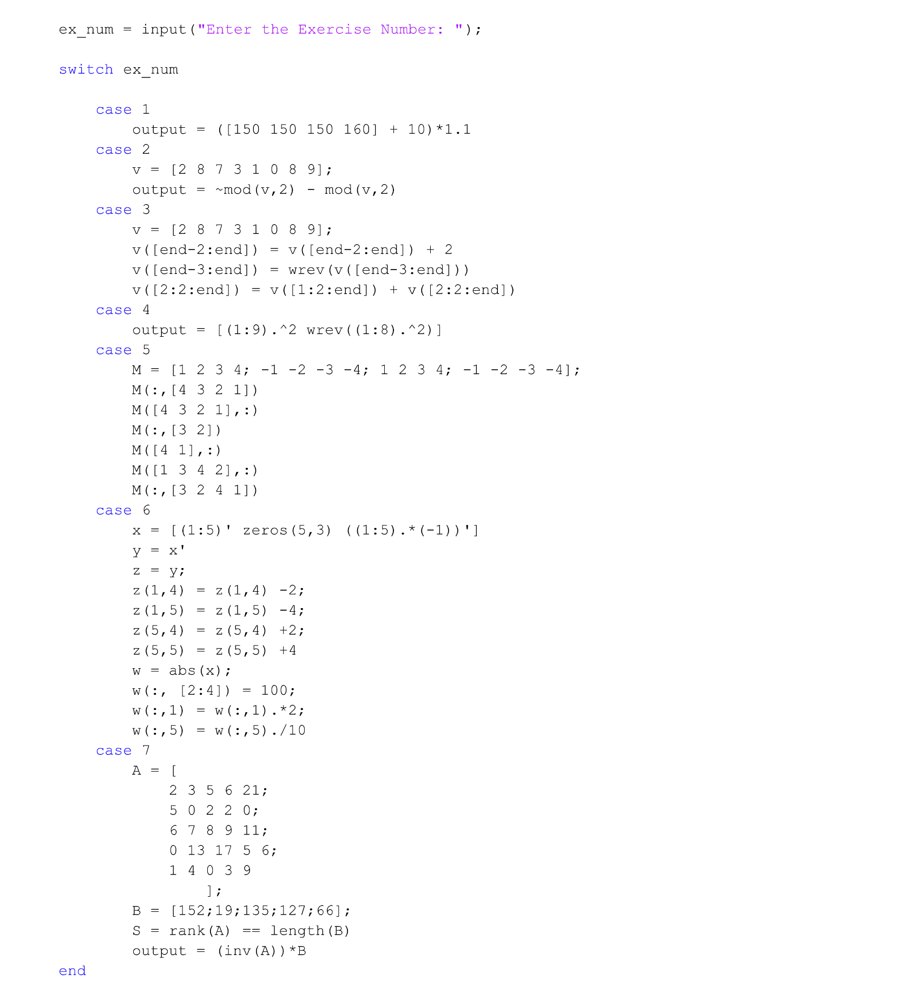

I used a single M-File to write the solution for all the exercises. You give the program the exercise number and it will prompt the solution to the command window.

**The function names in MATLAB (ex is exp(x)), (ln(x) is log(x)), (log2(x) and log10(x) for the base-2 and base-10 logarithms), (sqrt(X) for square root), (the sound command convert a matrix data into a sound), and (the image command display the matrix data as an image)**

# The solution results.

# A screenshot of a computer Description automatically generatedA white sheet with black text Description automatically generatedA paper with numbers and lines Description automatically generatedA screenshot of a computer Description automatically generated