List of Figures II

Acknowledgment II

Abstract III

Introduction 1

1. Electronic Commerce Payment Systems 1

2. Objectives 1

1. Credit Cards 2

2. Internet 3

3. Mobile Payments 4

4. Financial Service Kiosks 4

5. Television Set-Top Boxes and Satellite Receiver 5

6. Biometric Payments 5

7. Electronic Payments Networks 5

8. Person-to-Person (P2P) Payments 5

3. Techniques of E-commerce payment system 6

Payment by credit card 6

Digital cash 8

Electronic coupons 8

E-wallets 9

4. Methods of E-Commerce Payment system 10

4. Challenges E-Commerce Payment System 10

Conclusion 12

References 13

# List of Figures

Figure 1.Credit cards 8

Figure 2 Internet 9

Figure 3 Payment by credit cards 12

Figure 4 Digital Cash 13

Figure 5 Electronic Coupon 14

Figure 6 E-Wallet 15

# Acknowledgment

We like to thank our dear instructor Dr. shaik saidhbi for giving a chance to study about electronic commerce payment system which enables us to understand the electronic payment methods ,electronic payment techniques and challenges of electronic payment system.

# Abstract

Electronic payments are financial transactions made without the use of paper documents such as cheques. Electronic payments include debit card, credit card, smart card, e-wallet, e-cash, electronic cheques etc. E-payment systems have received different acceptance level throughout the world; some methods of electronic payments are highly adopted while others are relatively low. This document is aimed to identify electronic payment systems and its techniques, methods and challenges that it faces since its existence.

# Introduction

## Electronic Commerce Payment Systems

Electronic payment system is a mode of payments over an electronic network such as the internet. In other words we can say that e-payment is a method in which a person can make

On line payments for his purchase of goods and services without physical transfer of cash and cheques, irrespective of time and location.Electronic payment system is the basis of on-line payments and on-line payment system development is a higher form of electronic payments. It makes electronic payments at any time through the internet directly to manage the e-business environment.

## Objectives

Our main objective of this document is

* To create awareness about various methods of online payment systems.
* To create awareness about techniques of electronic commerce payments.
* To give understanding about challenges of electronic commerce payments

An e-commerce payment system facilitates the acceptance of electronic payment for online transactions. Also known as a sample of Electronic Data Interchange (EDI), e-commerce payment systems have become increasingly popular due to the widespread use of the internet-based shopping and banking. Over the years, credit cards have become one of the most common forms of payment for e-commerce transactions. In North America almost 90% of online B2C transactions were made with this payment type. Despite widespread use in North America, there are still a large number of countries such as China, India and Pakistan that have some problems to overcome in regard to credit card security. In the meantime, the use of smartcards has become extremely popular. A Smartcard is similar to a credit card; however it contains an embedded 8-bit microprocessor and uses electronic cash which transfers from the consumers’ card to the sellers’ device. A popular smartcard initiative is the VISA Smartcard. Using the VISA Smartcard you can transfer electronic cash to your card from your bank account, and you can then use your card at various retailers and on the internet.There are companies that enable financial transactions to transpire over the internet, such as PayPal. Many of the mediaries permit consumers to establish an account quickly, and to transfer funds into their on-line accounts from a traditional bank account (typically via ACH

transactions), and vice versa, after verification of the consumer's identity and authority to access such bank accounts. Also, the larger mediaries further allow transactions to and from credit card accounts, although such credit card transactions are usually assessed a fee (either to the recipient or the sender) to recoup the transaction fees charged to the mediary.

The speed and simplicity with which cyber-mediary accounts can be established and used have contributed to their widespread use, although the risk of abuse, theft and other problems with disgruntled users frequently accusing the mediaries themselves of wrongful behavioris associated with them.

The following types of electronic payments are most common today. That said, it is important to realize that new payment types are continual being discovered and there are additional methods that exist or are being developed continuously.

### Credit Cards

Credit cards, debit cards and prepaid cards currently represent the most common form of electronic payments. For all 3 types of cards the consumer or the business most often uses a plastic card, commonly with a magnetic stripe. The cardholder gives his or her card or card number to a merchant who swipes the card through a terminal or enters the data to a PC. The terminal transmits data to his or her bank, the acquirer. The acquirer transmits the data through a card association to the card issuer who makes a decision on the transaction and relays it back to the merchant, who gives goods or services to the cardholder. Funds flow later for settlement with credit cards and are debited immediately for debit or pre-paid cards.

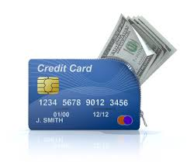

Figure 1.Credit cards

Along with magnetic stripe cards, smart cards are and will increasingly be used for payments. Smart cards are at present overwhelmingly plastic credit cards with an embedded computer chip. Until recently, many smart cards operated using proprietary rather than common standards. A standard set of specifications, EMV, has been developed and is being used increasingly so that the chips on smart cards are interoperable. Korea and Japan are among the most advanced countries in Asia for smart card payments, with Malaysia catching up fast due to government mandates for banks to issue smart cards. Most credit and debit cards are expected to be issued or reissued as smart cards by 2008 or earlier.

Over time, the chip for payment can be expected to move onto other devices. A smart card might then become the computer chip in a phone, PDA or other device that can perform the same function as chip in a plastic card, eliminating the need for the actual plastic card. Smart cards could thus evolve into smart phones, smart PDAs or other smart devices.

### Internet

Online payments involve the customer transferring money or making a purchase online via the internet. Consumers and businesses can transfer money to third parties from the bank or other account, and they can also use credit, debit and prepaid cards to make purchases online.



Figure 2 Internet

Current estimates are that over 80% of payments for online purchases are made using a credit card or debit card. At present, most online transactions involve payment with a credit card. While other forms of payment such as direct debits to accounts or pre-paid accounts and cards are increasing, they currently represent a less developed transaction methodology.

### Mobile Payments

Mobile phones are currently used for a limited number of electronic transactions. However, the percentage seems likely to increase as mobile phone manufacturers enable the chip and software in the phone for easier electronic commerce.

Consumers can use their mobile phone to pay for transactions in several ways. Consumers may send an SMS message, transmit a PIN number, use WAP to make online payments, or perform other segments of their transaction with the phone. As phones develop further, consumers are likely to be able to use infrared, Bluetooth and other means more frequently to transmit full account data in order to make payments securely and easily from their phone.

Additionally, merchants can obtain an authorization for a credit or debit card transaction by attaching a device to their mobile phone. A consortium in the US also recently announced PowerSwipe, for example, which physically connects to a Nextel phone, weighs 3.1 ounces, and incorporates a magnetic stripe reader, infrared printing port, and pass-through connector for charging the handset battery.

### Financial Service Kiosks

Companies and service providers in several countries, including Singapore and the US, have set up kiosks to enable financial and non-financial transactions. These kiosks are fixed stations with phone connections where the customer usually uses a keyboard and television-like screen to transaction or to access information.

At AXS stations in Singapore, for example, consumers can make electronic bill payments, send email or SMS message and make phone calls. Kiosks in the United States enable the customer to send money via wire transfers, cash checks, make purchases using cash, and make phone calls.

Located at convenient public locations such as bus or subway stations, convenience stores or shopping malls, these kiosks enable electronic payments by individuals who may not have regular access to the internet or mobile phones.

### Television Set-Top Boxes and Satellite Receiver

Specialized boxes attached to a television can also be used for payments in some locations. The set-top box attaches to the television and a keyboard or other device, and customers can make purchases by viewing items on the television. Payment is made electronically using a credit card or other account. While usage is presently low, it could grow substantially in countries with a strong cable or satellite television network.

### Biometric Payments

Electronic payments using biometrics are still largely in their infancy. Trials are underway in the United States, Australia and a limited number of other countries. Most biometric payments involve using fingerprints as the identification and access tool, though companies like Visa International are piloting voice recognition technology and retina scans are also under consideration. Essentially, a biometric identifier such as a fingerprint or voice could replace the plastic card and more securely identifies the person undertaking the transaction. The electronic payment is still charged to a credit card or other account, with the biometric identifier replacing the card, check or other transaction mechanism.

### Electronic Payments Networks

Various countries have electronic payments networks that consumer can use to make payments electronically. ACH (Automated Clearing House) in the United States, domestic networks in Australia and Singapore, and other networks enable electronic payments between businesses and between individuals. The consumer can go online, to a financial service kiosk or use other front-end devices to access their account and make payments to businesses or other individuals.

### Person-to-Person (P2P) Payments

P2P payments enable one individual to pay another using an account, a prepaid card or another mechanism that stores value. PayPal in the United States, which was recently purchased by EBay, is one of the most frequently used P2P mechanisms. The Tower Group estimates that the volume of P2P payments will grow from 105 million transactions in 2002 to 1.4 billion transactions by 2005. P2P payments can be made through a variety of means, including services like PayPal, transfers using card readers, or other. In the future other devices, such as mobile phones or PDAs, could also be used to enable P2P electronic payments

# Techniques of E-commerce payment system

With the rising interest in e-commerce, electronic payment techniques have exploded in number. The most popular way is payment by credit card, probably because of its simplicity. The user just enters the relevant numbers, the merchant gets these validated and payment has been made. For extra security, the communication between user and merchant should be encrypted. As alternatives to credit cards, electronic coupons and more recently various kinds of e-wallet have gained in popularity. Digital cash, which provides anonymity to the buyer, has been proposed often but seems to have less success in the marketplace.

1. Payment by credit card
2. Digital cash
3. Electronic coupons
4. E-wallets

With the rising interest in e-commerce, electronic payment techniques have exploded in number. The most popular way is payment by credit card, probably because of its simplicity. The user just enters the relevant numbers, the merchant gets these validated and payment has been made. For extra security, the communication between user and merchant should be encrypted. As alternatives to credit cards, electronic coupons and more recently various kinds of e-wallet have gained in popularity. Digital cash, which provides anonymity to the buyer, has been proposed often but seems to have less success in the marketplace.

## Payment by credit card

Probably because of the World-Wide Web's origin in the USA, payment by credit card is the most popular and the easiest way to pay for goods and services on line. A user simply enters his credit card number, his name and the expiry date of the card, the merchant validates this information and upon approval from the credit card company, ships the good or provides access to the service. Approval can be done on-line in almost real time.

An important aspect here is security. Since normally transmissions are preformed in the clear, it is possible to tap the connection and obtain credit card information in this way. So most shops use encryption to protect credit card information (SSL being the most well known choice). An often neglected aspect is the secure storage of credit card information at the merchant computers. The famous hacker Kevin Mitnick once managed to access 20,000 credit card numbers stored at Internet provider Netcom.

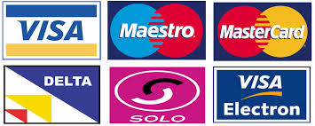

Figure 3 Payment by credit cards

An alternative to using encryption is to simply let the user indicate which credit card he wants to use without revealing the complete credit card number to the user (US 5,715,399). When the user is ready to place an order, he is presented with an overview of all the credit cards he used previously, identified only by the card name and last four digits on the card. This makes it possible for him to pick the card he wants to use but makes it impossible for an interceptor to determine the complete credit card number by tapping the line.

An interesting side-effect of payment by credit cards is that, since minors cannot get one, a payment by credit card serves as proof that one is an adult. This makes a credit card a natural choice for adult oriented services (of course an innocent looking name such as Interactive Services or Internet Entertainment Group needs to be used on the credit card statement).

This insight created a business opportunity for intermediaries such as Adult check. A user registers with Adultcheck and pays for the service using his credit card, which immediately proves he is an adult.Adultcheck then gives him a user code with which he can access protected adult content. The webmasters of those sites only needs to provide the Adultcheck login screen which is made available to them for free, so they can provide adults-only access to their website without any expenses. This is another example of selling complementary goods. Note that in this case, it is the provider who uses the free product, and the end-user who pays for the complementary product (the user code).

## Digital cash

Although highly popular in the literature, digital cash is not used in practice. This is for the most part due to several competing technologies (all patented of course) and the unwillingness to develop a common standard. Another hot item is whether digital cash should be anonymous or not.

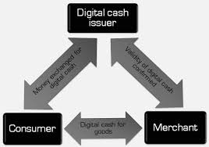

Figure 4 Digital Cash

Digital cash is basically a string of numbers representing an amount of money. A customer sends this string to a merchant which sends it to the bank for verification. When the verification passes, the bank adds the indicated amount to the merchants account. A problem is that such strings can be easily duplicate allowing double spending. Therefore the bank must keep track of all the spent numbers and refuse a payment if it already appeared on the list. Digital cash is protected against forgery by using digital signatures. Since only the bank could have placed a digital signature on a piece of digital cash, third parties cannot make up their own.

Digital cash allows so-called micropayments, since there is no reason why the value of digital cash should be restricted to any predefined amount. This makes it possible for instance to charge 25 millicents for retrieving one article from a database. Paying such a small amount is no problem for a user, but if the database operator can get a large enough userbase he still makes a profit.

### Electronic coupons

To encourage sales, it is known to provide electronic coupons, gift certificates and discount. This way, the recipients spend the coupon or certificate at that particular store, but since coupons often are not enough to pay for a complete item, they will need to spend additional money. Coupons need to be secure against forgery and double spending. These problems are related to the problem of electronic cash (indeed, a coupon can be said to be a specific type of electronic cash).



Figure 5 Electronic Coupon

### E-wallets

Recently, digital cash has become popular again, this time in the form of so-called digital wallets. A digital wallet or e-wallet is an application running on the user's set-top box or personal computer, which manages the user's digital money. When the user goes to a merchant to buy a product, he simply activates the e-wallet application, which transmits the user's personal information and payment data to the merchant.

The simplest type of wallet is the site wallet. A user enters his billing, shipping and credit card data at a merchant site, so he can re-use that data at subsequent purchases. This of course works only at individual merchants or virtual malls.

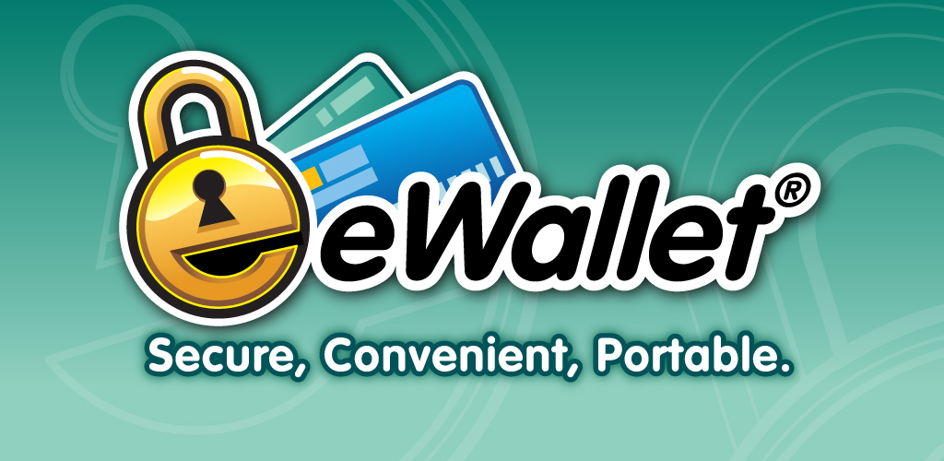

Figure 6 E-Wallet

An improvement is created by service providers who offer remote wallets. A user registers at a payment service provider, who in turn supplies the data to multiple merchant sites or virtual malls.

# Methods of E-Commerce Payment system

An electronic payment is any kind of non-cash payment that doesn't involve a paper check. Methods of electronic payments include credit cards, debit cards and the ACH (Automated Clearing House) network. The ACH system comprises direct deposit, direct debit and electronic checks (e-checks).For all these methods of electronic payment, there are three main types of transactions:

1. A one-time customer-to-vendor payment is commonly used when you shop online at an e-commerce site, such as Amazon. You click on the shopping cart icon, type in your credit card information and click on the checkout button. The site processes your credit card information and sends you an e-mail notifying you that your payment was received. On some Web sites, you can use an e-check instead of a credit card. To pay by e-check, you type in your account number and your bank's routing number. The vendor authorizes payment through the customer's bank, which then either initiates an electronic funds transfer (EFT) or prints a check and mails it to the vendor.
2. You make a recurring customer-to-vendor payment when you pay a bill through a regularly scheduled direct debit from your checking account or an automatic charge to your credit card. This type of payment plan is commonly offered by car insurance companies, phone companies and loan management companies. Some long-term contracts (like those at gyms or fitness centers) require this type of automated payment schedule.
3. To use automatic bank-to-vendor payment, your bank must offer a service called online bill pay. You log on to your bank's Web site, enter the vendor's information and authorize your bank to electronically transfer money from your account to pay your bill. In most cases, you can choose whether to do this manually for each billing cycle or have your bills automatically paid on the same day each month.

## Challenges E-Commerce Payment System

There are different challenges that e-payment system faces here are some of them.

* Lack of usability

Electronic payment system requires large amount of information from end users or make transactions more difficult by using complex elaborated websites interfaces. For example credit card payments through a website are not easiest way to pay as this system requires large amount of personal data and contact details in web form.

* Lack of Security

Online payment systems for the internet are an easy target for stealing money and personal information. Customers have to provide credit card and payment account details and other personal information online. This data is sometimes transmitted in an un-secured way, providing these details by mail or over the telephone also entails security risks.

* Issues with e-Cash

The main problem of e-cash is that it is not universally accepted because it is necessary that the commercial establishment accept it as payment method. Another problem is that when we makes payment by using e-cash, the client and the salesman have accounts in the same bank which issue e-cash. The payment is not valid in other banks.

* Lack of Trust

Electronic payments have a long history of fraud, misuse and low reliability as well as it is new system without established positive reputation. Potential customers often mention this risk as the key reason why they do not trust a payment services and therefore do not make internet purchases

* Users Perception Regarding Acceptance of Electronic Payment Systems

User’s acceptance is a pivotal factor determining the success or failure of any information system Project. Electronic payment systems are not an exception of it. It means these are not successful without acceptance of users. Electronic payment system is an innovative way for online payments. Issues are not accepting easily because of lack of security in changing business-environment. Online payment system requires improvement of information technology. The failure of electronic payment system is depend on the factor that it neglects the needs of users and the market.

* Lack of Awareness

Making online payment is not an easy task. Even educated people also face problems in making online payments. Therefore, they always prefer traditional way of shopping instead of online shopping. Sometimes there is a technical problem in server customers tried to do online payments but they fails to do. As a result they avoid it.

* Online Payments are not Feasible in Rural Areas

The population of rural areas is not very literate and they are also not able to operate computers. As they are unaware about technological innovations, they are not interested in online payments. So the online payment systems are not feasible for villagers.

* Highly Expensive and Time Consuming

Electronic payment system are highly expensive because it includes set up cost, machine cost, management cost etc and this mode of payment will take more time than the physical mode of payment.

# Conclusion

Electronic commerce payment system refers to the mode of payment which does not include physical cash or cheques. It includes debit card, credit card, smart card, e-wallet etc. E-commerce has its main link in its development on –line in the use of payment methods. The risk to the online payments are theft of payments data, personal data and fraudulent rejection on the part of customers.

Therefore, and until the use of electronic signatures is wide spread, we must use the technology available for the moment to guarantee a reasonable minimum level of security on the network. With respect to the payments methods they have been analyzed in this work, it is impossible to say that any one of them is perfect, although each one of them has advantages as opposed to others. If the client wants to maintain privacy, then they choose those payment methods which guarantee a higher level of privacy such as E-cash or NetBill Checks. If the priority is security, they should use, Smart Cards. Both consumers and service providers can benefit from e-payment systems leading to increase national competitiveness in the long run. The successful implementations of electronic payment systems depends on how the security and privacy dimensions perceived by consumers as well as sellers are popularly managed, in turn would improve the market confidence in the system.

# References

1. Bhasker, Bharat (2013). Electronic Commerce, Framework, Technologies and Applications.
2. McGraw Hill Education (India) Private Limited., p.9.2-9.16.
3. Chhabra, T.N., Suri, R.K., Verma, Sanjiv (2006). E-Commerce. Dhanpat Rai & Co. (P) Ltd.p.306-328.
4. Dennis, Abrazhevich (2004). Electronic Payment Systems: A User Centred Perspective and Interaction design. Eindhoven: Technical Universiteit Eindhoven. p.1to12
5. http:/www.fraudlabs.com
6. http:/www.uaipit.com