**Activity – Lesson 1**

1. Create a database named **school_db**.

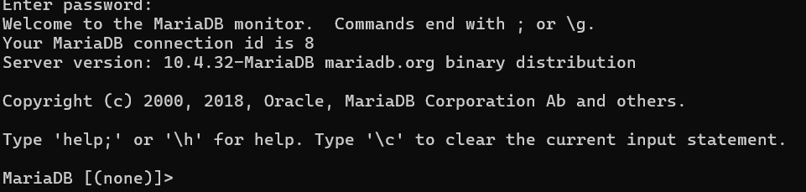

1. Show all databases.

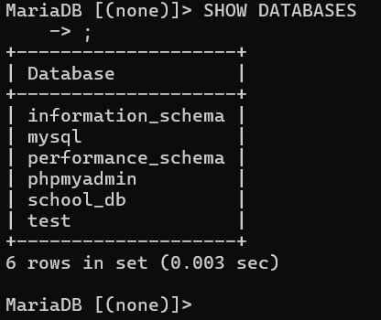

1. Use the database you have created.

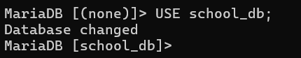

1. Create a table named **students** with the following columns:

|  |  |  |
| --- | --- | --- |
| Column name | Data Type | Notes |
| id | INT | Auto increment, primary key |
| name | VARCHAR(100) |  |
| age | INT |  |
| email | VARCHAR(100) |  |
| course | VARCHAR(100) |  |

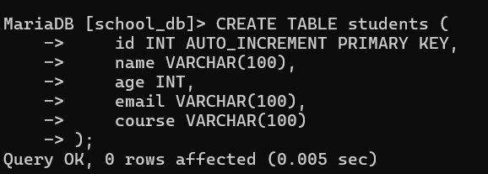

1. Show table structure

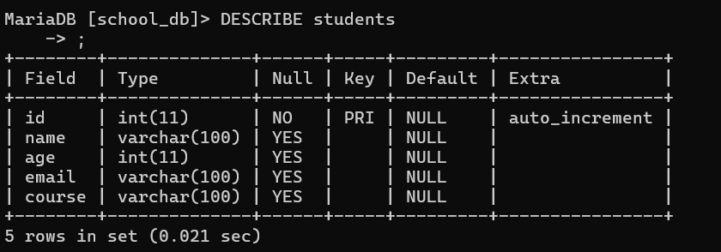

1. Insert 3 students into the table.
   1. Alice Johnson / 20 / [alice@example.com](mailto:alice@example.com) / BSCS
   2. Bob Smith / 22 / [bob@example.com](mailto:bob@example.com) / BSIT
   3. Clara Davis / 21 / [clara@example.com](mailto:clara@example.com) / BSEMC

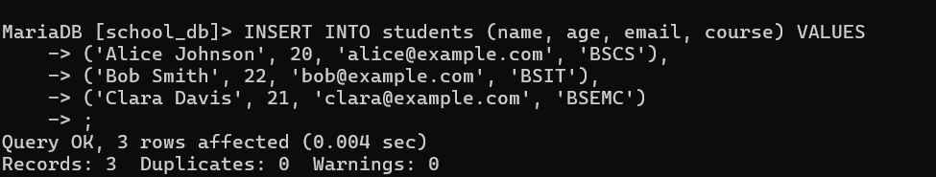

1. Display all records in the **students** table.

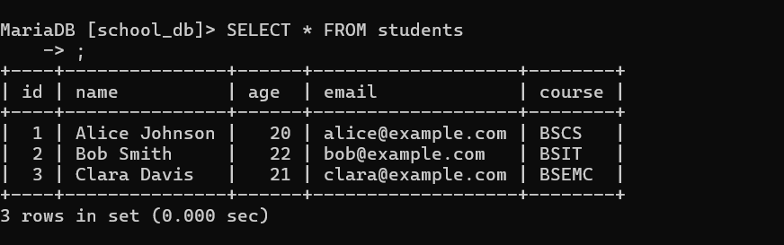

1. Display only names and emails.

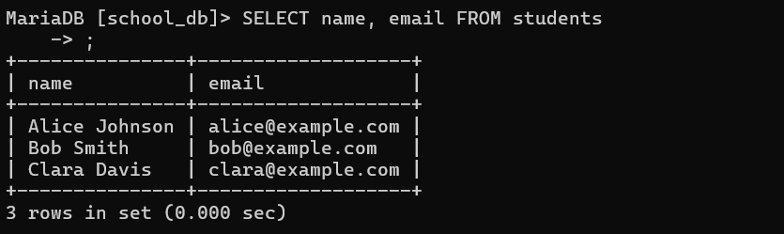

1. Display students older than 20.

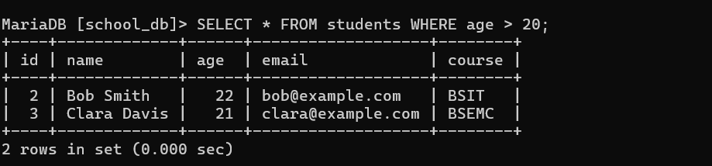

1. Change Clara’s course to Data Science.

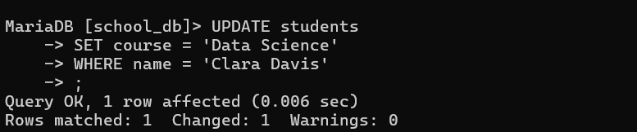

1. Delete the student named Bob Smith.

