Sociotechnical energy imaginaries of non-users of ECO-innovations: identification and

perceptions of residential households not adopting solar energy

Marco Bunt1,2

1. Erasmus school of social and behavioral sciences
2. Stedin netbeheer

Author Note

T his article is the graduation thesis om Marco Bunt for the study social science on the

Erasmus school of social and behavioral sciences, in collaboration with Stedin.

Correspondence concerning this article should be addressed to Marco Bunt, Stedin,

Blaak 8, 3011 TA Rotterdam. E-mail: marco.bunt@Stedin.net

Abstract

In the effort of the Dutch government to transition houses to sustainable (decentralized) ways of energy, everyone is expected to participate. In order to make the energy-transition inclusive for all societal groups, this thesis investigates imaginaries of people that are not participating in the adaptation of solar panels (PV). Although non-adopters are typically perceived as uneducated and reluctant to change, they can have real reasons for not adopting (Rogers, 1983). By examining the sociotechnical energy imaginaries and the sociotechnical imaginaries of the people in this group, this thesis seeks to understand why some people are not adopting sustainable technologies. The examination of the imaginaries is done via a process of interviewing non-adaptors and analyzing the transcripts. In this thesis, it is argued that adopting PV is not only a matter of having the material resources to purchase the technological equipment, but that it is also a matter of having the conviction that sustainable energy is a necessity for the future. Although there is research focused on people that are adopting, not a lot is understood about the motivations of people who are not transitioning their houses to sustainable energy. This thesis seeks to fill that gap. The literature for (Levy and Spices, 2013) is applied as a basis for sociotechnical energy imaginaries, e.g., climate apocalypse imaginary of fossil fuels forever. This thesis consists of two parts. The first part is a quantitative analysis of factors predicting adaptation of PV via an analysis of the geographical locations of PV on the part of the Dutch energy grid. From the data, peer-influence appeared to be the most useful prediction for the adoption of PV and is used to identify the non-users of PV. The second part is a qualitative part, were semi-structured interviews are conducted to gain insight in reasoning for non-adapting and the role of imaginaries in the decision-making process. People who lived in houses that were exposed to PV by their surrounding neighbors but ho nevertheless adopted PV were approached for the interviews. Via this process, three imaginaries of non-adaptors are identified: 1) collective action imaginary. Respondents that expressed this imaginary, described that action to improve the climate was a necessity but expected the government to arrange a collective effort via (very clear) subsidies or regulations. 2) Systemic change imaginary. Respondents made statements like _"climate change is done by big companies"_. Due to the external cause of climate change, respondents did not take individual action. 3) (Temporary) crisis imaginary. Respondents that hold this imaginary see the climate on earth as resilient and imagine that there is time to wait for fore better solutions before solving the climate issue. Together these imaginaries withheld people from taking measures to prevent human-induced climate change.

*Keywords:*

Sociotechnical energy imaginaries, ECO-innovation, diffusion of innovation, non-users

Word count:

9742

# Introduction: Energy transition via sustainable innovation

In the process of modernization, unsustainability is produced as a side-effect of economic and technological development (IPCC, 2014). The unsustainability becomes visible in the over-consumption of natural resources, loss of biodiversity, and climate change. To overcome the negative effects of human-induced climate change, European, national, and local governments to make policies to enable energy transition from fossil energy sources that are free from emitting carbon in the atmosphere. The Dutch government aims to reduce the emission of carbon by 50% or more before 2030. One of the challenges in this vision is the transformation of more than 7 million houses, mostly moderately insulated and almost all heated by natural gas, to well-insulated houses, headed with energy from a sustainable source and in which clean electricity is used (EZK, 2019, p. 21). This goal means a significant transformation of the Dutch society where everyone has to participate. The technology used for achieving this goal is mainly decentralized power generation through photovoltaic solar panels (PV), windmills, and heat pumps (HP). Fossil-based transport shall be replaced by electric vehicles (EV), either with batteries or hydrogen (EZK, 2019, p. 21). Technologies like these that enable a more sustainable way of living are addressed as “ECO-innovations” (James, 1997) in this article, as described in the theoretical framework of this article.

New technologies are more likely to be adopted by people that have more resourses (Rogers, 1983), and thereby improve their position in relative comparison to the people that are unable to adopt (Gladwell, 2013; Merton, 1968). Thereby people that can innovate can sustain their lifestyle as consumers while lowering their environmental impact with the help of government subsidies, while people that are not adopting the new technology can only create a sustainable lifestyle by consuming less (Jhagroe & Loorbach, 2015). In this way, Jhagroe (2016) argues that transitions increase the already existing gap between rich and poor. A large amount of research is devoted to identifying innovators in general (Bogers, Afuah, & Bastian, 2010) and innovators of sustainable technology such as PV (Vasseur & Kemp, 2015). However, there is not much theory (that we know of) about the people who are not transitioning themselves to sustainable forms of energy. Therefore academic research on this topic is needed. Late adopters of an innovation are most likely to be individually blamed for not adopting innovation or for being much later in adopting than the other members of their system, while careful analysis can show that an innovation maybe is not appropriate for this group (Rogers, 1983). Therefore it is vital to study the people that are not adopting sustainable innovations in the present-day energy transition, to prevent stigmatization for this group. In understanding why the group is not adopting this, this article gains social relevance. This article studies the people that are not adopting ECO-innovations by conducting a mixed-method inquiry. This inquiry includes a quantitative part to identify the non-adopters, and a qualitative part to explore the reasons for adopting. The former part is done via a multivariate regression analysis on the spatial diffusion of PV to find parameters predicting people not adopting. The latter part is via conducting semi-structured interviews with people from the identified groups.

# Problem statement: imaginaries of non-adaptors

The (potential) disruptive effect that the energy transition has on the Dutch society creates a needs to precisely identify and understand the precarious publics that are - by not adopting – targeted by the process of innovating to a carbon-free society. According to Rogers, late adopters are stereotypically perceived as being traditional, uneducated, resistant to change, low economic resources, and that may become a self-fulfilling prophecy (Merton, 1995; Rogers, 1983, p. 107). However, the choice to adopt is also not only a matter of economic resources. A division of adopters vs. not adopters of new sustainable energy technology is merely on the availability of recourses neglects other motivations (Wyatt, 2003). This reasoning ignores that technological innovation is always an interplay between material and social landscapes (Jasanoff & Kim, 2015). Due to both the risk and uncertainty of climate change, people use different discourses to depict the future (Cook, 2018). This process, which Jasanoff calls “co-production,” is about how knowledge about the world is inseparable from how we choose to live in it (2004). The adoption of innovation is, in that manner, influenced by personal and public visions of the desirable future in terms of social practices, identities, norms, and instruments. These imaginaries are diverse, and thereby, both innovators and non-innovators are divided into various publics for innovation discourse. Thus the economic resources of adopters are maybe not a motivator for innovation increasing the possibility of adoption on a continues scale as suggested by research (Bernards, Morren, & Slootweg, 2018), but more as an enabler with a threshold from where the investment becomes possible. Sociotechnical imaginaries shape the future of the transition to a sustainable future, understanding this imaginaries for the non-adopters is key in understanding why this group is not innovating.

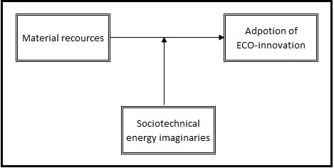

*Figure 1*. Conceptual model adaptation of sustainable technology

The real decision making for the investment in ECO-innovation is an interplay between the natural resources and the social world of the adopter. The effects this interplay has on the possibility of a household (not) to invest in sustainable innovations will be investigated in this article. Only the investigation of the interplay between these concepts will create an understanding of why household are not adopting new technology. This understanding makes possible public issues in the transition to sustainable energy visible and can thereby help in creating a more inclusive framework for transitions. The conceptual model is shown in figure 1. Built from the findings from Rogers that non-adopters are not just opposing to change, but can experience real boundaries in adopting an innovation (Rogers, 1983), the research question in this article is the following:

*What is the role of sociotechnical energy imaginaries, like “fossil fuels forever” or “sustainable future,” in the adoption of ECO-innovation by households in Dutch society?*

The investigation of this research question is conducted in two parts. In the first part of the research in this article is about finding parameters predicting the (none)adoption, by an empirical study of the distribution of ECO-innovations in Dutch neighborhoods. These parameters were used to select research areas for the second part of this study. The second part of the study is about identifying the energy imaginaries of people that are not adopting ECO-innovation. The energy imaginaries from this group are studied via interviews with people that have the needed resources, e.g., the ownership of a house or peers that own PV but are nevertheless not adopting PV. This assumes that the people in these areas hold imaginaries that make them resistant or reluctant towards ECO-innovation. Together these studies create understanding about why people are not adopting ECO-innovation and evaluate if the struggles for sustainability are (re)making urban spaces (Jhagroe, 2016).

# Theoretical framework: : social aspects of innovation

To investigate the sociotechnical imaginaries of the people that are not adopting an innovation, this article explores the normative framework of people from this group concerning sustainability. This chapter provides theories on imaginaries, the diffusion of ECO-innovation, and social influence.

# Sociotechnical energy imaginaries

Imaginaries describe the way people imagine their social surroundings and is made visible in images, stories, and legends, necessary for a common understanding of practices and a widely shared sense of legitimacy of things like borders and nationalities (Taylor, 2004). These shared understandings are embedded in social practices that shape the future through the development of, e.g., norms, policies, and technology. Before shooting into space, it is first the imagination dreaming about it (Jasanoff & Kim, 2009). Methods to investigate the role of imaginaries in the production of technology are conceptualized in the interpretive framework of CO-production by Jasanoff and Kim (2015) and argues that the interpretation of knowledge depends on the interest of society. Though they can originate in the visions of single individuals, sociotechnical imaginaries are collectively held by making the image public and brings together the normativity of the imagination with the materiality of networks in the production on technological (energy) projects. Adaptation of new technology is thereby not merely a matter of ability, but also a matter of vision. In the adaptation of PV, the public image is complicated by the depiction of the climate. Levy and Spices (2013) convincingly derive differed imaginaries from observation and analysis of the various framings of the climate actors and the media on sustainability. These four core imaginaries they identify are the 1) “fossil fuels forever”: this (obsolete) popular imaginary viewed abundant cheap fossil fuel as the prime motor behind competitive industrialization. 2) the “climate apocalypse” imaginary paints an alarming picture of the coming decades, visible in movies like “day after tomorrow” (*The day after tomorrow*, 2004). The article of Cook (2018) shows that people that hold this imaginary see change as inevitable and attempts to avoid it are useless. 3) “techno-market” is the combination of capitalism and sustainability. In this view, the marked provides a new product that enables life as consumers in a sustainable way’s. Cook (2018) also identifies a technology imaginary where people see a future where new technologies will provide a solution of the climate crisis, e.g., building vertical tubes in the ocean to help the ecosystem cure itself by increasing the mixing of nutrient-rich with the relatively barren waters at the ocean surface (Lovelock & Rapley, 2007). 4) “Sustainable lifestyle”: less materialistic lifestyle inspires these movements to lower the environmental impact; no additional assets are needed to achieve this goal. In this view, solar does not necessarily need to be adopted to reduce the production of CO2. The four imaginaries are plotted on to axes by Levy and Spicer (2013), as shown in figure 2. Another way to look at the concept of “resilient- or fragile climate,” is the stable-climate perspective as described by Lovelock (2014). Imagining the earth chemistry as stable, tels people that there is still time to fix the issue. The problem, however, is that the climate on earth is fundamentally unstable. A chemical unbalance is the premise for life; all the planets that are chemical balanced, are dead planets like Mars (Lovelock, 2014). Thereby, the concept of a stable-climate is misleading since a stable climate is a dead planet in this definition.

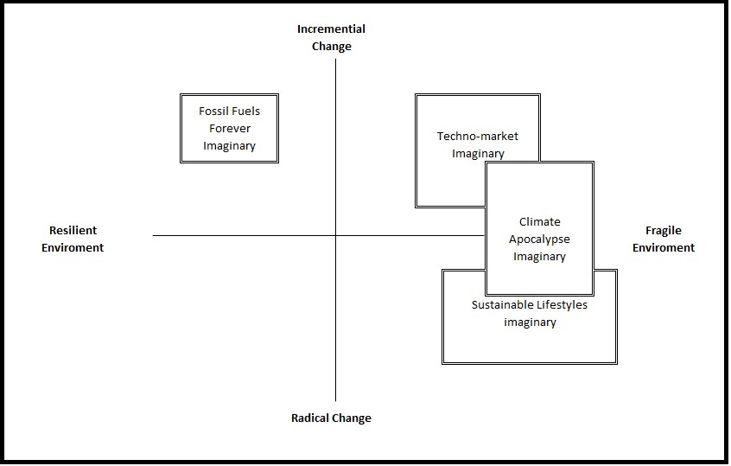

*Figure 2*. Climate Change Imaginaries (Levy and Spices, 2013)

# Diffusion of ECO-innovation

New technologies spread in society through a process of innovation. This adoption process depends on the perceived relative advantage, the complexity, the social influence, Table 1

*Roger’s five perceived components of innovations (Rogers, 1983).*

|  |  |
| --- | --- |
| Attributes | Definition |
| Relative advantage | The degree to which an innovation is perceived as better than existing (economic, advantage, social prestige, convenience, or satisfaction). |
| Compatibility | The degree to which an innovation is perceived as consistent with existing values, past experiences, and the needs of potential adopters. |
| Complexity | The perceived difficulty to understand and use the innovation. |
| Trialability | The degree to which the adoption of an innovation is experimented without making long-term commitments or incurring significant costs. |
| Observability | The degree to which the results of an innovation are visible to others |

and required knowledge and costs (Rogers, 1983). The spread of new technology in society is conceptualized as “the (diffusion) process by which an innovation is communicated through certain channels over time among the members of a social system.” (Rogers, 1983, p. 5). In this study, the focus is on ECO-innovations: new products and processes which provide customer and business value but significantly decrease environmental impacts (James, 1997). This combination of reducing carbon emission and provide economic opportunity’s, which is also the way the energy transition is described in the klimaatakkoord (EZK, 2019). Innovation is communicated from individual to another via channels, that can be things like media or personal relations. The strength of the ties an individual maintains with a communicator of an innovation influence the change of successful adoption. Time is involved in the speeds that communication “passes from first knowledge of an innovation to forming an attitude toward the innovation, to a decision to adopt or reject, to the implementation of the new idea, and to confirm this decision towards the rest of the world” (Rogers, 1983, p. 36). Thereby the time that it takes to spread innovation in a social system is key in this research. The innovation is distributed in a social system. There are differed types of social networks, and this article focused on private residential spatial networks. Rogers (1983) classified the categories of the adopters as innovators, early adopters, early majority, late majority and laggards, and innovation is spread through a network in the respective order. This diffusion of innovation theory leads to conclude that the diffusion of ECO-innovation follows a visible spatial path from innovators to the majority in a local network trough, in which the strength of the relations influences the speed of adoption. From this innovation theory, this article uses five steps in the adoption process of innovation: 1) knowledge about the system and the climate problem, 2) persuasion factors via the communication channels, 3) way of decision making, 4) implementation, and 5) confirmation.

# (Undetected) Social influence

Individuals in society do not act as independent decision-making units, but their behavior is influenced by the other members of the reference group (Salazar, Oerlemans, & Stroe-Biezen, 2012), defining social influence as the change in an individual’s attitude or behavior that results from the interaction" with other individuals or social group. Salazar et al. (2012) studies the social influence that peer groups like colleagues, family, and friends may have on sustainable consumption. They find evidence for “herd behavior” (imitations of others) and for “social learning” (learning via network). Nolan, Schultz, Cialdini, Goldstein, and Griskevicius (2008a) also investigated the persuasive impact of normative social influence. Additionally studied is the detectability of this social influence. In the study, even though participants expressed that social norms dod not influenced their energy conservation, the results show a high correlation between the descriptive norms of the network and those of the participants self. The false perception that people have of social influence leaves the researchers to conclude that “naive psychology-based” beliefs about energy conservation were inaccurate predictors of actual energy conservation. Social influence gives problems in predicting the diffusion of ECO-innovations since peoples motivation for adoption is less rational than they believe themselves. In this article, the focus is on the normative frameworks on an emergent level. The aim is to investigate how the individual believes fit in the social context of the individual. From these emergent patterns, we try to gain knowledge about why people are not adopting ECO innovations.

# Study 1: Identification non-adapters

The first part of this mixed- method study is a quantitative study about the identification (and localization) of households that are not adopting ECO-innovation. This part of the study is conducted as a preparation for the second part of this article.

# Method

The statistical analysis for PV is performed on the Stedin supply area, consisting of over 2 million connections, with 100.000+ houses with PV. The data from the connections in enriched with other data (as described in the data section below), and analyzed using logistic regression.

**Data.** Stedin Netbeheer provided datapoints of households that have installed PV. To the data, other variables are added. Demographic variables, e.g., average age or single-person households, are added via data from Centraal bureau Statistiek (CBS, 2018). This dataset provides data on the neighborhood level and is spatially joined to the data points. Also used is BRP (2019) for measuring residential mobility. This data is on the level of the municipality. Via this data, the effect of people living in an area for a short period is on the adoption of PV is measured. The expectation is that, if people stay loving in a house for a shorter time, the change that they will invest in the hose will be lower. BAG (2019) is used for extra information on the house, e.g., construction year. The expectation is that it will be more difficult to install PV on relatively old houses, and thereby, people who live in a relatively old house are less likely to adopt PV. To measure the social position of households, data about social economic status is also joined. To measure the effect of social influence (peer-influence) of neighbors adopting PV, a network representation of neighbors in the Stedin energy network was created using Delaunay triangulation (Chew, 1989). By doing so, the distance in the network is conceptualized as the numbers of neighbors that need to be passed while traveling from one point to another. Looking at the data this way is a way of saying: three houses next to us they have solar panels. This way, the effect of PV in the neighborhood can be measured. From a household, it is possible to trace the shortest path to the nearest PV panel[1].

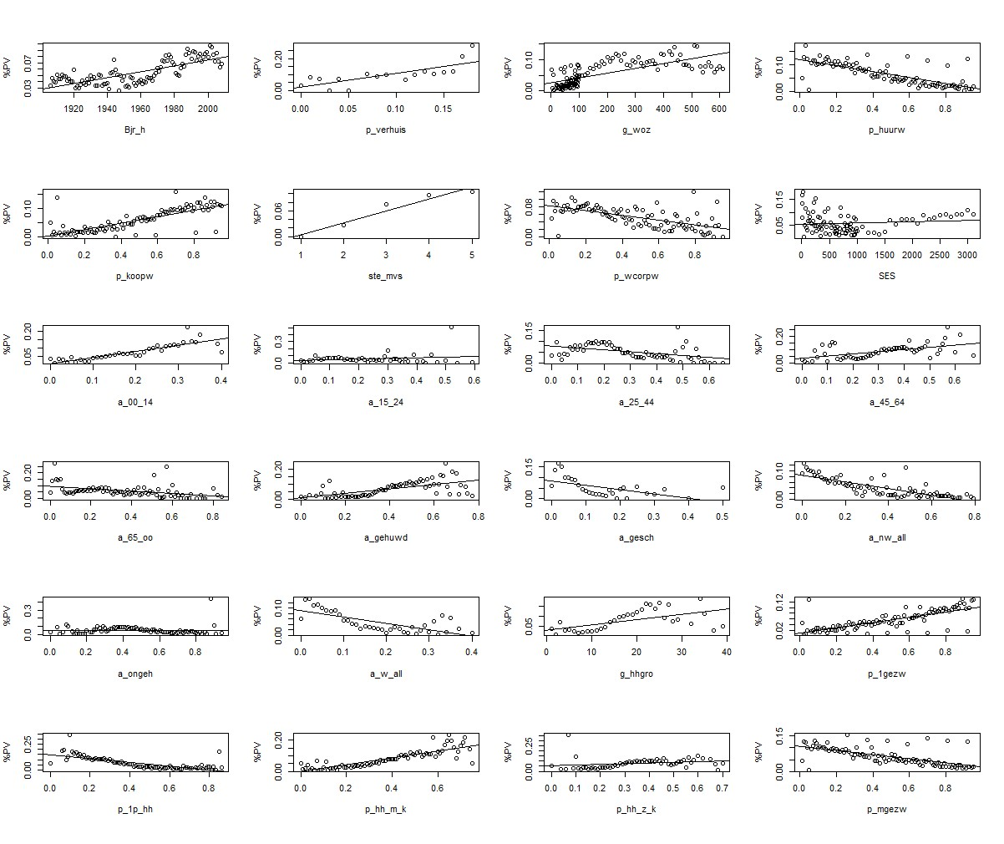

*Figure 3*. Variables for regression analysis

To determine the maximum radius for the search, the correlation between neighbors adopted PV was calculated via using Moran’s (Li, Calder, & Cressie, 2007). The mean difference between spatial points is displayed in figure 4. After 150 meters, there is no (positive) correlation. Therefore the influence that visibility of PV has on neighbors is assumed to be 150 max meter. The radius for the search for the nearest neighbor that has PV is restricted with by 150 meters. The study focused on the individual adaption of a household to PV. Houses that installed PV at the construction year are neglected in this research. Appendix I shows a list of all the sources for the data used in this study.

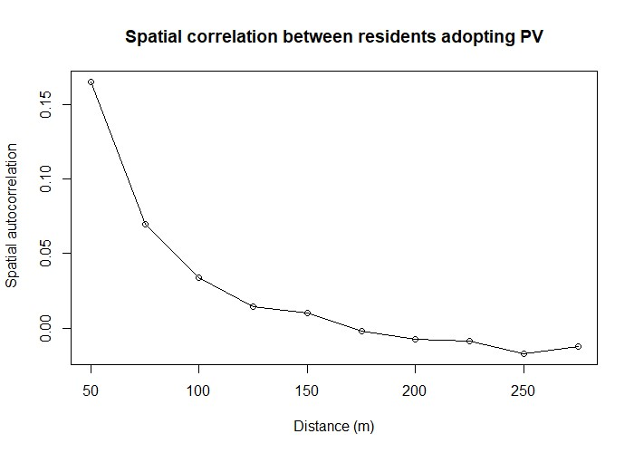

*Figure 4*. Moran’s I for spatial correlation, to measure social influence of PV in the neighborhood

The data of PV adoption by the collective income of a household is misleading. Income seems to have a positive effect on the adoption of PV. However, when the income levels are clustered into two separate groups via k-mean clustering, the effect changes (Simpson’s paradox, (Simpson, 1951)). The income has only a positive effect on households that have a collective income lower than *≈* 135K. If the income is higher than that level, income seems to have a negative effect on the change of a household adopting PV. For this reason, two extra variables are added to the data: “income high,” a variable for income levels > 135K, and “income low,” for income levels =< 135K. The construction year of the house has, without clustering, a positive effect on the adoption of PV. After the data is clustered via k-means clustering in three groups, this effect becomes less visible. The figures are shown in figure 3.

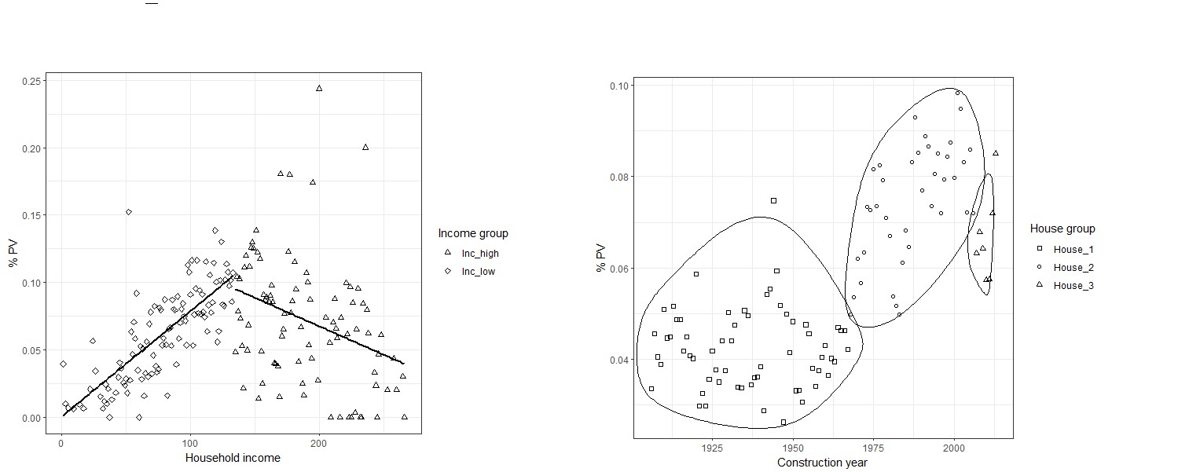

*Figure 5*. Clustering variables for collective income of a household and construction year

**Procedure.** Insight in the variables predicting (non-)adoption of ECO-innovation is obtained via multivariable regression analysis. The data is divided into different categories. Group A are variables for measuring the resources of the household. Group b measures demographic characteristics, and group C measures the peer-influence in adopting PV.

# Validity and reliability

The validity and reliability of this part of the research are ensured in various ways. Firstly, the method for building the network is derived from techniques to perform regression analysis on online networks. By copying the technical aspects of the data research, the change of mistakes are minimized, and thereby, the validity of output is assured. To further improve the validity of the qualitative part of the research is guaranteed by a critical process of peer-review from employees from Stedin. The code is written in a clear and structured way, so it is accessible to peer-review by data-scientists from Stedin. The code is tested on subsets of the data to ensure the reliability of the code. For subsets of the data, the output of the computation was similar to the results of the complete dataset. The internal validity is guaranteed by, e.g., checking the data for multicollinearity. The percentage of the population with an age between 15 and 44-year are removed due to high correlation. The core for Social Economic Status (SES) is removed due to a high correlation with the data about the house price (WOZ). The available data for SES is on town-level. The data from WOZ is more accurate and therefore selected to use in the model.

**Results.**

The model shows that the Peer effect is a good addition to the model to predict the adaptation of PV by a household. Most of the explained variance in the model is on the peer-effect of PV in an area. If the distance from a house to a house with PV increases, the chance that that house adapts PV decreases. Distance is measured as the distance in the network, as the number of steps in the network from one point to another point, as described in the data section of this chapter. The local housing-density (radius of 150 abound a house) has a negative effect on the individual adoption of PV. This finding is problematic and discussed in the following paragraph. The effect of residential mobility (p_verhuis) does not have a significant effect in model C. As also shown in figure **3**, residential mobility seems to have other influence than expected. The expectation was that higher mobility would result in a lower adoption rate because people are less likely to invest if they are leaving. The effect in model A is the opposite because, in the model, higher residential mobility correlates with higher adoption of PV. The reason for this is unclear. The data is on the municipality level, and thereby not very acute a possibly creates this issue.

Table 2: *Check for multicollinearity*

|  |  |  |  |  |  |  |  |  |  |  |  |  |  |  |  |  |
| --- | --- | --- | --- | --- | --- | --- | --- | --- | --- | --- | --- | --- | --- | --- | --- | --- |
|  | Aantal_Buur | PV_dist | a_man | a_00_14 | a_45_64 | a_65_oo | a_w_all | a_nw_all | bev_dich | g_woz | p_1gezw | p_koopw | ste_mvs | Inc_hi | Inc_low | p_verhuis |
| PV | -0.09 | -0.01 | 0.02 | 0.05 | 0.07 | -0.01 | -0.06 | -0.07 | 0.03 | 0.06 | 0.09 | 0.09 | 0.07 | 0.01 | 0.02 | 0.03 |
| Aantal_Buur |  | 0.31 | -0.08 | -0.16 | -0.28 | -0.15 | 0.31 | 0.24 | -0.06 | -0.25 | -0.32 | -0.32 | -0.48 | -0.05 | -0.03 | -0.19 |
| PV_dist |  |  | -0.08 | -0.12 | -0.21 | 0.02 | 0.18 | 0.27 | -0.07 | -0.18 | -0.28 | -0.31 | -0.25 | -0.06 | -0.04 | -0.12 |
| a_man |  |  |  | 0.19 | 0.19 | -0.56 | 0.03 | 0.08 | -0.05 | 0.05 | 0.17 | 0.24 | 0.15 | -0.10 | 0.02 | 0.04 |
| a_00_14 |  |  |  |  | -0.09 | -0.51 | -0.19 | 0.15 | 0.14 | 0.18 | 0.28 | 0.25 | 0.13 | -0.04 | 0.03 | 0.03 |
| a_45_64 |  |  |  |  |  | 0.00 | -0.24 | -0.37 | 0.14 | 0.19 | 0.42 | 0.49 | 0.36 | 0.15 | 0.02 | 0.12 |
| a_65_oo |  |  |  |  |  |  | -0.14 | -0.34 | 0.03 | -0.02 | -0.08 | -0.06 | 0.13 | 0.07 | 0.02 | 0.14 |
| a_w_all |  |  |  |  |  |  |  | 0.32 | -0.14 | 0.10 | -0.45 | -0.27 | -0.53 | 0.27 | -0.29 | -0.38 |
| a_nw_all |  |  |  |  |  |  |  |  | -0.12 | -0.35 | -0.44 | -0.62 | -0.50 | -0.23 | -0.09 | -0.33 |
| bev_dich |  |  |  |  |  |  |  |  |  | -0.01 | 0.09 | 0.09 | -0.03 | -0.02 | 0.11 | -0.03 |
| g_woz |  |  |  |  |  |  |  |  |  |  | 0.26 | 0.43 | 0.25 | 0.45 | -0.24 | 0.05 |
| p_1gezw |  |  |  |  |  |  |  |  |  |  |  | 0.53 | 0.54 | 0.00 | 0.13 | 0.29 |
| p_koopw |  |  |  |  |  |  |  |  |  |  |  |  | 0.45 | 0.18 | 0.04 | 0.23 |
| ste_mvs |  |  |  |  |  |  |  |  |  |  |  |  |  | 0.06 | 0.09 | 0.50 |
| Inc_hi |  |  |  |  |  |  |  |  |  |  |  |  |  |  | -0.85 | -0.05 |
| Inc_low |  |  |  |  |  |  |  |  |  |  |  |  |  |  |  | 0.09 |
| p_verhuis  max | 790.00 | 38.00 | 1.00 | 1.00 | 1.00 | 1.00 | 0.50 | 1.00 | 6400.00 | 680.00 | 1.00 | 1.00 | 6.00 | 260.00 | 130.00 | 0.26 |
| mean | 210.00 | 3.60 | 0.49 | 0.17 | 0.28 | 0.18 | 0.10 | 0.16 | 3600.00 | 170.00 | 0.61 | 0.57 | 3.30 | 40.00 | 66.00 | 0.02 |
| min | 2.00 | 1.00 | 0.00 | 0.00 | 0.00 | 0.00 | 0.00 | 0.00 | 1.00 | 1.00 | 0.01 | 0.01 | 2.00 | 0.00 | 0.00 | 0.00 |
| sd | 100.00 | 2.80 | 0.02 | 0.04 | 0.05 | 0.08 | 0.05 | 0.15 | 1900.00 | 100.00 | 0.29 | 0.22 | 1.20 | 71.00 | 46.00 | 0.03 |

Table 3

*Result lm*

|  |  |  |  |  |  |  |  |  |  |
| --- | --- | --- | --- | --- | --- | --- | --- | --- | --- |
| Var | B.x | SE.x | b.x | B.y | SE.y | b.y | B | SE | b |
| (Intercept) | -2.89 | 0.04 | -76.38 *** | -4.16 | 0.13 | -33.14 *** | -2.85 | 0.14 | -19.98 *** |
| g_woz | 0.11 | 0.00 | 26.53 *** | 0.10 | 0.00 | 22.61 *** | 0.06 | 0.01 | 11.06 *** |
| p_koopw | 0.92 | 0.02 | 44.9 *** | 0.09 | 0.03 | 3.28 ** | 0.03 | 0.03 | 1 |
| ste_mvs | 0.12 | 0.00 | 35 *** | 0.03 | 0.00 | 6.59 *** | -0.08 | 0.00 | -16.95 *** |
| Inc_grInc_low | -1.11 | 0.04 | -26.06 *** | -0.63 | 0.04 | -14.08 *** | -0.82 | 0.05 | -16.95 *** |
| Inc_hi | -0.22 | 0.02 | -12.84 *** | -0.09 | 0.02 | -4.85 *** | -0.10 | 0.02 | -4.99 *** |
| Inc_low | 0.30 | 0.01 | 36.32 *** | 0.21 | 0.01 | 22.03 *** | 0.27 | 0.01 | 26.34 *** |
| House_grHouse_2 | 0.39 | 0.01 | 50.37 *** | 0.32 | 0.01 | 38.79 *** | 0.36 | 0.01 | 40 *** |
| House_grHouse_3 | 0.24 | 0.02 | 14.88 *** | 0.15 | 0.02 | 8.98 *** | 0.09 | 0.02 | 4.85 *** |
| p_verhuis | 0.21 | 0.10 | 2.13 * | -0.18 | 0.10 | -1.71 . | 0.29 | 0.11 | 2.54 * |
| a_man |  |  |  | 1.34 | 0.22 | 5.96 *** | -0.08 | 0.25 | -0.3 |
| a_00_14 |  |  |  | 3.32 | 0.13 | 25.87 *** | 2.61 | 0.14 | 18.59 *** |
| a_45_64 |  |  |  | 2.43 | 0.09 | 25.89 *** | 1.54 | 0.10 | 14.93 *** |
| a_65_oo |  |  |  | 0.20 | 0.07 | 2.8 ** | -0.91 | 0.08 | -11.54 *** |
| a_w_all |  |  |  | -1.87 | 0.12 | -15.22 *** | -1.33 | 0.13 | -10.17 *** |
| a_nw_all |  |  |  | -1.20 | 0.05 | -24.17 *** | -1.58 | 0.06 | -28.65 *** |
| bev_dich |  |  |  | 0.03 | 0.00 | 8.72 *** | 0.05 | 0.00 | 10.63 *** |
| p_1gezw |  |  |  | 0.26 | 0.02 | 15.64 *** | 0.35 | 0.02 | 18.83 *** |
| Aantal_Buur |  |  |  |  |  |  | -0.35 | 0.01 | -66.7 *** |
| PV_dist |  |  |  |  |  |  | -0.07 | 0.00 | -54.24 *** |
| R_2 |  | 0.04 |  |  | 0.04 |  |  | 0.15 |  |

a Note: .p<0.1; *p<0.05; **p<0.05; ***p<0.005

# Discussion

The peer effect, as theorized by Salazar et al. (2012), seems to explain a part of the diffusion of PV. The same effect was also measured by Bernards et al. (2018) and Bollinger and Gillingham (2012). The findings in this part of the study that there is a social learning effect in the adaptation of PV seems to be valid. The addition to the existing literature on the topic is the finding that there is a negative correlation between the distance a house has to a neighbor with PV and the house having adopted PV itself. In other words, the closer a house is to another house, the higher the possibility of that house adopting PV. Distance is not measured in meters, but in the number of steps in the network, as described in the data section of this chapter. This way of measuring is new compared to existing literature en prooves to be an effective parameter in the regression analysis. The results also show an effect of the urban dencity in an area of 150 meters around a house. If the density increases, the chance of the household adopting PV decreases. This effect, however, this can be caused by another parameter that is missing in the data. If there are high-rise buildings in an area, the density increases. Since it is more complicated to install PV on, e.g., an apartment building, the effect of local density could be spurious. This complicates the finding of the effect of housing density on the possibility of adaption of PV by an individual household. To improve the computation, a variable the represents the type of house/building needs to be added to the dataset, e.g., if the building is an apartment or terraced houses. Most of the datasets that are used are inaccurate. The data about the price of homes is an average on neighborhood level (> 1000 houses per neighborhood). If the data would be more price, the results could be more accurate. Als, not only the mean ought to be considered, but also the spread of the income in an area.

# Study 2: Understanding non-adaptors

Although Rogers (1983) defines lagers of innovation typically as low educated and reluctant to change, Rogers also argues that this group can have real reasons for not adopting. This part of the thesis investigates the arguments of the lagers identified (and localized) in part [ONE, REF] of this study by interviewing people from this group. In this part of the study, people that are identified as having the resources to adopt ECO-innovation, but are however not adopting the innovation, are selected for interviewing participants about their views on the future energy system and the role of ECO-innovation in that perception on the future of energy. These interviews are analyses to find emerging patterns in the normative frameworks from this group. To gain more information about the process of innovating to ECE-innovation, interviews were also conducted with people that did purchase PV. Together, the interviews with both the adaptors and non-adapters helped to create a better understanding of energy imaginaries that people can have.

# Method

**Participants.** Participants in this part of the study are people who are, based on material resources, able to adopt PV but are nevertheless not adopting ECO-innovation. The parameters do to this selection are provided by part one of this study. The results of the regression [TABLE REF ] indicate that home ownership, availability of PV, and low residential movement correlates with the adoption of PV. Based on these parameters, two neighborhoods are selected to conduct interviews. In total, 12 people were interviewed, varying in time from 5 minutes to 1 hour. Some were conducted while standing in the doorway at the entrance of the house; other interviews were held inside of the house, depending on the hospitality of the household.

**Procedure.** The selection of the participants within the selected area’s was made via non-probability convenience sampling (Creswell & Poth, 2018 ). This way of sampling is because it enabled the interviewers to make the decision where to interview, based on the availability of people in the chosen area, at the time when the interviews were conducted. The interviews took place on weekday day during the day. The interviews were semi-structured. By asking things like how they view the relative advantage of the technique, and the complexity of the system, we tried to understand the participants view on their attributes towards ECO-innovation (Rogers, 1983). To investigate the future-climate imaginaries, the interview focused on the way the participants view the stability of the ecosystem and how the view change on a global scale (Levy & Spicer, 2013). The transcripts of the interviews are analyzed using Atlas.ti.

# Validity and reliability

The validity of the qualitative part of the research is guaranteed by a critical process of reflection. For example, the analyzes of the interviews were peer-evaluated by another the researcher. Clear inclusion and exclusion criteria have been drawn up for applying the codes, with which a high degree of inter-coder reliability is observed (Creswell & Poth, 2018; Neuman, 2014). By using the different methods, the general validity of the research is guaranteed by methodical triangulation (Neuman, 2014). Findings in this part of the study were matched with part one of the study. However, it is important to point out that the external validity of the study is limited. This is because it is a fairly select research target group. The availability of respondent, based on convenience, has a possible bias. Interviews were conducted during working hours. People that were at were a job, were not able to respond. Although some of the respondents had a job but were nevertheless at home due to parenting or because they were working at home, we did not encounter e.g., people that work 5 days a week as the office. The results are possibly biased by that fact the respondents were sampled at the same time, and not on different time frames. The conclusions of the study cannot, therefore, be generalized by definition. The findings are limited to the respondents in this part of the study.

**Results.**

In the interviews conducted amongst non-users, none of the respondents suggested that financing the panels was an issue that prevents them from buying PV. This finding corresponds with the finding in part one of this study, that shows that the income of a household does not predict the adaptation of PV on a continuous scale, but is more likely to function as an enabler to buy the technology. The respondents explained that they would be able to buy PV, but expressed other, diverse, reasons for not adopting the technology. In this result section of the second part of this thesis, first the contextual parameters are elaborated, after that the future energy imaginaries from the respondents that are not-adopting ECO-innovations are elaborated.

**Contextual parameters.**

As contextual parameters, the study finds a large influence, indirectly, of neo-liberal marked principles in the transition to sustainable energy. When respondents were asked: *“If you would like to purchase PV, would you know how to do it?”*, some respondents answered that they are uncertain about how to do it. The difficulty for them was not direct in the purchase itself, but in the part that comes after the purchase,

e.g., in accessing subsidies or getting the panels on the roof. Respondents thought that there would be subsidies available for them, but they did not know how to access them. For some respondents, also the installation of the panels itself was problematic. One respondent answered: *“I don’t know how to arrange the generated electricity with my VVE (owners association), and how am I supposed to get the cable from the rooftop the fuse box? The roof is collective property. If we buy the panels together, I don’t know how to divide the yield of the panels amongst the houses. If my fridge is on at the time there is energy from the panels, how do we deal with that financially?”* [responded 1]. Some of the respondents described how he tried to search for information on the internet, but that all the different information they encountered withheld them to continue the exploration of the possibilities. The uncertainty withheld them from buying PV. This uncertainty could explain why there is a peer-effect in the adaptation of PV, as described in the first part of this study since people can learn from each other how to overcome these difficulties.

Another finding that implies the existence of this peer-effect is that almost all of the respondents that did purchase PV told that neighbors contacted them in the past for information about the purchase. One respondent narrated, *“I’ve had people that I did not even know coming to my door, asking me how they could also buy and install these sole panels”* [responded 4]*.* The contact that neighbors have with each other concerning PV indicates a social learning mechanism as theorized by (Nolan, Schultz, Cialdini, Goldstein, & Griskevicius, 2008b), where the available knowledge in the network is used to gain knowledge to adopt ECO-innovation. It also corresponds with the notion of “Observability,” as defined by Rogers (1983). The first adaptation of PV in a neighborhood network is thereby essential in the transformation of an area to sustainable sources of energy. Other respondents expressed concerns about the visual aspect of the panels on the roof. One respondent explicitly stated: *“I don’t like these panels on the roof, I think it is ugly. Al long as others (neighbors) are not buying them (PV-panels), will also not do it. If someone in the steeds does is, then everyone can do just as well”* [responded 11].This indicates that some people are afraid of a negative social effect to buy PV. This is lifted after the first person installed PV on the roof. This (again) suggests that there is a neighborhood effect in the adoption of PV via social learning. The peer-effect in the adaptation of PV suggests that innovation neighborhoods to sustainable energy is not only a matter of constructing new, physical, infrastructure to generate carbon-free energy. With the adaptation of PV by one member of a community, nonphysical networks are formed om people interested in innovating. In these networks, the panels on houses are a way of communicating the possibility of transitioning to a sustainable future. Together with the technical functions of the panels, the panels also hold ethnographical aspects by influencing (local) attitudes and knowledge about sustainability (Star, 1999). The installation of PV is a way for the innovation to enter the public sphere, where people discuss and imagine a sustainable society(Jürgen, 2015, Warner (2014)). These publics form a civil society, where voluntary associations between members lead to a collective adoption of the new technology. Within this discourse, subaltern publics are unable to participate in the conversation (Fraser, 1990). While intervening, also respondents that rented the house they occupied were encountered. One respondent explained: *“We rent this house. I would like it to be more sustainable, but it is up the owner of the house to install the panels. It would be even greater if by energy bill could also drop, I would like that to happen”* [responded 3].This example explains how not everyone can actively participate in the public discussion of transforming the Dutch landscape to CO~2 neutral sources. The public for the EZK (2019) consist only of businesses and homeowners (both private and corporate), tenants are excluded from the conversation. Social learning is delimited to people who can participate in the public for sustainable innovation. Thereby, the neo-liberal activities exclude a large population of society from participating in the struggle for sustainability.

**Future energy imaginaries of non-adopters.**

This thesis investigates the future energy imaginaries of the non-adopters of ECO-innovation. From the interviews amongst people that did not adopt installed PV, thee imaginaries for a sustainable future are identified, namely: collective action, systemic change, and (temporary) crisis.

***Imagining collective action.*** In the transition to a sustainable landscape, the Dutch government uses subsidies to persuade citizens to adopt the new technology. This does not necessarily fit with the vision of some of the respondents in this inquiry since they expressed what seemed to be a desire for collective action, controlled by the government. The innovators in the diffusion of innovation are willing to take the risk of making a bad investment; other groups are more reluctant toward change and less willing to take this risk (Rogers, 1983 ). Respondents that did not adopt PV expressed that the uncertainty regarding the payback period of the investment. One respondent stated: *“it’s uncertain for how long the regulations of energy purchase (salderingsregeling) will stay. If the government decides to dismiss the current regulations, it will take a minimum of 20 years to recoup my investment”* [responded 5]*.* Respondents who were vocal about their desire for the government to provide insurance about their investment in the transition to sustainable technologies seemed to want the government to take collective action to improve the sustainability of their circumstances. A common argument, used by many of the respondents, was *“my share is just a drop in the ocean”* ( *“een drupel op een gloeiende plaat”* ). Most of the respondents that expressed this feeling told that only collective effort would solve the problem and desired (or demanded) that the government come up with a set of economically viable measures. Hobbes and Shapiro (2010) demonstrate that individuals, despite being rational actors, are unable to arrange and keep cooperative agreements without enforcement by the state. The respondents experience the struggle for sustainability as a prisoners dilemma, where people are willing to give up resources if everyone else in society does this as well. A sovereign government with absolute regulations for sustainability is security that others will not gain by their effort. The respondents express this in statements like "*the government is talking a lot, but not taking measures. They ought to come up with solutions*“ [responded 6]. This statement opposes the neo-liberal solution the Dutch government uses to cope with the climate crisis, as described in the previous section. The unwillingness of taking the risk of making an expensive investment while others continue to consume cheap (unsustainable) energy, restrain people in this group from purchasing PV.

Another uncertainty that respondents expressed was that they did not know for how long they will continue living in the house. One respondent stated: *“this house has lots of stairs. Now the going up and down goes well, but we’re old, so we’re not sure for how long we will stay here. Therefore we’re not buying panels. It can take ten years for the investment to pay back, that is too long”* [responded 2]. Respondents thought PV would be not a good investment since it is unsure if the investment will profit when they sell the house. When asked how they envision the future of the climate, these respondents expressed concern about the future of the climate. They were, however, rely upon on the government to create regulation that creates a sustainable future. They did not express a personal responsibility for sustainable lifestyles. This again is evidence for the prisoner’s dilemma in sustainability. Government subsidy regulations enforce this dilemma. One respondent explained: *“If I had been faster to buy PV, I could have benefitted from the available subsidies. These days the subsidies are less lucrative.”* [responded 5] Although the price of PV has decreased dramatically in the last decade (“The economist,” 2012), the respondent had the feeling he was missing out on the governmental contribution to his sustainable innovation. Hobbes’s argument for absolutism will solve the problem of the individual desire to profit from the global crisis. The Dutch government uses neo-liberal marked principles to push innovation towards a sustainable future. Via this marked, innovation is stimulated, but also inequality in produced. Exactly the risk of investing in sustainable innovations create the possibility for individuals to gain financially, and to lose. Respondents were expressing that the fear of making an unprofitable investment made them relucted to invest. That is: not if not everyone is doing it. This asks questions about the scale of the climate crisis. Some respondents (that adopted PV), expressed that they, as individuals like to live a sustainable lifestyle, while others that did not adopt PV expressed that they expect the government to take measures. People from the latter group seemed to expect that the government will take care of the well-being of the citizens, based on equal opportunities and equal distribution of wealth. This suggests that people who are more in favor of a well-fare state form of government are less likely to take individual measures to engage in a market-driven effort to a sustainable lifestyle. In this way, the image that citizens have of ideal government control influences their sustainable practices.

***Imagining systemic change.*** For an individual effort of citizens to adopt ECO-innovation, people need to feel responsible for the problem on an individual level. Some of the respondents in this thesis expressed that they did not feel individually responsible for climate change since, in their vision, others responsible for the effect human activity has on the climate. The climate crisis is in their view a result of a non-functioning system, and thereby, they are saying (not explicitly) that the crisis is a result of capitalism. A respondent questioned if, a problem created by technology can be solved by technology. When asked if he thought that ECO-innovation could fix the climate crisis, replied:

Most of the panels are produced in China. Due to work, I come there often, and I think it is questionable to participate in business with that regime. Also, for the production of PV, we need to use lots of materials. That is still wrong, so I’m not sure if panels and windmills are going to fix the problem. [respondent 1]

When respondents were asked if they were feeling responsible for the problems in the present climate on earth, some respondents expressed that they perceived the climate problem as a problem of big companies. They did not feel like they are not responsible for the massive production of *CO*2, but that this problem is created by a small group of big companies emitting large quantities of *CO*2. Moore (2015) conceptualizes this as the problem of accumulation of capital via the exploitation of cheap nature. As a result of the human activity on earth, the current era is imagined as the Anthropocene. In this depiction of the climate problem, climate change is the result of the Anthropocene, in which human influence on the planet is so profound that it will leave its legacy for millennia (Macfarlane, 2016). In the EZK (2019), the temperature on earth ought to be reversed to a pre-industrial era. This pre-industrial era refers to the period of several centuries prior to the start of the large-scale industrial activity around 1750, measured as the Global mean surface temperature

(GMST)(IPCC, 2014). By using this starting point of reference for the measurements, the scale of measuring climate change includes that climate change originates in the industrial age. By imagining climate change as the consequences of an Anthropocene era, the problem is portrayed as to which everyone contributes and thereby, everyone has to participate in reducing the impact that human life has on the earth temperature. In this way, a public is created for the EZK (2019) and the corresponding set of measures to prevent human-induced climate change. Moore (2015) shows that climate change is not necessarily a problem of industrialization, but primarily a problem of capitalism. Capitalism not only exploits labor, but it also appropriates nature. According to Moore (2015), the strive for economic progress, through the exploitation of man and nature, the capitalist system is the engine behind climate change, and industrialization is only a consequence of this. The capitalist framework within climate change takes place remains invisible in the EZK (2019) by depicting climate change as a problem of the Anthropocene. This is stated in the EZK (2019) as the following:

*“We staan aan de vooravond van een grote verbouwing. Een transformatie van onze ruim 7 miljoen huizen en 1 miljoen gebouwen, veelal matig geïsoleerd en vrijwel allemaal verwarmd door aardgas, tot goed geïsoleerde woningen en gebouwen, die we met duurzame warmte verwarmen en waarin we schone elektriciteit gebruiken of zelfs zelf opwekken. Klimaatverandering is een belangrijke reden voor deze verbouwing. Maar er is meer. We willen immers zo snel mogelijk kunnen stoppen met de aardgaswinning in Groningen. En we hebben allemaal wel behoefte aan een minder hoge energierekening en een comfortabeler woning.”* (EZK, 2019, p 21)

*“We are on the eve of a large scale renovation of the Dutch society. A transformation of our more than 7 million houses and 1 million buildings, mostly moderately insulated and almost all heated by natural gas, into well-insulated homes and buildings that we heat with sustainable heat and in which we use clean electricity or even generate it ourselves. Climate change is an important reason for this renovation. Also, there is more. After all, we want to be able to stop the extraction of natural gas in Groningen as quickly as possible. And we all need a lower energy bill and a more comfortable home.”* (EZK, 2019, p 21)

By depicting sustainability as is done in the EZK (2019), the environment is “made more sustainable”: the energy demand of society may remain but without the emission of *CO*2. The climate agreement creates the opportunity to imagine a future in which everyone lives in a clean (in terms of energy) and comfortable (in terms of temperature) home.

Because the current housing stock “is mostly moderately insulated and almost all are heated by natural gas,” the climate agreement justifies a large-scale renovation of the homes in the Netherlands. Houses with a gas connection are unsustainable, and houses with (as an example) a heat pump are sustainable. The interviews show that respondents depict the climate issue in another way, not as a problem of the anthropo (human), but as a problem of capitalism. The respondents that expressed that they did, although they communicated their concern for the climate, not feel responsible for climate change in a personal way. In their opinion, climate issues are created by large companies, and thereby the obligation to find suitable solutions for the problem ought, from their perspective, also come from these companies. From this perspective, the ecological crisis is not an external crisis. From a Capitalocene perspective, it is an internal crisis, caused by the way we as humans live together. Over the last decades, labor, food, energy, and raw materials were cheap (Moore, 2015 ). With the collapse of the ecosystem, this has come to an end. Respondents that expressed that they do not feel responsible for the crisis, because they blame others (commercial) parties for the damage done to the ecosystem. Because they see imagine the crisis caused by a neo-liberal system, they do not feel part of the cause of the problem and thereby also not a part of the solution. For them, the problem is in the means of production.

***Imagining a (temporary) crisis.***

One of the most interesting encounters during the interviews was with a man who initially offered to help to find the way around the neighborhood. When asked about his perception, the man expressed the concern he had for leaving a liveable planet for his grandchildren. As we went further in the conversation about the climate issue and the possibility of adopting a more sustainable lifestyle, the man said: *“it is weird, isn’t it, that I do have concerns about the future of the climate, but I’m not doing anything to change it. I do want to leave a good planet for my grand-children”* He emphasized that he tried to take measures for insulating his house, but when that seemed to be infeasible, he stopped the effort. The man repeatedly stated, as being hit by his the contradictory within this own behavior, *“it is strange, isn’t it?”.* Latour convincingly writes about this problem of “madness” (Latour, 2017). He writes:

*“Talking about a crisis would be just another way of reassuring ourselves, saying that this too will pass, the crisis will soon be behind us. If only it were just a crisis! If only it had been just a crisis! [...] According to the experts, all of us are affected, on the inside, in the intimacy of our precious little existences, by these news bulletins that warn us directly about what we ought to eat and drink, about our land use, our modes of transportation, our clothing choices. As we hear one piece of bad news after another, you might expect us to feel that we had shifted from a mere ecological crisis into what should instead be called a profound mutation in our relation to the world. And yet this is surely not the case. For we receive all this news with astonishing calm, even with an admirable form of stoicism. If a radical mutation were really at issue, we would all have already modified the bases of our existence from top to bottom. We would have begun to change our food, our habitats, our means of transportation, our cultural technologies, in short, our mode of production. [...] We might even be taking our grandchildren to visit museums devoted to this struggle, hoping that they would be as stunned by our progress as they are today when they see how the Second World War gave rise to the Manhattan Project, the refinement of penicillin, and the dramatic progress of radar and air travel”* (Latour, 2017, p. 21).

This attitudes towards climate was expressed during another encounter. When a respondent was asked about his perceptions on the resilience of the climate on earth (for “resilience,” see theory section), the respondent stated: *“some years ago, we had the problem that there was a hole in the ozone layer. now we have a new problem that is CO2. I’m sure that the earth will correct itself. I don’t know how, but I’m sure it will”.* The respondent referred to the climate as a stable object, that had the ability to correct itself. This perception on the climate as “stable” is opposed to how a stable climate is theorized by Lovelock (2014), who argues that a stable climate is a dead climate since the chemical unbalance is the premise for life on earth. Respondents that imagined the climate crisis as a temporary issue, without the risk of extinction of human life, see the stability as something that will guarantee the possibility of life on earth. In their perception, the earth is stable enough to cope with the problems that human life is creating for the climate. Looking at the climate issue as a (temporary) crisis implies that it is only a matter of time until a proper solution is found. The climate crisis is imagined as a crisis like a war is a crisis; we need to wait until it is over. When the climate issue is envisioned as a temporary and fixable problem, there is time to wait and find more proper measures. Respondents expressed their desire for better, more advanced ECO-innovation and also expressed a willingness to wait for this invention to happen. Thereby the climate crisis imaginary prevented respondents from adopting ECO-innovations.

# Discussion

Building from the findings of Levy and Spicer (2013), the expectation was to find apocalyptic views of the respondent on the climate. Although this image is widely spread via platforms like Netflix, none of the respondents communicated a view that correlates with this view. The opposite seemed accurate, they depicted the issue as a temporary crisis. It is, however, a possibility that respondents did had apocalyptic views on the climate, but that there were other reasons why they did not communicate it. Therefore, this thesis does not say that the climate-apocalypse is not valid, only that we were not able to identify it. There is a possibility that the respondents imagined the world coming to an end, but did not communicate it, due to other reasons. For a following study, it would be interesting to focus on the people that hold an apocalyptic view. Since these people are fully convinced about the impact of human life on earth on the climate, it is interesting to investigate if people from this group adopt ECO-innovations.

# General conclusion

This thesis investigated the imaginaries of non-adopters of ECO-innovation via a mix-method study and identifies three imaginaries: collective action imaginary, systemic change imaginary and (temporary) crisis imaginary. No evidence was found for the apocalypse imaginary, as identified by Levy and Spicer (2013). None of the non-adaptors of ECO-innovation in this inquiry expressed that they were opposed to taking measures to prevent climate change, but imagined other ways of accomplishing a transition to a sustainable climate. Also, this study concludes that there are different perspectives on the speed with which the sustainability challenge oughts to be completed. In identifying imaginaries that prevents people from adopting ECO-innovation, three imaginaries are identified: collective action, systemic change, and (temporary) crisis. A summary of these imaginaries is portrayed in figure 6. The figure shows two axes. The horizontal axis, derived from Levy and Spicer (2013) (see theory section), is about the way a person views the stability of the climate. Respondents that envisioned the climate as resilient imagined the earth able to correct itself, and thereby, climate change is not fundamentally challenging life on earth. On the opposite side is the depiction of a fragile climate. In this group, this thesis identifies two imaginaries of non-adopters. The difference of the imaginaries are on the way the government needs to act in the effort to prevent climate change, as depicted on the vertical axis of figure 6.

While the Dutch government uses neo-liberal marked principles to seduce residents to adopt ECO-innovation, imaginaries in this group depict other ways to a sustainable future. In this study, there is a group that imagines that measures need to be taken to prevent change from happening but is opposed to the way the Dutch government is taking measures. One of these depictions is the conversion to a sustainable environment via well-fare principles. In this imaginary, respondents expected the government to take control,

e.g., installing PV. Another group thinks that the government needs to address the issue to large companies. At the moment, nature does not have a price, and thereby, capitalists can exploit it to gain profit. In the systemic change imaginary, the system in which we live needs to change in order to prevent this from proceeding. The problem with this imaginary is, is that it is hard to imagine another system that the capitalistic. *“it is easier to imagine an end to the world than an end to capitalism”* (Fisher, 2009). The systemic change imaginary is a call for change but without clear ways of how this change ought to happen.

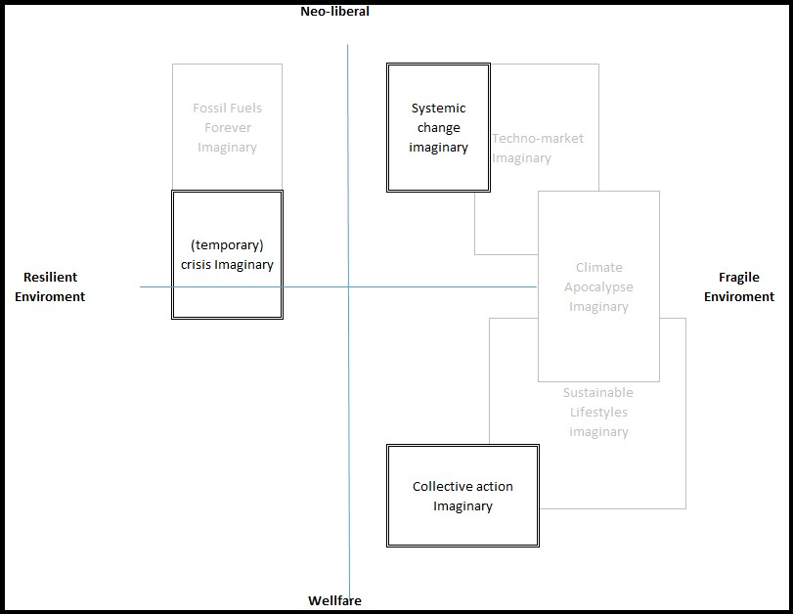

*Figure 6*. Imaginaries non-adaptors of ECO-innovation (Levy and Spices, 2013)

# General discussion

In this mixed-method study, non-adapters have a high possibility of being able to adopt (see results or the regression, table 3, but are nevertheless adopting new ECO-innovation. The results show that the respondents in this thesis that did not adopt, have a high possibility of not adopting in the future, if the Dutch government does not take action on (one of ) of thee aspects. 1) the perception of “crisis” needs to change via e.g., campaigns of the government want people to invest in unprofitable ECO-innovation. For some people, if they do not see the climate issue as urgent, they will not invest without the expectation of profit. Otherwise, they wait until a better moment of option comes to adopt. 2) the government needs to ensure the effort to a sustainable environment is collective. Some people are willing to invest in a sustainable climate without the expectation of a return of investment, as long as the investment is done by everyone. As a prisoner dilemma, the possibility of others profiting from their investment keeps them from investing. 3) the effect/necessity of private investments need to be legitimized. Some people see the climate issue as a problem created by the capitalistic system, not by individual action. This view hinders them from making a costly investment.

The findings of this thesis limits to people that do have the resources to adopt ECO-innovation, but are not adopting. This thesis does not contain information on how people who do not have the resources necessary to adopt ECO-innovation view the climate crisis. It would be interesting to investigate how people from this group see the challenge for a sustainable environment. Another limitation of this study is the missing of good information about the resources of the respondents. The interviews were unannounced, most of them were in the doorway of the house. This environment maybe was not comfortable enough for respondents to talk about financial struggles. A study that would merely focus on the role of natural resources in the process of not-adopting would create a better insight. However, since both the study’s in this thesis concluded that the role of, e.g., a higher annual income does not necessarily leads to a higher change of adopting, we feel confident to say that social technical energy imaginaries play a significant role in the process of (not) adopting sustainable technology.

**Personal reflection**

The insight in the role of imaginaries in the process of (not) adopting new technology is new for me as e researcher. Normally I work as a data scientist trying to make predictions based on data. Personally I do not believe that a problem that is created by a assets, can be eliminated by creating more assets. Think that the imaginary of climate crisis is pragmatic, since this is only a focus on the carbon that we are emitting. By solving the climate crisis via ECO-innovation, new problems like trade wars over rare-earth materials. During the interviews for this thesis, I became more aware that, due to the way we imagine climate change as the rising of the level of carbon in the atmosphere, we are missing the bigger problem of overconsumption. This shows how we shape our environment via the way we imagine it ought to be. During the interviews in this thesis, my natural response to incorrect argument of a responded would be to counter it with good statistics, and is was sometimes a struggle to only listen. During the thesis I learned that the a good understanding of the imaginary of how we think it ought to be way be just as important as good statistics.

**Apendix I: Variables regression**

**Bjr_h:** this is a variable for the contstruction year of the house [@CBS]

**P_verhuis:** this measures the relocation movements from the municipality register[@BRP]. A higher number means that more people are moving in and oud of the city.

g_**woz:** Average property value [x 1,000 euros] The average property value of residential objects based on the Property Valuation Act (WOZ value). For the determination of the average home value, use is only made of those WOZ objects described as dwellings serving as main residence (WOZ object code 10) and homes with practice space (WOZ object code 11) with a value greater than zero euros. [@CBS]

**p_huurw:** Rental properties in total [%] Reference date: January 1 of the relevant year. The number is stated as a percentage of the total number of homes and is stated for 20 homes or more per neighborhood and when the share of homes with unknown ownership was 50 percent or less. [@CBS]

**Age category [@CBS]**

a_00_14: 0 to 15 years [number] Number of inhabitants who are 0 to 15 years old on 1 January.

a_15_24: 15 to 25 years [number] Number of inhabitants who are 15 to 25 years old on 1 January.

a_25_44: 25 to 45 years [number] Number of inhabitants who are 25 to 45 years old on 1 January.

a_45_64: 45 to 65 years [number] Number of inhabitants who are 45 to 65 years old on 1 January.

a_65_oo: 65 years or older [number] Number of residents who are 65 or older on 1 January.

**Marital status [@CBS]**

**a_ongeh:** Unmarried [number] The number of inhabitants who are unmarried on 1 January. The marital status unmarried indicates that a person has never married or entered into a registered partnership.

**a_gehuwd:** Married [number] The number of inhabitants who were married on 1 January. The marital status married arises after a marriage or entering into a registered partnership. Married persons also include persons who are separated from the table, because they remain formally married.

**a_gesch:** Divorced [number] The number of residents divorced on January 1. The marital status separated arises after the dissolution of a marriage through divorce or after the dissolution of a registered partnership other than the death of the partner. Persons who are separated from the table and bed are counted as married people.

**Ethnic [@CBS]**

**a_w_all:** Western total [number] People of ethnic minority originate from one of the countries in the continents of Europe (excluding Turkey), North America and Oceania or Indonesia or Japan. On the basis of their socio-economic and socio-cultural position, immigrants from Indonesia and Japan are counted as western immigrants. This mainly concerns people who were born in the former Dutch East Indies and employees of Japanese companies with their families.

**all_nw:** Non-Western Ethnic minority with an origin grouping of one of the countries in the continents Africa, Latin America and Asia (excluding Indonesia and Japan) or Turkey. On the basis of their socio-economic and socio-cultural position, immigrants from Indonesia and Japan are counted as western immigrants. This mainly concerns people who were born in the former Dutch East Indies and employees of Japanese companies with their families.

**Households [@CBS]**

**a_1p_hh:** Single-person households [number] A private household consisting of one person.

**_hh_z_k:** Households without children [percentage] Multi-person households without children consist of unmarried couples without children, couples without children and other households. This is an adjustment from the CBS data, where only the absolute number is provided.

**p_hh_m_k:** Households with children [percentage] Multi-person households with children consist of unmarried couples with children, married couples with children and single-parent households. This is an adjustment from the CBS data, where only the absolute number is provided.

**p_1gezw:** Percentage of single-family dwelling [%] Reference date: January 1 of the relevant year. The number of single-family homes is stated as a percentage of the total housing stock and is only stated for at least 20 homes. Single-family home: Any home that also forms an entire property. This includes detached houses, adjoining houses, such as two whole houses built under one roof, farms with houses and furthermore all row houses.

**p_mgezw:** Percentage of multi-family dwelling [%] Reference date: January 1 of the relevant year. The number of multi-family homes is stated as a percentage of the total housing stock and is only stated for at least 20 homes. Multi-family home: Any home that, together with other living spaces or business premises, forms a whole building. This includes flats, gallery, porch, lower and upper dwellings, apartments and

**p_koopw:** non-rental houses [%] Homes that are owned by the (future) resident (s) or are used as a second home.

**Apendix II: List of respondents**

|  |  |  |  |  |  |  |
| --- | --- | --- | --- | --- | --- | --- |
| **Respondent** | **City** | **Neighborhood** | **Gender** | **Age** | **Home-owner** | **PV** |
| 1 | Rotterdam | A | Male | 40-50 | Yes | Yes |
| 2 | Rotterdam | A | Male | 50-60 | Yes | No |
| 3 | Rotterdam | A | Male | 60-70 | No | No |
| 4 | Rotterdam | B | Male | 50-60 | Yes | Yes |
| 5 | Rotterdam | B | Male | 30-40 | Yes | No |
| 6 | Rotterdam | B | Male | 60-70 | Yes | No |
| 7 | Rotterdam | B | Male | 50-60 | Yes | Yes |
| 8 | Rotterdam | C | Female | 60-70 | Yes | No |
| 9 | Rotterdam | D | Male/Female (2 pers) | 30-40 | No | No |
| 10 | Bodegraven | A | Male | 30-40 | Yes | No |
| 11 | Bodegraven | A | Female | 50-60 | Yes | Yes |
| 12 | Schoonhoven | A | male | 30-40 | Yes | No |

# References

BAG. (2019, January). Basisregistratie adressen en gebouwen (bag). *Basisregistratie Adressen en Gebouwen (BAG)*. online database. Retrieved from

<https://bag.basisregistraties.overheid.nl/>

Bernards, R., Morren, Johan, & Slootweg, H. (2018). Development and implementation of statistical models for estimating diversified adoption of energy transition technologies.

*Transactions on Sustainable Energy.*, *9*(4). doi:[10.1109/TSTE.2018.2794579](https://doi.org/10.1109/TSTE.2018.2794579)

Bogers, M., Afuah, A., & Bastian, B. (2010). Users as innovators: A review, critique, and future research directions. *Journal of Management*, *36*(4), 857–875. doi:[10.1177/0149206309353944](https://doi.org/10.1177/0149206309353944)

Bollinger, B., & Gillingham, K. (2012). Peer effects in the diffusion of solar photovoltaic panels. *Marketing Science*, *31*(6), 900–912. doi:[10.1287/mksc.1120.0727](https://doi.org/10.1287/mksc.1120.0727)

BRP. (2019, May). Basisregistratie personen (brp). *Privacy en persoonsgegevens | Rijksoverheid.nl*. Ministerie van Algemene Zaken. Retrieved from [https://www.rijksoverheid.nl/onderwerpen/privacy-en-persoonsgegevens/ basisregistratie-personen-brp](https://www.rijksoverheid.nl/onderwerpen/privacy-en-persoonsgegevens/basisregistratie-personen-brp)

CBS (2018, September). Geografische data. *Centraal Bureau voor de Statistiek*. Retrieved from <https://www.cbs.nl/nl-nl/dossier/nederland-regionaal/geografische-data>

Also: <https://www.cbs.nl/nl-nl/dossier/nederland-regionaal/wegwijzer/cbs-in-uw-buurt>

Chew, L. (1989). Constrained delaunay triangulations. *Algorithmica - Springer*.

Cook, J. (2018). *Imagined futures: Hopem risk and uncertainty* (PhD thesis No. 7). *Critical studies in risk and uncertainty*. University of Melborne.

Creswell, J. W., & Poth, C. N. (2018). *Qualitative inquiry & research design: Choosing among five approaches*. SAGE.

EZK. (2019, January). Klimaatakkoord. *Klimaatakkoord*. Ministerie van Economische Zaken en Klimaat. Retrieved from <https://www.klimaatakkoord.nl/>

Fisher, M. (2009). *Capitalist realism: Is there no alternative?* O Books.

Fraser, N. (1990). Rethinking the public sphere: A contribution to the critique of actually existing democracy. *Social Text*, (25/26), 56. doi:[10.2307/466240](https://doi.org/10.2307/466240)

Gladwell, M. (2013). *Outliers: The story of success*. Back Bay Books, Little, Brown;

Company.

Hobbes, T., & Shapiro, I. (2010). *Leviathan, or the matter, forme and power of a common-wealth, ecclesiasticall and civill*. Yale University Press.

IPCC. (2014). AR5 synthesis report: Climate change 2014. *IPCC*. Retrieved from <https://www.ipcc.ch/report/ar5/syr/>

James, P. (1997). The sustainability circle: A new tool for product development and design.

*Journal of Sustainable Product Design*, *2*(52).

Jasanoff, S. (2004). States of knowledge: The co-production of science and social order. doi:[10.4324/9780203413845](https://doi.org/10.4324/9780203413845)

Jasanoff, S., & Kim, S.-H. (2009). Containing the atom: Sociotechnical imaginaries and nuclear power in the united states and south korea. *Minerva*, (47), 119–146. doi:[DOI](https://doi.org/%20DOI%2010.1007/s11024-009-9124-4)

[10.1007/s11024-009-9124-4](https://doi.org/%20DOI%2010.1007/s11024-009-9124-4)

Jasanoff, S., & Kim, S.-H. (2015). Dreamscapes of modernity : Sociotechnical imaginaries and the fabrication of power. *Chicago: University of Chicago Press*. doi:[10.7208/chicago/9780226276663.001.0001](https://doi.org/10.7208/chicago/9780226276663.001.0001)

Jhagroe, S. (2016). *Urban transition politics:How struggles for sustainability are (re)making urban spaces* (PhD thesis). Erasmus university Rotterdam.

Jhagroe, S., & Loorbach, D. (2015). See no evil, hear no evil: The democratic potential of transition management. *Environmental Innovation and Societal Transitions*, *15*,

65–83. doi:[10.1016/j.eist.2014.07.001](https://doi.org/10.1016/j.eist.2014.07.001)

Jürgen, H. (2015). *The structural transformation of the public sphere an inquiry into a category of bourgeois society*. Polity.

Latour, B. (2017). *Facing gaia: Eight lectures on the new climate regime*. United Kingdom.

Levy, D. L., & Spicer, A. (2013). Contested imaginaries and the cultural political economy of climate change. *Organization*, *20*(5), 659–678. doi:[10.1177/1350508413489816](https://doi.org/10.1177/1350508413489816)

Li, H., Calder, C. A., & Cressie, N. (2007). Beyond morans i: Testing for spatial dependence based on the spatial autoregressive model. *Geographical Analysis*, *39*(4), 357–375. doi:[10.1111/j.1538-4632.2007.00708.x](https://doi.org/10.1111/j.1538-4632.2007.00708.x)

Lovelock, J. (2014). *Homage to gaia: The life of an independent scientist*. Souvenir Press.

Lovelock, J., & Rapley, C. (2007). Ocean pipes could help the earth to cure itself. *Nature*

*Publishing Group*, *26*(09). doi:[10.1093/sf/74.2.379](https://doi.org/10.1093/sf/74.2.379)

Macfarlane, R. (2016). Generation anthropocene. how humans have changed the planet forever. Retrieved from [https://www.theguardian.com/books/2016/apr/01/ generation-anthropocenealtered-planet-for-ever](https://www.theguardian.com/books/2016/apr/01/generation-anthropocenealtered-planet-for-ever)

Merton, R. (1968). The matthew effect in science. *Science*, *79*(159), 53–63. doi:[doi:10.1126/science.159.3810.56](https://doi.org/doi:10.1126/science.159.3810.56)

Merton, R. (1995). The thomas theorem and the matthew effect. *Social Forces*, *74*(2),

379–422. doi:[10.1093/sf/74.2.379](https://doi.org/10.1093/sf/74.2.379)

Moore, J. W. (2015). *Capitalism in the web of life: Ecology and the accumulation of capital*.

Verso.

Nolan, J. M., Schultz, P. W., Cialdini, R. B., Goldstein, N. J., & Griskevicius, V. (2008a).

Normative social influence is underdetected. *Personality and Social Psychology*

*Bulletin*, *34*(7), 913–923. doi:[10.1177/0146167208316691](https://doi.org/10.1177/0146167208316691)

Nolan, J. M., Schultz, P. W., Cialdini, R. B., Goldstein, N. J., & Griskevicius, V. (2008b).

Normative social influence is underdetected. *Personality and Social Psychology*

*Bulletin*, *34*(7), 913–923. doi:[10.1177/0146167208316691](https://doi.org/10.1177/0146167208316691)

Rogers, E. M. (1983). *Diffusion of innovations, 3th edition*. Free Press.

Salazar, H. A., Oerlemans, L., & Stroe-Biezen, S. V. (2012). Social influence on sustainable consumption: Evidence from a behavioural experiment. *International Journal of*

*Consumer Studies*, *37*(2), 172–180. doi:[10.1111/j.1470-6431.2012.01110.x](https://doi.org/10.1111/j.1470-6431.2012.01110.x)

Simpson, E. H. (1951). The interpretation of interaction in contingency tables. *Journal of the Royal Statistical Society: Series B (Methodological)*, *13*(2), 238–241. doi:[10.1111/j.2517-6161.1951.tb00088.x](https://doi.org/10.1111/j.2517-6161.1951.tb00088.x)

Star, S. (1999). The ethnography of infrastructure. *American Behavioral Scientist*, *43*(3). doi:[10.7208/chicago/9780226276663.001.0001](https://doi.org/10.7208/chicago/9780226276663.001.0001)

Taylor, C. (2004). Modern social imaginaries. *Modern Social Imaginaries*, 23–30.

*The day after tomorrow*. (2004).

The economist. (2012, November). *The Economist*. The Economist Newspaper. Retrieved from <https://www.economist.com/news/2012/11/21/sunny-uplands>

Vasseur, V., & Kemp, R. (2015). The adoption of pv in the netherlands: A statistical analysis of adoption factors. *Renewable and Sustainable Energy Reviews*, *41*, 483–494. doi:[10.1016/j.rser.2014.08.020](https://doi.org/10.1016/j.rser.2014.08.020)

Warner, M. (2014). *Publics and counterpublics*. Zone Books.

Wyatt, S. .M.E. (2003). Non-users also matter: The construction of users and non-users of the internet. In *Now users matter: The co-construction of users and technology* (pp.

67–79). Cambridge, MA: MIT Press.

# Informed Consent Form

Checklist for concent

I. You must provide all respondents with:

1. The identity and contact details of the researcher (the student, i.e. the data controller’s representative), making clear your affiliation with the Department and EUR (the data

controller);

1. The contact details of the EUR data protection officer (privacy@eur.nl);
2. The purposes of the processing data, i.e. an explanation of the research project and why the research is being conducted (the legitimate interests pursued by the controller);
3. The legal basis for processing data, i.e. the respondent’s unambiguous consent;
4. Who will have access to the data (e.g. the student, the supervisor, any third parties or data processors)
5. How long you will keep the data (or at least the criteria used to determine the length of data storage);
6. Notification of the data subjects’ rights, including the right to:
7. access to their data;
8. rectify, erase or restrict the processing of their personal data;
9. withdraw consent at any time;
10. lodge a complaint with a supervisory authority.

II. If you are collecting special categories of data, you must have explicit consent from the respondent to collect these data. For example: “You consent to me asking about and processing your data related to your [list special categories of data]”. Special categories of data include:

1. Racial or ethnic origin
2. Political opinions
3. Religious or philosophical beliefs
4. Trade union membership
5. Genetic data
6. Biometric data for the purpose of uniquely identifying a natural person
7. Data concerning health
8. Data concerning a natural person’s sex life or sexual orientation III. All information provided to the respondent must be:
9. Concise
10. Transparent
11. Presented clearly, using plain language (no scientific jargon!)
12. Intelligible and easily accessible (Article 12 GDPR)

Please include a copy of your informed consent document attached to your Ethics and

Privacy Checklist.

# Figure captions

|  |  |
| --- | --- |
| *Figure 1.* | Conceptual model adaptation of sustainable technology |
| *Figure 2.* | Climate Change Imaginaries (Levy and Spices, 2013) |
| *Figure 3.* | Variables for regression analysis |
| *Figure 4.* | Moran’s I for spatial correlation, to measure social influence of PV in the neighborhood |
| *Figure 5.* | Clustering of variables for collective income of a household and construction year of the houses |
| *Figure 6.* | Imaginaries non-adaptors of ECO-innovation (Levy and Spices, 2013) |

# Table captions

*Table 1.* Roger’s five perceived components of innovations (Rogers, 1983).

*Table 2.* Check for multicollinearity

*Table 3.* Result lm

1. a time dependency is added to this for the houses that already have PV, to be able to measure the distance to a neighbor with PV at the time the PV was constructed at the house.