# Elite Fashion Clothing Website

## Team Names:

Mohamed Elmonoufy

## Name of the Project:

Elite Fashion Clothing Website

## Brief Description of Project:

This is a clothing website with two sections: men and women. It lets users place orders through a cart, sign up, log in, and contact us.

## Skills Used (Tools and Programming Languages):

HTML  
CSS  
JavaScript  
PHP  
MySQL

## Key Jobs/Tasks that the Website Performs:

- User registration and login  
- Browsing clothing items by category (men and women)  
- Adding items to the cart  
- Placing orders through a checkout process  
- Contacting the website administrators through a contact form

## Entity-Relationship Diagram (ERD):

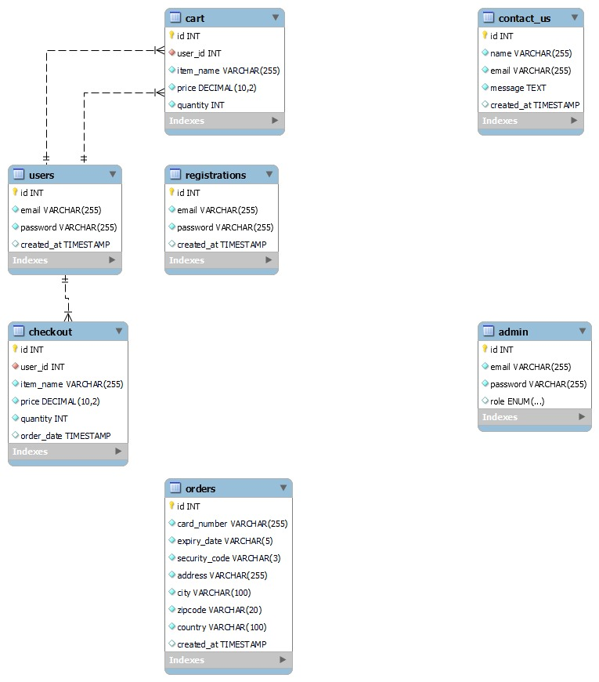

## Reflection:

### Project Explanation:

This project is an online clothing store for men and women. Users can browse clothes, add items to their cart, place orders, and contact us.  
It is used in the fashion retail industry to help businesses sell clothes online.  
One big challenge was making the checkout process work. We solved it by studying other online stores and adding a payment system. Testing and fixing issues was also important.

### Idea Generation:

We got the idea for this project from a project we did last semester. We made it better and added more features.

### Skill Acquisition:

We learned the skills for this project in our college courses. Classes like MAC250 (Database Management), MAC172 (Web Development 1), and MAC272 (Web Development 2) gave us the knowledge and practice we needed.  
Our courses at LaGuardia helped us understand both front-end and back-end development. Assignments and projects gave us real-life practice, preparing us for tasks like user login, database work, and making dynamic websites.

### Confidence Building:

Working on this project and others in our major has made us more confident in several ways:  
- Practical Application: We got to use what we learned in real projects, which helped us understand programming languages and tools better.  
- Problem-Solving: We improved our problem-solving skills by fixing issues like the checkout process.  
- Collaboration: Working with team members improved our communication and teamwork skills, which are important in software development.  
- Project Management: Managing this project taught us how to manage our time, delegate tasks, and keep the work organized.  
- Preparedness for the Industry: All the projects we worked on have prepared us to meet the demands of the software development industry, making us more confident in our abilities.