Laboratory Report

# Laboratory Report

|  |  |
| --- | --- |
| Common Data | |
| Student name | **Kormoua Khongmeng** |
| Neptun code | **I3MLPQ** |
| Department | **Dept. of Automation and Applied Informatics** |
| Instructor name | **AL-Magsoosi Husam Kareem Farhan** |
| Laboratory place | **BME IL206** |
| Laboratory time | **10:15 – 12:00** |
| Title or Sequence number | **6** |

|  |  |
| --- | --- |
| Exercises | |
| Task 2.1 |  |
| Task 2.2 |  |
| Task 2.2.1 |  |
| Task 2.3.1 |  |
| Task 2.3.2 |  |
| Task 2.3.3 |  |
| Task 2.4 |  |
| Task 2.4 cont |  |
| Task 2.5 |  |

# Exercises

### Task #2.1 Full stop

**Problem statement:** Write a regular expression for the follow pattern:

any character, followed by the letter a, followed by the letter r.

**Solution:**

**Reasoning:** a dot describes or can be replaced by any character.

### Task #2.2 character set

**Problem statement:** Write a regular expression for the follow pattern:

a lowercase character a, followed by letter r, followed by a period . character.

**Solution:**

Or

**Reasoning:** since normally the dot will be matched with any character to specify the dot itself we need [.] or \.

### Task #2.2.1 negated character set

**Problem statement:** Write a regular expression for the follow pattern:

any character except c, followed by the character a, followed by the letter r.

**Solution:**

**Reasoning:** we can use “^” character to specify that match with any character that is not the character which comes after this character “^”.

### Task #2.3.1 the star

**Problem statement:** Write a regular expression for the follow pattern:

* any number of lowercase letters in a row.
* zero or more spaces, followed by lowercase character c, followed by lowercase character a, followed by lowercase character t, followed by zero or more spaces.

**Solution:**

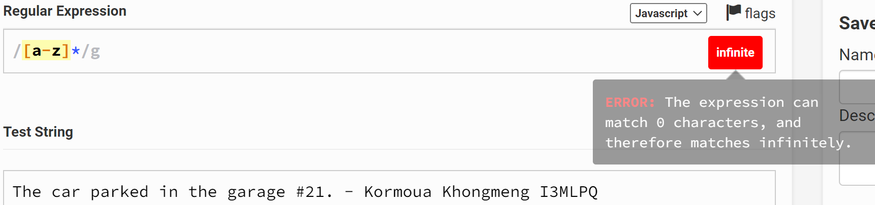

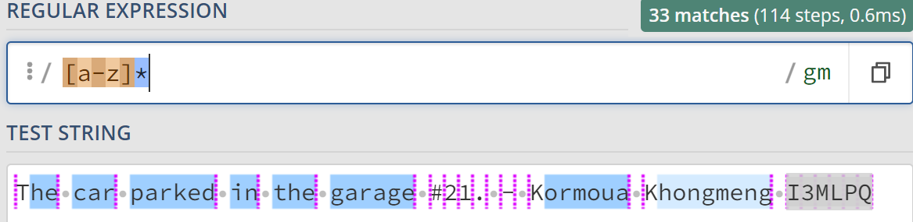

**Reasoning:** for the first patter “any number of lowercase letters in a row.” When we use the recommended regular expression tester to test it give infinite matches and cause an error as seen on the first figure. So I tried to use another regular expression tester which is called [www.regex101.com](http://www.regex101.com) which gave me an expected result as seen in the figure 2. So I think this is just how each platform they handle this exception differently.

For the second pattern, all we need to know is how to specify the whitespace character which is “\s”.

### Task #2.3.2 the plus

**Problem statement:** Write a regular expression for the follow pattern:

lowercase letter c, followed by at least one character, followed by the lowercase character t. It needs to be clarified that t is the last t in the sentence.

**Solution:**

**Reasoning:** for this pattern we want at least one of any character between character “c” and “t”, the only difference from the previous one “*” is that this pattern requires at least one. Normally it will find the latest “t” that match or the longest match for us.

### Task #2.3.3 the question mark

**Problem statement:** Write a regular expression for the follow pattern:

Optional the uppercase letter T, followed by the lowercase character h, followed by the lowercase character e.

**Solution:**

**Reasoning:** For this pattern we can solve easily by using “?” which match whether there is a character followed by this “?” or not.

### Task #2.4 Braces

**Problem statement:** Write a regular expression for the follow pattern:

Match at least 2 digits but not more than 3 ( characters in the range of 0 to 9).

**Solution:**

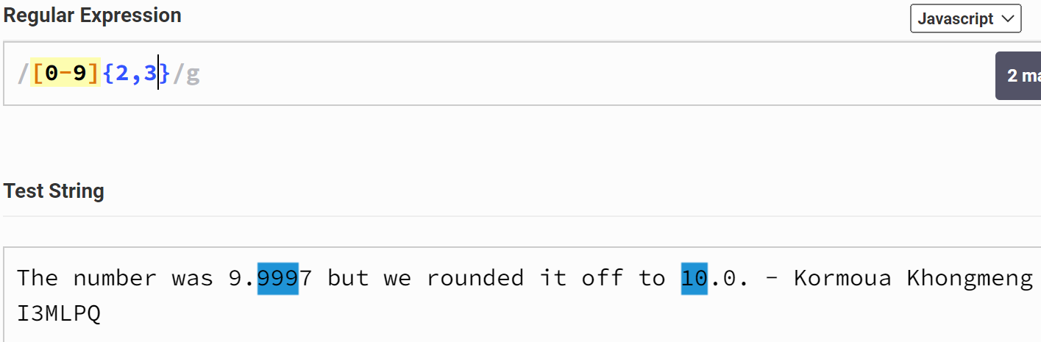

**Reasoning:** If we only want to match only a number, we can use “[0-9]” to specify that we only want to match the character in this range, then we can specify further the length of the match number we can specify the min or max or both in the “{}” as seen on the figure above.

### Task #2.4 Braces - cont

**Problem statement:** Write a regular expression for the follow pattern:

Match 2 or more digits. If we also remove the comma the regular expression [0-9]{3} means: Match exactly 3 digits.

**Solution:**

**Reasoning:** Here is the same pattern as the previous question. The only difference is that if we only want to specify the minimum length then we can leave the second parameter empty. If we want the exact length as we specified then we give only 1 argument.

### Task #2.5

**Problem statement:** Write a regular expression for the follow pattern:

lowercase character c, g or p, followed by character a, followed by character r.

**Solution:**

**Reasoning:** if we have multiple character that we want to match at some specific position we can put them in the group as “(c|g|p)” then if one of the character inside this group match, it will consider as a match.

### Instructions

1. **Problem statement is mandatory.**
2. **A solution without explanation is NOT accepted.**
3. **If you need to copy the source code, you can do it with copy/paste commands. Please do not use screenshots for code listings.**
4. **Other screenshots (figures, graphs, etc.) should be scaled appropriately. Please cut off unnecessary elements on the images.**