Laboratory Report

# Laboratory Report

|  |  |
| --- | --- |
| Common Data | |
| Student name | **Kormoua Khongmeng** |
| Neptun code | **I3MLPQ** |
| Department | **Dept. of Automation and Applied Informatics** |
| Instructor name | **AL-Magsoosi Husam Kareem Farhan** |
| Laboratory place | **BME IL206** |
| Laboratory time | **10:15 – 12:00** |
| Title or Sequence number | **1** |

|  |  |
| --- | --- |
| Exercises | |
| Task 1 |  |
| Task 2 |  |
| Task 3 |  |
| Task 4 |  |

# Exercises

**Problem statement for all task below:** We need a database for the bus service to the local public school district. Our bus drivers drive a bus on a morning route to pick up students up at each address and take them to school. In the afternoon drivers drive a route that takes students from the school to their homes. We need to keep track of the routes each driver drives and who is on those routes.

### Task #1

**Problem statement:** Creating Tables

**Solution:**

create table Address

(

City nvarchar(50) not null,

Street nvarchar(50) not null,

House int not null,

PostalCode int not null

)

create table Bus

(

LicensePlate nchar(6) not null,

Manufacturer nvarchar(50) not null,

Seats int not null,

Year int not null

)

create table Driver

(

Name nvarchar(50) not null,

Experience int,

PhoneNumber nchar(10) not null

)

create table Route

(

Priority int,

Financing nvarchar(50),

ID int not null

)

create table School

(

Title nvarchar(50) not null,

Type nvarchar(50) not null,

Capacity int

)

create table Student

(

Name nvarchar(50) not null,

DateOfBirth date not null,

Scholarship bit not null

)

create table DailyDrive

(

Date date not null,

BusID int not null,

DriverID int not null,

RouteID int not null,

ID int primary key not null

)

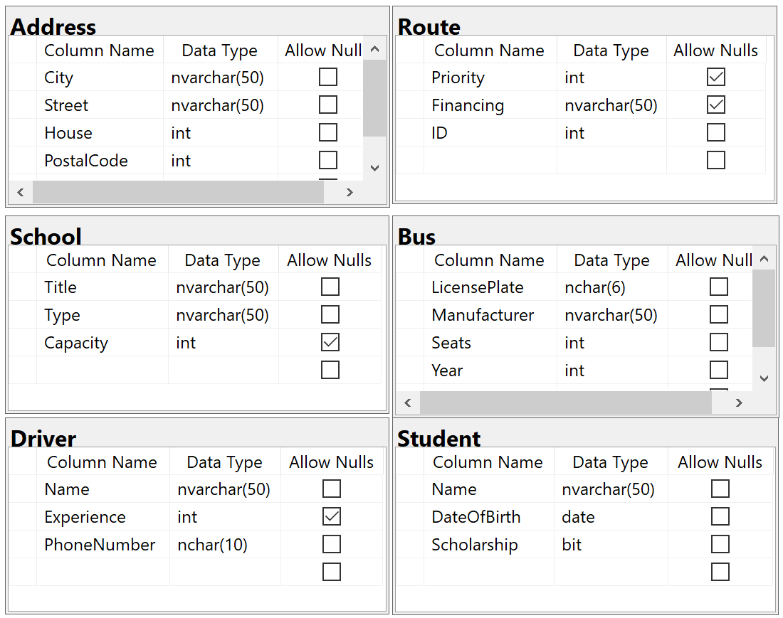

**Explanation:**

* A table is created based on the given data (column, data type).
* A table diagram is created by go to our working database, then at Database diagram, right click and new database diagram.
* Our table in database and our database diagram are synced. Therefore, If we edit our database in one way it will change the other one too. A refresh might be needed after any changes.

### Task #2

**Problem statement:** Keys, Relationships

**Solution:**

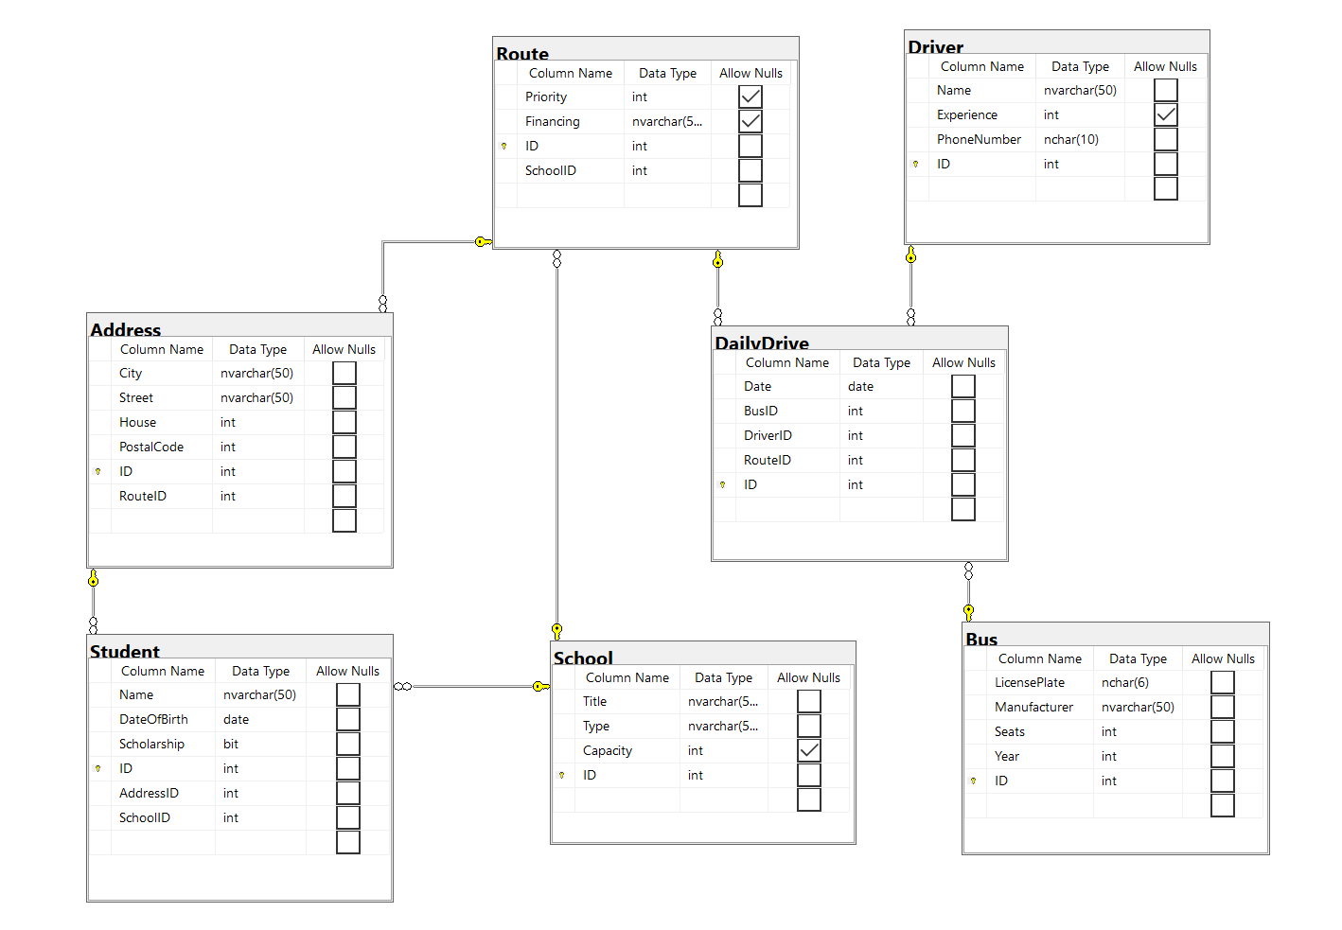

**Explanation:**

To complete our EER diagram as above, we added an ID to each table which will serve as a primary key. Then we can create a relationship for each table by drag one foreign key to a primary key of a table that we want that table to create a relationship with.

### Task #3

**Problem statement:** Add data to tables

**Solution:**

Address table:

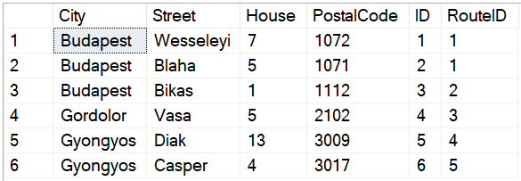

Bus table:

Driver table:

School table:

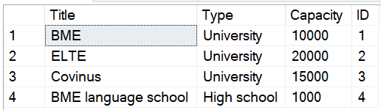

Student table:

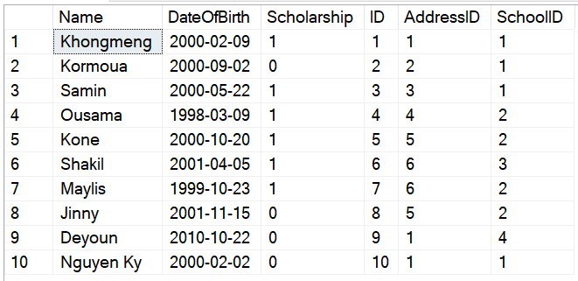

Route table:

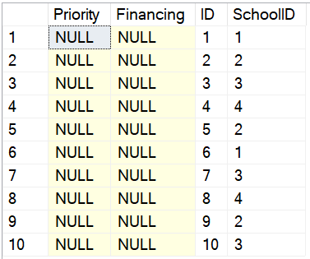

Daily Drive table:

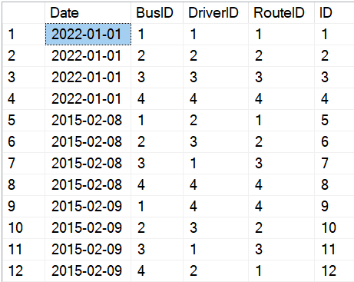

**Explanation:**

All information are filled base on needed and necessary in order to do some test query.

### Task #4

**Problem statement:** Write a simple query

Yesterday, one careless schoolboy forgot his schoolbag in the bus on his way home. The parents want to find out the phone number of the driver that was on the route at boy’s address on that day. The parents are sure that this information can be obtained from your database. Write a query to help them.

¬ They provided you the following data:   
 ¬ Name of the schoolboy: Nguyen Ky   
 ¬ Exact date when he lost his bag: 8 February 2015

**Solution:**

select Student.Name, DailyDrive.Date, Driver.Name, Driver.PhoneNumber from Driver

inner join DailyDrive on Driver.ID = DailyDrive.DriverID

inner join Route on DailyDrive.RouteID = Route.ID

inner join Address on Address.RouteID = Route.ID

inner join Student on Student.AddressID = Address.ID

where Student.Name = 'Nguyen Ky' and DailyDrive.Date = '2015-02-08';

**result:**

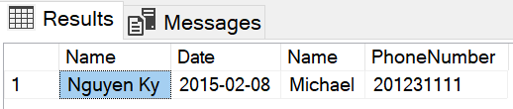

**Explanation:**

I have several table which linked together by primary key and foreign key as EER diagram. I use the inner join to join to link several table together by primary key and foreign key. Then I search from the joined table what or who I am looking for. In our case it is where Student.Name = 'Nguyen Ky' and DailyDrive.Date = '2015-02-08';. I do not want to show every column that available in the joined table, that is why I select only Student.Name, DailyDrive.Date, Driver.Name, Driver.PhoneNumber which is only what I want to know.

### Instructions

1. **Problem statement is mandatory.**
2. **A solution without explanation is NOT accepted.**
3. **If you need to copy the source code, you can do it with copy/paste commands. Please do not use screenshots for code listings.**
4. **Other screenshots (figures, graphs, etc.) should be scaled appropriately. Please cut off unnecessary elements on the images.**