Laboratory Report

# Laboratory Report

|  |  |
| --- | --- |
| Common Data | |
| Student name | **Kormoua Khongmeng** |
| Neptun code | **I3MLPQ** |
| Department | **Dept. of Automation and Applied Informatics** |
| Instructor name | **AL-Magsoosi Husam Kareem Farhan** |
| Laboratory place | **BME IL206** |
| Laboratory time | **10:15 – 12:00** |
| Title or Sequence number | **2** |

|  |  |
| --- | --- |
| Exercises | |
| Task 1 |  |
| Task 2 |  |
| Task 3 |  |
| Task 4 |  |
| Task 5 |  |
| Task 6 |  |
| Task 7 |  |
| Task 8 |  |
| Task 9 |  |
| Task 10 |  |

# Exercises

### Task #1

**Problem statement:** List the names of all countries in the Middle East, sorted by the 2004 population count in descending order.

**Solution:**

SELECT name

FROM country

WHERE region = 'Middle East' and year = 2004

ORDER BY population desc;

**Visual result:**

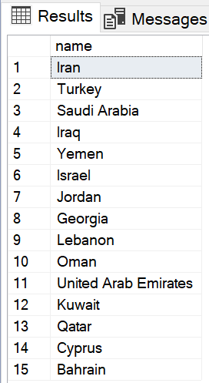

**Reasoning:**

We want a list of the name that is why we use only “SELECT name” and no other column. Then we specify the table that we want that name from by “FROM country”. After that we want only a country from Middle east and also from 2004 only, so we use a condition statement to filter out what we do not want using “WHERE region = 'Middle East' and year = 2004”. Finally, we need to sort our result in descending order based on population, we can do this easily by “ORDER BY population desc”.

### Task #2

**Problem statement:** List the names, area and GDP of any European countries with a 2009 population of more than 10,000,000. Here, by the statement “any European countries” means any region that belong to Europe area or consider as Europe which may consist of Western Europe, Eastern Europe, etc. we want to have a list with all of countries from any of those regions.

**Solution:**

SELECT name, area, gdp

FROM country

WHERE year = 2009 and population > 10000000 and region like '%Europe%';

**Visual result:**

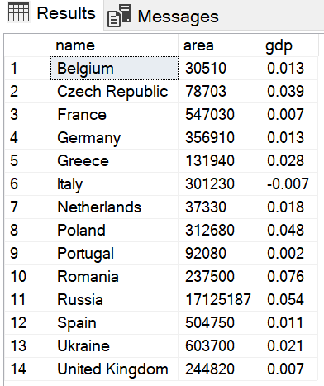

**Reasoning:**

In this task we want to show a table containing name, area and GDP of each country in the list, that is why we “SELECT” multiple columns “name, area, gdp”. We use the same table “FROM country”. We consider only “WHERE year = 2009” and we want a list of countries for those countries that have “population > 10000000”. Now comes to the most interesting part of this question which is we want a country from any region in Europe which there are several regions. We can easily accomplish this by using pattern matching as “region like '%Europe%'” this will look for a string which contain a word Europe and anything before or after this word does not matter in our case here, it can be anything so we can put “%” there.

### Task #3

**Problem statement:** List the names and regions of countries with an area larger than 2,000,000 but smaller than 5,000,000, sorted in descending order by 2002 GDP. Note that area does not change from year to year; do not overcomplicate the sorting.

**Solution:**

SELECT name, region

FROM country

WHERE (area < 5000000 and area > 2000000) and year = 2002

ORDER BY gdp desc;

**Visual result:**

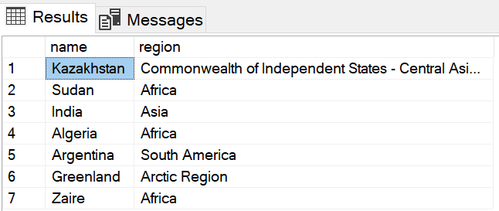

**Reasoning:**

In this task nothing new is needed, we want to know name and region so we can use “SELECT name, region”. Again from “FROM country”. Here comes to the condition which there are 3 conditions in the statement, “WHERE (area < 5000000 and area > 2000000)”. Another thing is to sort by gdp of year 2002. But we can filter only year 2002 together with other condition since no matter what year the area of any country does not change, so we add “year = 2002” to the condition checking as well. Finally, we sort everything those result that we got from filtering by gdp as “ORDER BY gdp” by descending order so we add “desc”.

### Task #4

**Problem statement:** List the regions (without duplicates) of all countries whose names start with 'S' (uppercase).

**Solution:**

SELECT DISTINCT region

FROM country

WHERE name like 'S%';

**Visual result:**

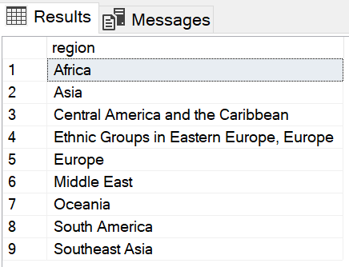

**Reasoning:**

In this task, everything is simple, we want a list of region so “SELECT region” “FROM country” table, our only condition here is all countries must start with “S”, we can be implemented easily by “WHERE name like 'S%'”. only one trick here is we would get a duplicated tuple on the list because there are several countries start with “S” and in the same region, So, the list would show one tuple for one country and we will get a duplicated region in the list. We can solve this by add “DISTINCT” between “SELECT” and “region”.

### Task #5

**Problem statement:** Insert a new row with country name "SQLvania", with year = 2004, area = 4707 and population = 65550. Check with SELECT.

**Solution:**

INSERT INTO country (name, year, region, area, population, gdp)

VALUES ('SQLvania', 2004, NULL, 4707, 65550, NULL);

SELECT *

FROM country

WHERE name = 'SQLvania';

**Visual result:**

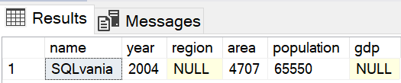

**Reasoning:**

This task is just to add a new row into the table so first we simply specify a target table as “INSERT INTO country” then a format of data as “(name, year, region, area, population, gdp)” and follow with the value of each parameter as “VALUES ('SQLvania', 2004, NULL, 4707, 65550, NULL)”. After inserting, we can try to check if that tuple exist in the table by “SELECT * FROM country WHERE name = 'SQLvania';”

### Task #6

**Problem statement:** Add 15,000 to the 2007 population of all countries with an area less than 10,000. Check with SELECT before and after your changes.

**Solution:**

SELECT *

FROM country

WHERE area < 10000 and year = 2007;

UPDATE country

SET population = population + 15000

WHERE area < 10000 and year = 2007;

**Visual result:**

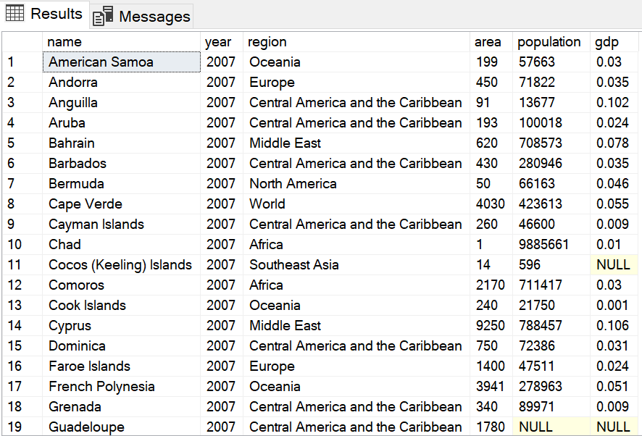 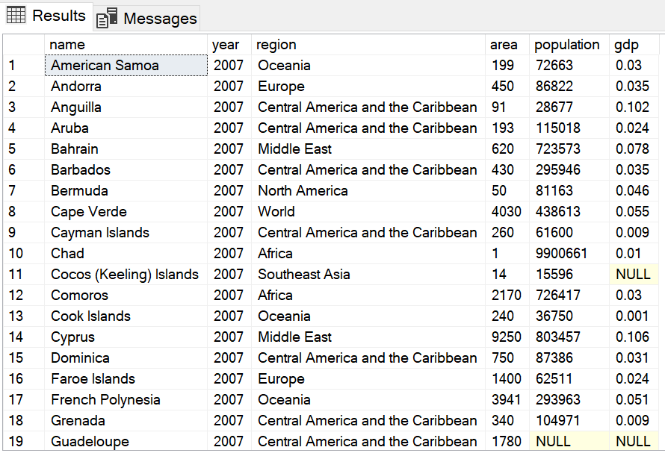

Before UPDATE After UPDATE

**Reasoning:**

This task we need to modify a data inside a table which can be done by update, we want to update a table by “UPDATE country” then we specify what to update by “SET” keyword then how to update by “population = population + 15000” because we need to add 15,000 to a population of each country that match the condition. We can finally add a condition later as they mentioned “WHERE area < 10000 and year = 2007”

### Task #7

**Problem statement:** Delete all rows that have a negative GDP. Count the number of rows before and after deletion.

**Solution:**

-- for counting

SELECT COUNT(name) as Rows

FROM country;

-- deleting

DELETE FROM country

WHERE gdp < 0;

**Visual result:**

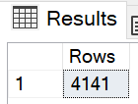 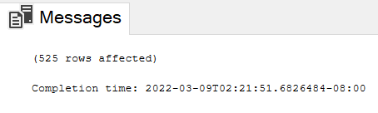 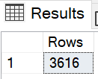

Before deleting Window show the result of query After deleting

**Reasoning:**

For this task we want to delete a tuple from the table but before that we need to count the number of rows of the table using aggregate function COUNT() we can do this like “SELECT COUNT(name) as Rows FROM country”, we count name because we can be sure that every countries cannot have same name. After we check number of row before we delete, we can delete a row from the table by “DELETE FROM country” with some kind of condition otherwise all the data will be deleted, our condition is all rows that have negative GDP “WHERE gdp < 0;”. Then we can check the number of row again using the same query as before to check the number of remaining row.

### Task #8

**Problem statement:** List a country with the biggest population in 2010. The resulting table should contain name, region, and population.

**Solution:**

SELECT name, region, population

FROM country

WHERE year = 2010 and population IN (

SELECT MAX(population)

FROM country

WHERE year = 2010

);

**Visual result:**

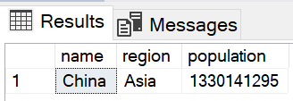

**Reasoning:**

This task the idea is we want to show a name, region and population of a country that has most population, first we can use normal method to select a rows that has population equal to the max population. Now the trick is how to get the max population, we can get it by nested select. We can create another select at WHERE. Then inside a nested select we can just use MAX(population) functions to get a max population and return it back to the first SELECT.

### Task #9

**Problem statement:** List three Asian countries with the smallest total GDP growth for all years. The resulting table should contain name and total GDP.

**Solution:**

SELECT TOP 3 name, SUM(gdp) AS [Total GDP]

FROM country

WHERE region = 'Asia'

GROUP BY name

ORDER BY [Total GDP] ASC;

**Visual result:**

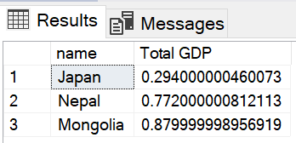

**Reasoning:**

This task, a new thing is the question mention to list only three countries, so we use “SELECT TOP 3”. They said to sort by smallest total GDP, so we can use “SUM(gdp) AS [Total GDP]” to find the total GDP and refer to it as Total GDP since we need to show like this in our result table. We want the smallest Total GDP comes first to the list so sort by ascendant order “ORDER BY [Total GDP] ASC”

### Task #10

**Problem statement:** List any countries with total GDP growth greater than 1.4. The resulting table should contain name, region and total GDP.

**Solution:**

SELECT name, region, SUM(gdp) AS [Total GDP]

FROM country

GROUP BY name, region

HAVING SUM(gdp) > 1.4;

**Visual result:**

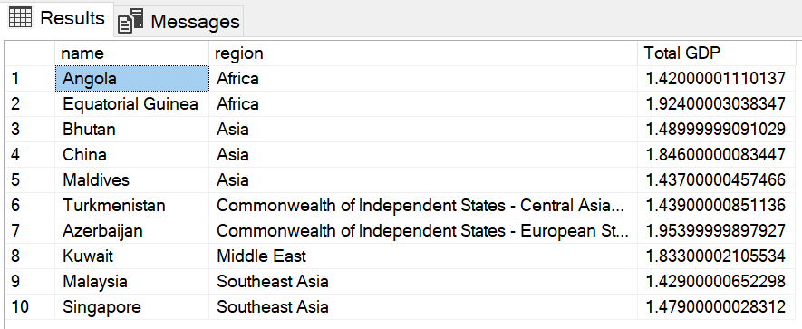

**Reasoning:**

This task task we select all the columns that we need such as “name, region, SUM(gdp) AS [Total GDP]” since we use aggregate function here “SUM(gdp)”, we need to sort our table base on the name and region. After sorting we can apply a condition later to filter our condition using HAVING “HAVING SUM(gdp) > 1.4;”

### Instructions

1. **Problem statement is mandatory.**
2. **A solution without explanation is NOT accepted.**
3. **If you need to copy the source code, you can do it with copy/paste commands. Please do not use screenshots for code listings.**
4. **Other screenshots (figures, graphs, etc.) should be scaled appropriately. Please cut off unnecessary elements on the images.**