Laboratory Report

# Laboratory Report

|  |  |
| --- | --- |
| Common Data | |
| Student name | **Kormoua Khongmeng** |
| Neptun code | **I3MLPQ** |
| Department | **Dept. of Automation and Applied Informatics** |
| Instructor name | **AL-Magsoosi Husam Kareem Farhan** |
| Laboratory place | **BME IL206** |
| Laboratory time | **10:15 – 12:00** |
| Title or Sequence number | **4** |

|  |  |
| --- | --- |
| Exercises | |
| Task 1 |  |
| Task 2 |  |
| Task 3 |  |
| Task 4 |  |
| Task 5 |  |
| Task 6 |  |
| Task 7 |  |
| Task 8 |  |
| Task 9 |  |
| Task 10 |  |
| Task 11 |  |
| Task 12 |  |
| Task 13 |  |

# Exercises

### Task #1

**Problem statement:** Get connected to the SQL Server and create a bank account database using the following SQL script.

**Solution:**

create table account

(id int primary key,

balance int)

insert into account values(1, 5000)

insert into account values(2, 8500)

insert into account values(4, 6400);

**Visual result:**

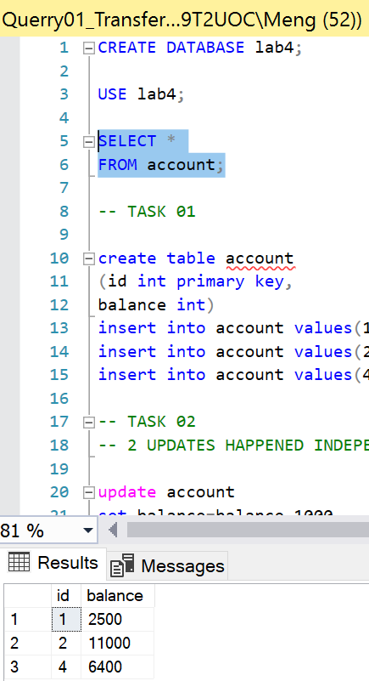

**Reasoning:**

I just created a table as the guide said.

### Task #2

**Problem statement:** Transfer 1000 HUF from bank account 1 to 2. In order to check the transfer open another query window, this creates a second parallel connection to the database. Check balance during transfer continuously. What did you notice and why?

**Solution:**

select * from

account;

update account

set balance=balance-1000

where id=1;

select * from

account;

update account

set balance=balance+1000

where id=2;

select * from

account;

**Visual result:**

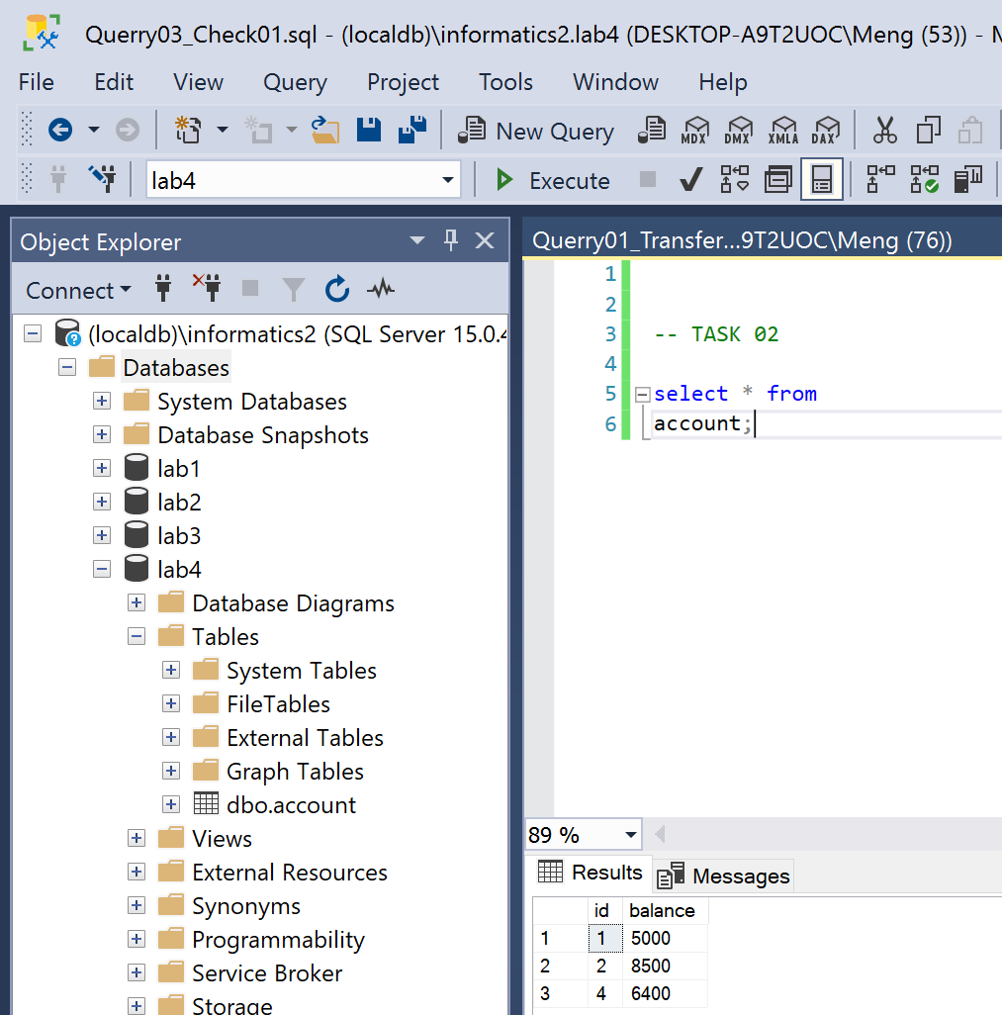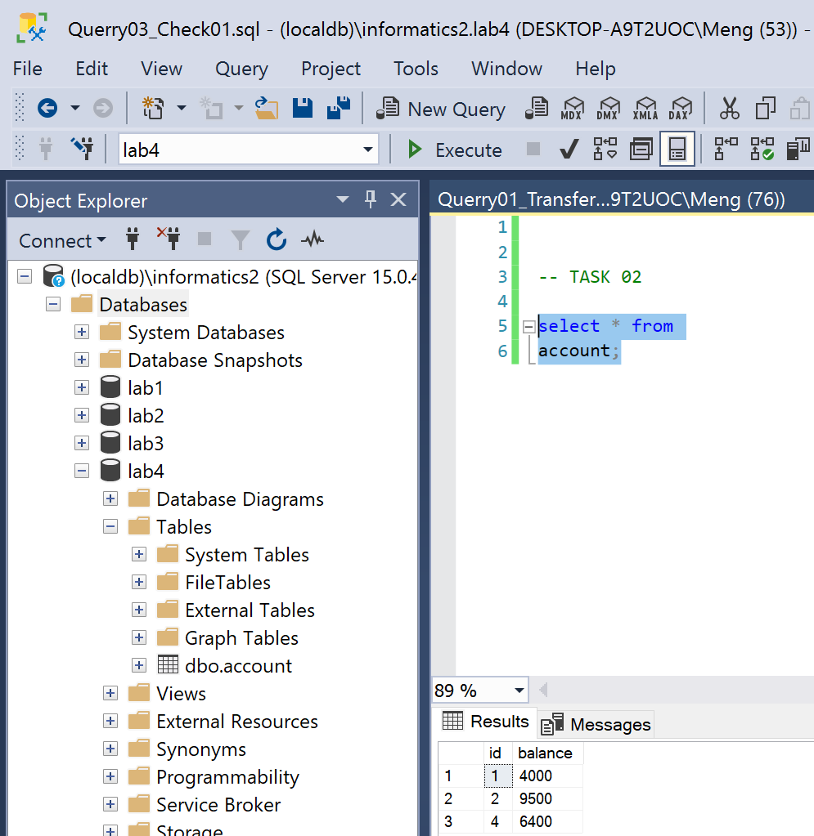

Before transaction At the middle of transaction After the transaction

**Reasoning:**

We can see that this is not a single process or atomic process. they are a state that 1000 balance just disappear from the database which is because I did not begin transaction and commit as atomic manner.

### Task #3

**Problem statement:** Change the above script in a way that the data manipulation operations are put into the same transaction. Replay the second task. What did you notice and why?

**Solution:**

begin transaction

select * from account;

update account

set balance=balance-1000

where id=1;

select * from account;

update account

set balance=balance+1000

where id=2;

select * from account;

commit;

select * from account;

**Visual result:**

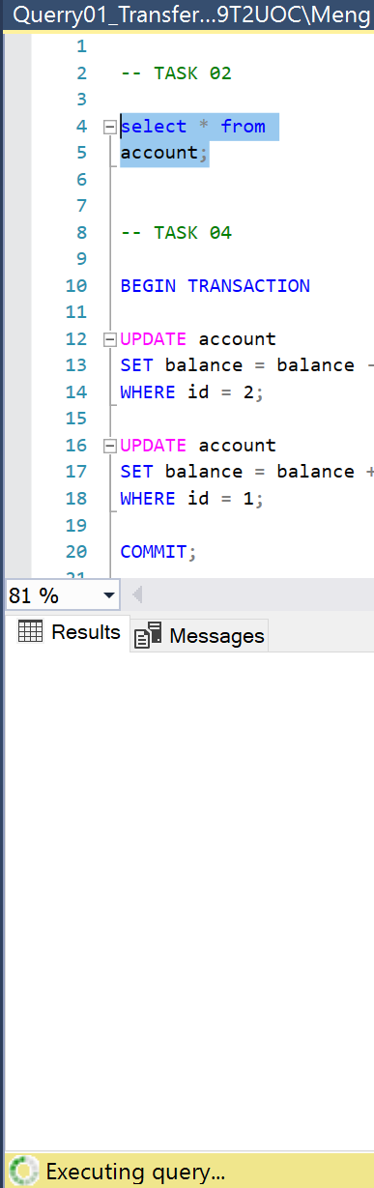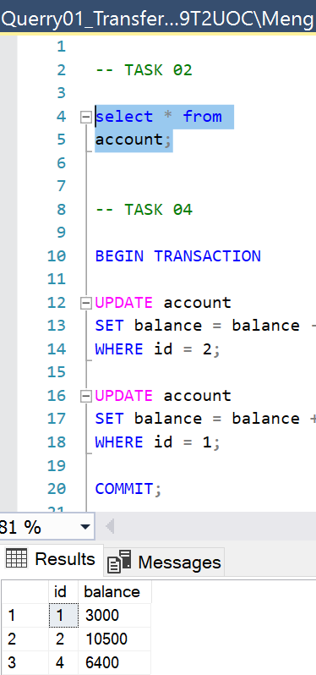

Before an update Between the update After the commit

**Reasoning:**

Here before we transfer balance, we begin transaction and after that we commit transaction. This will make our process an atomic process. on the other script which I use as a second person that want to check the balance of the account; we see that during the transaction the second person has to wait until the first transaction is done since SSMS use “read committed” isolation level as default.

### Task #4

**Problem statement:** Deadlock creation. There are two transfers running in parallel: one of them sends 500 HUF from account 1 to 2 while the second one sends 300 HUF from bank account 2 to 1. Let the transactions schedule be the following:

**Solution:**

|  |  |
| --- | --- |
| **First transaction** | **Second transaction** |
| BEGIN TRANSACTION |  |
|  | BEGIN TRANSACTION |
| UPDATE account  SET balance = balance - 500  WHERE id = 1; |  |
|  | UPDATE account  SET balance = balance - 300  WHERE id = 2; |
| UPDATE account  SET balance = balance + 500  WHERE id = 2; |  |
|  | UPDATE account  SET balance = balance + 300  WHERE id = 1; |
| COMMIT; |  |

**Visual result:**

Before transaction Transaction 2 is aborted due to deadlock After transaction

**Reasoning:**

We see that a deadlock happened since both tried to access the same resource at the same time. One of the transactions is forced to be aborted and only one of the transactions is executed successfully which in our case is the first transaction.

### Task #5

**Problem statement:** Create a simple exam signup system using the following SQL script.

**Solution:**

drop table signup;

drop table exam;

create table exam

( id int primary key,

subject varchar(20),

date datetime,

limit int

);

create table signup(

examid int references exam(id),

studentid int,

primary key (examid,studentid)

);

insert into exam

values(1, 'Informatics2',convert(datetime,'2007.06.15',102),3);

insert into exam

values(2, 'Mathematics',convert(datetime,'2007.06.18',102),3);

insert into signup values(1,111);

insert into signup values(1,222);

**Visual result:**

**Reasoning:**

Here I just created a table based on the given script.

### Task #6

**Problem statement:** Simulate two concurrent signups to the first exam. Schedule of the processes should be the following:

**Solution:**

|  |  |  |
| --- | --- | --- |
| **Step** | **Student 1’s signup** | **Student 2’s signup** |
| 1 | select limit  from exam  where id=1; |  |
| 2 |  | select limit  from exam  where id=1; |
| 3 | select count(*)  from signup  where examid=1; |  |
| 4 |  | select count(*)  from signup  where examid=1; |
| 5 | insert into signup  values(1, 333); |  |
| 6 |  | insert into signup  values(1, 444); |

**Visual result:**

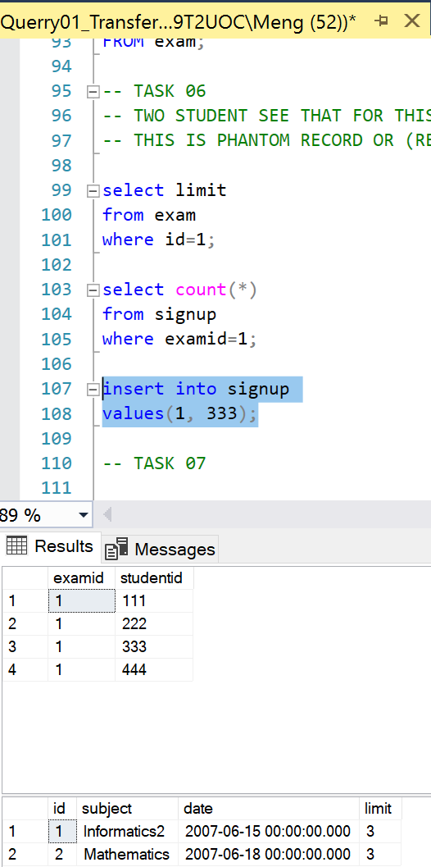

State before transactions State after transactions

**Reasoning:**

We have a problem that two transactions are not properly isolated (phantom read). In this case both student wants to register to a course, two students check the available place, and two students see that there is 1 available place, so both of them register at the same time, since this is not done in atomic manner with some proper isolation level (default level read committed cannot prevent this) then both get registered in the exam.

### Task #7

**Problem statement:** If transactions are isolated properly, the problem described in exercise 6 can be avoided. Increase isolation levels of transactions to ‘serializable’ and replay the previous task as follows.

**Solution:**

|  |  |  |
| --- | --- | --- |
| **Step** | **First signup** | **Second signup** |
| 1 | set transaction isolation  level serializable;  Begin transaction |  |
| 2 |  | set transaction isolation  level serializable;  Begin transaction |
| 3 | select limit  from exam  where id=1; |  |
| 4 |  | select limit  from exam  where id=1; |
| 5 | select count(*)  from signup  where examid=1; |  |
| 6 |  | select count(*)  from signup  where examid=1; |
| 7 | insert into signup  values(1,555); |  |
|  |  | insert into signup  values(1,666); |

**Visual result:**

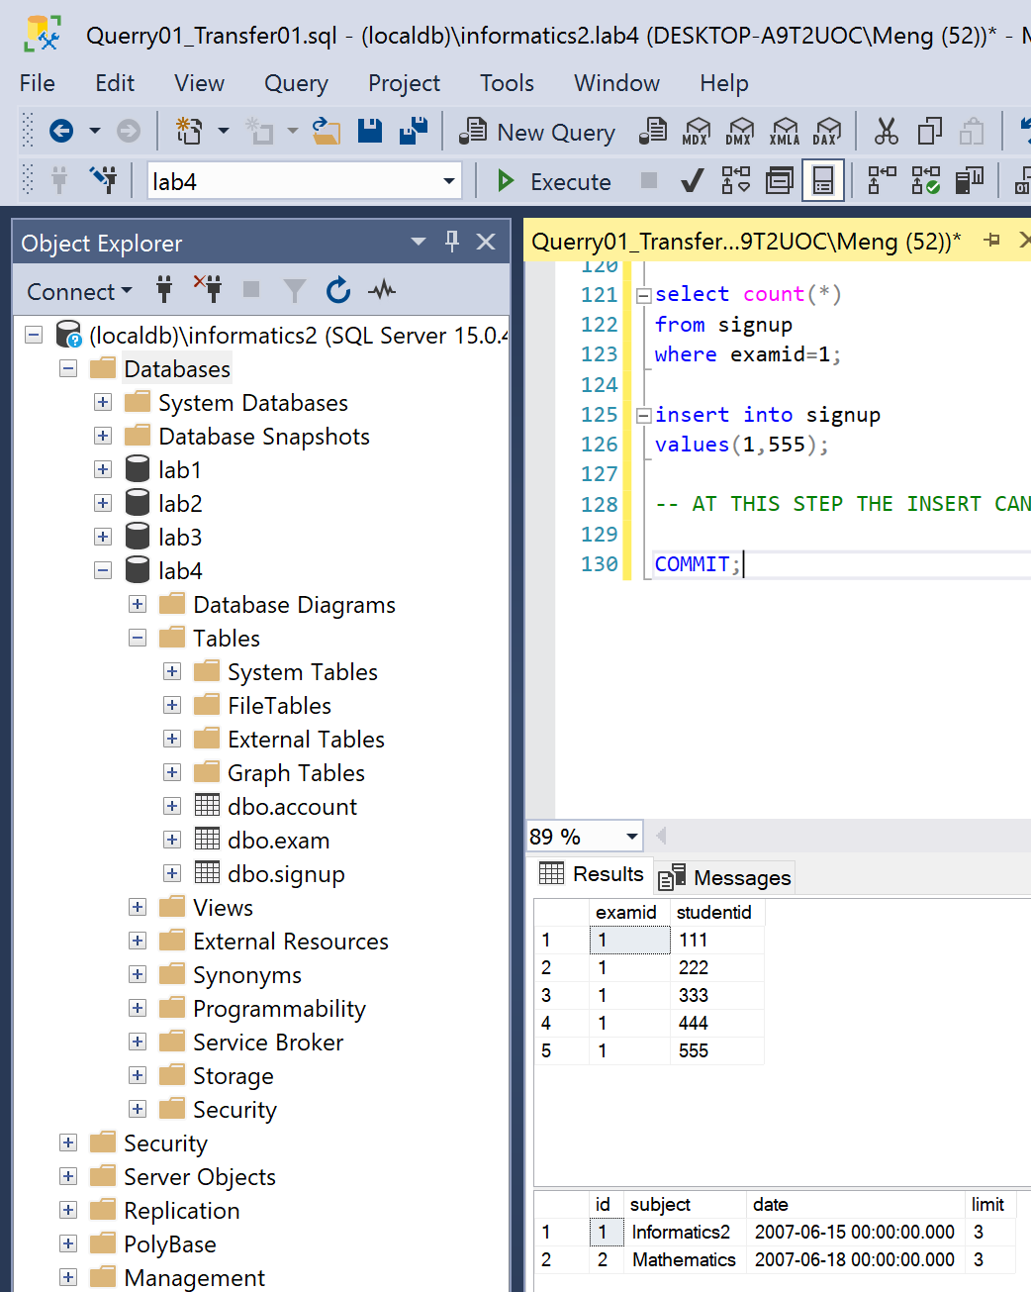

State before transactions deadlock happen State after transactions

**Reasoning:**

In this serializable isolation level, we can solve problem about phantom read, by while two transactions try to insert value into table, a deadlock happened, one of the transactions is aborted and the other one is successfully executed.

### Task #8

**Problem statement:** Increase limit of the first exam to 5. Replay example 7. What is the result? Why?

**Solution:**

|  |  |  |
| --- | --- | --- |
| **Step** | **First signup** | **Second signup** |
| 1 | UPDATE exam  SET limit = 5  WHERE exam.id = 1; |  |
| 2 | set transaction isolation  level serializable;  Begin transaction |  |
| 3 |  | set transaction isolation  level serializable;  Begin transaction |
| 4 | select limit  from exam  where id=1; |  |
| 5 |  | select limit  from exam  where id=1; |
| 6 | select count(*)  from signup  where examid=1; |  |
| 7 |  | select count(*)  from signup  where examid=1; |
| 8 | insert into signup  values(1,555); |  |
| 9 |  | insert into signup  values(1,666); |

**Visual result:**

**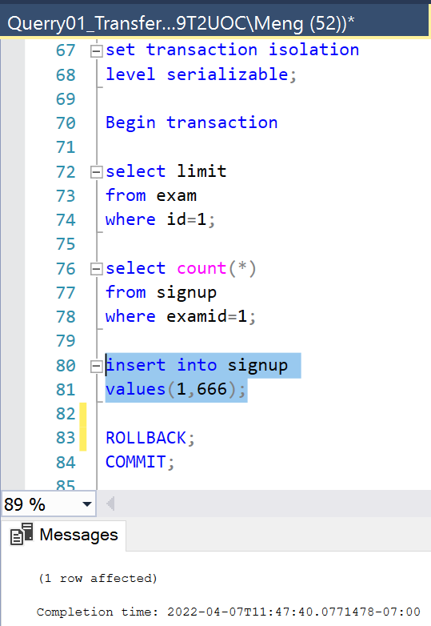

State before transactions deadlock happen State after transaction

**Reasoning:**

Here we increase the limit of the first exam to 5 and repeat steps from task 7, both will see that there is enough space for 2 people. However, if they tried to insert at the same time, a deadlock happened again and only one of them is registered to the exam.

### Task #9

**Problem statement:** Replay example 7 but the first student should signup to the first exam while the second one should signup to the second exam. What is the result? Why?

**Solution:**

|  |  |  |
| --- | --- | --- |
| **Step** | **First signup** | **Second signup** |
| 1 | set transaction isolation  level serializable;  Begin transaction |  |
| 2 |  | set transaction isolation  level serializable;  Begin transaction |
| 3 | select limit  from exam  where id=1; |  |
| 4 |  | select limit  from exam  where id=2; |
| 5 | select count(*)  from signup  where examid=1; |  |
| 6 |  | select count(*)  from signup  where examid=2; |
| 7 | insert into signup  values(1,555); |  |
| 8 |  | insert into signup  values(2,666); |

**Visual result:**

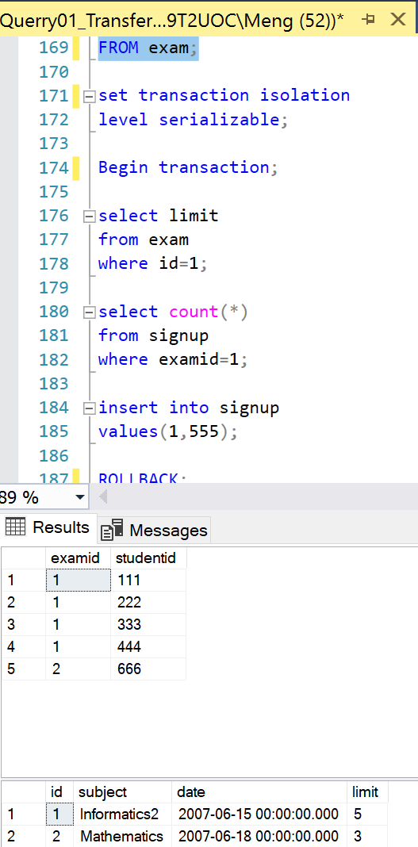

**Reasoning:**

In this “serialization” isolation level, even though, two students tried to read and register to a different exam, but only one of their transactions will be executed successfully while the other one will be aborted as previous task.

### Task #10

**Problem statement:** Reset our database by executing the script of example 5 again

**Solution:**

drop table signup;

drop table exam;

create table exam

( id int primary key,

subject varchar(20),

date datetime,

limit int

);

create table signup(

examid int references exam(id),

studentid int,

primary key (examid,studentid)

);

insert into exam

values(1, 'Informatics2',convert(datetime,'2007.06.15',102),3);

insert into exam

values(2, 'Mathematics',convert(datetime,'2007.06.18',102),3);

insert into signup values(1,111);

insert into signup values(1,222);

**Visual result:**

**Reasoning:**

Here I just drop and recreate tables based on the given code.

### Task #11

**Problem statement:** The efficiency of the system can be increased by using read committed isolation level and mutual locking. If concurrent transactions lock only the record they need, mutual exclusion can be achieved. The schedule of the processes should be the following:

**Solution:**

|  |  |  |
| --- | --- | --- |
| **Step** | **First signup** | **Second signup** |
| 1 | set transaction isolation  level read committed  begin transaction |  |
| 2 |  | set transaction isolation  level read committed  begin transaction |
| 3 | select limit  from exam with(XLOCK)  where id=1 |  |
| 4 |  | select limit  from exam with(XLOCK)  where id=1 |
| 5 | select count(*)  from signup  where examid=1 |  |
| 6 | insert into signup  values(1,333) |  |
| 7 | commit |  |
| 8 |  | select count(*)  from signup  where examid=1 |
| 9 |  | commit |

**Visual result:**

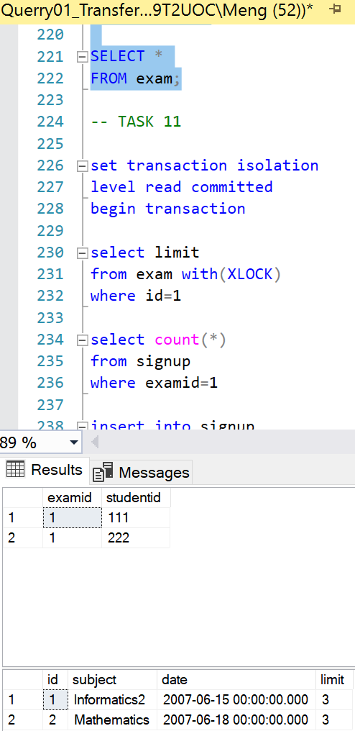

State before transaction State after transacion

**Reasoning:**

In this approach we use “read committed” isolation level which solve a problem that 2 students see an available place for them if they check it at the same time. In this approach, if one already started the transaction, the other one cannot even read anything from the table until the first student commit his transaction. Not after the first student committed his transaction, the second student see that no place is available for him. In this way 2 of them will not be able to register and go exceed the limit number of student of the exam.

### Task #12

**Problem statement:** Increase limit of the first exam to 6. Replay example 11. What is the result? Why?

**Solution:**

|  |  |  |
| --- | --- | --- |
| **Step** | **First signup** | **Second signup** |
| 1 | UPDATE exam  SET limit = 6  WHERE id = 1; |  |
| 2 | set transaction isolation  level read committed  begin transaction |  |
| 3 |  | set transaction isolation  level read committed  begin transaction |
| 4 | select limit  from exam with(XLOCK)  where id=1 |  |
| 5 |  | select limit  from exam with(XLOCK)  where id=1 |
| 6 | select count(*)  from signup  where examid=1 |  |
| 7 | insert into signup  values(1,333) |  |
| 8 | commit |  |
| 9 |  | select count(*)  from signup  where examid=1 |
| 10 |  | insert into signup  values(1,444); |
| 11 |  | commit |

**Visual result:**

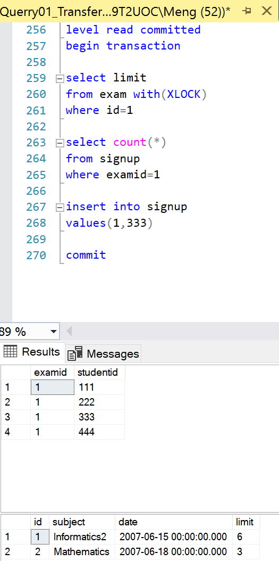

State before transactions State after transaction

**Reasoning:**

Here we set the limit to the number where both student can be registered in to the exam. Again with this “read committed” isolation level, if both start the transaction, one of them cannot even read anything until the other commit their transaction. After the first student committed his transaction, the second one now can read and check the available place for him. He will see that he still can register and he will get registered since the limit has been increased and there is still a place for him.

### Task #13

**Problem statement:** Replay example 12 but the first student should signup to the first exam while the second one should signup to the second exam. What is the result? Why?

**Solution:**

|  |  |  |
| --- | --- | --- |
| **Step** | **First signup** | **Second signup** |
| 1 | UPDATE exam  SET limit = 6  WHERE id = 1; |  |
| 2 | set transaction isolation  level read committed  begin transaction |  |
| 3 |  | set transaction isolation  level read committed  begin transaction |
| 4 | select limit  from exam with(XLOCK)  where id=1 |  |
| 5 |  | select limit  from exam with(XLOCK)  where id=2 |
| 6 | select count(*)  from signup  where examid=1 |  |
| 7 | insert into signup  values(1,333) |  |
| 8 | commit |  |
| 9 |  | select count(*)  from signup  where examid=2 |
| 10 |  | insert into signup  values(2,444); |
| 11 |  | commit |

**Visual result:**

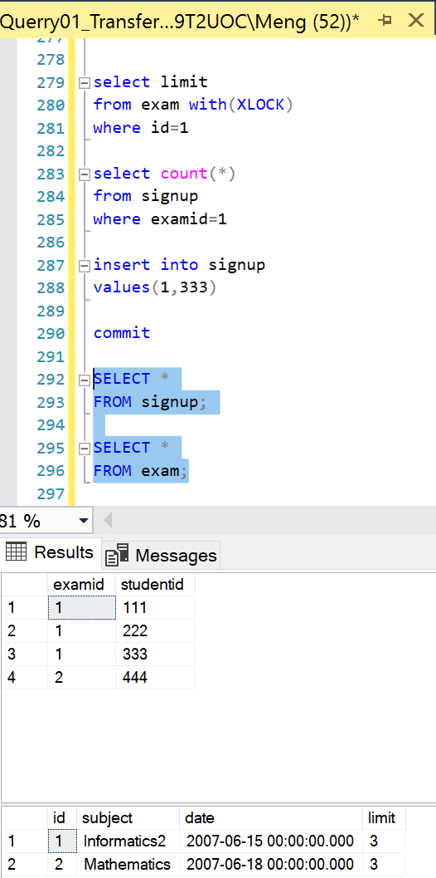

State before transactions State after transaction

**Reasoning:**

For this approach “read committed” isolation level, if both wants to access the same resource, they need to wait for the other one to commit there transaction first. But in this case, two of them tried to register for different exam. They can read, access and insert into table independently from each other without any waiting at all. Everything is perfect in this case.

### Instructions

1. **Problem statement is mandatory.**
2. **A solution without explanation is NOT accepted.**
3. **If you need to copy the source code, you can do it with copy/paste commands. Please do not use screenshots for code listings.**
4. **Other screenshots (figures, graphs, etc.) should be scaled appropriately. Please cut off unnecessary elements on the images.**