Mechanism, Implementation, Measurement and Feedback

of the Galvanic Skin Response on Wireless Wearable Device

Kormoua Khongmeng

Budapest University of Technology and Economics

TTK MTA

Abstract

Galvanic Skin Response (GSR), also known as Skin Conductance (SC), refers to change in sweat gland activity, which reflects the intensity of an individual person’s emotional state or emotional arousal. People’s emotional arousal changes in response to the environment they are in. There are mainly some different methodologies of measuring GSR based on a very fundamental Ohm’s law. Nowadays people are starting to give an interest to wireless wearable GSR devices either for research purposes or just individual usages. The main problem of wireless wearable GSR device is that, the sensor cannot be place at the most favor spot for measuring GSR and usually the device must be wear tightly to have a considerable result of GSR which leads to an inflexibility and uncomfortable to wear. In the end we conduct the GSR measurement both on the fingers which is a more suitable place compare to the GSR that measured from the wrist to verify whether data that measured from the wrist are acceptable or not. However, the result is pretty satisfying and we found that another important factor that affect the GSR measurement is also the characteristic of the person’s hands. A really dry hands will definitely give a bad and not responsive GSR. While a too much sweaty hands will also give an unstable GSR as well.

**Mechanism, Measurement and Feedback**

**of the Galvanic Skin Response**

Galvanic Skin Response or GSR in short is a measurement regarding a changing of skin electrical conductance which is induced by sweat, which again is triggered by emotional arousal. By measuring GSR while we are emotionally engaged, we can get a unique pattern of data reflecting a level of engagement.

Now, coming to the question that we want to study, how can we measure GSR? How to implement that system? What can we learn more about measuring GSR? And the feedback from users of existing devices which have a GSR measurement system integrated.

Based on previous studies, there are three principle theories relate to the GSR phenomenon.

1. **Muscular theory**

Muscular theory states that GSR directly displays the bioelectric changes in muscle. There is evidence which shows that there is an uncasual relationship with each other. Later on the Muscular theory was discarded (by Waller, 1918). However, its evidence is found to be supporting the Secretory theory and against the Vascular theory.

1. **Vascular theory**

Vascular theory states that GSR is the electrical activity attendant on vasodilatation and vasoconstriction. This evidence is interesting and persuasive, but it shows us how related they are more than how they can cause each other.

1. **Secretory theory**

Secretory theory states that GSR is caused by a change in activity of the sweat gland. The evidence is likely to select this theory most out of three.

The Galvanic Skin Response (GSR) is an accessible and sensitive neurotransmitter. GSR can be used to judge the autonomics neuro-cardiac disturbance taking place in diabetics, chronic alcoholics, and in patients with Parkinsonism. GSR already exists in Lie-detectors, stress level indicators, etc.

GSR is involved solely through the sympathetic cholinergic nerve supply to the skin, and that is attributable to changes in the sweat glands.

After placing two electrodes on the intact surface of the body, the resistance between them is virtually the skin’s resistance. Within the skin, the resistance lies largely in the stratum corneum which acts like an insulator on the body surface. However, the stratum corneum is perforated by the sweat ducts, which gives conducting paths through the protector depending on the activity of sweat glands. An increase in the activity of sweat glands reduces the skin resistance.

**The principle of measuring GSR**

As mentioned before that DC method is more commonly used then the measurement techniques below will be considered in relation to the DC method. Measuring GSR we have a typical methodology with only a basic components like figure below.

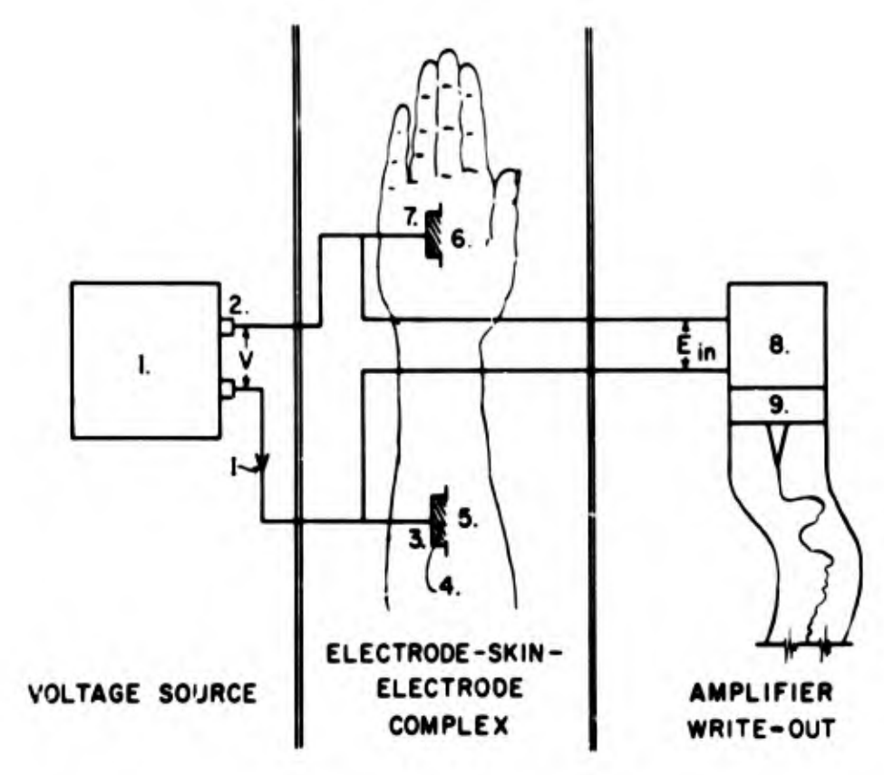

Figure 1: typical methodology of measuring GSR

Essential components and fundamental relationship for the measurement of GSR: (1) voltage source; (2) current polarity; (3) electrodes; (4) contact medium; (5) reference site; (6) current density; (7) active site; (8) amplifier; (9) write-out unit.

A voltage source provides a current to the electrodes making contact through electrolytic gel or solution. One of the electrodes contacts an area of skin known as the “potential site”, which maintain a relatively constant potential against which the potential of an “active site” may be measured. The potential between the reference and the active site is amplified by the amplifier then the amplified signal is written out or displayed by some output device.

There are mainly 2 variations of GSR measurement: a constant-voltage method and a constant-current method.

1. **The constant-voltage method (exosomatic method)**:

We want to measure a resistance therefore we need a constant voltage as a supply then we measure the current flow throw 2 electrodes and by the help of Ohm’s law the skin resistance can be measured which can be derived to the skin conductance. This is a basic concept. A Galvanic Skin Response Amplifier will apply a small voltage that cannot harm or be perceived by humans but can be detected through the amplification.

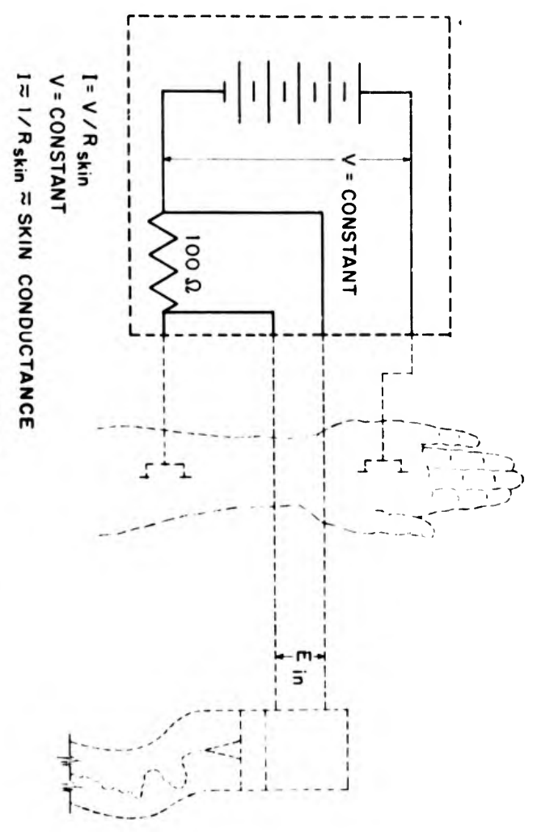

r

Figure 1: Constant voltage

The principle is shown in Figure 1, a voltage source is connected across the electrodes and the current is measured by measuring a voltage drop across a small resistance “r”. This method is to make sure that a voltage across the electrodes is virtually steady and constant regardless of any fluctuation on the subject’s resistance. Here we should note that the value of series resistance should be at least 10 times smaller than the value of “”.

In the constant-voltage method, since the physiological units are in parallel, the voltage across each unit is equal to the voltage source. However, the current varies based on the number of active units.

Based on the experiments, a source of 1 V or usually 0.5 V seems to be a reasonable choice, the error from this source will be small. If the resistance of the subject varies between extreme 500,000 ohms and 20,000 ohms. The current varies from 2 to 50 uA. With a resistance of 1000 ohms for “r”. The measured voltage across “r” will change between 2 and 50 mV. Since this voltage range are very small, it requires a more sensitive amplifier.

1. **The constant-current method (endosomatic method)**:

Another method measuring skin conductance by applying steady current through the object and recording the voltage changes across it. The voltage will be directly proportional to the resistance. As shown in the figure 2 below, the electrodes are connected in series with a resistor “r”, which in order to obtain a value with 5% deviation, the value of “r” must be at least 20 times larger than the resistance of the subject which is denoted by “Rs”. The current should remain steady regardless of the changes or fluctuation on “Rs”. since the total resistance from “r” and “Rs” are large we should have a considerably high voltage source as well. In this method, the current density per unit area of the electrode is fixed.

A constant current of 10 uA is passed through the active electrode which is around 0.7 on the distal of a thumb. With all these conditions, the recorded resistances fall with a between 25 000 ohms and 500 000 ohms, that is a measured voltage range from 250 mV to 5 V.

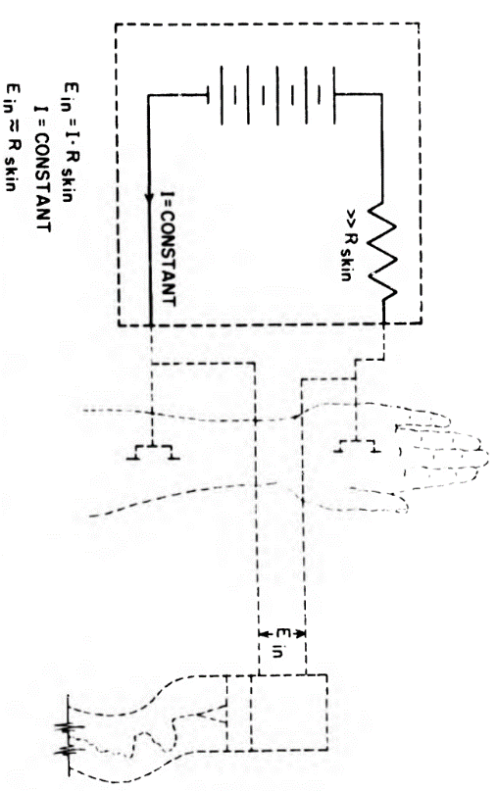

r

Figure 3: Constant current

The GSR measurement device contains operational amplifiers, high-pass filters, low-pass filters, microcontrollers, band-pass filters and some LEDs. It measures the conductance of the skin. Stress produces sweat and is measured through copper electrodes. The measured data is displayed as a graph by GUI software on a computer or LED if no computer is available.

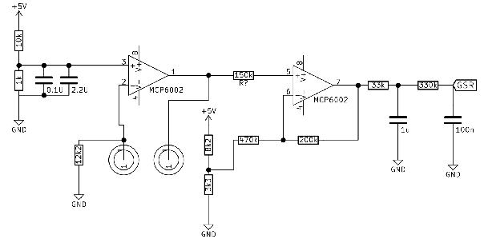

Figure 4: a schematic of GSR circuit

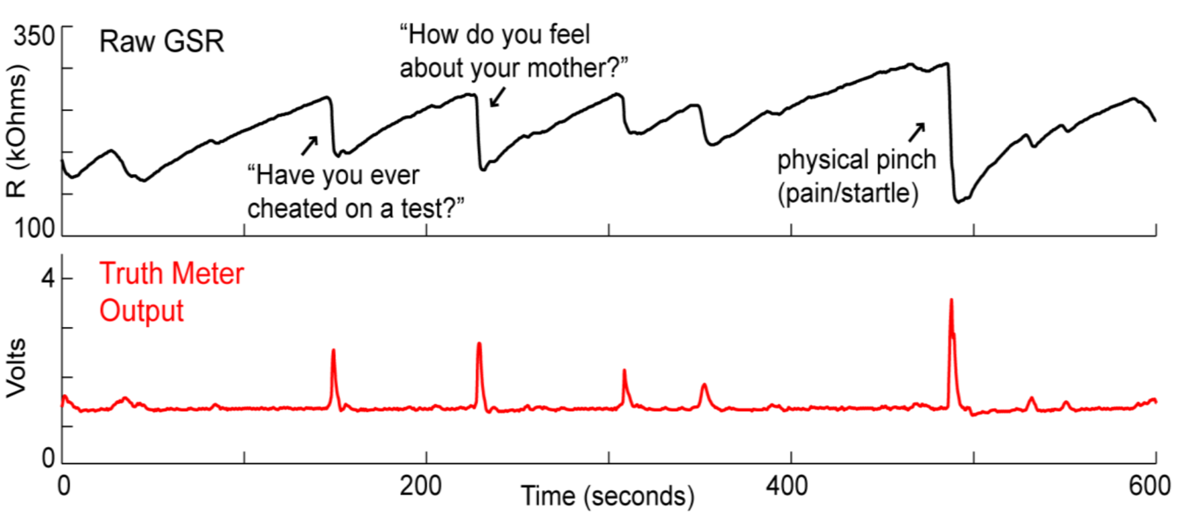

Figure 5: Graphical representation of GSR

**Some GSR Sensors available**

|  |  |  |  |
| --- | --- | --- | --- |
| Device | Analog Front-End? | Sensor? | electrode? |
| Empatica E4 from MIT spin-off | N/A | unknown | 1 pair of stainless steel electrodes  Stainless Steel SUS 303F  Brass, Ag Plated |
| Microsoft Band 2 | N/A | N/A | N/A |
| Moodmetric smart ring | N/A | N/A | N/A |
| Jawbone’s UP3 | N/A | N/A | N/A |
| zenta from vinaya | N/A | N/A | N/A |
| Everion from biovotion | N/A | N/A | N/A |
| Fitbit sense | Maxim Integrated MAX30001 Single-Channel Integrated Biopotential/Bioimpedance Analog Front End | The edge around the display features two separated metal brackets for reading your EDA levels (electrodermal activity) and taking that ECG. | Two more brackets tucked up against the sides of the housing keep a few more key components in place: loudspeaker and pressure sensor on one side, and a microphone, vibration motor, and psuedo-button on the other. |
| Ring from Bitbrain | N/A | N/A | N/A |
| emotibit | N/A | N/A | N/A |
| MAXREFDES73# from maxim | N/A | N/A | N/A |
| eHealth Sensor Platform | N/A | N/A | N/A |
| BITalino (not a complete device) | N/A | N/A | N/A |

**Review of wearable device with GSR**

**Empatica E4**

A company called Empatica has produced a rigid wireless wearable device with GSR integrated named Empatica E4 wristband. This device is tested carefully by a team and documented as follows, there is one participant whom they cannot extract over 90 percent of data, which they assumed to be a result of a wristband not being worn tight enough or not in an exact position. There are other cases as well where they found the data lost is about 10 percent to 30 percent, but this seems to be normal since portable devices are characterized by relatively high missing data. More importantly, since this device does not use electrodes to attach on the finger or on the hand, but measure one the wrist directly, therefore, for scientific purposes, the current device and method of GSR is not satisfactory yet.

**Shimmer3 GSR+**

A company called Shimmer has deployed a watch-like device which attaches to the user's hand and has electrodes attached to the fingers as well. This is a robust method to correct GSR data and currently seems like this device and this method provide the most reliable data about GSR. but because of the wires and the electrodes that need to be attached to the fingers, it might restrict some movement of the user's hand.

**Fabrication GSR Biofeedback Unit**

Another GSR device, although it is a hand-held device from “Fabrication GSR Galvanic Skin Response Biofeedback Unit” is said that it does its jobs in several functions, but it has no graphical interface and is not totally automatic. Users complain about the audio feedback which could become annoying due to the high pitch sound to indicate stress and a lower tone when you successfully relax. When measuring, users need to keep both significant lengths of finger on two metal strips to get a response, but users get tired of doing so for a long time especially until the user can finally relax. One more suggestion is to save a history in the long term because users want to track their progress.

**Microsoft band 2**

Microsoft also have a fitness tracker called Microsoft band 2 which is a size of a watch. The MS band 2 has same problem as the “Emphatica E4”, its GSR sensor is placed at the opposite ends of the device or the display, meaning that in order to measure GSR accurately, user must wear a device tight to user’s wrist to achieve proper contact, restricting the flexibility and comfortable. One more thing to mention is, this device is not waterproof, it is just water and dust resistant. For MS band 2 itself, GSR measurement alone is aimed to give an information whether the device is worn or not, but together with heart rate sensor and other stuff, the device could give an information about stress, etc.

**Jawbone UP3**

This is another wearable wireless device which has GSR measurement integrated, but it is not tested and documented properly yet, and no user give a feedback regarding GSR of this device yet.

**Implementation of Bluetooth communication of GSR**

We want to measure a GSR value from the sensor and send this information through bluetooth to the receiver device, mainly a portable device. I use a “arduino ble nano 33” bluetooth module to send a data from the sensor (Grove - GSR_Sensor V1.2 and ABS05-32.768KHz_9_T) to a receiver which is a phone by application like (lightblue, nRF Connect, BLE Scanner, etc).

From the central side, I will use third party applications. So, I do not need to implement some code there.

However, in the peripheral side, I need to implement a code to process data from the sensor, filter, additional input like a button input to mark a time of question, etc. then send this information to the central side. The setup for the measurement is as below:

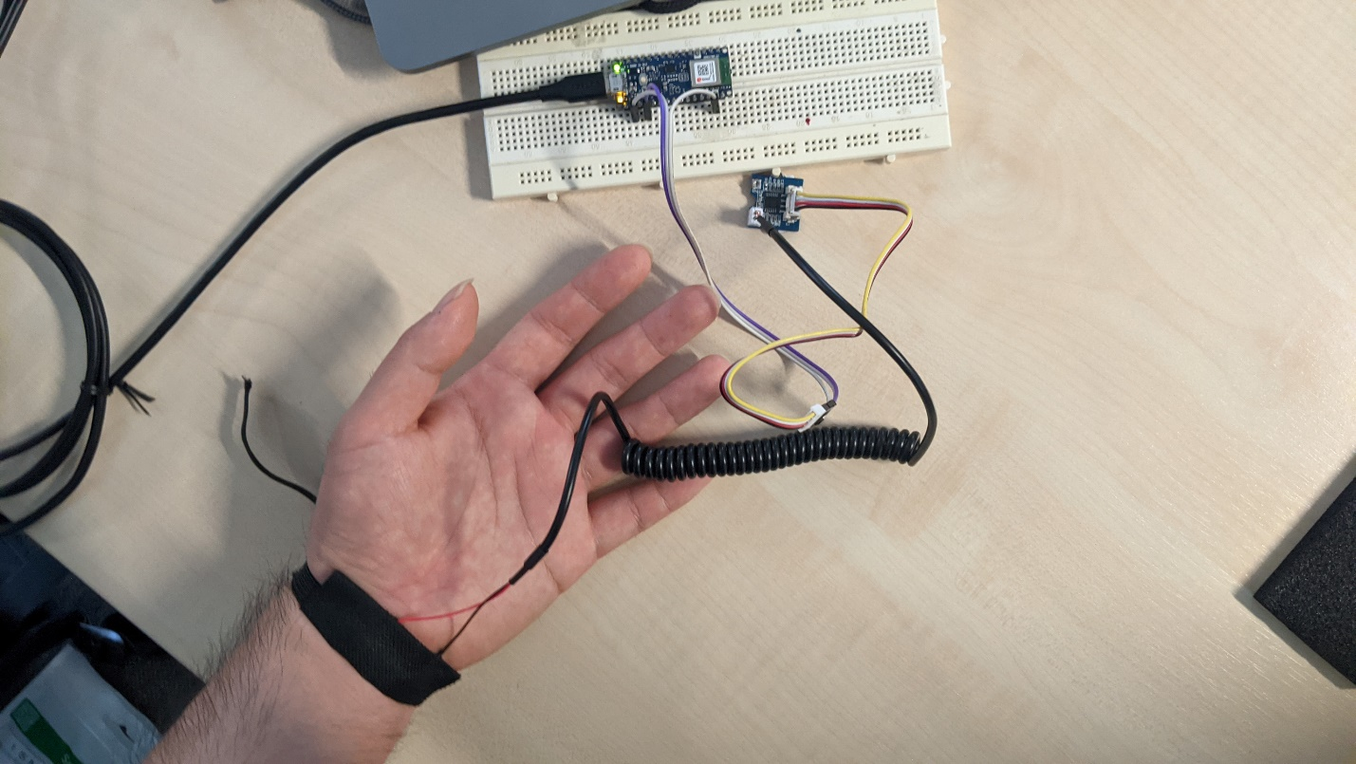

Electrodes

GSR sensor

Bluetooth module

Figure 6: GSR measurement setup

From the above communication setup, we can remotely monitor the GSR value and save log data for later use like data analysis. Below is some collected data from several measurement that I have conducted:

1. First participant:

This person has a nice response in term of GSR, his GSR react to the questions is more or less satisfying, although the correlation between the response and the truth or lie are not completely correct.

Figure 7: GSR of first participant during asking truth/lie questioning

1. Second participant

For this participant, again the GSR behave well, although the correlation between the answer and the signal is not completely correct but overall, these GSR is what we would like to have.

Figure 8: GSR of second participant during asking truth/lie questioning

**Verifying position of measuring GSR on wrist compare to fingers**

Measuring GSR, ideally the position of electrodes should be placed on fingers or palm. But our goal is to put electrodes on wrist. So, here we want to compare and verify the GSR result from both position at the same time (wrist and fingers) and compare whether the measurement taken from the wrist is acceptable or not.

For this we can use the same board but we need 2 sensors and another pair of electrodes. Here is a setup arrangement for measuring two GSR from two different places at the same times.

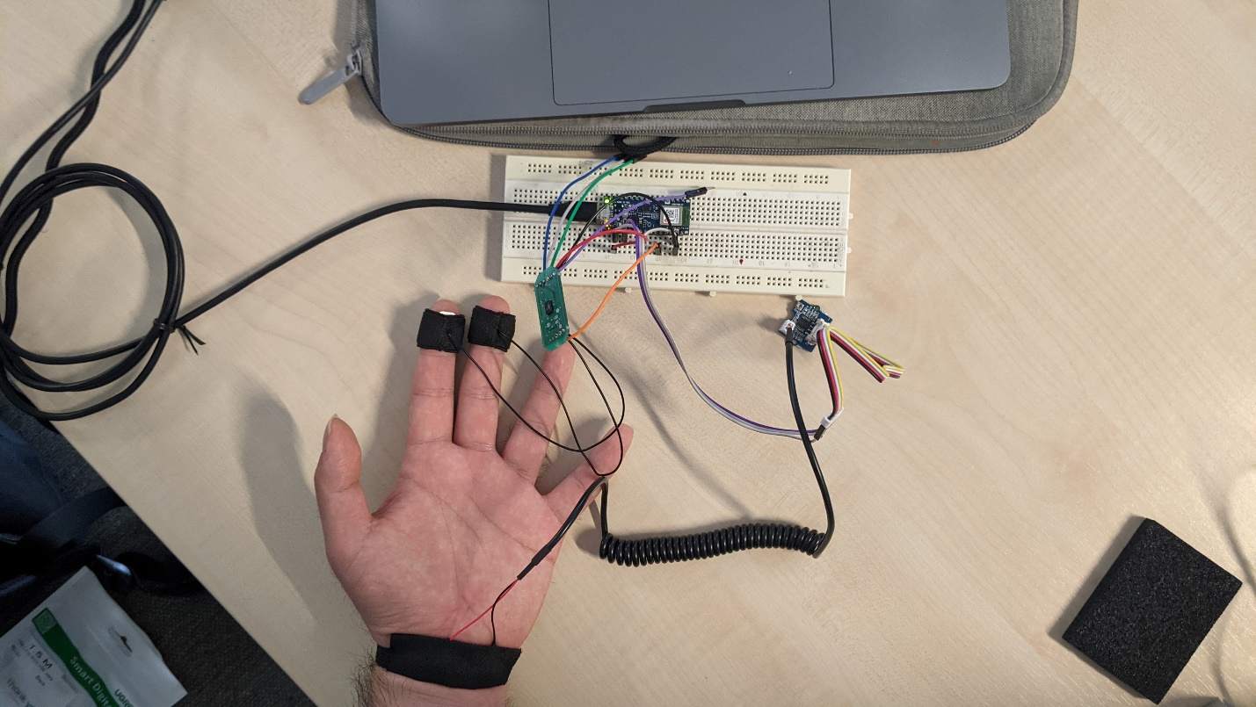

GSR sensor 1

Bluetooth module

GSR sensor 2

Electrodes pair 2

Electrodes pair 1

Figure 9: GSR setup measurement for 2 places at the same time

From the above communication setup, we can remotely monitor the GSR value and save log data for later use like data analysis.

This time Instead of asking participants a questions, I will just let the participants watch some video, either scary video, funny video, music, etc. during the recording, I tried to indicate when participants change video, or any media that he/she is currently watching or listenning.

Below is some collected data from several measurement that I have conducted:

1. First participant

For this second participant, we let him watch the same scary clip. First thing we can conclude from this participant is that both the GSR follow and behave in the same way and also responsive to the content of the video which is a really satisfying results. Another thing to note here which is also what we expected is that the level of GSR on the fingers and on the wrist will be different in term of having some offset to each other.

Figure 10: GSR of first participant during watching a scary video

1. Forth participant

This participant’s GSRs also represent a good result as we expected. Both GSR follow each other really well despite the offset of the them which is not as important as the behavior of them which response simonteneously.

Figure 11: GSR of second participant while listening to a music video

Noted that since the lessons from previous measurements that we did about questioning, we founded that some people has a hand’s characteristic that is not suitable for measurement and we did not get a really satisfying results. That is why those participants for these measurements I also ask some people who I thought would have a good response to come as well so at least I will have some good results.

**In conclusion**, it might depend on a person as well, but based on the measurement above we can conclude that we could collect GSR data from the wrist as well and it should be as good as on the fingers or on the palm but again, I tested in only a few groups of people. There might be tons of factor that determine this fact.

References

1. Montagu, J. D.; Coles, E. M. (1966). Mechanism and measurement of the galvanic skin response.. Psychological Bulletin, 65(5), 261–279.
2. Rickles, William Jr H (1964). Engineering Considerations in GSR Research, AD0610222
3. Mahima Sharma; Sudhanshu Kacker; Mohit Sharma (2016). A brief Introduction and Review on Galvanic Skin Response.. International Journal of Medical Research Professionals, P-ISSN: 2454-6356; E-ISSN: 2454-6364.
4. Milstein, Nir; Gordon, Ilanit (2020). Validating Measures of Electrodermal Activity and Heart Rate Variability Derived From the Empatica E4 Utilized in Research Settings That Involve Interactive Dyadic States. Frontiers in Behavioral Neuroscience, 14(), 148–.
5. Nicole S. Chudy, Daniel S. McConnell, Janan A. Smither (2016). The Performance of Microsoft Band 2 and Basis Peak: A Validity and Reliable Test.
6. Villarejo, María Viqueira; Zapirain, Begoña García; Zorrilla, Amaia Méndez (2012). A Stress Sensor Based on Galvanic Skin Response (GSR) Controlled by ZigBee. Sensors, 12(12), 6075–6101.
7. <https://www.amazon.com/gp/customer-reviews/RMJKQU5RMDTKZ/ref=cm_cr_arp_d_viewpnt?ie=UTF8&ASIN=B01IPSUIZ0#RMJKQU5RMDTKZ>
8. <https://www.pocket-lint.com/fitness-trackers/reviews/microsoft/136205-microsoft-band-2-review-function-over-form>
9. [The Best Wearable Device for Research on Emotion and Affect? - AffecTech](https://www.affectech.org/2018/07/the-best-wearable-device-for-research-on-emotion-and-affect/)
10. Toomin, M. K., & Toomin, H. (1975). *GSR biofeedback in psychotherapy: Some clinical observations. Psychotherapy: Theory, Research & Practice, 12(1), 33–38.* doi:10.1037/h0086402
11. Nagai, Y., Jones, C. I., & Sen, A. (2019). *Galvanic Skin Response (GSR)/Electrodermal/Skin Conductance Biofeedback on Epilepsy: A Systematic Review and Meta-Analysis. Frontiers in Neurology, 10.* doi:10.3389/fneur.2019.00377
12. Tan, C. S. S., Schöning, J., Luyten, K., & Coninx, K. (2014). *Investigating the effects of using biofeedback as visual stress indicator during video-mediated collaboration. Proceedings of the 32nd Annual ACM Conference on Human Factors in Computing Systems - CHI ’14.* doi:10.1145/2556288.2557038
13. Boucsein, W. (2012). Electrodermal activity. Springer Science & Business Media.
14. Bakker, J., Pechenizkiy, M., & Sidorova, N. (2011). *What’s your current stress level? Detection of stress patterns from GSR sensor data In Proceedings – IEEE International Conference on Data Mining, ICDM*
15. Grayenhorst, F., Muaremi, A., Troster, G., Arnrich, B., & Gruenerbl, A. (2013). *Towards a Mobile Galvanic Skin Response Measurement System for Mentally Disordered Patients. In Proceedings of the 8th International Conference on Body Area Networks*
16. Ritesh Sharma, Ravi Shanker Singh, *in IoT*-*Based Data Analytics for the Healthcare Industry, 2021*
17. McCleary, R. A. (1950). *The nature of the galvanic skin response*. Psychological Bulletin, 47(2), 97–117. [https://doi.org/10.1037/h0059810](https://psycnet.apa.org/doi/10.1037/h0059810)
18. Rankin, R. E., & Campbell, D. T. (1955). *Galvanic skin response to Negro and white experimenters.*The Journal of Abnormal and Social Psychology, 51*(1)*. [https://doi.org/10.1037/h0041539](https://psycnet.apa.org/doi/10.1037/h0041539)
19. N. Nourbakhsh, Y. Wang, F. Chen, R.A. Calvo, *Using galvanic skin response for cognitive load measurement in arithmetic and reading tasks, in Proceedings of the 24th Australian Computer-Human Interaction Conference, New York, NY,* USA, 2012,
20. Y. Shi, N. Ruiz, R. Taib, E. Choi, F. Chen, *Galvanic Skin Response (GSR) as an index of cognitive load, in CHI ’07 Extended Abstracts on Human Factors in Computing Systems*, ed. by R. Mary Beth, pp. 2651–2656