**Control of a Mobile Platform in LabView Environment**

**Laboratory report 03**

**Microcontroller Laboratory Exercise**

|  |  |
| --- | --- |
| **Group:** | **G10** |
| **Students:** | **Kormoua Khongmeng – I3MLPQ**  **Muneeb Ali – ZG0KE2** |
| **Date:** | **12 April 2022** |
| **Instructor:** | **Paczolay Gábor** |

**Budapest University of Technology and Economics**

**2022**

Task 1

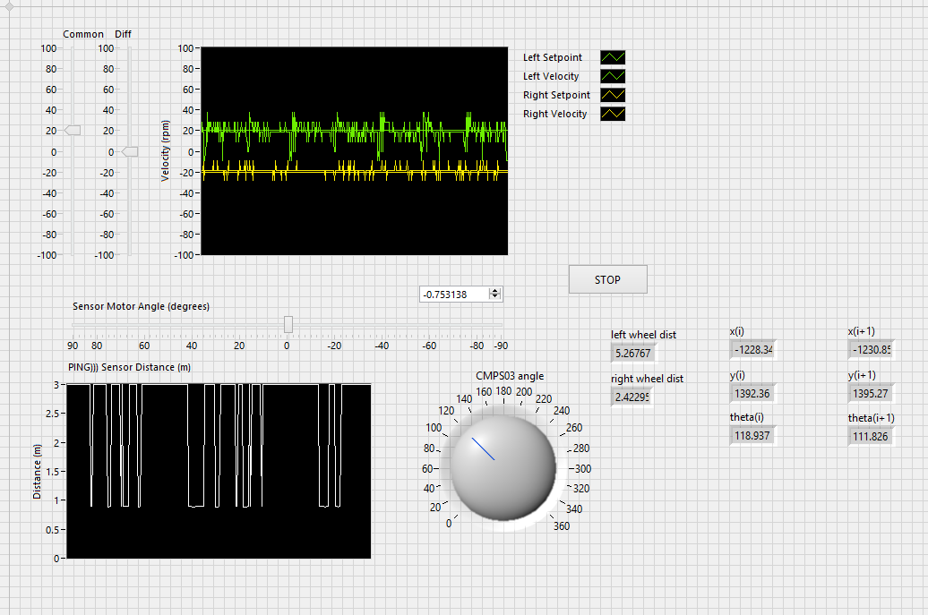

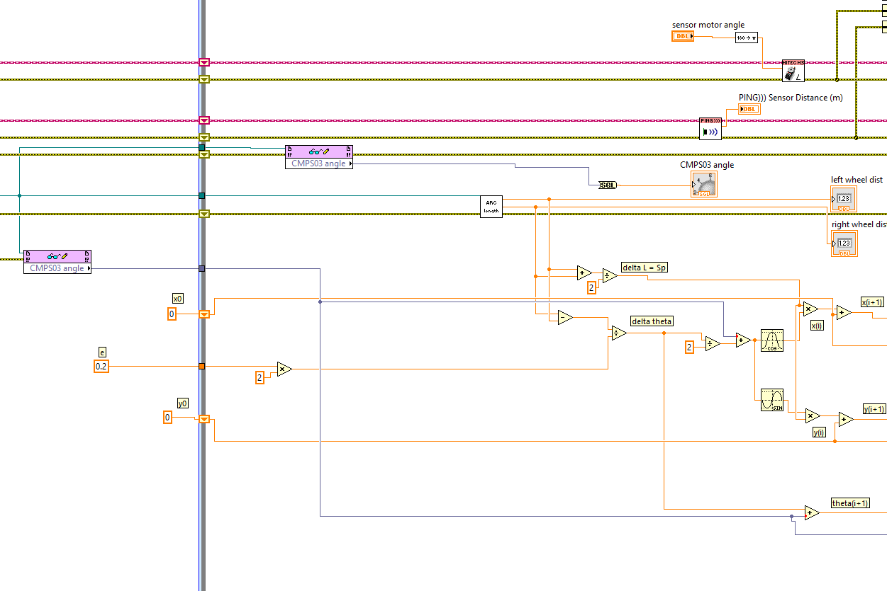

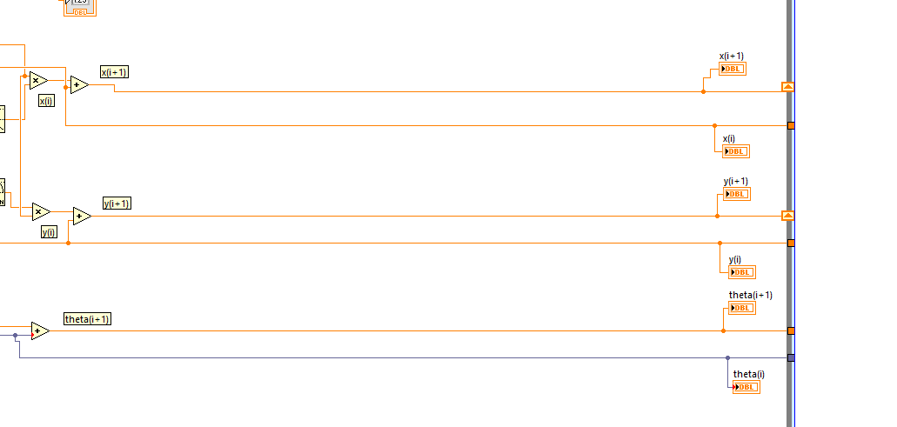

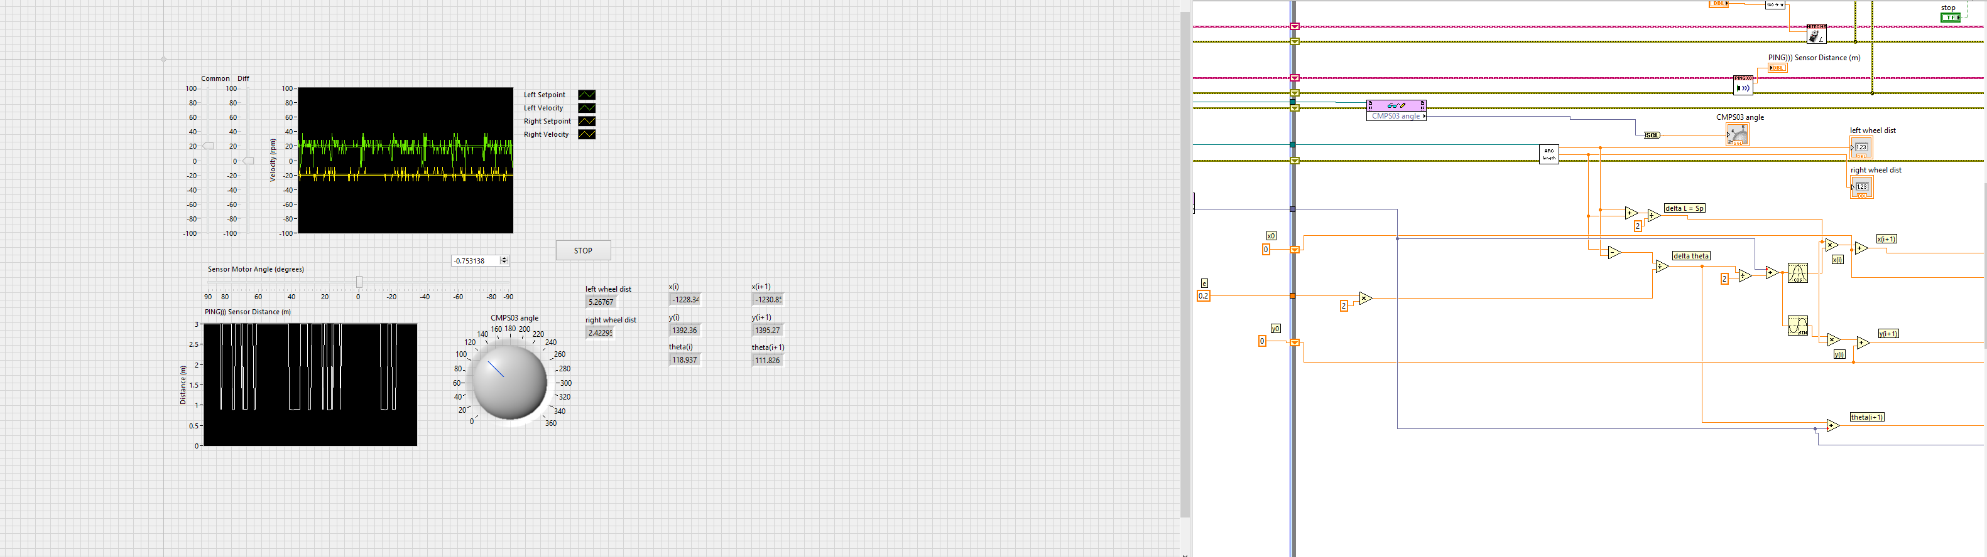

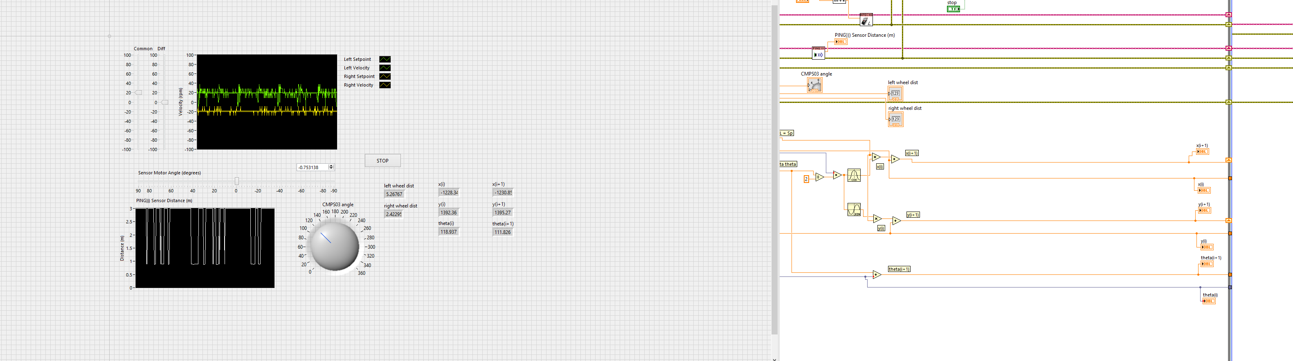

Task 2

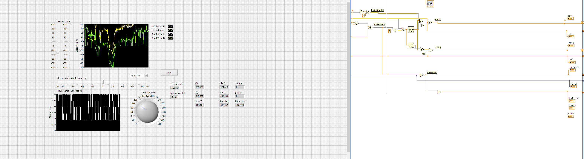

Task 3

Task 5

