

**Thermal Issues of Integrated Circuits**

**Laboratory report 03**

**Microelectronics**

**Student: Kormoua Khongmeng – I3MLPQ**

**Budapest University of Technology and Economics**

**2022**

# Simulation Task

### Task #1: temperature measurement in 3 differenet positions

**Task description:**

A 2x2x0.35mm Si substrate of an integrated circuit is soldered to a 1mm thick Cu plate. The bottom of the Cu is at constant 25 °C. Place a 5W dissipating transistor on the chip. 1Try three different cases: put the dissipator in the center of the substrate, put it in the center of at one edge and place it in the corner. Compare the results, summarize the experiences!

**Simulation and Results:**

Here is my first simulation where I putted a transistor right at the middle of the plate and simulated a heat dissipation of the transistor along the horizontal axis. We see that the heat can be transferred to the substrate in every direction around it makes its MAX temperature is around 77.75 degree celcius.

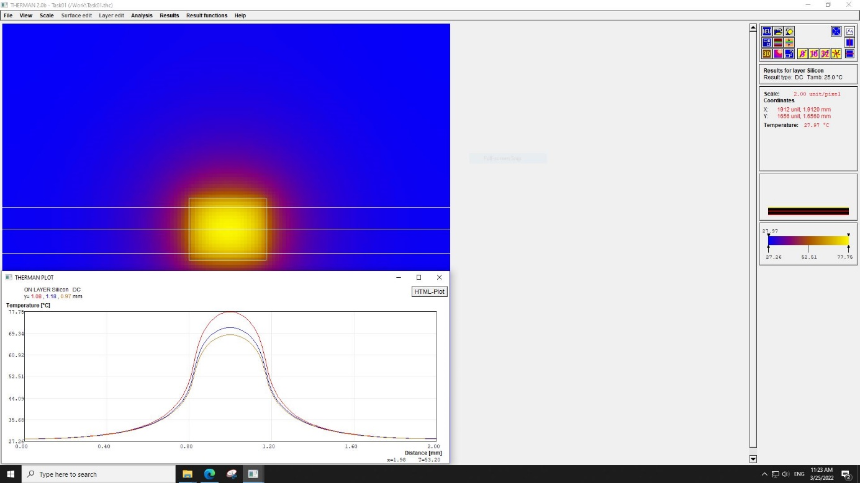

Now, I placed the transistor on the edge of the plate and measure its temperature at this arrangement. We can observe that in this arrangement the heat can be transferred through the substrate in only 3 directions which theoretically should make the temperature of the transistor higher than the first case and my assumption is correct, the highest temperature in this arrangement went up to 86.6 degree celcius.

Based on the previous 2 simulation we can predict that in the third case where the transistor is placed at the corner of the substrate, the temperature of the transistor should go up even higher than the first two case since it has only 2 directions available to dissipate heat through the substrate. After the simulation we found that it is true. The temperature of the transistor in this case went up to 108.81 degree celcius.

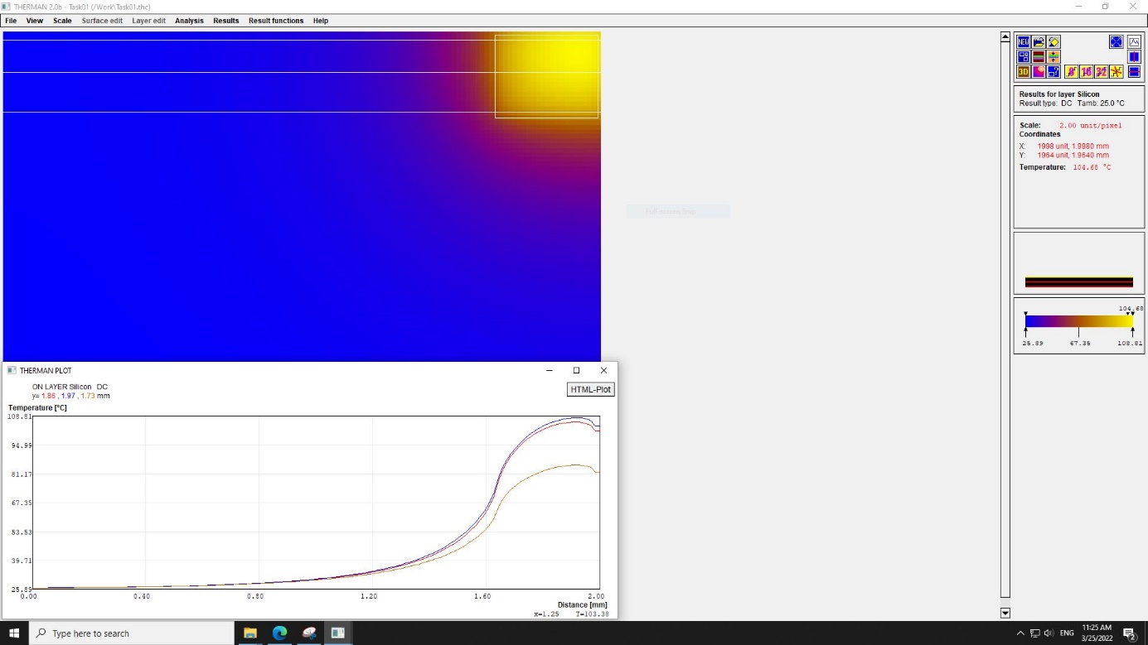

Base on the simulations above we can briefly conclude that it is a general rule to place a components in the middle of the plate for better heat dissipation.

### Task #2: Measuring voltage with a labview controlled multimeter

**Task description:**

The dimensions of the substrate of an operational amplifier chip are 1x1x0.3 mm. The bottom side of the chip is cooled to some extent that can be accounted by setting the heat transfer of the lower side of the substrate to convection with a heat transfer coefficient h=2000W/m2K. The transistor of the output stage (P=0.1W) is 400x50 µm, the transistors of the input differential amplifier are 25x25µm (P=0.001W)2 . Position the three transistors so that the dissipation of the output transistors does not cause a temperature difference between the transistors of the input differential amplifier. Provide the adaquate layout topology and explain it

**Simulation and Results:**

In this task there are a few things to keep in mind. First thing is that all the components should be place roughly at the middle of the plate for better heat dissipation but also not too close to allow them to dissipate heat to each other. Second thing is that from the working principle of the operational amplifier, 2 inputs transistor should have as close temperature to each other as possible since the temperature offset of these two will result in a wrong op-amp working principle. Therefore, a simmetrical arrangement below is formed. We can see that the temperature of each components does not influence each other much and both inputs transistor have approximately same temperature. So this arrangement should satisfy all our needs.

