# Site Map

About

Contact

Main

Reviews

Aesthetics

# Wireframes

## For Main Page

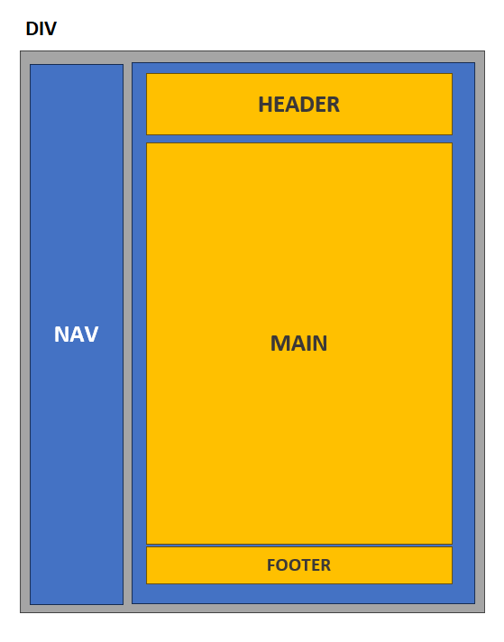

## For About, Aesthetics and Reviews Page

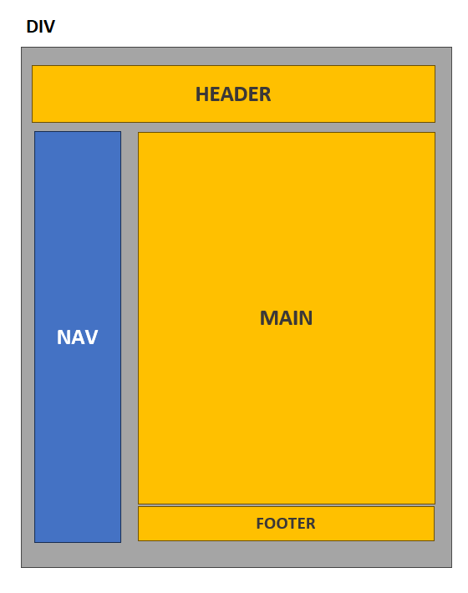

# Reference List

Cliffsnotes.com 2017, *About the Novel: Introduction.*

# Wikipidia.org 2024, *Dream of the Red Chamber.*

ChinaCulture.org 2008, *Cao Xueqin.*

Liu, H 2018, *A Comparative Study of Two English Versions of a Poem in Hong Lou Meng by Yang and Hawkes,* Ning Xia Normal University, Ningxia.

Wang, J & Yu, Y 2019, *A Study on the Translation of Architecture in Hong Lou Meng,* University of Shanghai for Science and Technology, China.

Xu, B 2020, *Rewriting to reproduce beauty: A comparative case study of Hong Lou Meng,* Queen's University, Kingston.