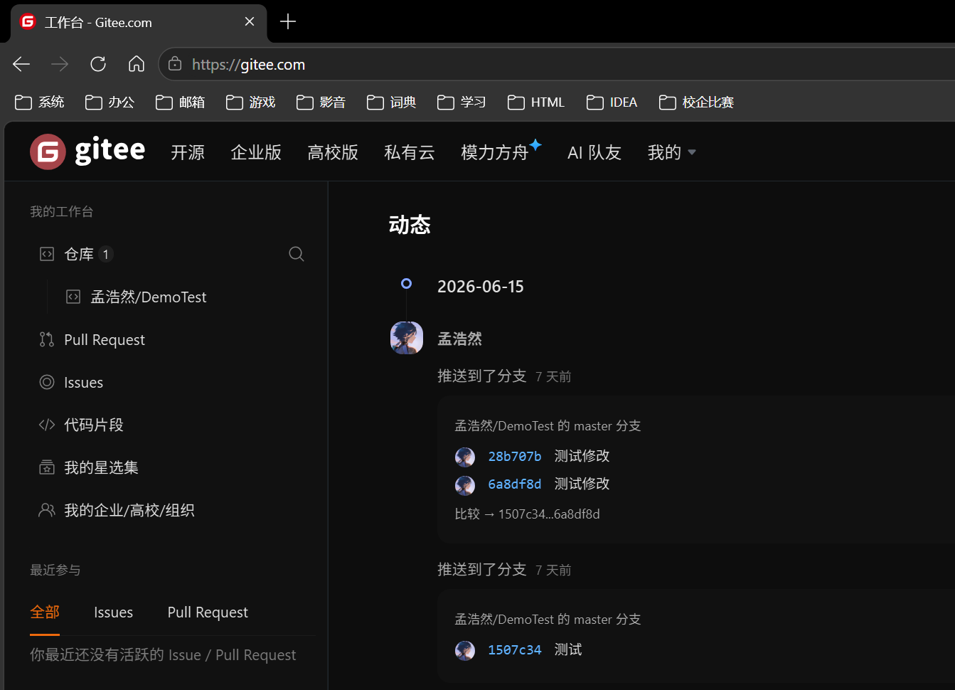
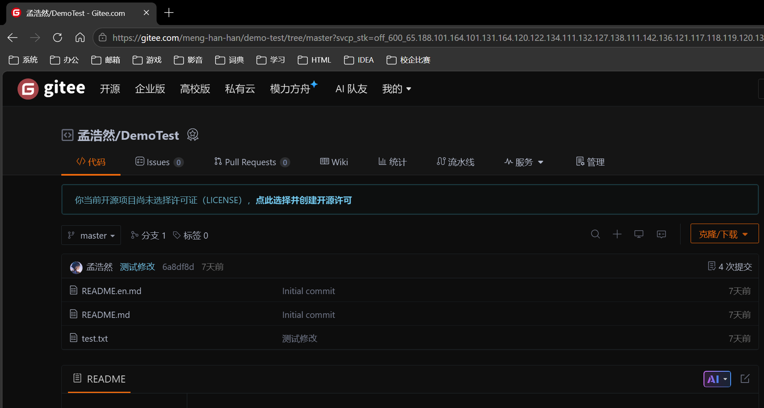
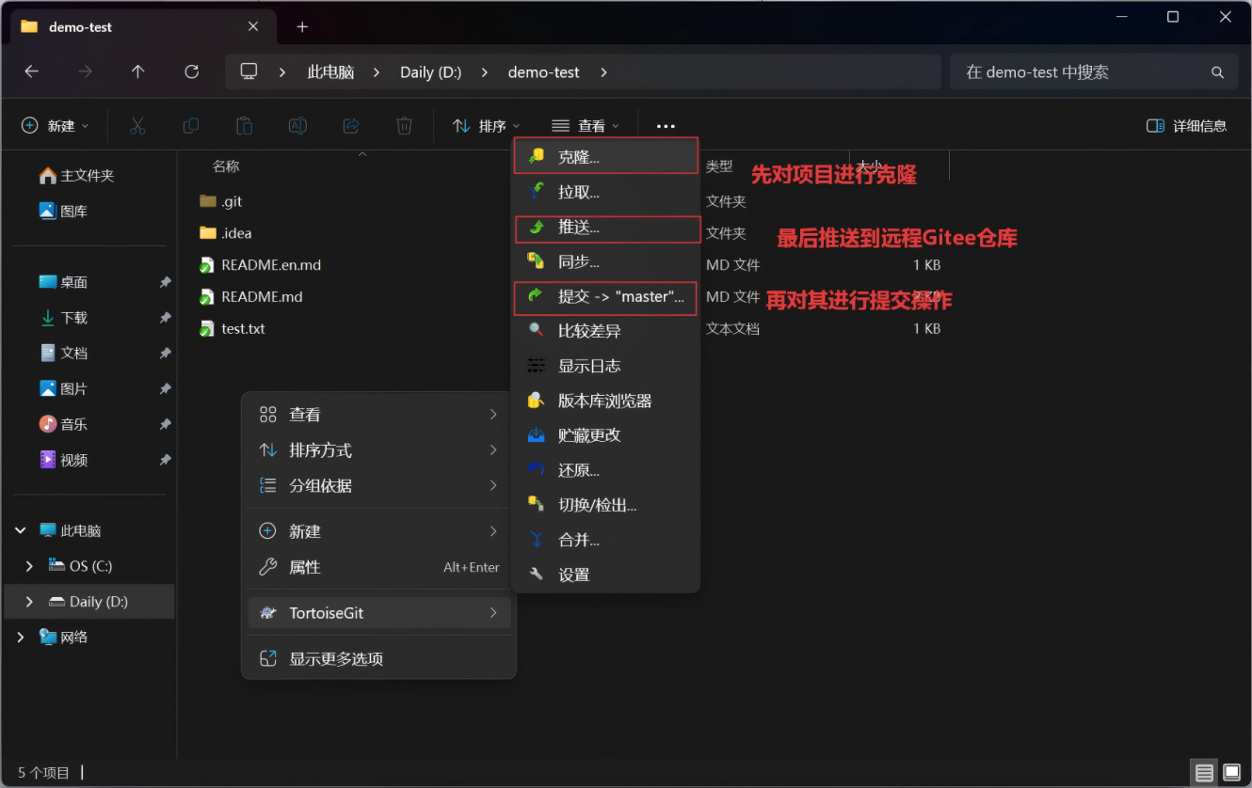

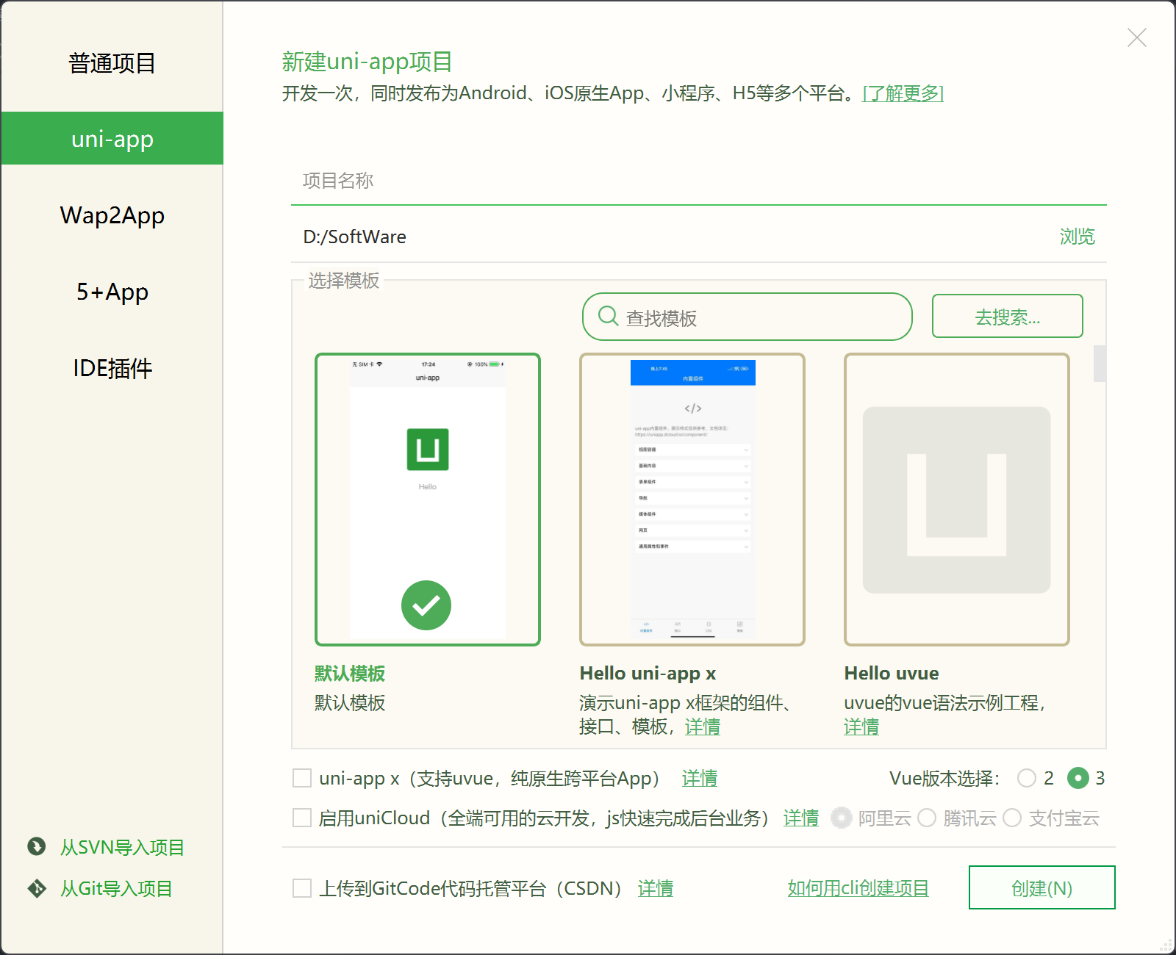
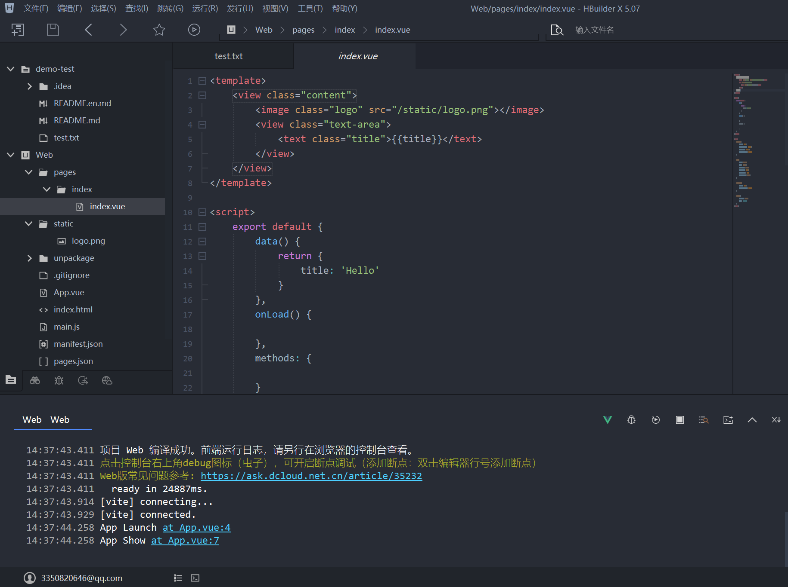
<template>
<view class="content">
<image class="logo" src="/static/logo.png"></image>
<view class="text-area">
<text class="title">{{title}}</text>
</view>
</view>
</template>
<script>
export default {
data() {
return {
title: 'Hello'
}
},
onLoad() {
},
methods: {
}
}
</script>
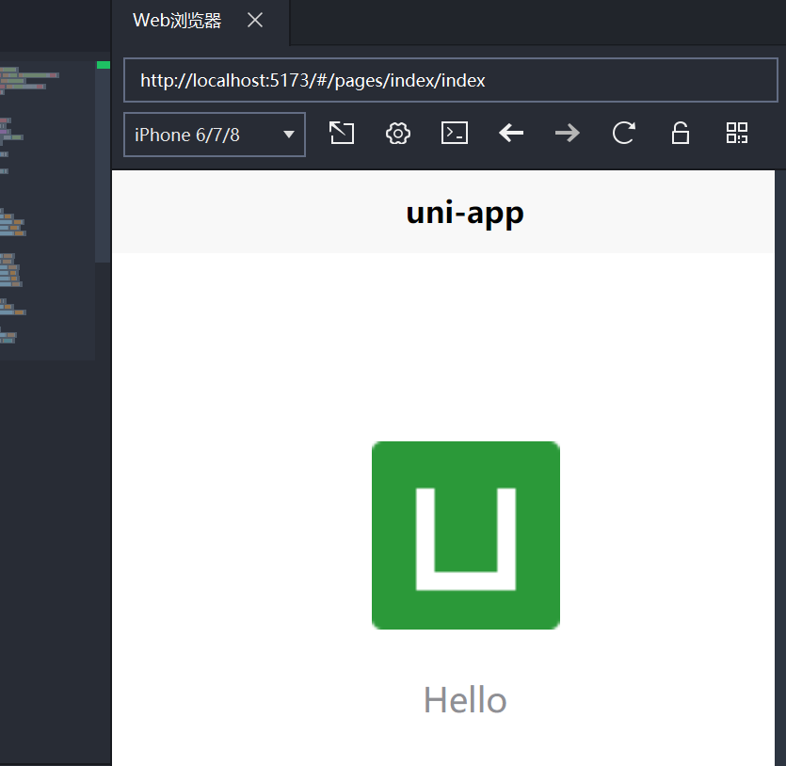
<script setup>
import { ref, computed, onUnmounted } from "vue";
// 核心状态
const phoneNumber = ref("");
const verificationCode = ref("");
const isagree = ref(false);
const loading = ref(false);
const countdown = ref(0);
let timer = null;
// 表单校验逻辑
const phoneError = computed(() => {
if (!phoneNumber.value) return "";
if (!/^1[3-9]\d{9}$/.test(phoneNumber.value)) return "手机号格式不正确";
return "";
});
const codeError = computed(() => {
if (!verificationCode.value) return "";
if (!/^\d{4,6}$/.test(verificationCode.value)) return "验证码格式不正确";
return "";
});
// 获取验证码
const getVerificationCode = () => {
if (phoneError.value || !phoneNumber.value) {
return uni.showToast({ title: phoneError.value || "请输入手机号", icon: "none" });
}
if (countdown.value > 0) return;
// TODO: 此处替换为实际的后端发送验证码接口调用
// await api.sendSmsCode(phoneNumber.value)
uni.showToast({ title: "验证码已发送", icon: "none" });
countdown.value = 60;
timer = setInterval(() => {
countdown.value--;
if (countdown.value <= 0) {
clearInterval(timer);
timer = null;
}
}, 1000);
};
// 协议状态变更
const agreeChange = (e) => {
isagree.value = e.detail.value.length > 0;
};
// 提交登录
const submitForm = () => {
if (phoneError.value || codeError.value) return;
if (!phoneNumber.value || !verificationCode.value) return;
if (!isagree.value) return uni.showToast({ title: "请先同意协议", icon: "none" });
loading.value = true;
// TODO: 此处替换为实际的后端登录接口调用
setTimeout(() => {
loading.value = false;
uni.showToast({ title: "登录成功", icon: "success" });
setTimeout(() => uni.reLaunch({ url: "/pages/index/index" }), 1500);
}, 1500);
};
// 组件卸载清理定时器
onUnmounted(() => {
if (timer) {
clearInterval(timer);
timer = null;
}
});
</script>
<template>
<view class="login-core">
<!-- 手机号输入 -->
<input
class="input-field"
type="tel"
placeholder="请输入手机号"
maxlength="11"
v-model="phoneNumber"
/>
<view class="error-tip" v-if="phoneError">{{ phoneError }}</view>
<!-- 验证码输入与按钮 -->
<view class="code-group">
<input
class="input-field"
type="number"
placeholder="请输入验证码"
maxlength="6"
v-model="verificationCode"
/>
<view class="code-btn" :class="{ 'disabled': countdown > 0 }" @click="getVerificationCode">
{{ countdown > 0 ? `${countdown}s` : "获取验证码" }}
</view>
</view>
<view class="error-tip" v-if="codeError">{{ codeError }}</view>
<!-- 协议勾选 -->
<checkbox-group @change="agreeChange">
<label>
<checkbox value="agree" :checked="isagree" />
<text>已阅读并同意相关协议</text>
</label>
</checkbox-group>
<!-- 提交按钮 -->
<button
class="submit-btn"
:disabled="!isagree"
:loading="loading"
@click="submitForm"
>
立即登录
</button>
</view>
</template>
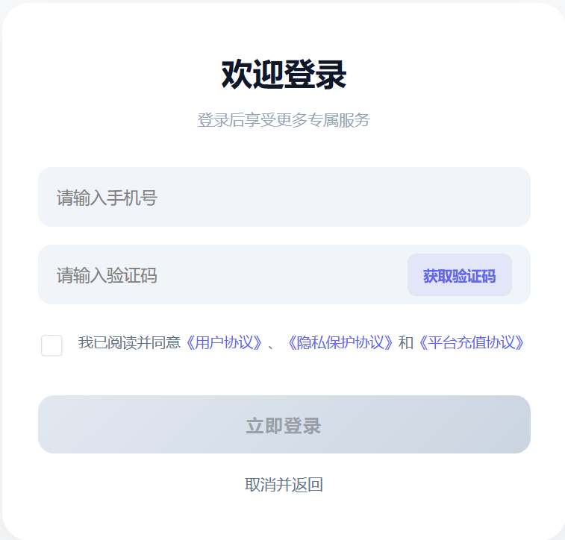

<script setup>
import { ref, computed } from 'vue';
// ================= 核心状态 =================
const phone = ref('');
const content = ref('');
const isAgreed = ref(false);
const loading = ref(false);
// ================= 表单校验 =================
const phoneError = computed(() => {
if (!phone.value) return '';
return /^1[3-9]\d{9}$/.test(phone.value) ? '' : '手机号格式不正确';
});
// ================= 计费逻辑 =================
// 假设逻辑：每 70 字为 1 条，单价 0.05 元
const price = computed(() => {
if (!content.value) return '0.00';
const count = Math.ceil(content.value.length / 70);
return (count * 0.05).toFixed(2);
});
// ================= 时间选择器核心逻辑 =================
const pad = n => String(n).padStart(2, '0');
const now = new Date();
const currentYear = now.getFullYear();
// 基础数据池
const rangeYears = Array.from({ length: 11 }, (_, i) => currentYear - 5 + i);
const rangeMonths = Array.from({ length: 12 }, (_, i) => i + 1);
const rangeHours = Array.from({ length: 24 }, (_, i) => i);
const rangeMinutes = Array.from({ length: 60 }, (_, i) => i);
const rangeSeconds = Array.from({ length: 60 }, (_, i) => i);
const getDays = (y, m) => new Date(y, m, 0).getDate(); // 获取某月最大天数
// 索引状态 (默认选中当前时间)
const indexY = ref(5); // 对应当前年份
const indexM = ref(now.getMonth());
const indexD = ref(now.getDate() - 1);
const indexH = ref(now.getHours());
const indexMin = ref(now.getMinutes());
const indexS = ref(now.getSeconds());
// 动态天数列表
const rangeDays = computed(() => Array.from({ length: getDays(rangeYears[indexY.value], rangeMonths[indexM.value]) }, (_, i) => i + 1));
// 格式化选中时间
const selectedTimeStr = computed(() => {
if (!rangeDays.value[indexD.value]) return '';
return `${rangeYears[indexY.value]}-${pad(rangeMonths[indexM.value])}-${pad(rangeDays.value[indexD.value])} ${pad(rangeHours[indexH.value])}:${pad(rangeMinutes[indexMin.value])}:${pad(rangeSeconds[indexS.value])}`;
});
const rangeData = computed(() => [
rangeYears.map(y => `${y}年`),
rangeMonths.map(m => `${m}月`),
rangeDays.value.map(d => `${d}日`),
rangeHours.map(h => `${pad(h)}时`),
rangeMinutes.map(m => `${pad(m)}分`),
rangeSeconds.map(s => `${pad(s)}秒`)
]);
const currentIndex = computed(() => [indexY.value, indexM.value, indexD.value, indexH.value, indexMin.value, indexS.value]);
// 列滚动联动处理
const syncDay = () => {
const maxD = rangeDays.value.length;
if (indexD.value >= maxD) indexD.value = maxD - 1;
};
const onColumnChange = (e) => {
const col = e.detail.column;
const val = e.detail.value;
if (col === 0) { indexY.value = val; syncDay(); }
else if (col === 1) { indexM.value = val; syncDay(); }
else if (col === 2) indexD.value = val;
else if (col === 3) indexH.value = val;
else if (col === 4) indexMin.value = val;
else if (col === 5) indexS.value = val;
};
// 确认选择
const onPickerChange = (e) => {
indexY.value = e.detail.value[0];
indexM.value = e.detail.value[1];
indexD.value = Math.min(e.detail.value[2], rangeDays.value.length - 1);
indexH.value = e.detail.value[3];
indexMin.value = e.detail.value[4];
indexS.value = e.detail.value[5];
};
// ================= 业务交互 =================
const checkAgree = (e) => { isAgreed.value = e.detail.value.length > 0; };
const submitOrder = () => {
if (!isAgreed.value) return uni.showToast({ title: '请同意协议', icon: 'none' });
if (!phone.value) return uni.showToast({ title: '请输入收件人手机号', icon: 'none' });
if (phoneError.value) return uni.showToast({ title: phoneError.value, icon: 'none' });
if (!content.value) return uni.showToast({ title: '请输入信件内容', icon: 'none' });
loading.value = true;

// TODO: 替换为实际下单接口
// const payload = { phone: phone.value, content: content.value, sendTime: selectedTimeStr.value, price: price.value }
// await api.createLetterOrder(payload)
setTimeout(() => {
loading.value = false;
uni.showToast({ title: '提交成功', icon: 'success' });
setTimeout(() => uni.reLaunch({ url: '/pages/index/index' }), 1000);
}, 1000);
};
</script>
<template>
<view class="core-form">
<!-- 手机号 -->
<view class="input-group">
<input type="number" v-model="phone" placeholder="收件人手机号" maxlength="11" />
<text class="err-msg" v-if="phoneError">{{ phoneError }}</text>
</view>
<!-- 内容区域 -->
<view class="input-group">
<textarea v-model="content" placeholder="信件内容..." maxlength="2000" />
<view class="bottom-meta">
<text>{{ content.length }}/2000</text>
<text class="price">￥{{ price }}</text>
</view>
</view>
<!-- 时间选择 -->
<view class="input-group time-row">
<text class="val-text">{{ selectedTimeStr || '请选择送达时间' }}</text>
<picker mode="multiSelector" :range="rangeData" :value="currentIndex" @change="onPickerChange" @columnchange="onColumnChange">
<text class="edit-text">修改时间</text>
</picker>
</view>
<!-- 协议 -->
<view class="agreement">
<checkbox-group @change="checkAgree">
<label><checkbox value="agree" :checked="isAgreed" /></label>
</checkbox-group>
<text>阅读并同意《用户协议》与《隐私政策》</text>
</view>
<!-- 提交 -->
<button class="send-btn" :disabled="!isAgreed || loading" :loading="loading" @click="submitOrder">
确认发送
</button>
</view>
</template>
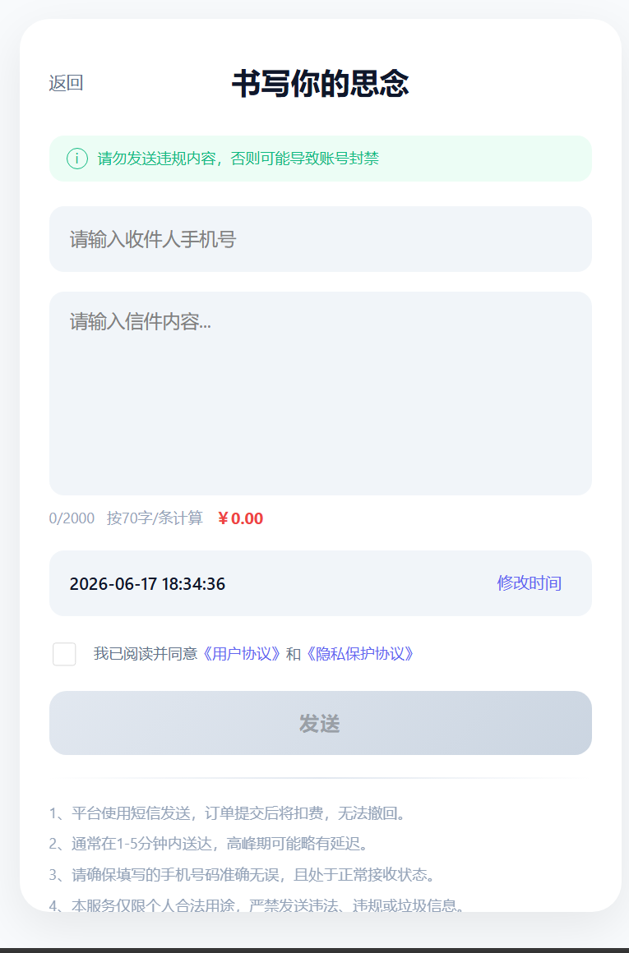
<template>
<view class="write-core">
<view class="header">
<text class="back" @click="goBack">←</text>
<text class="title">纸质书信</text>
</view>
<view class="editor-box">
<!-- 使用 @input 规避部分小程序端 v-model 兼容性问题 -->
<textarea :value="content" @input="onInput" maxlength="900" @focus="isFocused = true" @blur="isFocused = false" />
<view v-if="!content && !isFocused" class="placeholder">
<text>见字如面，请输入您的寄语。</text>
</view>
<text class="counter">{{ content.length }}/900</text>
</view>
<button class="next-btn" :disabled="!content.trim()" @click="handleNext">下一步</button>
</view>
</template>
<script setup>
import { ref } from 'vue';
// 1. 状态管理 (尝试恢复本地草稿)
const content = ref(uni.getStorageSync('currentLetterContent') || '');
const isFocused = ref(false);
// 2. 输入同步
const onInput = (e) => { content.value = e.detail.value; };
// 3. 业务跳转
const handleNext = () => {
if (!content.value.trim()) return uni.showToast({ title: '内容不能为空', icon: 'none' });
uni.setStorageSync('currentLetterContent', content.value);
uni.navigateTo({ url: '/pages/paper-letter/config' });
};
const goBack = () => {
uni.removeStorageSync('currentLetterContent');
uni.navigateBack();
};
</script>
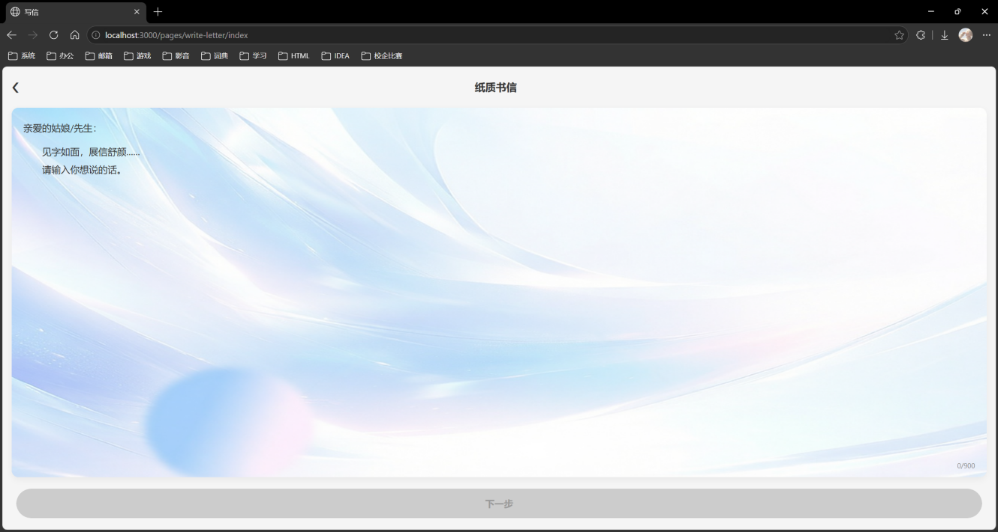
<template>
<view class="config-core">
<scroll-view scroll-y class="scroll-body">
<!-- 纸张选择 -->
<scroll-view scroll-x class="paper-list">
<view v-for="(img, i) in paperOptions" :key="i" :class="{ active: selectedPaper === i }" @click="selectedPaper = i">
<image :src="img" mode="aspectFill" />
</view>
</scroll-view>
<!-- 表单信息 -->
<input v-model="senderName" placeholder="寄信人姓名" class="form-input" />
<input v-model="senderPhone" type="tel" placeholder="寄件人手机号" class="form-input" />
<input v-model="receiverName" placeholder="收信人姓名" class="form-input" />
<input v-model="receiverPhone" type="tel" placeholder="收件人手机号" class="form-input" />
<view class="loc-trigger" @click="openRegionPicker">{{ locationDisplay }}</view>
<input v-model="detailAddress" placeholder="详细街道/门牌号" class="form-input" />
<!-- 寄出时间 -->
<view class="chip-group">
<view v-for="(t, i) in timeOptions" :key="i" :class="{ active: selectedTime === i }" @click="selectedTime = i">{{ t }}</view>
</view>
<!-- 信件类型 -->
<view class="type-group">
<view :class="{ active: selectedType === 'basic' }" @click="selectedType = 'basic'">基础版</view>
<view :class="{ active: selectedType === 'gift' }" @click="selectedType = 'gift'">礼盒版</view>
</view>
</scroll-view>
<button class="submit-btn" @click="handleSubmit">确认提交</button>
<!-- 地区选择器 Modal -->
<view v-if="showRegionPicker" class="mask" @click="showRegionPicker = false">
<view class="picker-modal" @click.stop>
<view v-for="item in currentOptions" :key="item" :class="{ active: isSelected(item) }" @click="selectOption(item)">
{{ item }}
</view>
</view>
</view>
</view>
</template>
<script setup>
import { ref, computed } from 'vue';
// 假设已引入地区数据源
import { provinces, getCities, getDistricts } from './region-data.js';
const paperOptions = ['img1.jpg', 'img2.jpg', 'img3.jpg'];
const timeOptions = ['今日寄出', '明日寄出', '3日后', '自定义'];
// 1. 表单状态
const senderName = ref(''), senderPhone = ref('');
const receiverName = ref(''), receiverPhone = ref(''), detailAddress = ref('');
const selectedPaper = ref(0), selectedTime = ref(0), selectedType = ref('basic');
// 2. 级联选择器状态
const showRegionPicker = ref(false);
const regionStep = ref('province'); // province -> city -> district
const selectedProvince = ref(''), selectedCity = ref(''), selectedDistrict = ref('');
// 3. 核心计算属性
const currentOptions = computed(() => {
if (regionStep.value === 'province') return provinces;
if (regionStep.value === 'city') return getCities(selectedProvince.value);
return getDistricts(selectedProvince.value, selectedCity.value);
});
const locationDisplay = computed(() => {
if (!selectedProvince.value) return '省 / 市 / 区';
const muni = ['北京', '上海', '天津', '重庆'];
let res = selectedProvince.value;
if (!muni.includes(selectedProvince.value) && selectedCity.value) res += ` ${selectedCity.value}`;
if (selectedDistrict.value) res += ` ${selectedDistrict.value}`;
return res;
});
const isSelected = (item) => {
if (regionStep.value === 'province') return item === selectedProvince.value;
if (regionStep.value === 'city') return item === selectedCity.value;
return item === selectedDistrict.value;
};
// 4. 级联逻辑处理
const selectOption = (item) => {
if (regionStep.value === 'province') {
selectedProvince.value = item;
const isMuni = ['北京', '上海', '天津', '重庆'].includes(item);
regionStep.value = isMuni ? 'district' : 'city';
if (isMuni) selectedCity.value = getCities(item)[0]; // 直辖市自动跳过市级
} else if (regionStep.value === 'city') {
selectedCity.value = item; regionStep.value = 'district';
} else {
selectedDistrict.value = item; showRegionPicker.value = false;
}
};
const openRegionPicker = () => { showRegionPicker.value = true; regionStep.value = 'province'; };
// 5. 提交校验
const handleSubmit = () => {
if (!senderName.value || !receiverName.value) return uni.showToast({ title: '请完善收件人信息', icon: 'none' });
if (!/^1[3-9]\d{9}$/.test(senderPhone.value)) return uni.showToast({ title: '寄件人手机格式错误', icon: 'none' });
if (!/^1[3-9]\d{9}$/.test(receiverPhone.value)) return uni.showToast({ title: '收件人手机格式错误', icon: 'none' });
if (!selectedDistrict.value) return uni.showToast({ title: '请选择完整省市区', icon: 'none' });
// TODO: 构造 Payload 并调用后端下单接口
const payload = {
content: uni.getStorageSync('currentLetterContent'),
paperIndex: selectedPaper.value,
sender: { name: senderName.value, phone: senderPhone.value },
receiver: { name: receiverName.value, phone: receiverPhone.value, address: locationDisplay.value + detailAddress.value },
timeType: selectedTime.value,
type: selectedType.value
};
console.log('Submit Payload:', payload);
};
</script>
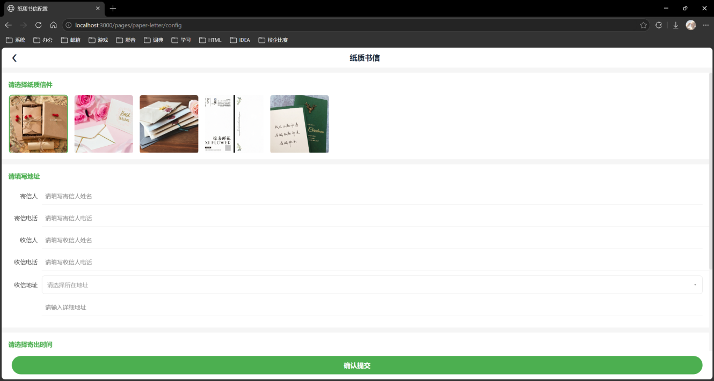
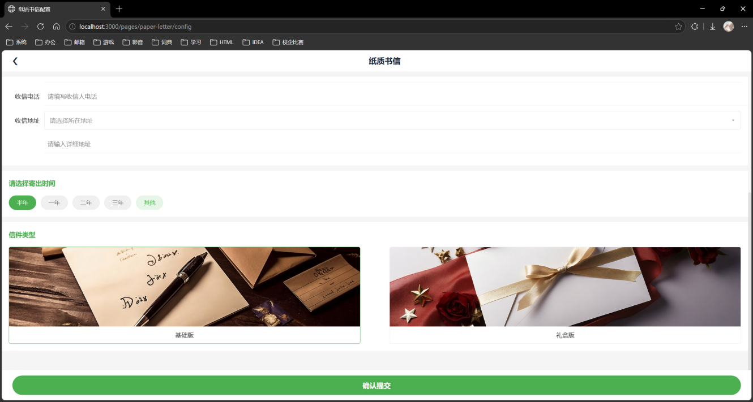

<template>
<view class="core-list">
<!-- 顶部导航 -->
<view class="nav-row">
<text class="back-btn" @click="goBackHome">← 返回</text>
<text class="page-title">数据列表</text>
</view>

<!-- 列表容器 -->
<view class="list-container">
<view class="list-item" v-for="item in listData" :key="item.id">
<text class="item-title">{{ item.title }}</text>
<view class="item-actions">
<button class="btn btn-edit" @click="handleEdit(item)">编辑</button>
<button class="btn btn-del" @click="handleDelete(item)">删除</button>
</view>
</view>
</view>
</view>
</template>
<script setup>
import { ref } from 'vue';
// 核心状态（演示数据，实际项目应替换为 API 请求）
const listData = ref([
{ id: 101, title: '示例数据 A', content: '' },
{ id: 102, title: '示例数据 B', content: '' },
{ id: 103, title: '示例数据 C', content: '' }
]);
// 编辑交互
const handleEdit = (item) => {
// TODO: 替换为实际跳转或弹窗编辑逻辑
uni.showToast({ title: `进入编辑：${item.title}`, icon: 'none' });
};
// 删除交互（含安全确认）
const handleDelete = (item) => {
uni.showModal({
title: '确认操作',
content: `确定要删除「${item.title}」吗？`,
success: (res) => {
if (res.confirm) {
// TODO: 替换为后端删除接口调用，成功后更新本地状态
listData.value = listData.value.filter(i => i.id !== item.id);
uni.showToast({ title: '删除成功', icon: 'success' });
}
}
});
};
// 路由返回
const goBackHome = () => {
uni.reLaunch({ url: '/pages/index/index' });
};
</script>
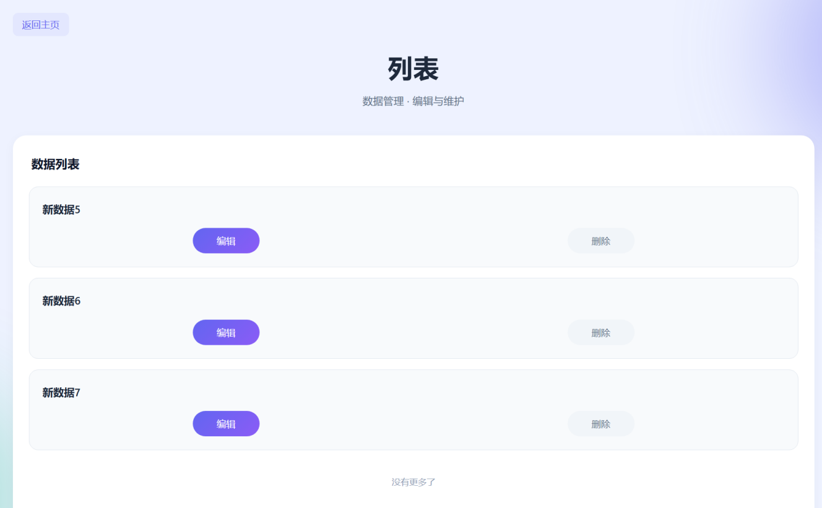

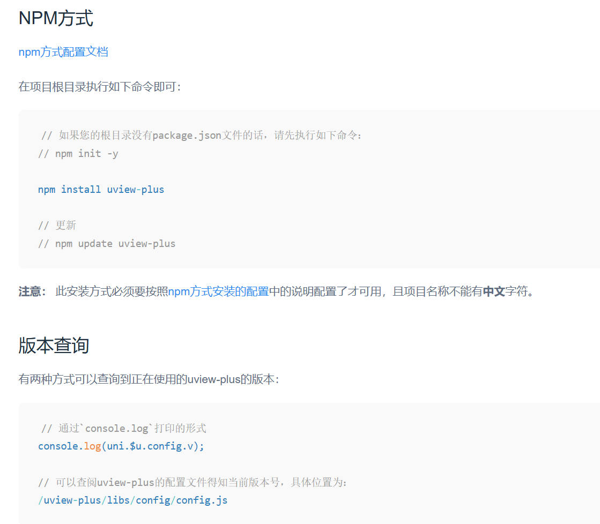
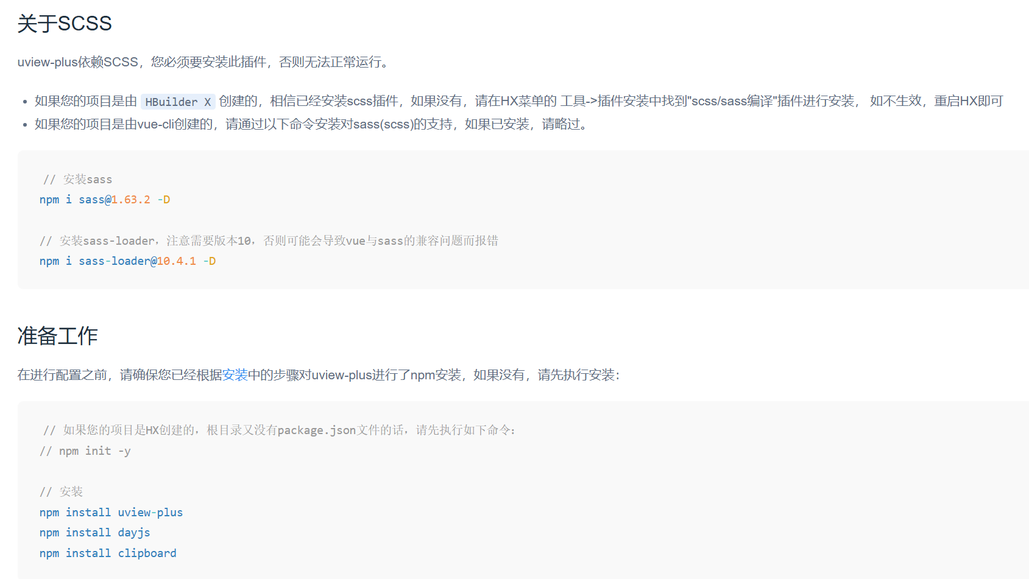
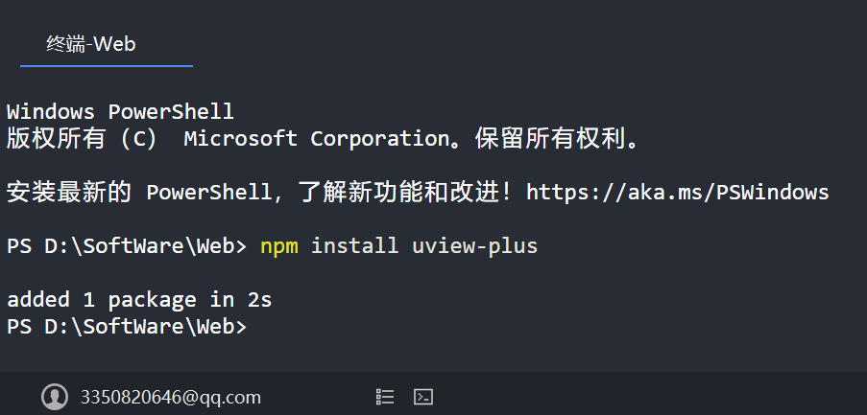
<script setup>
import { ref, getCurrentInstance } from 'vue'
const { proxy } = getCurrentInstance()
// 信纸列表
const paperList = ref([])
// 信件类型列表
const paperCateList = ref([])
// 寄出时长列表
const paperTimeList = ref([])
// 获取信纸列表
const getPaperList = () => {
proxy.$HTTP.requestPOSTLoading(
true, // 显示 Loading
proxy.$API.GETPAPERLIST,
{},
'',
(res) => {
console.log('信纸列表：', res)
paperList.value = res
},
(err) => {
console.error('请求失败：', err)
}
)
}
// 获取信件类型列表
const getPaperCateList = () => {
proxy.$HTTP.requestPOSTLoading(
true,
proxy.$API.GETPAPERCATELIST,
{},
'',
(res) => {
console.log('信件类型列表：', res)
paperCateList.value = res
},
(err) => {
console.error('请求失败：', err)
}
)
}
// 获取寄出时长列表
const getPaperTimeList = () => {
proxy.$HTTP.requestPOSTLoading(
true,
proxy.$API.GETPAPERTIMELIST,
{},
'',
(res) => {
console.log('寄出时长列表：', res)
paperTimeList.value = res
},
(err) => {
console.error('请求失败：', err)
}
)
}
</script>
var baseUrl = "https://nmsms.wwvnkpb.cn"
export default {
// 状态码
SUCCESS: "200", // 接口请求成功
FAIL: "500", // 错误信息
NEEDLOGIN: "201", // 登录
NEEADAUTH: "205", // 授权
LOCK: "202", // 锁定
BASEURL: baseUrl,
// 纸质信相关
GETPAPERLIST: baseUrl + "/api/Other/GetPaperListNt", // 获取信纸列表
GETPAPERCATELIST: baseUrl + "/api/Other/GetPaperCateListNt", // 获取信件类型列表
GETPAPERTIMELIST: baseUrl + "/api/Other/GetPaperTimeListNt" // 获取寄出时长列表
}
import URL from './url'
function requestPOST(toast, url, params, success, fail) {
requestLoading(toast, url, params, "POST", "", success, fail)
}
function requestPOSTLoading(toast, url, params, message, success, fail) {
requestLoading(toast, url, params, "POST", message, success, fail)
}
function requestGET(toast, url, params, success, fail) {
requestLoading(toast, url, params, "GET", "", success, fail)
}
function requestGETLoading(toast, url, params, message, success, fail) {
requestLoading(toast, url, params, "GET", message, success, fail)
}
function requestPUT(toast, url, params, success, fail) {
requestLoading(toast, url, params, "PUT", "", success, fail)
}
function requestPUTLoading(toast, url, params, message, success, fail) {
requestLoading(toast, url, params, "PUT", message, success, fail)
}
function requestDELETE(toast, url, params, success, fail) {
requestLoading(toast, url, params, "DELETE", "", success, fail)
}
function requestDELETELoading(toast, url, params, message, success, fail) {
requestLoading(toast, url, params, "DELETE", message, success, fail)
}

