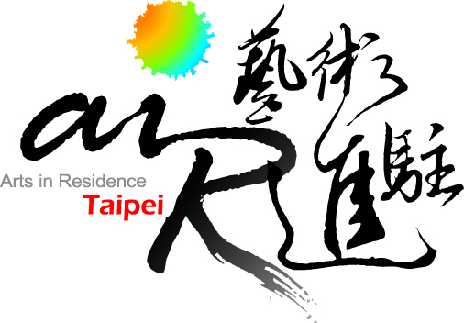

2013 OPEN CALL
FOR
INTERNATIONAL RESIDENCE PROJECTS

Guidelines：

- All materials included in and attached to this application must be typed, and presented in English.

- The application form should be completed in full. Incomplete applications will not be reviewed.

- Due to limitations of program resources, artist-in-residence grantees from 2011 and 2012 are not eligible to apply.

- E-mail applications will not be accepted. Applications are only accepted by post.

- Send two “hard” copies of all application materials on A4 paper, and a digital version on CD or DVD. All materials must use A4 paper, and be paper clipped on the upper left. Only printed publications may be accepted that are of a different size.

- Application deadline is May 20th (Sunday), 2012.

- Decisions will be announced by September, 2012, on TAV website. Do not provide original work as samples. Application material will not be returned; but may be collected in person, by appointment only, before the end of October 2012.

- Further inquiry: air@artistvillage.org or Contact “2013 AIR Selection Administration Team” at office hour: +886 2 3393 7377 or +886 2 2364 5313 ext 112.

Program Description:
AIR Taipei is consists of two sites and they are Taipei Artist Village (TAV) and Treasure Hill Artist Village (THAV).
TAV is a four story building located in the heart of Taiwan's vibrant Governmental District in Taipei City. Secluded by a serene garden, this facility, a former public office building for the Maintenance Engineering Public Works Bureau of Taipei City Government, has been renovated breathing new life into this thriving area. Since the establishment of TAV, the Cultural Affairs Bureau of Taipei has actively launched the artist-in-residence program as well as artist exchange programs with other international artist residency centers in different cities across the globe.
Located at the waterfront of Taipei City, THAV was listed in 2004 as the first “historic architectural community” by the Department of Cultural Affairs, Taipei City Government. The unique location of Treasure Hill with its narrow alleys and stairways traversing the hillside, gives THAV a rural village feel. Over the years, various groups settled the hillside with their own lifestyles and needs creating a tribal-like organic scene. With the existing residents, together with the urban policy of preservation and revitalization, the Artist-in-Residence program and Youth Hostel it is hoped that the parties will collaborate in the spirit of “paragenesis” to create a better future of the entire community.
- Residency location：Taipei Artist Village (No. 7, Beiping East Road, Taipei, Taiwan)
Treasure Hill Artist Village (No. 2, Aly. 14, Ln. 230, Sec. 3, Tingzhiu Rd., Taipei, Taiwan)
- Residency programs and schedules for each location are different. Please find the detailed descriptions in the Appendix 1. Projects with higher relevance to the specifications of each location are preferable.
- Admission to AIR Taipei International Residence Program is based on review of applications by the AIR Taipei Admission Committee. Residence projects from 3 categories are requested in 2013:
1) Projects from Individual Artists or Teams － including artists, curators, administrators or researchers with a professional background in any media or discipline, for example: visual art; public art; performing art; film or new media; creative fiction, nonfiction, or playwriting. This also includes artists who work/collaborate across more than one discipline.
2) Projects from Creative Industry － including designers, researchers or administrators of fashion, industrial / product design, art market, cultural heritage, publishing and cultural tourism etc.
3) Projects from Interdisciplinary and Business-Arts Collaboration － including interdisciplinary collaboration between arts disciplines, and all business- arts collaborative projects and/or corporate initiatives for the involvement of any creative activity, process or idea etc.

* Notice: The residence project must be designed for and relevant to one specific village responding to the individuality of the site. Projects for different sites should be submitted in separate applications.

Fellowship:
- AIR Taipei International Artist Residence
  - ELEVEN proposals will be accepted in 2013.
  - Selected artists will be provided with free accommodation and studio.
  - For Fellowship 1) no limitation for nationalities except from the Republic of China (Taiwan).
- Special Project: Sisters Cities of Taipei
  - THREE proposals will be accepted in 2013.
  - Selected artists will be provided with free accommodation and studio.
  - Selected artists will be provided with 1 round trip economic flight ticket.
  - Applicants for Fellowship 2) must be based in the following Sisters Cities of Taipei. Applicants must provide a recommendation letter from individuals or organizations of the following cities.
Asia | Manila (Philippines), Quezon City (Philippines), Seoul (Korea), Daegu (Korea), Ho Chi Minh City (Vietnam), Ulan Ude (Buryat), Ulan Bator (Mongolia),Yokohama (Japan)
Africa | Lomé (Togo), Cotonou (Benin), Johannesburg (South Africa), Pretoria (South Africa), Lilongwe (Malawi), Dakar (Senegal), Banjul (Gambia), Bissau (Guiné-Bissau), Mbabane (Swaziland), Monrovia (Liberia), Ouagadougou (Burkina Faso)
Australia | Gold Coast City, Perth
Central and South America | Asunción (Paraguay), Guatemala City (Guatemala), La Paz (Bolivia), Panama City (Panama), San José (Costa Rica), San Nicolás de los Garza (Mexico), Santo Domingo (Dominicana), Tegucigalpa (Honduras), Managua (Nicaragua), San Salvador (El Salvador),
Europe | Riga (Latvijas), Versailles (France), Vilnius (Lithuania), Warsaw (Poland)
Middle East | Jeddah (Saudi Arabia)
Oceania | Majuro (Marshall Islands)
USA | Houston, San Francisco, Guam, Cleveland, Indianapolis, Marshall, Phoenix, Los Angeles, Atlanta, Okalahoma, Boston, Dallas, Anchorage and Orange County.

NOTE: Artists are not required, but encouraged, to give exhibitions/performances at the end of their residency. AIR Taipei will provide logistic support but NOT monetary support.

How to Apply:
Eligibility:
- Applicants from the Republic of China (Taiwan) are NOT eligible to apply any of the 2 fellowships.
- Applicants must have a minimum of 3 years experience or professional practice. Students are not eligible to apply.
- Must be able to converse in English.

Complete Application Form
- Completed Application Form – this must be typed, and presented in English.
- One recommendation letter.
- Curriculum Vitae (in English) – the following information is requisite: educational qualifications, artistic experience, and education/work experience abroad.
- Portfolios. Samples should be representative of work, preferably produced within the past two years.
- Up to a maximum 6 pieces of works. No one piece should contain more than 4 images or exceed 2 minutes in length, OR an excerpt of works which in total should not exceed 24 images or longer than 12 minutes on PC (MICROSOFT) compatible CD-ROM//DVD/VCD on jpg or mpg format, Images should be of good quality and at least 200dpi jpg images. Due to the time limitation of review committee, all the images will be played by the given sequence.
- Other than printed publications, all materials should be printed in A4 format and paper clipped on the upper left. For the ease of reproducing copies, please do not staple, add covers, or use any binder.
Sending applications
- The application form and related information can be downloaded from AIR Taipei official website www.artistvillage.org under AIR Program, Application.
- All applications must be posted by registered mail or delivered in person to the front desk of TAV (No. 7 Beiping East Road, Taipei 10053). Please mark “2013 AIR” clearly on the envelope.
- Please submit the application by May 20th (Sunday), 2012 by post (postmark as the proof) or in person/delivery by 5:00 pm of the date. Email applications are NOT acceptable.
- Late/incomplete applications or those unable to meet the requested format will not be reviewed.
- For applications not selected, the materials may be returned to the applicant by post if a self-addressed stamped envelope is attached with the application, or can be picked up in person by appointment before October 2012. If there is insufficient postage or the applicant fails to collect their application by the set date, the applications will not be returned.
- For any further questions, please contact by email: air@artistvillage.org

Admission Process:
Open Application- Each applicant’s portfolio, as well as all supporting material will be screened by the AIR Taipei Admission Committee. The decision will be announced through the major press media and AIR TAIPEI website by September 2012.

Attention:
- The Committee will make selection decisions on the basis of the proposed projects without the consideration of allocation from different art forms or media.
- The selected applicants will need to sign an agreement with AIR Taipei and complete the residency project in the set year. If for any reason the applicant cannot fulfil the residency, the applicant will need to have AIR Taipei’s agreement or the residency will be regarded as forfeited and candidates on the waiting list will replace the applicant. No objection or correspondence will be entered into.
- The selected applicants will be committed to fulfil the full residency as agreed. If there is any reason to withdraw from the residency, the applicant should notify AIR Taipei for approval. During the residency, selected applicants who wish to travel will also need to notify AIR Taipei and follow the residency guidelines as stated in the agreement.
- The selected applicants should cooperate with AIR Taipei for the planned schedule of presentations, press campaign, educational program to the public and open studio, etc.
- Any confirmed violation to the guidelines, AIR Taipei has the right to discontinue the residency. The selected applicants should return to AIR Taipei the cost which has been paid.

Suggested Residency Schedule of the Villages
SUGGESTED RESIDENCY SCHEDULE
Time table |  | Taipei  Artist Village | Treasure Hill  Artist Village
1st Season | January ~ April , 2013
2nd Season | April ~ July , 2013
3rd Season | July ~ October , 2013
4th Season | October , 2013 ~ January , 2014
Number of weeks for residency schedule |  | minimum of 4, maximum of 8 | minimum of 12, maximum of 24

Appendix 1: The Statement of the Village ── Arts-in-Residence Taipei

Arts-in-Residence Taipei (AIR Taipei) provides a platform for diverse cultural collaboration across artistic disciplines throughout the globe. The capital of Taiwan, Taipei is AIR’S base encouraging professional artists exchanges between Taiwanese and international artists. These interactions help create intercultural and interdisciplinary dialogues that resonate between communities and individuals long after the artist’s residence is completed.

A “village” not a “museum”
A village is a community of people living and working together all calling the same place HOME. Both villages within AIR Taipei contain artist studios for living and working, support administration, performance venues and exhibition spaces. Rather than collecting and displaying objects AIR Taipei believes that ‘Work in Progress’ is a truly humane and engaging vision. In fact AIR Taipei is, as an organization, exactly this – a work in progress!

Two locations of the Villages
AIR Taipei is the umbrella organization overseeing two very different and unique artists-in-residence sites around the city. The Taipei Artist Village was establishment in 2001 by the Department of Taipei Cultural Affairs and has been developing relationships linking the artists exchange program with cities throughout the world. The second site Treasure Hill Artist Village, a historical architectural community, was launched in 2010. Both sites complement each other through diverse landscape, scale and location yet each site helps place the arts firmly in the cultural sights for a local and international audience.

Located in central Taipei the Taipei Artist Village is a great spot for artists to explore the urban landscape and offers easy access to activities and institutions throughout the city; Treasure Hill Artist Village is located in a special enclave in Taipei with its own history being part of the first wave of buildings in Taipei. It follows the idea of “paragenesis” creating dialogues between artists and the wider community providing the arts a social space for interacting and expressing ideas.

Cultivation of the Villages
1. Artists-in-Residence and Artists Exchange Program
AIR Taipei has developed a systematic artist selection scheme that provides the platform for artists to connect with the local and international community.
The scheme includes: 1) Open Call for both Taiwan and international artists 2) Sister Cities Artists Program and 3) Artist Exchange Program with global partner institutions.

By December 2010, 253 artists from 44 countries had taken the residence in AIR Taipei while 108 Taiwanese artists had been taken residences abroad in 32 cities of the world through Artists Exchange Program.

Over the years, AIR Taipei has taken on a lead role in nourishing the arts by providing opportunities for artists’ projects and residencies throughout the world as well as bringing into Taipei the intercultural aspirations of a global community

2. Exhibitions, performances and workshops
Resident artists bring diversity to both villages by creating challenging artworks and performances. Visual and performing art is regularly presented to the general community in the form of solo shows, group exhibitions and performances. All these artistic avenues help to activate discussion and ideas between local and international artists. Along with education programs, this combination of artists and community infuses surprises into the neighborhood and across the entire city.

“Artists Open Studio” offers audience an insight into the artists’ creativity by opening the doors of their studios for a weekend and letting the artist talk about their inspirations.

Children’s workshops help kids to feel and appreciate art spontaneously. Both resident international artists and teachers offer different cultural perspectives leading the children to expand their view of the world and increase racial tolerance. The two villages welcome reservations for guided group tours and fun educational workshops!

Prospect of the Villages
1. Artists-in-Residence – Interacting locally
AIR Taipei actively invites local communities to participate in the creative process either physically by volunteering or to attend an event. Activities are carried out locally and plugged back into the city.
2. Activating spaces – Conversing with the city
By activating diverse spaces throughout the city artists can, together with the cultural input of AIR Taipei, bring about an intercity conversation between Taipei and international cities helping to enhance the understanding of each other.
3. A day in the Village – A life in the Village
AIR Taipei constructs a global network for creative minds, builds an international platform for artistic exchange, creates a worldwide zone for stimulating ideas, and offers a space for innovative Taiwanese energy.
History of the Villages
※ Taipei Artist Village
Centrally located in Taipei City, housed in a modest building at No. 7 Beiping East Road, Taipei Artist Village (TAV) stands quietly among other magnificent structures, often going unnoticed by passerby. This four-storey building was once the office for the Department of Public Maintenance and Construction of the Taipei City Government and also temporarily, the office for the Taipei Rapid Transit Corporation. In October 2001 the city government’s Department of Cultural Affairs decided to transform the building into Taipei’s first artist village. Since May 2004, TAV has been running the “Artists-in-Residence” program collaborating with organizations around the world. It has instigated art and cultural events throughout the city and facilitated interactions between artists and local Taipei residents.

TAV’s 13 individual studio spaces, dance rehearsal space, piano studio, darkroom and performance hall, supports projects at various stages of development. Research, development, exhibitions, performances, and workshops are presented year round by artists working across a variety of fields. A multifunctional art, bar and dining space completes the village. Integrating the resources of the three villages, TAV creates both an international and interdisciplinary networking venue advancing civil esthetics and building bridges between different cultures.

※ Treasure Hill Artist Village
Located at the Section 3 of Ting-Zhou Road, Treasure Hill Artist Village (THAV) was listed in 2004 as the first “historic architectural community” by the Department of Cultural Affairs, Taipei City Government. Following on from the event “Taipei Treasure” in 2006 and various research projects in 2007-2009, AIR Taipei officially took over the operation of the THAV in 2010. The unique location of Treasure Hill with its narrow alleys and stairways traversing the hillside, gives THAV a European rural village feel. Over the years, various groups settled the hillside with their own lifestyles and needs creating a tribal-like organic scene. With the existing residents, together with the urban policy of preservation and revitalization, the Artist-in-Residence program and Youth Hostel it is hoped that the parties will collaborate in the spirit of “paragenesis” to create a better future of the entire community.

THAV provides 14 studios for the “Artists-in-Resident” program. In each 3-6 month residency the selected artists are encouraged to execute projects only after spending time observing the intricacies of the site. THAV also provides 2 rehearsal studios, exhibition spaces and various outdoor plazas spread throughout the village. These plazas are public open space and can be used for exhibition and performances. Another 10 arts and Culture Group Offices are provided on site for individuals and organizations creating a cluster and a platform for the arts and cultural exchange. Whilst the artist in residence projects are process based, running in tandem to these will be a curatorial approach (workshops, exhibitions and educational programs) that cultivates a village lifestyle encouraging participation for all segments of the community

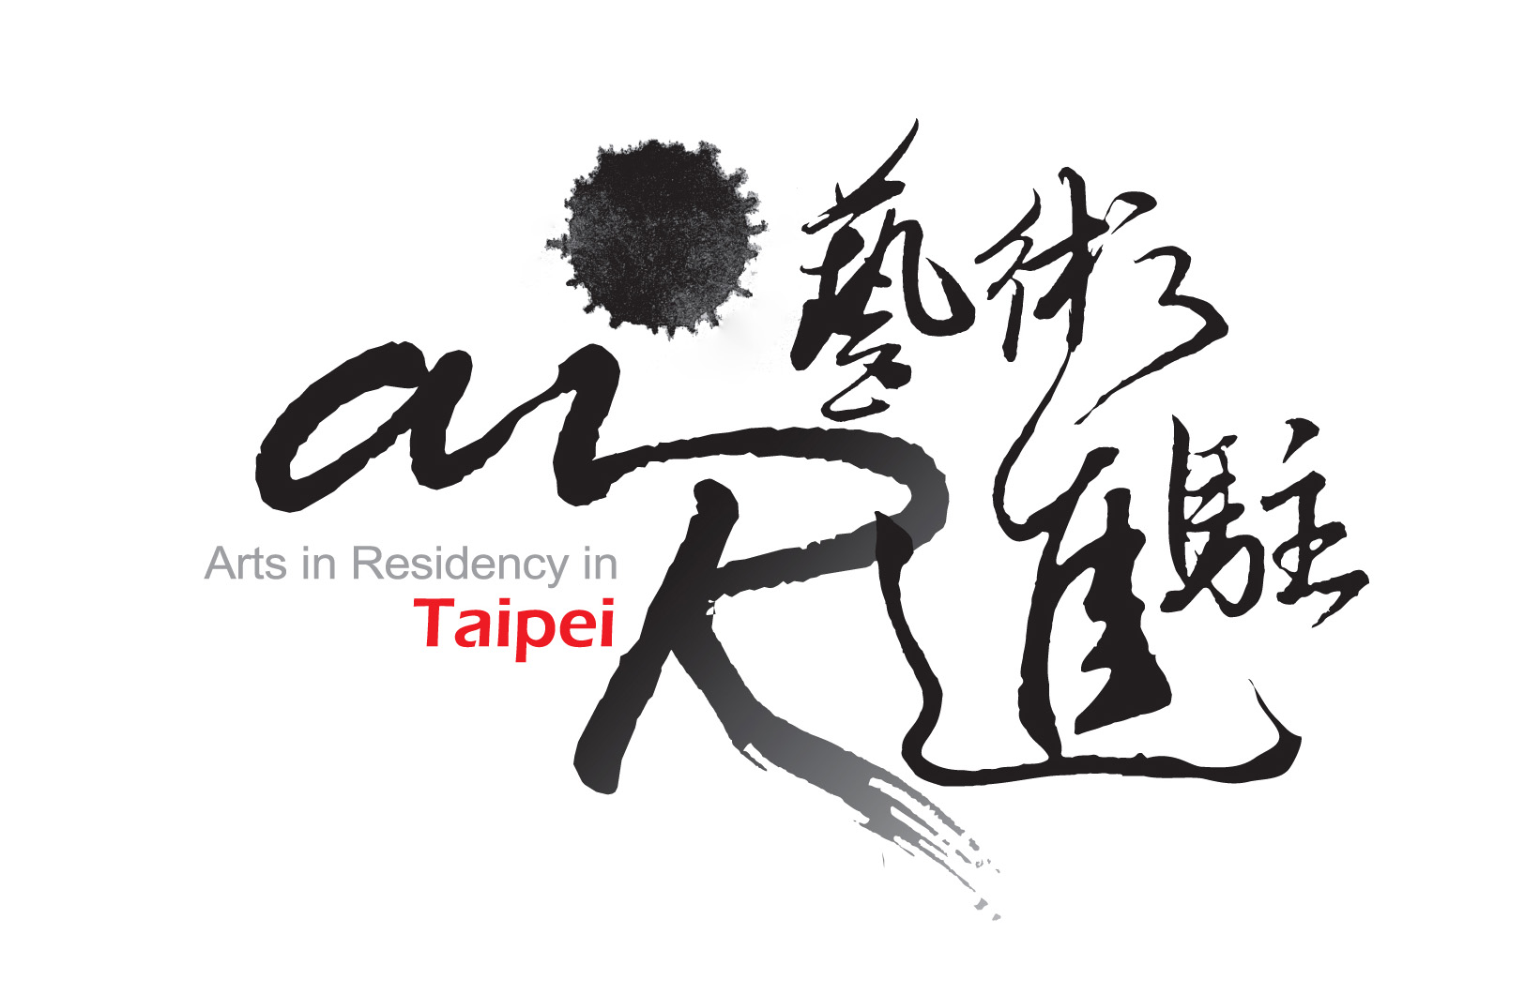

2013 OPEN CALL FOR
INTERNATIONAL RESIDENCE PROJECTS
Guidelines：
- All materials included in and attach to this application must be typed, and presented in English.
- The application form should be completed in full. Incomplete applications will not be reviewed.
- Due to limitations of program resources, artist-in-residence grantees from 2011 and 2012 are not eligible to apply.
- E-mail applications will not be accepted. Applications are only accepted by post.
- Send two ”hard” copies of all application materials on A4 paper, and a digital version on CD or DVD. All materials must use A4 paper, and be paper clipped on the upper left. Only printed publications may be accepted that are of a different size.
- Application deadline is May 20th (Sunday) , 2012 by postmark.
- Decisions will be announced by September, 2012, on TAV website. Do not provide original work as samples. Application material will not be returned; but may be collected in person, by appointment only, before the end of October 2012.
- For questions and further information, please contact：air@artistvillage.org

I have read the application form and notices, and agree to the regulations of applying for 2013 AIR program. Please check the type of fellowship and residency location as below (select only one for each).

Fellowship | Residency location
□ Fellowship 1: International Artist Residence  □ Fellowship 2: Special Project - Sister Cities Project | □ Taipei Artist Village  □ Treasure Hill Artist Village

Signature and date:
Further inquiry: air@artistvillage.org or
Contact “2013 AIR Selection Administration Team” during office hours: +886 2 3393 7377 or +886 2 2364 5313 ext 112

Applicant Information
Family Name  (Group) |  | Given Name
Contact Person
（Group Only）
Date of Birth | (day/month/year) | Sex |  Male  Female
Nationality |  | Residence
Email |  | Referee
Phone | Tel:  Mobile: | Fax
Address
List your participation in other Artist-in-Residency programs
（program/country/year）
How did you  know the program? |  website of AIR Taipei/ E-flyer of AIR Taipei   facebook   magazines / newspapers   art museum / institution (please specify)   others (please specify)

RESIDENCY SCHEDULE
(mark all possibilities for your residency)
Time table |  | Taipei  Artist Village | Treasure Hill  Artist Village
1st Season | January ~ April , 2013
2nd Season | April ~ July , 2013
3rd Season | July ~ October , 2013
4th Season | October , 2013 ~ January , 2014
Number of weeks for which you are applying |  | (minimum of 4, maximum of 8) | (minimum of 12, maximum of 24)

biographical highlights
Academic Background
Work Experience
Important Awards
（5 awards maximum）
Exhibitions or Performances within the past 5 Years
Major themes and ideas within your practice
（200 words maximum）
Residency Plan
(please refer to the selected residency location)
Type | （In 5 words or less, please briefly define your art practice, for example, Media, Prose, Classical Music, Modern Dance, etc.）
Residency Plan
（1000 words maximum）
A Brief Artist Statement（1000 words maximum）
Residency Presentation or Educational Programs（500 words maximum）

SUPPORT MATERIAL LIST
List of Sample Works
Samples must represent artworks from your art practice, preferably produced within the past two years - Up to a maximum 6 pieces of work. No one piece should contain more than 4 images or exceed 2 minutes in length, OR an excerpt of works which in total should not exceed 24 images or longer than 12 minutes, on PC (MICROSOFT) compatible CD-ROM/DVD/VCD on jpg or mpg format. Images should be of good quality and at least 200dpi jpg images.
Due to the time limitation of review committee, all the images will be played by the given sequence.
No. | Title | Content / Media | Description/Role | Length (minutes) | Year
Publication List of Submitted Material
Other than printed publications, all materials should be printed in A4 format and paper clipped on the upper left. For the ease of reproducing copies, please do not staple, add covers, or use any binder.
Please do not submit more than 2 items.
No. | Title | Content / Type | Publisher | Description/Role | Year

Recommendation Letter
（written by the referee）
Name |  | Telephone
Occupation |  | Title
Email
    - Affiliation with the applicant: _________.
    - Please brief describe the cooperation experience if there is any:
_________________________________________________________________________________
    - Do you recommend the applicant’s ability to execute the residency plan?
 Highly recommend  Recommend  Reluctantly recommend  Do not recommend
    - Do you recommend this residency plan?
 Highly recommend  Recommend  Reluctantly recommend  Do not recommend
Other supplements:

Signature and date:
*Personal signing of the referee is needed. Please mark “recommendation letter” clearly on the envelope.
**Please feel free to attach other supplements behind if there is any.

