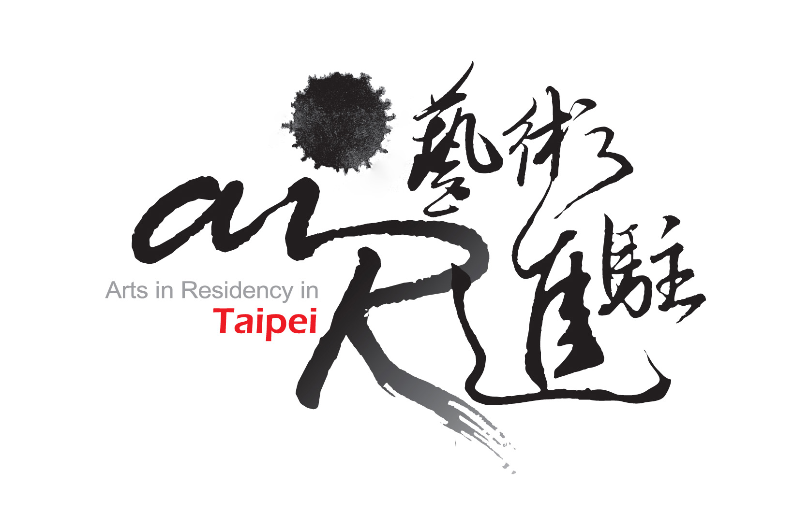

2013 OPEN CALL
FOR
EXHIBITION PROPOSALS

Guidelines：

- All materials included in and attach to this application must be typed, and presented in English.
- The application form should be completed in full. Incomplete applications will not be reviewed.
- Due to limitations of program resources, artist-in-residence grantees in 2012 are not eligible to apply.
- E-mail applications will not be accepted. Applications are only accepted by post.
- Send two ”hard” copy of all application materials on A4 paper, and a digital version on CD or DVD. All materials must use A4 paper, and be paper clipped on the upper left. Only printed publications may be accepted that are of a different size.
- Application deadline is May 20th (Sunday), 2012.
- Decisions will be announced by September, 2012, on AIR Taipei website. Do not provide original work as samples. Application material will not be returned; but may be collected in person, by appointment only, before the end of October 2012.
- Further inquiry: air@artistvillage.org or Contact “2013 Exhibition Selection Administration Team” at office hour: +886 2 3393 7377 ext 208.

Program Description:
Arts-in-Residence Taipei (AIR Taipei)’s mission is to catalyze interaction between contemporary artists, the local community and the wider public and has been serving as a springboard for artists from the global as well as local artists since the establishment of TAV in 2001 which locates in the central of Taipei City.
AIR Taipei invites artists or curators (individuals or groups) from all levels of experience to submit exhibition proposals for realization in its gallery space, Barry Room of TAV in 2013. Please see floor plans of the space in the attachment.
- Exhibition Space:
Barry Room, Taipei Artist Village (No. 7, Beiping East Road, Taipei, Taiwan)
- Admission to 2013 AIR Taipei Exhibition Program is based on review of applications by the AIR Taipei Admission Committee. Proposals must be original and conceived for AIR Taipei space i.e. may not have been realized in any other venue. Proposed exhibitions can be solo, two-person, or group and are open to all visual arts media. Proposals from 3 categories are requested in 2013:
1) Projects from Individual Artists or Teams － including artists, curators or researchers’ with a professional background in any media or discipline. This also includes artists who work/collaborate across more than one discipline.
2) Projects from Creative Industry － including designers, researchers or administrators of fashion, industrial/product design, art market, cultural heritage, publishing and cultural tourism etc.
3) Projects from Interdisciplinary and Business-Arts Collaboration － including interdisciplinary collaboration between arts disciplines, and all business- arts collaborative projects and/or corporate initiatives for the involvement of any creative activity, process or idea etc.

How to Apply:
Eligibility
- No limitation of nationalities for the applicants.
- Must be able to converse in English.
Complete Application Form
- Completed Application Form – this must be typed, and presented in English.
- One recommendation letter.
- Curriculum Vitae (in English) – the following information is requisite: educational qualifications, artistic experience, and education/work experience abroad.
- Portfolios. Samples should be representative of work, preferably produced within the past two years.
- Up to a maximum 6 pieces of works. No one piece should contain more than 4 images or exceed 2 minutes in length, OR an excerpt of works which in total should not exceed 24 images or longer than 12 minutes on PC(MICROSOFT) compatible CD-ROM//DVD/VCD on jpg or mpg format. Images should be of good quality and at least 200dpi jpg images.
- Other than printed publications, all materials should be printed in A4 format and paper clipped on the upper left. For the ease of reproducing copies, please do not staple, add covers, or use any binder.

Sending applications
- The application form and related information can be downloaded from AIR Taipei official website www.artistvillage.org under AIR Program, Application.
- All applications must be posted by registered mail or delivered in person to the front desk of TAV (No. 7 Beiping East Road, Taipei 10053). Please mark “2013 Exhibition” clearly on the envelope.
- Please submit the application by May 20th, 2012 by post (postmark as the proof) or in person/delivery by 5:00 pm of the date. Email applications are NOT acceptable.
- Late/incomplete applications or those unable to meet the requested format will not be reviewed.
- For applications not selected, the materials may be returned to the applicant by post if a self-addressed stamped envelope is attached with the application, or can be picked up in person by appointment before October 2012. If there is insufficient postage or the applicant failures to collect their application by the set date, the applications will not be returned.
- For any further questions, please contact by email: exhibition@artistvillage.org
Selected proposals are provided:
- Gallery space: free use of the gallery space, Barry Room of TAV, for 5 weeks (time for installing and removing the exhibition inclusive.)
- Equipments: Equipments will be provided as much as what are available. (Please see Appendix I & II or the floor plans and list of equipments.)
- Manpower: A limit number of volunteers will be provided to assist setting up and removing the exhibits.
- Promotional campaign: A limit number of printed flyers and posters, e-flyers and information on AIR Taipei website homepage.
- Other spaces: If any other spaces are needed, e.g. studios, accommodation, etc., selected are entitled with 20% discount for spaces rental fee.

Admission Process:
Open Application- Each applicant’s portfolio, as well as all supporting material will be screened by the AIR Taipei Admission Committee. The decision will be announced through the major press media and AIR Taipei website by September 2012.

Attention:
- The Committee will make selection decisions on the basis of the proposed projects without the consideration of allocation from different art forms or media.
- The selected applicants will need to sign an agreement with AIR Taipei and complete the exhibition in the set year. If for any reason the applicant cannot fulfil the exhibition, the applicant will need to have AIR Taipei’s agreement or the exhibition will be regarded as forfeited and candidates on the waiting list will replace the applicant. No objection or correspondence will be entered into.
- The selected applicants will be committed to fulfil the full residency as agreed. If there is any reason to withdraw from the residency, the applicant should notify AIR Taipei for approval. During the residency, selected applicants who wish to travel will also need to notify AIR Taipei and follow the residency guidelines as stated in the agreement.
- The selected applicants should cooperate with AIR Taipei for the planned schedule of presentations, press campaign, educational program to the public and open studio, etc.
- Any confirmed violation to the guidelines, AIR Taipei has the right to discontinue the residency. The selected applicants should return to AIR Taipei the cost which has been paid.

Appendix I 【Barry Room / Taipei Artist Village】

Equipment: Lighting, TV sets, Projectors, DVD players (available in small number)
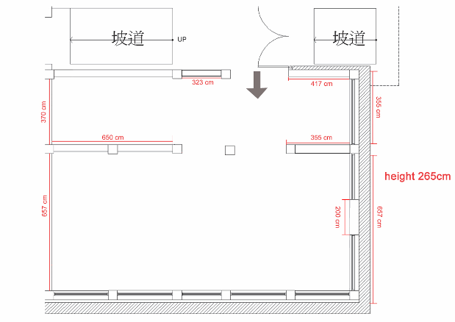

2013 OPEN CALL FOR

EXHIBITION PROPOSALS
Guidelines：

- All materials included in and attach to this application must be typed, and presented in English.
- The application form should be completed in full. Incomplete applications will not be reviewed.
- E-mail applications will NOT be accepted. Applications are only accepted by post.
- Send three ”hard” copies of all application materials on A4 paper, and a digital version on CD or DVD. All materials must use A4 paper, and be paper clipped on the upper left. Only printed publications may be accepted that are of a different size.
- Application deadline is May 20th, 2012 (Sunday) by postmark.
- Decisions will be announced by September, 2012, on AIR Taipei website. Do not provide original work as samples. Application material will not be returned; but may be collected in person, by appointment only, before the end of October 2012.
- For questions and further information, please contact：air@artistvillage.org

□ I have read the application form and attentions, and agree to the regulations of applying for AIR Taipei 2013 Exhibition Program at Taipei Artist Village

Signature and date:

Further inquiry: air@artistvillage.org or
Contact “2013 Exhibition Proposals Execution Team” during office hours: +886 2 3393 7377

Applicant Information
Family Name  (Group) |  | Given Name
Contact Person
（Group Only）
Date of Birth | (day/month/year) | Sex |  Male  Female
Nationality |  | Residence
Email |  | Referee
Phone | Tel:  Mobile: | Fax
Address
List your previous exhibition projects
（program/country/year）
How did you know about this program? |  website of AIR Taipei/ E-flyer of AIR Taipei   facebook   magazines / newspapers   art museum / institution (please specify)   others (please specify)

Exhibition SCHEDULE
(mark all possibilities for your project)
Time table |  | Taipei Artist Village
1st Season | February 25 ~ March 31, 2013
2nd Season | June 17 ~ July 21, 2013
3rd Season | October 21 ~ November 24, 2013

biographical highlights
Academic Background
Work Experience
Important Awards
（5 awards maximum）
Exhibitions or Performances within the past 5 Years
Major themes and ideas within your practice
（200 words maximum）
Exhibition Plan
(please refer to the selected location)
Type | （In 5 words of less, please briefly define your art practice, for example, Media, Prose, Classical Music, Modern Dance, etc.）
Exhibition Plan
（1000 words maximum）
A brief artist statement
（1000 words maximum）
Extended or educational programs
（500 words maximum）

SUPPORT MATERIAL LIST
List of Sample Works
Samples must present artworks from your art practice, preferably produced within the past two years - Up to a maximum 6 pieces of work. No one piece should contain more than 4 images or exceed 2 minutes in length, OR an excerpt of works which in total should not exceed 24 images or longer than 12 minutes, on PC (MICROSOFT) compatible CD-ROM/DVD/VCD on jpg or mpg format. Images should be of good quality and at least 200dpi jpg images.
Due to the time limitation of review committee, all the images will be played by the given sequence.
No. | Title | Content / Media | Description/Role | Length (minutes) | Date(s)
Publication List of Submitted Material
Other than printed publications, all materials should be printed in A4 format and paper clipped on the upper left. For the ease of reproducing copies, please do not staple, add covers, or use any binder.
Please do not submit more than 2 items.
No. | Title | Content / Type | Publisher | Description/Role | Date

Recommendation Letter
（written by the referee）
Name |  | Telephone
Occupation |  | Title
Email
    - Affiliation with the applicant: _________.
    - Please brief describe the cooperation experience if there is any: _________________________________________________________________________________
    - Do you recommend the applicant’s ability to execute the exhibition plan?
 Highly recommended  Recommended  Reluctantly recommended  Do not recommended
    - Do you recommend this exhibition plan?
 Highly recommended  Recommended  Reluctantly recommended  Do not recommended
Other supplements：

Signature and date:
*Personal signing of the referee is needed. Please mark “recommendation letter” clearly on the envelope.
**Please feel free to attach other supplements behind if there is any.

