
FYP-Monthly-Report-November
Topic: Web3 Phishing Attack games
Supervisor: Professor Wang Ye, TA Guan Young Qi
Student: LEONG CHON MENG DC226771
November Work Summary: Web3 Security Serious Game Design
1. Theoretical Framework Analysis & Research
Analyzed "Serious Game" Pedagogical Models: In-depth analysis of the use of Quinn's (2005) "e-Learning simulation" definitions applied to Web3 security. Focus on the "Health Belief Model" (HBM) as the foundational psychological driver for behavior modification.
Studied threat models, including a review of academic literature and security reports (Tan et al., 2025; Microsoft Security, 2022), to understand the attack vectors: Social Engineering, Ice Phishing-authorization attacks, and Address Poisoning.
Defined Cognitive Objectives: The learning objectives for the user were established, mapping game mechanics to HBM pillars.
Perceived Severity: Catastrophic loss of assets simulated.
Perceived Susceptibility: Breaking the "it won't happen to me" bias.
Self-Efficacy: Building confidence through "safe failure" (Trial and Error).
2. Iterative Game Design & Mechanics ("Game Change Designing")
Moved from Passive to Active Learning: The tutorial approach was redesigned. Instead of simple instructions, the design now integrates active "traps" where, through observation, the player has to fail or succeed.
Designed the "Novice to Expert" User Journey: Structured a path mirroring a real Web3 user's lifecycle:
Onboarding: Setting up a wallet -> Asset management: CEX/on ramp -> DeFi interaction: DEX/airdrop -> Advanced Defense: Permission revoking.
Developed analytical feedback loops: Designed the backend logic to not just train but also track user blind spots, such as logging whether a user falls for visual UI tricks versus social engineering trust tricks.
3. Detailed Level Architecture & Scenario Construction Refined the specific logic for the core gameplay levels to ensure high fidelity to real-world scams:

Game design purpose:
This report aims at proposing a design scheme for a Web3 Security Training Platform in the form of a "Serious Game." Here, by serious game, I mean an "e-Learning simulation" of explicit instructional goals (Quinn, 2005). Its core value lies in being able to provide a risk-free high-fidelity environment where learners can acquire, through Trial and Error, skills without causing an actual loss of assets.
The Health Belief Model forms the core rationale behind this platform. High-intensity contextualized simulation training seeks to systematically reshape threat perception and defensive behaviors of Web3 users through this system. The game is going to simulate a complete onboarding path of a Web3 user and will guide the player along different stages starting from novice to advanced. The key operations during a player's journey will be in the following order:
Basic Operations: Emulation of wallet download, creating an account, and safely recording mnemonic phrases.
Asset Management: This includes credit card deposits, on-ramping, the evaluation, and utilization of Centralized Exchanges, and transfers.
Web3 Interaction: Learn to connect to a DEX, simulate investing in DeFi projects, buy NFTs, and claim airdrops.
Security Practices: Carrying out the main security operations, by means of checking allowances, including revoking permissions.
In all of the above, the core mechanism is not simply operational tutorials but integrating three core threat models. While doing these daily operations, it is up to the player to actively make judgments and identify hidden phishing traps or malicious content.
In total, the content of this game will focus on the most destructive types of attacks in the Web3 world that most frequently exploit human error. Through this series of highly contextualized levels, players will deeply learn how to deal with the following three core threats:
Social Engineering: All attacks are founded on this basis. In the game, attackers will simulate inducing players to make wrong decisions through a variety of methods such as building trust, impersonating communities, and fake airdrops as described by Tan et al. (2025).
Authorization Attacks-Ice Phishing: The game will be targeting this unique Web3 threat by recreation of the process of tricking users into signing malicious "Approvals" in order to train players in identifying interface traps in wallet pop-ups, as described by Microsoft Security (2022).
Address Poisoning: Players have to overcome the obstacle of transfer fraud using "similar start/end addresses." This challenge strives to surmount cognitive laziness when it comes to address checking-as analyzed in Characterizing Ethereum Address Poisoning Attack, n.d. More importantly, this is not a pure training tool but an analytical tool. We will leverage the system to analyze player behavior data, record in what kind of specific scenarios or interfaces players are most likely to be deceived-for instance, what kind of airdrop lowers their guard or at what transfer step they skip checking the address. Through the analysis of these "potential phishing points," we are able to quantify users' common blind spots in cognition and iteratively optimize level difficulty and instructional prompts for more precise reshaping of defensive behaviors.

Enhancing Threat Perception
Component | Definition & Goal | Gamified Simulation Method
Perceived Severity | The user's subjective perception of the catastrophic consequences caused by malicious IT attacks (e.g., losing control of the entire wallet). | By simulating catastrophic asset loss (e.g., an in-game alert of irreversible token theft), users deeply experience the negative consequences of incorrect operations.
Perceived Susceptibility | The user's subjective probability that malicious IT attacks (e.g., NFT trading, airdrops, DeFi investments) will negatively affect them. | By simulating scam scenarios that come from the community and appear legitimate and contextually relevant, the game breaks the user's "it won't happen to me" mentality.

Reshaping Defense Assessment
Component | Definition & Goal | Gamified Mechanism
Safeguard Effectiveness | The user's assessment of the effectiveness of protective measures (e.g., checking signature authorization content, verifying official domains) in avoiding threats. | Through Immediate Feedback upon winning a level, demonstrating that correct defensive actions can immediately stop an attack, establishing the belief that defense is "effective."
Safeguard Cost | The user recognizes that the physical and cognitive effort required for defense (e.g., time, inconvenience, difficulty of understanding) is low. | Through simple and clear game mechanisms (e.g., a convenient operation of spending just two more seconds to check an address or a one-click revoke), reinforcing the perception of "low cost, high return."

Building Final Confidence
Self-Efficacy: Through all the above training, users build "personal confidence in taking protective measures," ensuring that when they face complex threats in the real world, they believe they have the ability to make the correct decisions.
Attack Principle and Human Factor
Basis: Address Poisoning Attacks take advantage of users' cognitive laziness about addresses and their partial comparison habit. Characterizing Ethereum Address Poisoning Attack
Mechanism: The attacker sends a transaction of negligible value to the wallet of the victim. The only purpose is to make the attacker's malicious address appear in the "recent transaction history" of the victim. The first few and last few characters of this malicious address are highly similar to some legitimate address which is frequently used by the victim.
Key Human Factor: People are accustomed to copying the last sent address from the transaction history while doing a transfer, and they check only the first and last few characters of the address. Thus, by mistake, they copy the malicious address and transfer funds to the attacker.
Gamified Training Design
This level will rely on data collection in social engineering for building context-a simulated instance of how attackers use trust and historical data to conduct attacks. Source: Tan et al., 2025, in "Human Factors in Information Security".
HBM Element | Level Design Element | Game Mechanism
Perceived Severity | Simulate Large Asset Mistransfer | The player is tasked with transferring a high-value game token (e.g., paying a "partner's salary"), but both the malicious address and the legitimate address exist in the transfer interface. An incorrect transfer results in mission failure and permanent asset loss.
Perceived Susceptibility | Simulate Community Trust Building | Create a "Friend Character" in the game (based on social scam methods mentioned in "Human Factors in Information Security"), who initially provides correct investment info. Once trust is built, the friend implies a "quick transfer" is needed to seize an opportunity, prompting the player to skip the full address check.
Safeguard Effectiveness | Mandatory Full Address Matching | The player must perform a "Full Address Comparison" operation, lighting up all matching characters to trigger the immediate feedback of successful protection.
Safeguard Cost | Training Visual Memory | The game challenge requires players to overcome the habit of copying addresses while under settings like MetaMask's middle truncation, training players to verify the full address before trading.
Flow Chart code
graph TD
%% --- Initialization ---
Start((Start Assessment)) --> PreTest{Prior Knowledge Check}

subgraph Phase0 [Phase 0: Scaffolding]
PreTest -- Novice --> Scaffold["Instruction: PKI Basics & Non-custodial Responsibility"]
Scaffold --> P1_Stimulus
PreTest -- Experienced --> P1_Stimulus
end

%% --- Phase 1: Infrastructure Sourcing (The Wallet Download) ---
subgraph Phase1 [Phase 1: Supply Chain & Infrastructure Integrity]
P1_Stimulus["Stimulus: Need to Download Wallet App"] --> P1_Choice{Decision: Source Selection}

%% Path A: Google (Assumed Safe per design)
P1_Choice -- "Google Search (Top Result)" --> P1_Pass_Google["Outcome: Official Site<br>(Safe Path)"]

%% Path B: Discord (Assumed Safe per design)
P1_Choice -- "Discord Community (Manager Link)" --> P1_Pass_Discord["Outcome: Social Proof Validated<br>(Safe Path)"]

%% Path C: X / Twitter (The Trap)
P1_Choice -- "X (Twitter) 'Urgent Update' Post" --> P1_Trap_X["Trap: Typosquatted Domain<br>(metarnask.io)"]
P1_Trap_X --> P1_Action{Action: Click Link?}

P1_Action -- "Click immediately (Panic)" --> P1_Fail_Urgency["FAIL: Succumbed to Urgency"]
P1_Fail_Urgency -.-> Err_Urgency["[Error Captured]<br>Metric: Urgency/Fear Appeal Susceptibility"]

P1_Action -- "Click without reading URL" --> P1_Fail_Typo["FAIL: Visual Oversight"]
P1_Fail_Typo -.-> Err_Typo["[Error Captured]<br>Metric: Typosquatting Blindness"]
end

P1_Pass_Google --> P2_Stimulus
P1_Pass_Discord --> P2_Stimulus

%% --- Phase 2: Key Management (Storage) ---
subgraph Phase2 [Phase 2: Secret Key Management]
P2_Stimulus["Stimulus: Backup 12-Word Seed Phrase"] --> P2_Action{Decision: Storage Medium}

P2_Action -- "Digital (Screenshot/Cloud/Email)" --> P2_Fail["FAIL: Attack Surface Exposure"]
P2_Fail -.-> Err_Cloud["[Error Captured]<br>Metric: Cloud Security Misconception"]

P2_Action -- "Analog (Physical Paper)" --> P2_Pass["Pass: Air-gapped Storage"]
end

P2_Pass --> P3_Stimulus

%% --- Phase 3: Capital Injection (Fiat On-Ramp) ---
subgraph Phase3 [Phase 3: Source of Funds Verification]
P3_Stimulus["Stimulus: Deposit via Credit Card"] --> P3_Action{Decision: Channel Selection}

P3_Action -- "Discord DM (30% Discount Link)" --> P3_Fail["FAIL: Trusting Unsolicited DM"]
P3_Fail -.-> Err_Social["[Error Captured]<br>Metric: Baiting/Greed Susceptibility"]

P3_Action -- "Official App / Exchange" --> P3_Pass["Pass: Channel Verified"]
end

P3_Pass --> P4_Stimulus

%% --- Phase 4: Direct Threats (Cognitive Inertia) ---
subgraph Phase4 [Phase 4: Transaction Pattern Recognition]
%% Module A: Address Poisoning
P4_Stimulus["Stimulus: Transfer to Friend<br>(History shows similar address)"] --> P4_Action{Decision: Address Selection}

P4_Action -- "Copy recent (Head/Tail match)" --> P4_Fail["FAIL: Address Poisoning"]
P4_Fail -.-> Err_Inertia["[Error Captured]<br>Metric: Cognitive Inertia / Heuristic Bias"]

P4_Action -- "Verify Full String" --> P4_Pass["Pass: Integrity Check"]

%% Module B: Spam Token
P4_Pass --> P4_Spam_Stimulus["Stimulus: Received Mystery High-Value Token"]
P4_Spam_Stimulus --> P4_Spam_Action{Decision: Handling}

P4_Spam_Action -- "Trade/Sell on DEX" --> P4_Spam_Fail["FAIL: Malicious Interaction"]
P4_Spam_Fail -.-> Err_Curiosity["[Error Captured]<br>Metric: Curiosity/Greed Vector"]

P4_Spam_Action -- "Ignore/Hide" --> P4_Spam_Pass["Pass: Risk Avoidance"]
end

P4_Spam_Pass --> P5_Stimulus

%% --- Phase 5: Platform Verification (CEX & DEX) ---
subgraph Phase5 [Phase 5: Platform Due Diligence]
%% Module A: CEX Analysis
P5_Stimulus["Stimulus: Choose CEX for Trading"] --> P5_Tools["Tool: FinCEN MSB Search & Volume Charts"]
P5_Tools --> P5_CEX_Action{Decision: Platform Choice}

P5_CEX_Action -- "Unregistered / Low Volume" --> P5_CEX_Fail["FAIL: High Counterparty Risk"]
P5_CEX_Fail -.-> Err_Analysis["[Error Captured]<br>Metric: Lack of Analytical Diligence"]

P5_CEX_Action -- "Regulated + High Volume" --> P5_CEX_Pass["Pass: Institutional Trust"]

%% Module B: DEX Authentication
P5_CEX_Pass --> P5_DEX_Stimulus["Stimulus: Connect to DEX Interface"]
P5_DEX_Stimulus --> P5_DEX_Action{Decision: Auth Method}

P5_DEX_Action -- "Input Seed Phrase / Password" --> P5_DEX_Fail["FAIL: Phishing (Credential Harvesting)"]
P5_DEX_Fail -.-> Err_Phish["[Error Captured]<br>Metric: Semantic Protocol Confusion"]
P5_DEX_Action -- "WalletConnect Protocol" --> P5_DEX_Pass["Pass: Correct Authentication"]
end
P5_DEX_Pass --> End((Training Complete))
%% --- Styling ---
style P1_Fail_Urgency fill:#ffcccc,stroke:#333
style P1_Fail_Typo fill:#ffcccc,stroke:#333
style P2_Fail fill:#ffcccc,stroke:#333
style P3_Fail fill:#ffcccc,stroke:#333
style P4_Fail fill:#ffcccc,stroke:#333
style P4_Spam_Fail fill:#ffcccc,stroke:#333
style P5_CEX_Fail fill:#ffcccc,stroke:#333
style P5_DEX_Fail fill:#ffcccc,stroke:#333

%% Style for Error Tags (The dashed yellow boxes)
style Err_Urgency fill:#fff5e6,stroke:#f66,stroke-dasharray: 5 5
style Err_Typo fill:#fff5e6,stroke:#f66,stroke-dasharray: 5 5
style Err_Cloud fill:#fff5e6,stroke:#f66,stroke-dasharray: 5 5
style Err_Social fill:#fff5e6,stroke:#f66,stroke-dasharray: 5 5
style Err_Inertia fill:#fff5e6,stroke:#f66,stroke-dasharray: 5 5
style Err_Curiosity fill:#fff5e6,stroke:#f66,stroke-dasharray: 5 5
style Err_Analysis fill:#fff5e6,stroke:#f66,stroke-dasharray: 5 5
style Err_Phish fill:#fff5e6,stroke:#f66,stroke-dasharray: 5 5
https://mermaid.live/edit#pako:eNqlWG1T27gW_iua7HQ3mdvwloRSz529AwksTKHNkJRltux0VFtJtNhSriRDswz_fR9JsWM7DtAlH8gLOu_Pec6RHxqhjFgjaEwVnc_IeHAjCF5v3pB2u03OBDecxvxvargU9if_75GhyjSb7o0cas20TpgwrRaO_EqGio2ZNg9DxaUiH4S8j1k0ZaQ_Y-Hto9fg_-r0m7c7nFHNdsgX9052AjIK6WQih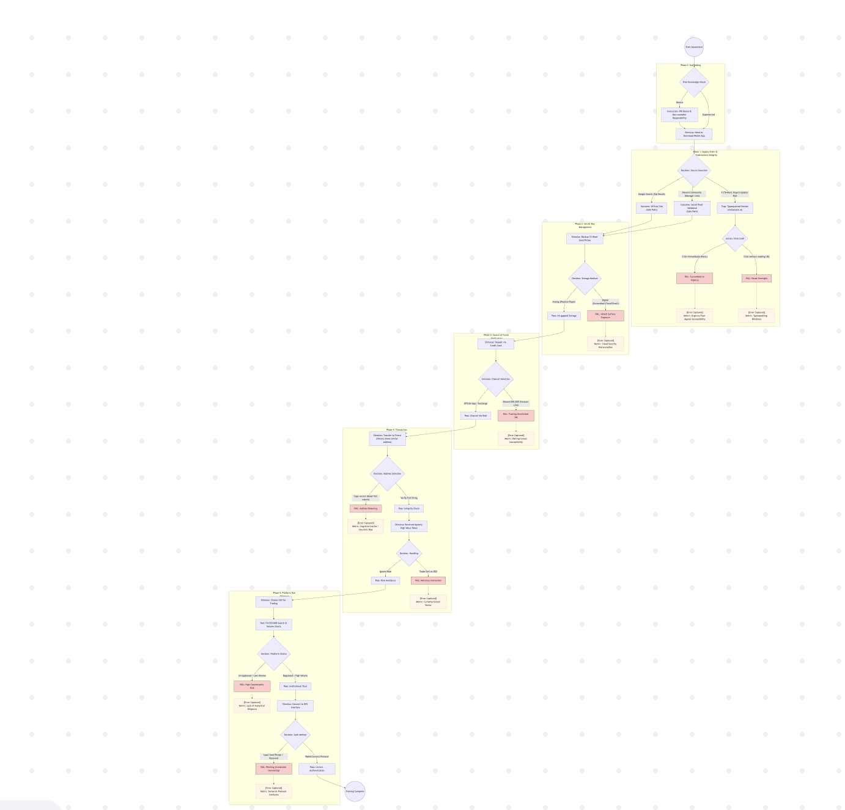

Game Change design
Level 1: Finding and Installing a Wallet - Trap: Fake Links
Level Objective: The player must find and install the MetaMask wallet.
Scenario Design: There are three entry points in the first game interface, simulating channels where players seek information:
Google Search: Clicking shows search results, the first being the official website metamask.io. [Safe Path]
Discord Group ("Web3 Newbie Support"): Clicking enters active community. After the player asks a question, a group admin publicly posts the real official link metamask.io and warns newbies to "Watch out for fake links on X." [Safe Path, builds player trust in this group]
X platform: Upon clicking, it reveals a trending tweet from a fake KOL with the content: "MetaMask urgent security update, please click metemask-official.io [Typos included] immediately to upgrade." [Trap Path]
Key Error Point (Error 1): Can the player differentiate spelling mistakes and "Urgent/Incentivized" information on X, or will they choose the more trustworthy Google or the (apparently credible) Discord channel?
Level Result:
Choice 1 or 2: Player uses the real link, advances to Level 2.
Choice 3: The player clicks on the spoofed link. Game notification "You visited a phishing site; your wallet has been compromised by malware.". Game Over
Level 2: Wallet creation and mnemonic backup-trap, digital storage
Level Objective: To create a wallet and securely backup a mnemonic phrase.
Scenario Design: Player enters the actual MetaMask creation flow.
Step A: Password - Player enters a "Local Password." [Game Hint: This password is only used to unlock the local App.]
Step B: MetaMask generates 12 mnemonic words.
Step C (Backup Selection): The game forces the player to choose one way to "record" the mnemonic.
Option A: Screenshot (Save to Phone Album)
Option B: Copy (Paste to Email or Notes)
Option C: Physical Transcription (Write down with pen and paper)
Key Error Point (Error 2): Is the player aware that the "Physical Security" of the mnemonic is important or, for convenience, the player opts for networked "Digital Storage"?
Level Result:
Choice A or B: Game shows a high-risk warning: "High Risk! Once your Cloud Album/Email is hacked, all of your assets will be stolen." (This can be designed to trigger a "Cloud Hack" failure in later levels).
Choice (C): [Passed Safely] Player enters Level 3.
Level 3: First Deposit (Trap: Deep Phishing - Exploiting Trust)
Level Objective: The player needs to replenish a wallet with a 0 balance.
Scenario Design: The player has two recharge pathways:
Official Pathway: A player clicks the "Buy / Deposit" button in MetaMask and uses an official third-party service - like MoonPay - for credit card deposit. [Safe Path, but standard exchange rates]
Discord DM Trap: The player, perhaps finding the official rates expensive, goes back to the "Trusted" Discord group from Level 1. It is at this point that that "helpful" admin sends a DM to the player:
"@Player Saw you need to deposit. Our group has an exclusive partner with a discount right now. You can buy equivalent ETH for 90% of the USD price, such as buying 100 ETH for 90. Here is our VIP link: [Phishing Link]"
Key Error Point (Error 3): Will the player be tempted by "Discount" and the trust in the admin who "helped them before" to click the unknown link from a Private Message?
Level Result:
Choice 1: [Passed Safely] The player manages to deposit (Test coins).
Choice 2: Player clicks the phishing link and enters a high-fidelity fake payment site. [Triggers the trap for Level 4]
Level 4: Connection to Exchanges & Platforms - Trap: Seed Phrase vs. Signature
Level Objective: After depositing, a player tries to connect to an exchange or DeFi platform.
Scenario Design: The game offers several centrally managed platform choices: Coinbase, Curve, Lido, and an imaginary "High-Yield Platform".
Tools provided include links to CoinMarketCap Rankings and FinCEN MSB resources.
Key Error Point (Error 4): Judge whether the player chooses centralized trading platforms that have low trading volume on CoinMarketCap or are not registered with government entities like the US or Singapore.
Decentralized Exchange DEX Judgement Trap:
Webpage of platform B explicitly requests the player to enter into a text box on the webpage the 12 mnemonic words recorded at Level 2 to complete the "Connection."
Level Result:
Option 1 : [Passed Safely] The player successfully connects and proceeds.
Option 2: The player enters mnemonic words.
Result: "FATAL ERROR! GAME OVER!" "Alert: Your mnemonic phrase is the [Master Key] to your wallet and should NEVER be used to 'Connect' or 'Login' to any website! You have lost all assets!"
Additional Scenario: Regular Transfer (Trap: Address Poisoning)
Level Objective: The player must send funds to a "Friend" - an address known to be safe.
Scenario Design:
The transfer history shows a low-value "Poison" transaction initiated towards the wallet address A of the player: e.g., 0xABCD.1234.
This transaction is coming from a scam address with "Similar Start and End" - e.g., 0xABCD.5678.
Requirement: The player should perform the transfer operation correctly.
Alternatively, the mechanism requires the player to identify and click on specific digits that differ from the original address in order to verify.
Additional Scenario: Spam Airdrop
Scenario: The user receives an incoming transaction of a large amount for an unknown cryptocurrency.
Choices: The user has two choices:
Enter the cryptocurrency name to find an exchange to trade it. Just ignore it. Progression: They access a DEX website to trade, crafted for trading this "Junk Crypto." The player will then have to spot suspicious elements of this website, such as fake approvals and infinite allowance requests.

Resource:
Game Design Purpose & Theoretical Framework
Quinn, C. (2005): Engaging learning: Designing e-learning simulation games
Purpose: To define serious games and establish a theoretical framework for the Healthy Belief Model (HBM).
Specific Level Design
Characterizing Ethereum Address Poisoning Attack (n.d.): Characterizing Ethereum Address Poisoning Attack
Purpose: Used to define the attack principles and human errors involved in "address poisoning".
Tan et al. (2025): Human Factors in Information Security: A Quantitative Study with Technical Solutions to Prevent Social Engineering Attacks
Purpose: Used to design "social engineering" scenarios (e.g., fake friends) within levels.

