#### 中国足球协会超级联赛（CSL）

1.概念模型ER图

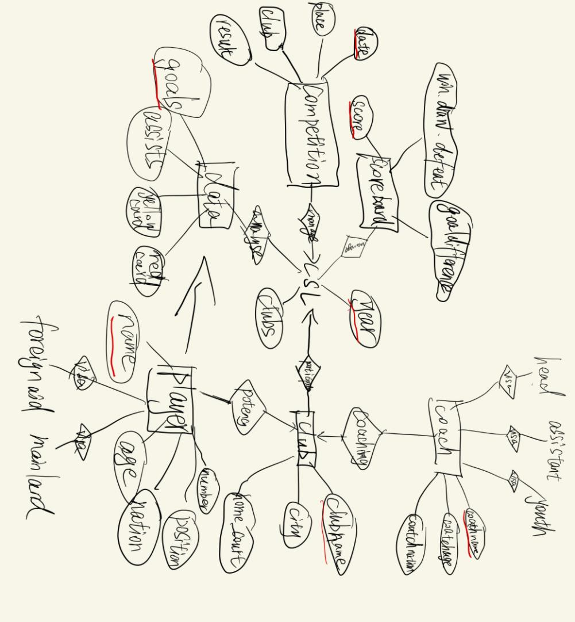

1. 关系模型

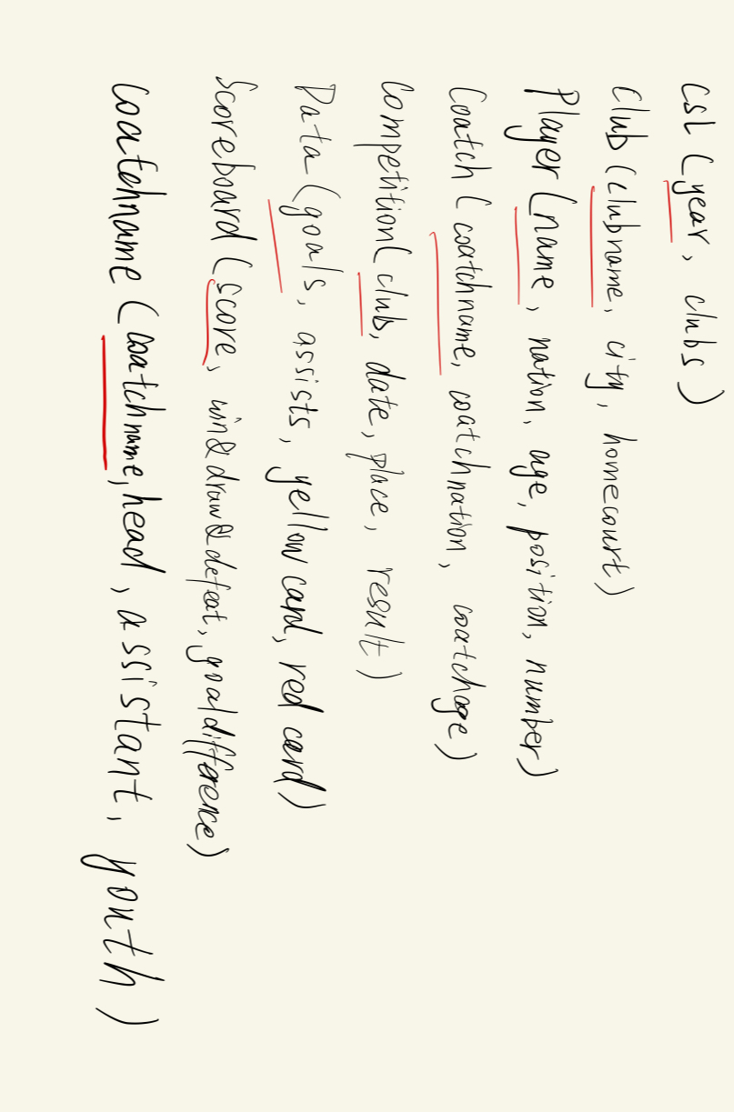

1. 用SQL语句创建关系模型

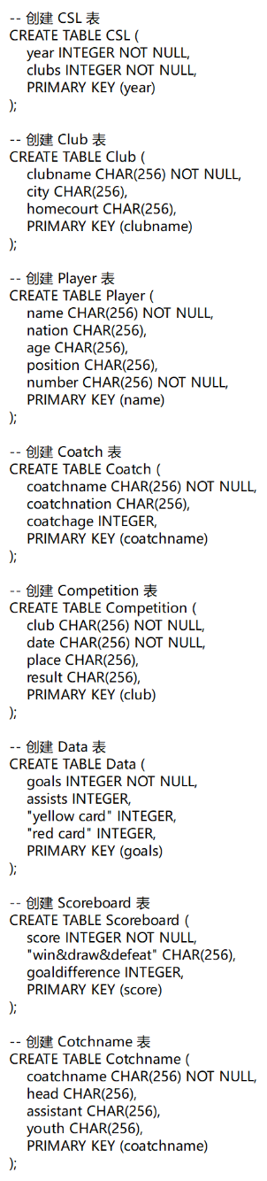

1. 五个查询语句样例

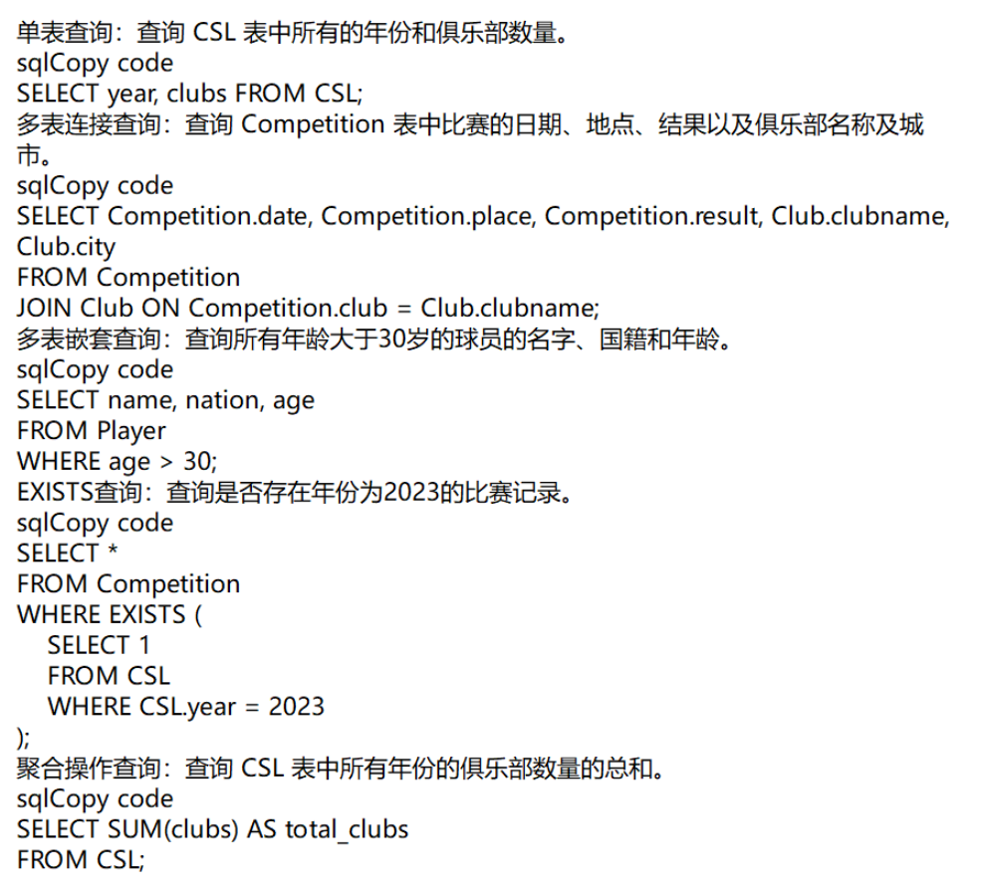

1. power designer画ER图

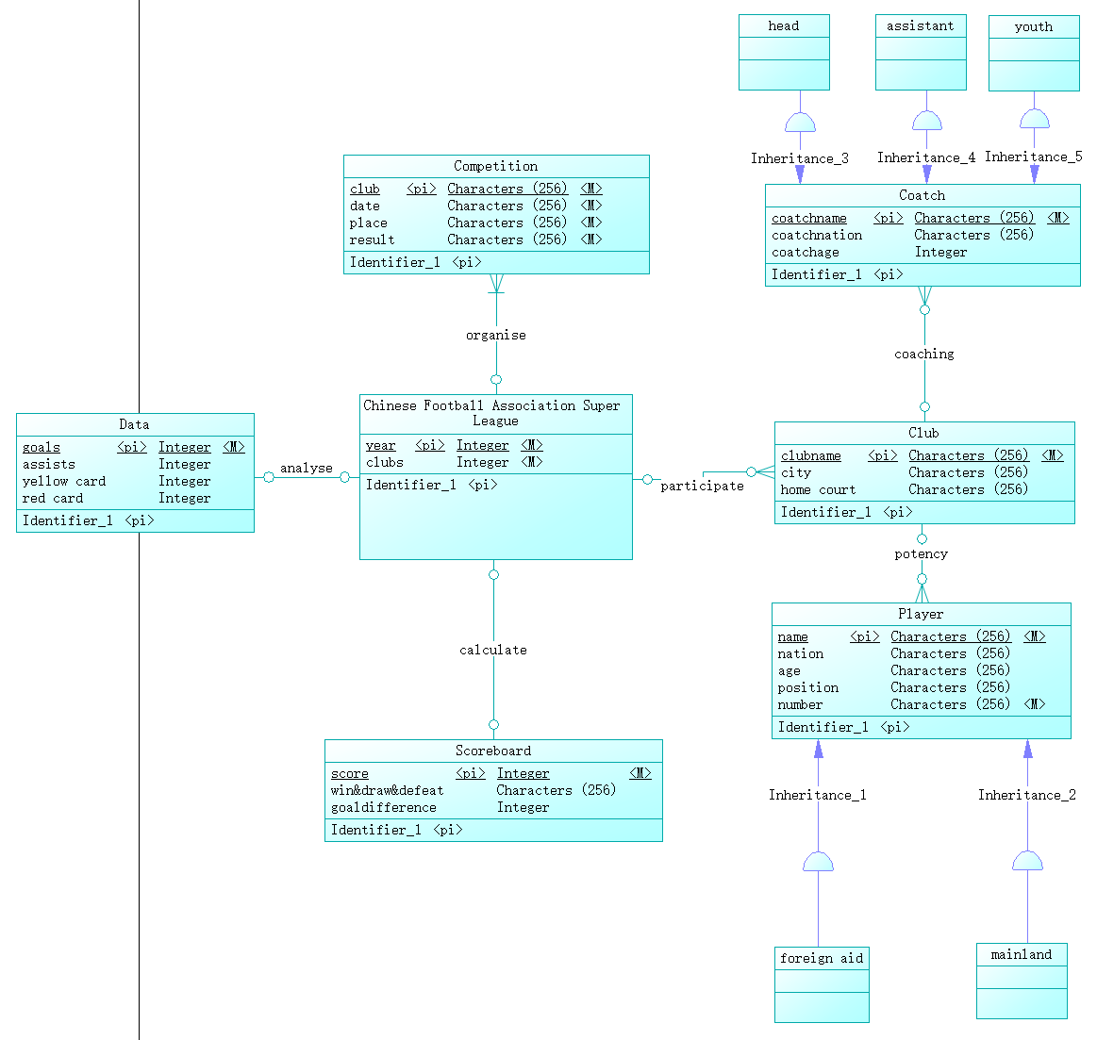

6.power designer画关系模型

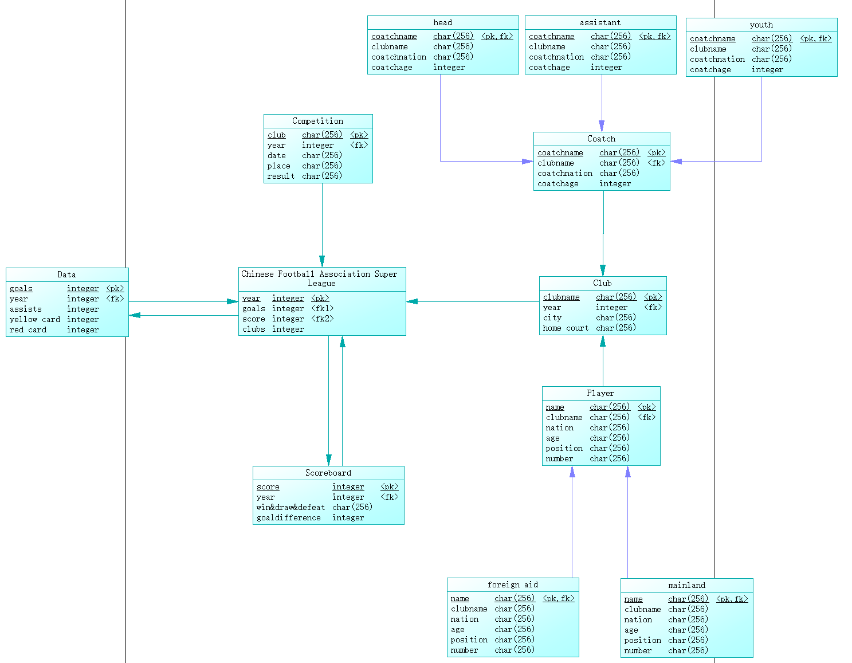

7.power designer生成创建数据库的SQL语句

/*==============================================================*/

/* DBMS name: Sybase SQL Anywhere 12 */

/* Created on: 2024/4/15 19:54:43 */

/*==============================================================*/

if exists(select 1 from sys.sysforeignkey where role='FK_CHINESE _ANALYSE2_DATA') then

alter table "Chinese Football Association Super League"

delete foreign key "FK_CHINESE _ANALYSE2_DATA"

end if;

if exists(select 1 from sys.sysforeignkey where role='FK_CHINESE _CALCULATE_SCOREBOA') then

alter table "Chinese Football Association Super League"

delete foreign key "FK_CHINESE _CALCULATE_SCOREBOA"

end if;

if exists(select 1 from sys.sysforeignkey where role='FK_CLUB_PARTICIPA_CHINESE') then

alter table Club

delete foreign key FK_CLUB_PARTICIPA_CHINESE

end if;

if exists(select 1 from sys.sysforeignkey where role='FK_COATCH_COACHING_CLUB') then

alter table Coatch

delete foreign key FK_COATCH_COACHING_CLUB

end if;

if exists(select 1 from sys.sysforeignkey where role='FK_COMPETIT_ORGANISE_CHINESE') then

alter table Competition

delete foreign key FK_COMPETIT_ORGANISE_CHINESE

end if;

if exists(select 1 from sys.sysforeignkey where role='FK_DATA_ANALYSE_CHINESE') then

alter table Data

delete foreign key FK_DATA_ANALYSE_CHINESE

end if;

if exists(select 1 from sys.sysforeignkey where role='FK_PLAYER_POTENCY_CLUB') then

alter table Player

delete foreign key FK_PLAYER_POTENCY_CLUB

end if;

if exists(select 1 from sys.sysforeignkey where role='FK_SCOREBOA_CALCULATE_CHINESE') then

alter table Scoreboard

delete foreign key FK_SCOREBOA_CALCULATE_CHINESE

end if;

if exists(select 1 from sys.sysforeignkey where role='FK_ASSISTAN_INHERITAN_COATCH') then

alter table assistant

delete foreign key FK_ASSISTAN_INHERITAN_COATCH

end if;

if exists(select 1 from sys.sysforeignkey where role='FK_FOREIGN _INHERITAN_PLAYER') then

alter table "foreign aid"

delete foreign key "FK_FOREIGN _INHERITAN_PLAYER"

end if;

if exists(select 1 from sys.sysforeignkey where role='FK_HEAD_INHERITAN_COATCH') then

alter table head

delete foreign key FK_HEAD_INHERITAN_COATCH

end if;

if exists(select 1 from sys.sysforeignkey where role='FK_MAINLAND_INHERITAN_PLAYER') then

alter table mainland

delete foreign key FK_MAINLAND_INHERITAN_PLAYER

end if;

if exists(select 1 from sys.sysforeignkey where role='FK_YOUTH_INHERITAN_COATCH') then

alter table youth

delete foreign key FK_YOUTH_INHERITAN_COATCH

end if;

drop index if exists "Chinese Football Association Super League".calculate_FK;

drop index if exists "Chinese Football Association Super League".analyse2_FK;

drop index if exists "Chinese Football Association Super League"."Chinese Football Association Super League_PK";

drop table if exists "Chinese Football Association Super League";

drop index if exists Club.participate_FK;

drop index if exists Club.Club_PK;

drop table if exists Club;

drop index if exists Coatch.coaching_FK;

drop index if exists Coatch.Coatch_PK;

drop table if exists Coatch;

drop index if exists Competition.organise_FK;

drop index if exists Competition.Competition_PK;

drop table if exists Competition;

drop index if exists Data.analyse_FK;

drop index if exists Data.Data_PK;

drop table if exists Data;

drop index if exists Player.potency_FK;

drop index if exists Player.Player_PK;

drop table if exists Player;

drop index if exists Scoreboard.calculate2_FK;

drop index if exists Scoreboard.Scoreboard_PK;

drop table if exists Scoreboard;

drop index if exists assistant.assistant_PK;

drop table if exists assistant;

drop index if exists "foreign aid"."foreign aid_PK";

drop table if exists "foreign aid";

drop index if exists head.head_PK;

drop table if exists head;

drop index if exists mainland.mainland_PK;

drop table if exists mainland;

drop index if exists youth.youth_PK;

drop table if exists youth;

/*==============================================================*/

/* Table: "Chinese Football Association Super League" */

/*==============================================================*/

create table "Chinese Football Association Super League"

(

year integer not null,

goals integer null,

score integer null,

clubs integer not null,

constraint "PK_CHINESE FOOTBALL ASSOCIATIO" primary key (year)

);

/*==============================================================*/

/* Index: "Chinese Football Association Super League_PK" */

/*==============================================================*/

create unique index "Chinese Football Association Super League_PK" on "Chinese Football Association Super League" (

year ASC

);

/*==============================================================*/

/* Index: analyse2_FK */

/*==============================================================*/

create index analyse2_FK on "Chinese Football Association Super League" (

goals ASC

);

/*==============================================================*/

/* Index: calculate_FK */

/*==============================================================*/

create index calculate_FK on "Chinese Football Association Super League" (

score ASC

);

/*==============================================================*/

/* Table: Club */

/*==============================================================*/

create table Club

(

clubname char(256) not null,

year integer null,

city char(256) null,

"home court" char(256) null,

constraint PK_CLUB primary key (clubname)

);

/*==============================================================*/

/* Index: Club_PK */

/*==============================================================*/

create unique index Club_PK on Club (

clubname ASC

);

/*==============================================================*/

/* Index: participate_FK */

/*==============================================================*/

create index participate_FK on Club (

year ASC

);

/*==============================================================*/

/* Table: Coatch */

/*==============================================================*/

create table Coatch

(

coatchname char(256) not null,

clubname char(256) null,

coatchnation char(256) null,

coatchage integer null,

constraint PK_COATCH primary key (coatchname)

);

/*==============================================================*/

/* Index: Coatch_PK */

/*==============================================================*/

create unique index Coatch_PK on Coatch (

coatchname ASC

);

/*==============================================================*/

/* Index: coaching_FK */

/*==============================================================*/

create index coaching_FK on Coatch (

clubname ASC

);

/*==============================================================*/

/* Table: Competition */

/*==============================================================*/

create table Competition

(

club char(256) not null,

year integer null,

"date" char(256) not null,

place char(256) not null,

result char(256) not null,

constraint PK_COMPETITION primary key (club)

);

/*==============================================================*/

/* Index: Competition_PK */

/*==============================================================*/

create unique index Competition_PK on Competition (

club ASC

);

/*==============================================================*/

/* Index: organise_FK */

/*==============================================================*/

create index organise_FK on Competition (

year ASC

);

/*==============================================================*/

/* Table: Data */

/*==============================================================*/

create table Data

(

goals integer not null,

year integer null,

assists integer null,

"yellow card" integer null,

"red card" integer null,

constraint PK_DATA primary key (goals)

);

/*==============================================================*/

/* Index: Data_PK */

/*==============================================================*/

create unique index Data_PK on Data (

goals ASC

);

/*==============================================================*/

/* Index: analyse_FK */

/*==============================================================*/

create index analyse_FK on Data (

year ASC

);

/*==============================================================*/

/* Table: Player */

/*==============================================================*/

create table Player

(

name char(256) not null,

clubname char(256) null,

nation char(256) null,

age char(256) null,

position char(256) null,

number char(256) not null,

constraint PK_PLAYER primary key (name)

);

/*==============================================================*/

/* Index: Player_PK */

/*==============================================================*/

create unique index Player_PK on Player (

name ASC

);

/*==============================================================*/

/* Index: potency_FK */

/*==============================================================*/

create index potency_FK on Player (

clubname ASC

);

/*==============================================================*/

/* Table: Scoreboard */

/*==============================================================*/

create table Scoreboard

(

score integer not null,

year integer null,

win&draw&defeat char(256) null,

goaldifference integer null,

constraint PK_SCOREBOARD primary key (score)

);

/*==============================================================*/

/* Index: Scoreboard_PK */

/*==============================================================*/

create unique index Scoreboard_PK on Scoreboard (

score ASC

);

/*==============================================================*/

/* Index: calculate2_FK */

/*==============================================================*/

create index calculate2_FK on Scoreboard (

year ASC

);

/*==============================================================*/

/* Table: assistant */

/*==============================================================*/

create table assistant

(

coatchname char(256) not null,

clubname char(256) null,

coatchnation char(256) null,

coatchage integer null,

constraint PK_ASSISTANT primary key clustered (coatchname)

);

/*==============================================================*/

/* Index: assistant_PK */

/*==============================================================*/

create unique clustered index assistant_PK on assistant (

coatchname ASC

);

/*==============================================================*/

/* Table: "foreign aid" */

/*==============================================================*/

create table "foreign aid"

(

name char(256) not null,

clubname char(256) null,

nation char(256) null,

age char(256) null,

position char(256) null,

number char(256) not null,

constraint "PK_FOREIGN AID" primary key clustered (name)

);

/*==============================================================*/

/* Index: "foreign aid_PK" */

/*==============================================================*/

create unique clustered index "foreign aid_PK" on "foreign aid" (

name ASC

);

/*==============================================================*/

/* Table: head */

/*==============================================================*/

create table head

(

coatchname char(256) not null,

clubname char(256) null,

coatchnation char(256) null,

coatchage integer null,

constraint PK_HEAD primary key clustered (coatchname)

);

/*==============================================================*/

/* Index: head_PK */

/*==============================================================*/

create unique clustered index head_PK on head (

coatchname ASC

);

/*==============================================================*/

/* Table: mainland */

/*==============================================================*/

create table mainland

(

name char(256) not null,

clubname char(256) null,

nation char(256) null,

age char(256) null,

position char(256) null,

number char(256) not null,

constraint PK_MAINLAND primary key clustered (name)

);

/*==============================================================*/

/* Index: mainland_PK */

/*==============================================================*/

create unique clustered index mainland_PK on mainland (

name ASC

);

/*==============================================================*/

/* Table: youth */

/*==============================================================*/

create table youth

(

coatchname char(256) not null,

clubname char(256) null,

coatchnation char(256) null,

coatchage integer null,

constraint PK_YOUTH primary key clustered (coatchname)

);

/*==============================================================*/

/* Index: youth_PK */

/*==============================================================*/

create unique clustered index youth_PK on youth (

coatchname ASC

);

alter table "Chinese Football Association Super League"

add constraint "FK_CHINESE _ANALYSE2_DATA" foreign key (goals)

references Data (goals)

on update restrict

on delete restrict;

alter table "Chinese Football Association Super League"

add constraint "FK_CHINESE _CALCULATE_SCOREBOA" foreign key (score)

references Scoreboard (score)

on update restrict

on delete restrict;

alter table Club

add constraint FK_CLUB_PARTICIPA_CHINESE foreign key (year)

references "Chinese Football Association Super League" (year)

on update restrict

on delete restrict;

alter table Coatch

add constraint FK_COATCH_COACHING_CLUB foreign key (clubname)

references Club (clubname)

on update restrict

on delete restrict;

alter table Competition

add constraint FK_COMPETIT_ORGANISE_CHINESE foreign key (year)

references "Chinese Football Association Super League" (year)

on update restrict

on delete restrict;

alter table Data

add constraint FK_DATA_ANALYSE_CHINESE foreign key (year)

references "Chinese Football Association Super League" (year)

on update restrict

on delete restrict;

alter table Player

add constraint FK_PLAYER_POTENCY_CLUB foreign key (clubname)

references Club (clubname)

on update restrict

on delete restrict;

alter table Scoreboard

add constraint FK_SCOREBOA_CALCULATE_CHINESE foreign key (year)

references "Chinese Football Association Super League" (year)

on update restrict

on delete restrict;

alter table assistant

add constraint FK_ASSISTAN_INHERITAN_COATCH foreign key (coatchname)

references Coatch (coatchname)

on update restrict

on delete restrict;

alter table "foreign aid"

add constraint "FK_FOREIGN _INHERITAN_PLAYER" foreign key (name)

references Player (name)

on update restrict

on delete restrict;

alter table head

add constraint FK_HEAD_INHERITAN_COATCH foreign key (coatchname)

references Coatch (coatchname)

on update restrict

on delete restrict;

alter table mainland

add constraint FK_MAINLAND_INHERITAN_PLAYER foreign key (name)

references Player (name)

on update restrict

on delete restrict;

alter table youth

add constraint FK_YOUTH_INHERITAN_COATCH foreign key (coatchname)

references Coatch (coatchname)

on update restrict

on delete restrict;

8.两种关系模式的设计存在的差异：

属性约束：第一种只能显示多对多关系的约束和具有其他属性的约束。

会对后期实验产生一些影响，比如数据一致性、SQL查询语句的编写等。

9.PowerDesigner生成的SQL 语句具有规范性、完整性、可读性和自动化等特点，能够有效地帮助开发人员快速生成符合要求的数据库对象定义和操作语句，提高了数据库设计和开发的效率和质量。

PowerDesigner生成的SQL语句中可能会出现一些附加语句，例如创建表之前可能会先删除已存在的同名表，或者创建外键之前会先删除已存在的同名外键等。这些附加语句的作用主要是为了保证生成的SQL能够在目标数据库上正确执行，避免出现重复对象或约束的情况，确保数据库的一致性和完整性。