目录
1.Data的定义 4
2.database的定义 4
3. System catalogue (metadata)的定义 4
4.实体Entity，属性Attribute，关系Relationship 4
5. Database Management Systems (DBMS) 4
6. Database application program 5
7. Data model 5
8. Schema vs Data 有什么区别 5
9. DBMS的构成？ 5
10. what are the different roles in Database Environment 5
11. Three level ANSI-SPARC architecture 6
12. Three level ANSI-SPARC architecture的目标/reason 6
13.关系表格的几个特征 6
14. Integrity Constraints，完整性约束 7
15. Relational Algebra： 8
16. data model，data modelling 10
17. Entity-relationship (E-R) modelling 11
18. Relationship 11
19. Recursive Relationships 11
20. Multiplicity 11
21. Degree of a Relationship 12
22. One-to-many (1:*) binary relationships 12
23. One-to-one (1:1) binary relationships 12
24. One-to-many (1:*) recursive relationships 13
25. One-to-one (1:1) recursive relationships（不怎么懂） 13
26. Many-to-many (*:*) binary relationships 14
27. SQL语言 14
28.关键用法（共30种左右） 15
29. Database Design Methodology 21
30. Database Design Methodology步骤 22
31. build conceptual data model步骤 22
32. (2) build and validate logical data model步骤 23
33. translate logical data model for target DBMS的步骤 23
34. design file organizations and indexes步骤 23
35. Normalization的定义 23
36.suitable set of1relations 24
37. Benefits of using “suitable relations” 24
38. update anomalies 24
39. Two important properties of decomposition（去除冗杂数据的方式就是decomposition）： 24
40. Functional dependency describes relationship between attributes. 24
41. The Process of Normalization： 25
42.UNF AND 1NF 25
43.2NF 26
44.3NF 26
45.BCNF 27
46.BCNF无法转变的情况 27
47.4NF： 27
48.Normalization的优劣： 28
49. Transaction 29
50. Properties of Transactions (ACID) 29
51. Transaction outcomes 29
52. Concurrency（并发运行） 30
Problems: 30
53. Concurrency Control 31
54.Schedule(调度)和serial schedule（串行调度） 31
55. Nonserial Schedule 和Serializable Schedule 31
56. Concurrency Control Techniques 32
57.Locking 32
58. Two-Phase Locking (2PL) 33
59.2PL解决不掉的 33
60. General techniques for handling deadlock: 33
• Timeouts. 33
• Deadlock prevention. 34
61. Database Recovery 34
Recovery Facilities 34
62.Log File 34
63.Checkpointing 35
64. Database architectures（数据库架构） 35
65.第一种Personal databases 35
66.第二种Two-Tier Client/Server Architecture 36
67. 第三种Multi-tier Client/Server Architecture 36
68. Distributed Database 37
69. Distributed DBMS 37
70.分布式过程和分布式数据库管理系统不同 37
71. Types of DDBMS（Distributed DBMS） 37
• Homogeneous DDBMS同构分布式数据库管理系统 37
• Heterogeneous DDBMS（异构分布式数据库管理系统） 38
72. Functions of a DDBMS 38
73. Reference Architecture for DDBMS（参考架构） 38
74. Component Architecture for a DDBMS（组件架构） 39
75. Distributed Database Design – key issues 39
76. Disadvantages of Fragmentation 39
77. Fragmentation’s correctness 40
78. Strategies for Data Allocation 40
79. Hiding DDBMS complexity, is called transparency 41
1. Distribution Transparency 41
2. Transaction Transparency 41
3. Performance Transparenc 42
80. DDBMSs 的优缺点 42
81. Database security 42
82. 6个数据库安全措施 42
83.sql注入 43
84.预防SQL注入 44
85.Data Ethics 44
86. eXtensible Markup Language (XML) 45
87. XML – Elements 45
88. XML – Attributes 45
89. XML – Other Sections 46
90. XML – Ordering 46
91. “Well-Formed” XML 46
92. Displaying XML 47
93. Document Type Definitions (DTDs)："Valid" XML 47
94.DTDS的三大要求 48
1. Element Type Declarations（元素类型声明） 48
2. Attribute List Declarations（属性列表声明） 48
3. Element Identity: ID, IDREF, IDREFS 49
95.另一种XML valid的方法XSD 50
1.DTD与XSM 50
2. XML Schema 定义 50
3. XSD Types 50
4. XSD 键声明（<xsd:key>） 51
5. XSD 引用（<xsd:keyref>） 51
6. XSD 的出现次数（Cardinality and Occurrences） 51
96. Relational Model versus XML（考过） 52
97. Advantages of XML 52
98. motivation for NoSQL 53
99. NoSQL 概念与特征 | Concepts & Characteristics 53
100. NoSQL 类型 | Types of NoSQL Databases 53
键值存储 Key-Value Stores 53
文档型数据库 Document Stores 54
图数据库 Graph Databases 54
101. 为何需要半结构化数据存储？ | Why are such (semi-structured) data stores needed? 54
102. NoSQL 应该避免的场景 | What NoSQL should NOT be used for 55

1.Data的定义
facts and statistics collected together for reference or analysis

2.database的定义
a shared collection of logically related data (and a description of this data), designed to meet the information needs of an organization.

3. System catalogue (metadata)的定义
description of data to enable program–data independence.

4.实体Entity，属性Attribute，关系Relationship
Entity: a distinct object in the organization that is to be represented in the database.
Attribute: a property that describes some aspect of the object that we wish to record.
Relationship: an association between entities.

5. Database Management Systems (DBMS)
A software system – enables users to define, create, maintain, and control access to the database.

6. Database application program
A computer program that interacts with database

7. Data model
A model is a representation of ‘real world’ objects and events, and their associations.

8. Schema vs Data 有什么区别
The description of the database is the database schema.
Data is the actual information stored in the database.

9. DBMS的构成？
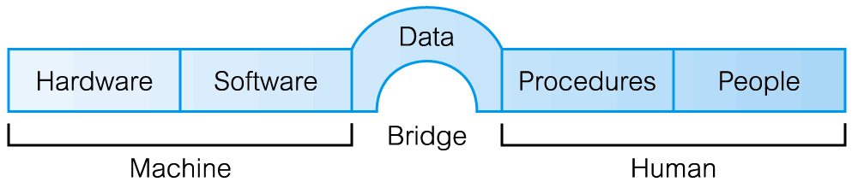

10. what are the different roles in Database Environment
Data Administrator (DA) 管理数据的
Database Administrator (DBA) 管理数据库的
Database Designer (Logical and Physical) 设计数据库的
Application Developer 开发程序的
End User (naive and sophisticated) 用户

11. Three level ANSI-SPARC architecture
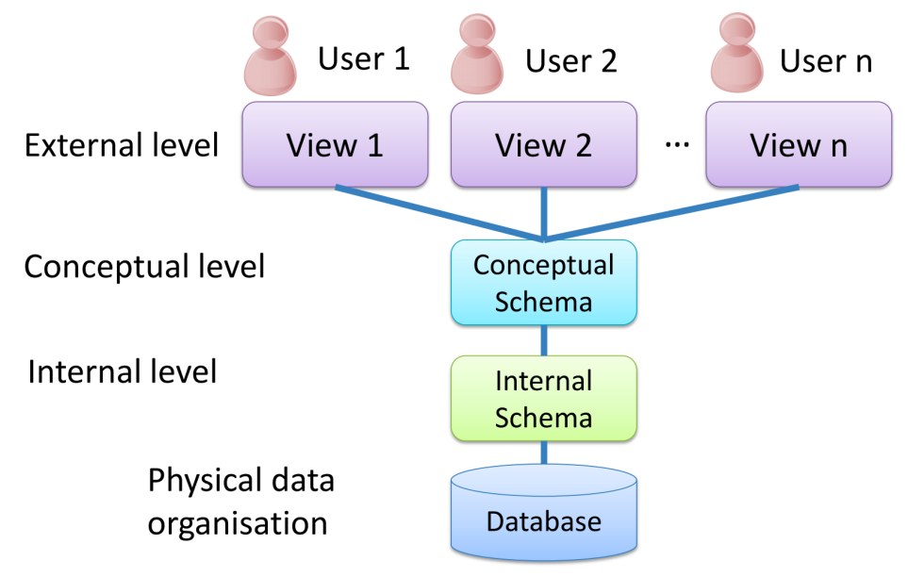

12. Three level ANSI-SPARC architecture的目标/reason
separate each user’s view of the database from the way the database is physically represented

13.关系表格的几个特征
Relation: A relation is a table with columns and rows.
Attribute: An attribute is a named column of a relation.
Domain: the set of allowable values for one or more attributes（每个属性（例如，年龄、姓名等）都有一个规定的取值范围或范围，这个范围就是该属性的“域”。）
Tuple: A tuple is row of a relation.
Degree: the number of attributes in a relation
Cardinality: the number of tuples in a relation.
Relational database: A collection of normalized relations with distinct relation names.

Relational keys：
Candidate Key：A set of attributes that uniquely identifies a tuple within a relation.
性质：
– Uniqueness : In each tuple, candidate key uniquely identify that tuple.
– Irreducibility: No proper subset of the candidate key has the uniqueness property
Primary Key：Candidate key selected to identify tuples uniquely within relation
Foreign Key：Attribute, or set of attributes, within one relation that matches candidate key of some other (possibly same) relation.
Composite Key: A candidate key that consists of two or more attributes.
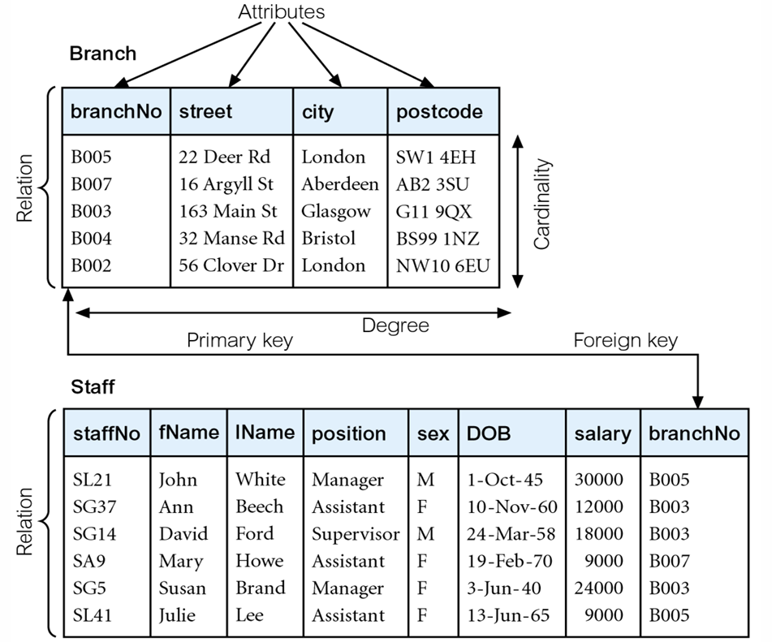

14. Integrity Constraints，完整性约束
Null（感觉很重要）
– Represents value for an attribute that is currently unknown or not applicable for tuple.
– Deals with incomplete or exceptional data.
– Represents the absence of a value and is not the same as zero or spaces, which are values.
Entity Integrity：In a base relation, no attribute of a primary key can be null.
Referential Integrity：If foreign key exists in a relation, either foreign key value must match a candidate key value of some tuple in its home relation or foreign key value must be null.
General Constraints: specific constraints on values.

15. Relational Algebra：
Relational algebra is formal language associated with the relational model.
Relational algebra operations work on one or more relations to define another relation without changing the original relations.

Basic operations:
- Selection
- Projection
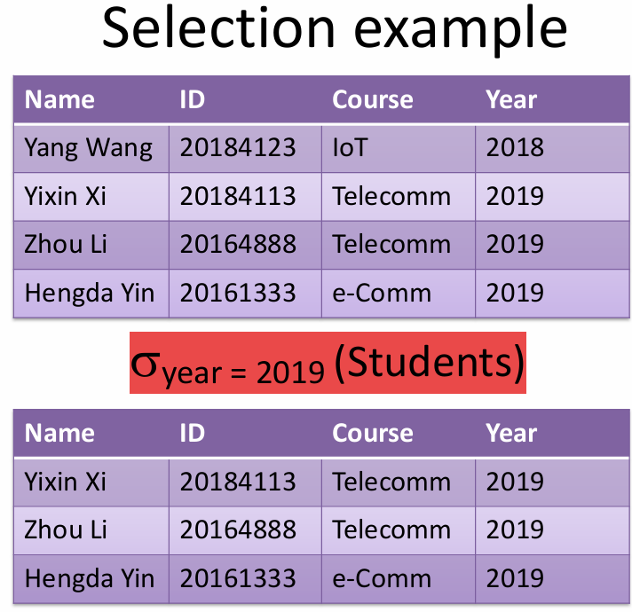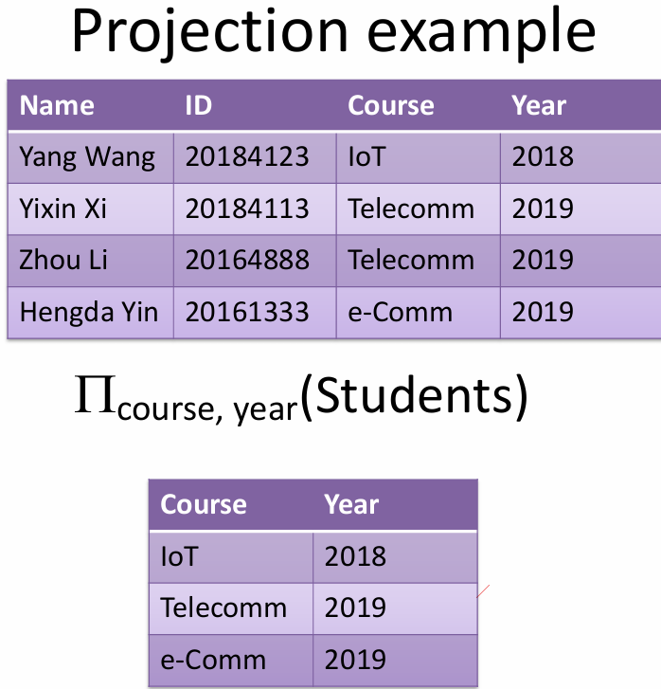
注：σsalary > 10000 ^ sex =“F” (Staff)，和是^，字符串需要“”。这两个也是常用组合
List staff number, position and salary of any staff whose salary is greater than £20,000.
Answer 1: σsalary > 20000(ΠstaffNo, position, salary(Staff))
Answer 2: ΠstaffNo, position, salary(σsalary > 20000 (Staff))
- Cartesian product
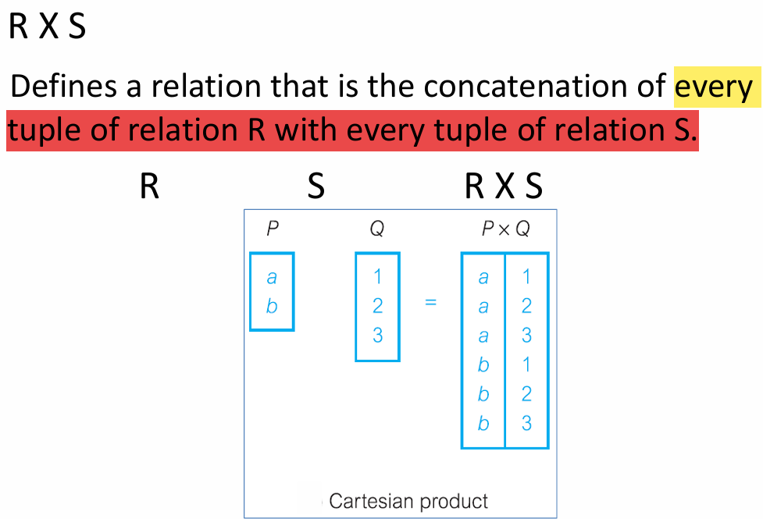
- Join
Natural join
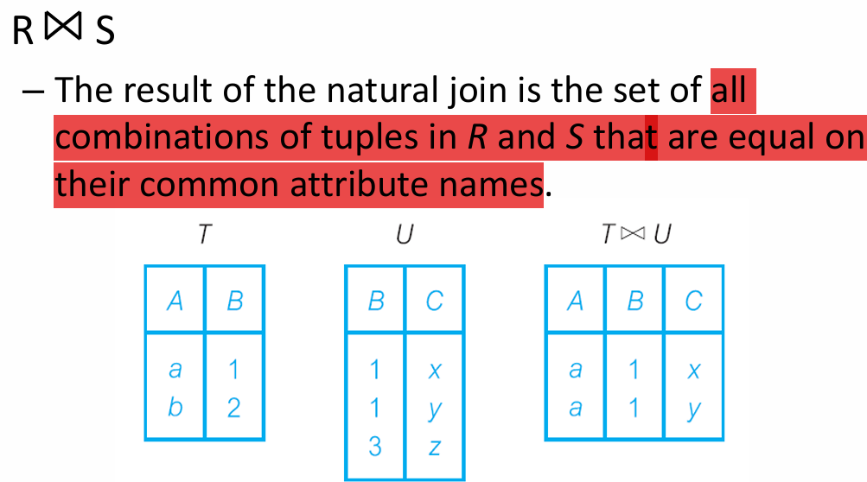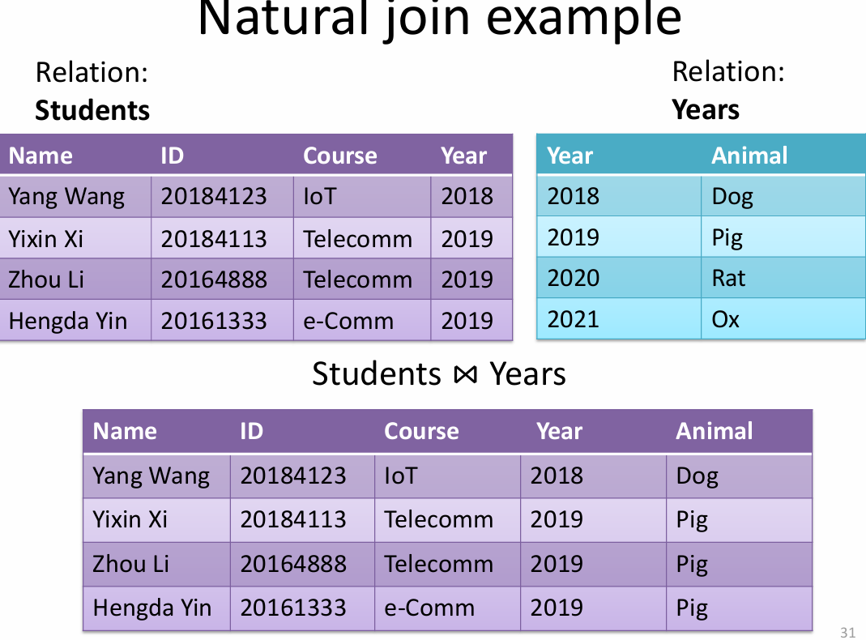

Theta join
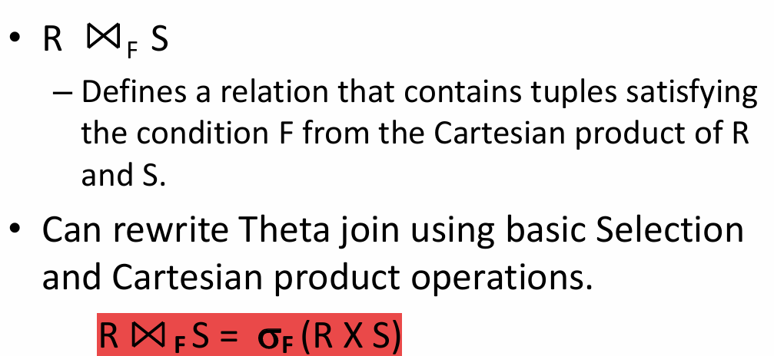
红色标记很好理解。就是有条件的合并，只选出列出那些符合条件的tuples

Set operations:
- Union
Union of two relations R and S defines a relation that contains all the tuples of R, or S, or both R and S, duplicate tuples being eliminated. R and S must be union-compatible.
Union compatible : Same number of attributes and corresponding attributes have the same domain.
R和S必须有相同的attributes，每个attributes有共同的domain。并起来之后，最大的cardinality是两个tuples之和。
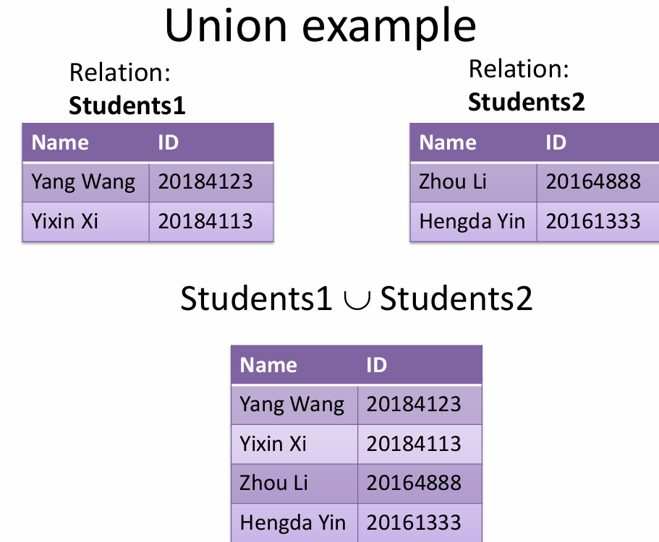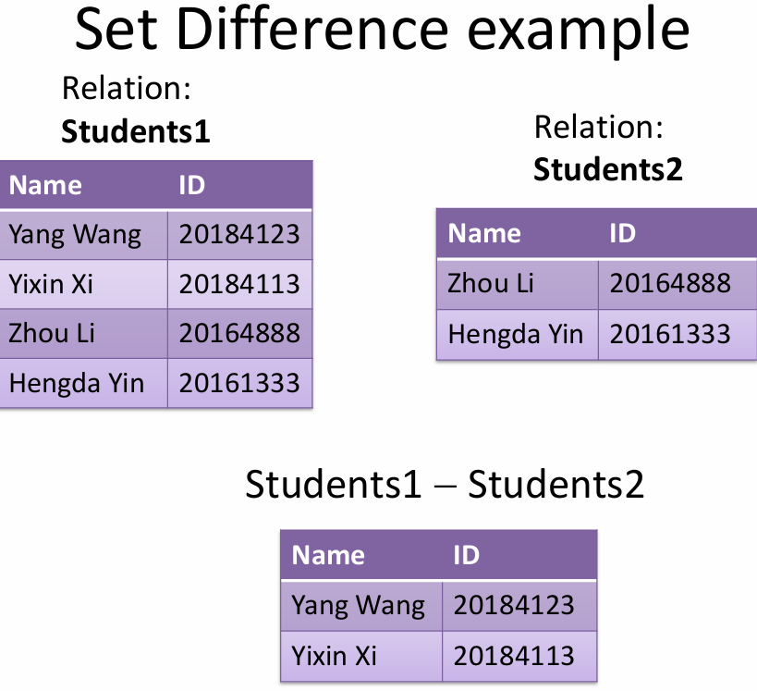
- Set difference
– Defines a relation consisting of the tuples that are in relation R, but not in S.
– R and S must be union-compatible.
- Intersection
– Defines a relation consisting of the set of all tuples that are in both R and S.
– R and S must be union-compatible.
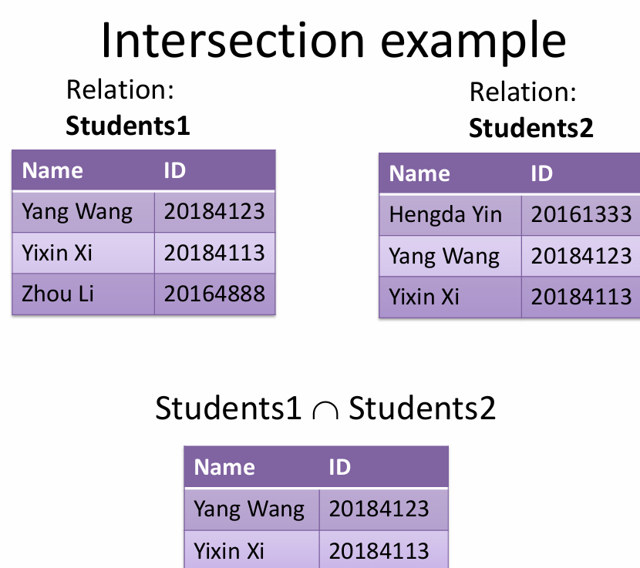

16. data model，data modelling
A data model is a graphical description of the components of database.
A technique called data modelling helps you to understand the structure and meaning of data.

17. Entity-relationship (E-R) modelling
E-R modelling is a high-level conceptual modelling technique for DB applications
Main concepts: Entity, attributes, relationship(PPT1.3详细描述了如何画，实体是一个长方形，名字在上面，特征在名字下面罗列，并且有一个是PK)

18. Relationship
Relationship describes a linkage between two entities and is represented by an arc between them.
- One-to-many (1:m) relationship
- Many-to-Many (m:m) relationship
- One-to-one relationship

19. Recursive Relationships
relationship type where same entity type participates more than once in different roles
一个老板有很多员工，老板也是员工
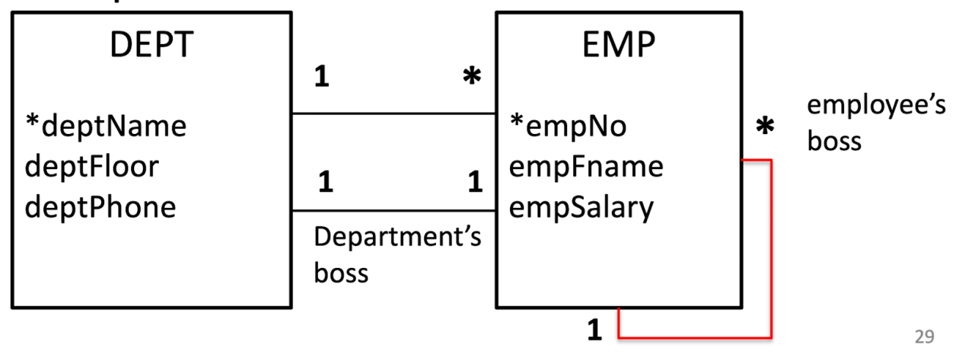

20. Multiplicity
defines the possible number of occurrences of each entity type in a relationship(就是一个实体关联实体的数量)

21. Degree of a Relationship
Number of participating entities in a relationship.
two is binary：one-to-one (1:1)– one-to-many (1:*)– many-to-many (*:*)
three is ternary：In a ternary relationship, three simultaneously involved. A ternary relationship is not the same as three binary relationships!
four is quaternary
n-ary is general n-entity relationship

22. One-to-many (1:*) binary relationships
Post a copy of the primary key attribute(s) of one-side entity into the relation representing the many-side, to act as a foreign key.（在多的那一面里面加上1的主键，毕竟一个country有多个city，在country价格cityCode不就乱了吗）
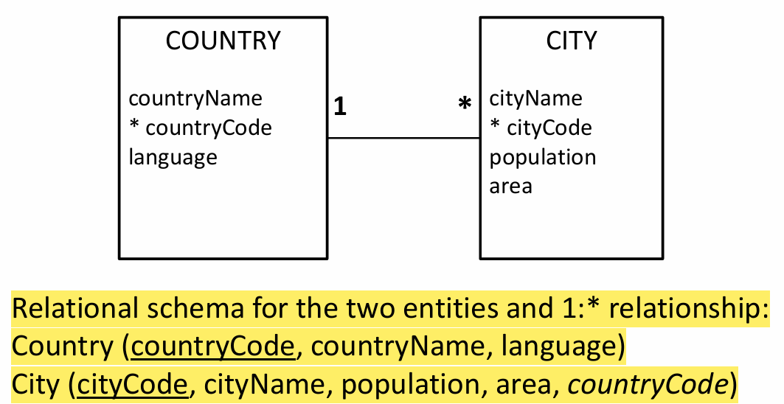

23. One-to-one (1:1) binary relationships
有三种转换的方法。一种就是把外键放在其中一个表中（推荐放在必须参与的一方），第二种把外键常在两个表中，形成双向存储。第三种方法就是像多对多一样，创建一个额外地关系表示。
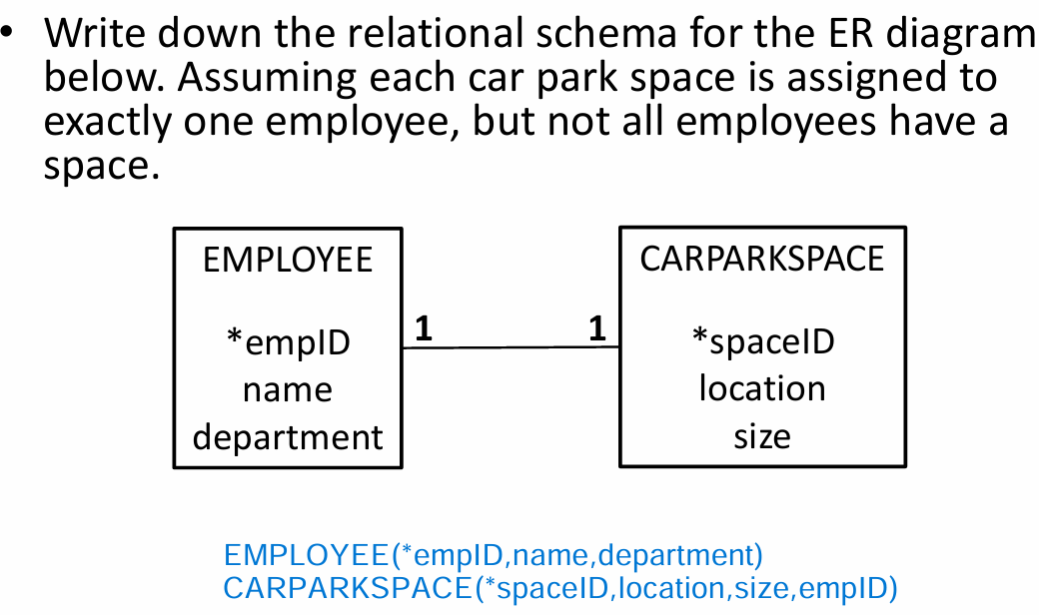

24. One-to-many (1:*) recursive relationships
For a 1:* recursive relationship, follow same rules for a 1:* relationship. Add column(s) for foreign key, for the entity at the “many ” side of the relationship.
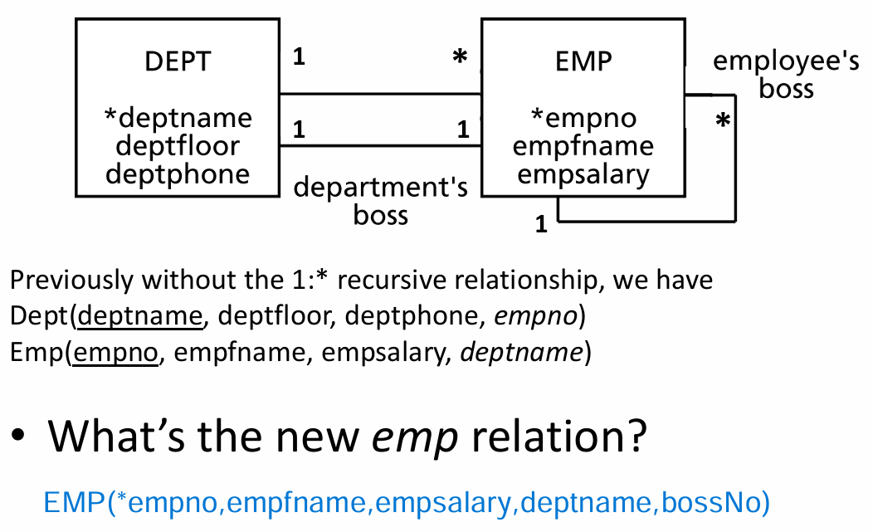
多的还是EMP，所以在EMP加上老板的编号即可

25. One-to-one (1:1) recursive relationships（不怎么懂）
双方都有强制性参与：将递归关系表示为一个关系，其中包含两个主键副本。一个主键作为外键，并应重命名以表明递归关系。
双方都是可选参与：创建一个新关系来表示关系。两个属性，都是主键副本。主键副本作为外键，并需要重命名以表明每个外键的用途。
只有一方有强制性参与：a) 一个包含两个主键副本的单一关系（与双方都是强制性参与时相同）。或 b) 创建一个新关系来表示关系（与双方都是可选参与时相同）。
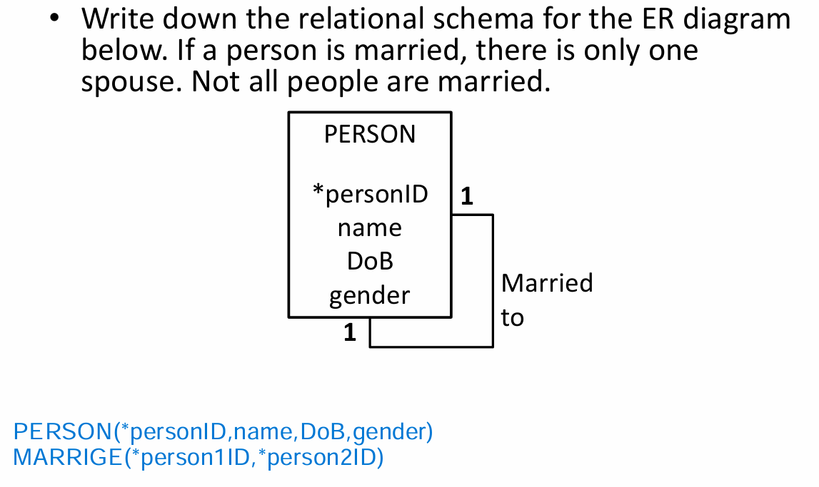

26. Many-to-many (*:*) binary relationships
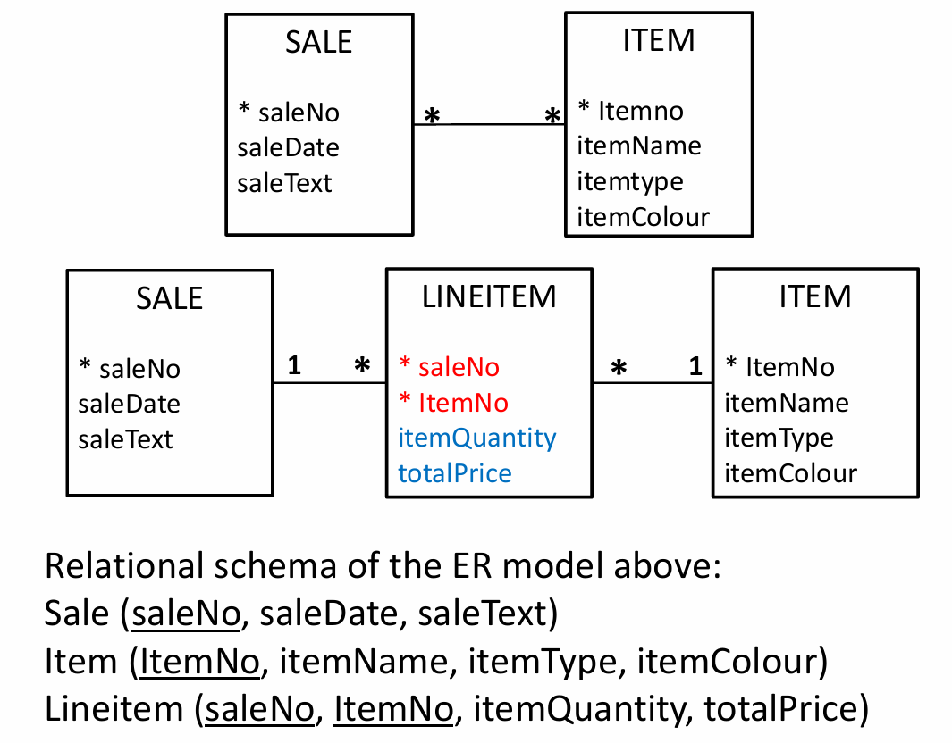

27. SQL语言
a transform-oriented language
由DDL+DML构成
(what do DDL and DML stand for)
DDL(data definition): define database structure，包括create/drop table
DML(data manipulation): retrieve and update data，包括insert/delete/update/select

28.关键用法（共30种左右）
（1） SELECT * FROM Staff;// Can use * as an abbreviation for ‘all columns’
（2） SELECT DISTINCT propertyNo FROM Viewing;// Use DISTINCT to eliminate duplicates
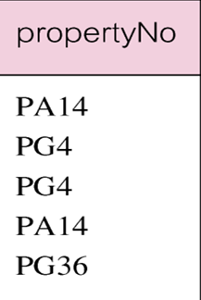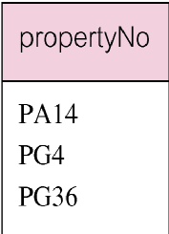
（3）SELECT staffNo, fName, lName, salary/12 AS monthlySalary FROM Staff;// To name column, use AS clause，如果需要某些计算，可以直接计算像上面一样
（4）比较大小，where ……>……
SELECT staffNo, fName, lName, position, salary FROM Staff WHERE salary > 10000;
（5）和，或者的关系用AND,OR
SELECT * FROM Branch WHERE city = “London” OR city = “Glasgow”;
- 在什么范围用between and
SELECT staffNo, fName, lName, position, salary FROM Staff WHERE salary BETWEEN 20000 AND 30000;
- %x%,表示x前后不管有多少个字符只要有x就满足。_x_表示字符长度是三位且中间为x使用这两种符号是，必不可少LIKE
SELECT ownerNo, fName, lName, address, telNo FROM PrivateOwner WHERE address LIKE “%Glasgow%”;
- 如果要选择内容为空的，需要用的IS NULL，不为空就是 IS NOT NULL
SELECT clientNo, viewDate FROM Viewing WHERE propertyNo = “PG4” AND comment IS NULL;
（8）排序，DESC是降序排序,ASC是升序，排序可以排多次，需要按照顺序。
SELECT propertyNo, type, rooms, rent FROM PropertyForRent ORDER BY type, rent DESC;
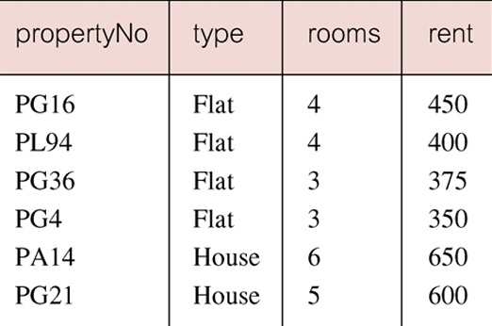
（9）COUNT(*)，数一数符合条件的tuples有多少
SELECT COUNT(*) AS myCount FROM PropertyForRent WHERE rent > 350;
（10）COUNT(DISTINCT )数一数符合条件的tuples，但是名称不同的的有多少个
SELECT COUNT(DISTINCT propertyNo) AS myCount FROM Viewing WHERE viewDate BETWEEN “2004-05-01” AND “2004-05-31”;
（11）SUM（）用于求和
SELECT COUNT(staffNo) AS myCount, SUM(salary) AS mySum FROM Staff WHERE position = “Manager”;
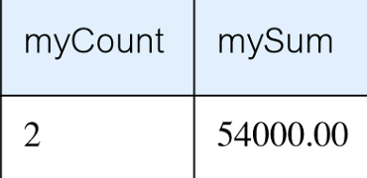manager的个数和总薪资
（12） MIN,MAX,AVG用于找到最小值，最大值，和平均值
SELECT MIN(salary) AS myMin, MAX(salary) AS myMax, AVG(salary) AS myAvg FROM Staff;
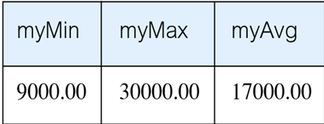员工中的最小薪资，最大薪资，和平均薪资
（13） 对不同特征进行分组，将相同特征的归纳为一组，对组内进行代码
在 GROUP BY branchNo 的语句中，SELECT 中出现的每个字段必须要么出现在 GROUP BY 中，要么是聚合函数（如 SUM、COUNT）；
SELECT branchNo, COUNT(staffNo) AS myCount, SUM(salary) AS mySum FROM Staff GROUP BY branchNo ORDER BY branchNo;
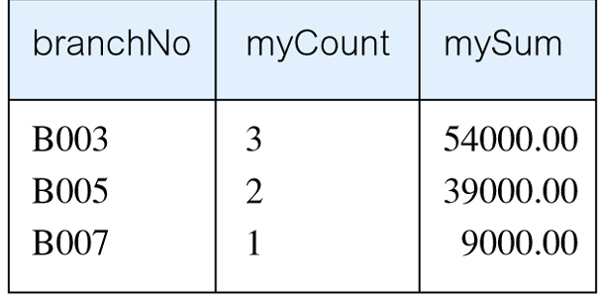
（14） HAVING只能出现在group by，和where不同，where是对每个tuple做要求，而HAVING是对group中的聚合函数做出要求的。
SELECT branchNo, COUNT(staffNo) AS myCount, SUM(salary) AS mySum FROM Staff GROUP BY branchNo HAVING COUNT(staffNo) > 1 ORDER BY branchNo;
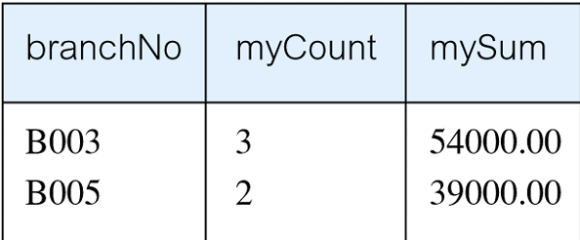
（15）简单的join,比较常用也比较好用，可以进行group和order
SELECT s.branchNo, s.staffNo, COUNT(*) AS myCount FROM Staff s, PropertyForRent p WHERE s.staffNo = p.staffNo GROUP BY s.branchNo, s.staffNo ORDER BY s.branchNo, s.staffNo;
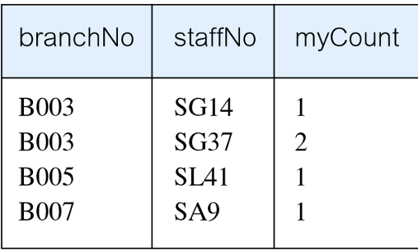
注（16）组合
SELECT staffNo, fName, lName, position, salary - (SELECT AVG(salary) FROM Staff) As SalDiff FROM Staff WHERE salary > (SELECT AVG(salary) FROM Staff);
Cannot write ‘WHERE salary > AVG(salary)，因为直接用AVG（salary）已经不能表示原本的聚合了
（17）IN表示是否在这个attraction里面
List properties handled by staff at ‘163 Main St’.
SELECT propertyNo, street, city, postcode, type, rooms, rent FROM PropertyForRent WHERE staffNo IN (SELECT staffNo FROM Staff WHERE branchNo = (SELECT branchNo FROM Branch WHERE street = “163 Main St”));
（18）ANY和SOME返回true如果部分符合即可，空的话返回false。
Find staff whose salary is larger than salary of at least one member of staff at branch B003
SELECT staffNo, fName, lName, position, salary FROM Staff WHERE salary > SOME (SELECT salary FROM Staff WHERE branchNo = ‘B003’);
（19）ALL，返回true如果全部符合要求，空的话返回true。
Find staff whose salary is larger than salary of every member of staff at branch B003.
SELECT staffNo, fName, lName, position, salary FROM Staff WHERE salary > ALL (SELECT salary FROM Staff WHERE branchNo = ‘B003’);
（20）(NOT) EXISTS，和IN有点相似，但是IN必须是在相同attraction之间，但是exist不需要。
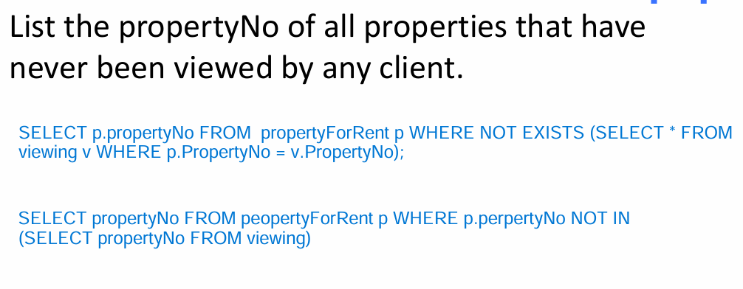

DML语句：
- UPDATE
UPDATE Staff SET salary = salary*1.05 WHERE position = ‘Manager’;
UPDATE Staff SET position = ‘Manager’, salary = 18000 WHERE staffNo = ‘SG14’;
- DELETE
DELETE FROM Viewing WHERE propertyNo = ‘PG4’;
Delete all records from the Viewing table.
DELETE FROM Viewing;
- INSERT
INSERT INTO BRANCH VALUES ('B005', '22 Deer Rd', 'London', 'SW1 4EH');
注：The DATE type in MySQL follows the 'YYYY-MM-DD' format. The supported range is '1000-01-01' to '9999-12-31'.

JOIN语句：
- Natural join example
SELECT * FROM Students NATURAL JOIN Years;
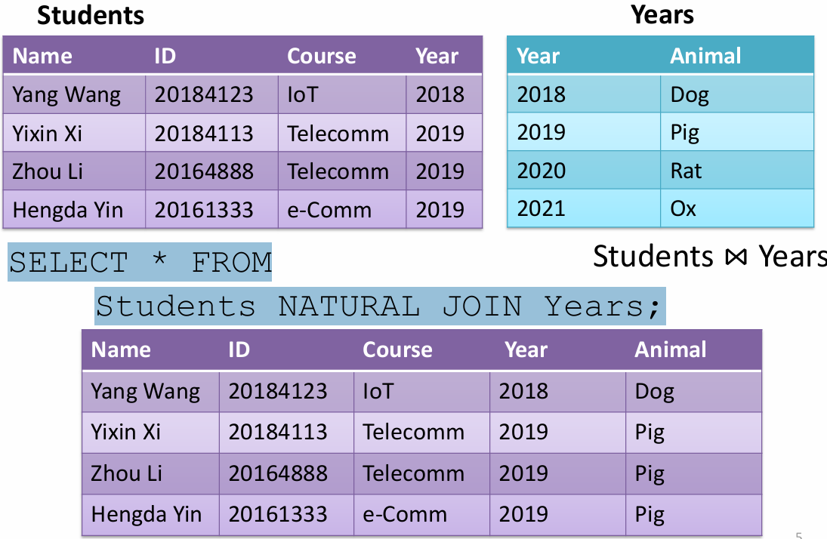
- USING()用括号里面的attraction来进行join。
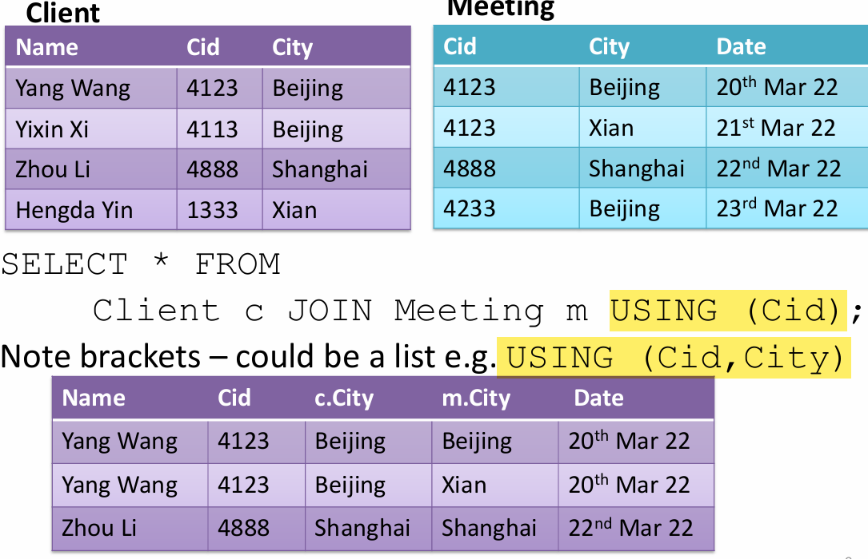
- ON，需要对两个实体进行命名，并用相等的条件进行组合


- CROSS JOIN 就相当于X乘
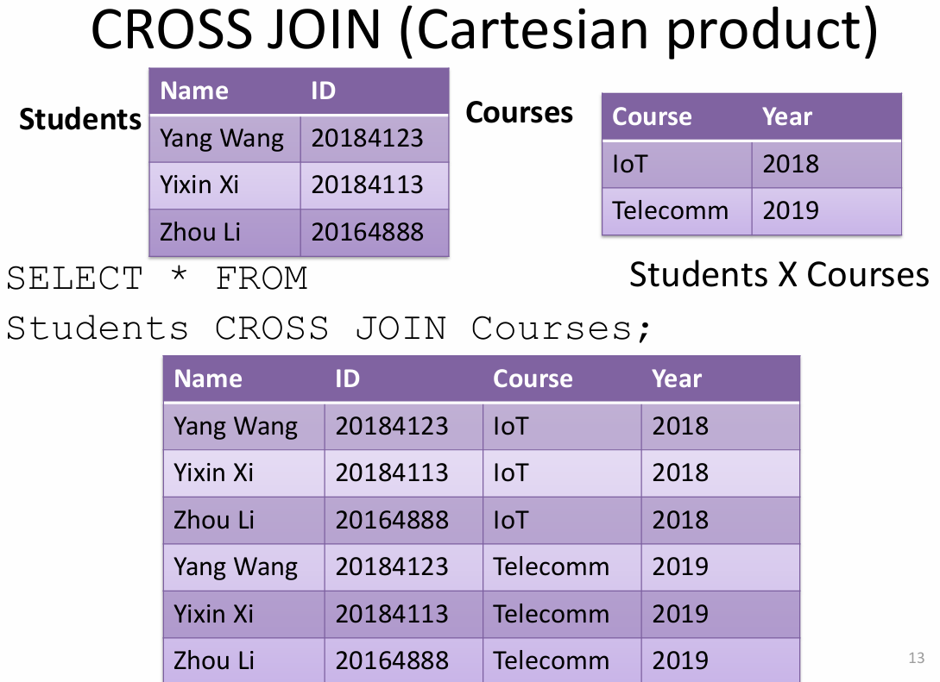
- LEFT JOIN 和 RIGHT JOIN 和 FULL JOIN，left就相当于看左边这个实体，把它对应的右边实体的全部填上，right则相反，看右边这个实体，把其对应的全部写上。FULL就是左右都看重复的只写一遍，没有对应的用NULL。
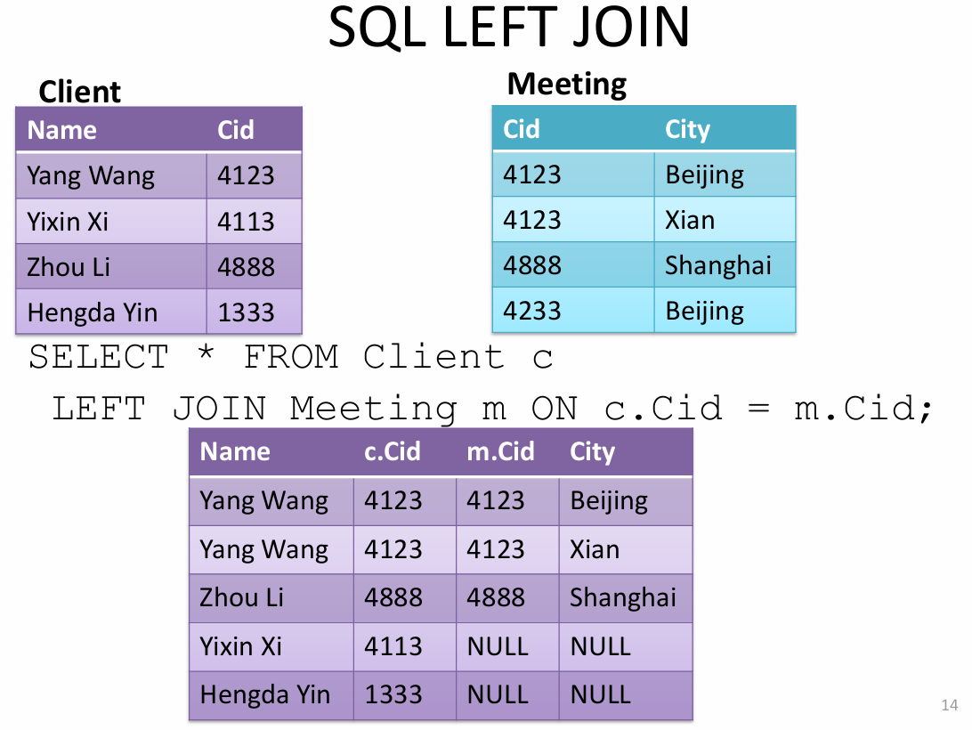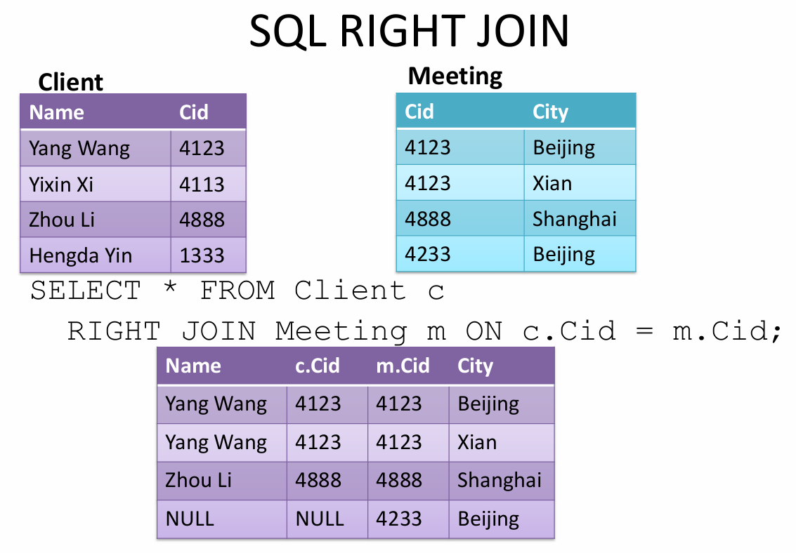
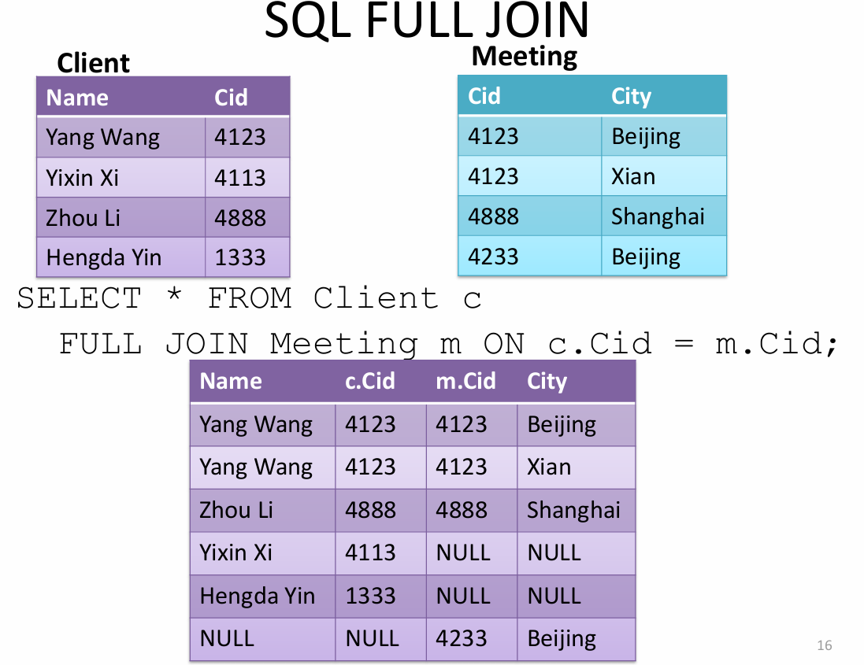

29. Database Design Methodology
Main phases
–Gather requirements
–Conceptual database design
The process of constructing a model of the data used in an enterprise, independent of all physical considerations.
构建企业所用数据模型的过程，该过程独立于所有物理因素考量。
–Logical database design
Maps the conceptual data model on to a logical model (e.g. relational), but independent of a particular DBMS and other physical considerations.
将概念数据模型映射为逻辑模型（如关系模型），但独立于特定的数据库管理系统及其他物理因素。
–Physical database design
The process of producing a description of the implementation of the database (tailored to specific DBMS); it describes the base relations, file organizations, and indexes design, and any associated integrity constraints and security measures.
生成数据库实现描述的过程（针对特定数据库管理系统进行定制）；该过程需描述基本关系、文件组织结构与索引设计，以及所有相关的完整性约束和安全措施。

30. Database Design Methodology步骤
(1) build conceptual data model
(2) build and validate logical data model
(3) translate logical data model for target DBMS
(4) design file organizations and indexes
(5) design user views
(6) design security mechanisms
(7) consider the introduction of controlled redundancy
(8) monitor and tune the operational system

31. build conceptual data model步骤
（1）identify entity types
（2）identify relationship types
（3）identify and associate attributes with entity or relationship types
（4）determine attribute domains
（5）determine candidate, primary, and alternate key attributes（后面有）
（6）consider use of enhanced modeling concepts
（7）check model for redundancy（后面有）
（8）validate conceptual model against user transactions
（9）review conceptual data model with user

32. (2) build and validate logical data model步骤
（1）derive relations for logical data model
（2）validate relations using normalization
（3）validate relations against user transactions
（4）check integrity constraints（后面有）
（5）review logical data model with user
（6）merge logical data models into global model (选做)
（7）check for future growth

33. translate logical data model for target DBMS的步骤
（1）design base relations
（2）design representation of derived data
（3）design general constraints

34. design file organizations and indexes步骤
（1）analyze transactions
（2）choose file organization
（3）choose indexes
（4）estimate disk space requirements

35. Normalization的定义
Normalization is a technique for producing a suitable set of relations that support the data requirements of an enterprise.

36.suitable set of1relations
attribute的数量少
同一个表格里放的都是关系最紧密的attributes
一个attribute最好只在一个表格里出现，除非是key

37. Benefits of using “suitable relations”
Easier for the user to access and maintain the data
Take up minimal storage space on the computer.

38. update anomalies
Relations that contain redundant information may have problems called update anomalies：
insertion anomalies：不能插一个branch with no staff，staffNo是PK/PK的一部分，entity integreity
deletion anomalies：只想删除一个staff，但是和一个branch相关的所有信息都也跟着没了
modification anomalies：想修改B004这个branch的地址，结果要改好多行

39. Two important properties of decomposition（去除冗杂数据的方式就是decomposition）：
Lossless-join property: ensures that any instance of the original relation can be identified from corresponding instances in the smaller relations.（在原本大关系里面的实例，可以从小关系的联系中识别）
Dependency preservation property: ensures that a constraint on the original relation can be maintained by enforcing some constraint on each of the smaller relations.（大关系中的约束，也可以在小关系中施加约束）

40. Functional dependency describes relationship between attributes.
Full Functional Dependency：Determinants should have the minimal number of attributes necessary to maintain the functional dependency with the attribute(s) on the right hand-side.
partial dependency ：A functional dependency A -> B is a partial dependency if there is some attribute that can be removed from A and the dependency still holds.
Transitive dependency：A, B, and C are attributes of a relation such that if A → B and B → C, then C is transitively dependent on A via B

41. The Process of Normalization：
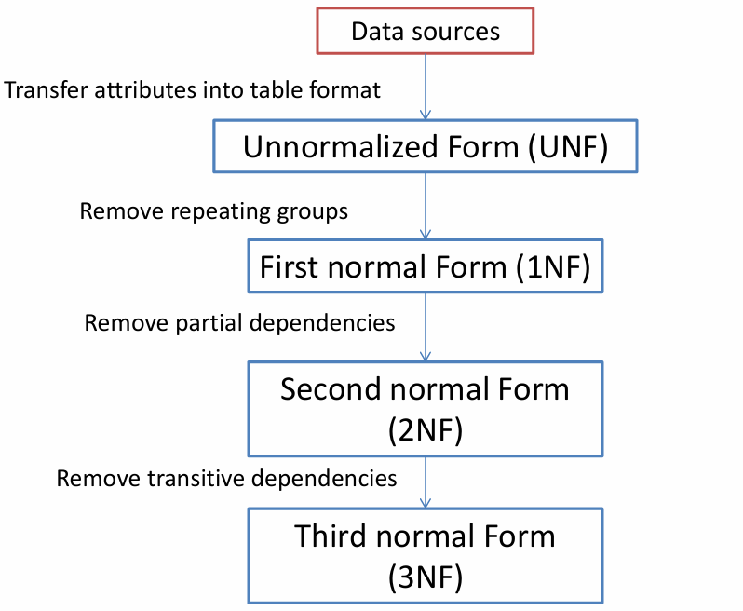

42.UNF AND 1NF
UNF: A table that contains one or more repeating groups.
1NF：A relation in which the intersection of each row and column contains one and only one value
UNF to 1NF
• Nominate an attribute or group of attributes to act as the key for the unnormalized table.
• Identify the repeating group(s) in the unnormalized table which repeats for the key attribute(s)
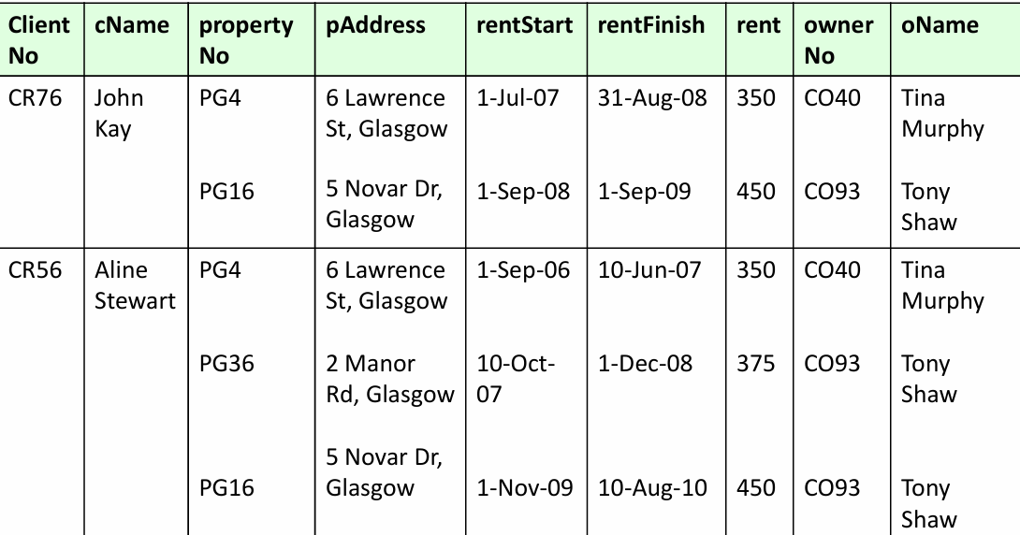
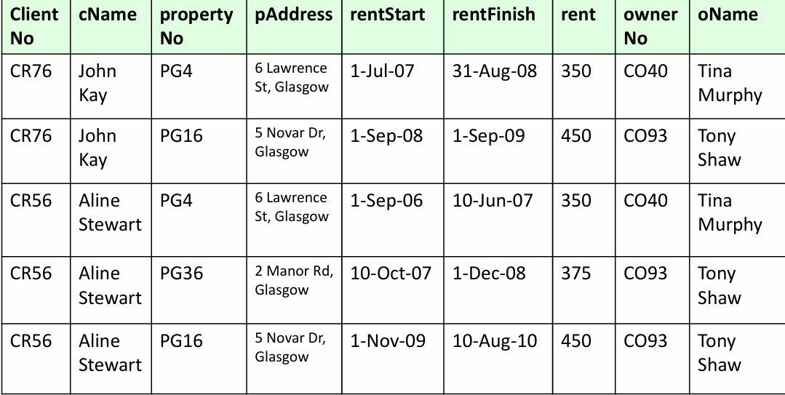

43.2NF
2NF：关系必须在1NF中，每个 非主键属性 完全函数依赖于 主键。
a relation that is in 1NF
every non-primary-key attribute is fully functionally dependent on the primary key
没有partial functional dependency
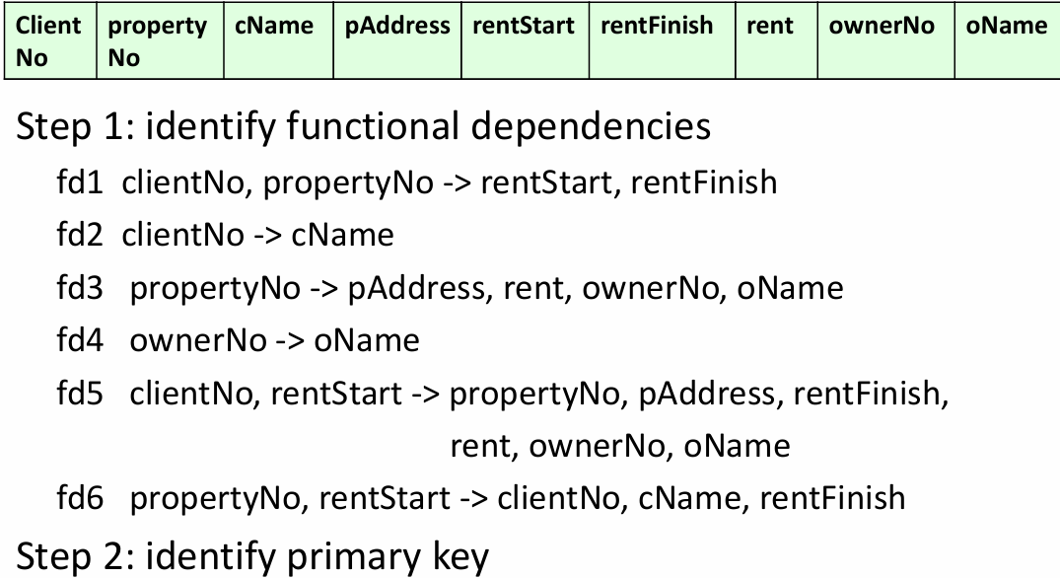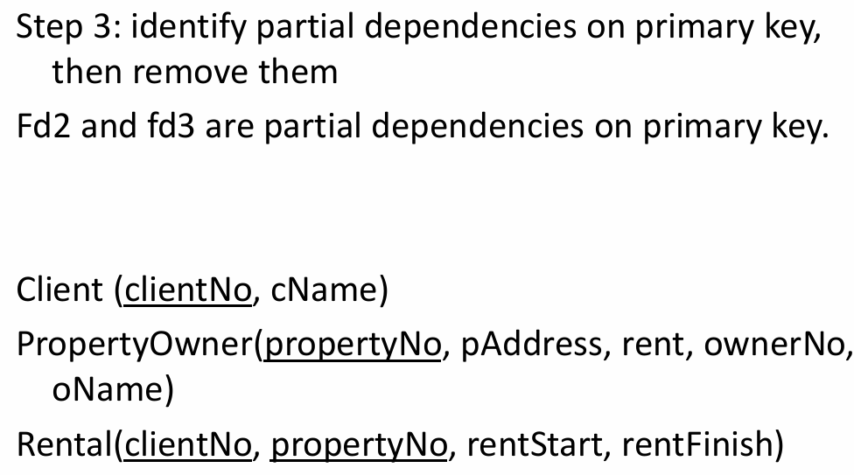

44.3NF
3NF：关系必须在2NF中，没有 非主键属性 传递依赖于 主键。
a relation that is in 1NF and 2NF
no non-primary-key attribute is transitively dependent on the primary key
没有transitive，没有A推B，B推C
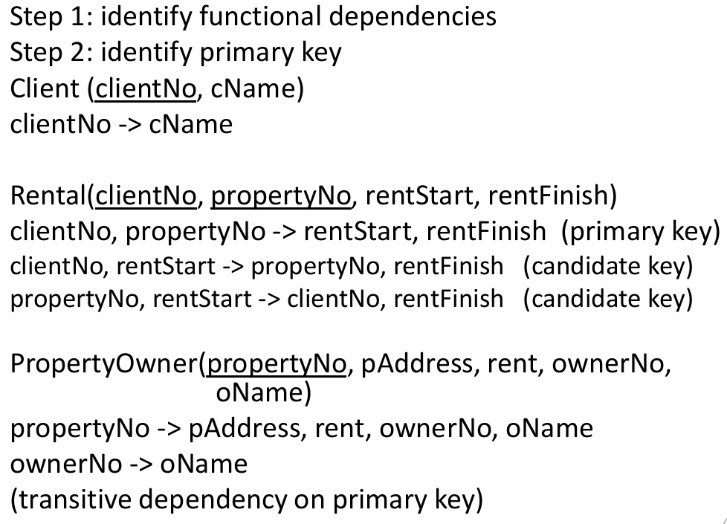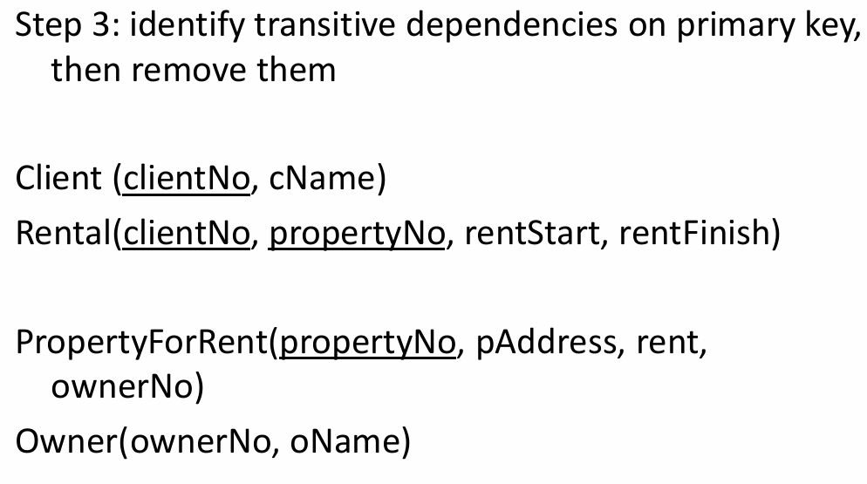

45.BCNF
BCNF：当且仅当每个决定因素都是候选键，那么这个关系在BCNF
a relation is in BCNF if and only if
every determinant is a candidate key
左边的东西都是candidate key
所有BCNF都满足3NF，满足3NF的却不一定是BCNF
The potential of 3NF relation to violate BCNF may occur in a relation that:
– contains two (or more) composite candidate keys;
– the candidate keys overlap, that is, they have at least one attribute in common.

转化BCNF：将不符合BFNF的FD，改写成两个关系，不符合的FD是一个关系，原本的符合的去处那个不符合右边的attraction就行。例如
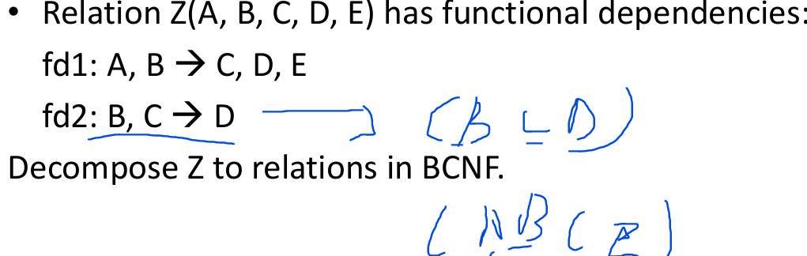

46.BCNF无法转变的情况
A set of functional dependencies {AB → C, C → B} cannot be represented by a BCNF schema。因为改变过后可能原本的候选键被破坏，所以避免麻烦就不能表示成BCNF。

47.4NF：
4NF要求在满足博茨-科德范式（BCNF）的基础上，移除所有的多值依赖。具体来说，若关系中的某个属性集X对某些属性集Y和Z同时具有多值依赖（即X -> Y, X -> Z），那么为了使关系符合4NF，X必须是Y和Z的超键。也就是说，若一个关系包含多值依赖，它必须消除这些依赖，确保每个多值依赖的左侧都是超键
多值依赖：多值依赖发生在一个属性集决定了另外两个属性集的值，而这两个属性集之间相互独立。
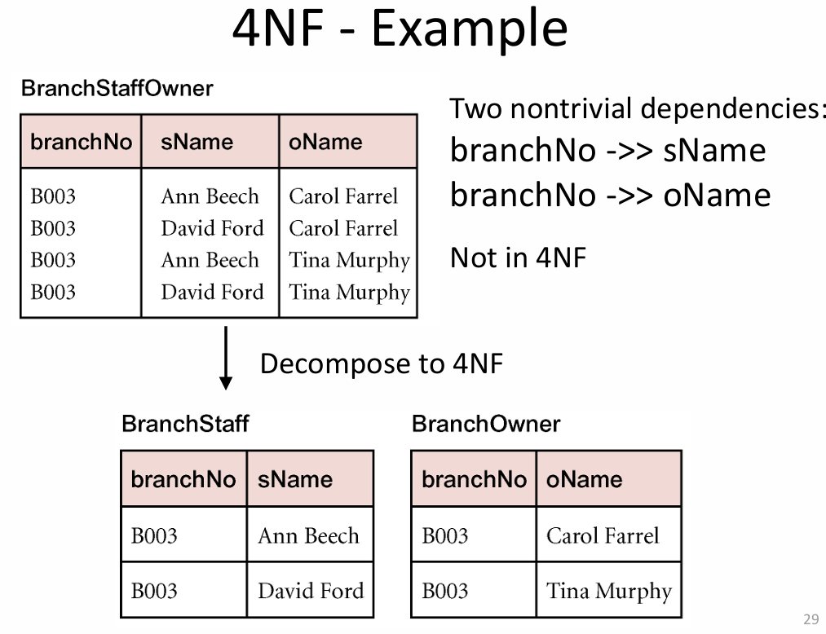
注：多值依赖和函数依赖是两个东西。这个表中，就不存在函数依赖，即没有一个合适的主键。所以就不存在函数依赖，自然就没有部分依赖和传递依赖，所以就是BCNF。但存在多值依赖，所以不是4NF。

48.Normalization的优劣：
– Removes data redundancy
– Solves INSERT, UPDATE, and DELETE anomalies
– This makes it easier to maintain the information in the database in a consistent state
However
– It leads to more tables in the database
– Often these need to be joined back together, which is expensive to do

前面很多基础知识点都是一些名词的定义以及什么的好坏和步骤之类的。大题可能会出Relational Algebra语言，ER模型的创建，ER模型转换成schema，SQL语句以及范式。

之后的知识点可能会考一个事务的时间上的大题。但是大多数都会是概念性值得题目，以及BLOCK4几乎都是概念型题目。

49. Transaction
Action, or series of actions, carried out by user or application, which reads or updates contents of database. *事务（Transaction）**是由用户或应用程序执行的一系列操作，这些操作读取或更新数据库的内容。

50. Properties of Transactions (ACID)
Atomicity | all transactions are completed or non is completed
Consistency | must transform database from one valid state to another
Isolation | partial effects of incomplete transactions should not be visible to other transactions
Durability | effects of a committed transaction are permanent and mustn’t be lost because of later failure
原子性（Atomicity）：事务中的操作要么完全执行，要么完全不执行（即全有或全无）。
一致性（Consistency）：事务的执行应将数据库从一个一致的状态转换到另一个一致的状态。
隔离性（Isolation）：并发执行的事务彼此之间应当独立，不受其他事务的干扰。
持久性（Durability）：一旦事务提交，它对数据库的更改应该是永久的，即使系统发生故障，也不会丢失。

51. Transaction outcomes
事务 commit（提交），数据库进入一个新的一致状态。
所有由该事务做出的更改会被保存。
这些更改将对其他事务可见。
关键点：提交意味着事务已经成功完成，其更改将永久存在于数据库中。

事务 abort（中止），数据库必须恢复到事务开始之前的一致状态
。
这种事务会被 rolled back（回滚） 或 undone（撤销）。
所有更改都会被撤销。
最终状态就像这个事务从未发生过。
关键点：回滚是为了保证数据一致性，避免半完成状态污染数据库。

52. Concurrency（并发运行）
大型数据库服务多个用户，同时需要处理多个事务（transactions）。
并发运行事务可提高系统效率，而不是让它们一个接一个地排队执行。
目标是：在提高吞吐量的同时仍然保持“隔离性（Isolation）”。

Problems:
Lost Update Problem（丢失更新）
两个事务读同一数据并更新，后提交的事务覆盖了前一个事务的更新。
Successfully completed update is overridden by another user.
示例：两个用户同时更新一个账户余额，但最后只保留了一个的修改。
Uncommitted Dependency Problem（未提交依赖）：
一个事务依赖于另一个尚未提交的事务的数据，如果该事务回滚，会导致前者用到了无效数据。又称脏读（Dirty Read）。
Occurs when one transaction can see intermediate results of another transaction before it has committed. Failure to commit causes a rollback, but other transactions are unaware of the rollback.
Inconsistent Analysis Problem（不一致分析）：
一个事务在读取多个记录时，其他事务正在更新其中一些记录，导致分析结果不一致。
Occurs when a transaction reads several values from the database but a second transaction updates some of them during the execution of the first.
例如：一个事务正在统计工资总额，另一个事务正好在修改员工工资。

53. Concurrency Control
process of managing simultaneous operations on the database without having them interfere with one another(就是解决不同事务之间冲突的过程)

54.Schedule(调度)和serial schedule（串行调度）
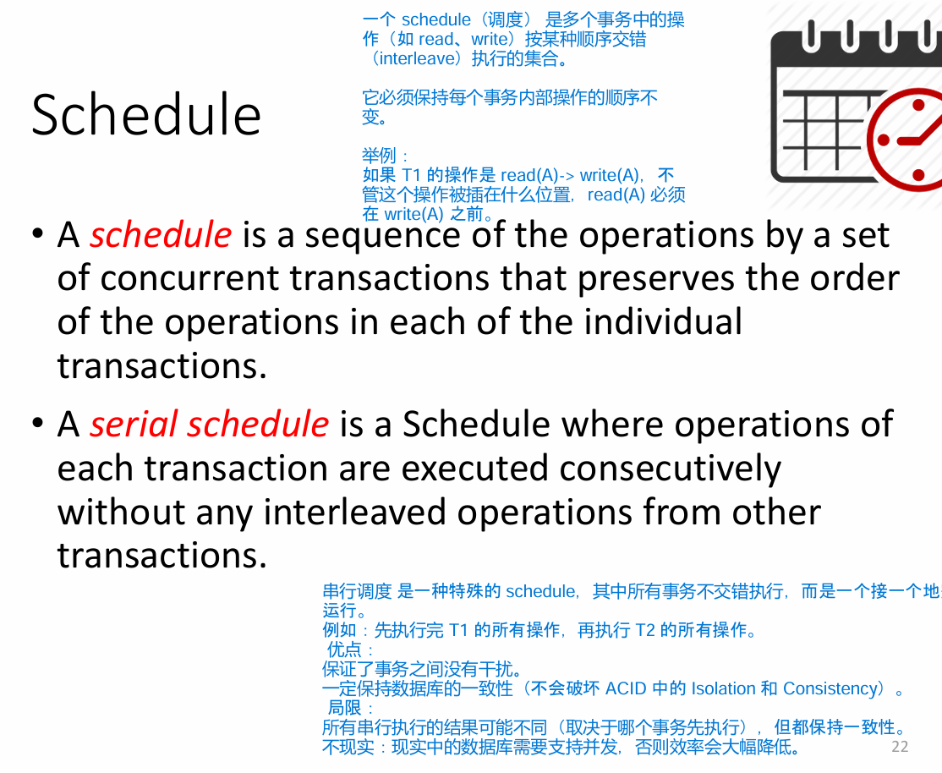

55. Nonserial Schedule 和Serializable Schedule
Nonserial Schedule: Schedule where operations from set of concurrent transactions are interleaved. 非串行调度（Nonserial Schedule）多个事务的操作交错执行，以提高并发度。
有可能导致冲突或不一致。
Objective of serialisability is to find nonserial schedules that allow transactions to execute concurrently without interfering with one another。可串行调度（Serializable Schedule）一个非串行调度，但它的执行结果与某个串行调度相同。这样可以同时获得并发性能和正确性。
目标就是找出哪些交错调度是“安全的”并允许它们发生。

56. Concurrency Control Techniques
o Locking,
o Timestamping

57.Locking
Locking: Transaction uses locks to deny access to other transactions and so prevent incorrect updates.
两种类型：
Shared lock (read-lock)：Read-lock allows several transactions simultaneously to read a resource (but no transactions can change it at the same time)只读不改
Exclusive lock (write-lock)：Write-lock allows one transaction exclusive access to write to a resource. No other transaction can read this resource at the same time.只能一个人操作
规则：
• Before reading from a resource a transaction must acquire a read-lock 读操作前 ->申请 read-lock。
• Before writing to a resource a transaction must acquire a write-lock 写操作前 ->申请 write-lock。
• Locks are released on commit/rollback 锁的释放时机：**在事务提交（commit）或回滚（rollback）时释放。
• A transaction may not acquire a lock on any resource that is write-locked by another transaction 不能对已被写锁的资源再加锁。
• A transaction may not acquire a write-lock on a resource that is locked by another transaction 不能对被任意锁定的资源加 write-lock。
• If the requested lock is not available, transaction waits如果锁被占用：当前事务**必须等待（wait）**直到锁释放。

58. Two-Phase Locking (2PL)
Principle of 2PL
• Every transaction must lock an item (read or write) before accessing it
• Once a lock has been released, no new items can be locked
Two phases for transaction: （就是增长阶段，只能申请所，收缩阶段，不能申请所，只能回首锁）所以必须一次性申请，之后一次性解锁。
1. Growing phase - acquires all locks but cannot release any locks.
2. Shrinking phase - releases locks but cannot acquire any new locks.

59.2PL解决不掉的
Cascading Rollback: a transaction (T1) causes a failure and a rollback must be performed. Other transactions dependent on T1's actions must also be rollbacked, thus causing a cascading effect.
解决方式就是使用严格的2PL（Rigorous 2PL）所有的解锁都必须到commit之后。
Deadlock：A deadlock occurs when two (or more) transactions are each waiting for locks held by the other to be released.
Only one way to break deadlock: abort one or more of the transactions.

60. General techniques for handling deadlock:

• Timeouts.
-Transaction that requests lock will only wait for a system-defined period of time.
-If lock has not been granted within this period, lock request times out.
-In this case, DBMS assumes transaction may be deadlocked, even though it may not be, and it aborts and automatically restarts the transaction.
简而言之，就是申请锁以后，只能在规定时间办事，时间一到，就自动松锁

• Deadlock prevention.
-DBMS looks ahead to see if the transaction would cause a deadlock and never allows a deadlock to occur.
-Conservative 2PL: All data items have to be locked at the beginning of a transaction
简而言之，相较于strict，在commit后松锁，这个必须beginning之前锁，确保开始之后再请求出现死锁的问题。但是会有一些问题
很难预测需要什么锁，第二可能申请了却用不到，导致锁很长时间，影响他人使用。

61. Database Recovery
Process of restoring database to a correct state in the event of a failure.

Recovery Facilities
DBMS should provide following facilities to assist with recovery:
• Backup mechanism, which makes periodic backup copies of database.
• Logging facilities, which keep track of current state of transactions and database changes. • Checkpoint facility, which enables updates to database in progress to be made permanent. • Recovery manager, which allows DBMS to restore database to consistent state following a failure.

62.Log File
记录数据库的所有更新信息：
- 事务记录（Transaction records）：包含对数据库所做的更改的详细信息。
- 检查点记录（Checkpoint records）：用于在数据库与日志之间同步信息，帮助恢复机制高效运行。
日志文件中Transaction records有：
• Transaction identifier.
• Type of log record, (transaction start, insert, update, delete, abort, commit).
• Identifier of data item affected by database action (insert, delete, and update operations).
• Before-image of data item.
• After-image of data item.
• Log management information

63.Checkpointing
Point of synchronization between database and log file. All buffers are force-written to secondary storage. 当发生检查点时，所有缓存的数据会被强制写入到磁盘中（force-write），保证数据一致性。
Checkpoint record is created containing identifiers of all active transactions. 包括所有“正在进行的事务”的标识符。这样一来系统就知道在崩溃恢复时哪些事务还未完成。
When failure occurs, redo all transactions that committed since the checkpoint and undo all transactions active at time of crash. •
Redo（重做）：对所有在检查点之后提交的事务进行重做操作，保证其修改反映到数据库中。
Undo（撤销）：对在崩溃时仍未提交的事务进行撤销，防止其未完成的修改破坏数据库一致性。
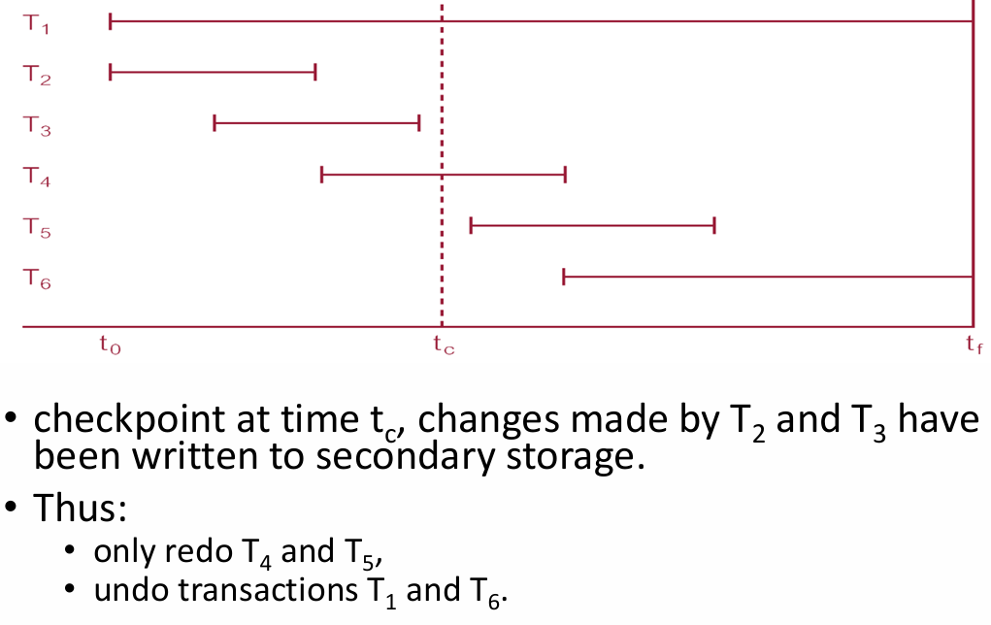

64. Database architectures（数据库架构）
Elements:
• Client: the machine running the user interface of the applications.
• Database server: the machine that runs the DBMS and contains the database.
Categories: 1. Personal databases 2. Two-tier databases 3. Multi-tier databases.

65.第一种Personal databases
Purpose: allow the user to manage (store, update, delete, and retrieve) small amounts of data in an efficient manner.
• Pro: can improve personal productivity
• Con: the data cannot easily be shared with other users

66.第二种Two-Tier Client/Server Architecture
• Computers (client) connected over wired or wireless local area network (LAN)
• The database itself and the DBMS are stored on a central device called the database server, which is also connected to the network.
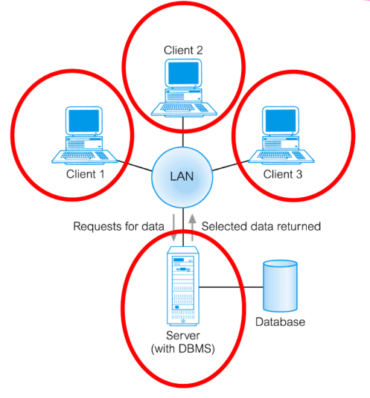
 | 2-tier的任务 | 3-tier的任务
Client | user interface  business logic  data processing logic | user interface
Application server |  | business logic  data processing logic
Database server | server-side validation  database access | data validation  database access

67. 第三种Multi-tier Client/Server Architecture
PPT上简单介绍了一下，也是分为上面三种处理。但是可以拓展到更多层，更灵活。（没介绍，感觉是空话）

68. Distributed Database
定义：a logically interrelated collection of shared data and a description of this data, physically spread over a computer network

69. Distributed DBMS
定义：software system that permits the management of the distributed database and makes the distribution transparent to users.

70.分布式过程和分布式数据库管理系统不同
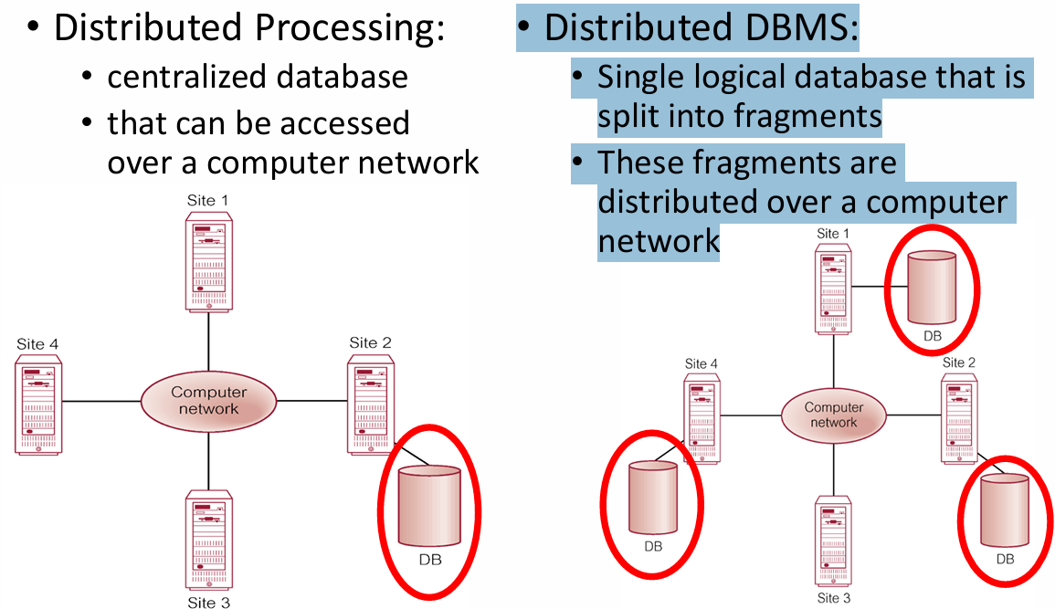

71. Types of DDBMS（Distributed DBMS）

• Homogeneous DDBMS同构分布式数据库管理系统
- 所有站点使用相同的 DBMS 产品（例如都用 Oracle 或 MySQL）。
- 系统设计和管理更简单，因为没有异构环境带来的兼容性问题。
- 支持系统的逐步扩展（incremental growth），并且能够提升整体性能。

• Heterogeneous DDBMS（异构分布式数据库管理系统）
- 各站点可能使用不同的 DBMS 产品，甚至底层的数据模型也不同（如关系型 vs 非关系型）。
- 这种情况通常出现在：各站点独立实现数据库，之后才考虑整合。
- 系统需要进行翻译（translation），以处理：
  - 不同的硬件；
  - 不同的 DBMS；
  - 硬件和 DBMS 都不同的情况。
- 解决方案：使用网关（Gateways）
  - Gateway 是一种软件，它让一个 DBMS 看起来像另一个 DBMS，以实现兼容。

72. Functions of a DDBMS
DBMS的功能，再加上下面的
extended communication services
extended data dictionary
distributed query processing
extended concurrency control
extended recovery services

73. Reference Architecture for DDBMS（参考架构）
A reference architecture consists of:
• Set of global external schemas.
• Global conceptual schema (GCS).
• Fragmentation schema and allocation schema.
• Set of schemas for each local DBMS conforming to 3 level ANSI/SPARC.

74. Component Architecture for a DDBMS（组件架构）
1. Local DBMS (LDBMS): standard DBMS, responsible for controlling the local data at each site that has a database
2. Data Communications (DC): software enabling all sites to communicate with each other.
3. Global System Catalogue (GSC): holds information specific to the distributed nature of the system, such as the fragmentation, replication, and allocation schemas (it can be managed as a distributed database).
4. Distributed DBMS (DDBMS): the controlling unit of the entire system.

75. Distributed Database Design – key issues
• Fragmentation
Relation may be divided into a number of sub-relations, which are then distributed (a fragment is a logical data unit).
• Allocation
Each fragment is stored at the site with “optimal” distribution.
• Replication
Copy of fragment may be maintained at several sites

76. Disadvantages of Fragmentation
• Performance: the performance of global applications that require data from several fragments located at different sites may be slower. 性能：对于需要从位于不同站点的数据片段中获取数据的全局应用程序而言，其运行性能可能会变慢。
• Integrity: Integrity control may be more difficult if data and functional dependencies are fragmented and located at different sites. 完整性：如果数据和函数依赖关系被分散并位于不同站点，完整性控制可能会更加困难。

77. Fragmentation’s correctness
1. Compose all of the fragments should get a complete relation 必须确保能保存所有数据
2. Reconstruction : it must be possible to define a relational operation that will reconstruct the complete relation from fragments. This rule ensures that functional dependencies are preserved.必须能够还原原关系
3. Disjointness: 各处的数据不重复
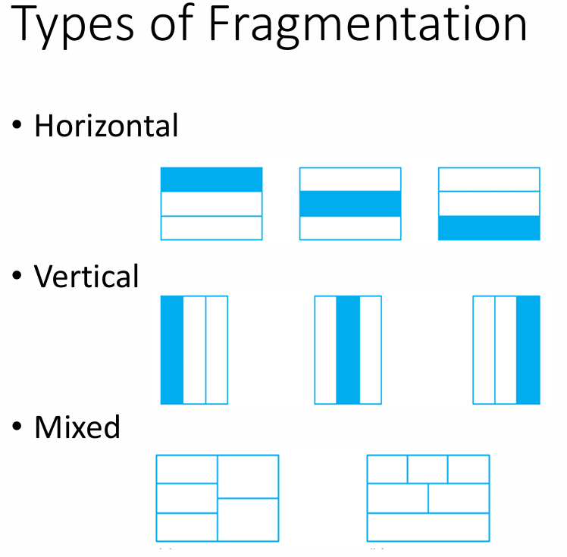

78. Strategies for Data Allocation
• Centralized: a single database and DBMS stored at one site with users distributed across the network – essentially distributed processing
• Fragmented (or Partitioned): Database partitioned into disjoint fragments; each fragment assigned to one site.
• Complete Replication: Consists of maintaining complete copy of database at each site.
• Selective Replication: Combination of fragmentation, replication, and centralization.
• 集中式：单一数据库及数据库管理系统（DBMS）集中存储于一个站点，用户通过网络分布式访问——本质上是分布式处理
• 分片式（或分区式）：数据库被划分为互不重叠的分片，每个分片分配至特定站点
• 完全复制：在每个站点维护数据库的完整副本
• 选择性复制：分片、复制与集中化三种模式的组合
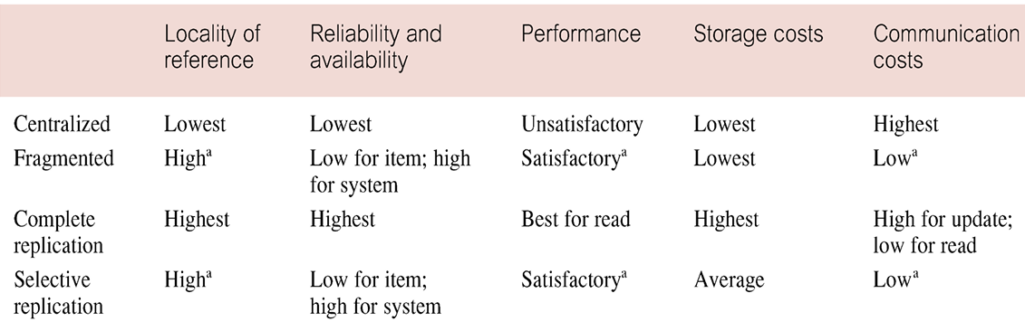

79. Hiding DDBMS complexity, is called transparency

1. Distribution Transparency
• Distribution transparency allows the user to perceive the database as a single, logical entity. • If distribution transparency is available, then the user does not need to know:
• how data is fragmented (fragmentation transparency),
• or the location of data items (location transparency)
• No distribution transparency = the user needs to know how the data is fragmented and the location of fragments (i.e., local mapping transparency). This is undesirable.

2. Transaction Transparency
• Ensures that all distributed transactions maintain distributed database’s integrity and consistency.
• A distributed transaction accesses data stored at more than one location.
• Each transaction is divided into number of subtransactions, one for each site that has to be accessed.
• DDBMS must ensure the synchronization of both the global transaction and each of the subtransactions.

3. Performance Transparenc
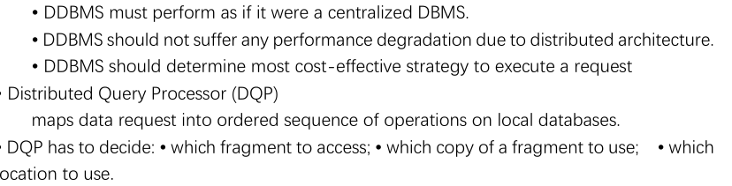

80. DDBMSs 的优缺点
良好的结构
可分享性和本地扩展性
可访问性，可靠性
更好的查询 方便扩展
但 复杂，数据规模大的时候贵
安全问题，完整性约束更加困难，标准不统一，数据库设计更加困难

81. Database security
定义: mechanisms that protect the database against intentional or accidental threats

82. 6个数据库安全措施
(1) authorization
定义：involves authentication of subjects requesting access to objects
authentication定义: a mechanism that determines whether a user is who he claims to be
(2) access controls
定义：allows a user to create or access some database object or run certain DBMS utility
based on the granting and revoking of privileges
(3) views
定义：the dynamic result of one or more relational operations on the base relations
(4) backup and recovery
backup定义：process of periodically taking a copy of the database and log file to offline storage media
recovery定义：process of restoring database to a correct state in the event of a failure.
(5) integrity
定义：Prevent data from becoming invalid and give misleading or incorrect results
(6) encryption
定义：the encoding of the data by a special algorithm that renders the data unreadable by any program without the decryption key.
(1) 授权
定义：涉及对请求访问对象的主体进行身份验证
身份验证定义：一种用于确定用户是否如其声称身份的机制
(2) 访问控制
定义：基于权限的授予与撤销，允许用户创建或访问某些数据库对象，或运行特定的数据库管理系统工具
(3) 视图
定义：对基本关系执行一个或多个关系操作后得到的动态结果
(4) 备份与恢复
备份定义：定期将数据库和日志文件复制到离线存储介质的过程
恢复定义：在发生故障时将数据库恢复至正确状态的过程
(5) 完整性
定义：防止数据失效，并避免产生误导性或错误的结果
(6) 加密
定义：通过特殊算法对数据进行编码，使得未经解密密钥的任何程序都无法读取该数据

83.sql注入
1.通过注释
2.通过加恒成立条件
3.通过加union条件
4.通过盲注，观察服务器反映判断正确或错误，然后用字串一个一个猜管理员的密码，无法 直接获取的情况下使用

84.预防SQL注入
（1）use prepared statements (parameterized statements)
（2）escape all user supplied input
（3）pattern check
（4）database permissions
（5）detect SQL injection vulnerabilities, manually or using web vulnerability scanner
（1）使用预处理语句(参数化语句)
而不是在语句中连接用户输入，而是使用占位符(参数)来接受用户输入。
占位符只能存储给定类型的值;因此，SQL注入将被视为一个奇怪的(无效的)参数值。
（2）转义所有用户提供的输入
例如，输入字符串中的单引号(')应该加上反斜杠(\)，以便数据库理解单引号是给定字符串的一部分，而不是其结束符。
（3）模式检查
可以检查参数以确定值是否是给定类型的有效表示。可以检查字符串以遵循特定的模式(例如日期，电话号码)。
（4）数据库权限
将web应用程序使用的数据库登录的权限限制为仅需要的权限
（5）检测SQL注入漏洞，手动或使用web漏洞扫描器。

85.Data Ethics
Owenership
•数据伦理的第一原则是个人对其个人信息拥有所有权。•个人应该能够对个人数据做出有意义的选择。
•在收集某人的个人数据之前，应征得同意。
Transparency
•透明度指的是明确沟通将收集哪些数据，是否(以及如何)存储数据，如何使用数据以及可能与谁共享数据。
Data Privacy
•数据隐私是保障数据主体的隐私
•个人身份信息(PII)是指与个人身份相关的任何信息;
包括:全名、出生日期、地址、电话号码、信用卡信息、银行账号、护照号码等
•为了保护个人隐私，数据库安全机制是必不可少的，所以个人化
数据不会落入坏人之手。
Accountability
•问责制是指一个组织在收集个人数据后对个人数据的处理负责。
•从数据泄露到向第三方销售，企业需要对其流程可能给用户造成的损害承担责任

86. eXtensible Markup Language (XML)
• A meta-language (i.e. a language for describing other languages) that enables designers to create their own customised tags to provide functionality not available with HTML.
• Standard for data representation and exchange
• Also streaming format

87. XML – Elements
• Elements, or tags, are most common form of markup.
• First element must be a root element, which can contain other (sub)elements.
• XML document must have one root element .
• start-tag <Bookstore>
• end-tag </Bookstore>
• XML elements are case sensitive.
• An element can be empty, in which case it can be abbreviated to <EMPTYELEMENT/>
• Elements must be properly nested.

88. XML – Attributes
• Attributes are name-value pairs that contain descriptive information about an element.
• Attribute is placed inside start-tag after corresponding element name with the attribute value enclosed in double quotes.
<Book ISBN=”0590353403” Price=”20” Edition=”1st”>
• A given attribute may only occur once within a tag, while sub-elements with same tag may be repeated.

89. XML – Other Sections
• XML declaration: optional at start of XML document.
E.g.,<?xml version=”1.0” encoding=”UTF-8” standalone=”no”?>
• Entity references: serve various purposes, such as shortcuts to often repeated text or to distinguish reserved characters from content.
E.g., < is the same as &It
• Comments: enclosed in <!—and--> tags.
E.g.,<!—this is a comment -->

90. XML – Ordering
• elements are ordered.
• attributes are unordered.

91. “Well-Formed” XML
核心概念：
- 一个 XML 文档被称为“well-formed”（结构良好）是指它满足基本的语法规则。
要求如下：
- 单一根元素（Single root element）：整个 XML 必须有且只有一个最外层标签。
- 匹配标签、正确嵌套（Matched tags, proper nesting）：所有开始标签必须有对应的结束标签，且标签不能交叉嵌套。
- 元素内属性不能重复（Unique attributes within elements）：同一个标签内不能出现两个同名属性。
流程图说明：
XML Document 输入 → XML Parser
若结构良好：输出 Parsed XML
若不良好：输出 "Not well-formed"

92. Displaying XML
核心概念：
- XML 本质是数据格式，不具备展示功能，需要通过规则语言将其转换为 HTML 等可视形式。
使用的规则语言：
- CSS（层叠样式表）：控制标签的外观样式，提供替代的渲染方式。
- XSL（可扩展样式表语言）：更强大的转换语言，定义如何将 XML 转换为其他格式，比如 HTML。
流程图说明：
- XML Document（数据）→ XML Parser → CSS/XSL Interpreter（解释器）+ 规则 → HTML Document（可视页面）

93. Document Type Definitions (DTDs)："Valid" XML
核心概念：
- 一个“Valid”（有效）的 XML 不仅需要是结构良好的（well-formed），还需要符合一套结构定义，即 DTD 或 XSD（XML Schema Definition）。
定义内容包括：
- 元素、属性、嵌套规则、出现次数限制；
- 特殊属性类型如 ID 和 IDREF(S)；
- 被称为 XML 的“vocabulary（词汇表）”，用于定义结构；
- 语法使用 EBNF（扩展巴科斯范式），而不是 XML 本身。

94.DTDS的三大要求

1. Element Type Declarations（元素类型声明）
作用：
定义 XML 文档中哪些元素可以出现，以及它们出现的顺序和重复次数。Identify the rules for elements that can occur in the XML document. Options for repetition are
重复选项符号：
- * ：出现 0 次或多次zero or more occurrences for an element;
- + ：出现 1 次或多次one or more occurrences for an element;
- ? ：出现 0 次或 1 次zero occurrences or (exactly) one occurrence for an element
语法注意事项：
- 没有这些符号的元素必须正好出现一次。Name with no qualifying punctuation must occur exactly once.
- 用 逗号分隔的元素名，表示必须按顺序出现。
- 如果没有逗号（如用 | 表示选择），表示这些元素可以任意顺序出现。
Commas between element names indicate they must occur in succession; if commas are omitted, elements can occur in any order.
- #PCDATA：表示该元素可以包含文本内容（Parsed Character Data）。
#PCDATA: parsable character data, declares the base elements.
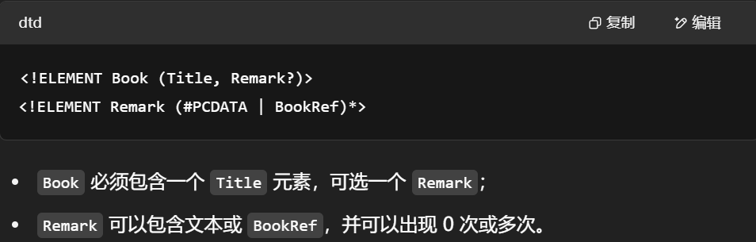

2. Attribute List Declarations（属性列表声明）
作用：
指定哪些元素可以拥有属性、这些属性的类型、是否必须、是否有默认值等。
属性类型常见种类：
- CDATA：字符数据，可包含任意文本。
- ID：唯一标识符，用于唯一标识一个元素。
- IDREF / IDREFS：引用别的元素的 ID（单个 / 多个）。
- #REQUIRED：属性必须存在。
- #IMPLIED：属性可选，允许不出现。
- 枚举值列表：属性只能取某些限定值。
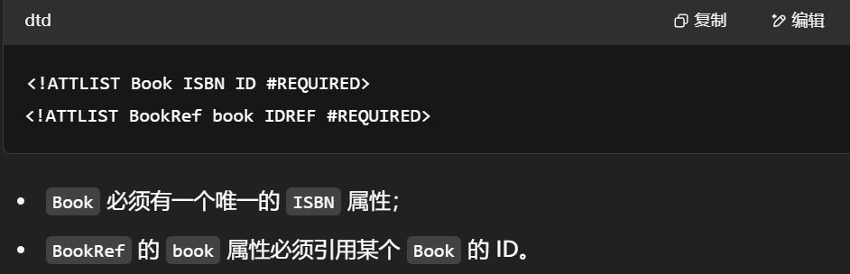

3. Element Identity: ID, IDREF, IDREFS
核心概念：
- ID：为元素定义一个唯一标识（如主键）。
- IDREF：允许一个元素引用另一个元素的 ID（一对一引用）。
- IDREFS：允许引用多个元素的 ID（一对多引用）。
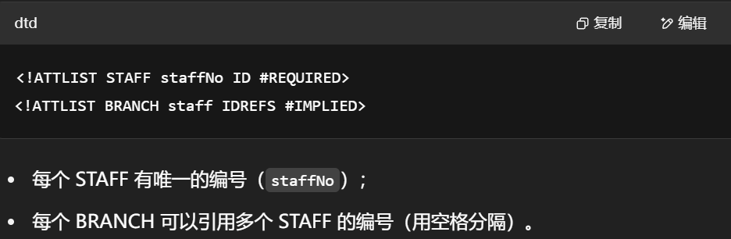

95.另一种XML valid的方法XSD

1.DTD与XSM
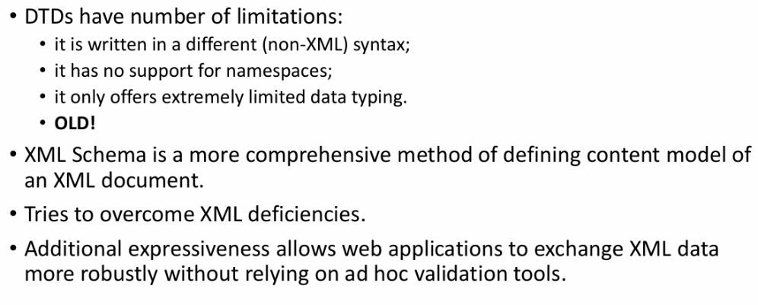
DTD 的局限性：
- 写法不是 XML 语法（非 XML 格式）。
- 不支持命名空间。
- 数据类型支持非常有限（几乎没有类型验证）。
- 技术老旧。
为什么用 XSD？
- 是一种更现代、功能更强的 XML 结构定义方法。
- 更强表达力，适用于 Web 应用中的复杂数据交换和验证。

2. XML Schema 定义
XSD 的能力：
- 定义结构（元素、属性、嵌套、顺序、次数等）。
- 支持数据类型（如整数、字符串、布尔值等）。
- 支持键（key）、引用（reference）、指针等。
- 本质上是一个 XML 文档，便于编辑和自动处理。
语法方面可定义的内容：
- 数据类型（Type）
- 键声明（Key declaration）
- 引用关系（References）
- 出现次数约束（Occurrence constraints）

3. XSD Types
常用基本类型：
- xs:string
- xs:decimal
- xs:integer
- xs:boolean
- xs:date
- xs:time
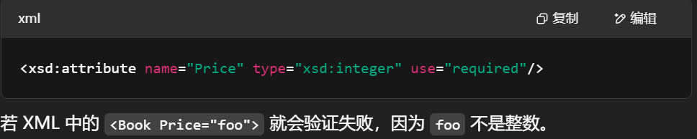

4. XSD 键声明（<xsd:key>）
- 声明某个属性或元素为“主键”，必须唯一、非空且存在。
- 用于后续引用验证。
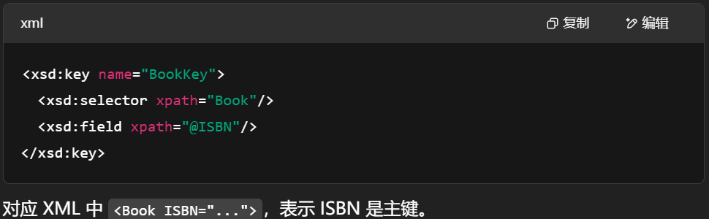

5. XSD 引用（<xsd:keyref>）
- 表示某个元素或属性是对一个已定义 key 的引用。
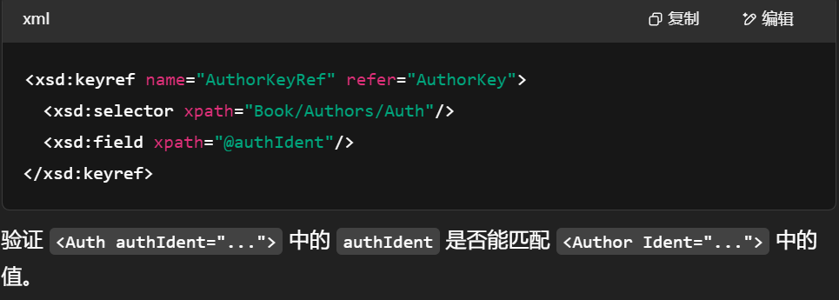

6. XSD 的出现次数（Cardinality and Occurrences）
使用 minOccurs 和 maxOccurs 控制元素出现次数：
属性 | 说明
minOccurs | 最小出现次数（默认 1）
maxOccurs | 最大出现次数（默认 1，可为 "unbounded"）
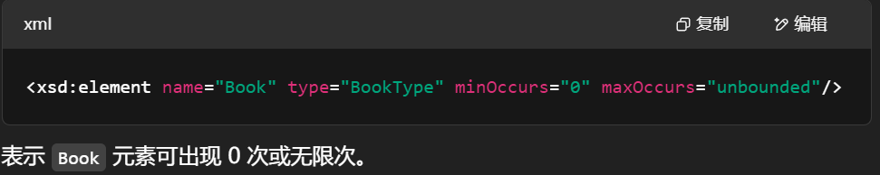

96. Relational Model versus XML（考过）
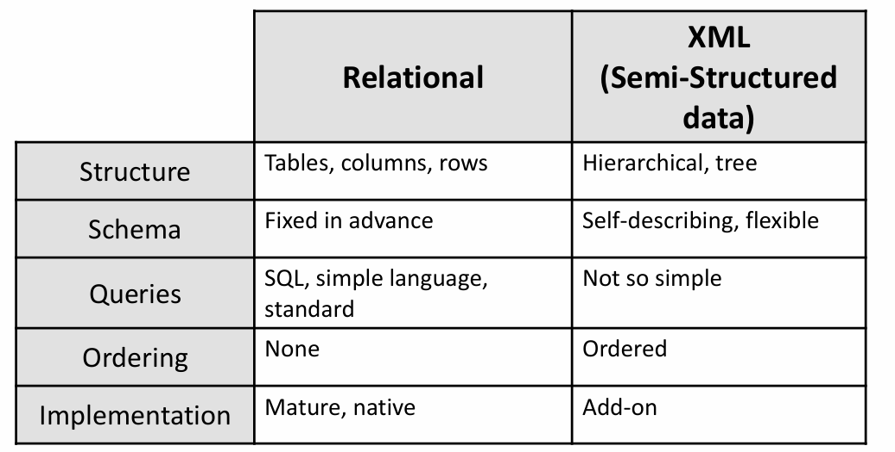

97. Advantages of XML
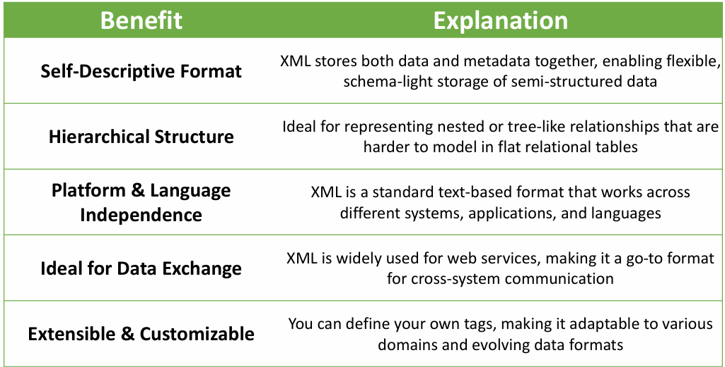

98. motivation for NoSQL
- 数据爆炸：数据量急剧上升，类型多样，传统关系型数据库无法扩展以应对大数据场景。
- Big Data Challenges：大数据场景下需要新的数据库架构，NoSQL 是应对之道。

99. NoSQL 概念与特征 | Concepts & Characteristics
- Not Only SQL / 非关系型数据库，不是传统 SQL 模型。
- 主要特征：
  - 灵活的模式（Flexible schema）
  - 更易部署（Low setup cost）
  - 极高扩展性（Massive scalability）
  - 弱一致性（Relaxed consistency）
- 缺点：
  - 无声明式查询语言（需更多编程）
  - 一致性保证较弱（特别是事务）
NoSQL gives up ACID for BASE:
- BASE = Basically Available, Soft state, Eventually consistent
- ACID = Atomicity, Consistency, Isolation, Durability

100. NoSQL 类型 | Types of NoSQL Databases

键值存储 Key-Value Stores
  - 数据模型：(key, value)
  - 代表系统：Redis, DynamoDB, Memcached
  - 特点：极简、高效、易扩展；适合缓存或简单事务
efficiency, scalability, fault-tolerance

文档型数据库 Document Stores
  - 数据模型：(key, document)，如 JSON/XML 格式
  - 代表系统：MongoDB, CouchDB
  - 特点：适用于半结构化数据，如 CMS 系统、用户配置文件
Helpful in managing semi-structured data

图数据库 Graph Databases
  - 数据模型：节点（Nodes）+ 边（Edges）
  - 用于建模对象间复杂关系，如社交网络、推荐系统
Graph databases are used for storing and managing a network of connections between elements within the graph.
  - 代表系统：Neo4j, FlockDB

101. 为何需要半结构化数据存储？ | Why are such (semi-structured) data stores needed?
- 适合大数据场景：半结构化或平面文件（flat files）最适合处理大量数据，这些数据通常频繁读取，但更新较少。
- 低开销处理：相对于传统数据库，处理这种格式的数据开销较小。
- 灵活性：能够处理那些结构不完全固定的数据，适应灵活的数据模型。
- 可扩展性：NoSQL 数据库在这种存储格式下具有显著的可扩展性优势。
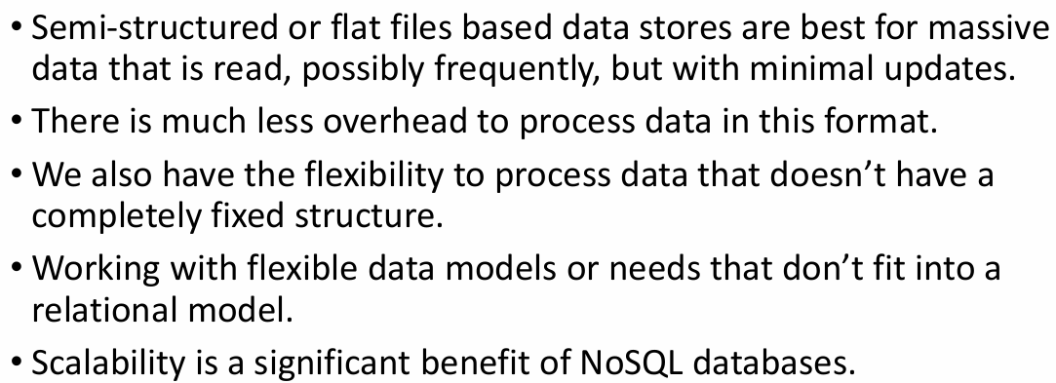

102. NoSQL 应该避免的场景 | What NoSQL should NOT be used for
- 需要频繁更新的数据：NoSQL 不适合需要频繁更新和读取的应用，特别是需要高一致性和原子性（ACID 属性）保证的场景。
- 事务型数据库：如库存管理和金融记录等需要强事务支持的数据。这些应用对于数据完整性和一致性要求高，适合使用关系型数据库。
- 大规模分布式数据和处理：虽然 NoSQL 适合大规模数据存储，但当涉及到高一致性、事务性需求时，关系型数据库更为合适。像 Visa 和 Amazon 等大规模分布式系统通常需要更结构化的数据和事务语义。
- 总结：NoSQL 是一种非传统的数据库技术，适用于大规模环境下，当事务（ACID）不是优先考虑时使用。
