Fundamentals of Programming (SCIFF 009)

Group Assignment Submission Sheet

GROUP NO:_______1_________

STUDENT NAME(S) | STUDENT ID | CONTACT NUMBER
1. Mirza Hizriyan Nubli Hidayat | 20310915 | +97433250326
2. Hong MengZe | 20306517 | +60173782016
3. Ahmed Hani Ahmed Ibrahim Moustafa | 20265505 | +201147956186
4. Ibraheem Haitham Abdulhameed Shanshal | 20286003 | +9647709293950
5. Mohamed Abubaker Mohamed Ahmed MohamedS | 20302059 | +97433638319

Table of Contents
Fundamentals of Programming (SCIFF 009) 1
Group Assignment Submission Sheet 1
Table of Contents 2
Graphical User Interface (GUI) 3
M - Scripts 8
Explanation of Features / Function 14
Key Functions 14
Key Features (other than calculating the data) 15
Testing 19

Graphical User Interface (GUI)
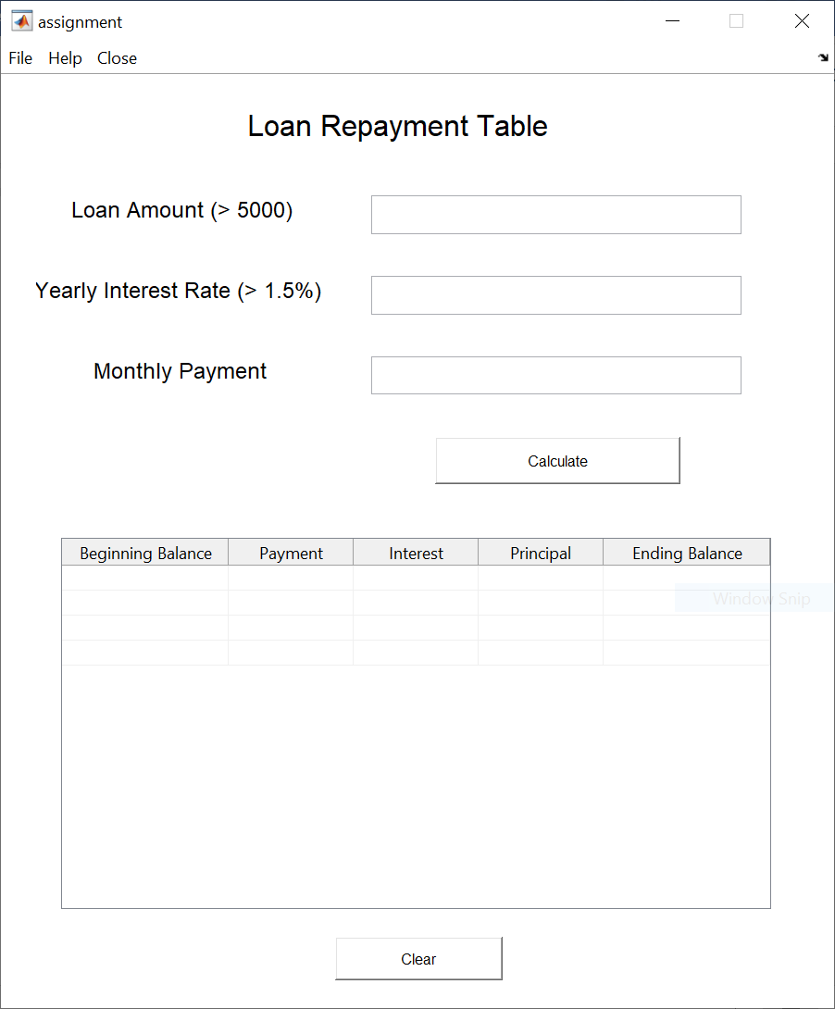

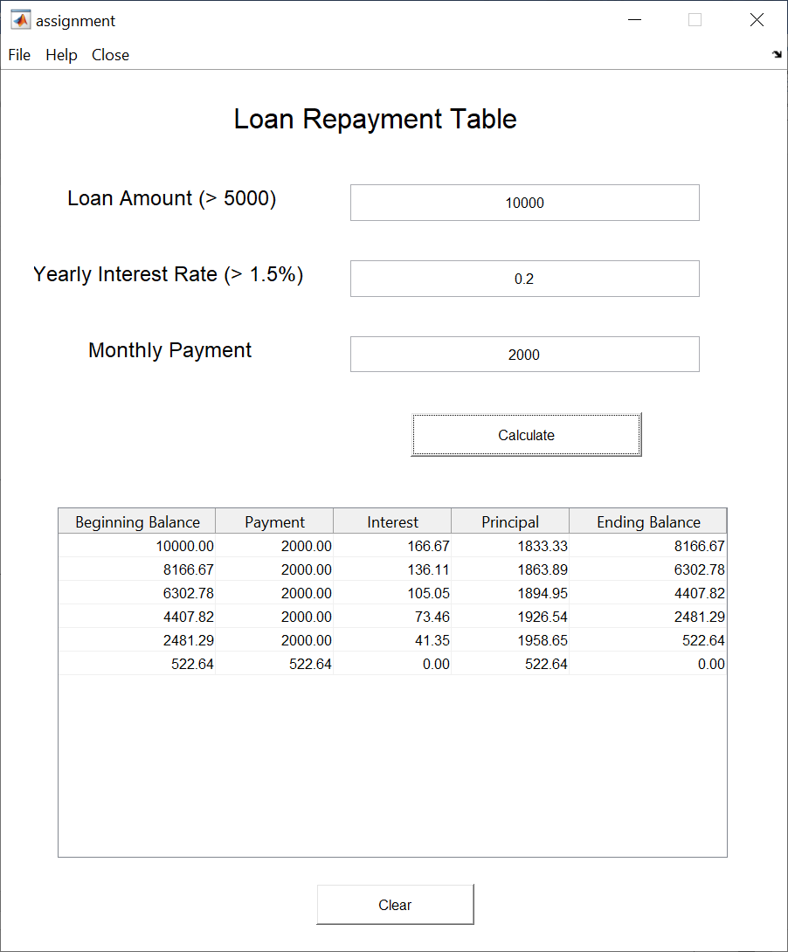
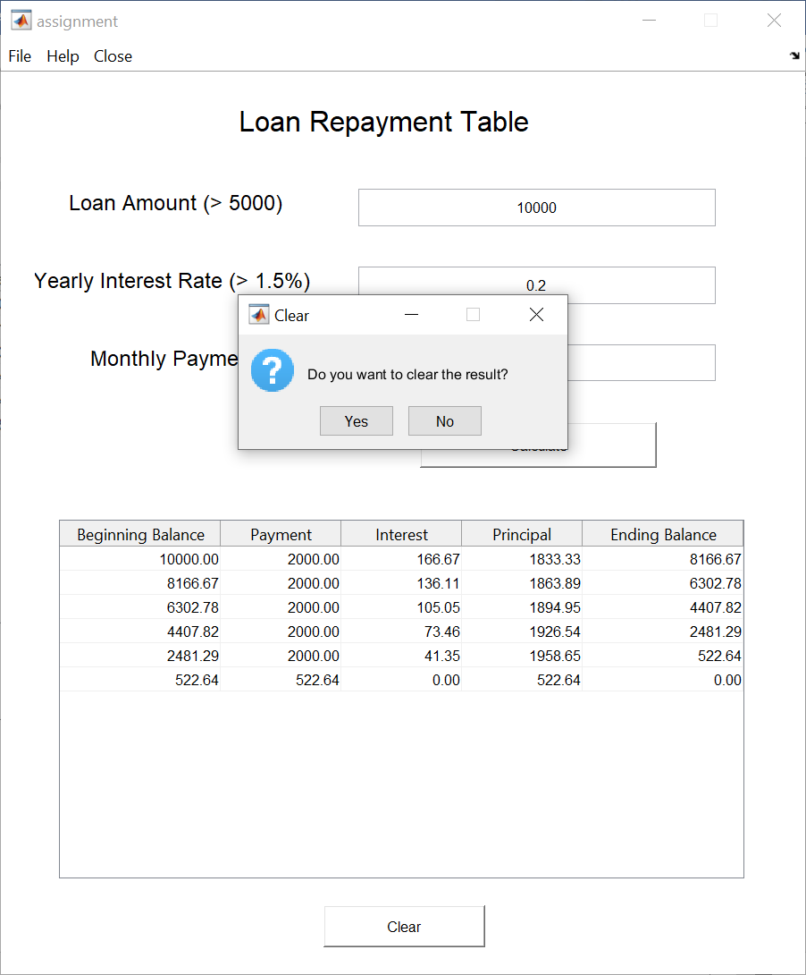

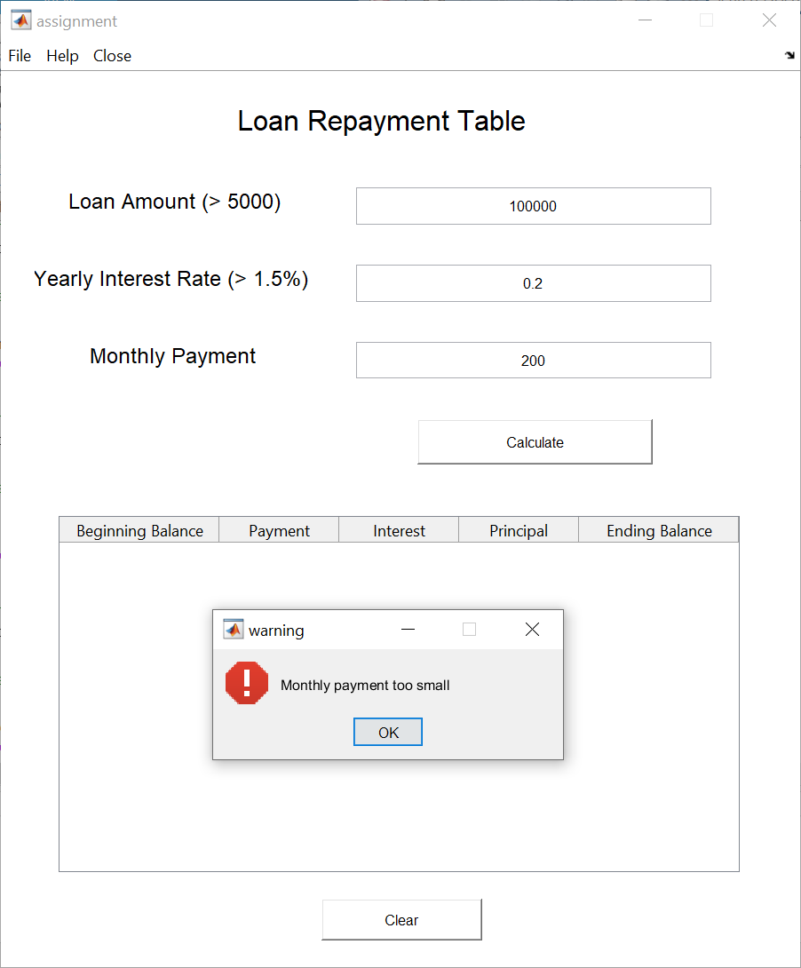
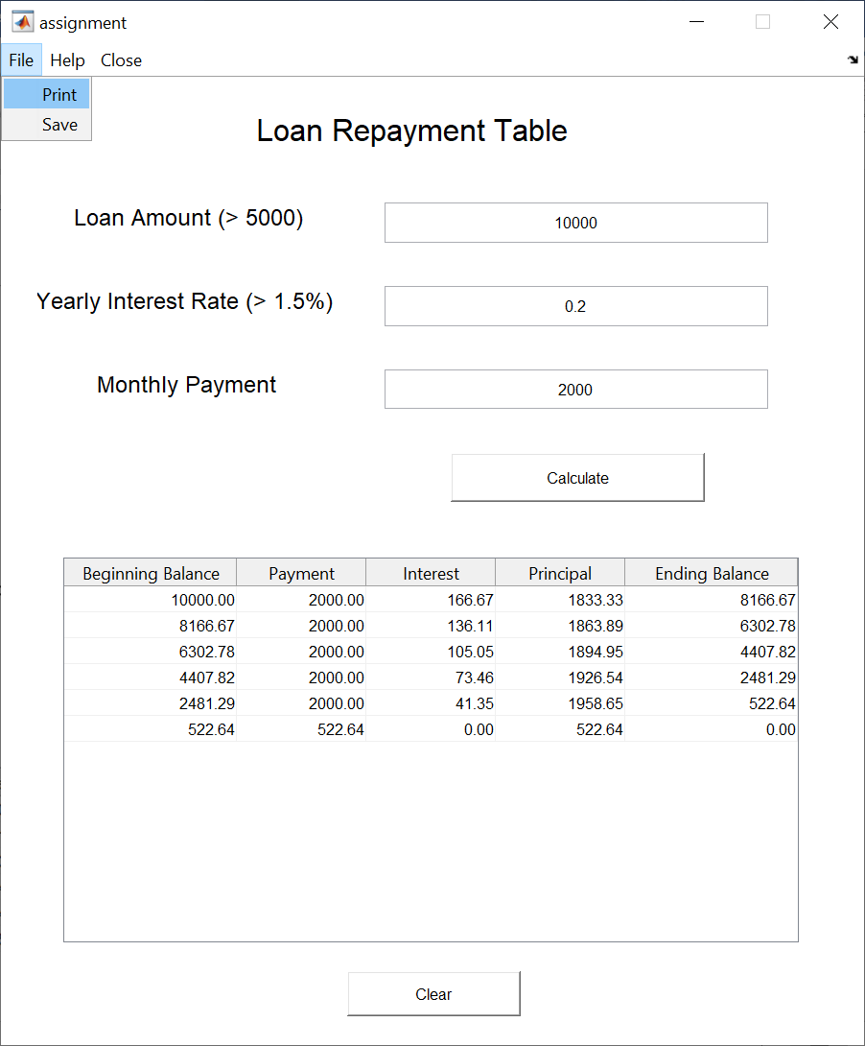

M - Scripts
function varargout = assignment(varargin)
% ASSIGNMENT MATLAB code for assignment.fig
% ASSIGNMENT, by itself, creates a new ASSIGNMENT or raises the existing
% singleton*.
%
% H = ASSIGNMENT returns the handle to a new ASSIGNMENT or the handle to
% the existing singleton*.
%
% ASSIGNMENT('CALLBACK',hObject,eventData,handles,...) calls the local
% function named CALLBACK in ASSIGNMENT.M with the given input arguments.
%
% ASSIGNMENT('Property','Value',...) creates a new ASSIGNMENT or raises the
% existing singleton*. Starting from the left, property value pairs are
% applied to the GUI before assignment_OpeningFcn gets called. An
% unrecognized property name or invalid value makes property application
% stop. All inputs are passed to assignment_OpeningFcn via varargin.
%
% *See GUI Options on GUIDE's Tools menu. Choose "GUI allows only one
% instance to run (singleton)".
%
% See also: GUIDE, GUIDATA, GUIHANDLES
% Edit the above text to modify the response to help assignment
% Last Modified by GUIDE v2.5 25-Mar-2021 17:09:53
% Begin initialization code - DO NOT EDIT
gui_Singleton = 1;
gui_State = struct('gui_Name', mfilename, ...
'gui_Singleton', gui_Singleton, ...
'gui_OpeningFcn', @assignment_OpeningFcn, ...
'gui_OutputFcn', @assignment_OutputFcn, ...
'gui_LayoutFcn', [] , ...
'gui_Callback', []);
if nargin && ischar(varargin{1})
gui_State.gui_Callback = str2func(varargin{1});
end
if nargout
[varargout{1:nargout}] = gui_mainfcn(gui_State, varargin{:});
else
gui_mainfcn(gui_State, varargin{:});
end
% End initialization code - DO NOT EDIT
% --- Executes just before assignment is made visible.
function assignment_OpeningFcn(hObject, eventdata, handles, varargin)
% This function has no output args, see OutputFcn.
% hObject handle to figure
% eventdata reserved - to be defined in a future version of MATLAB
% handles structure with handles and user data (see GUIDATA)
% varargin command line arguments to assignment (see VARARGIN)
% Choose default command line output for assignment
handles.output = hObject;
% Update handles structure
guidata(hObject, handles);
% UIWAIT makes assignment wait for user response (see UIRESUME)
% uiwait(handles.figure1);
% --- Outputs from this function are returned to the command line.
function varargout = assignment_OutputFcn(hObject, eventdata, handles)
% varargout cell array for returning output args (see VARARGOUT);
% hObject handle to figure
% eventdata reserved - to be defined in a future version of MATLAB
% handles structure with handles and user data (see GUIDATA)
% Get default command line output from handles structure
varargout{1} = handles.output;
function editLoan_Callback(hObject, eventdata, handles)
% hObject handle to editLoan (see GCBO)
% eventdata reserved - to be defined in a future version of MATLAB
% handles structure with handles and user data (see GUIDATA)
% Hints: get(hObject,'String') returns contents of editLoan as text
% str2double(get(hObject,'String')) returns contents of editLoan as a double
% --- Executes during object creation, after setting all properties.
function editLoan_CreateFcn(hObject, eventdata, handles)
% hObject handle to editLoan (see GCBO)
% eventdata reserved - to be defined in a future version of MATLAB
% handles empty - handles not created until after all CreateFcns called
% Hint: edit controls usually have a white background on Windows.
% See ISPC and COMPUTER.
if ispc && isequal(get(hObject,'BackgroundColor'), get(0,'defaultUicontrolBackgroundColor'))
set(hObject,'BackgroundColor','white');
end
function editInterest_Callback(hObject, eventdata, handles)
% hObject handle to editInterest (see GCBO)
% eventdata reserved - to be defined in a future version of MATLAB
% handles structure with handles and user data (see GUIDATA)
% Hints: get(hObject,'String') returns contents of editInterest as text
% str2double(get(hObject,'String')) returns contents of editInterest as a double
% --- Executes during object creation, after setting all properties.
function editInterest_CreateFcn(hObject, eventdata, handles)
% hObject handle to editInterest (see GCBO)
% eventdata reserved - to be defined in a future version of MATLAB
% handles empty - handles not created until after all CreateFcns called
% Hint: edit controls usually have a white background on Windows.
% See ISPC and COMPUTER.
if ispc && isequal(get(hObject,'BackgroundColor'), get(0,'defaultUicontrolBackgroundColor'))
set(hObject,'BackgroundColor','white');
end
function editMonthlyPayment_Callback(hObject, eventdata, handles)
% hObject handle to editMonthlyPayment (see GCBO)
% eventdata reserved - to be defined in a future version of MATLAB
% handles structure with handles and user data (see GUIDATA)
% Hints: get(hObject,'String') returns contents of editMonthlyPayment as text
% str2double(get(hObject,'String')) returns contents of editMonthlyPayment as a double
% --- Executes during object creation, after setting all properties.
function editMonthlyPayment_CreateFcn(hObject, eventdata, handles)
% hObject handle to editMonthlyPayment (see GCBO)
% eventdata reserved - to be defined in a future version of MATLAB
% handles empty - handles not created until after all CreateFcns called
% Hint: edit controls usually have a white background on Windows.
% See ISPC and COMPUTER.
if ispc && isequal(get(hObject,'BackgroundColor'), get(0,'defaultUicontrolBackgroundColor'))
set(hObject,'BackgroundColor','white');
end
% --- Executes during object creation, after setting all properties.
function dataDisplay_CreateFcn(hObject, eventdata, handles)
% hObject handle to dataDisplay (see GCBO)
% eventdata reserved - to be defined in a future version of MATLAB
% handles empty - handles not created until after all CreateFcns called
table = ["Beginning Balance", "Payment", "Interest", "Principal", "Ending Balance"];
set(hObject,'ColumnName',table);
% --- Executes on button press in calculateButton.
function calculateButton_Callback(hObject, eventdata, handles)
% hObject handle to calculateButton (see GCBO)
% eventdata reserved - to be defined in a future version of MATLAB
% handles structure with handles and user data (see GUIDATA)
% Get the user input into a buffer/temp var
tempLoan = str2double(get(handles.editLoan, "string"));
tempInterest = str2double(get(handles.editInterest, "string"));
tempMPayment = str2double(get(handles.editMonthlyPayment, "string"));
% Declaring variables outside as 0
loan = 0;
interest = 0;
monthlyPayment = 0;
% Check whether inputs are NaN, if so, output Error Dialogue
if (isnan(tempLoan) || isnan(tempInterest) || isnan(tempMPayment))
% Not A Number
errordlg("One of the inputs can't be registered!", "warning");
set(handles.dataDisplay, 'Data', []);
else
loan = tempLoan;
interest = tempInterest;
monthlyPayment = tempMPayment;
end
% Getting the Monthly Interest
monthlyInterest = (loan * interest) / 12;
if ((loan ~= 0) && (interest ~= 0) && (monthlyPayment~=0)) % Just ensuring it's not from the initialization value
if loan > 5000
if interest > 0.015
if monthlyPayment >= monthlyInterest
data = calculateData(loan, monthlyPayment, interest);
set(handles.dataDisplay, 'Data', data);
else
errordlg("Monthly payment too small", "warning");
set(handles.dataDisplay, 'Data', []);
end
else
errordlg("Insufficient interest rate, minimum 1.5%", "warning");
set(handles.dataDisplay, 'Data', []);
end
else
errordlg("Insufficient loan amount, minimum $5000", "warning");
set(handles.dataDisplay, 'Data', []);
end
end
function data = calculateData(loan, monthlyPayment, interest)
data = [];
ending_balance = loan;
iteration = 1;
while ending_balance ~= 0
if monthlyPayment < ending_balance
beginning_balance = ending_balance;
monthlyInterest = (beginning_balance * interest) / 12;
principal = monthlyPayment - monthlyInterest;
ending_balance = beginning_balance - principal;
else
beginning_balance = ending_balance;
monthlyPayment = ending_balance;
principal = ending_balance;
monthlyInterest = 0;
ending_balance = 0;
end
data(iteration, 1:5) = [beginning_balance, monthlyPayment, monthlyInterest, principal, ending_balance];
iteration = iteration + 1;
end
% --- Executes on button press in clearButton.
function clearButton_Callback(hObject, eventdata, handles)
% hObject handle to clearButton (see GCBO)
% eventdata reserved - to be defined in a future version of MATLAB
% handles structure with handles and user data (see GUIDATA)
selection = questdlg('Do you want to clear the result?', 'Clear', 'Yes', 'No', 'Yes');
if strcmp(selection, 'Yes') == 1
set(handles.dataDisplay, 'Data', []);
end
% --------------------------------------------------------------------
function FileMenu_Callback(hObject, eventdata, handles)
% hObject handle to FileMenu (see GCBO)
% eventdata reserved - to be defined in a future version of MATLAB
% handles structure with handles and user data (see GUIDATA)
% --------------------------------------------------------------------
function PrintMenuItem_Callback(hObject, eventdata, handles)
% hObject handle to PrintMenuItem (see GCBO)
% eventdata reserved - to be defined in a future version of MATLAB
% handles structure with handles and user data (see GUIDATA)
printdlg(handles.figure1)
% --------------------------------------------------------------------
function SaveImage_Callback(hObject, eventdata, handles)
% hObject handle to SaveImage (see GCBO)
% eventdata reserved - to be defined in a future version of MATLAB
% handles structure with handles and user data (see GUIDATA)
selection = questdlg('Save this result as jpg?', 'Save', 'Yes', 'No', 'Yes');
if strcmp(selection,'Yes')
saveas(handles.figure1, 'saved_image', 'jpg');
end
% --------------------------------------------------------------------
function Help_Callback(hObject, eventdata, handles)
% hObject handle to Help (see GCBO)
% eventdata reserved - to be defined in a future version of MATLAB
% handles structure with handles and user data (see GUIDATA)
msgbox({'This is an app made in MATLAB for calculating interest.'; 'If you encounter any bug, please contact: hfymh2@nottingham.edu.my'}, 'Help', 'help');
% --------------------------------------------------------------------
function CloseMenuItem_Callback(hObject, eventdata, handles)
% hObject handle to CloseMenuItem (see GCBO)
% eventdata reserved - to be defined in a future version of MATLAB
% handles structure with handles and user data (see GUIDATA)
selection = questdlg('Close without saving?',...
['Close ' get(handles.figure1,'Name') '...'],...
'Yes','Save','Cancel', 'Yes');
if strcmp(selection,'Yes')
delete(handles.figure1);
elseif strcmp(selection,'Save')
saveas(handles.figure1, 'saved_image', 'jpg');
delete(handles.figure1);
else
return;
end
% --------------------------------------------------------------------
function CopyPasteMenuLoan_Callback(hObject, eventdata, handles)
% hObject handle to CopyPasteMenuLoan (see GCBO)
% eventdata reserved - to be defined in a future version of MATLAB
% handles structure with handles and user data (see GUIDATA)
% --------------------------------------------------------------------
function PasteTextLoan_Callback(hObject, eventdata, handles)
% hObject handle to PasteTextPayment (see GCBO)
% eventdata reserved - to be defined in a future version of MATLAB
% handles structure with handles and user data (see GUIDATA)
contents = clipboard('paste');
set(handles.editLoan, 'string', contents);
% --------------------------------------------------------------------
function CopyPasteMenuInterest_Callback(hObject, eventdata, handles)
% hObject handle to CopyPasteMenuInterest (see GCBO)
% eventdata reserved - to be defined in a future version of MATLAB
% handles structure with handles and user data (see GUIDATA)
% --------------------------------------------------------------------
function PasteTextInterest_Callback(hObject, eventdata, handles)
% hObject handle to PasteTextPayment (see GCBO)
% eventdata reserved - to be defined in a future version of MATLAB
% handles structure with handles and user data (see GUIDATA)
contents = clipboard('paste');
set(handles.editInterest, 'string', contents);
% --------------------------------------------------------------------
function CopyPasteMenuPayment_Callback(hObject, eventdata, handles)
% hObject handle to CopyPasteMenuPayment (see GCBO)
% eventdata reserved - to be defined in a future version of MATLAB
% handles structure with handles and user data (see GUIDATA)
% --------------------------------------------------------------------
function PasteTextPayment_Callback(hObject, eventdata, handles)
% hObject handle to PasteTextPayment (see GCBO)
% eventdata reserved - to be defined in a future version of MATLAB
% handles structure with handles and user data (see GUIDATA)
contents = clipboard('paste');
set(handles.editMonthlyPayment, 'string', contents);
% --------------------------------------------------------------------
function CopyTextPayment_Callback(hObject, eventdata, handles)
% hObject handle to CopyTextPayment (see GCBO)
% eventdata reserved - to be defined in a future version of MATLAB
% handles structure with handles and user data (see GUIDATA)
monthlyPayment = get(handles.editMonthlyPayment, "string");
clipboard('copy', monthlyPayment);
% --------------------------------------------------------------------
function CopyTextInterest_Callback(hObject, eventdata, handles)
% hObject handle to CopyTextInterest (see GCBO)
% eventdata reserved - to be defined in a future version of MATLAB
% handles structure with handles and user data (see GUIDATA)
interest = get(handles.editInterest, "string");
clipboard('copy', interest);
% --------------------------------------------------------------------
function CopyTextLoan_Callback(hObject, eventdata, handles)
% hObject handle to CopyTextLoan (see GCBO)
% eventdata reserved - to be defined in a future version of MATLAB
% handles structure with handles and user data (see GUIDATA)
loan = get(handles.editLoan, "string");
clipboard('copy', loan);

Explanation of Features / Function

Key Functions

Function 1:
function calculateButton_Callback(hObject, eventdata, handles)
Explanation:
This function firstly gets the user input using `get()` function and store them in variables.
Example
loan = str2double(get(handles.editLoan, "string"));
Then it checks the validity of data using if statements.
Example
if loan > 5000
When the inputted data is invalid, prompt an error message.
Example
errordlg("Monthly payment too small", "warning");
When all the inputted data are valid, call function
function data = calculateData(loan, monthlyPayment, interest)

Function 2:
function data = calculateData(loan, monthlyPayment, interest)
Explanation:
This function has 3 arguments which are the user inputted data.
An empty array `data[]` is created for storing calculated data later.
To calculate the data for every month, a `while` loop is used and the iteration of this while loop is recorded for storing the data accordingly, as:
data(iteration, 1:5) = [beginning_balance, monthlyPayment, monthlyInterest, principal, ending_balance];

Function 3:
function clearButton_Callback(hObject, eventdata, handles)
Explanation:
This function prompt a question dialog when the user clicks.
selection = questdlg('Do you want to clear the result?', 'Clear', 'Yes', 'No', 'Yes');
When the user chooses ‘Yes’, the data in the table is cleared.
set(handles.dataDisplay, 'Data', []);

Key Features (other than calculating the data)

Feature 1:
Save the result as image in .jpg form.
Example:
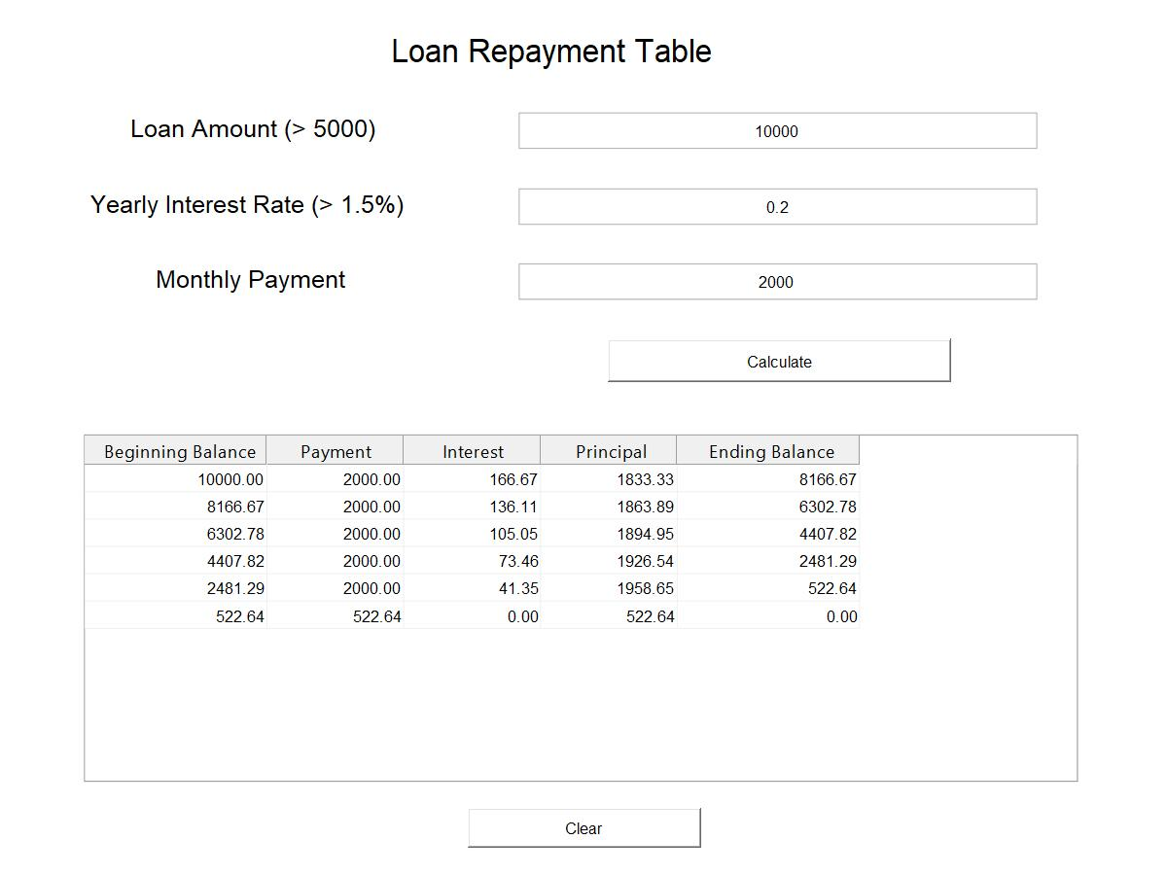
(Note: MATLAB is still developing on this `saveas()` function so the display ratio is bad, not because of the GUI design)
Explanation:
When the user clicks on ‘Save’ in the menu bar, the following function is executed.
function SaveImage_Callback(hObject, eventdata, handles)
To save the GUI as an image, `saveas()` is used.
saveas(handles.figure1, 'saved_image', 'jpg');

Feature 2:
Copy and paste data into the input box.
Example:
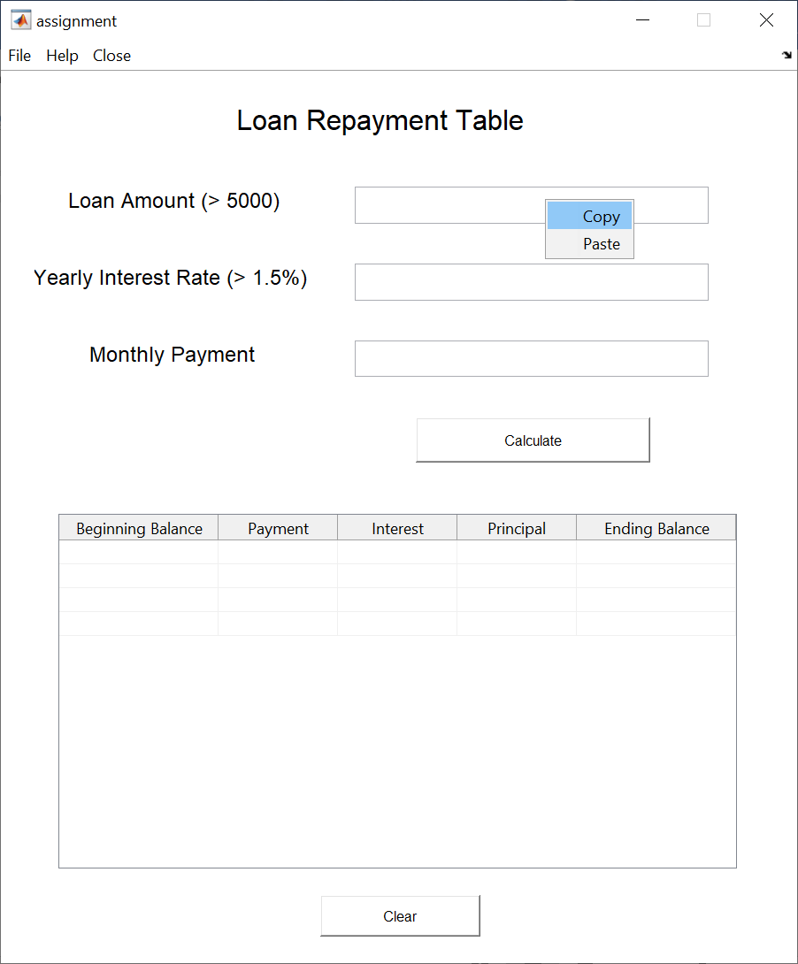

Explanation:
When the user right clicks on the input box, a context menu is displayed with ‘Copy’ and ‘Paste’ options.
When the user chooses either one of the options, a function is executed.
Example 1 - Copy:
function CopyTextPayment_Callback(hObject, eventdata, handles)
This function firstly gets the text inside the input box and save it in the clipboard.
monthlyPayment = get(handles.editMonthlyPayment, "string");
clipboard('copy', monthlyPayment);
By doing this, the text is stored in the clipboard and can be pasted in other location.

Example 2 – Paste:
function PasteTextPayment_Callback(hObject, eventdata, handles)
This function firstly gets the text from clipboard and place the text in the input box.
contents = clipboard('paste');
set(handles.editMonthlyPayment, 'string', contents);
By doing this the text in the clipboard is pasted to the input box.

Feature 3:
A help message will be displayed when the user clicks ‘Help’ on the menu bar.
Example:
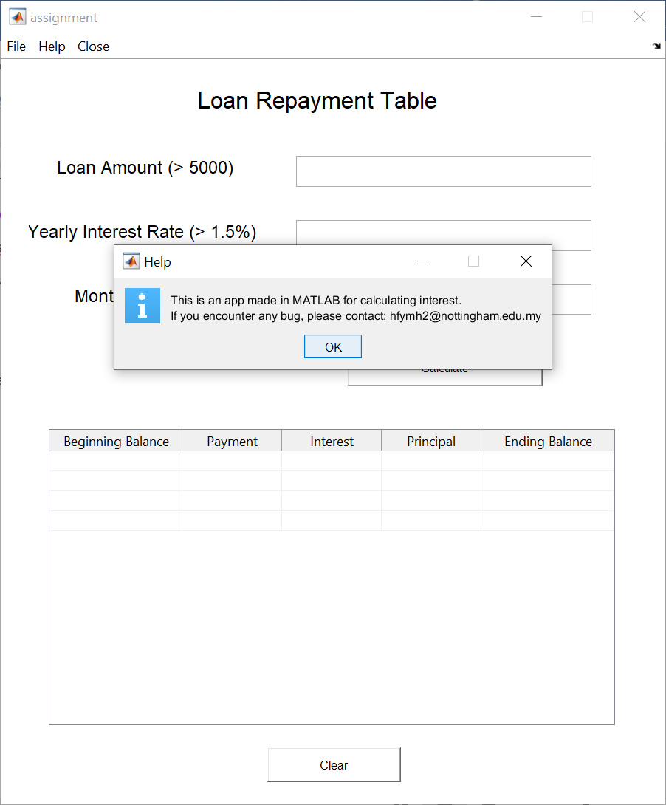
Explanation:
When the user clicks on the ‘Help’ option on the menu bar, a function is executed which creates a message dialog.
msgbox({'This is an app made in MATLAB for calculating interest.'; 'If you encounter any bug, please contact: hfymh2@nottingham.edu.my'}, 'Help', 'help');

Testing

No. | Test Case | Output
1. | Input  10000,  0.2  3000  (Valid inputs) | 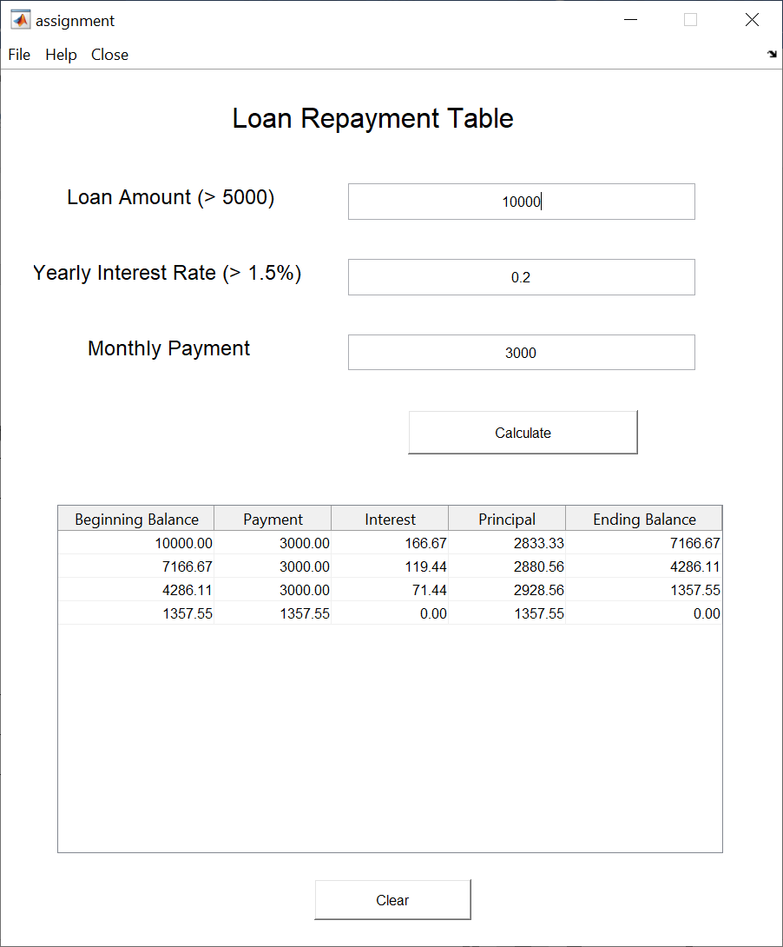
2. | Input  0,  0,  0  (All data inputs are invalid) | 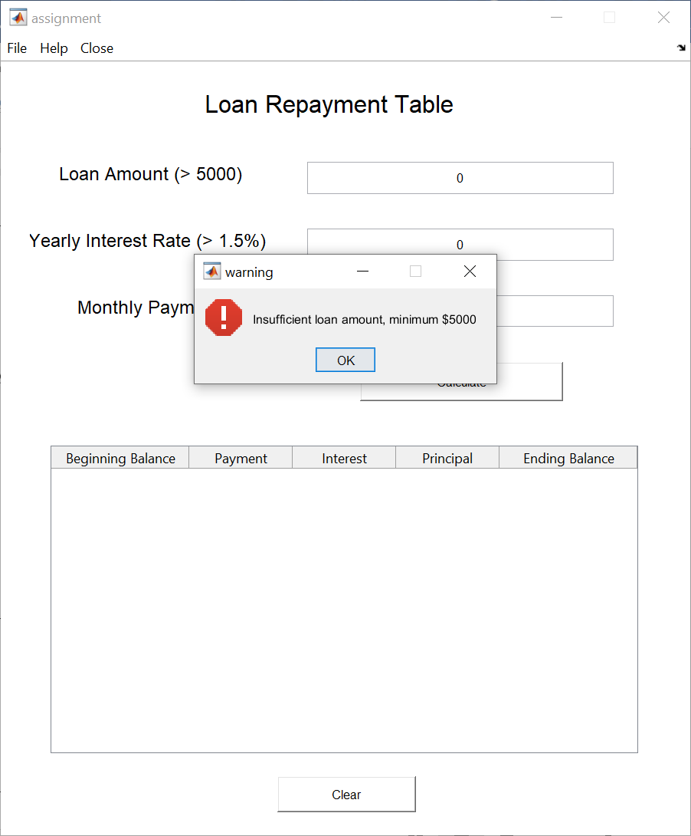
3. | Input  10000,  0,  0  (Valid loan amount, invalid interest and payment) | 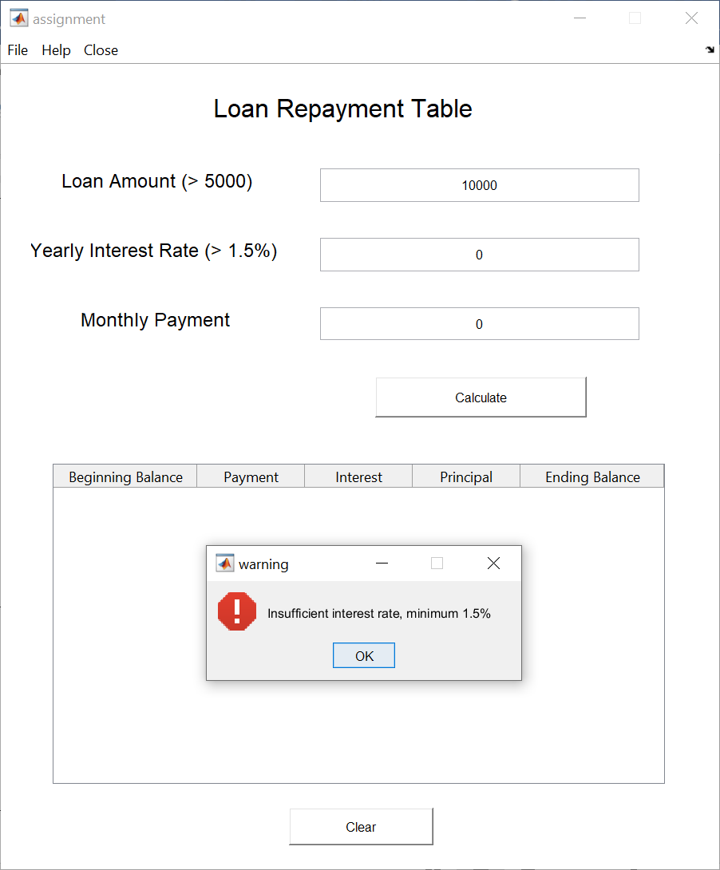
4. | Input  10000,  0.2  100  (Valid loan and interest rate, invalid monthly payment) | 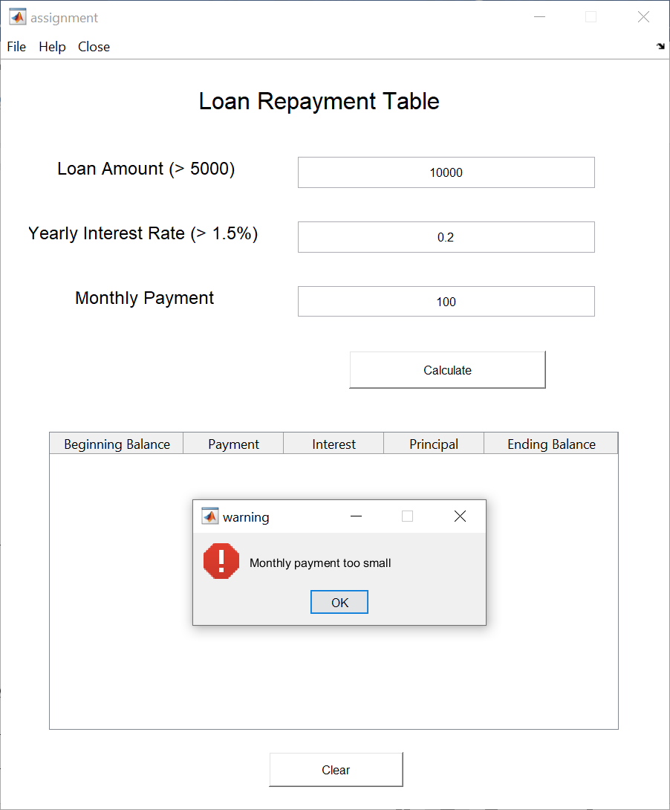
5. | If any of the input box is blank | 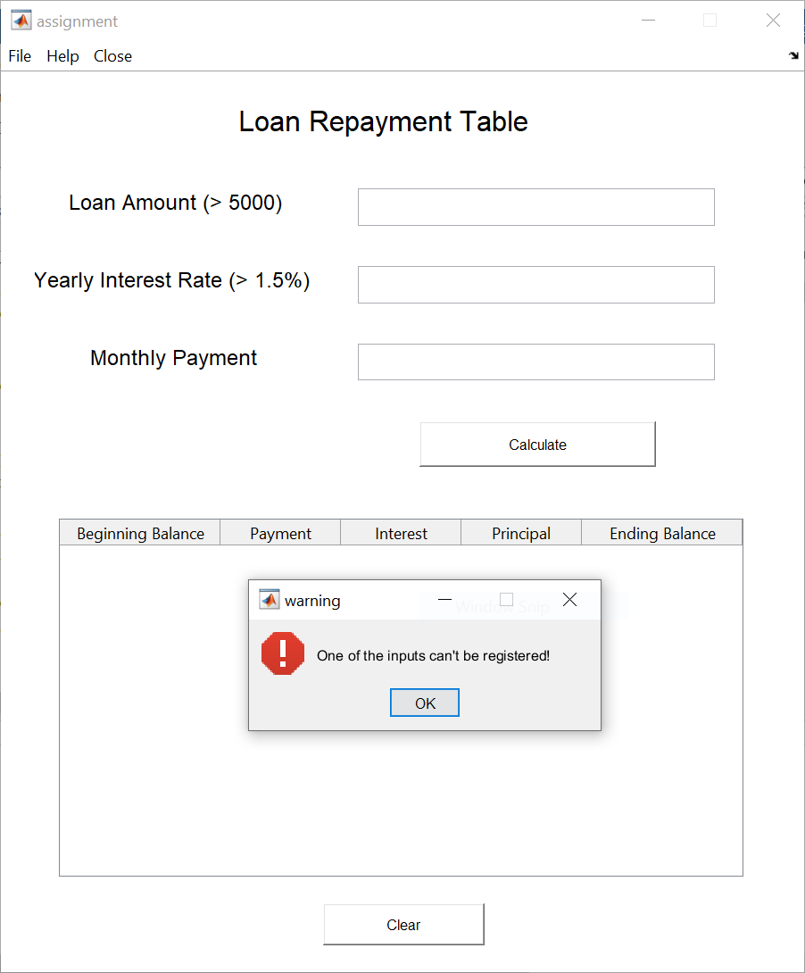  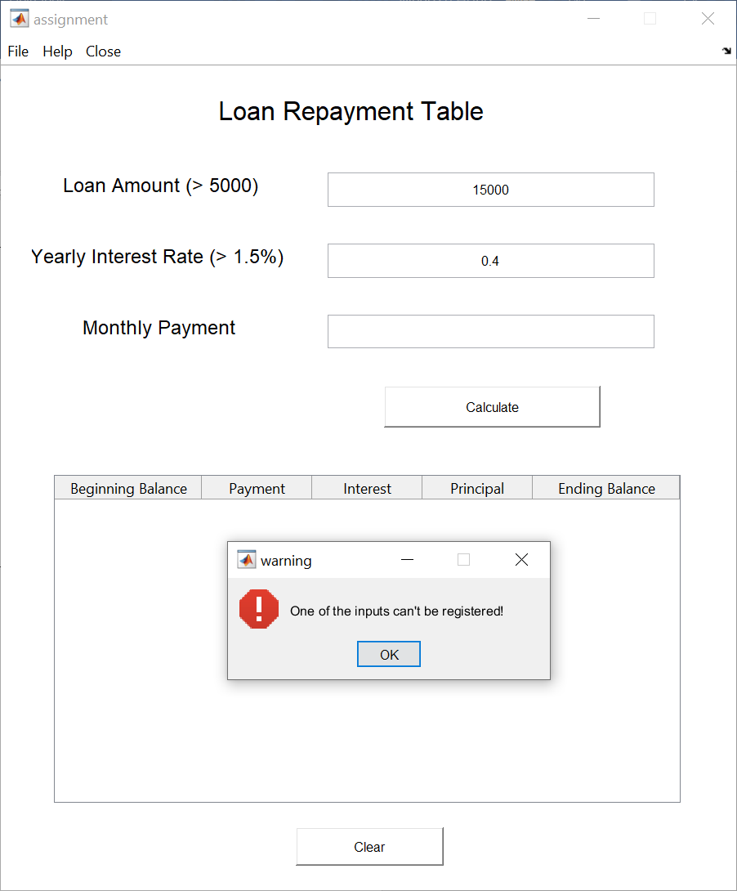
6. | If non-numerical value is inputted | 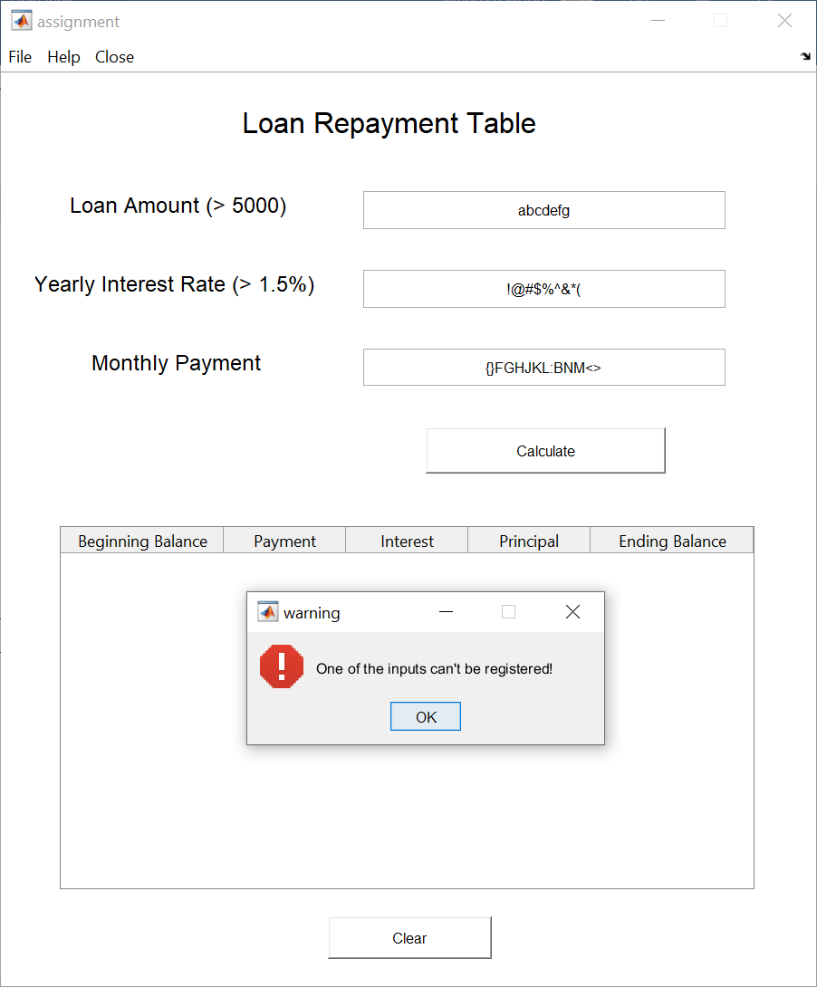

Marking Rubric
Group | CRITERIA | EXCELLENT | GOOD | SATISFACTORY |  | UNSATISFACTORY | TOTAL
 |  | 10 | 8-9 | 6-7 |  | 5
GUI | Interactive/ appropriate | Additional features/ creative/ menu interface for the task | Appropriate interface for the task with menu only |  | Appropriate interface for the task. | Not appropriate interface for the task.
Output | Accuracy of output based on range of test data | Accurate and covering all the criteria in question | Accurate and covering majority of criteria in question |  | Accurate and covering average number of criteria in question | Acceptable output and covering any random criteria in question
M- Scripts | Scripts and creativity | Able to execute without any error and additional creativity such as use of customize function /control structure wherever it’s applicable in meeting basic requirements of the program. | Able to execute without any error and additional creativity such as use of built in function/control structure in meeting basic requirements of the program. |  | Able to execute without any error and meet basic requirements of the program | Able to execute with inaccurate output and missing of basic requirements of the program.
Features | Features/ explanation | Detailed explanation on the GUI features | Appropriate and acceptable explanation on the GUI features |  | Very minimal explanation on the GUI features | Not explaining at all
Testing | Validation | Include warning messages/ error messages more than twice and providing option to the user to rectify the error | Include warning messages/ error messages minimum twice |  | Include warning messages/ error messages minimum once | Not including warning messages/ error messages
Feedback TOTAL |  |  |  |  |  |  | /50

