**Simple Arithmetic Calculator Report**

**ECE 2220 – Digital Logic**

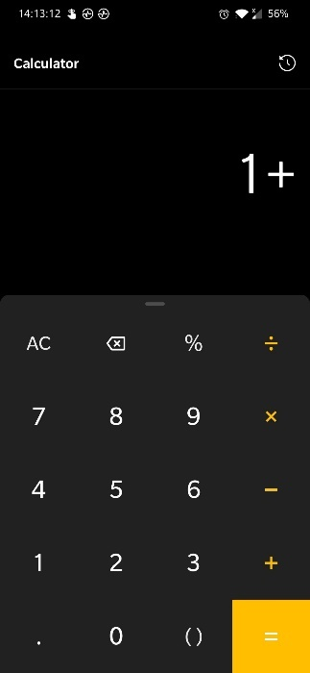

|  |  |  |  |
| --- | --- | --- | --- |
| Team members: | Alvin John Widya Sieman | (7900543) | B01 |
| Matthew Banayos | (7868363) | B03 |
| Meng Zhong Kuan | (7895449) | B02 |
| Mohamed Krache | (7863300) | B04 |

**Abstract:**

The goal of this team project is to program and setup the DE-10 Standard for Intel FPGA University Program board provided by this course as a calculator capable of arithmetic logic unit operations. The Quartus II Lite Edition software is used to write, compile, and upload the simple calculator code onto the DE-10 board. With the Verilog script coded and uploaded onto the DE-10 board, it is capable of performing simple arithmetic operations such as addition, subtraction, multiplication, division, square of a number, square root of a perfect square number, and a number of logical operations such as AND, OR and complement. A push button provided on the DE-10 board is utilized to feed the programmed board with the input numbers in binary form. Short pressing the push button will increment of the input number by 1, while a long press will increment it by 10. There is a set limit for the input numbers for the calculator to not be more than an 8-bit number. In order to allow the users to select the arithmetic operation desired, the slide switches on the board are used to select the operations. The board is programmed to display the outputs of the calculator using its seven-segment displays (SSDs) and LEDs.

**Introduction:**

The calculator is a very important and useful tool used to calculate multiple Mathematical operations.

1. **Team Members and their Contributions**

|  |  |
| --- | --- |
| Team member | Contribution |
| Alvin John Widya Sieman | Addition and subtraction |
| Matthew Banayos | Square and square roots |
| Meng Zhong Kuan | AND, OR, compliment operations and code synthesis |
| Mohamed Krache | Multiplication and division |

1. **Summary of Inputs and Outputs**

Our simple calculator is programmed to accept for integer input 2 numbers between 0-99 and output the calculation result also for numbers 0-99. We used the 4 available push buttons as a mean to input the values and we used slide switches to select which mathematical operations to be executed:

SW[0] : Addition

SW[1] :Subtraction

SW[2] : Multiplication

SW[3] : Division

SW[4] : Square

SW[5] : Square root

SW[6] : AND operation

SW[7] : OR operation

SW[8] : Compliment

SW[9] : Reset

For any output of a Mathematical operation results in a negative number, numbers above 99 or square roots with decimal numbers, the calculator will show “Er” for error.

1. **Verilog Code:**

(Verilog code is attached in a separate file due to its large size)

1. **Future Improvements**

Our method of realizing this simple arithmetic calculator is far from being perfect and the lab teaching assistance has pointed out some improvements we could make for our current operations.

Firstly, the codes for the 7-segment display can be shortened and this would allow the compiler to run faster and take up less memory. Instead of putting every number from 0-99, we could instead just minimize it to the code for displaying 0-9. The numbers in the tens place and ones place could be taken care of by getting the modulus of the number and 10. The quotient(result) represents the number in the tens place and the remainder shows the number in the ones place.

Secondly, for the square root operation, a more efficient way of coding it is to keep subtracting an odd number from the input (starting from 1, then 3, 5, etc.) until the result reaches zero. It is important to keep track of the number of times the subtraction occurs since this is the value needed for the result of the square root operation.

1. **References**
2. ECE 2220 Course website, course notes, lab instructions.
3. [Include a module in verilog - Stack Overflow](https://stackoverflow.com/questions/19661868/include-a-module-in-verilog) (For learning about the include statement)