Login

The image A) represents the user graphic interface which allows the user to enter his or her first name, last name; Image B is the screenshot of the information the user enters then the next step pointes on selecting the state of birth following by the gender. Four (4) states have been selected for the purpose and are the follows: Maryland, Arizona, New Jersey, and Virginia. It’s also to consider that the case (user’s information) is supposed set to get information of people from such states only.

The table shows the inputs (first name, last name, state of birth, and gender), output (display user’s information exactly as shown on the JTextArea), and result of the program after testing it. The message welcome has been displayed on the JButton text field once the user clicks on such a button.

**Table**

|  |  |  |
| --- | --- | --- |
| Inputs | Output | Result |
| First name: John | Name: John Smith  Gender: Male, and  State of birth: Arizona | The program runs successfully |
| Last name: Smith |
| Gender: Male |
| State of Birth: Arizona |
|  |

**A)**

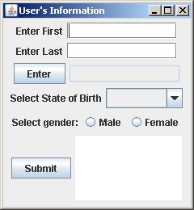

B)

