編號 | GEO2010 | SYMBOL | 中文 | 英文
0 | 112 | 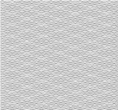 | 回填土 | BACKFILL
1 | 103 | 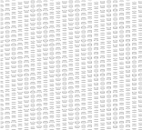 | 良好、不良級配卵礫石、砂礫石 | WELL GRADED GRAVELS,POORLY GRADED GRAVELS , GRAVEL-SAND MIXTURES
2 | 222 | 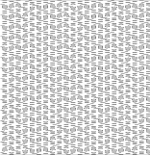 | 粉質卵礫石 | SILTY GRAVEL
3 | 206 | 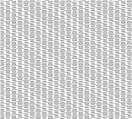 | 黏質卵礫石 | CLAYEY GRAVEL
4 | 104 202 |  | 良好、不良級配砂土、礫砂土 | WELL GRADED SAND、POORLY GRADED SANDS,GRAVELLY SANDS
5 | 227 | 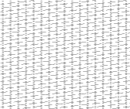 | 粉質砂土 | SILTY SANDS
6 | 262 | 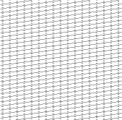 | 黏質砂土 | CLAYEY SANDS
7 | 106 | 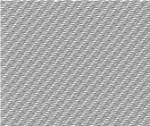 | 低至中等塑性無機黏土、低塑性粉質黏土 | INORGANIC CLAY OF LOW TO MEDIUM PLASTICITY ,SILTY CLAYS OF LOW PLASTICITY
8 | 107 |  | 黏質粉土、有機黏土 | CLAYEY SILTS , ORGANIC SILTS,AND ORGANIC SILTY CLAYS OF LOW PLASTICITY
9 | 107 |  | 高塑性無機黏土、中等至高塑性有機黏土 | INORGANIC CLAYS OF HIGH PLASTICITY ,ORGANIC CLAYS OF MEDIUM TO HIGH PLASTICITY
10 | 105 | 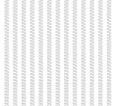 | 無機質粉土 | INORGANIC SILTS
11 | 242 |  | 砂質粉土 | SANDY SILT
12 | 713 | 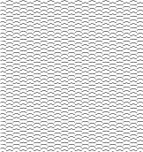 | 安山岩 | ANDESITE
13 | 301 | 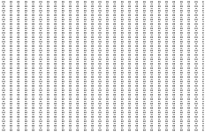 | 卵礫石 | CONGLOMERATE
14 | 303 |  | 砂岩 | SANDSTONE
15 | 302 | 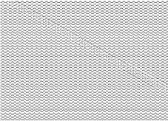 | 碎屑岩 | BRECCIA
16 | 308 |  | 粉砂岩 | SILTSTONE
17 | 307 | 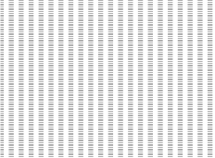 | 泥岩 | MUDSTONE
18 | 309 |  | 頁岩 | SHALE
19 | 343 | 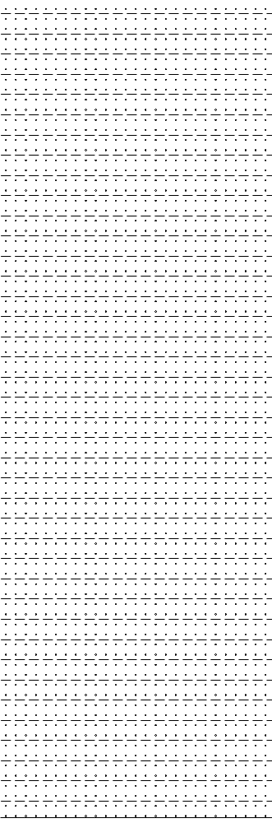 | 凝灰岩 | TUFF
20 |  | 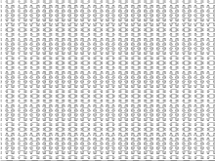 | 火山碎屑
21 | 111 | 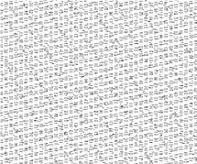 | 崩積層

