Ostracods Outline Recognition for Four Species

| Mengdie Cao  College Station, US  mcao26@tamu.edu | Jigna Reshamwala  College Station, US  jigna@tamu.edu |
| --- | --- |

# ABSTRACT

Since the process of selecting and identifying ostracods, also known as seed shrimp, under microscope can be laborious, an interface that can recognize ostracods based on outline sketched on top of pictures captured under microscope can be a useful tool. Our goal is to recognize four species (Baffinicythere Emarginata, Cytheropteron Nodosoalatum, Elofsonela Consinna, and Leptocythere Pellucida) from sketched outline of them. In this paper, we propose both gesture-based and geometric-based features that allow us to classify BE, CN, EC, and L.

# INTRODUCTION

Ostracods, also known as seed shrimp, have more than 70,000 identified species [5]. The ultimate goal is to recognize most of them, but for the purpose of this interface and classification method, we will focus on four of them: Baffinicythere Emarginata (BE), Cytheropteron Nodosalatum (CN), Elofsonela Consinna (EC), and Leptocythere Pellucida (L).

To understand the mechanism of our project, one need to know the terminology and structure of a typical ostracod. Ostracods are bivalved Crustacea [13]. Two valves of ostracods connect at the hinge located at the top of the valve around dorsal margin as shown in Figure 1. There are two classes of valves, left and right. The position of the maximum height (red line in Figure 1) determines whether a valve is left or right. As we can see in Figure 1, the position of the 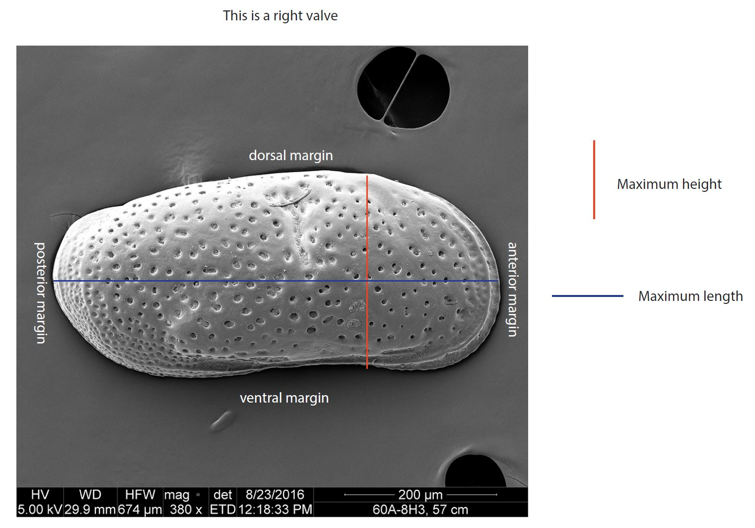

Figure 1. Right valve example

maximum height is located on the right side of the centroid of the valve, which means it is a right valve. In addition, as shown in Figure 1, the anterior margin (i.e. the valve side) is smooth and round, whereas the posterior margin (i.e. the non-valve side) is more sharp and pointy. This is another feature that can be used in distinguish left and right valve. According to Dr. Stepnova, an expert in ostracods, these two features apply to most of the species, except for some special cases, which will not be covered in this paper. However, if the ostracods is not oriented correctly (ventral margin on the top), then the valve class will be the opposite (rotated 180 degrees). Therefore, to correctly identify top and bottom is crucial in classifying valves. In Figure 1 and Figure 2, all ostracods are oriented correctly (dorsal margin at the top). We can see that there is a small corner at the top of the maximum height (red line), and an arch at the bottom of the maximum height. This feature is also almost universal across different species.

Now, why do we choose these four specific species? As we can see from Figure 2, L is more ellipsoid, EC and BE are more rectangular, and CN is more triangular. Therefore, if we can successfully identify these four species, it will be beneficial when we extend the algorithm to recognize more species where we first group the species by their outlines.

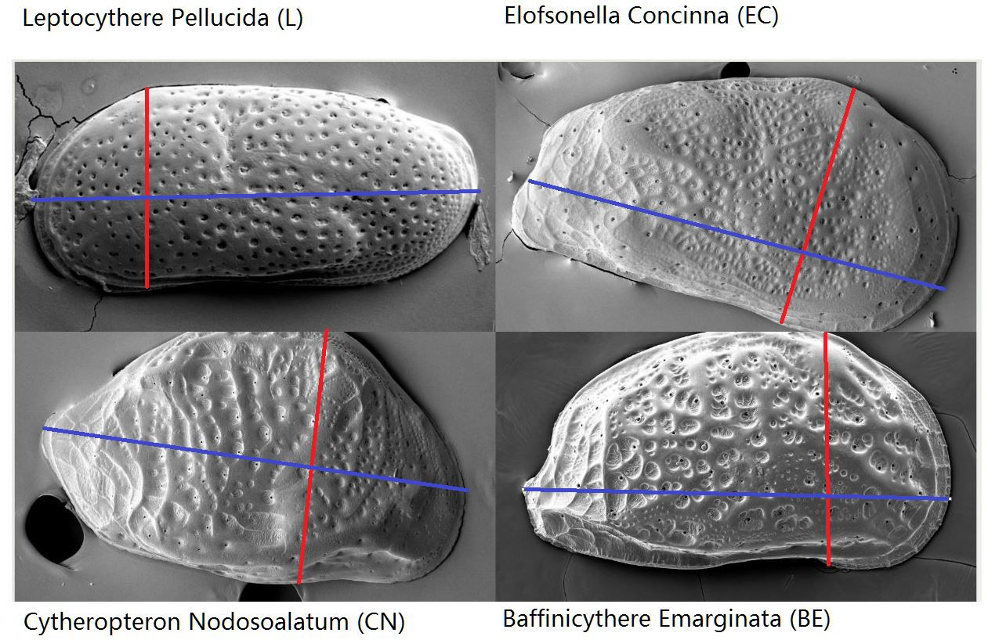

Figure 2. Comparison of L, EC, CN, and BE

Our interface allows user to upload an ostracod image and trace the outline of the ostracod. After running our classification algorithm, valve and species classification will be displayed in the interface. There are three main steps in our algorithm: preprocessing, classifying valve, and classifying species.

# Related Works

At first glance, it seems intuitional to approach the classification problem using vision-based methods such as $1 recognizer and electric cocktail napkin system. However, at a closer look, these vision-based methods have their limitations in the case of recognizing ostracods species.

$1 recognizer is a template matching recognizer that compare strokes with stored templates by finding the closest match to the template in 2D Euclidean space [14]. There are some characteristics of ostracods that make template matching not ideal. The first problem is that shapes varies greatly within species (female, male, and juvenile ostracods from same species can differs). The second problem is that some species resembles other species. However, rotating sketch from $1 recognizer is a crucial step in our preprocessing step. Electric cocktail napkin system considers how the sketch passes through a grid [6]. However, we want the algorithm to be rotation independent. Moreover, the same problems mentioned above can be applied to electric cocktail napkin system as well.

As mentioned above, the orientation of the ostracod in the picture is crucial in classifying valve, and not producing the opposite result. This means that we need the dorsal margin (the top) to be recognized as the top of the outline. Since there is almost always a corner at the top of the maximum height on the dorsal margin and an arch at the bottom of the maximum height on the ventral margin, we first implemented ShortStraw corner finder to detect corners. However, since ShortStraw corner finder is a polyline corner detection system, it does not work well with ostracod outlines because the outlines are mainly arcs and rarely lines [15]. The other option to detect corners is Sezgin’s corner detection method. It uses the speed and curvature graph to identify corners [11]. When sketching, user tends to slow down around the corner [16]. This is the reason why Sezgin’s methods works well in detecting corners. However, since user is tracing the outline instead of free-hand sketching, the overall velocity is slow and the difference in velocity is small.

Therefore, while we adopt some aspects of previous methods, we decided to approach the problems of classifying valve and species statistically by using gesture-based and geometric-based features.

# system overview

Our algorithm has three major steps:

1. Preprocessing
2. Identifying valve
3. Identifying species

In preprocessing, we rotate the sketched outline based on the maximum length and the dorsal margin of the ostracod in the photo. It includes three sub-steps: removing identical points (points with same x- and y-coordinates) finding maximum length, finding maximum height, determining dorsal margin (top). After successfully orient the sketched outline correctly, we move to identifying valve step. In this step, we simply compared the position of the maximum height against the position of centroid of the sketch. Finally, we identify the species.

## Preprocessing

Removing identical points is trivial. The other steps of preprocessing are proven to be quite challenging because finding the correct maximum length, maximum height, and determining top and bottom depend on one another. To preprocess the sketched outline, we need to find the maximum length of the ostracod. It is important to note that the definition of maximum length of an ostracod is different from our concept of maximum length. The maximum length of an ostracod should be sub-parallel to the ventral margin (bottom), whereas our concept of maximum length is to search the maximum length across all points. Thus, our concept of maximum length will return a somewhat diagonal line whereas the true maximum length of the ostracod is almost parallel to the bottom side. However, to have the algorithm search for the sub-parallel maximum length, we need to know where is the bottom side of the ostracod. The problem is that we cannot distinguish top and bottom without the maximum height based on the feature determining top and bottom (corner at the top of maximum height and arch at the bottom of maximum height). Moreover, finding the maximum height will also require the system to do a horizontal (parallel to the bottom side) scan across the outline, so we need to know where the bottom side is located and how it is oriented. In short, we have the problem that finding top and bottom depends on maximum height and maximum length, and finding maximum height and length depends on finding top and bottom.

We can use algorithms (finding convex hull and compare points to the hull, or rotating the bounding box to get a bounding box with maximum length) to determine top and bottom based on the geometric feature that top is more convex whereas bottom is more concave. However, these options are computationally heavy. Hence, we simply ask the user to draw the maximum length using a line tool. And rotate the outline with maximum length horizontal.

With the correct maximum length, we can easily determine maximum height by scanning along the maximum length. And we can determine top and bottom by using the concept of Long’s density metric 2 (a line test) [8]. More specifically, 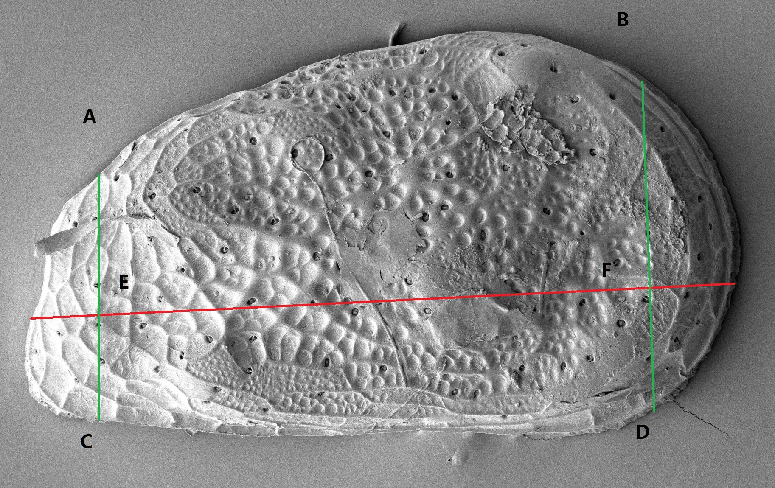

Figure 3. Top and bottom calculation

consider Figure 3, we take the middle portion of the maximum length (from E to F), and take the ratio of the stroke length from point A to B with distance from point E to F, as well as the ratio of the stroke length from point C to D with distance from point E to F.

The top stroke will have higher ratio whereas the bottom stroke will produce a ratio about 1. If ventral margin (bottom) is at the top of the outline, then we rotate the sketch 180 degrees, do nothing otherwise. With the correct orientation, we can easily determine the maximum height and the location of maximum height. We have two options. One is to find the points in the top half and bottom half with the same x-coordinates (top half and bottom half split from maximum length) and calculate the distance between these two points. We also have another option based on the characteristics of ostracods. Since there is almost always a corner at the top side of the maximum height, the location of the maximum height corresponds to the location of the protruding corner. Hence, we can simply look at the top half of the stroke, and find the maximum vertical distance squared from points to the horizontal line that passes through the centroid of the sketch. This method is computationally cheaper than the first method.

## Valve Classification

After preprocessing step, we now have the correct orientation as well as the position of maximum length. By comparing the position of maximum height to the position of centroid, we can determine whether it is a left valve or right valve. More specifically, we only look at the x-coordinates of the position of the maximum height and the position of the centroid. If the maximum height is to the right of the centroid, then it is a right valve. Otherwise, it is a left valve. As a precaution to the special cases where the maximum height rule do not apply, we also identified the end that is smoother and rounder. As shown in Figure 4, we take the same amount of distance from the ends inward (CD = GH), and compare the distance between point A and B with the distance from point E and F. The rounder and smoother side will have longer distance. The ostracod in Figure 4 is a left valve, and the rounder side is left side as well since AB is greater than EF.

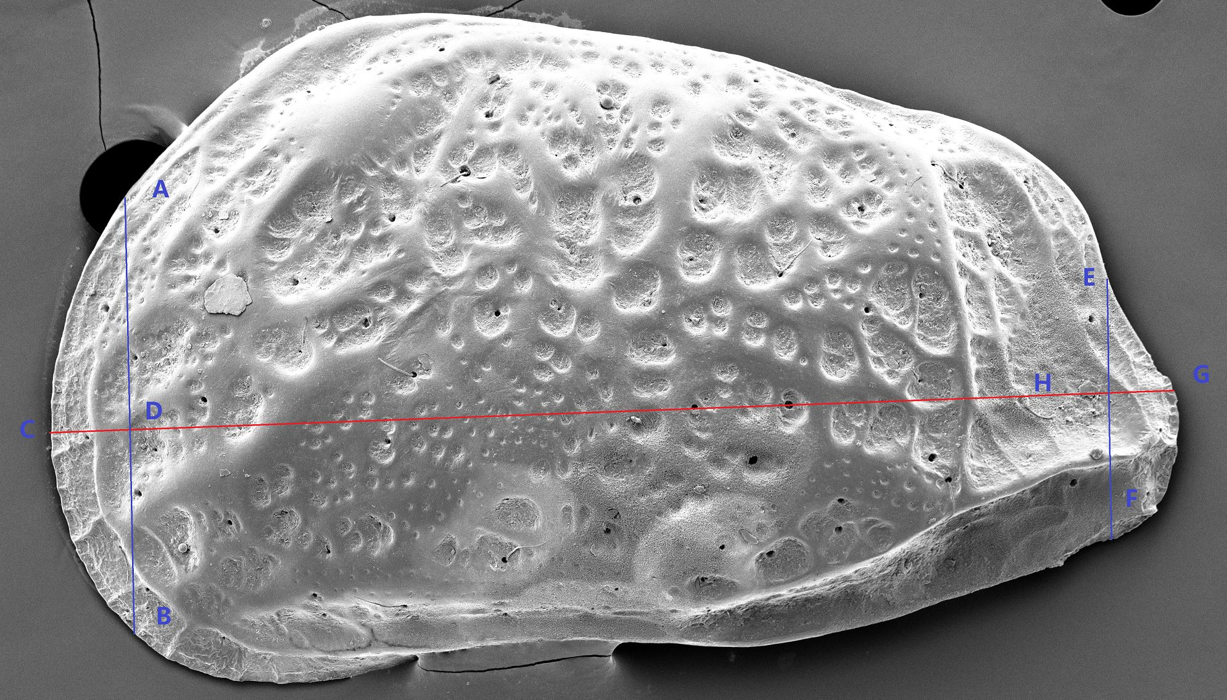

Figure 4. Determine rounder end calculation

## Species Identification

The final step is to identify species from the sketched outline. As mentioned above, since template matching might not be working well to identify ostracods, we approach this problem statistically with different features. The sections below will include how we collect the training data, how and why we select each feature, as well as classification model.

# DATA

Since we are approaching recognition of ostracod species statistically, data is extremely important. Over the course of a week, we have taken the pictures of organisms from EC, BE, CN, and L under the same microscope. For species EC and L, there are abundant shells (valves), whereas for BE and CN, the amount of shells is limited. To take into consideration of both species variation and user tracing variation, we traced each photo multiple times, and ended up with thirty samples of outline sketch for each species. Along with the point data from the sketched outline, we also stored the maximum length end points that user defined.

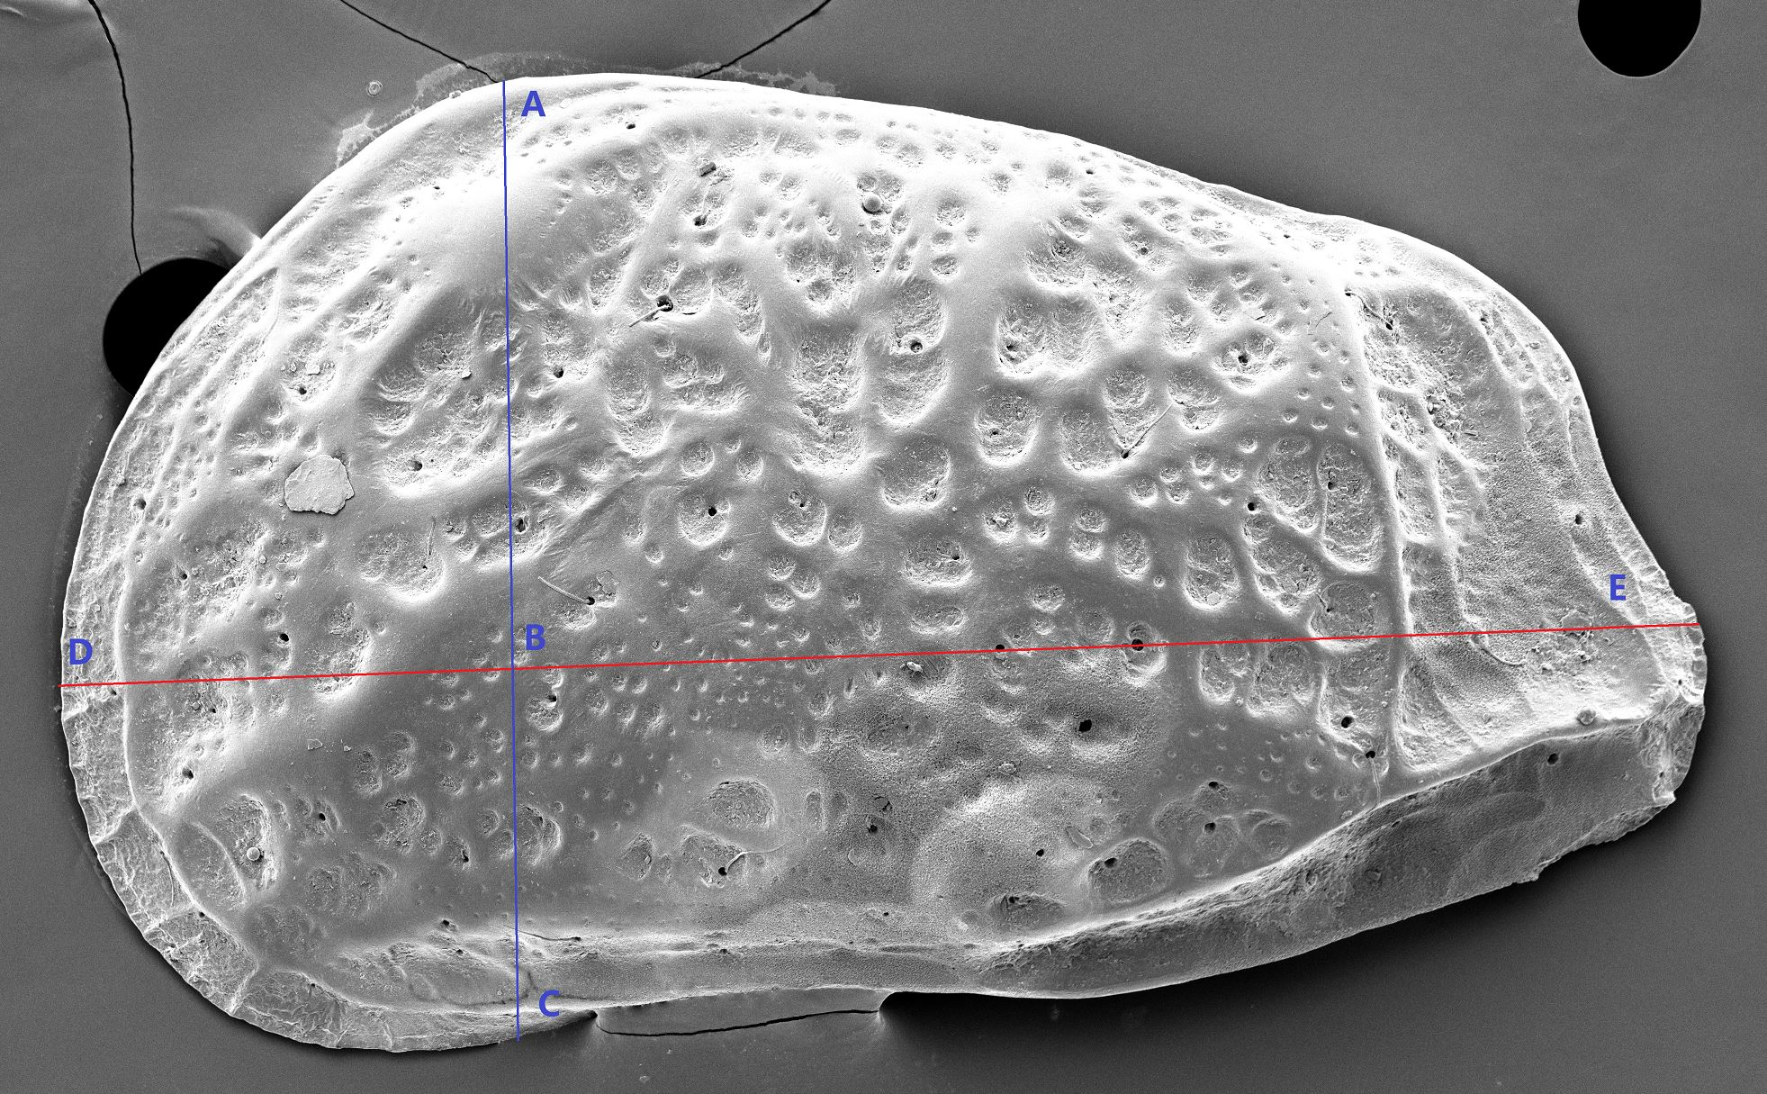

Figure 5. Ratio calculation

# features

For recognizing ostracods, we used some of the Rubine features such as total rotation, total absolute rotation, and total squared rotation. However, these features are size-dependent. Specifically, the bigger the photo is, the larger the rotation values will be. We can rescale and normalize the outline, but the how to reduce each species will be problematic. The reason is that different species have different sizes, and this size information is critical in identifying similarly shaped ostracods for that they may differ greatly in sizes. Hence, the rescaling and normalizing depends on the species. However, we rely on these features to help us identify the species. Therefore, we have the dependent relationship that makes it hard to solve the problem (we cannot solve one without solving the other).

To reduce the significance of size-dependent rotation features, we came up with several ratio features that would cancel out the size factor, consider Figure 5:

1. Ratio between the maximum length and the maximum height
2. Position of maximum length (ratio between distance from point A to point B and distance from point A to point C, AB/AC)
3. Ratio between top half stroke length and maximum length (top stroke length from point D to E over distance between point E and F)
4. Ratio between bottom half stroke length and maximum length (bottom stroke length from point D to E over distance between point E and F)
5. Ratio between top half stroke length and bottom half stroke length (top stroke length from D to E over bottom stroke length from D to E)

By combining these features, we combined gesture-based features and geometric-based features. This combination will produce better result than using just gesture-based features or just geometric-based features [9].

## Rubine Rotation Features

The first three features we calculated are Rubine rotation features [10]. The reason for this is that we want to capture the differences between ellipsoid, rectangular and triangular outlines that distinguish the four species we are identifying. As we can see from Figure 2, EC, BE, and CN have a sharp corner at the non-valve side, whereas L does not. Furthermore, the outlines of CN and L are smoother compared to those of EC and BE. Therefore, since total absolute rotation measures smoothness, total squared rotation exaggerates the angles and measures sharpness, rotation features can be useful in identifying ostracods from outline. Because we need rotation to calculate smoothness and sharpness, we include the total rotation as well.

## Size-Independent Ratio Features

Besides Rubine rotation features mentioned above, we also added five size-independent ratio features. Each of these features includes some geometric characteristics of the outlines of ostracods.

### Ratio between Maximum Length and Maximum Height

This feature measures whether the outline is elongated or rounder. Since this feature provides the most basic estimation of an ostracod’s overall outline, it is commonly used in geometric morphometric in statistical studies of ostracods [2]. Consider Figure 2, this feature value for L will be larger compared to the other species (EC, BE, and CN).

### Position of Maximum Length

This feature measures the position of the maximum length respect to the maximum height (i.e. in Figure 5, AB/AC). Consider Figure 2, we can see that the position of the maximum length of L is almost at midpoint of the maximum height. The maximum length of EC and BE is located towards the bottom of the ostracods. As for CN, the position is lower than that of L but higher than that of EC and BE.

### Ratio between Top Half Stroke Length and Maximum Length

This feature measures the ratio between the top half stroke length and the maximum length. Consider Figure 2, L and CN will have about the same ratio, whereas EC and BE will have approximately the same ratio. In addition, the ratio for L and CN will be smaller than that of EC and BE.

### Ratio between Bottom Half Stroke Length and Maximum Length

This feature measures the ratio between the bottom half stroke length and the maximum length. Consider Figure 2, L and CN will have about the same ratio, whereas EC and BE will have approximately the same ratio. In addition, the ratio for L and CN will be greater than that of EC and BE.

### Ratio between Top Half Stroke Length and Bottom Half Stroke Length

This feature measures the ratio between the top half stroke length and the bottom half stroke length. It represents how the top (portion of the outline above the maximum length) and the bottom (portion of the outline below the maximum length) differs in curvature. Consider Figure 2, the ratio for L and CN will be close to 1 since the top and bottom are almost the same. The ratio for EC and BE will be large since the top is curved whereas the bottom is almost a line.

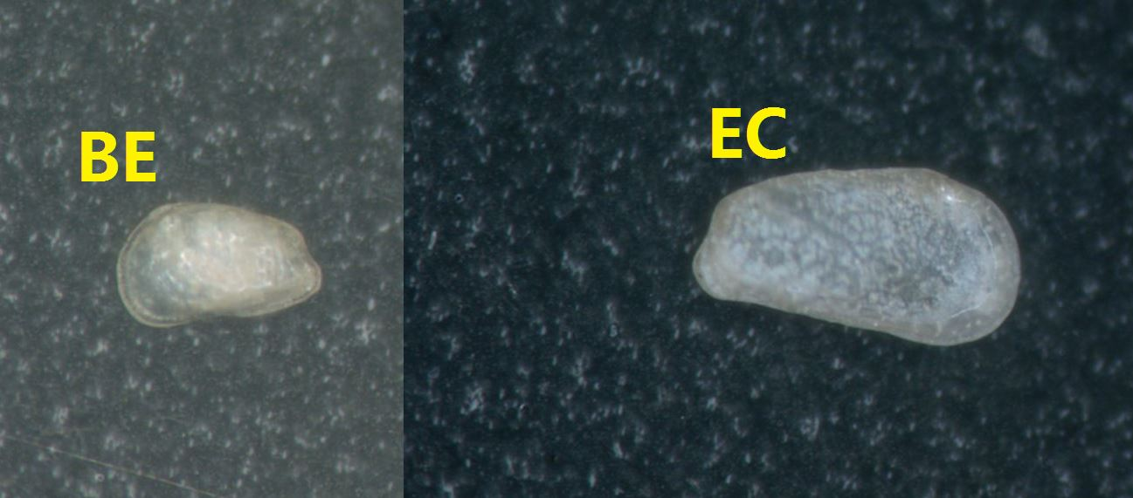

Figure 6. Comparison between BE and EC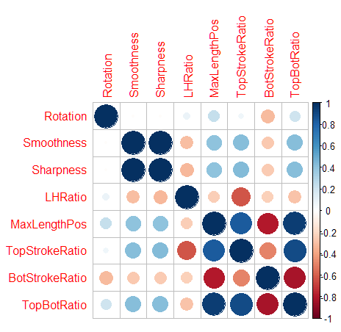

Figure 7. Correlation Matrix

## Combination Effect

Figure 8. Results for Model 1 and Model 2

All these features alone do not show much information. However, when combining them, there will be much more information of the outline of the ostracods. While Ratio Feature 2, 3, 4, 5 are similar for BE and EC, with rotation we can distinguish between BE and EC. Since rotation is size-dependent, the larger ostracods will have higher rotation feature values (total absolute rotation and total squared rotation). This is also why we choose not to rescale the outlines. From the photos from the same microscope taken at same focus length (Figure 6), we can see that EC (300 micrometers) is a lot bigger than BE (200 micrometers). The ratio features 2, 3, 4, 5 are similar for CN and L, but by looking at ratio feature 1, we can separate CN and L.

# cLASSIFICATION

With feature values calculated, we move on to classification model. Since each of these four species outline represents a typical outline shape, we want to output potential candidate species ranked by probability, we want a classification model that can compute probabilities so that we can have a confidence measure. Since we have discrete classes and

continuous feature values, we decide to use multinomial logistic regression. We proposed two potential models:

1. Model 1: all the features mentioned above
2. Model 2: remove total rotation and total absolute rotation

For Model 1, we used all features mentioned above. However, at a closer look at the features, we decided to remove total rotation and total absolute rotation. The reason for removing total rotation is that the value of total rotation depends on the direction of the sketch (clockwise and counter clockwise), and the direction has no effect on the shape of the sketched outline. As for the reason to remove total absolute rotation, we looked at the correlation matrix (Figure 7) across all features. Total absolute rotation (smoothness) and total squared rotation (sharpness) have almost perfect correlation (dark blue circle). According to the rules for selecting variables, we need independence between variables [3]. Therefore, we need to remove one of total absolute rotation and total squared rotation. Since squared rotation exaggerate the rotation values, we removed smoothness for Model 2.

To train and test the model, we used random 60% data split and trained the model in R using multinomial logistic regression.

# result

To select the better model, we compared not only the accuracy measure of these two models but also the AIC (Akaike information criterion, a goodness-of-fit measure that also considers the issue of over-fitting) value of these two models [17]. Model 1 has AIC value of 54, whereas Model 2 has AIC value of 42. From AIC value alone, Model 2 is the better predictive model. We also analyzed the confusion matrix output and accuracy for these two models. Figure 8 shows the side by side comparison between Model 1 and Model 2. We can see that Model 2 has an accuracy of 89.58% accuracy, whereas Model 1 has an accuracy of 83.33%. This result also agrees with the AIC measure. Hence, we used Model 2 as our predictive model.

# LIMITATION

As we can see from the confusion matrix in Figure 8, as well as balanced accuracy, our model has lower accuracy for classifying BE and EC. This is reasonable because as we can see from analysis of ratio features, five out of five of them are almost the same for BE and EC.

There are other limitations as well. As mentioned above, since size of the ostracods is important information. Hence, the rescaling of the sketch of the outline will need to be species specific to preserve the size information. To rectify this problem, we can use our predictive model to predict general genus first based on the outline (ellipsoid, rectangular, triangular). Then we can rescale the sizes based on the genus.

# Future Work

The first future step is to remove the limitations of the algorithm. Besides fixing limitation, there are several things we can do in the future.

## Automatic Maximum Length Selection

Currently our system asks user to input the maximum length of the ostracods. In the future, it will be more beneficial to make the system more autonomous so that the user only need to sketch the outline. We have the option of rotation the bounding box around the ostracods so that the diagonal maximum length is in the direction of the diagonal of the bounding box but less in length. This means that we can rotate the bounding box until we have the bounding box with maximum length.

## Independent Top and Bottom Identification

Currently, our algorithm for identifying top and bottom depends on the maximum length. However, if we can identify top and bottom independent from the maximum length, then we can find the maximum length easily by looking at the bottom side and scan vertically. There are several options that we can consider. First, we can find the convex hull of the sketched outline. Since top is almost always convex and bottom is somewhat concave, there will be more points on the bottom half that are not on the convex hull. As a result, by looking at which portion has more points that are not on the convex hull, we can determine top and bottom. The other option is to unravel the graph around centroid and look at the intersection. Similarly, we can calculate the derivative of rotation. As we can see from Figure 2, bottom side is almost a line, then the change in rotation will be small, whereas the top rotation change will be larger.

## Automatic Outline Processing

As we can see, the photos under microscope have strong contrast. Therefore, we can automatically process the outline by checking the color value at each pixel so that we can get the outline (there are algorithm already for this).

## Interior Analysis

As we can see from Figure 2, besides outline, there are information regarding the ostracods located within the outline as well. It will offer even more features we can use. We can use entropy to measure how much information is inside the outline similar to the method of recognizing text and shape [4]. Furthermore, with information inside the outline, we can also use thin plate spine analysis to study different ostracods [1]. However, we will be needing higher level recognition to get the hierarchy of shapes. For this we might be able to use LADDER system with modified shape constraints [7].

## More Data and Decision Tree

Currently, we have thirty sample data per species. The first step is to get more data on these four species and more accurate photos of these four species so that we can have more features that can help us improve accuracy. As mentioned before, the ultimate purpose is to recognize much more than just four species, we will be needing multiple layering of prediction. The first layer will be to predict genus based on the outline (human classification works this way). Then we will proceed to look at other features (inside outline) such as ridges, nodes, reticulation, etc. It will be almost impossible to predict using multinomial logistic regression anymore because there are too many classes and multinomial logistic regression is limited to model with few predictors [12]. Also, multinomial logistic regression under many assumptions such as normality and independence [3]. It will be more accurate to predict using decision tree or neural network. However, both decision tree and neural network require a large number of sample data.

## Provide Error Curve for Sketched Outline

Since there will be human error when tracing the outline of the ostracods, it will be useful to process the outline, and provide a feedback on how the sketched outline differs from the precise outline of the ostracod in the photo. We can get the precise outline of the ostracod easily by using photo editing tools and algorithms.

# Conclusion

Our algorithm has three major components. First is to gather general information, the simplest representations of the shape of the outline: top and bottom (dorsal and ventral margin), maximum length, and maximum height. Second, our algorithm identifies the posterior margin and anterior margin. Finally, our algorithm combined gesture-based and geometric-based features to identify the outline among four species: Baffinicythere Emarginata (BE), Cytheropteron Nodosalatum (CN), Elofsonela Consinna (EC), and Leptocythere Pellucida (L). In our system, we applied old methods from several different system and features, such as $1, Rubine and Long, to new problem of classifying valve and ostracods. In the future, we can use our algorithm to sort ostracods into genus first based on outline alone, and work from there to classify more species accurately.

# REFERENCES

1. Aiello, G., Barattolo, F., Barra, D., Fiorito, G., Mazzarella, A., Raia, P., & Viola, R. (2007). Fractal analysis of ostracod shell variability: A comparison with geometric and classic morphometrics. *Acta Palaeontologica Polonica*, *52*(3).
2. Baltanás, Á., & Danielopol, D. L. (2011). Geometric Morphometrics and its use in ostracod research: a short guide. *Joannea Geologie und Paläontologie*, *11*, 235-272.Anna Cavender, Shari Trewin, Vicki Hanson. 2014. Accessible Writing Guide. Retrieved August 22, 2014 from <http://www.sigaccess.org/welcome-to-sigaccess/resources/accessible-writing-guide/>
3. Bayaga, A. (2010). Multinomial logistic regression: usage and application in risk analysis. *Journal of applied quantitative methods*, *5*(2), 288-297.
4. Bhat, A., & Hammond, T. (2009, July). Using Entropy to Distinguish Shape Versus Text in Hand-Drawn Diagrams. In *IJCAI* (Vol. 9, pp. 1395-1400).
5. Brusca, R. C., Brusca, G. J., & Haver, N. (1990). *Invertebrates* (No. QL362 B78 2003). Sunderland, Massachusetts: Sinauer Associates.
6. Gross, M. D. (1994, June). Recognizing and interpreting diagrams in design. In *Proceedings of the workshop on Advanced visual interfaces* (pp. 88-94). ACM.Nintendo R&D1 and Intelligent Systems. 1994. *Super Metroid*. Game [SNES]. (18 April 1994). Nintendo, Kyoto, Japan. Played August 2011.
7. Hammond, T., & Davis, R. (2006, July). LADDER: A language to describe drawing, display, and editing in sketch recognition. In *ACM SIGGRAPH 2006 Courses* (p. 27). ACM.
8. Long Jr, A. C., Landay, J. A., Rowe, L. A., & Michiels, J. (2000, April). Visual similarity of pen gestures. In *Proceedings of the SIGCHI conference on Human Factors in Computing Systems* (pp. 360-367). ACM.
9. Paulson, B., Rajan, P., Davalos, P., Gutierrez-Osuna, R., & Hammond, T. (2008, September). What!?! no Rubine features?: using geometric-based features to produce normalized confidence values for sketch recognition. In *HCC Workshop: Sketch Tools for Diagramming* (pp. 57-63).
10. Rubine, D. (1991). *Specifying gestures by example* (Vol. 25, No. 4, pp. 329-337). ACM.
11. Sezgin, T. M., Stahovich, T., & Davis, R. (2006, July). Sketch based interfaces: early processing for sketch understanding. In *ACM SIGGRAPH 2006 Courses* (p. 22). ACM.
12. Tutz, G., & Pößnecker, W. Variable Selection for the Multinomial Logit Model.
13. Van Den Broecke, L., Martens, K., Pieri, V., & Schön, I. (2012). Ostracod valves as efficient UV protection. *Journal of Limnology*, *71*(1), 12.ACM. How to Classify Works Using ACM’s Computing Classification System. 2014. Retrieved August 22, 2014 from [http://www.acm.org/class/how_to_use.html](http://www.acm.org/class/how_to_use.html%20)
14. Wobbrock, J. O., Wilson, A. D., & Li, Y. (2007, October). Gestures without libraries, toolkits or training: a $1 recognizer for user interface prototypes. In *Proceedings of the 20th annual ACM symposium on User interface software and technology* (pp. 159-168). ACM.Jofish Kaye and Paul Dourish. 2014. Special issue on science fiction and ubiquitous computing. *Personal Ubiquitous Comput*. 18, 4 (April 2014), 765-766. <http://dx.doi.org/10.1007/s00779-014-0773-4>
15. Wolin, A., Eoff, B., & Hammond, T. (2008, June). ShortStraw: A Simple and Effective Corner Finder for Polylines. In *SBM* (pp. 33-40).Marilyn Schwartz. 1995. *Guidelines for Bias-Free Writing.* Indiana University Press.
16. Xiong, Y., & LaViola Jr, J. J. (2009, August). Revisiting ShortStraw: improving corner finding in sketch-based interfaces. In *Proceedings of the 6th Eurographics Symposium on Sketch-Based Interfaces and Modeling* (pp. 101-108). ACM.
17. Yanagihara, H., Kamo, K. I., Imori, S., & Satoh, K. (2012). Bias-corrected AIC for selecting variables in multinomial logistic regression models. *Linear Algebra and its Applications*, *436*(11), 4329-4341.