# MODULE 4 UNIT 3

## Assignment

Learning outcomes:

LO2: Practise using data and technology to automate the investment decision-making process.

LO3: Produce financial metrics using an automated approach to inform your investment strategy.

|  |
| --- |
| **Plagiarism declaration** |
| **1. I know that plagiarism is wrong. Plagiarism is to use another’s work and pretend that it is one’s own.**  **2. This assignment is my own work.**  **3. I have not allowed, and will not allow, anyone to copy my work with the intention of passing it off as their own work.**  **4. I acknowledge that copying someone else’s assignment (or part of it) is wrong and declare that my assignments are my own work.** |

### Name:

#### 1. Instructions and guidelines (Read carefully)

##### Instructions

1. Insert your name and surname in the space provided above, as well as in the **file name.** Save the file as: **First Name Last Name M4U3 Assignment** – **e.g. Lilly Smith M4U3 Assignment.** **NB:** *Please ensure that you use the name that appears in your participant profile on the Online Campus.*
2. Write all your answers in this document. There is an instruction that says, “Start writing here” under each question. Please type your answer there.
3. Submit your assignment as a **Microsoft Word document only**. No other file types will be accepted.
4. Do not delete the plagiarism declaration or the assignment instructions and guidelines. They must remain in your assignment when you submit.

**PLEASE NOTE:** **Plagiarism cases will be investigated in line with the Terms and Conditions for Participants.**

IMPORTANT NOTICE: Please ensure that you have checked your course calendar for the due date for this assignment.

##### Guidelines

1. There are 10 pages and 3 questions in this assignment.
2. Make sure that you have carefully read and fully understood the questions before answering them. Answer the questions fully but concisely and as directly as possible. Follow all specific instructions for individual questions (e.g. “list”, “in point form”).
3. Answer all questions in your own words. Do not copy any text from the notes, readings, or other sources. **The assignment must be your own work only.**

#### 2. Grade allocation

Each question receives a grade allocation. However, you will only receive a final competency score and will not be given individual grades for each question. The grade allocation is there to show you the weighting of each question.

Question 1 45%

Question 2 22%

Question 3 33%

**TOTAL 100%**

#### 3. Questions

You have covered the skills necessary to design an investment portfolio according to your own risk appetite. This includes using your investment knowledge to filter through different investment opportunities and allocate capital towards ones that suit your desired portfolio.

Module 3 introduced you to the risk–return trade-off that you can align with your own risk appetite to guide your investment decisions. You also learnt about the BASS metrics, which can be used to analyse financial data. Additionally, you explored how to build and manage a portfolio using a combination of different stocks to diversify your risk exposure.

Module 4 described how you can automate the data collection and preparation processes before using complex functions to calculate the relevant metrics and visualise the data. As a result, you can visualise financial data from online sources and calculate the BASS metrics to inform your investment decisions aligned with designing an optimal portfolio.

In this assignment, you have the opportunity to use what you have learnt in Modules 3 and 4 to achieve three objectives:

1. Interpret financial data collected using Python and compare the attractive traits of different stocks.
2. Project the average returns and standard deviation to determine which attractive traits are likely to continue.
3. Evaluate the merits of two investment portfolios to provide advice to other investors.

##### Question 1

Imagine that you have engaged with a Python notebook and manipulated the code to include the following variables:

* **price_data:** Pandas dataframe containing daily prices of Microsoft (MSFT) and the S&P 500 (^GSPC), between 2020-01-01 and 2020-12-13

The two figures provided capture the notebook’s output.

Figure 1: MSFT’s describe function

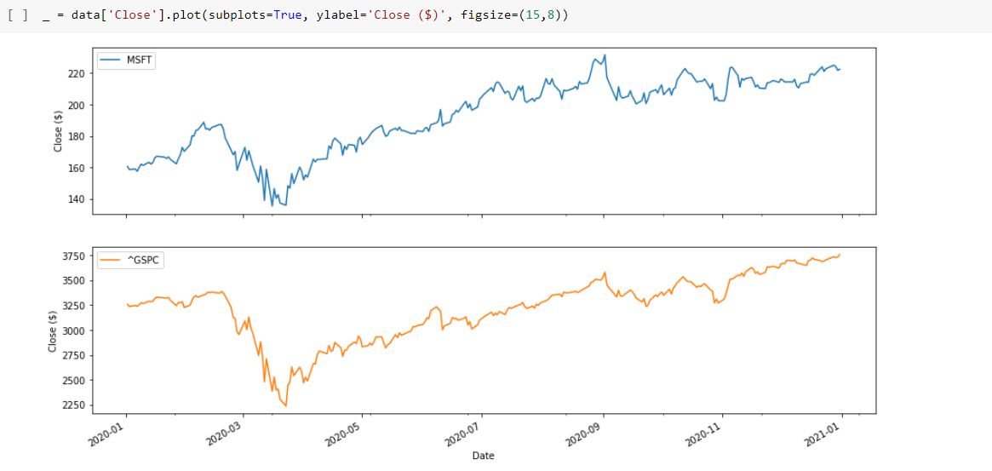

Figure 2: Visualising MSFT and ^GSPC

To compare the attractive traits of MSFT and AAPL stocks, use Figures 1 and 2 to answer the following prompts:

* 1. Indicate MSFT’s average return (mean) and the standard deviation of its closing prices.

|  |  |  |
| --- | --- | --- |
|  | **Microsoft Corporation (MSFT)** | **Apple Inc. (AAPL)** |
| **Average returns** | 0.18% | 0.28% |
| **Standard deviation** | 2.77% | 2.94% |

* 1. Compare MSFT’s average return and standard deviation with that of Apple Inc. (AAPL). Indicate attractive traits for each but focus on the risk–reward relationship. As indicated in the table, assume AAPL’s average return and standard deviation are 0.28% and 2.94%, respectively.

(Max. 100 words)

Start writing here: AAPL has an average return of 0.28% and a standard deviation of 2.94%, indicating higher returns but also higher risk. MSFT, with an average return of 0.177738% and a standard deviation of 2.769921%, offers slightly lower returns and risk. AAPL is more appealing for risk-tolerant investors seeking higher returns, while MSFT suits those preferring stability and lower risk.

* 1. Describe MSFT’s closing share price trend compared to the S&P 500 in 2020. Indicate the significance of what you interpret from the comparison.

(Max. 100 words)

Start writing here: In 2020, MSFT's share price showed a strong upward trend, outperforming the S&P 500, which experienced a significant dip in March before recovering. MSFT’s resilience and growth highlight its strong fundamentals, making it a more attractive investment compared to the broader market.

##### Question 2

Psi is a fictional company operating in the packaged software industry within the technology services sector. Project Psi’s returns and standard deviation for the next 5 and 252 days to determine whether you would want to incorporate its stock into your investment portfolio. The following financial information has been provided to you:

* The closing share price is currently $97.
* The daily average return is 0.2%.
* The daily standard deviation is 1.2%.

Recall that the daily average return can be multiplied by the number of days, but the daily standard deviation needs to be multiplied by the square root of the number of days when calculating your projections.

Use the following guiding questions to project the returns and inform your decision:

* 1. What are the daily average returns and the standard deviation at Days 5 and 252?

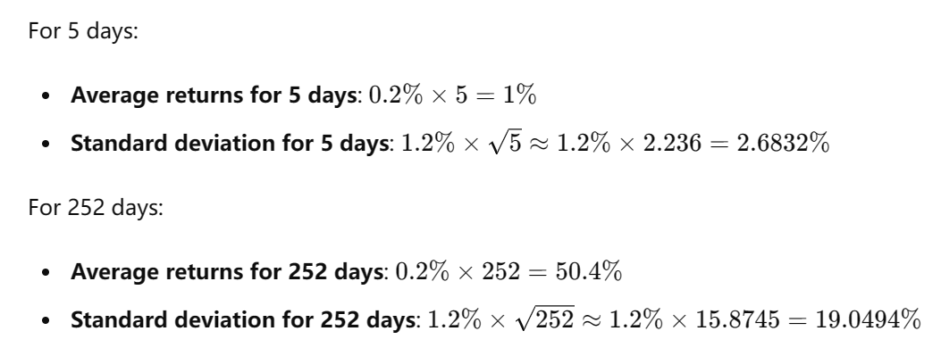

* 1. What are the top and bottom band prices for Days 5 and 252?

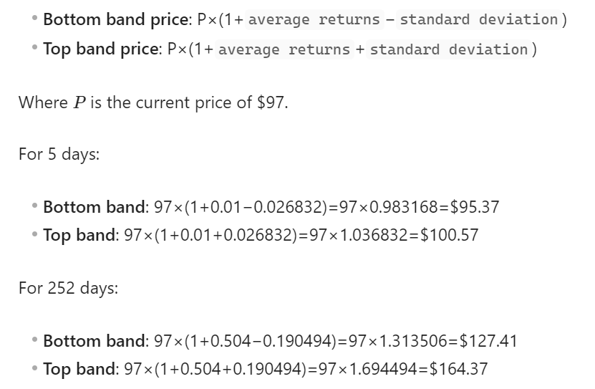

|  |  |  |
| --- | --- | --- |
|  | **5 days** | **252 days** |
| **Average returns** | 1% | 50.4% |
| **Standard deviation** | 2.6832% | 19.0494% |
| **Bottom band** | $95.37 | $127.41 |
| **Top band** | $100.57 | $164.37 |

* 1. Apply your understanding of a normal distribution when you interpret the top and bottom bands at Day 252. Use your interpretation to describe your investment decision?

(Max. 150 words)

Start writing here: Interpreting the top and bottom bands at Day 252 using a normal distribution suggests a 68% confidence interval for the stock price. The calculated range indicates that there is approximately a 68% probability that the stock price will fall between $127.41 and $164.37 at the end of 252 days. Given this range, the expected return and the current market conditions, incorporating Psi's stock into an investment portfolio could be considered a favorable decision, particularly if the portfolio strategy supports moderate to high-risk investments and is aimed at long-term growth.

##### Question 3

Imagine that you have been approached by a friend looking for advice on two portfolios that show potential for growth. Before giving your advice, you take some time to investigate the portfolios so that you may make an informed comparison. Using Tables 1 and 2, you begin by calculating a few key metrics required as the foundation for your advice. Thereafter, you formulate your comparison.

**Table 1:** Financial data on two portfolios.

|  |  |  |
| --- | --- | --- |
|  | **Portfolio A** | **Portfolio B** |
| **Expected return on the stock (R)** | 10% | 15% |
| **Expected return on the market (Rm)** | 3% | 3% |
| **Beta (β)** | 1.5 | 2.5 |
| **Standard deviation (σ)** | 8% | 16% |
| **Risk-free rate (Rf)** | 0 | 0 |

**Table 2:** Financial metric formulae.

|  |  |
| --- | --- |
| **Alpha** | R − Rf − β (Rm − Rf) |
| **Sharpe ratio** | (R − Rf) ÷ σ |

Use the following prompts to guide your response:

* 1. Calculate the alpha of both portfolios.
  2. Calculate the Sharpe ratio of both portfolios.

|  |  |  |
| --- | --- | --- |
|  | **Portfolio A** | **Portfolio B** |
| **Alpha** | 5.5% | 7.5% |
| **Sharpe ratio** | 1.25 | 0.9375 |

* 1. Analysing all of the metrics available to you but focusing on the Sharpe ratio as the primary metric from which to make your comparison, describe the advice you might provide to your friend about choosing between the portfolios. Your advice should indicate a preference for either portfolio, based on risk and expected return.

(Max. 250 words)

Start writing here:

When analyzing the metrics, Portfolio A has an alpha of 5.5%, while Portfolio B has a higher alpha of 7.5%, indicating that Portfolio B has better outperformance relative to its risk-adjusted return.

However, the Sharpe ratio, which is a key metric for assessing risk-adjusted return, favors Portfolio A (1.25) over Portfolio B (0.9375). The higher Sharpe ratio indicates that Portfolio A provides better returns per unit of risk compared to Portfolio B. This suggests that Portfolio A is more efficient in terms of risk-reward balance.

While Portfolio B shows a higher alpha, the increased risk (as indicated by the higher standard deviation and lower Sharpe ratio) might not be justified for a risk-averse investor. If your friend prioritizes a balanced approach with better risk management, Portfolio A is preferable due to its higher Sharpe ratio, indicating better risk-adjusted returns.

In summary, despite Portfolio B's higher alpha, Portfolio A is the recommended choice based on its superior Sharpe ratio, suggesting a more favorable balance between expected return and risk.

#### 4. Rubric

|  |  |  |  |  |  |
| --- | --- | --- | --- | --- | --- |
|  | **Requirements not met** | **Poor** | **Satisfactory** | **Good** | **Exceptional** |
| **Question 1:**  *Identification of risk and return values* | No submission.  OR  The response identifies the incorrect average return and standard deviation values. | The response identifies either the average return or standard deviation value incorrectly. |  |  | The response identifies both the average return and standard deviation values correctly. |
| **Question 1:**  *Interpretation of historical data* | No submission.  OR  The response does not interpret the historical financial data. | The response compares the average return and standard deviation between MSFT and AAPL indicating attractive investment traits or provides a description of the trend in closing share price of MSFT. | The response compares the average return and standard deviation between MSFT and AAPL indicating attractive investment traits. The response describes the trend in the closing share price of MSFT compared to the S&P 500. | The response provides a clear comparison of the average return and standard deviation between MSFT and AAPL indicating attractive investment traits. The response clearly describes the trend in the closing share price of MSFT compared to the S&P 500. | The response provides a thorough comparison of the average return and standard deviation between MSFT and AAPL indicating attractive investment traits. The response thoroughly describes the trend in the closing share price of MSFT compared to the S&P 500. |
| **Question 2:**  *Calculation of projected returns* | No submission.  OR  The response fails to calculate any of the correct projected values. | The response calculates a minimum of two correct projected values. | The response calculates a minimum of four correct projected values. | The response calculates a minimum of six correct projected values. | The response calculates all eight of the correct projected values. |
| **Question 2:**  *Interpretation of projections* | No submission.  OR  The response does not interpret the 252-day normal distribution. | The response provides a poor interpretation of the 252-day normal distribution to inform an investment decision. | The response interprets the 252-day normal distribution to inform an investment decision. | The response provides a clear interpretation of the 252-day normal distribution to inform an investment decision. | The response provides a thorough interpretation of the 252-day normal distribution to inform an investment decision. |
| **Question 3:**  *Calculation of financial metrics* | No submission.  OR  The response fails to calculate any of the correct alpha and Sharpe ratio values. | The response calculates a minimum of one correct alpha or Sharpe ratio value. | The response calculates a minimum of two correct alpha or Sharpe ratio values. | The response calculates a minimum of three correct alpha or Sharpe ratio values. | The response calculates all four of the correct alpha and Sharpe ratio values. |
| **Question 3:**  *Comparison of portfolios* | No submission.   OR  The response does not compare the two portfolios using the financial metrics. | The response uses the financial metrics to compare the two portfolios but does not indicate a preference based on risk and expected return. | The response uses the financial metrics to compare the two portfolios indicating a preference based on risk and expected return. | The response uses the financial metrics to make a clear comparison between the two portfolios indicating a clear preference based on risk and expected return. | The response uses the financial metrics to thoroughly compare the two portfolios indicating a clear and appropriate preference based on risk and expected return. |