L3 P50往后

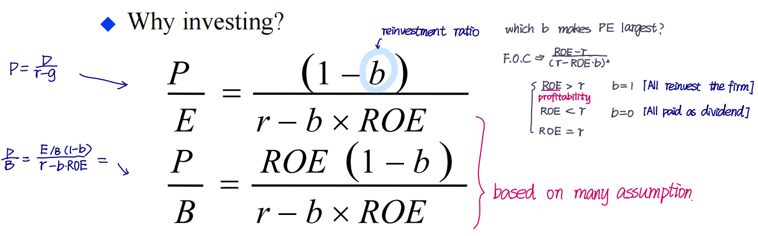Investment b decrease cash flow. (firm with heavy asset are inferior to light asset)

- ROE critical point: ROE > r -- high growth company
ROE < r -- new investment ruin profit

- Why company do not pay dividend?
Need for future investment; risk control (eg. Dutch save money in hand for accident); tax rate; signal for long-term profitability (may used to cheat investors); management benefit (manager want to use many update his office environment).

- ROIC (Return on input Capital): if ROIC < WACC, the firm is wasting capital.

- Growth path of a company:
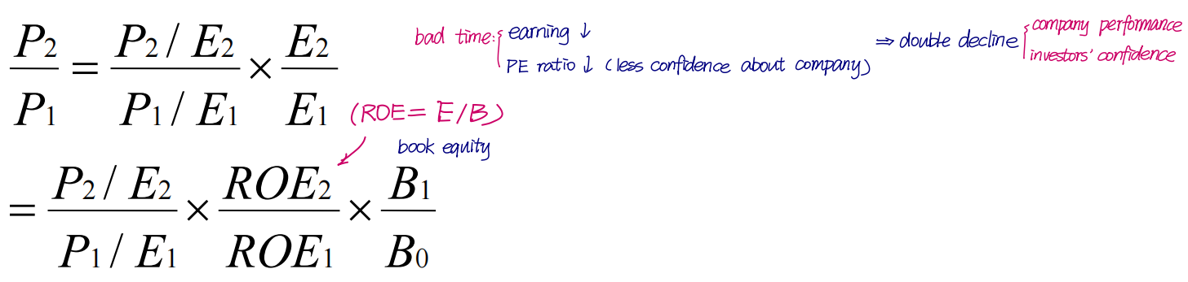

- How a company get high ROE
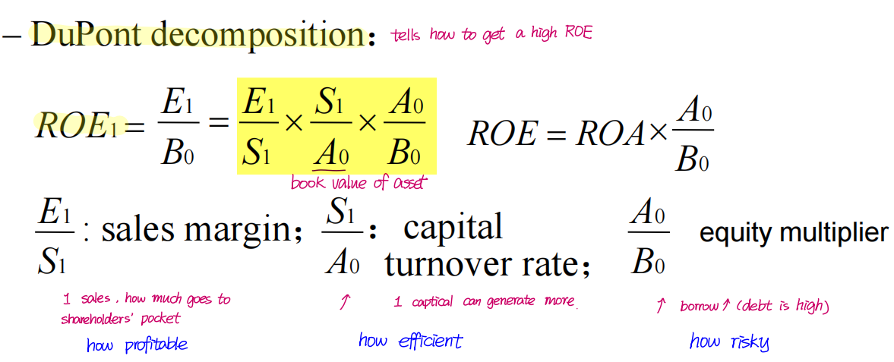
- Large capital expenditure and change of working capital could be bad signal
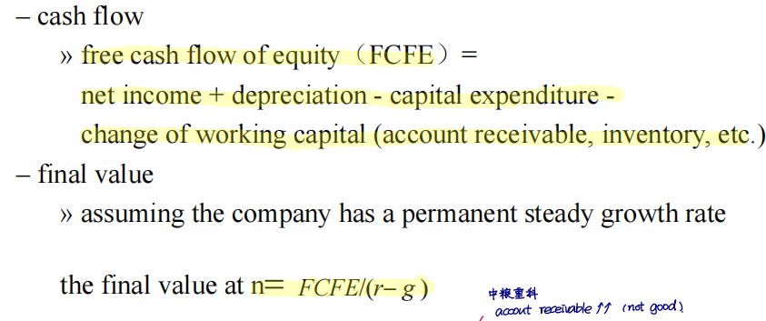

L4

L5 RP: Comparison and Reflection of Pricing Method
- PE = Stock price/ EPS
—— Normally, use current price (sometime use average price of past 6 month)
——EPS: use recent/past 4 seasons(make E larger, show the power of manager) / the comming 1 year( make E larger, PE smaller, attract investors)
People want to invest in PE which are undervalued (PE high, company is cheap)

Averagely, China PE > USA. High-tech have higher PE [Related to growth rate]
A country has high PE: low interest rate; high GDP; ,ow risk
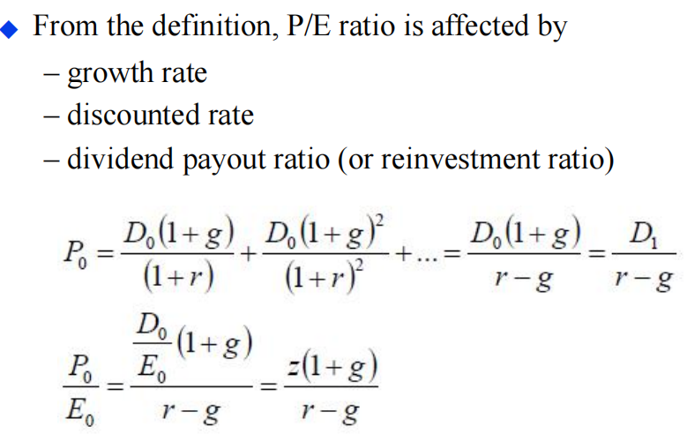

Hard to look for target, but try to study relationship btw PE and other factors (Regression)

- PEG: PE ratio/expected growth rate
- When E is negative or close to zero, or E has large volatile, PE is useless; Then use PB

L6 CAPM
FV: fundamental / fair value :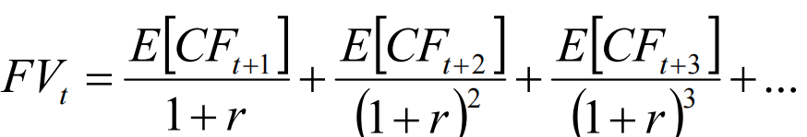
How to get the discount rate r? -- CAPM provides the fair discount rate
- How to construct market portfolio? 2 stage model; repetitive investors all have same information; all use risk-reward (mean-variance) analysis.
- A security’s risk is therefore driven by its covariance with existing portfolio

- By CAPM, 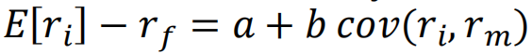linear reg:
Using Risk free -- a=0; market portfolio == b = (E[Rm]-Rf) / Var(Rm)
E[Rm]-Rf is the market risk premium, or equity premium
Beta : amount of risk (also known as “systematic risk”) ; E[Rm]-Rf: price of risk

Beta need to be estimated: excess regression (here Rf need chose period;太小noise多，太大时间长company grow beta已经改变；通常取过去12个月)
Alpha = the actual average historical return - the fair expected return implied by the CAPM。
CAPM says alpha should be zero. But not, why?
- May suffer form limitation of observation
- Investors can make mistake, thus price is wrong
- Reality investors are more than mean and variance
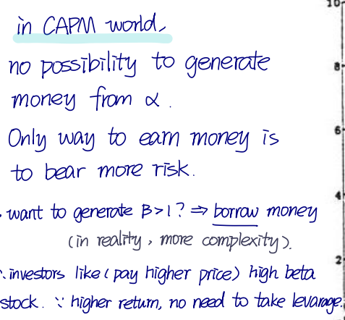
Assumption of CAPM:
Individuals :Mean-variance optimizers ; Homogeneous expectations ( repetitive one investors) ; All assets are publicly traded
Markets : All assets are publicly held ; All information is available ; No taxes ; No transaction costs.
Illiquidity premium: discount seller accept to a quick sale, measured partly by bid-asked spread;
Trading cost higher, illiquidity discount higher. Liquidity Risk: systemic, second order
L7 Risk and Return
Gross net return; expected realized return; real nominal (inflation);
Equity premium is average return of stocks minus the average return on T-Bills. (about 6%)
Negative expected return: 1. insurance (volatility); 2. lottery (people not always hat risk)

Mean & Variance unknown; need to estimate
Mean: Arithmetic & geometric (Difference is larger if more volatile)

Sharp Ratio: Risk premium / SD of excess returns
Excess return: actual return - actual risk-free;
Risk Premium: expected return - risk-free
If not normally distributed, skewness & kurtosis (峰度; eg. Fat-tail)

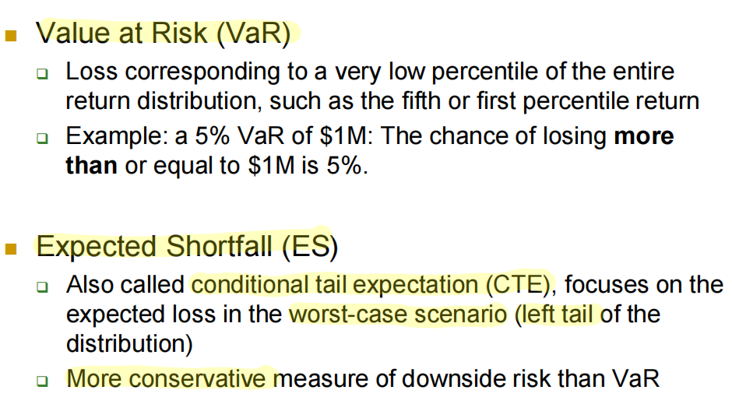
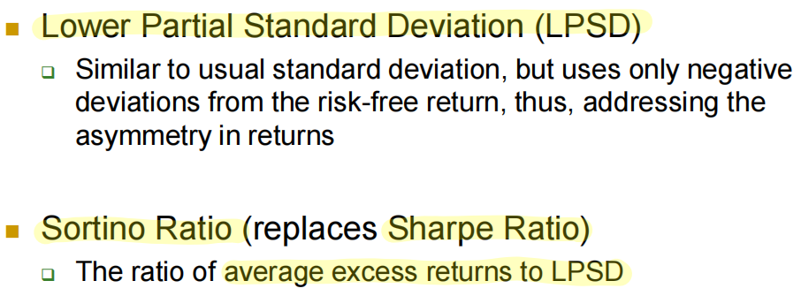
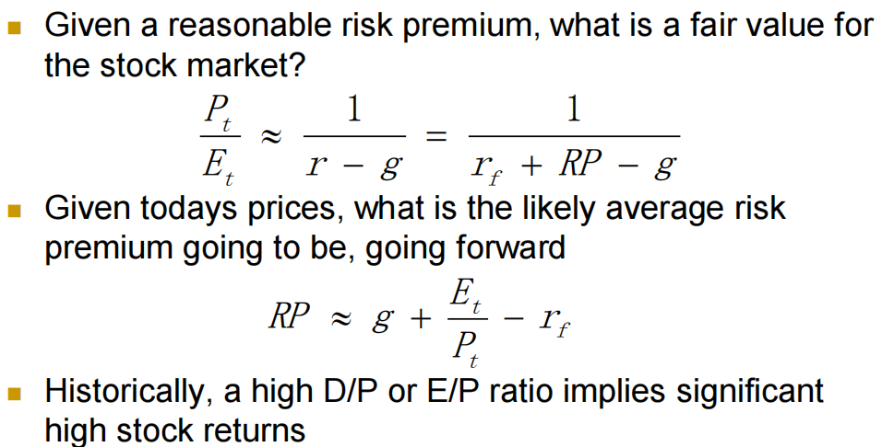

Inflation: Bond falls, discount rate up, lender will raise interest rate to cover
Stock do Not react as much to inflation. (discount rate up, expected cash flow up, cancel each other.
If unemployment are better than expected (i.e. good) , discount rate up, company borrow more, pushing riskless rate up, Bond falls.
Stocks not react as much to unemployment report. Discount rate up, stronger economy means cash flow up, cancel out each other.1q

Formulas:
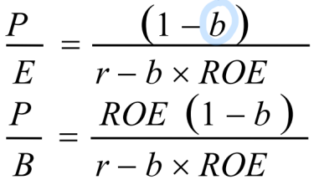L3_P51

L3_P58

